Date:21.11.2021

**Third Year B. Tech., Sem V 2021-22**

**Programming Lab 3**

**Practical No- 7**

**PRN/ Roll No: 2019BTECS00064**

**Full name: Kunal Santosh Kadam**

**Batch: T2**

**Title of Practical: To create a Node.js HTTP server and REPL Commands.**

**Problem Statement 1:**

1. Create a separate workspace for your project using selected IDE.

Ans:

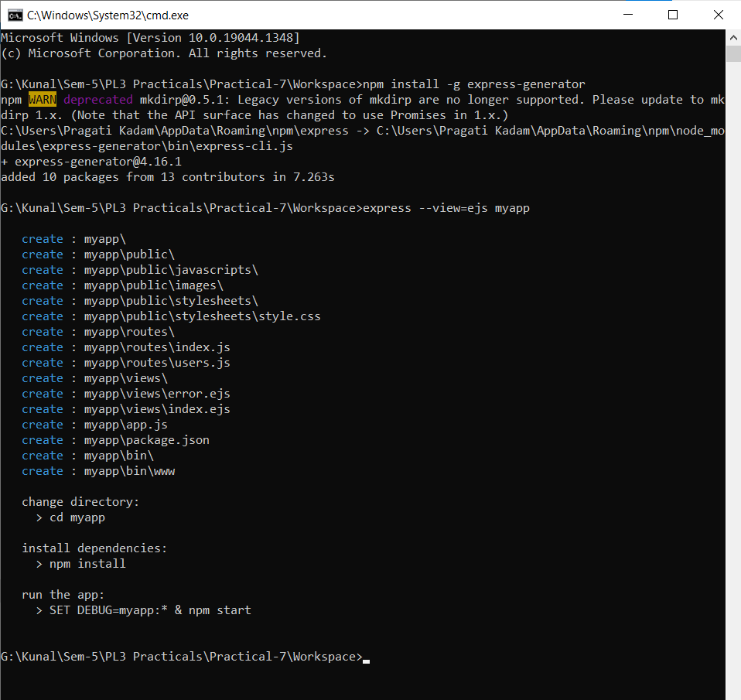

1. Write a program to start a Node.js server on localhost and listens to the client requests on port number 8080.

Ans:

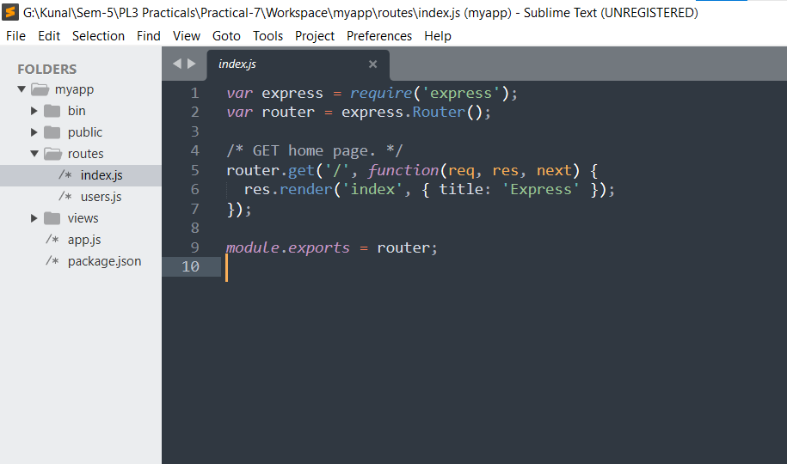

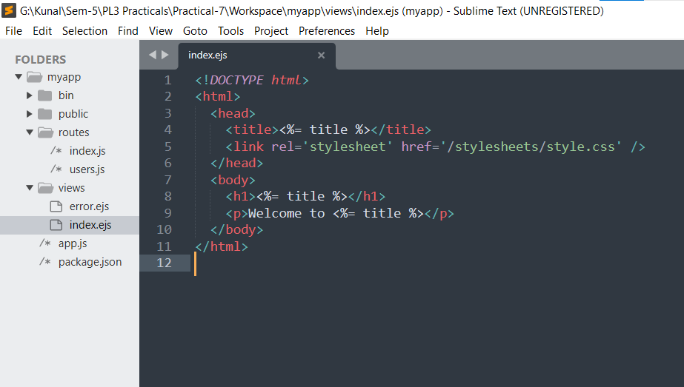

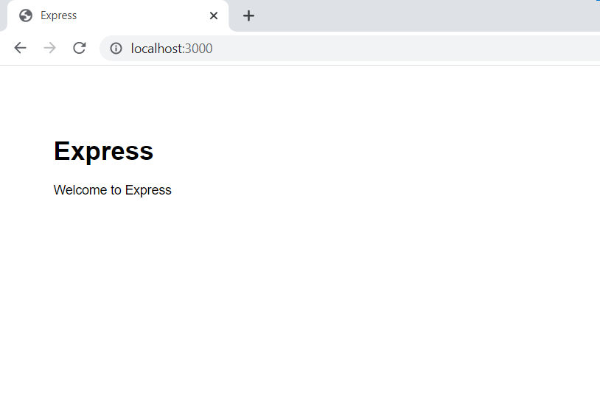

1. Change the Node.js IP address and port number and start the server again.

Ans:

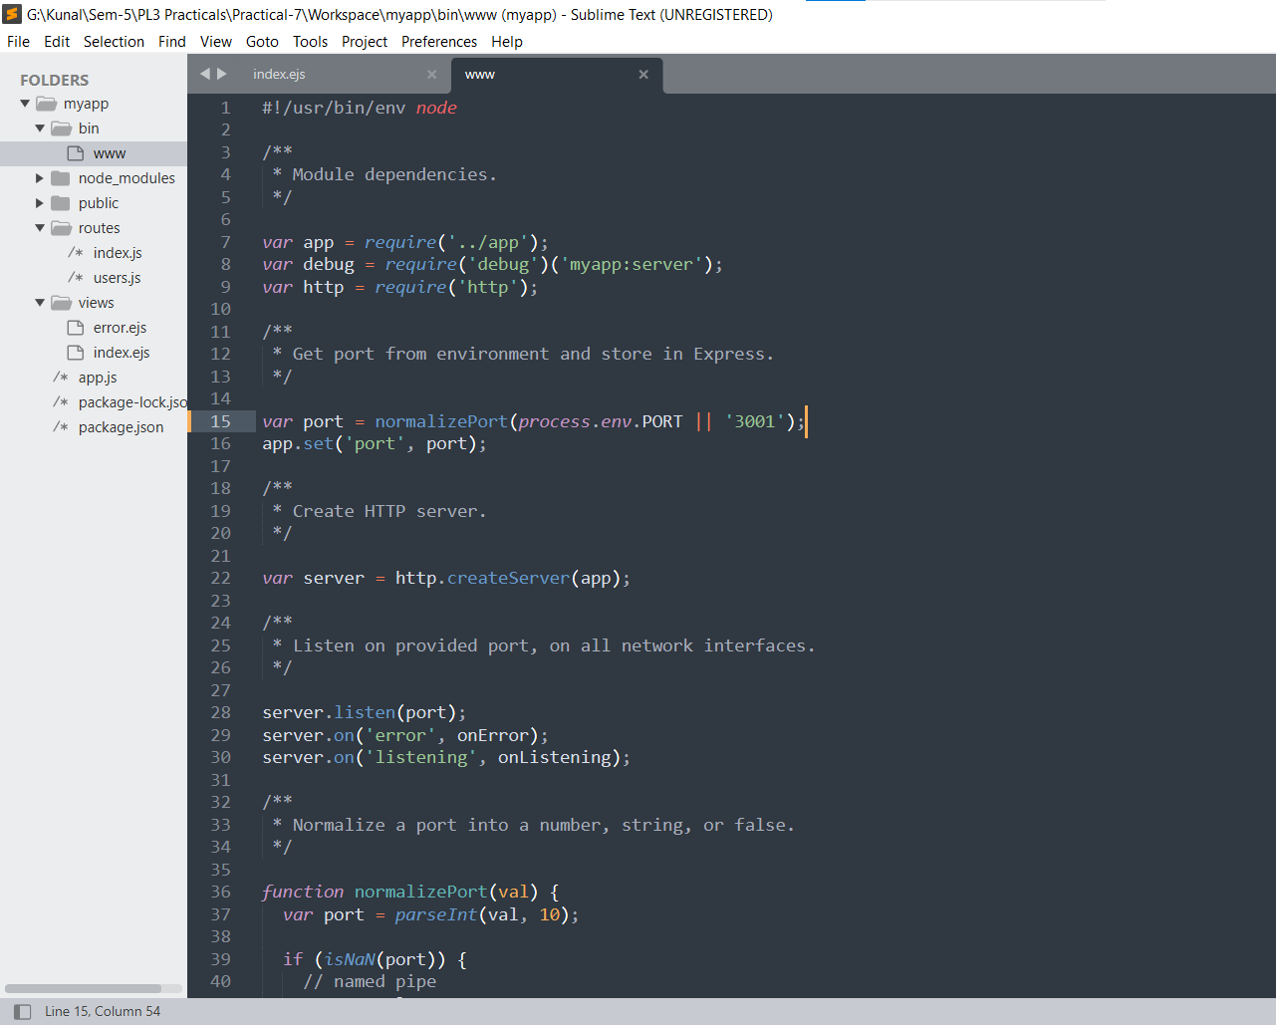

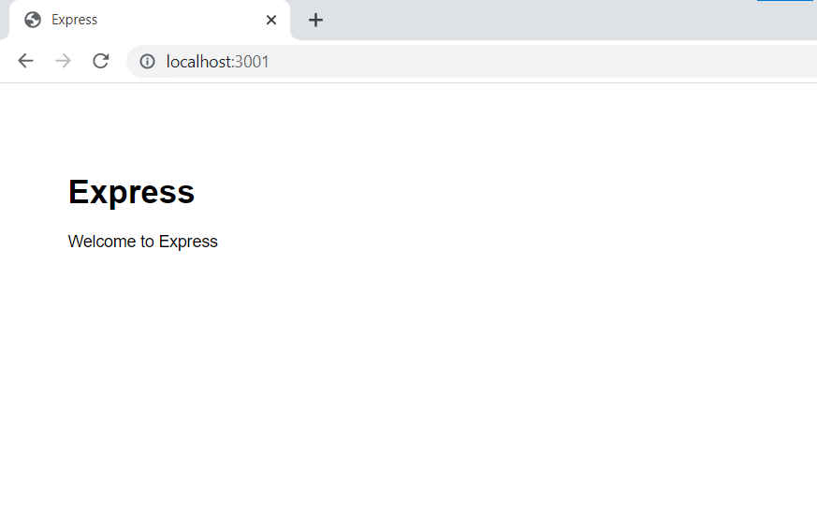

**Problem Statement 2:**

1. Perform the fundamentals programming constructs such as operations, loops, variable assignments and print their values using Node.js REPL environment.
2. Save the REPL session to a file and reload the REPL session.

Ans:

