Date:21.11.2021

**Third Year B. Tech., Sem V 2021-22**

**Programming Lab 3**

**Practical No- 8**

**PRN/ Roll No: 2019BTECS00064**

**Full name: Kunal Santosh Kadam**

**Batch: T2**

**Title of Practical: To use pre-built and user defined modules in Node.js Application.**

**Problem Statement 1:**

1. With the help of suitable examples use following Node.js pre-built modules in Node.js Application.
2. File System Modules (fs)

Read Operation:

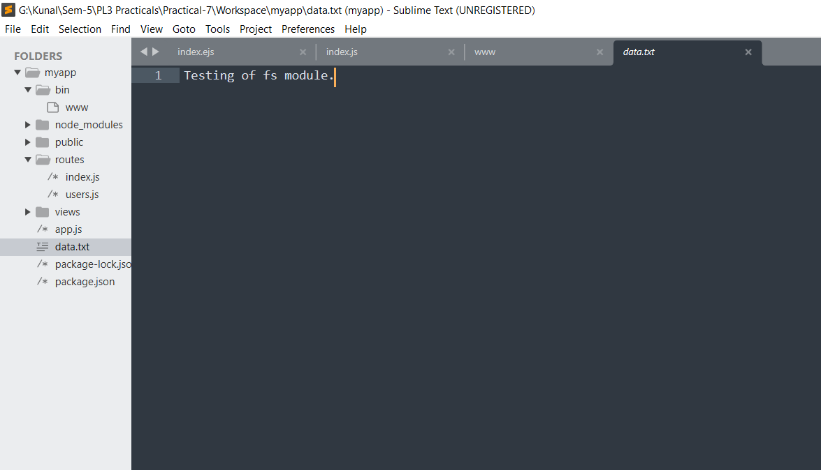

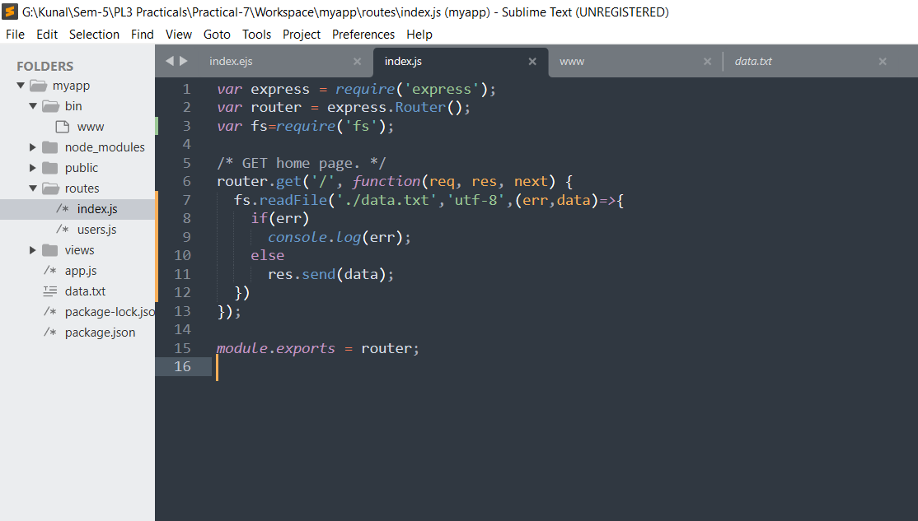

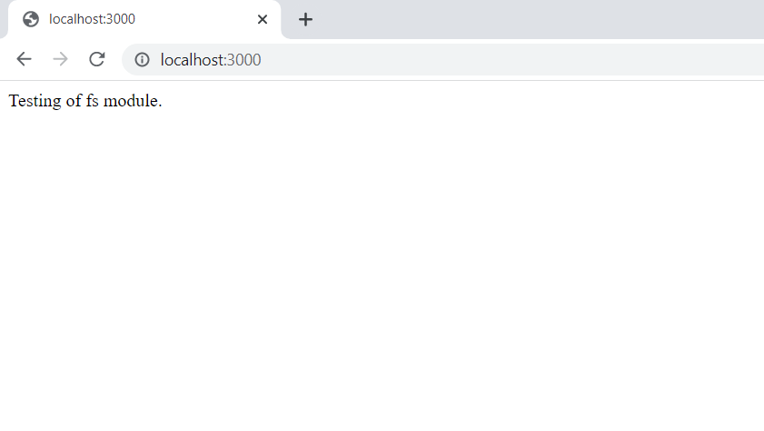

Write Operation:

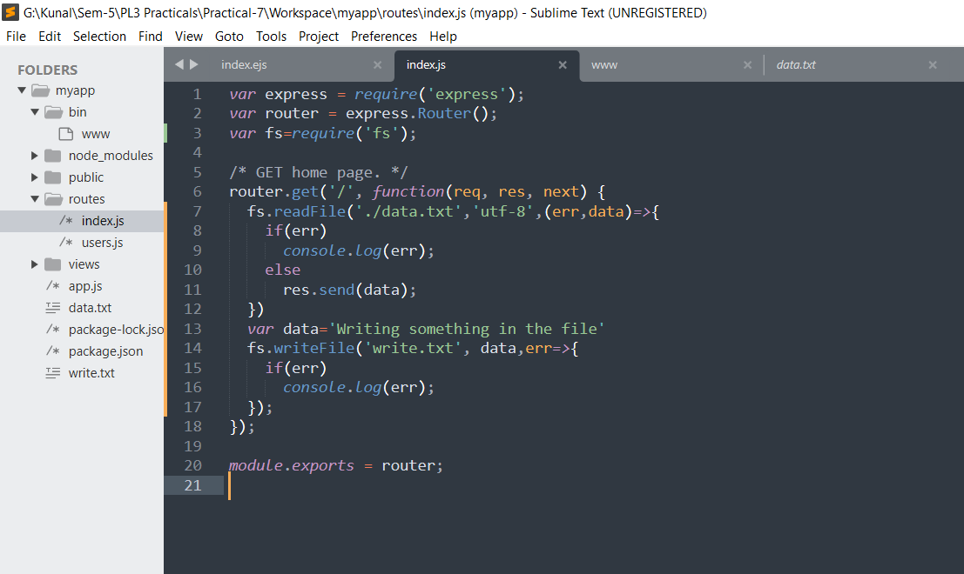

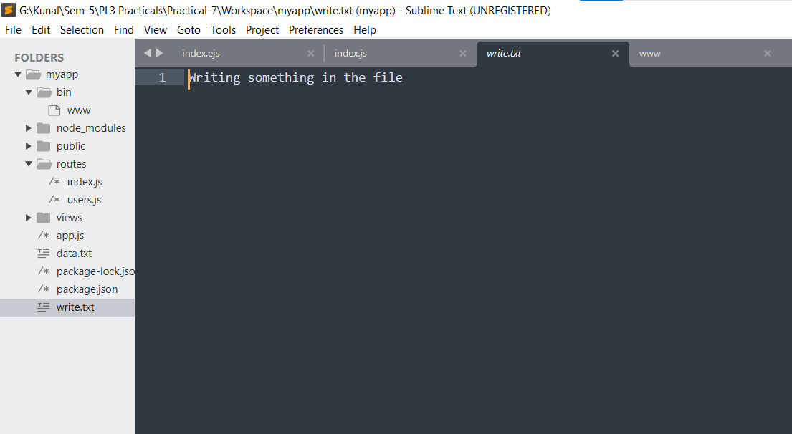

1. Secure HTTP Module (https)

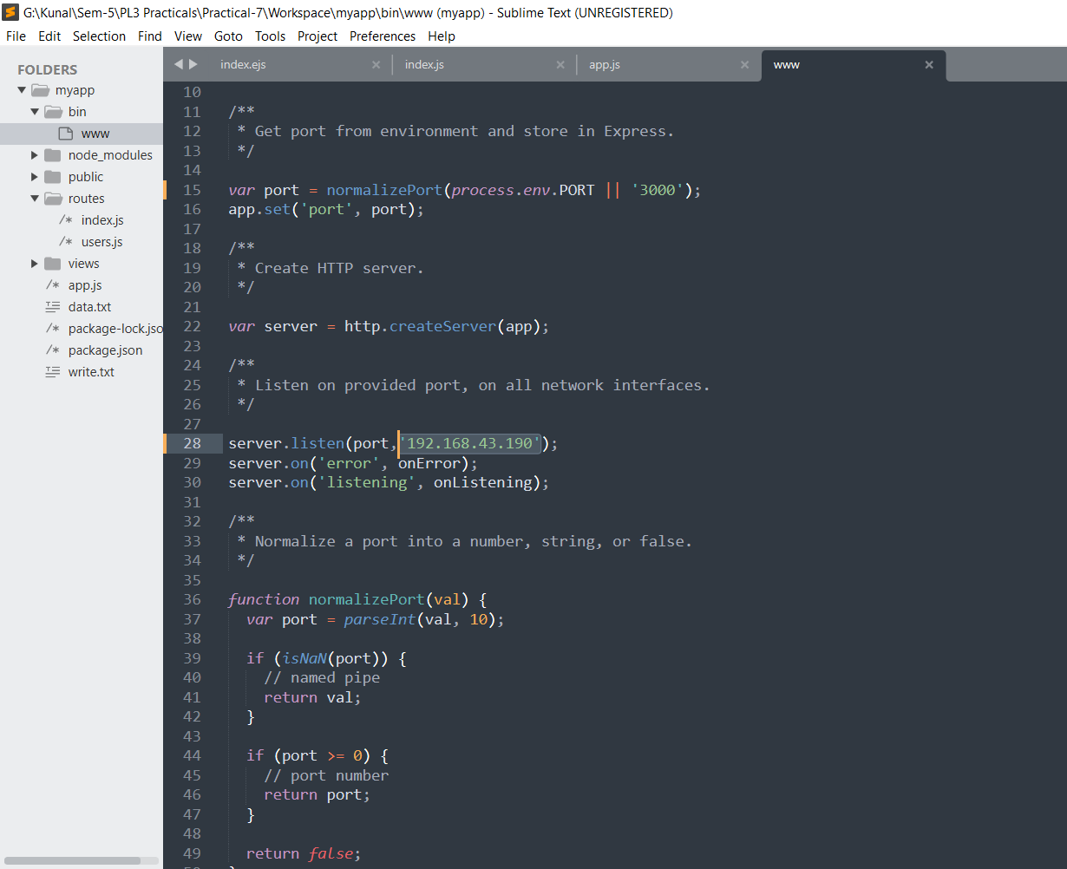

1. Nodemailer Module (nodemailer)
2. Install this module from npm

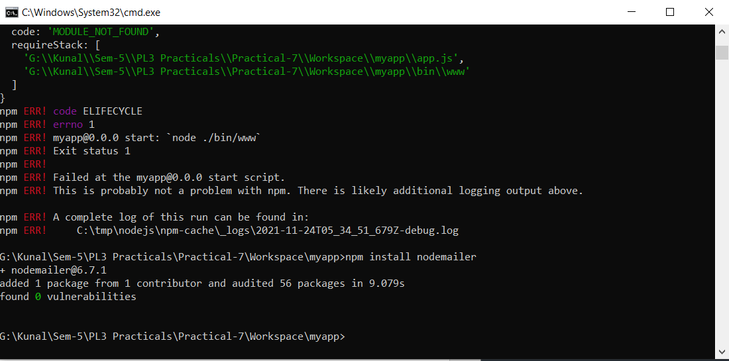

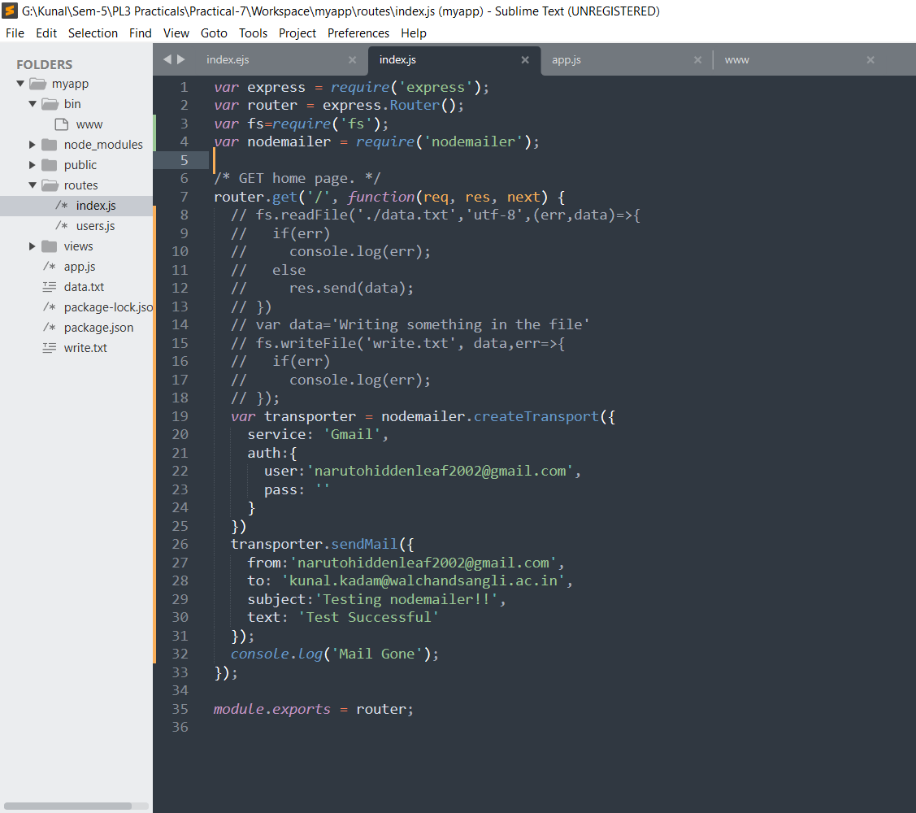

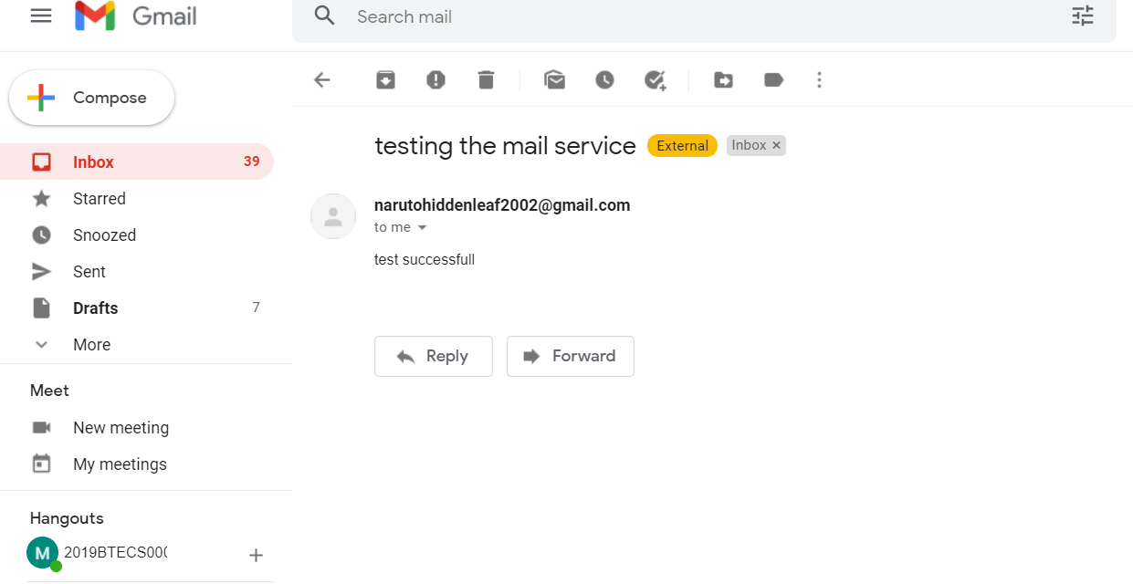

**Problem Statement 2:**

1. Create a user defined module and use it in Node.js Application that uses HTTP server.

Ans:



