LifeTrak Donor Schedule API SDS(System Design Specification)

  - SCOPE

The document contains the System Design specification including the technical details of the LifeTrak-donor scheduling API. The API is an interface for any external scheduling application to push the scheduling data into the LT system.

    - Purpose

The LifeTRAK scheduling API provides the interface between LifeTRAK donor scheduling and any external donor scheduling module (E.g.: DRM). The external application shall populate the data in the API tables. The interface reads the data from the API tables and process by applying the LifeTRAK logic and populates the LifeTrak transaction tables.

    - Limitations
- Cannot delete any records physically.

  - System Functions

- The external application populates the data in the given API tables. The outside application will be given the access to write into the tables through the role LT_DONOR_SCHEDULE_ROLE.
- The LT_DONOR_SCHEDULE_API.pkg is the core interface routine which read the data from the API tables, process and upload the LT tables.
- The API uses translation table to translate the data from the external data to the LT data for the predefined data (Ex: STATUS etc).
- The API logs all the processed details in the API log table for the user to review the failure or success status.
- The API will periodically check the API tables and upload the data to the corresponding LifeTrak tables.
- The API would update the LT_UPLOAD_DATE and LT_UPLOAD_STATUS after processing each record. The status will be S for the success status and F for the failed status.
  - The flag that will not allow the record to be picked up more than one time.
    - The interface will set the Upload_status flag to not pick up the entry, so duplication will be prevented.
    - The interface will set the upload_date in which the file was loaded to the main database.

- Data that is read from the API holding tables would go through the same LifeTrak control logic as it does when the data is input in the fields on the LifeTrak screens.
- The separate cron job is set to purge the holding tables after the data has been processed.
- The API will determine if LifeTrak is going to create a new number for EVENT_ID and SCHEDULE_ID.
  - If the IDs ( MS, DS) defined under the master code type IDCON is Y then the interface will reassign the Lifetrak ID like MS00090111, DS00009890 while processing, after reassigned the old ID and the new ID will be logged in the API_UPLOAD_CONVERSION table. The user will be able to view through the APIQCONV screen.

- If the IDs defined in the master code type IDCON is N then the API will not convert but take the value as it is but performs the following check.
  - Event ID have the ‘DS’ appended to a 8 digit number.
  - Schedule ID will have the ‘MS’ appended to a 8 digit number.

- The API will check if a number that is coming from the outside source is in conflict with an internal number and place an entry in the API log query table.

- The API will check if the donation type and procedure code/group are valid, if required the donation type and procedure code will be translated to the LT value from the translation table

- If the inbound record is not present in the LT table then the record will be inserted, if the record is already present then the record will be updated, there is no status flag to decide if the record should be updated or inserted.

  - Technical Specifications

    - Database requirements

- Create/use the database schema LTAPI.
- Create a Database role LT_DONOR_SCHEDULE_ROLE and grant all the required table access to the role. This role is optional.
- Create the following API holding tables to capture the data from the external data source.

- API_MOBILE_SCHEDULE

- API_DONOR_SCHEDULE

    - API Interface components:

# | API COMPONENT | TYPE | DESCRIPTION
1 | LT_DONOR_SCHEDULE_API.SCHEDULING_PROCESSOR | Procedure | Main routine
2 | LT_DONOR_SCHEDULE_API.PROCESS_MOBILE_SCHEDULE | Function | Create or update MOBILE_SCHEDULE
3 | LT_DONOR_SCHEDULE_API.FIX_DONOR_SCHEDULE | Procedure | Create or update DONOR_SCHEDULE
4 | LIFETRAK_DONOR | Procedure | General routine to insert or update the records

    - Process

      - LT_DONOR_SCHEDULE_API.SCHEDULING_PROCESSOR

Purpose:

This is the primary routine in the donor scheduling interface. This routine calls each component mentioned in the above table and populate the corresponding tables.

Prerequisites:

            - All the API tables should have been created with the proper access.
            - Data should have been populated in the API tables
            - The package LT_DONOR_SCHEDULE_API should have been created with the proper execute permission
            - The package LIFETRAK_DONOR should have been created with the proper access.

Functionality:

  - The input parameter to the main routine is the external application name Ex: DRM

  - From this routine each component mentioned in the above table 3.2 is called one after another to populate the appropriate table. The routine process the data for each table and return the status S if everything goes fine otherwise the error will be logged in the log table

  - The following are the different routines to process different API tables.

LT_DONOR_SCHEDULE_API.PROCESS_MOBILE_SCHEDULE

- This routine is used to populate the LifeTrak MOBILE_SCHEDULE table.

- The records with LT_UPLOAD_DATE null from the API_MOBILE_SCHEDULE table will be loaded into a cursor for the processing

- Each data field from every record is parsed and stored in a string array for validation

- Check the validity of the SITE_ID, if it is not a valid then log the error and skip to the next record. The SITE_ID must be present in the LOCATIONS table

- Check the validity of the CHAPTER_ID. The Chapter ID must be present in the Chapters table, if it is not valid the record is skipped.

- Check the validity of the DONATION_TYPE, PROCEDURE_GROUP. If the values are matching with the LT values the API will take it as it is, if the values are not in the LT table then go to the translation table to get the values, if the values are not defined then the error will be logged.

- Check the validity of the schedule date and time. An error will be logged for incorrect date and time

- If the validation is passed then it calls the LIFETRAK_DONOR routine to insert or update the record

- After the transaction is done, the LT_UPLOAD_DATE and LT_UPLOAD_STATUS fields will be updated. If the upload is success then the LT_UPLOAD_STATUS field will be S otherwise it will be F.

- The status of each transaction will be logged in the log table

LT_DONOR_SCHEDULE_API.PROCESS_FIX_DONOR_SCHEDULE

- This routine is used to populate the LifeTrak DONOR_SCHEDULE where fixed site donor schedules are captured.

- The records with LT_UPLOAD_DATE null from the API_FIX_DONOR_SCHEDULE table will be loaded into a cursor for the processing

- Each data field from every record is parsed and stored in a string array for validation

- Check the validity of the SITE_ID, if it is not a valid ID then log the error and skip to the next record. The SITE_ID must be present in the LOCATIONS table

- Check the validity of the CHAPTER_ID. The Chapter ID must be present in the Chapters table, if it is not valid the record is skipped.

- Check the validity of the DONATION_TYPE, PROCEDURE_CODE. If the values are matching with the LT values the API will take it as it is, if the values are not in the LT table then go to the translation table to get the values, if the values are not defined then the error will be logged.

- Check the validity of the schedule date and time. An error will be logged for incorrect date and time

- If the validation is passed then it calls the LIFETRAK_DONOR routine to insert or update the record

- After the transaction is done, the LT_UPLOAD_DATE and LT_UPLOAD_STATUS fields will be updated. If the upload is success then the LT_UPLOAD_STATUS field will be S otherwise it will be F.

- The status of each transaction will be logged in the log table

    - Data translation

- The IDP_COV_REF_VALUES is the translation table. The table will be populated with the source type, source value, target type and target value. The values are defined as shown in the diagram. Source Type and source value are from the external application and the target type and the target value are from the LT application.

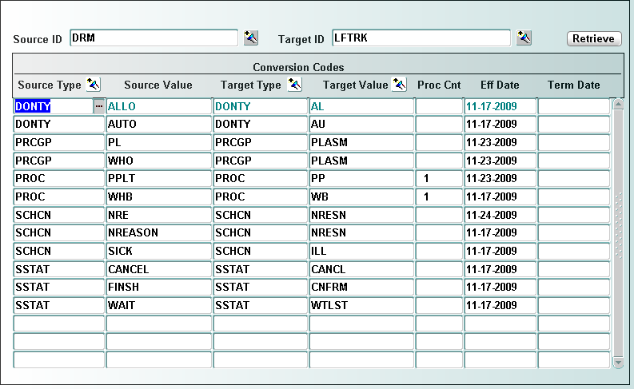

    - Message Logging

LifeTrak-Recruit API maintains a log of processed data in a separate table LIT_DONOR_API_LOG.
The following columns are in the table. The API cannot upload the data if any failure during the processing of data.

- SOURCE_ID (External application name)
- DATA_SOURCE_NAME (file name or key data if there is no file)
- MSG_LOG
- DATE
- PROGRAMID

      - The message log and saved messages are periodically purged.

      - A separate screen is provided to query the log messages.

DATABASE TABLES USED
Tables Used
Table Name | Mode | Description
MOBILE_SCHEDULE | S/I | Used to populate mobile schedule record
DONOR_SCHEDULE | S/I | Used to populate donor schedule record
LOCATION | S/I | Read location info
VALID_DONATION_TYPE | SI/I | Read donation type info
VALID_PROC_CODES | S/I | Read procedure code info
VALID_PROC_GROUPS | S | Read proc group info
API_MOBILE_SCHEDULE | S | Read mobile donors schedule info
API_FIX_DONOR_SCHEDULE | S | Read fix donor schedule info

    - Table Purging

The Holding tables will be purged periodically based on a cron job setting.

    - Revision History

REVISION HISTORY
Version # | Date | Author | Reason/ Remarks
01 | 11/25/2009 | Basker Edwin | Original  LifeTrak-Donor Schedule API provides the communication between LifeTrak™ and an external donor scheduling module

