4.1.3.4.4 LifeTrak API Log Information (APILTLOG)

Version: 01

- Intended Use:

- Provide log information (Error or Successful) generation of External conversions for data that is coming from external sources to LifeTrak application.

- program Functions

- Provide a control block with the following fields to enter the test criteria.

- Source ID (External ID), From Date and To Date

- Provide another block based on the LIFETRAK_API_LOG table to populate the following fields

- Internal ID
- External ID
- Date
- Log Text

- The Source ID (External ID) can be entered manually or selected from a list of values (LOV). This field is required If a value is not entered into this field, then it will display error 0204.

- The From Date can be entered manually or can leave blank , this field is optional

- The From Date can be entered manually or can leave blank , this field is optional

- If both the Fields (From and To date) left blank then it consider to show all data or If it filled by valid dates the data will show based on the given date range

Log Text Results

- Internal ID: This is a display only field. This field is automatically populated after the Source ID, From Date and To Date have entered. Field is not navigable and not updatable.

- External ID: is a display only field. This field is automatically populated after the Source ID, From Date and To Date have entered. Field is not navigable and not updatable.

- Date: is a display only field. This field is automatically populated after the Source ID, From Date and To Date have entered. Field is not navigable and not updatable.

- Log Text: is a display only field. This field is automatically populated after the Source ID, From Date and To Date have entered. Field is not navigable and not updatable.

- Post Conditions

- Error Conditions

- DATA REQUIREMENTS:

FIELD NAME | DATATYPE | LENGTH | ENTERABLE | LOV | BASE TABLE
C_EXTERNAL_ID | CHAR | 15 | Y | Y

- Screen Layout:

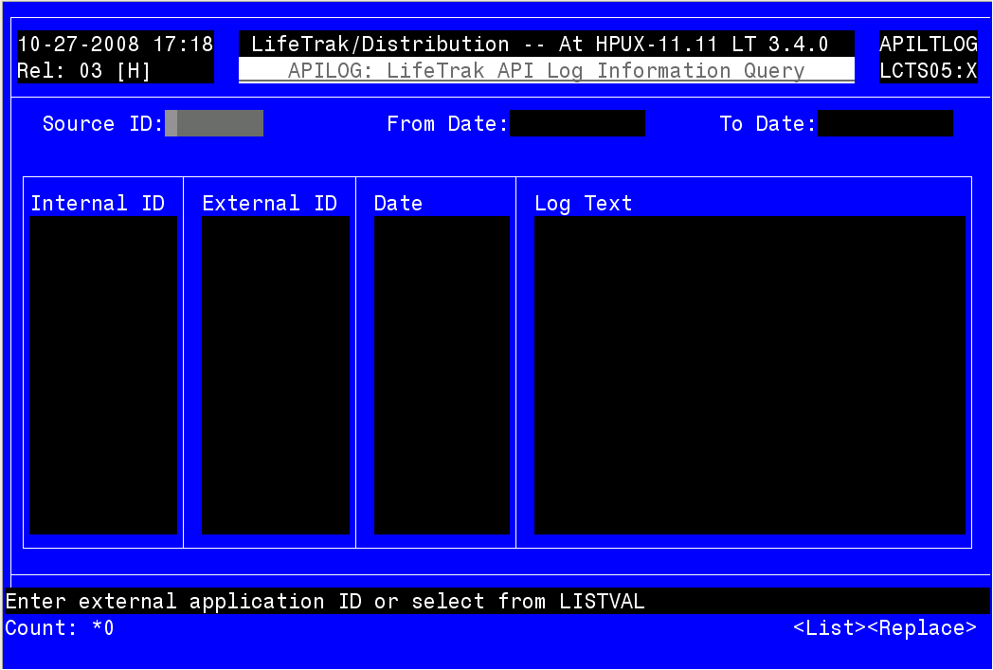

Revision History

REVISION HISTORY (APILTLOG)
Rel | Ver | Modification | Reference | Revision Date | Revised By
3.4.0 | 01 | Developed | 11347 | 10/27/08 | Touqeer

