4.1.3.4.4 LifeTrak Data Conversion (APILCONV)

Version: 02

- Intended Use:

- Provide conversions for data that is coming from external sources to LifeTrak application.

- program Functions

- Provide a control block with the following fields to enter the test criteria.

- Source ID and Source Description
- Target ID and Target Description

- Provide another block based on the UTRS table to populate the following fields

- Source Value
- Target Value
- Target Type
- Effective Date
- Termination Date
- Last Modified Date

- The Source ID can be manually entered or selected from a list of values. If a value is not entered into this field, then display error 0204. The Source Description is automatically populated based on the entry in the Source ID field.

- The Target ID field has a constant value of “LT” and the corresponding Target Description field also has a constant value of “LifeTrak”.

- The conversion values will be populated in the detail block based on the entry criteria in the Source ID field.

- If there are no results in the detail block, new records can be inserted. If some conversion records have retrieved based on the criteria in the Source ID field, then these records can be modified or new records can be inserted or both.

Conversion Results

- Source Value: Entry in this field is required. Validate for duplicate entry of the combination of Source ID, Target ID, Source Value, Target Value and Target Type. Also validate for duplicate entry of active Source Value records.

- Target Value: Entry in this field is required. Validate for duplicate entry of the combination of Source ID, Target ID, Source Value, Target Value and Target Type.

- Target Type: Entry in this field is required. Enter Target Type or select from a list of values [LOV]. Validate for duplicate entry of the combination of Source ID, Target ID, Source Value, Target Value and Target Type.

- Effective Date: Entry in this field is required. Populate Last Modified Date automatically after Effective Date is entered. Validate for duplicate entry of active Source Value records.

- Termination Date: Entry in this field is optional. Validate for duplicate entry of active Source Value records.

- Last Modified Date: This is a display only field. This field is automatically populated after the Effective Date is entered. Field is not navigable.

- At commit, validate for duplicate entry of the combination of Source ID, Target ID, Source Value, Target Value and Target Type. Also validate for duplicate entry of active Source Value records.

- Post Conditions

- Error Conditions

- DATA REQUIREMENTS:

FIELD NAME | DATATYPE | LENGTH | ENTERABLE | LOV | BASE TABLE
C_SOURCE_ID | CHAR | 15 | Y | Y
C_SOURCE_DESC | CHAR | 50 | N | N
C_TARGET_ID | CHAR | 15 | N | N
C_TARGET_DESC | CHAR | 50 | N | N
SOURCE_VALUE | CHAR | 15 | Y | N | API_LT_CONVERSION
TARGET_VALUE | CHAR | 15 | Y | N | API_LT_CONVERSION
TARGET_VALUE_TYPE | CHAR | 50 | Y | Y | API_LT_CONVERSION
EFF_DATE | DATE | 11 | Y | N | API_LT_CONVERSION
TERM_DATE | DATE | 11 | Y | N | API_LT_CONVERSION
LAST_MOD_DATE | DATE | 11 | N | N | API_LT_CONVERSION

- Screen Layout:

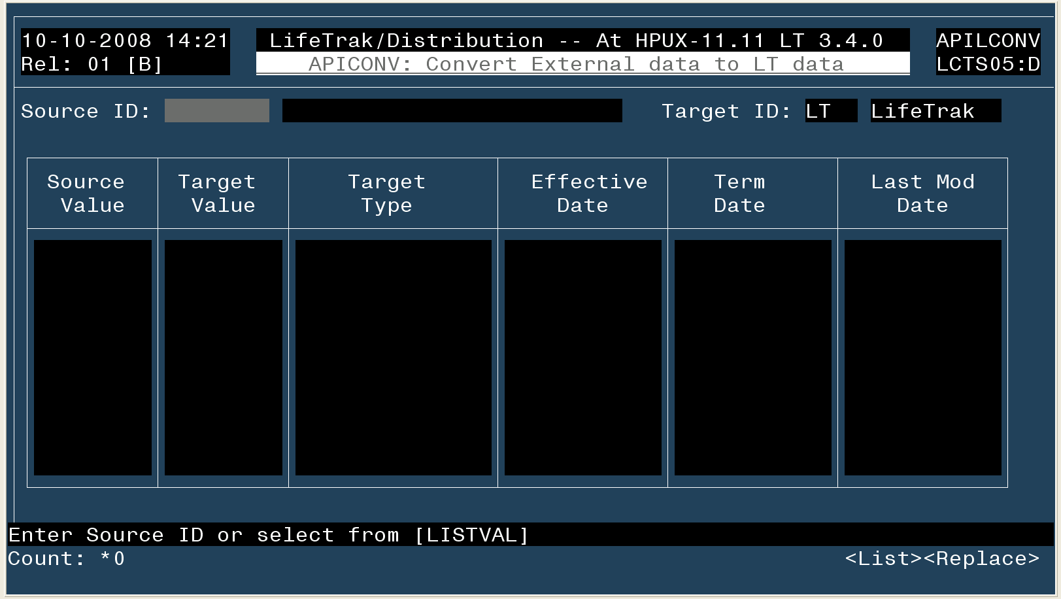

Revision History

REVISION HISTORY (APILCONV)
Rel | Ver | Modification | Reference | Revision Date | Revised By
3.4.0 | 01 | Developed | 11347 | 10/10/08 | Kishore
3.4.0 | 02 | Modified | 11347 | 10/14/08 | Kishore

