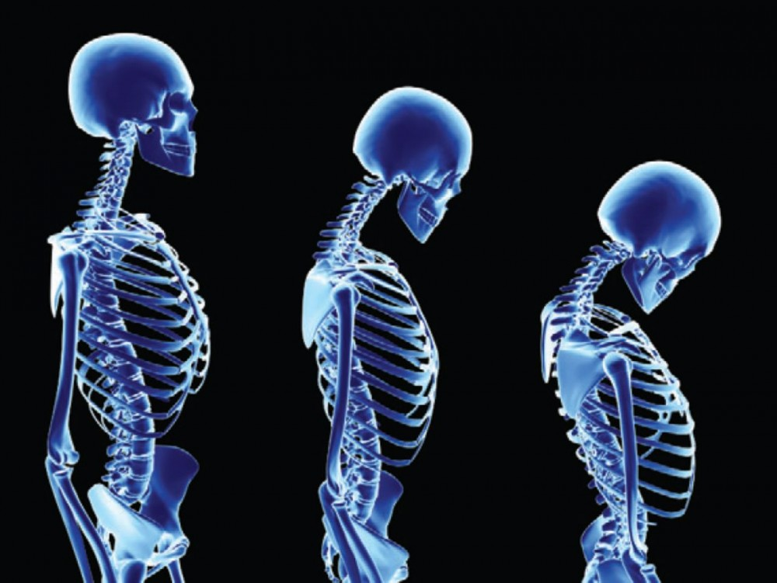

[This Photo](http://tinoshare.com/what-are-the-effects-of-osteoporosis-in-the-body/) by Unknown Author is licensed under [CC BY-NC](https://creativecommons.org/licenses/by-nc/4.0/)

Data on Children who have had Corrective Spinal Surgery

**Description**

The kyphosis data frame has 81 rows and 4 columns. representing data on children who have had corrective spinal surgery

**Format**

This data frame contains the following columns:

Kyphosis

a factor with levels absent present indicating if a kyphosis (a type of deformation) was present after the operation.

Age

in months

Number

the number of vertebrae involved

Start

the number of the first (topmost) vertebra operated on.

**Source**

John M. Chambers and Trevor J. Hastie eds. (1992) *Statistical Models in S*, Wadsworth and Brooks/Cole, Pacific Grove, CA.