Project Wireframe

*Predictive Maintenance - NASA Turbofan Jet Engine RUL Prediction*



Author : Kunal Lokhande

February 2025

iNeuron Internship

End to End Machine Learning Internship Project

Document version control

Date issued - February 2025

Version - 0.0.1

Description - Project wireframe Document

Author - Kunal Lokhande

**Table of contents**

| index. | contents | page |
| --- | --- | --- |
| A | Document version control | 1 |
| B | Abstract | 3 |
| 1 | Homepage | 4 |
| 2 | User input | 5 |
| 3 | Result page | 6 |

**Abstract**

Machine learning is revolutionizing industries by enabling data-driven decision-making and predictive analytics. In aviation, predictive maintenance plays a crucial role in optimizing engine performance and reducing operational costs. This project focuses on leveraging machine learning to estimate the **Remaining Useful Life (RUL)** of aircraft engines, ensuring timely maintenance and minimizing downtime.

The study involves **data exploration, feature engineering, and model development** using advanced regression and deep learning techniques. By analyzing sensor data from aircraft engines, the model predicts degradation patterns, helping airlines schedule maintenance proactively. Additionally, the aviation industry faces challenges such as fluctuating demand, safety regulations, and dynamic pricing strategies. This research also explores key factors influencing flight ticket pricing, including demand-supply dynamics, booking trends, and operational constraints.

The findings aim to enhance **predictive maintenance efficiency** while providing insights into **cost optimization** for airline operations. The integration of machine learning in aviation not only improves safety but also drives economic sustainability in a highly competitive sector.

**1. Homepage**

Our web page is one single interface where both input from the user and the prediction is displayed.

Whenever user wants to predict the results he just have to go further by clicking on start prediction button.

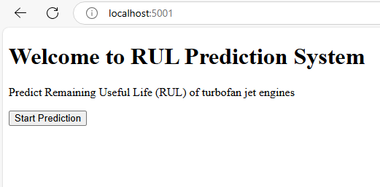

**2. User Input**

Whenever the user hits our URL, they first see the user input page here they must provide the information like:

⦁ User can be able to enter the values directly or every user input has its own dropdown where the user can select their input.

⦁ After providing the required input and pressing the submit button, the page refreshes and displays the output

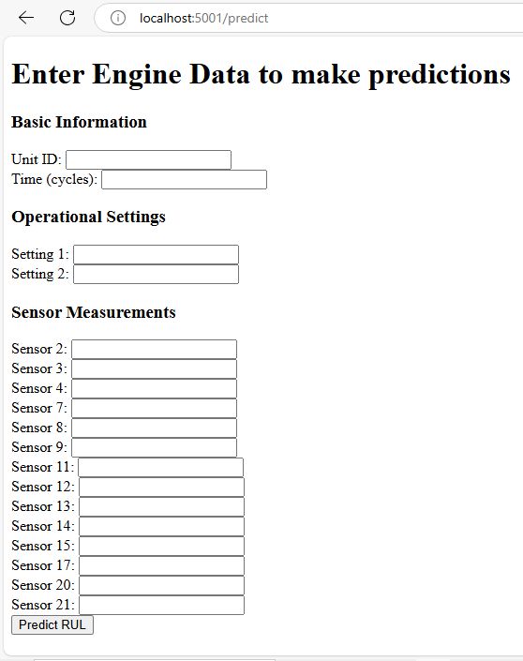

**3. Result Page**

After the user hits the submit button the page gets refreshed, and the results are being displayed in the highlighted area in the above frame.

The user can refill all the inputs in same page and get the results in the same way.



