**References**

**CODING**

Movement - <https://www.youtube.com/watch?v=wi-RL4sUayo&t=523s>

Jump - <https://www.youtube.com/watch?v=7KiK0Aqtmzc&ab_channel=BoardToBitsGames>

Flipping character - <https://www.youtube.com/watch?v=MvRqEDcJoJQ>

Enemy AI - <https://www.youtube.com/watch?v=nEYA3hzZHJ0>

Health System - <https://www.youtube.com/watch?v=3uyolYVsiWc>

Combat - <https://youtu.be/sPiVz1k-fEs>

Knockback - <https://www.youtube.com/watch?v=ahadN8aGvXg>

Scene transitions - <https://www.youtube.com/watch?v=CE9VOZivb3I>

Projectiles - <https://www.youtube.com/watch?v=pWVR3g2PWow>

Boss animation transitions - <https://www.youtube.com/watch?v=cXefXSD2SM0>

**PIXEL ART**

Tiles, background, props - <https://assetstore.unity.com/packages/2d/environments/nature-pixel-art-base-assets-free-151370>

**AUDIO**

All audio is free to use from “mixkit” under the mixkit license which can be found here - <https://mixkit.co/license/#sfxFree>

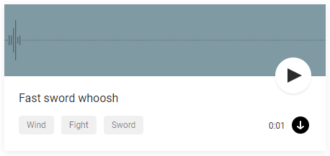

Sword swing sound effect –

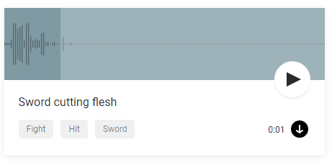

Sword hitting enemy -

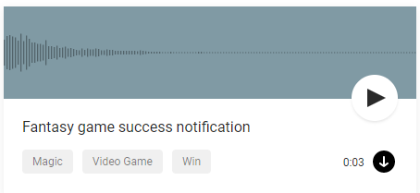Player picking up equipment -

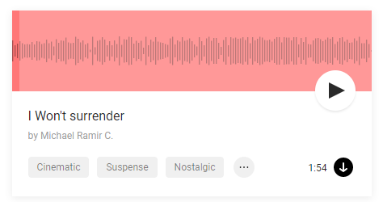

Background music for level 1 and 2 -

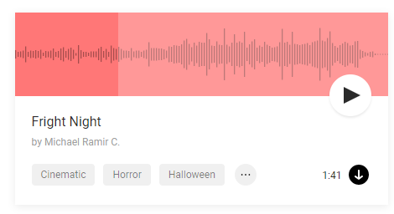

Background music for level 3 -