The overview of the LLM model has been shown by the diagram below.
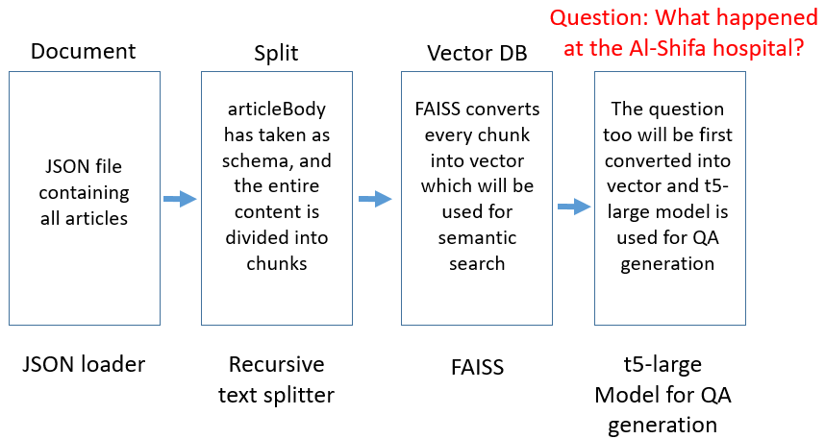
- Required Python packages necessary are installed.
- Langchain framework has been used and Json file are uploaded using Json uploader, here only the article body has been taken into consideration as page_content.
- RecursiveCharacterTextSplitter is used to convert the whole content into multiple chunks, an overlap is given to maintain consistency between successive chunks.
- FAISS has been used to encode the text data into vectors, and then it has been indexed. It returns two arguments as indices and Euclidean distances.
- The indices are stored by the name ‘relevant chunks’, which will be called later while usinf QA model.
- Lastly, t5-large model has been used, which is one of the popular choice for QA type projects.

