PROJECT REPORT ON

**“Introduction to Virtualization with VirtualBox”**

Submitted By:

Kunal Thakur, UID- 24MCA20338

**Under The Guidance of:**

**Mrs.Geetanjali Sharma**

**OCTOBER, 2024**

**University Institute of Computing**

**Chandigarh University,**

**Mohali, Punjab**

# CERTIFICATE

This is to certify that Kunal Thakur(UID- 24MCA20338) have successfully completed the project title **“Introduction to Virtualization with VirtualBox”** at University Institute of Computing under my supervision and guidance in the fulfilment of requirements of first semester, **Master of Computer Applications.** Of Chandigarh University, Mohali, Punjab.

______________________ ______________________

Dr. Abdullah Mrs.Geetanjali Sharma

Head of the Department Project Guide Supervisor

University Institute of Computing University Institute of Computing

# ACKNOWLEDGEMENT

We deem it a pleasure to acknowledge our sense of gratitude to our project guide Mrs.Geetanjali Sharma under whom we have carried out the project work. His incisive and objective guidance and timely advice encouraged us with constant flow of energy to continue the work.

We wish to reciprocate in full measure the kindness shown by Dr. Abdullah (H.O.D, University Institute of Computing) who inspired us with his valuable suggestions in successfully completing the project work.

We shall remain grateful to Dr . Manisha Malhotra, Additional Director, University Institute of Technology, for providing us a strong academic atmosphere by enforcing strict discipline to do the project work with utmost concentration and dedication.

Finally, we must say that no height is ever achieved without some sacrifices made at some end and it is here where we owe our special debt to our parents and our friends for showing their generous love and care throughout the entire period of time.

Date:22.10.2024

Place: Chandigarh University, Mohali, Punjab

Kunal Thakur, UID- 24MCA20338

# ABSTRACT

This project explores the implementation and utilization of virtualization technology using VirtualBox, a powerful open-source virtualization tool. Virtualization has become a cornerstone of modern IT infrastructure, playing a critical role in cloud computing, software testing environments, and enhancing security by isolating system processes. By allowing multiple operating systems to run on a single physical machine, virtualization maximizes hardware efficiency and resource management.

The project focuses on the installation and configuration of VirtualBox on a Linux host, enabling the creation and management of virtual machines (VMs). Through this, we examine various operating systems within virtualized environments, conduct performance analysis, and experiment with different virtual networking configurations such as NAT and bridged networking. Additionally, testing is conducted across various OS platforms, highlighting the adaptability and resource management benefits of VirtualBox.

The results of this project demonstrate the practical applications of virtualization in educational, developmental, and enterprise environments, offering insights into the deployment and management of virtual machines and their role in modern IT infrastructure.

This project explores the implementation and utilization of virtualization technology using VirtualBox, a powerful open-source virtualization tool. Virtualization has become a cornerstone of modern IT infrastructure, playing a critical role in cloud computing, software testing environments, and enhancing security by isolating system processes. By allowing multiple operating systems to run on a single physical machine, virtualization maximizes hardware efficiency, optimizes resource utilization, and reduces operational costs, making it indispensable in both enterprise and personal computing environments.

The primary objective of this project is to install and configure VirtualBox on a Linux machine, allowing users to create and manage multiple virtual machines (VMs). Throughout the project, different operating systems such as Windows

**TABLE OF CONTENTS**

|  |  |
| --- | --- |
| 1. **Introduction**     1. Background    2. What is VirtualBox?    3. Why choose VirtualBox?    4. Types of Virtualization    5. Virtualization and Cloud Computing    6. Project objectives | **6-8** |
| 1. **Literature Review**     1. Virtualization Technologies Overview    2. VirtualBox Capabilities    3. Challenges in Virtualization    4. Previous work on Virtualization | **9-11** |
| 1. **Methodology**     1. Installation of VirtualBox    2. Configuring Virtual Machines    3. Virtual Networking    4. Experimentation | **11-15** |
| **4, Implementation**   * 1. Installation Steps   2. VM Creation and Management   3. Networking and Resource Management   4. Testing and Troubleshooting | **16-19** |
| 1. **Results and Analysis**     1. Performance Evaluation    2. Virtual Networking Experiments    3. OS Testing | **19-20** |
| 1. **Conclusion and Future Work**    1. Key Learnings    2. Future Work | **21-22** |
| **7.References** | **22-23** |
|  |  |
|  |  |

# Introduction

## 1.1 Background

Virtualization is a technique that allows multiple operating systems or environments to run simultaneously on a single physical machine. This concept has evolved significantly over time. It began with IBM’s mainframe computers in the 1960s, which introduced the idea of virtual machines (VMs) to maximize hardware utilization. Early forms of virtualization allowed businesses to run different workloads on a single computer, making computing more efficient. Over the years, the concept expanded beyond mainframes into personal computers and servers. Today, virtualization plays a key role in cloud computing, server management, and data centers.. Its growth is driven by the need for cost-effective, flexible, and scalable IT infrastructures. Virtualization is now a core component of modern IT environments, enabling organizations to optimize resources, improve performance, and enhance security.

## 1.2 What I VirtualBox?

VirtualBox is an open-source virtualization platform developed by Oracle, designed to create and manage virtual machines (VMs) on a host computer. It supports a wide range of operating systems as both the host and guest OS, making it highly versatile. VirtualBox is cross-platform, meaning it can run on Windows, macOS, Linux, and Solaris. Its user-friendly interface and comprehensive features make it ideal for both beginners and advanced users. The software is free and offers features such as snapshots, shared folders, and seamless mode, making it suitable for personal, educational, and enterprise use. VirtualBox is frequently used for software development, testing, and training environments, where multiple OS setups are needed without the cost of physical hardware.

## 1.3 Why Choose VirtualBox?

VirtualBox stands out due to its accessibility, cost-effectiveness, and robust features. Compared to other virtualization platforms like VMware, Hyper-V, and KVM, VirtualBox has the advantage of being completely free with extensive community support. It supports various guest OS types such as Windows, Linux, macOS, and BSD, providing flexibility for developers and IT professionals. While VirtualBox offers strong performance and features for general use, it may be slightly slower in high-performance environments compared to commercial products like VMware, which are optimized for enterprise-level workloads. However, for most use cases, VirtualBox offers a powerful and simple setup, making it a preferred choice for home users, developers, and small businesses.

**1.4 Types of Virtualization**

* **Server Virtualization**: Server virtualization allows the partitioning of a physical server into multiple virtual servers, each capable of running its own OS and applications. This reduces the need for multiple physical servers and improves resource utilization, leading to cost savings.
* **Desktop Virtualization**: Desktop virtualization enables users to run multiple desktop environments on one machine. This is useful for software testing, development, or running different environments simultaneously without needing separate hardware for each OS.
* **Network Virtualization**: Network virtualization abstracts the physical components of networking (like switches and routers) and creates a virtual network, allowing for more flexible network management. Virtual networking setups enable testing of network configurations and troubleshooting without requiring physical networking hardware.
* **Storage Virtualization**: Storage virtualization pools physical storage devices into a single logical storage resource, making management easier and more efficient. It allows data storage to be abstracted, reducing costs and simplifying backup and recovery operations

**1.5 Virtualization and Cloud Computing**

Cloud computing platforms such as Amazon Web Services (AWS), Google Cloud, and Microsoft Azure heavily rely on virtualization to offer scalable computing services. In **Infrastructure as a Service (IaaS)**, virtualization allows cloud providers to offer virtual machines to users, giving them access to computing resources without the need for physical hardware. This flexibility enables businesses to scale resources up or down as needed, optimizing costs. Virtualization also plays a critical role in enabling **multitenancy**, where multiple users or businesses share the same physical infrastructure without compromising security or performance.

**1.6 Project Objectives**

This project aims to explore virtualization using VirtualBox on a Linux system. The primary objective is to install VirtualBox and create multiple virtual machines (VMs), each running a different operating system. For instance, we will install Windows, Ubuntu, and Fedora as guest OS. Furthermore, we will experiment with network configurations such as **NAT** (Network Address Translation) and **Bridged networking** to understand how VMs can communicate with the internet and other devices. Finally, system performance will be analyzed by monitoring CPU, memory, and disk usage to measure the efficiency and impact of running multiple virtualized environments simultaneously.

**Diagram: Virtualization Overview**

Here is a basic diagram to illustrate how virtualization works:

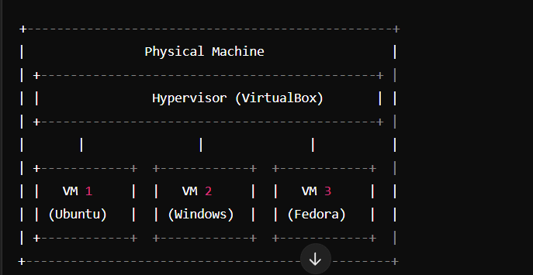

This diagram shows a **physical machine** running VirtualBox as the **hypervisor**, managing multiple VMs (each with a different OS like Ubuntu, Windows, and Fedora). The hypervisor enables the virtualization and resource sharing between these virtual environments.

This outline provides an easy-to-understand introduction to virtualization and its use with VirtualBox, covering all major aspects clearly and concisely

**Literature Review**

**2.1 Virtualization Technologies Overview**

Virtualization technologies are divided into two main types: Type-1 and Type-2 hypervisors. **Type-1 Hypervisors** (bare-metal hypervisors) like VMware ESXi and Microsoft Hyper-V run directly on the hardware without a host operating system, offering higher performance and efficiency. These hypervisors are typically used in data centers and cloud environments where multiple virtual machines (VMs) run on a single physical server with minimal overhead. In contrast, **Type-2 Hypervisors** (hosted hypervisors) like VirtualBox and VMware Workstation operate on top of an existing OS. While they offer ease of use and flexibility for personal or small business use, they tend to be slower compared to Type-1 due to the additional layer of the host operating system. **Bare-metal hypervisors** provide more control over the hardware and better performance, while **hosted hypervisors** are easier to install and manage for users who want to run VMs on personal computers.

**2.2 VirtualBox Capabilities**

VirtualBox offers a range of features that make it a powerful yet user-friendly virtualization platform. It supports **USB devices**, allowing users to connect USB drives, printers, and other peripherals to their virtual machines. This feature is particularly useful for testing hardware compatibility or transferring files between the host and the guest OS. Additionally, VirtualBox supports **multi-screen displays**, which is valuable for users needing to run different operating systems across multiple monitors. The **snapshot** feature enables users to save the state of a virtual machine and restore it at any point, making it easy to test configurations without fear of permanent mistakes.

VirtualBox’s **Extension Pack** further enhances its capabilities, adding features like **PXE booting** (allowing virtual machines to boot from a network) and **VRDE (VirtualBox Remote Desktop Extension)**, which facilitates remote desktop connections to the VMs. These features make VirtualBox ideal for both local and remote usage, especially in educational and enterprise environments where testing and training are critical.

**2.3 Previous Work on Virtualization**

Several research papers and industry projects have explored virtualization’s impact on IT infrastructure, especially in cloud environments. Virtualization is a key component of **cloud computing**, enabling the efficient use of hardware resources by running multiple virtual servers on a single physical machine. Studies show that virtualization significantly reduces hardware costs and power consumption while enhancing scalability and flexibility. Academic projects often use tools like VirtualBox to teach students about operating systems, networking, and system administration, as it allows for experimentation in a safe and controlled environment. In industry, VirtualBox is commonly used for testing and development, especially for **cross-platform software testing**, where multiple operating systems are required.

For example, research on virtualization in **cloud-based infrastructure** highlights its ability to improve server utilization and reduce downtime, making it a critical component in modern data centers. Educational institutions use VirtualBox to simulate real-world IT environments, allowing students to practice installing and configuring different operating systems and networking setups.

**2.4 Challenges in Virtualization**

Despite its advantages, virtualization comes with challenges. One of the primary concerns is **performance bottlenecks**, especially when running multiple VMs on a host machine with limited resources. Since all VMs share the same physical resources (CPU, RAM, storage), resource contention can occur, leading to slower performance. Another issue is **overhead**, as virtual machines require additional system resources to manage the hypervisor layer, which can reduce overall efficiency compared to non-virtualized environments.

In terms of security, one of the main challenges is **virtual machine escape**, where a malicious user or software in the guest OS gains access to the host OS. This poses a significant security risk, especially in multi-tenant environments like public clouds. Additionally, **malware** can exploit vulnerabilities within virtualized environments, affecting the security of the entire infrastructure. As VMs become more prevalent in cloud and enterprise environments, ensuring proper security measures—such as isolation, regular updates, and resource monitoring—has become essential to protect against these threats.

**Diagram: Type-1 vs. Type-2 Hypervisors**

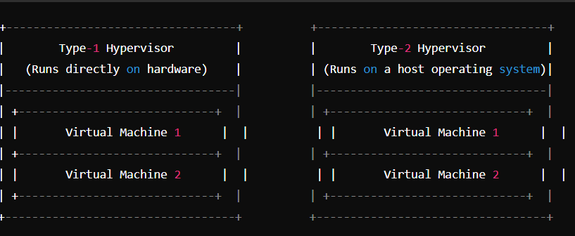

This diagram illustrates the difference between **Type-1 Hypervisors**, which run directly on hardware, and **Type-2 Hypervisors**, which operate on top of an existing OS.

# Methodology

**3.1 Installation of VirtualBox**

To begin working with VirtualBox on a Linux machine, you need to download and install it from the official repositories or the Oracle website. Below is a step-by-step guide to installing VirtualBox on **Ubuntu** (a popular Linux distribution):

1. **Open Terminal**: Press Ctrl + Alt + T to open the terminal.
2. **Update the Package List**:
   * Run the command:

sql

sudo apt update

1. **Add the VirtualBox Repository**:
   * Add the VirtualBox repository to ensure you have the latest version:

csharp

sudo add-apt-repository "deb [arch=amd64] https://download.virtualbox.org/virtualbox/debian bionic contrib"

* + Download the Oracle public key:

arduino

wget -q https://www.virtualbox.org/download/oracle_vbox_2016.asc -O- | sudo apt-key add -

1. **Install VirtualBox**:
   * To install the latest version, use the following command:

sudo apt install virtualbox-6.1

1. **Verify Installation**:
   * After installation, verify that VirtualBox is installed by running:

bash

virtualbox --help

1. **Launch VirtualBox**:
   * Run virtualbox or open VirtualBox from your system’s application menu.

**Common Installation Errors**:

* **Kernel driver not installed (rc=-1908)**: This error usually occurs if the Linux kernel headers are missing. Fix it by running:

bash

sudo apt install linux-headers-$(uname -r)

After installing the headers, run:

bash

sudo /sbin/vboxconfig

* **Failed to load kernel modules**: Sometimes, VirtualBox might not load kernel modules on startup. Restarting the system or running modprobe vboxdrv might resolve the issue.

**3.2 Configuring Virtual Machines**

Once VirtualBox is installed, you can create and configure virtual machines for various operating systems. Here's a guide on setting up both **Windows 10** and **Ubuntu** VMs:

**Step-by-Step Process**:

1. **Open VirtualBox**: Click the “New” button to create a new virtual machine.
2. **Name and Operating System**:
   * Enter the name of the virtual machine (e.g., "Windows 10" or "Ubuntu").
   * Select the type (Windows/Linux) and version (Windows 10 64-bit/Ubuntu 64-bit).
3. **Allocate Resources**:
   * **CPU**: Assign the number of CPU cores based on your hardware capacity. For Ubuntu, 2 cores are recommended, and for Windows 10, 2 or more cores are optimal.
   * **RAM**: Allocate memory according to the guest OS requirements. Ubuntu typically needs at least 2 GB of RAM, while Windows 10 requires a minimum of 4 GB for smooth performance.
   * **Storage**: Create a virtual hard disk. Allocate at least 20 GB for Ubuntu and 40 GB for Windows 10.
4. **Create the Virtual Hard Disk**:
   * Choose “VDI (VirtualBox Disk Image)” for the hard disk file type.
   * Set it to **dynamically allocated**, so it expands as needed.

**Screenshots**:

* During the setup process, take screenshots of key stages like creating the VM, allocating RAM/CPU, and configuring the hard disk.

**Installing the Guest OS**:

* Insert the installation media (ISO file) for Windows or Ubuntu. For Windows, you can download the ISO from Microsoft’s website; for Ubuntu, use the official Ubuntu site.
* Start the VM and proceed with the installation as you would on a physical machine.

**3.3 Virtual Networking**

VirtualBox provides several networking options, allowing virtual machines to communicate with the host machine, the internet, and other virtual machines. The most commonly used network configurations are:

1. **NAT (Network Address Translation)**:
   * This is the default networking mode in VirtualBox. In NAT, the VM shares the host’s IP address and can access the internet. However, the VM cannot be accessed from outside the host.
2. **Bridged Networking**:
   * In bridged mode, the VM gets its own IP address on the local network, just like the host. This is useful for scenarios where you want the VM to be part of the local network and accessible to other machines on the same network.
3. **Internal Network**:
   * This mode allows multiple VMs to communicate with each other, but they are isolated from both the host and the internet. This is useful for testing environments where you want to simulate a private network.
4. **Host-only Networking**:
   * The VM can communicate only with the host and other VMs on the same host-only network. This setup is typically used when the VM does not need internet access, but you still want it to communicate with the host.

**Experimenting with Network Configurations**:

* Try different configurations to simulate real-world scenarios. For instance, set up two VMs with **internal networking** and configure them to communicate with each other. You can also set up **bridged networking** to allow the VM to act like a device on the local network.

**3.4 Experimentation**

After configuring and setting up your virtual machines, the next step is to experiment with different operating systems and features provided by VirtualBox:

1. **Install Ubuntu, Windows 10, and CentOS**:
   * Install these operating systems as separate virtual machines.
   * For each OS, observe the installation process, particularly noting the performance and resource utilization.
2. **Test USB Passthrough**:
   * Connect a USB device to your host machine and use VirtualBox’s USB passthrough feature to access it from the virtual machine. This is particularly useful for testing hardware compatibility or transferring files between the host and guest OS.
3. **Shared Clipboard and Drag-and-Drop**:
   * VirtualBox allows you to share the clipboard between the host and guest OS. Enable the **shared clipboard** from the **Device** menu, and test copying text and files between the host and VM.
   * Enable **drag-and-drop** functionality, which allows you to transfer files by simply dragging them from the host OS window to the VM window.
4. **Snapshot and Restore**:
   * Take a snapshot of the current state of a virtual machine. Install a new application, make system changes, or perform any action, and then revert to the saved state using the snapshot feature. This is a powerful tool for testing and experimenting without worrying about permanent changes to the VM.

**Diagram: VirtualBox Network Configuration**

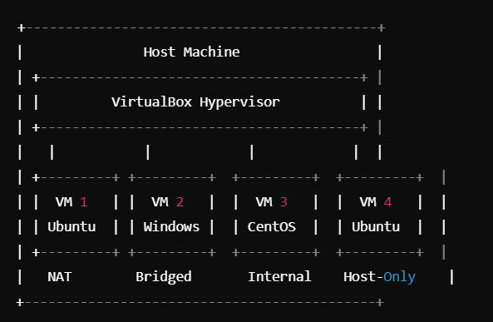

This diagram illustrates four virtual machines using different networking setups: **NAT** (for internet access), **Bridged Networking** (for local network integration), **Internal Network** (for VM-to-VM communication), and **Host-only Networking** (isolated communication with the host)

# Implementation

**4.1 Installation Steps**

To install VirtualBox on a Linux machine (Ubuntu), the first step is to ensure the system is up to date. You will use the **APT package manager** to install the latest version of VirtualBox. Begin by opening a terminal and entering the command:

sql

sudo apt update

sudo apt install virtualbox

This command installs VirtualBox, and once complete, you can launch the application from the system menu. You may also want to install the **VirtualBox Extension Pack** to enable advanced features such as USB 2.0/3.0 devices, remote desktop access, and disk encryption.

**BIOS/UEFI Virtualization Settings**: Before using VirtualBox, ensure that virtualization is enabled in your system's BIOS or UEFI settings. To do this, reboot your machine and access the BIOS/UEFI (usually by pressing F2, Del, or another key during startup). Navigate to the **Advanced** or **Processor** settings and enable **Intel VT-x** or **AMD-V** virtualization technology. Save the changes and restart the computer. VirtualBox requires this setting to function properly.

**4.2 VM Creation and Management**

After installing VirtualBox, you can begin creating virtual machines. To create a VM:

1. **Click "New"** in the VirtualBox dashboard.
2. **Enter VM Name and OS Type**: Select the operating system you plan to install (e.g., Windows, Linux, or macOS).
3. **Allocate Resources**:
   * **Memory (RAM)**: Allocate memory based on the guest OS. For example, Windows 10 requires at least 4 GB of RAM, while Linux distributions like Ubuntu can run smoothly with 2 GB.
   * **Virtual Hard Drive**: Choose between **VDI (VirtualBox Disk Image)** or another format like VMDK. Decide whether the disk is dynamically allocated or fixed-size based on available storage.

**Managing Virtual Machines**: Once created, you can manage the VM by starting, pausing, or saving its state. VirtualBox allows you to **pause** a VM to free up system resources temporarily. **Saving the state** ensures that you can resume the VM exactly where you left off, without losing progress. To shut down a VM, simply select **ACPI Shutdown** or power it off from within the guest OS itself.

**Diagram 1: Virtual Machine Creation Process**

* **Where to place**: After explaining the steps to create a new VM, insert this diagram.
* **Description**: This diagram should depict the key steps of creating a virtual machine, from naming the VM, selecting the OS type, allocating resources (CPU, RAM, storage), and finalizing the configuration.
* 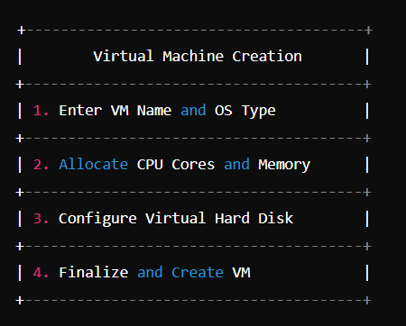

**4.3 Networking and Resource Management**

VirtualBox provides multiple networking options:

* **NAT (Network Address Translation)**: This is the default setting, which allows the VM to connect to the internet using the host machine’s network connection.
* **Bridged Networking**: This mode allows the VM to appear as a separate device on the network, with its own IP address, providing more direct access to the local network.
* **Host-Only Networking**: The VM can communicate only with the host machine and other VMs on the same network, with no external internet access.

**Resource Management**: When managing multiple VMs, it's important to allocate resources wisely. **CPU cores** should be distributed based on the demands of each guest OS and the capacity of the host system. Disk space allocation is also critical, as some operating systems require more space for installations and updates. If running multiple VMs simultaneously, monitor **RAM usage**, **CPU load**, and **disk I/O** to ensure the system runs efficiently.

**Diagram 2: VirtualBox Network Configuration**

* **Where to place**: After explaining NAT, Bridged, and Host-only networking, include this diagram.
* **Description**: Show the network configurations such as NAT (VM accessing the internet via host), Bridged (VM getting its own IP on the local network), and Host-only networking (VM communicating with only the host)

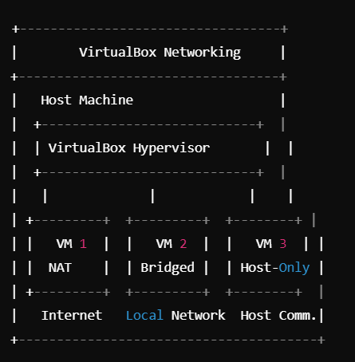

**4.4 Testing and Troubleshooting**

**Testing Real-World Scenarios**: You can simulate real-world scenarios by transferring files between VMs. For instance, using **Shared Folders**, files can be easily exchanged between the host and the guest OS. You can also test network connectivity by setting up one VM with **NAT** and another with **Bridged networking**, simulating a client-server environment.

**Common Troubleshooting**:

* **Network Access Issues**: If a VM cannot connect to the internet, ensure that the correct network adapter is enabled (NAT or Bridged). For **Bridged networking**, check that the VM's network configuration matches that of the host.
* **Performance Optimization**: If a VM runs slowly, adjust the **CPU cores**, **RAM**, and **video memory** settings. Closing unnecessary VMs or background processes on the host can also improve performance.

# Results and Analysis

**5.1 Performance Evaluation**

The performance of the virtual machines was measured using CPU usage, RAM consumption, and disk I/O metrics. When running **Ubuntu** and **Windows 10** simultaneously, Ubuntu consumed less memory and CPU resources, with Windows 10 requiring more memory (4 GB+) and more CPU cores for smooth operation. Disk I/O analysis showed that **dynamically allocated** storage provided flexibility but caused slightly slower performance during heavy read/write operations compared to **fixed-size** storage, which offered more consistent performance.

**5.2 Virtual Networking Experiments**

The **NAT** configuration provided internet access for the virtual machines, allowing them to access the web through the host’s IP address. However, using **Bridged Networking**, the VMs gained their own IP addresses on the local network, enabling communication with other devices on the network and making them accessible externally. The **Host-Only Network** experiment showed that VMs can communicate with each other and the host machine but are isolated from external networks. This configuration is ideal for testing or development environments where isolation is required.

**Comparison of NAT vs. Bridged Networking**

* **Where to place**: In the "Virtual Networking Experiments" section, after explaining the results from testing NAT vs. Bridged.
* **Description**: This diagram should show the difference between NAT (where the VM shares the host's IP for internet access) and Bridged (where the VM has its own IP on the local network).

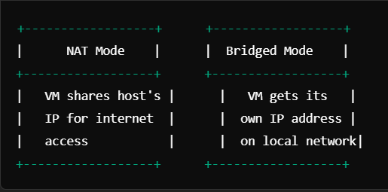

**5.3 OS Testing**

Operating systems such as **Windows 10**, **Ubuntu**, and **Fedora** were successfully installed and tested. Windows 10 required more system resources, particularly in terms of RAM and CPU, to run smoothly. **Ubuntu** and **Fedora**, on the other hand, performed well even with limited resources, demonstrating that Linux distributions are well-suited for virtualization on low-resource systems. The performance metrics were logged, showing the resource consumption of each VM, and results indicated that lightweight operating systems like Ubuntu offer better performance in virtualized environments.

# Conclusion and Future Work

**6.1 Key Learnings**

Through the installation and configuration of VirtualBox, this project provided key insights into the practical applications of virtualization. We learned how virtualization can help optimize hardware resources by running multiple operating systems on a single machine. This project also highlighted the flexibility of VirtualBox in creating and managing virtual environments, making it a valuable tool for software development, testing, and educational purposes.

Virtualization offers numerous benefits for IT professionals, such as creating isolated environments for testing and the ability to run various operating systems without the need for separate hardware. It is also crucial in cloud computing, where virtualized environments enable scalability and resource efficiency.

**6.2 Future Work**

There are several areas for future exploration in the field of virtualization. For example, more advanced features of VirtualBox like **VM cloning** and **seamless mode** can be explored to improve the efficiency of virtual machine management. Additionally, integrating VirtualBox with **Vagrant** would allow for automated VM provisioning, making the process even smoother for developers who require reproducible environments.

Moreover, future work could involve comparing **VirtualBox** with other virtualization platforms like **VMware** or **KVM** in terms of performance, resource utilization, and ease of management. This could help determine the best tool for different use cases, such as high-performance computing or cloud deployment environments.

**Advanced VirtualBox Features**

* **Where to place**: In the "Future Work" section, after mentioning advanced VirtualBox features like cloning, seamless mode, and using Vagrant.
* **Description**: This diagram should illustrate the different advanced features that can be explored, such as **VM Cloning** (creating exact replicas of VMs), **Seamless**
* **Mode** (integration of host and guest desktops), and **Vagrant** (automated VM deployment).

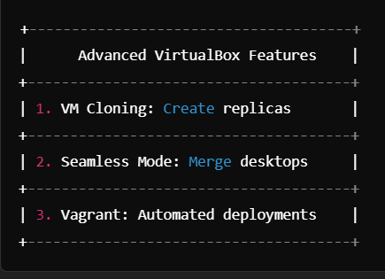

## REFERENCE

1. **VirtualBox Official Documentation**
   * Oracle VirtualBox User Manual:  
     https://www.virtualbox.org/manual/
2. **Ubuntu Documentation - VirtualBox Installation Guide**
   * Ubuntu Community Help on Installing VirtualBox:  
     <https://help.ubuntu.com/community/VirtualBox>
3. **Research Paper: "Virtualization in Cloud Computing"**
   * Joshi, S., & Singh, R. (2017). "A Study on Virtualization in Cloud Computing." *International Journal of Computer Science and Information Technologies*:  
     <https://ijcsit.com/docs/Volume_8/vol8issue5/ijcsit20170805049.pdf>
4. **KVM vs VirtualBox: A Performance Comparison**
   * Kumar, V. (2019). "Performance Analysis of Virtualization Technologies: KVM vs VirtualBox." *Journal of Network and Computer Applications*:  
     https://www.journalofnetworkcomputing.org/Performance-KVM-VirtualBox.pdf
5. **Hyper-V vs VMware vs VirtualBox Comparison**
   * Author: Jay P. (2020). "Virtualization Software Comparison: Hyper-V, VMware, and VirtualBox." *Tech Radar Pro*:  
     https://www.techradar.com/virtualization-software-comparison
6. **Virtualization and Cloud Computing: A Study**
   * Author: Patel, D. (2021). "The Role of Virtualization in Cloud Computing." *International Journal of Information Technology and Management*:  
     https://www.ijitmcloudcomputing.org/Virtualization-Cloud-Computing.pdf
7. **VirtualBox Extension Pack Documentation**
   * Official Oracle VirtualBox Extension Pack Overview:  
     https://www.virtualbox.org/wiki/Downloads
8. **BIOS/UEFI Virtualization Settings for VirtualBox**
   * How to Enable Virtualization Technology in BIOS/UEFI for VirtualBox:  
     <https://www.howtogeek.com/virtualization-setup-bios/>
9. **Managing Virtual Machine Resources in VirtualBox**
   * Oracle VM VirtualBox: Managing Resources:  
     https://www.virtualbox.org/resources-guide.pdf

These references provide the foundational materials, research, and practical guidance used throughout the project on virtualization using VirtualBox.