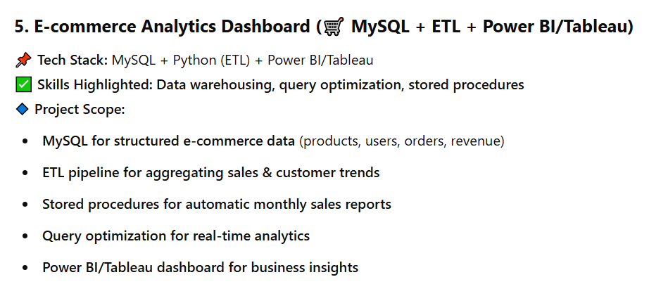

**Project: E-commerce Analytics Dashboard (MySQL + ETL + Power BI/Tableau)**

This project focuses on **designing, optimizing, and analyzing e-commerce data** to provide **business insights** using **SQL, ETL processes, and data visualization tools** like **Power BI/Tableau**.

**📌 Breakdown of the Project**

**1️⃣ Database Design (MySQL) – Week 1-2**

**Complexity: Medium**

* **Schema Design:**
  + users (UserID, Name, Email, Location, Signup Date)
  + products (ProductID, Name, Category, Price, Stock)
  + orders (OrderID, UserID, ProductID, Quantity, Order Date, Status)
  + revenue (OrderID, Total Amount, Discount, Payment Method)
  + **Indexing & Normalization** for faster query execution
* **Stored Procedures & Triggers:**
  + Automatically **update stock levels** when an order is placed
  + **Calculate total revenue** per month and store it

**2️⃣ ETL Pipeline Implementation (Python) – Week 3-4**

**Complexity: Medium-High**

* **Extract:** Fetch e-commerce sales data from MySQL
* **Transform:**
  + Aggregate **daily, weekly, and monthly sales trends**
  + Categorize customers based on **purchase behavior**
  + Detect **bestselling products & customer retention trends**
* **Load:** Store the transformed data back into a **data warehouse** for reporting

**3️⃣ Query Optimization & Performance Tuning (MySQL) – Week 5**

**Complexity: High**

* **Indexing & Partitioning:** Speed up queries for large datasets
* **Query Optimization:** Use JOINs, GROUP BY, EXPLAIN ANALYZE to enhance performance
* **Materialized Views:** Store pre-aggregated sales reports for faster retrieval

**4️⃣ Power BI/Tableau Dashboard – Week 6**

**Complexity: Medium**

* **KPIs & Metrics:**
  + Revenue growth trends 📈
  + Top-selling products & categories
  + Customer segmentation based on spending behavior
  + Real-time order tracking 📊
* **Dashboard Interactivity:**
  + Drill-down views for product-wise & location-wise analysis
  + Filters for date range selection

**📅 Timeline (6 Weeks Total)**

✔ **Week 1-2:** MySQL database schema design, indexing, and stored procedures  
✔ **Week 3-4:** Python ETL pipeline development (Extract, Transform, Load)  
✔ **Week 5:** Query optimization & performance tuning  
✔ **Week 6:** Power BI/Tableau dashboard creation and final testing

**🔹 Complexity Breakdown:**

✅ **Easy:** Database schema design, ETL extraction  
✅ **Medium:** Query optimization, Power BI/Tableau integration  
✅ **Hard:** Performance tuning, real-time analytics, large dataset processing

🚀 **Final Outcome:** A **fully functional E-commerce Analytics Dashboard** that can track revenue, product sales, customer behavior, and business insights in real-time.

**Implement a Star Schema:** Create dimension (DimCustomers, DimProducts, etc.) and fact (FactSales) tables.

**Automate ETL:** Use Python scripts (or similar) to populate these tables, ideally scheduled with a tool like Airflow.

**Create Stored Procedures:** Develop procedures for complex reporting (e.g., MonthlySalesReport).

**Incorporate Advanced Analytics:** Calculate Customer Lifetime Value (CLTV) or similar metrics.

**Build Advanced Dashboards:** Use Power BI/Tableau to visualize the star schema, CLTV, and other advanced metrics with interactive elements.