Pharma TPR

“Proposal”

By


A CMMI 3 Company
ISO/IEC 27001
Information Security Management Certified

Revised By | Revised On | Version | Changes Made | Reference
Kapilkumar / Kewal singh | 02nd Sept 2025 | 1.0
Table of Contents
1. Confidential Information 4
2. Executive Summary 5
2.1. Executive Profile 5
3. Our Understanding 6
3.1. Requirements understanding 6
3.2. Flow Diagrams 7
3.3. Queries/ Assumptions 8
4. Proposed Solution 9
4.1. Proposed Technology & Framework 9
4.2. Proposed Technology & Framework - ASP.Net Core 9
4.3. ASP.NET Web API 2 10
4.4. Quick features of .net Core 11
4.5. Key Features of Angular: 12
4.6. Software Development Methodology 13
4.7. Development, Test and Pre-Production Environments 14
4.8. Software Requirements 16
5. Budget 17
5.1. Effort Estimation 17
5.2. Budget 17
5.3. Terms & Conditions 17
5.4. Delivery Milestone 18
5.5. Payment Milestones 18
6. Project Management & Methodology 19
6.1. Company Profile 19
6.2. smartData’s Methodology 19
6.3. Assumptions 21
6.4. Delivery Mechanism 22
6.5. Change Management 23

- Confidential Information
This Response to RFP is confidential to smartData Enterprises and the client. This document contains information and data that smartData considers confidential and proprietary (“Confidential Information”).
Confidential Information includes, but is not limited to, the following:
Corporate and Infrastructure information about smartData
smartData’ project management and quality processes
Project experiences provided to illustrate smartData capability

Any disclosure of Confidential Information to, or use of it by a third party (i.e., a party other than client), will be damaging to smartData. Ownership of all Confidential Information, no matter in what media it resides on, remains with smartData.
Confidential Information in this document shall not be disclosed outside the buyer’s response evaluators and shall not be duplicated, used, or disclosed – in whole or in part – for any purpose other than to evaluate this informational package without specific written permission of smartData Enterprises.

- Executive Summary

  - Executive Profile

The proposed application focuses on digitizing and streamlining the Pharmaceutical Supplier Audit process, integrating FDA regulatory form handling (Forms 482, 483, 484, 463) directly into the audit workflow.

Primary Problem:
Manual and inconsistent handling of supplier audit data, regulatory documentation, and CAPA tracking increases compliance risk and delays audit closure.
Secondary Problem:
Absence of a centralized system for managing FDA form issuance and linking them with supplier compliance metrics leads to inefficiency and fragmented records.

Project Summary – Supplier Auditing Program

The Supplier Auditing Program is designed to ensure that all vendors involved in manufacturing, laboratory, and distribution processes comply with GxP standards and global regulatory requirements (FDA, EMA, WHO, etc.). The initiative strengthens quality oversight, reduces supply chain risks, and enhances patient safety by maintaining consistent quality standards.

Key Objectives:
Verify supplier compliance with regulatory and quality frameworks.
Evaluate systems, capabilities, and operational integrity.
Identify and mitigate risks such as data integrity issues, contamination, and traceability gaps.

Audit Types:
Pre-Qualification Audits for new suppliers.
Routine/Periodic Audits for ongoing quality oversight.
For-Cause Audits triggered by complaints or deviations.
Desktop/Remote Audits for low-risk or follow-up assessments.
Critical Audit Areas:
Quality Systems: CAPA, change control, deviations, and risk management.
Facilities & Equipment: Validation, calibration, and maintenance compliance.
Documentation: Batch records, SOPs, training logs, and audit trails.
Supply Chain & Logistics: Traceability, cold chain, and warehousing controls.
Regulatory Compliance: FDA 21 CFR Part 11, EU GMP Annex 11, and data integrity.
Material Handling: Raw material testing, quarantine, and release protocols.

Audit Process:
Risk assessment and planning.
Advance notification and agenda sharing.
On-site or remote audit execution by trained auditors.
Grading findings as Critical, Major, or Minor.
CAPA follow-up and closure.
Final reporting and supplier scorecard update within the QMS.

Tools & Practices:
Customized audit checklists.
QMS integration (TrackWise, MasterControl).
Audit trail review for electronic systems.
Supplier portal for CAPA documentation and communication.

Key Benefits:
Mitigates compliance and operational risks.
Ensures consistent product quality and patient safety.
Builds stronger, transparent supplier partnerships.
Enhances readiness for regulatory inspections.

- Our Understanding
  - Requirements understanding
Based on the client discussions, walkthrough sessions, and iterative requirement gathering, our understanding of the project is as follows:
Wireframe as finalised on 29th Aug 2025 between smartData and client.
https://v0-pharma-supplier-risk.vercel.app/
- Module Scope
Build a Supplier Audit Management module integrated into the client’s existing pharma compliance platform.
Include audit scheduling, on-site/off-site inspections, findings documentation, and CAPA tracking.
Incorporate FDA forms (482, 483, 484, 463) at relevant stages of the audit workflow.
Provide real-time dashboard views of supplier compliance status, pending CAPAs, and audit history.

- Core Features
Audit Planning: Calendar-based scheduling, auditor assignment, audit scope definition.
FDA Form Integration:
    - Form 482 – Notification of Inspection (Opening Meeting)
    - Form 483 – Inspectional Observations (Closing Meeting)
    - Form 484 – Receipt for Samples Collected (During Audit)
    - Form 463 – Affidavit or Written Statement (As Needed)
Findings & Observations: Capture audit findings with severity classification and link to CAPA.
Sample Tracking: Maintain log of collected samples with audit trail.
CAPA Management: Assign corrective and preventive actions with deadlines and status monitoring.
Reporting: Generate audit summary reports with all linked forms and CAPA details.

- Non-Functional Requirements
Compliance with 21 CFR Part 11 for electronic records & signatures.
Secure role-based access control (RBAC).
Integration with existing client ERP/compliance modules.
Audit trail for all actions performed within the system.

- Key Considerations
Client frequently introduces new ideas during walkthroughs, requiring a flexible change management process.
Limited in-house pharma domain expertise on both sides.
Strong existing working relationship with the client team ensures smooth communication.

  - Flow Diagrams
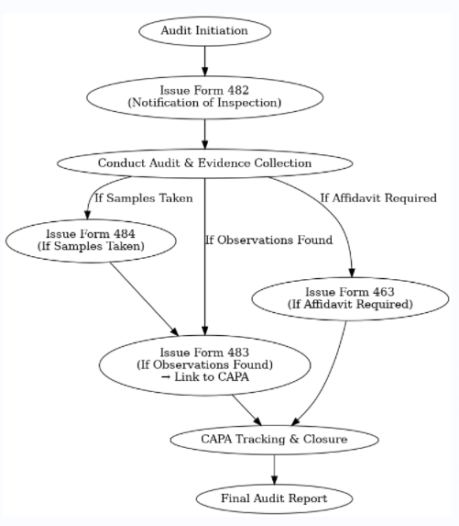

  - Queries/ Assumptions
Assumptions:
Client will provide final FDA form templates in PDF/Word format.
Regulatory workflows will follow US FDA standards unless specified otherwise.
Initial deployment will be for the US market; other regulatory body forms can be added in later phases.
Queries:
- Should the system support multi-country regulatory templates from Phase 1 or only US FDA?
- Is real-time integration with FDA submission portals expected, or will forms be stored internally only?
There were multiple discussion over calls to clarify
On based of call we finalized wireframe with FDA forms and categories Phase I feature listing.

- Proposed Solution
  - Proposed Technology & Framework
Web based applications can be built on different frameworks such as .NET and Open source. The parameters, which govern choice of framework, are numerous such as strategic directions, technology standards or resource availability. smartData has experience and the capability to provide solutions on both competing technologies.
smartData proposes to architect and develop this web application using MS .NET stack (ASP .NET Core with C#.NET, MSSQL using .NET Framework 4.5).
The various third party services that needs to be provided by client to development team for implementation purpose includes following:

  - Quick features of .net Core
- Free and Open Source: open source and hence available on GitHub.
- Cross Platform: it can run on Windows, Mac OS, Linux and even ported to other operating systems.
- Versatile Deployment:
  - In Framework dependent deployment or FDD: porting app between different installations of .NET Core is possible.
  - Self-contained deployments (SCDs): deploying not just apps and all the relevant third-party dependencies, but also the version of the .NET Core to ensure target system your app.
- Modular: Small feature-centric packages are always better than one large assembly.
- Compatible: compatible with .NET framework, Xamarin and Mono.
- Fast: 8 times faster than Node.js, leading to better response time and lesser compute time.
- Unified Code Framework: framework that combines MVC and Web API controllers as a single programming mode.
- Built-in Dependency Injection: allows for applications to be integrated with loosely coupled modules.
- Microservices Architecture: .NET core support microservices architecture that allows a mix of technologies across a service boundary.

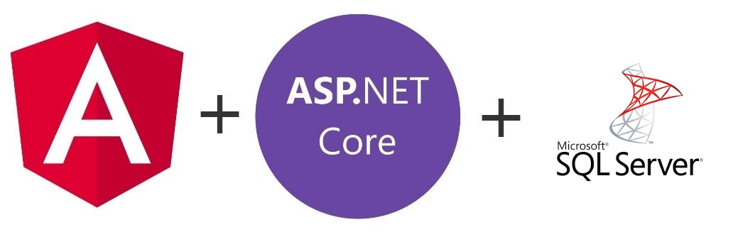
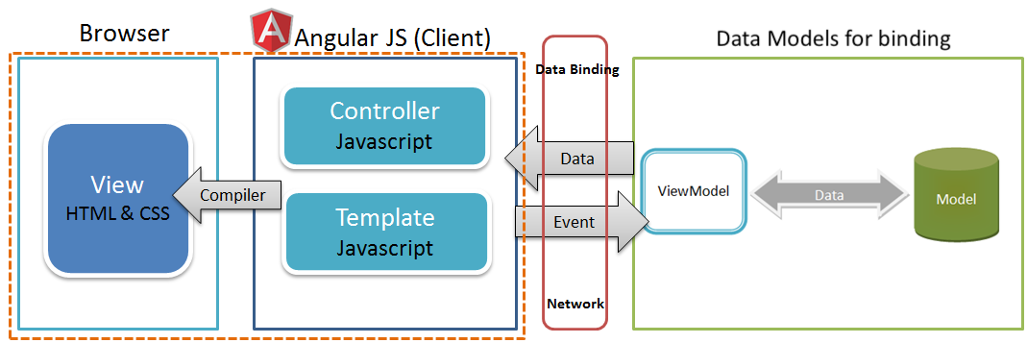
  - Key Features of Angular:
- Progressive Web Apps: deliver app-like experiences
- Component-based architecture: that provides a higher quality of code. Angular is written using TypeScript language; it provides better tooling, cleaner code, and higher scalability
- High Performance: Angular apps load quickly with the new Component Router, which delivers automatic code-splitting
- Cross Platform: It can create Native and Create desktop-installed apps across Mac, Windows, and Linux using the same Angular methods
Internal Architecture
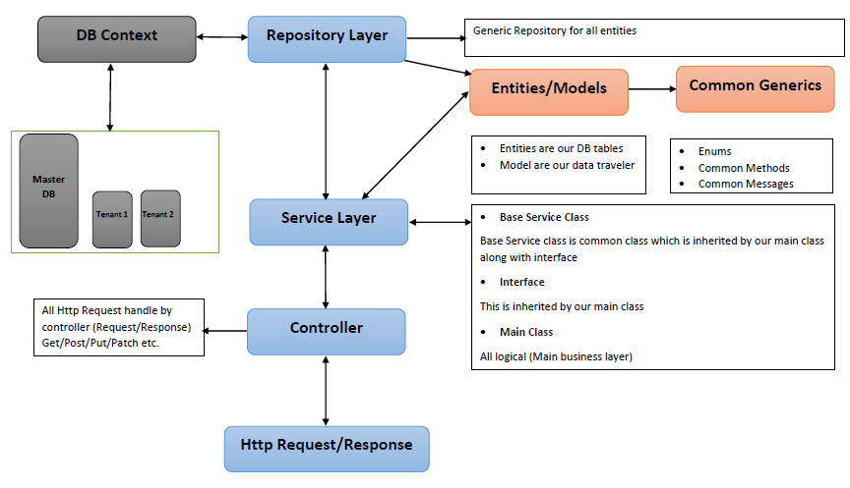
  - Software Development Methodology
For CMMI 3 Level accreditation based SDLC:
Using Agile methodology, we take an adaptive approach where there is planning and clarity on future tasks only in respect of what features need to be developed. There is feature driven development and the team adapts to the changing product requirements (User Stories) dynamically. The product is tested frequently, through the release iterations, minimizing the risk of any major failures in future. Tasks received from out of defined scope are treated as a change request which is done with the approval of both client and BDG.
In project planning we break the product into small incremental builds(Sprint). These builds are provided in iterations. Each iteration typically lasts from about one to two weeks (maximum 15 days). Every iteration involves cross functional teams working simultaneously on various areas like −
- Planning
- Requirements Analysis
- Design
- Coding
- Unit Testing and
- Delivery/Acceptance from the client – At the end of the iteration, a working product is displayed to the customer and important stakeholders for the feedbacks.
- Code structure - we have standard architecture of project and we follow industry guidelines for this. In our code structure we prefer all modules loosely coupled.
- Code management – We understand Code management as the process of handling changes to computer code. Code management deals in the precise management of code modules or collections of lines of code in order to support changes or particular goals such as maintenance or debugging.
- Every day developer commits the code before he left for the day. After every release we create branch so we can do changes in running build if needed.
- Version control – We are using TFS, SVN GIT version control tool based on client need, we have SVN standard for all code in case of no preference from client side.
- Configuration management – We are maintaining configuration management document for each project to keep all important information of the project like source Code path, SVN details, hosting details, any third party tools used then details of that tools along with Key.
- For CI/CD we are using Jenkin tool and TFS based on client preference. Jenkins enables developers to find and solve defects in a code base rapidly and to automate testing of their builds. Jenkins Pipeline: https://docsend.com/view/e6wa42w
  - Development, Test and Pre-Production Environments
- Project lead is responsible for release deployment management on smartData server.
- For client server smartData server team is responsible for one-time configuration & setup. After that it will be client's or his team's responsibility, if client is not hiring server infrastructure resource from smartData for support & maintenance purpose after launch.
- Entire development is at client server (VM) no specific configuration is needed from our side.
- We are offering Manual QA with test cases in give scope. We use Selenium tool for automation testing. Automation QA hiring is as per client requirement at additional cost. We do have required skillset in house.We can use DevOps tool based on hosting provider & cost involved to make the overall process automated between servers.
- Configuration & managing servers: smartData configures & manages their servers for development process. For client server smartData Server infrastructure team does configure / manage the server once to get the application hosted on his pre-production/production server once ready. For client server one-time configuration/setup is done free, but if it required continues configuration/support from server infrastructure team then it will be a paid job to client.
- During migration complete application source code are been migrated to client server, once everything is tested, approved & paid by client as per agreement.
Deployment Guidelines
- smartData development team will provide prerequisite for proper functioning of the software to the customer prior to live deployment process
- Customer shall be responsible for the purchase and configuration of the deployment environment as suggested by the team
- smartData shall ensure that the software works exactly as verified by the customer in smartData's staging environment.
- smartData shall not be responsible for any loss of data, hacking or any other malicious attempts made on server once the application is made live.
- smartData can provide a paid support for any server related issues and configurations, charged hourly which will be separate from the development work
- In cases where the team members are continuously updating the live environment due to customer needs and/or end user requirements, smartData will update the customer about the process of securing the code and database, decision to implement the process will be taken by the customer, smartData shall bear no responsibility in case of any loss of data.

  - Software Requirements
Type | Name
Server * | Windows Server 2012
Web Server ** | IIS 7.0 and Above
Database *** | MS SQL database 2012 / 2014
Scripting Language | ASP .NET Core with C#
Framework | .NET Framework 5
Architecture | Angular JS
Browser Compatibility | IE 10, Firefox, Safari, Google Chrome (Latest Stable Releases)

Note:
* Server is operating system of server where web server and (or) database will be installed.
** Web Server is the server which hosts the application.
*** Database will be hosted on server

- Budget
  - Effort Estimation
This section describes the indicative smartData’s effort estimate to deliver the Development Phase of this engagement. All effort is in “person hours” unit of measure
Sprint | Modules & Sub-Modules | Features Covered | Key Deliverables | Outcome
Sprint 1: Analysis and Design | System analysis, UI UX | - System Analysis Design | Functional Analysis and Design | UI/ UX Upgrade | C
Sprint 1: Analysis and Design | System analysis, UI UX | - Database Design and Setup | Database schema with entity definitions and ER diagrams | UI/ UX Upgrade | M
Sprint 1: Analysis and Design | System analysis, UI UX | - GUI and Graphics Design | Converted UI mockups to responsive HTML/CSS | UI/ UX Upgrade | M
Sprint 2: Pharmaceutical Supplier Audit Management | Dashboard, Suppliers, Audits, Findings, Compliance Dashboard | - Dashboard with supplier counts, compliance scores, high-risk insights - ( not AI based ) | - Calendar-based audit planning with prioritization | Compliance-ready platform and international expansion support | M
Sprint 2: Pharmaceutical Supplier Audit Management | Dashboard, Suppliers, Audits, Findings, Compliance Dashboard | - Alerts for recent activities, | - Audit types: Pre-qualification, routine, for-cause, remote
Sprint 2: Pharmaceutical Supplier Audit Management | Dashboard, Suppliers, Audits, Findings, Compliance Dashboard | Form 482 – Notification of Inspection | Establishment name and address,Inspection authority statement,Inspection start date,Investigator name(s),FDA district office |  | C
Sprint 2: Pharmaceutical Supplier Audit Management | Dashboard, Suppliers, Audits, Findings, Compliance Dashboard | - Supplier listing with status counts and actions (View, Audit) | - Role-based auditor assignment and status tracking |  | M
Sprint 2: Pharmaceutical Supplier Audit Management | Dashboard, Suppliers, Audits, Findings, Compliance Dashboard | - New findings creation and classification by severity | - Compliance scoring, certification tracking, KPI metrics |  | M
Sprint 3: Quality Management | Overview, CAPA Management, Change Control, Deviations, Risk Management | - Overview with counts for CAPAs, Change Controls, Deviations, Risks | - CAPA creation, tracking, and effectiveness monitoring | Improved quality control, traceability, and risk mitigation support | M
Sprint 3: Quality Management |  | - Centralized visibility of active quality processes | - Change Control creation and process management with approvals |  | M
Sprint 3: Quality Management |  | - Deviation reporting and investigation tracking | - Risk assessment listing with mitigation workflows |  | C
Sprint 3: Quality Management |  | - Quick actions for CAPAs, Deviations, and Risk items | - Detailed view/update options across all quality records |  | C
 |  | - Unit Testing, Regression Testing |  |  | M
Sprint 4: Facilities Management | Overview, Cleanroom Validation, HVAC Systems, Calibration, Maintenance | - Overview with cleanroom, HVAC, calibration & maintenance stats | - HVAC and calibration listing with monitor/schedule actions | Robust facility control for validations and upkeep management | M
Sprint 4: Facilities Management |  | - Cleanroom validation with add/view/validate functionality | - Maintenance logs with scheduling and technician tracking |  | S
Sprint 4: Facilities Management |  | - Filter/search support for validation and maintenance records | - Action buttons for real-time operations (Validate, Maintain) |  | S
Sprint 4: Facilities Management |  | Form 483 – Inspectional Observations | Observation number,Observation details,Reference to regulation,Investigator name,Date of issue |  | C
Sprint 4: Facilities Management |  | - Unit Testing, Regression Testing |  |  | M
Sprint 5: Document Control | Overview, Batch Records, SOPs, Training Records, Audit Trail | - Dashboard with batch records, SOPs, training stats, and audit logs | - Batch record listing with view/download and completeness tracking | Centralized document control with traceability and audit readiness | M
Sprint 5: Document Control | Overview, Batch Records, SOPs, Training Records, Audit Trail | - Upload new SOPs, training docs, certificates | - SOP version control with revise and approve workflows |  | M
Sprint 5: Document Control | Overview, Batch Records, SOPs, Training Records, Audit Trail | - Training record tracking with expiry alerts, score, and trainer | - Detailed audit trail for user and document actions |  | M
Sprint 5: Document Control | Overview, Batch Records, SOPs, Training Records, Audit Trail | Maintain all document with FDA Form ( 482, 483, 484, 463 ) | Supplier wise FDA form details |  | C
Sprint 5: Document Control | Overview, Batch Records, SOPs, Training Records, Audit Trail | - Unit Testing, Regression Testing |  |  | M
Sprint 6: Supply Chain Managemen | Traceability, Cold Chain, Warehousing | - Shipment traceability with tracking details and expected delivery | - Real-time temperature and humidity monitoring for cold chain | End-to-end material tracking for regulatory and quality compliance | M
Sprint 6: Supply Chain Managemen | Traceability, Cold Chain, Warehousing | - Inventory management with location, conditions, and status | - Track and release functions for cold chain and inventory |  | C
Sprint 6: Supply Chain Managemen | Traceability, Cold Chain, Warehousing | - Unit Testing, Regression Testing |  |  | M
Sprint 7: Regulatory Compliance | FDA 21 CFR Part 11, EU GMP Annex 11, Data Integrity | - Initiate assessments for regulatory frameworks and ALCOA+ | - Track gaps, findings, risk level, and remediation actions | Streamlined compliance review and digital record integrity | C
Sprint 7: Regulatory Compliance | FDA 21 CFR Part 11, EU GMP Annex 11, Data Integrity | - Review functions for regulatory systems and principles | - Report, Review, and Remediate workflows for compliance gaps | Streamlined compliance review and digital record integrity | M
Sprint 7: Regulatory Compliance | FDA 21 CFR Part 11, EU GMP Annex 11, Data Integrity | - Unit Testing, Regression Testing |  | Streamlined compliance review and digital record integrity | S
Sprint 8: Material Management | Raw Material Testing, Quarantine, Release Procedures | - Create and manage raw material test records with COAs | - Quarantine materials with tracking and release process | Controlled material quality lifecycle with audit readiness | M
Sprint 8: Material Management | Raw Material Testing, Quarantine, Release Procedures | - Release approvals, expiry tracking, and status logging | - Action buttons for COA, View, Review, Release | Controlled material quality lifecycle with audit readiness | M
Sprint 8: Material Management | Raw Material Testing, Quarantine, Release Procedures | Form 484 – Receipt for Samples Collected | List of collected samples, description, Quantity,Collection date,Signature of receiver | Controlled material quality lifecycle with audit readiness | M
Sprint 8: Material Management | Raw Material Testing, Quarantine, Release Procedures | - Unit Testing, Regression Testing |  | Controlled material quality lifecycle with audit readiness | M
Sprint 9: Manufacturing Execution | Overview, Process Overview, Batch Records, Validations, Equipment Qualification |  |  | Integrated production process with qualification and compliance checks | M
Sprint 9: Manufacturing Execution |  | - Manufacturing dashboard with process stats and batch tracking | - Batch registration, review, and deviation monitoring |  | S
Sprint 9: Manufacturing Execution |  | - Validation and equipment qualification listings with actions | - Search and filter tools for process visibility |  | M
Sprint 9: Manufacturing Execution |  | Form 463 – Affidavit or Written Statement | Individual details,Statement text,Date and location,Signature on documents |  | C
Sprint 9: Manufacturing Execution |  | - Unit Testing, Regression Testing |  |  | M
Sprint 10: Deployment & Documentation | Deployment, Documentation | - Application deployed to staging/production with validations | - Deployment logs, rollback procedures, and release checklist completed | Successful release enablement and team alignment through documentation | M
Sprint 10: Deployment & Documentation | Deployment, Documentation | - Verified environment configurations and version tagging | - Release notes, module-level documentation, and user guides prepared |  | M
Sprint 10: Deployment & Documentation | Deployment, Documentation | - Knowledge transfer and onboarding materials delivered | - Final handover package created for support teams |  | M
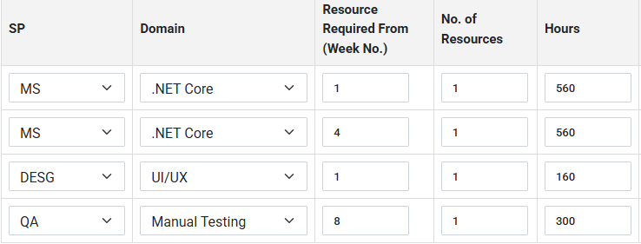

  - Budget
smartData will execute the development phase of the project in Upwork hourly mode following a fixed number of hours____ at hourly rate of $........for the functionalities as mentioned in section $ and mutually agreed in the proposal will be implemented for the application. Customer shall not be charged beyond the number of hours and $......... quoted here. In case, during the project development phase, customer comes up with new features, not being part of the effort shown in above section as mentioned above the same would be treated as the change request after discussing/explaining and seeking consent from the customer and they will be processed as per the clause ............... defined in the proposal.
  - Terms & Conditions
- The scope will be contained to the line items mentioned in the above estimates. While creating the proposal, it has been assumed that the requirements given by the client form the complete scope of the application. Any requirement, not explicitly mentioned in this document, do not form a part of this estimate.
- Functional QA is being conducted in house. If any specialized testing is required, please indicate. Performance Testing is not part of the scope.
- Writing the content of Help files is not considered to be part of the scope.
- Client shall provide all third party software and hardware components. This includes hosting details, hardware environment etc. The cost of all these components will be borne by the client and does not form the part of the proposed estimated cost in the development cost section above
- If required, the client shall provide all the test data to run the test cases.
- Client shall be available to solve the queries, which the development team may have, to ensure that project timelines are met.
- SDEI will be responsible for the development of the software alone and can only recommend the Hosting service provider. The hosting service will be a client decision.
- Client shall perform timely review of the deliveries, as per the schedule of deliveries defined at the project initiation. Any delays from the client end would lead to subsequent delays in development of the project, which will be communicated at that time itself.
- Client will provide all requirement details in first only after awarding the project.
  - Delivery Milestone
The following table outlines billing schedule. The milestone dates are indicative in nature
Milestone | Milestone Date | Delivery
Advance to get started | T
System Analysis, Database Designing & GUI | T + 1 weeks
Front End | T + 8 weeks
Administrator Section | T + 10 weeks
System Integration, Testing and Deployment | T + 11 weeks
Billing Schedule for Development phase T = Start Date of the Project

  - Payment Milestones
The following table outlines billing schedule. The milestone dates are indicative in nature
Milestone | Payment % of total amount | Amount
Milestone 1 - 50% Advance | 25%
Milestone 1 - 50% on delivery | 25%
Milestone 2 - on delivery | 25%
Milestone 3 - on delivery | 25%
Milestone 4 - on delivery | 25%

- Project Management & Methodology
  - Company Profile
smartData Enterprises is a CMMI 3 – (accreditation for software process improvement standards) IT consulting and a contract services provider, providing end-to-end consulting for global clients. smartData has partnered with several Startups, SME’s and Fortune 500 companies, in building their next generation digital information infrastructure for competitive advantage. The smartData portfolio of services includes Healthcare services, Business automation, Digital Enterprise, IT Services and E-strategy consulting. Our solutions focus on addressing market and technology challenges for customers across multiple industries. The offshore model of the company leverages talent and infrastructure to provide high quality, rapid time-to-market solution using scrum methodology and empirical software development processes, as a result we have 2000+ satisfied customers, 500 published apps on itunes and Google play store, Microsoft partnership and Certificate of Status (State of California).
smartData has 3 development offices in India (located at Mohali (Head Quarter), Nagpur and Dehradun) along with business development offices in New York, USA and Sydney, Australia. smartData has team of app. 850 developers, designers, QA and other associated technologies senior resource pool. Major teams include 350+ Microsoft, 250+ OpenSource (MEAN, PHP, MERN, Python etc.) along with 150+ mobility (Native iOS & Android, Hybrid) resources. Beside these dedicated team of UI/UX developers, designers, QA/QC along with new technology/R&D team are also available.
  - smartData’s Methodology
Our methodology follows Scrum, the agile process with an iterative and rapid incremental development approach, where each set of features is fully operational after a short cycle.
Step 1: Product vision and the scope is defined in terms of short user stories comprising of the product backlog items. Product owner defines, prioritize and presents the ready backlog to Scrum master and the team. Master sprint plan is prepared with 1 week sprints.
Step 2: Sprint backlog is the list of work that the development team addresses during the sprint, the list is derived by the scrum team progressively selecting the backlog items in priority order, core features are at the top (developed first) followed by the non-essential.

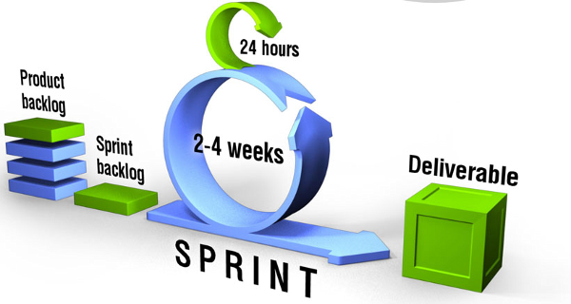
Step 3: Sprints are initiated with daily standup meetings, team presents backlogs that are done, impediments are identified and removed by cross functional collaboration. Continuous retrospection is done by the scrum master, and the team identifies, the top process improvements. Inspect and Adapt cycle is followed. Github is used for code repository and source revision, ACE project management tool is used for day to day progress and tracking.
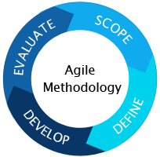
Step 4: Scrum master does the product backlog management, clearly communicates vision, goals and product backlog items to the team, facilitate scrum event (release planning) facilitates daily standups, sprint planning and impediments removal. Estimate is done in terms of the story size and not time, they are done by the people who are going to do the work, 10% of the sprint time is allocated to the product owner, and continuous estimates are done during the project and not all upfront. The desired product with user feedback is developed rapidly with quick turnaround time and minimal cost. Any new functionality to be added or a change, required in functionality that may result in change of work flow is considered a change request for which the process mentioned under section 5.4 is followed.
  - Assumptions
- We are providing the estimates only for the application development as per the requirements provided.
- The scope will be contained to line items mentioned in section 2.2 and 2.3 of the proposal. While creating proposal, it has been assumed that requirements given by client forms complete scope of application. Any requirement, not explicitly mentioned in this document, do not form part of these estimates. For any changes required in application, it will be considered as change request and proper estimates (in man hrs.) of changes will be provided by smartData.
- Client shall provide all third party software, hardware components, images/content or any material needed for project. This includes hosting details, hardware environment etc. Cost of all these components/images/content if any, will be borne by client and does not form part of proposed estimated cost in development cost section 4.1
- smartData will be responsible for the development of the software alone and can only recommend the Hosting service provider. The hosting service will be a client decision. Any new requirement or changes in server settings recommended by smartData developers will be provided by client. Any delay in the project delivery due to this will NOT be smartData’s responsibility.
- Client shall regularly participate in the weekly sprint meetings and provide acceptance of the sprints within a week’s time, if not then it will be considered as accepted. Client will provide all requirement details by first week after awarding the project.
Deployment
smartData development team will provide prerequisite for proper functioning of the software to the customer prior to live deployment process
Customer shall be responsible for the purchase and configuration of the deployment environment as suggested by the team
smartData shall ensure that the software works exactly as verified by the customer in smartData's staging environment.
smartData shall not be responsible for any loss of data, hacking or any other malicious attempts made on server once the application is made live.
smartData can provide a paid support for any server related issues and configurations, charged hourly which will be separate from the development work
In cases where the team members are continuously updating the live environment due to customer needs and/or end user requirements, smartData will update the customer about the process of securing the code and database, decision to implement the process will be taken by the customer, smartData shall bear no responsibility in case of any loss of data.

  - Delivery Mechanism
The inherent benefit smartData brings on to the table is our 21 years of experience and ability to successfully deliver 8000+ projects of which 80% are fixed cost. We understand how to deliver on time and budget through a very tight knit delivery process which entails following points mentioned below. Other than this 90% of our seniors who deal client relationships are over 15 plus years with smartData and they have a vast understanding of domain know how and know what works and what does not in today fast paced, attention deficit world. Our ability to consult our customers in the aspect of "do's and do not" makes us stand out from our competition. We have focused on domains and this gives us both across and in-depth understanding or what modern day management guru call "T" shaped thinking both in domain as well engineering sphere.
Some of the details about our delivery mechanism: -
- Hear & understand client requirements
- Observe and absorb the finer points
- Develop a detailed feature listing at modular and line items level
- Discuss or recommend tech stack
- Seniors participate in architecture and design level discussion at our cost
- Agile and SCRUM based development model
- Sprint based delivery and retrospective meetings to improve via effective project management tools like Jira, Trello, Slack and code repos like github, bit bucket etc.
- Reporting on daily and weekly progress
- CMMI level 3 delivery process adhering to quality deliverables - separate process team cross check delivery quality
- CI/CD – Jenkins, AWS, gitlab
- Last but not the least, delivering a working, reliable and scalable product & continue the partnership in customer growth journey

  - Change Management
Change Management is an integral portion of smartData Quality Management System (QMS). Processes that govern change management activities are described in these clauses in smartData QMS. Project-specific change management processes are tailored from this organizational standard software process and represented in operational software process for project. Tailoring takes into account, amongst other factors, nature of workflow, client-communication channels, the routing of work packets, location of development, and associated technology.
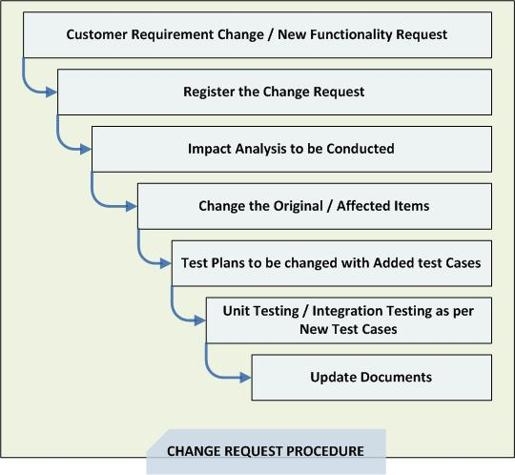
Typically, changes are received through Change Requests (CR) and log ged in Change Register. An impact analysis is done on change requests to identify depth of changes on software components. The result translates into a change introduction strategy that would involve scope of change, methods involved in establishing change, type and extent of testing required and other parameters.

--------------- End of Document ---------------

