25.**Write a program in C to read n number of values in an array and display them in**

**reverse order.**

**Test Data :**

**1Input the number of elements to store in the array :3**

**Input 3 number of elements in the array :**

**element - 0 : 2**

**element - 1 : 5**

**element - 2 : 7**

**Expected Output :**

**The values store into the array are :**

**2 5 7**

**The values store into the array in reverse are : 7 5 2**

#include <stdio.h>

int main() {

int n, i;

printf("Input the number of elements to store in the array: ");

scanf("%d", &n);

int arr[n];

printf("Input %d number of elements in the array:\n", n);

for (i = 0; i < n; i++) {

printf("element - %d : ", i);

scanf("%d", &arr[i]);

}

printf("The values stored in the array are:\n");

for (i = 0; i < n; i++) {

printf("%d ", arr[i]);

}

printf("\nThe values stored in the array in reverse are:\n");

for (i = n - 1; i >= 0; i--) {

printf("%d ", arr[i]);

}

return 0;

}

Output:

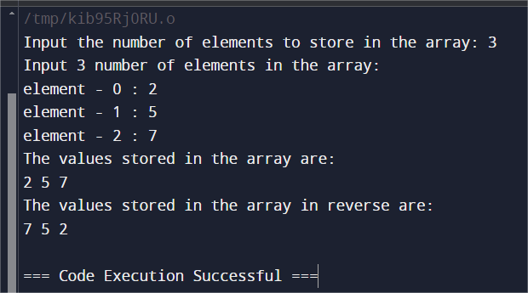

**Write a program in C to count the total number of duplicate elements in an array.**

**Test Data :**

**Input the number of elements to be stored in the array :3**

**Input 3 elements in the array :**

**element - 0 : 5**

**element - 1 : 1**

**element - 2 : 1**

**Expected Output :**

**Total number of duplicate elements found in the array is : 1**

#include <stdio.h>

int main() {

int n, count = 0;

printf("Input the number of elements to be stored in the array: ");

scanf("%d", &n);

int arr[n];

printf("Input %d elements in the array:\n", n);

for (int i = 0; i < n; i++) {

printf("element - %d : ", i);

scanf("%d", &arr[i]);

}

for (int i = 0; i < n; i++) {

for (int j = i + 1; j < n; j++) {

if (arr[i] == arr[j]) {

count++;

break;

}

}

}

printf("Total number of duplicate elements found in the array is: %d\n", count);

return 0;

}

Output:

