Project Synopsis/Project Concept Document

Project number | SSAD11
Project Title | FITAI Companion Android App
Document | SSAD Project Concept Document
Creation date | 26/08/17
Created By | Nirvan Singhania, Kunal Garg , Mohit Sharma, Akshay Prabhakant
Client | Bhat Dittakavi (Variance.AI)

Description:
- Fitai Companion is an Android App for fitness .
- The app aims at helping users in achieving their fitness goals without going to any fitness centre.
- It also provides support for interaction with other people of similar interests .
- The modules of the app consist of registration process, sign-in, work-outs, programs , schedules, dashboard and profile page .
- One of the most important features include a chat-bot to support interactive user interface.
- The App aims at creating awareness among users before the release of actual FITAI device and getting response.

Profile of Users
Google/Facebook Sign-in, if user does not have account on any of this, then he can make a new account using out platform. This app targets people from all walks of
life who are interest in achieving any kind of fitness goal e.g flexibility, strength, yoga. App will have simple and easy interface, so even people with little or no experience in technology can use it conveniently.
- There are 2 types of end-users:
  - Customer:
    - The user who will use this app to achieve his/her fitness goals.
    - Our assumption is that this user has at least used one similar kind of application.
    - The registration and login processes is self-explanatory.
    - We have also created a step-by-step procedure of filling up the profile page.
- Client:
  - The admin control is reserved with our client.
  - The admin has been given the functionalities of managing, tracking and deleting the users.

Usage Model and Diagrams (if any):

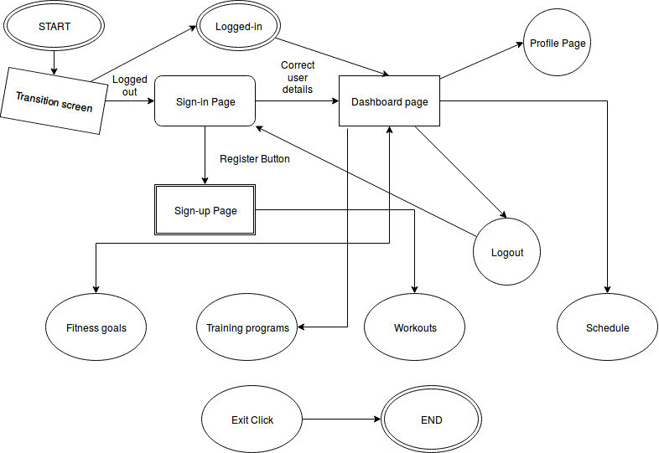
- On starting the app, the transition screen loads.Then the user id redirected to sign-in page, where he is provided with 4 options- sign-in , facebook sign-in , google sign-in and sign-up for the app.
- After successful sign-in through any of 3 modes, user is redirected to dashboard.
- If the user chooses the register option, he has to enter his credentials, and agree to the terms and conditions of the app, in order to successfully register through the app.
- After successful registration, he is redirected to dashboard.
- From dashboard, the user can go to fitness goals(choose his desired goals), choose the according workouts, training programs and plan schedules accordingly.
- There is an option of logout in the dashboard, which logs out the current session of user, and redirects him to sign-in page.
- At any point of time, the user can press exit button of his device to exit from the application. After reopening the app, transition screen will be loaded and user will be redirected to dashboard if logged-in , else to sign-in page.

