Product Design
Project : NAME - Fitai Companion Android App ,
TEAM : NAME - SSAD11
TEAM MEMBERS:
Nirvan Singhania ( 20161070 )
Kunal Garg ( 20161067 )
Mohit Sharma ( 20161031 )
Akshay Prabhakant ( 20161074 )

Design Model
Draw a simple class diagram and describe the classes in the table in this section. This diagram should represent the classes and their relationships. It is only necessary to show methods that are publically accessible by other classes. Only show an instance variable of a class if it is publically accessible. The diagram and the table should be consistent with each other.
Identify the classes (logical groupings of software methods that provide a related set of services). Make sure the design conforms to good design principles.
For each class, specify the information it maintains and the functionality it provides. Provide sufficient detail so that the purpose of each class in the design is clear.

<Class No. 1> | eClass state  - What information is the class responsible for maintaining?  - E.g., a printing subsystem might hold the current status of all the printers it controls as well as the queue of print jobs waiting to be printed.  Class behavior  - What methods does the class implement?  - E.g., classes related to the printing subsystem might support the queuing up of new jobs, estimating the time until a given job completes, or emailing status information at the end of a job.
<Class No. 2> | Class state  - What information is the class responsible for maintaining?  Class behavior  - What methods does the class implement?
<Class No. 3>  add more rows as needed. | Class state  - Etc.  Class behavior  - Etc.
.

Sequence Diagram(s)
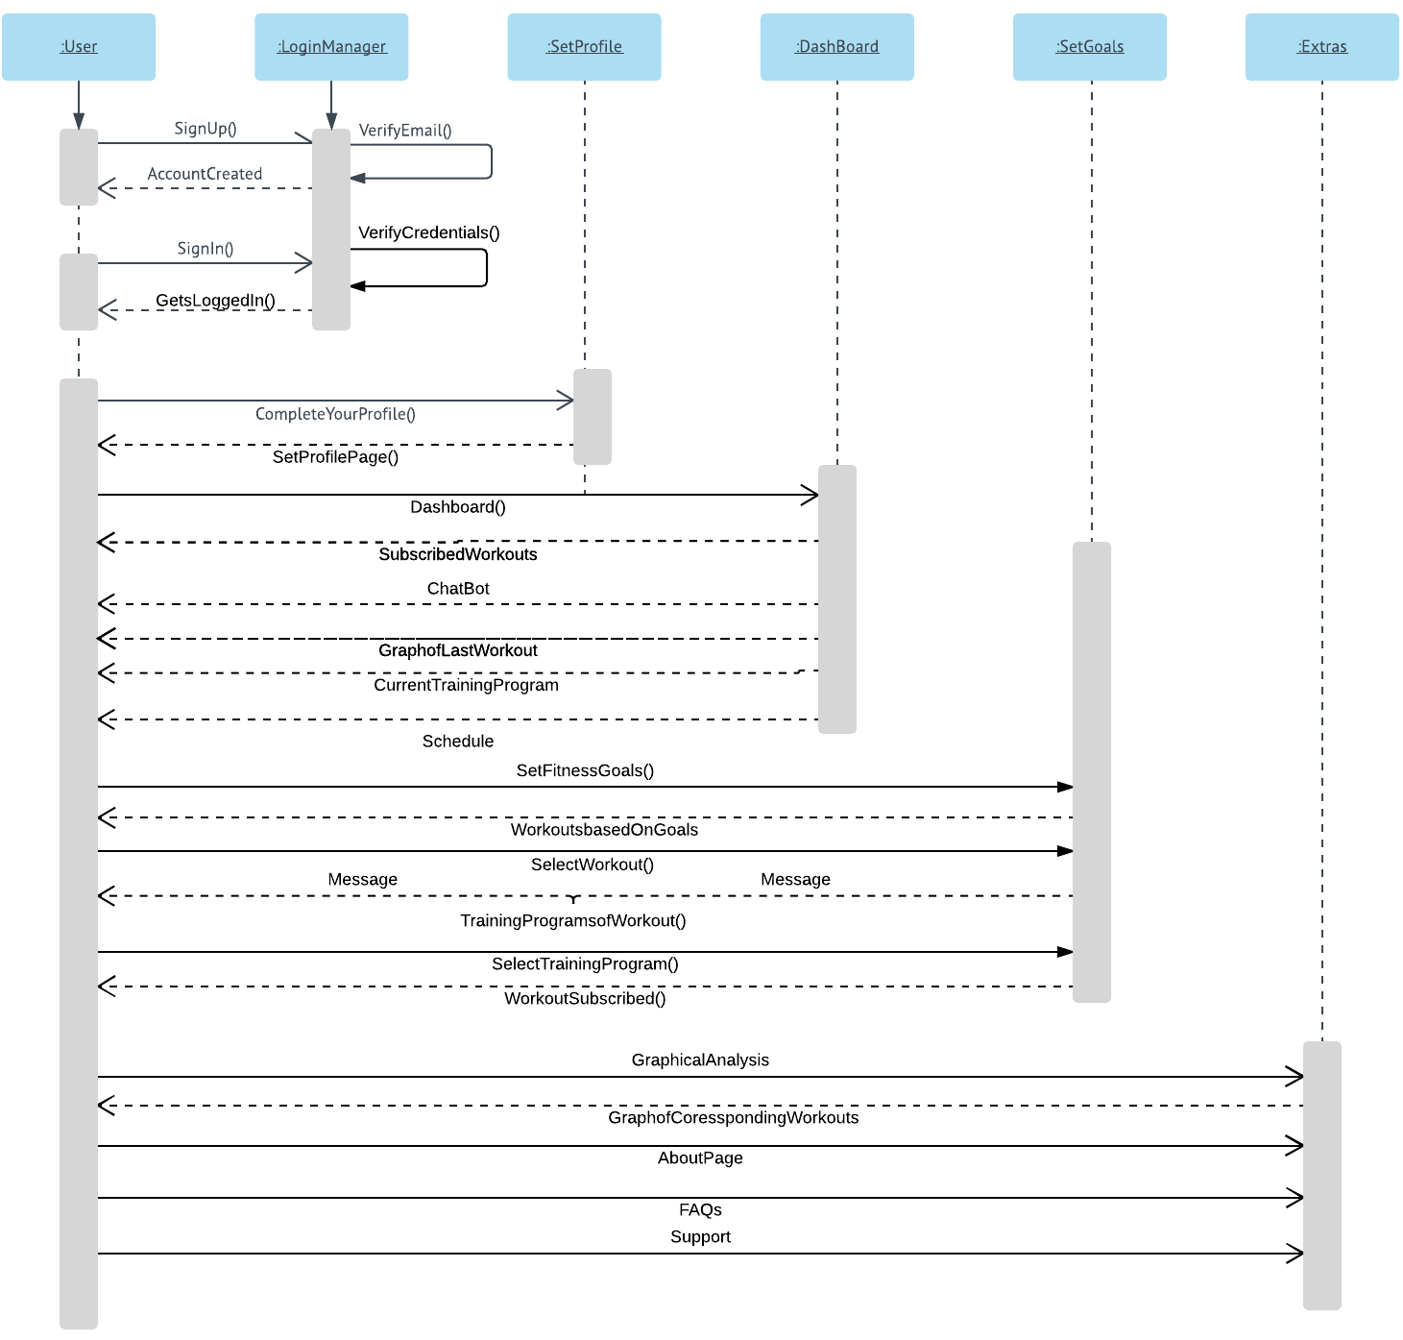

Design Rationale
This is a running list of issues that arise as your design process proceeds. This is an important section of the design document as it captures the thought process of the product's designers. It includes why or why not (rejected solutions) a design decision was made and supports future changes to the product. It should be updated whenever a design change occurs.

It is RARELY the case that the first design you consider is the best one that you can come up with that meets the requirements and that can be implemented, tested, and delivered on schedule. Your instructor will be looking for signs that you considered at least a few approaches, and that you had a coherent rationale for preferring the design your team eventually adopts.
This is the place to record such thoughts – what alternatives did you consider? What are the strengths (and deficiencies) of the final design compared to the other alternatives considered? Why did you select the approach you finally chose? This last question should be answered with an eye to the tradeoffs inevitably involved in creating an appropriate design.

