Software Requirements Specification (SRS) Document
Project : NAME - Fitai Companion Android App ,
TEAM : NAME - SSAD11
MEMEBERS:
Nirvan Singhania ( 20161070 )
Kunal Garg ( 20161067 )
Mohit Sharma ( 20161031 )
Akshay Prabhakant ( 20161074 )

Brief problem statement
Fitai Companion is an Android App for fitness . The app aims at helping users in achieving their fitness goals without going to any fitness centre . It also provides support for interaction with other people of similar interests . The modules of the app consist of registration process, sign-in, work-outs, programs , schedules, dashboard and profile page . One of the most important features include a chat-bot to support interactive user interface. The App aims at creating awareness among users before the release of actual FITAI device and getting response.

System requirements
Android Studio
Java Openjdk
Facebook and Google Play Services SDK support
FITAI API

Users profile
Google/Facebook Sign-in, if user does not have account on any of this, then he can make a new account using out platform. This app targets people from all walks of life who are interest in achieving any kind of fitness goal e.g flexibility, strength, yoga. App will have simple and easy interface, so even people with little or no experience in technology can use it conveniently.

Feature requirements (described using use cases)
No. | User Case Name | Description | Release
1 | Register User | Used to register a new user | R!
2 | Login User | Functionality to login the user using google, facebook or using email registered with the app. | R1
3 | Profile | Basic information about individual user. | R2
4 | Workouts | Information about individual user’s interested or selected workouts. | R2
5 | Schedule | Information about user regarding his workout schedule. | R2
6 | Accounts | Information about user regarding his account details. | R3
7 | Activity | User gets timely notifications about workouts sessions | R3
8 | Chat Bot | Providing interaction with app | R3
9 | Manage User | Manage user permissions and Activities | R3
10 | Delete User | Delete inappropriate Users from system | R3
11 | Fitness Goals | To set timely goals | R3

Use case diagram
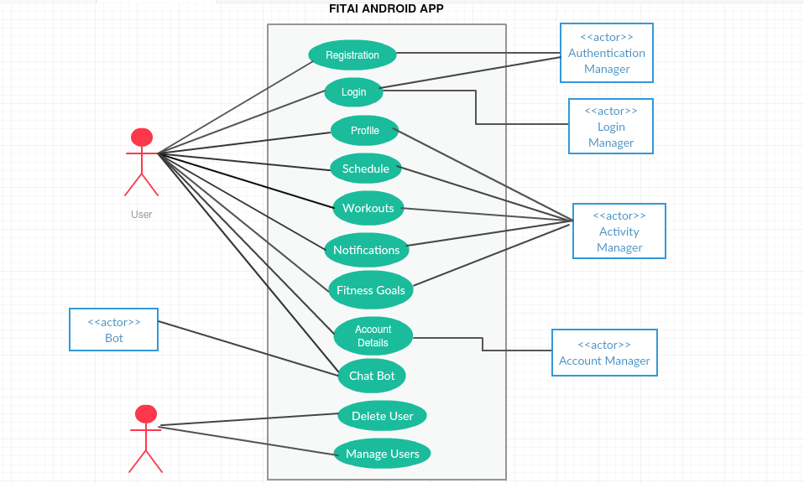

Use case description
Use Case Number: | UC-01
Use Case Name: | Register User
Overview: | Used to register a new user
Actors: | Customer  Authentication Manager
Pre condition: | The user must click on the “Create a new Account” button.
Flow: | Main (success) Flow:  1. User enters appropriate details for creating a new account which includes  email , password and username.  2 . After the authentication manager validates the details, the user is redirected to the login page .
Alternate Flow:
1. If the details do not match the mandatory requirements error messages would be shown and the register button would not accept any response.
Alternate Flows:
1. If the user is already registered a message is shown that username already exists.
Post Condition: | User is redirected to the login page.

Use Case Number: | UC-02
Use Case Name: | Login
Overview: | Functionality to login the user using google, facebook or using email registered with the app.
Actors: | Customer  Authentication manager  Login Manager
Pre condition: | The user is on the login page.
Flow: | Main (success) Flow:  1. User selects one of the three options:  Sign-in with Google  Sign-in with Facebook  Enter email and password used for registering with the app.  2. The Authentication Manager validates the credentials.  3. If the user has logged in for the first time he is taken to the profile  else he is taken to the dashboard.
Alternate Flow:
1. If the user is not already registered with an email on the app (sign in using app) a message that username does not exist is returned.
Alternate Flows:
`1. If authentication using google or facebook fails return to the login page with
message “Login Failed”
Post Condition: | User Session started if login successful.

Use Case Number: | UC-3
Use Case Name: | Profile
Overview: | Basic information about individual user.
Actors: | Customer,Activity Manager.
Pre condition: | Initially,just after the user registers,these should be blank.
Flow: | Main (success) Flow:  1. User enters profile image  2. User enters gender.  3. User enters Age.  4. User enters Weight.  5. User enters BMI.  6. User enters height.
 | Alternate Flows: -
Post Condition: | Any of the following data can be nil .Not necessary to fill any of the above data .If filled,otherwise,it would be stored in the main database. User should stay on this page unless he navigates onto some other page.

Use Case Number: | UC-4
Use Case Name: | Workouts
Overview: | Information about individual user’s interested or selected workouts.
Actors: | Customer,Actiivity Manager.
Pre condition: | Initially,just after the user registers,these should be blank. User should be on workouts page and any previous saved workouts should be shown.
Flow: | Main (success) Flow:  1. Add or delete workouts.
 | Alternate Flows: -
Post Condition: | Workouts data can be nil. Not necessary to fill any of the above data .If filled,otherwise,it would be stored in the main database. User should stay on this page unless he navigates onto some other page.

Use Case Number: | UC-5
Use Case Name: | Schedule
Overview: | Information about user regarding his workout schedule.
Actors: | Customer,Activity Manager.
Pre condition: | Initially,just after the user registers,schedule should be blank. Any ongoing schedule should be saved and displayed if asked.
Flow: | Main (success) Flow:  1. Organize schedule.  2. Delete a schedule/s.  3. Display a schedule.
 | Alternate Flows: -
Post Condition: | Schedule data can be nil .Not necessary to fill any of the above data .If filled,otherwise,it would be stored in the main database. User should stay on this page unless he navigates onto some other page.

Use Case Number: | UC-6
Use Case Name: | Account Details
Overview: | Information about user regarding his account details.
Actors: | Customer,Accounts Manager.
Pre condition: | Initially,this field should be nil.
Flow: | Main (success) Flow:  1. Fill in the details in correct format.  2. Wait for confirmation from account manager.
 | Alternate Flows: -
Post Condition: | After transaction has occurred,the user should have whatever subscription/items he paid for.

Use Case Number: | UC-07
Use Case Name: | Activity notifications
Overview: | User gets timely notifications about workouts sessions
Actors: | User, Activity Manager
Pre condition | User should be logged into the app and a valid session is running.
Flow: | Main (success) Flow:  1. User have to choose a workout program from the available programs according to their interest.  2. They have to set notifications details like how frequently they want notifications.  3. Permissions should be granted to app for notifications.  4. After completing all the steps user willl get notifications time to time (as provided) describing their workouts they have to perform.
Alternate Flows:
1. User cannot choose a new program without completing their previous program.
Post Condition: | User is now enrolled for a workout program session.

