**Name: Kunal.S.Kharat**

**Roll no: 33**

**Class: CSAIML-A**

**Write a Shell Script program using all featues of shell script:**

1. **Factorial.sh:**

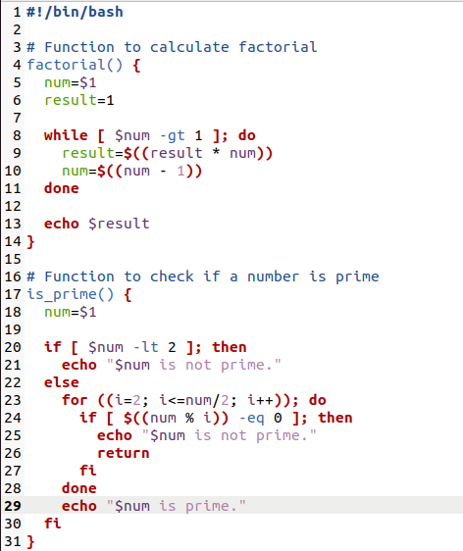

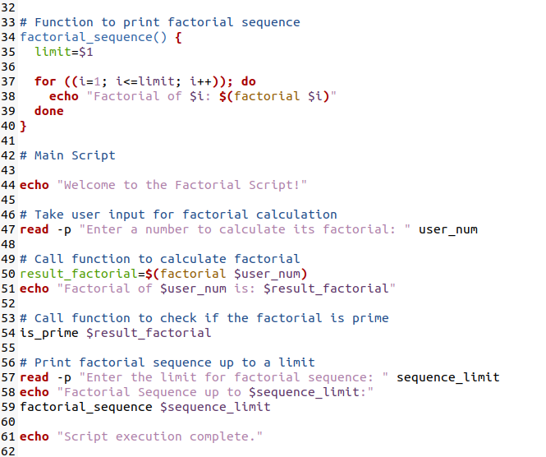

**Output:**

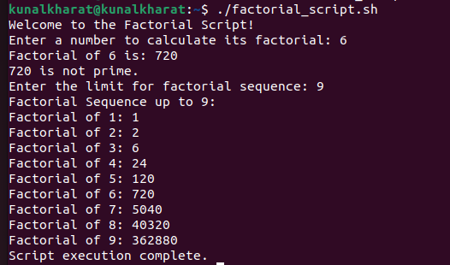

1. **Palindrome.sh:**

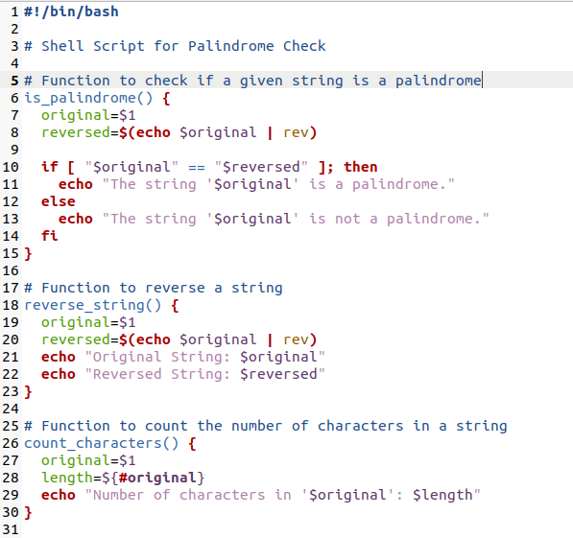

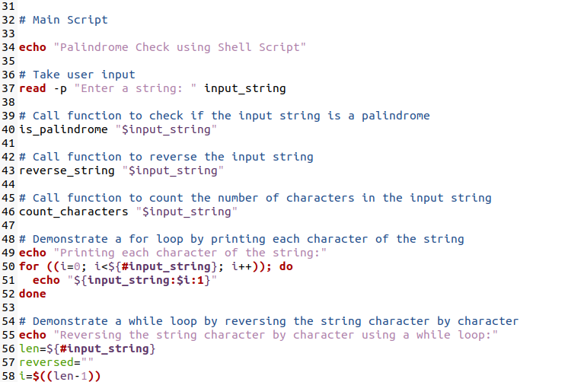

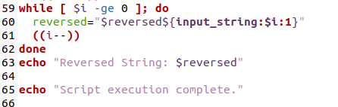

**Output:**

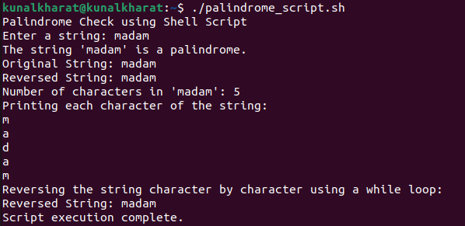

1. **Anagram.sh :**

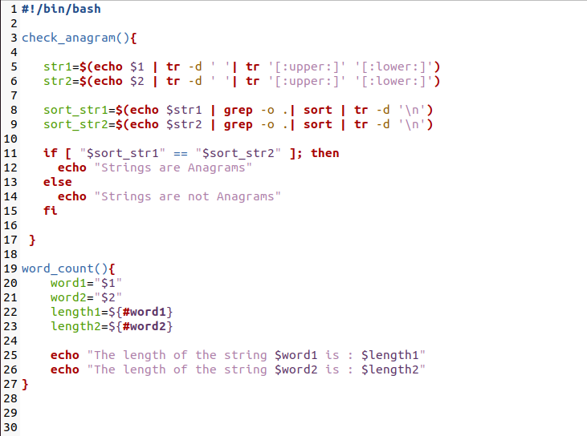

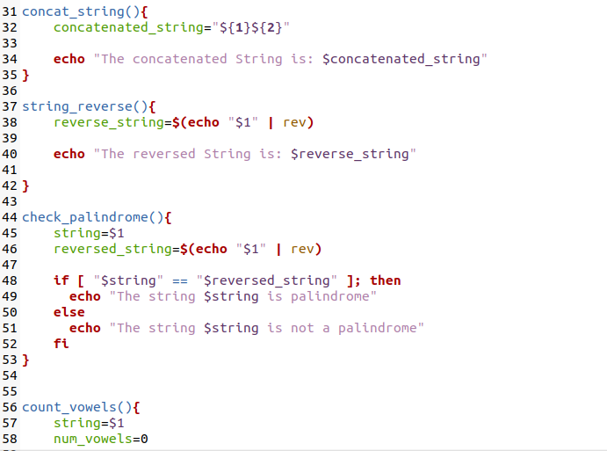

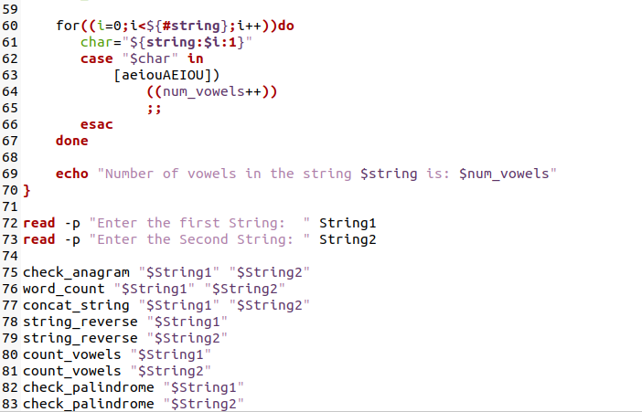

**Output:**

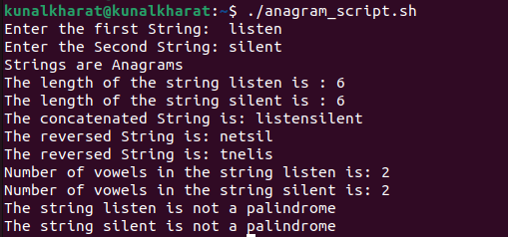

**Conclusion:**

In summary, the three shell scripts successfully perform distinct tasks. The factorial script calculates the factorial of a given number, the palindrome script determines if a string is a palindrome, and the anagram script checks if two strings are anagrams. Together, they showcase diverse functionality in shell scripting for mathematical computations and string manipulations.