**Features of Operating System**

**Configuration:**

**Processor :** AMD Ryzen 7 4800H with Radeon Graphics, 2901 Mhz, 8 Core(s), 16 Logical Processor(s)

**Install Ram**: 16.0 GB (15.7 GB usable)

**System type**: 64-bit operating System, x64 based processor

(no pen or touch input is available for display)

**Manufacturer**: AsusTek Computer INC

**Graphics:** 4GB DDR6 (RTX 3050) NVDIA getforce

**Storage:** 512 GB (expandable)

**24M cache with 4.7 GHZ Turbo boost**

**Display:** 35.56 cm & 144hz refresh rate

**8 Cores and 12 Threads**

**Windows Specifications:**

**Edition:** Windows 11 home single Language

**Version:** 22H2

**OS build:** 22621.3007

**Experience:** Windows Feature Experience Pack 1000.22681.1000.0

**Other Features:**

**Graphical User Interface:** It provides a graphical user Interface using which user can interact.

**Support for peripheral devices**: It supports multiple peripheral devices like mouse, printer, headset and headphones

**Multitasking:** Windows 11 supports multitasking related activities enabling user to perform multiple tasks asynchronously.

**Start Menu**: It is starting point of all actions in windows 11 through which user can check the option he/she wants.

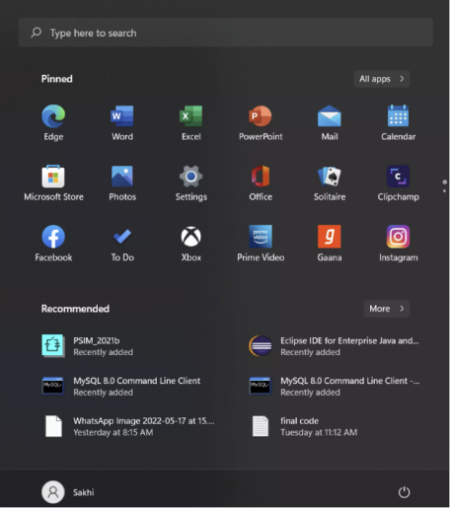

**File Explorer:** It gives the collection of all files present on the device maintained in an organized way. User can select specific files they want through search process in file explorer.

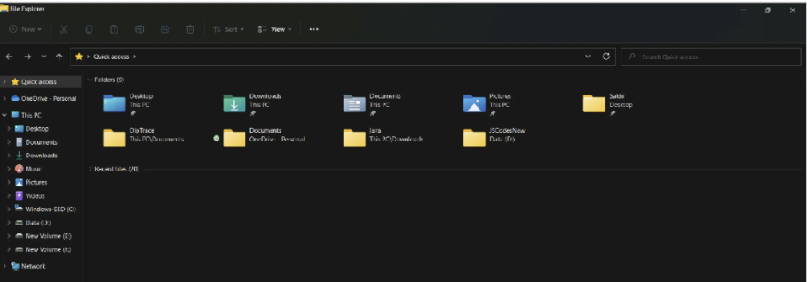

**Control Panel:** The control panel off windows 11 operating System controls and configures the resources and applications from the device. It acts as a central control unit through which multiple settings of various applications can be managed.

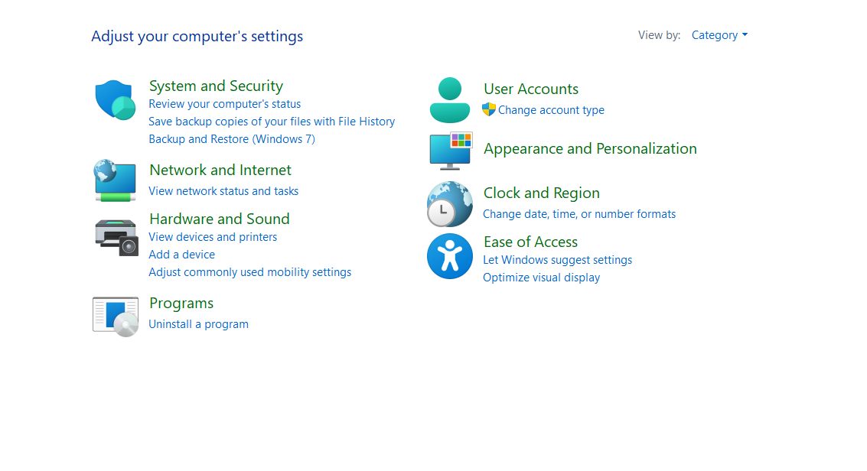

**Cortana:** An AI based voice assistant is provided which can be helpful whenever user stuck with a certain problem related to the usage of system, currently replaced by the name copilot in new versions.

**Task Manager:** It manages all the tasks performed by the user.

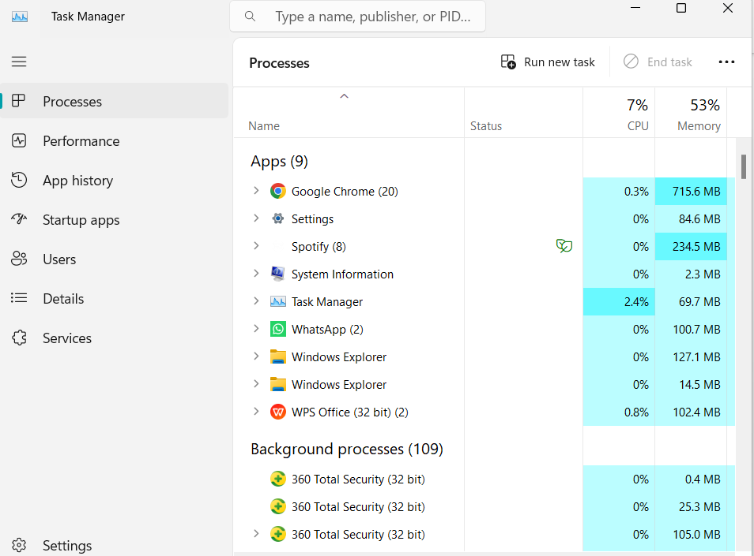

**Microsoft Office365:** Microsoft office 365 in windows provides an efficient way of multitasking through different functionalities like Microsoft PowerPoint, Word, Excel, Teams etc.

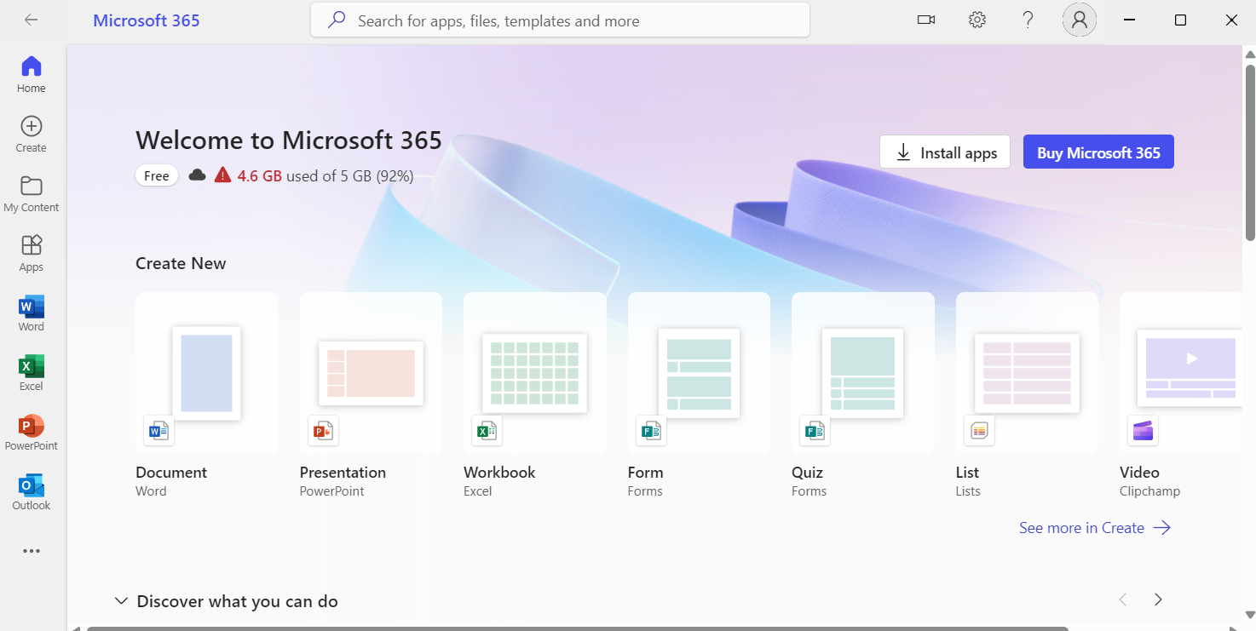

**Security Services:** To protect the System from any king of virus or malfunctioning, windows operating System provides pre-installed security measures like:

Windows defender antivirus: It is built in antivirus software which helps to protect the System From malware and malicious activities.

Windows Firewall: It manages the flow of input and output network to and from the device using an applied rule. It helps to prevent unauthorized access from an unknown network.

BitLocker Drive Encryption: It helps to protect the disk drives through the process of encryption of data for the entire disk volumes.

**Windows subsystem for Linus (WSL): WSL allows users to use Linux**

WSL allows users to run Linux on a Windows system, providing a versatile environment for development and testing purposes.

**Microsoft Store:**

The Microsoft Store serves as a centralized platform for users to discover, download, and install a wide range of applications, including both free and paid software.

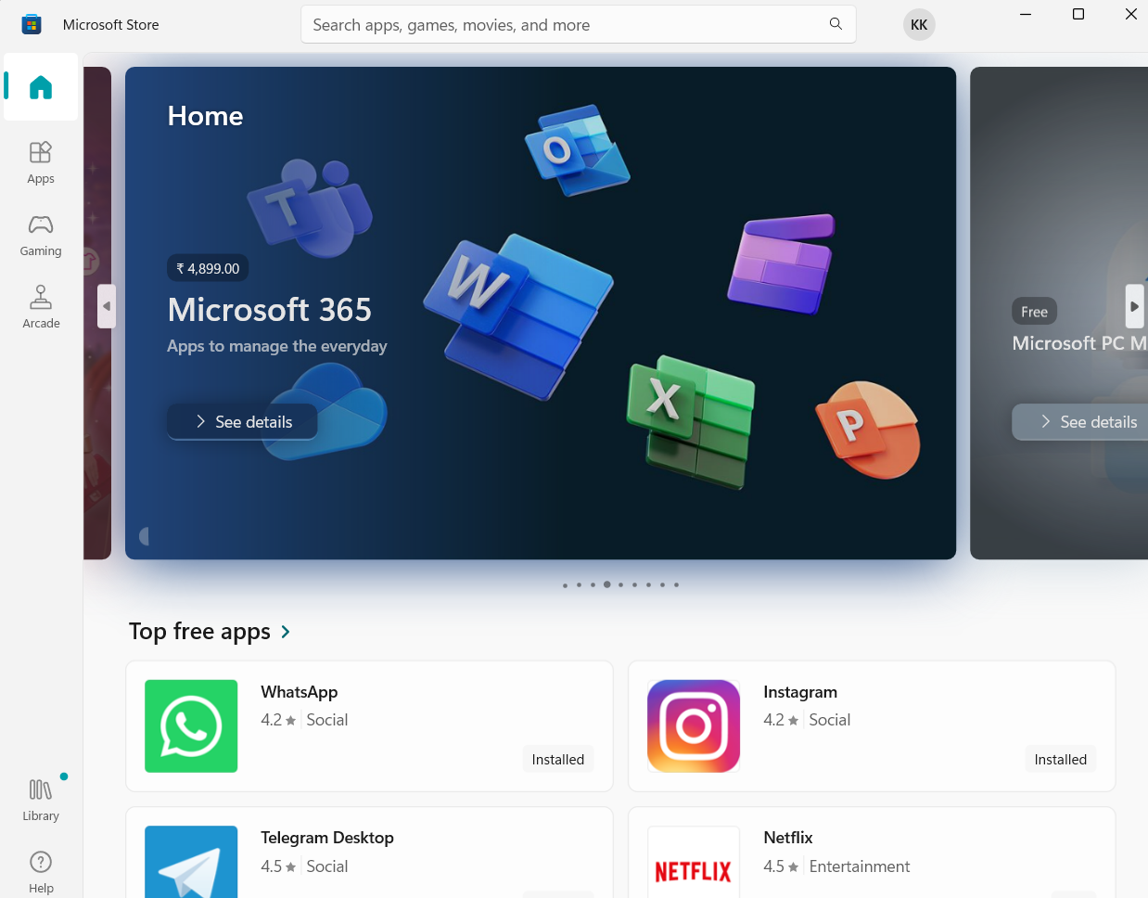

**Virtual Desktops:**

Windows 11 allows users to create and manage virtual desktops, providing a way to organize and separate different tasks or projects.

**Snap Assist:**

Snap Assist is a feature that facilitates easy window management. Users can quickly snap windows to the edges of the screen for efficient multitasking.

**Night Light:**

Night Light is a built-in feature that reduces blue light emissions from the screen during the evening, promoting better sleep and reducing eye strain.

**Gesture Support:**

If the laptop has a touchscreen, Windows 11 supports various touch gestures for navigation and interaction, enhancing the user experience.

**Biometric Authentication:**

Windows 11 supports biometric authentication methods such as fingerprint recognition or facial recognition for secure and convenient login.

**Power Management:**

The operating system includes power management features to optimize battery life on laptops, adjusting power settings based on usage and preferences.

**Windows Hello:**

Windows Hello provides a secure and convenient way to log in using facial recognition, fingerprints, or PINs, enhancing overall system security.

**Accessibility Features:**

Windows 11 offers a range of accessibility features, including screen readers, magnifiers, and voice control, making the system accessible to users with diverse needs.

**Taskbar Customization:**

Users can customize the taskbar to include favorite applications, quick access to settings, and system notifications, allowing for a personalized desktop experience.

**Dynamic Lock:**

Dynamic Lock is a security feature that automatically locks the system when a paired Bluetooth device, such as a smartphone, is out of range.

**Storage Sense:**

Storage Sense helps users manage disk space by automatically cleaning up temporary files and old downloads, optimizing storage utilization.

**Game Mode:**

Windows 11 includes a Game Mode that prioritizes system resources for an improved gaming experience, minimizing background tasks for better performance.

**Feedback Hub:**

The Feedback Hub allows users to provide feedback on the operating system, helping Microsoft identify and address issues or improve features based on user input.

**Quick Settings:**

Windows 11 features a quick settings menu that provides easy access to essential functions such as Wi-Fi, Bluetooth, airplane mode, and more.

**Device Drivers:**

Windows 11 manages device drivers through the Windows Driver Model (WDM), ensuring compatibility with a wide range of hardware components. The Device Manager allows users to view and manage installed drivers.

**Privacy Settings:**

Windows 11 includes robust privacy settings, allowing users to control data collection and app permissions. Settings cover areas like location, camera, microphone, and diagnostic data.

**Conclusion:** Windows 11 stands as a sophisticated operating system that seamlessly integrates powerful hardware support with a user-friendly interface. Its robust architecture, extensive device driver compatibility, and comprehensive management features empower users with a secure and personalized computing experience. From networking flexibility to advanced troubleshooting tools, Windows 11 showcases a commitment to performance, security, and adaptability, making it a versatile choice for a diverse range of users and computing environments.