**APPENDIX 1**

### 

**TRAVEL GUIDE WEBSITE**

PROJECT REPORT

***by***

Ujjwal Kumar

Kunal Kumar

Saurab Deep

(Section: K23NR)

(Roll No. 34,33,31)



**Department of Intelligent Systems - II**

**School of Computer Science Engineering**

**Lovely Professional University**

**Jalandhar, Punjab**

## November - 2023

**APPENDIX 2**

# Student Declaration

This is to declare that this report has been written by me/us. No part of the report is copied from other sources. All information included from other sources has been duly acknowledged. I/We aver that if any part of the report is found to be copied, I/we are shall take full responsibility for it.

Signature

Ujjwal Kumar

Roll number: 34

Signature

Kunal Kumar

Roll number: 33

Signature

Saurab deep

Roll number: 31

Place : Jalandhar, Punjab

Date : 15/11/2023

### APPENDIX 3

**TABLE OF CONTENTS**

|  |  |  |
| --- | --- | --- |
| **SNO** | **TITLE** | **PAGE NO.** |
|  | Introduction……………………………………. | 1 |
|  | Objectives of Project…………………………… | 5 |
|  | Features of Project…………………………….. | 6 |
|  | Project Screenshots…………………………… | 7 |
|  | Future Scope of Project……………………….. | 10 |

### APPENDIX 4

BONAFIDE CERTIFICATE

Certified that this project report “Travel Guide website” is the bonafide work of

“UJJWAL KUMAR, KUNAL KUMAR, SAURAB DEEP”

Who carried out the project work under my supervision.

**Dr. Bhupinder Singh**

Assistant Professor

ID: 28636

Department of Intelligent Systems -II

#### **Chapter-1**

#### **Introduction:**

**HTML**stands for Hypertext Markup Language. It was created by Tim Berners-Lee in 1991. The first version of HTML is HTML 2.0 which was published in 1999, and the latest version is HTML 5. We can save HTML files with an extension .html. It is the most basic language, and simple to learn and modify.

It contains the elements that can change/develop a web page’s look and the displayed contents. Or we can say that HTML creates or defines the structure of web pages. We can create websites using HTML which can be viewed on internet-connected devices like laptops, android mobile phones, etc. It is a combination of both hypertext and markup language.

Text that is not restricted to a sequential format and that includes links to other text is called Hypertext. The links can connect online pages inside a single or different website.

Markup Language is a language that is interpreted by the browser and it defines the elements within a document using “tags”. It is human-readable, which means that markup files use common words rather than the complicated syntax of programming languages.

HTML is the first language you should learn if you want to go for web development. HTML is a markup language that loads fast and is also light weighted. Whenever you use your browser to contact a server, you will receive a response in the form of HTML and CSS. Many tags are supported by HTML, making your web page more appealing and recognizable. HTML5 has recently incorporated new tags and elements to aid in the development of professional-looking web pages.

## Applications of HTML:

HTML is used for various purposes. Let us take a look at them

* Web Pages Development
* Embedding Images and Videos
* Game development
* Data entry support
* Store Things On The Client-Side

**CSS**stands for Cascading Style Sheets, is a simple design language intended to simplify the process of making web pages presentable. Using CSS, you can control the color of the text, the style of fonts, the spacing between paragraphs, how columns are sized and laid out, what background images or colors are used, as well as a variety of other effects.

CSS handles the look and feel part of a web page. CSS is easy to learn and understand but it provides a powerful control over the presentation of an HTML document. Most commonly, CSS is combined with the markup languages HTML or XHTML.

.

Advantages of CSS:

* **Multiple Device Compatibility**
* Superior styles to HTML**.**
* **CSS saves time**
* **Pages load faster**
* **Easy maintenance**
* **Global web standards**

CSS is created and maintained through a group of people within the W3C called the CSS Working Group. The CSS Working Group creates documents called specifications. When a specification has been discussed and officially ratified by the W3C members, it becomes a recommendation. These ratified specifications are called recommendations because the W3C has no control over the actual implementation of the language. Independent companies and organizations create that software.

The World Wide Web Consortium or W3C is a group that makes recommendations about how the Internet works and how it should evolve.

Cascading Style Sheets level 1 (CSS1) came out of W3C as a recommendation in December 1996. This version describes the CSS language as well as a simple visual formatting model for all the HTML tags.

CSS2 became a W3C recommendation in May 1998 and builds on CSS1. This version adds support for media-specific style sheets e.g. printers and aural devices, downloadable fonts, element positioning and tables.

The motivation for making CSS was to provide a system to style the information which is being presented (At that time, this was solely lacking), and to isolate the process of styling from that of content creation. Without using CSS, it is very typical thing for web designers to lay out pages with techniques like HTML tables that obstruct accessibility for the vision-impaired users.

**JavaScript** is a lightweight, cross-platform, and interpreted compiled programming language which is also known as the scripting language for webpages. It is well-known for the development of web pages; many non-browser environments also use it. JavaScript is both imperative and declarative type of language. JavaScript contains a standard library elements of objects, like [Array](https://www.geeksforgeeks.org/arrays-in-javascript/), [Date](https://www.geeksforgeeks.org/javascript-date-objects/), and [Math](https://www.geeksforgeeks.org/javascript-math-object/), and a core set of language like [operators](https://www.geeksforgeeks.org/javascript-operators/), control structures, and [statements](https://www.geeksforgeeks.org/javascript-statements/). JavaScript is also being used widely in game development and[Mobile](https://www.guru99.com/mobile-testing.html)application development.

JavaScript was developed by Brendan Eich in 1995, which appeared in Netscape, a popular browser of that time. The language was initially called LiveScript and was later renamed JavaScript.

Being a scripting language, JavaScript cannot run on its own. In fact, the browser is responsible for running JavaScript code. When a user requests an HTML page with JavaScript in it, the script is sent to the browser and it is up to the browser to execute it. The main advantage of JavaScript is that all modern web browsers support JavaScript. So, you do not have to worry about whether your site visitor uses Internet Explorer, Google Chrome, Firefox or any other browser.

To start with, you need a text editor to write your code and a browser to display the web pages you develop. You can use a text editor of your choice including Notepad++, Visual Studio Code, Sublime Text, Atom or any other text editor you are comfortable with.

There are many programmers who think that JavaScript and[Java](https://www.guru99.com/java-tutorial.html)are the same. In fact,  **Java is a very complex programming language whereas JavaScript is only a scripting language.** The syntax of JavaScript is mostly influenced by the programming language C.

Advantages of JavaScript:

* **Reduce the time**
* **Provides various interfaces**
* **Capable of front-end as well as back-end development**
* **Reduces code length**
* **Works perfect with other programming languages**
* **Data validation is possible on the browser itself rather than sending it off to the server**

**Bootstrap** is an open-source and free CSS framework that helps in directing a responsive device-friendly mobile-first front-end webpage development tool. This tutorial series will teach you about Bootstrap and its various features.

Bootstrap mainly includes CSS (Cascading Style Sheets) and an optional JavaScript-supported design template (plug-ins) that deals with typography, buttons, forms, and other user interface components. This Bootstrap framework helps rapid web development and supports developers in creating responsive web pages.

Twitter Blueprint was the first name for Bootstrap and was developed on Twitter by Mr. Mark Otto and Jacob Thornton. It was released as an open-source product on GitHub in August 2011. The framework is primarily built to encourage design uniformity and reliability of web pages across applications. Before its existence, developers used various external libraries to perform responsive web development, leading to incompatibilities in web development and heavy maintenance burdens.

Advantages of Bootstrap:

* **Responsive design and looks**
* **Easy customization**
* Faster and Easier Web Development
* **Simple and easy to start**
* **Clean interface or Developers**

Bootstrap Features:

* **HTML and CSS based design templates for forms, buttons, navigation, and other components.**
* **Modularity. Change or remove components or component colors.**
* **Re-usable code with CSS classes.**
* **Out of the box JavaScript components with additional features like tooltips, modal windows, etc.**

The use of mobile devices to surf the web continues to grow at an astronomical pace, and these devices are often constrained by display size and require a different approach to how content is laid out on the screen.

A multitude of different screen sizes exist across phones, "phablets," tablets, desktops, game consoles, TVs, and even wearables. Screen sizes are always changing, so it's important that your site can adapt to any screen size, today or in the future. In addition, devices have different features with which we interact with them. For example some of your visitors will be using a touchscreen. Modern responsive design considers all of these things to optimize the experience for everyone.

Pages optimized for a variety of devices must include a meta viewport tag in the head of the document. A meta viewport tag gives the browser instructions on how to control the page's dimensions and scaling.

To attempt to provide the best experience, mobile browsers render the page at a desktop screen width (usually about 980px, though this varies across devices), and then try to make the content look better by increasing font sizes and scaling the content to fit the screen. This means that font sizes may appear inconsistent to users, who may have to double-tap or pinch-to-zoom in order to see and interact with the content.

**Using the meta viewport value width=device-width instructs the page to match the screen's width in device-independent pixels. A device (or density) independent pixel being a representation of a single pixel, which may on a high density screen consist of many physical pixels. This allows the page to reflow content to match different screen sizes, whether rendered on a small mobile phone or a large desktop monitor.**

#### **Chapter-2**

**Objectives Of Project:**

The main objective of the Project on Current News is to introduce the people with current world that what happens in this running world. News websites help in mass education and information, providing the latest news and current happenings around the globe. Before digital resolution, we need to wait for long hours to know what’s happening around the world. Later comes the television, but people might not always be in front of the TV. Then comes the digital world that has speeded up everything.

People started using smartphones and the day-by-day number of smartphone users is increasing. People can access their mobile phones, social networking sites, WhatsApp, Facebook, etc., anywhere anytime so they can be updated very quickly using online news portals. News websites and social media can provide the fastest and most reliable news updates.

People always want up to date with the latest news, most news publications and channel have invested in web design and its development to create their news sites and introduce the people with the latest update.

In now a days, few of news portals also offer many benefits to the business and a platform to stay connected with the readers. Websites have become the right hand of news and publication businesses to get more and more people to read their news and articles.

Furthermore, internet news sites provide mobile updates or notifications on your mobile device, which are related to technology. The news portal allows you to have the most up-to-date headlines, news headlines, and front-page headlines delivered to you at all times.

There are the few points which are the purpose of any news website.

* **Informing the audience:**
* **Educating the audience:**
* **Guiding the audience**
* **Interpreting facts and news:**
* **Source of entertainment:**
* **Forming opinions**
* **Spreading Awareness**
* **Advertising**

#### **Chapter-3**

**Features Of Project:**

* **All-inclusive news can be provided**
* **Instant service**
* **Updates on live events**
* **Readers can access it from any device**
* **Cost-effective advertising solutions**
* **Customization messaging capabilities**

Frequent content update is essential for the existence of any news website. Without frequent updates, your website will not attract an audience. Frequent content affects your results in search engines as well. If more people visit a website regularly then more likely Google like it. Online news portal development should provide readers with the possibility to customize their hope page giving them the power to choose sections, contents, topics of their interest.

If the design fails to offer this personalized reader experience, visitors are more likely to leave the portal looking for some others which offer them that.News portal websites are commonly built with grid-based designs. This design is a popular choice not only because of the sharp and impressive look it creates but also it is one of the most effective ways to manage and organize a large amount of content.

In news portal development, monetary features are as important as content and service features. Integrating advertisement in the right part of the design is crucial for the monetary benefits of the news portal. You must be able to use ads without turning readers away from your website. The right places for banner ads are sidebar, both left and right, header or footer.

This news website provides public-interest information, such as political, economic, sports, and entertainment news.

* Accessibility is a big plus.
* News can be accessed according to one’s preferences.
* Matches of test matches, as well as other sports, are broadcast live.
* A reader can readily express his or her opinion on any topic.
* Any important news is covered in real time.
* Headline news videos that aren’t available anywhere else.

#### **Chapter-4**

**Project Screenshots:**

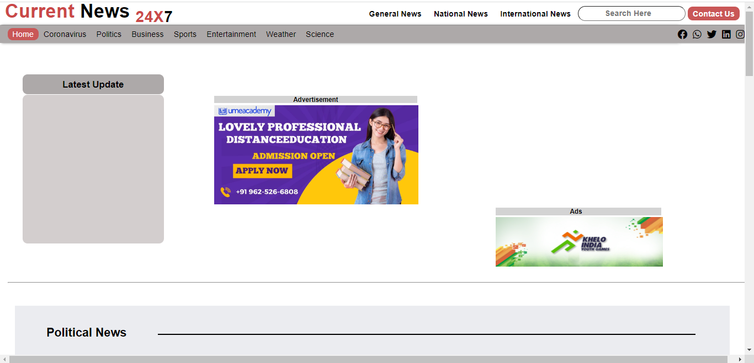

**Figure 1. Shows top view of home page**

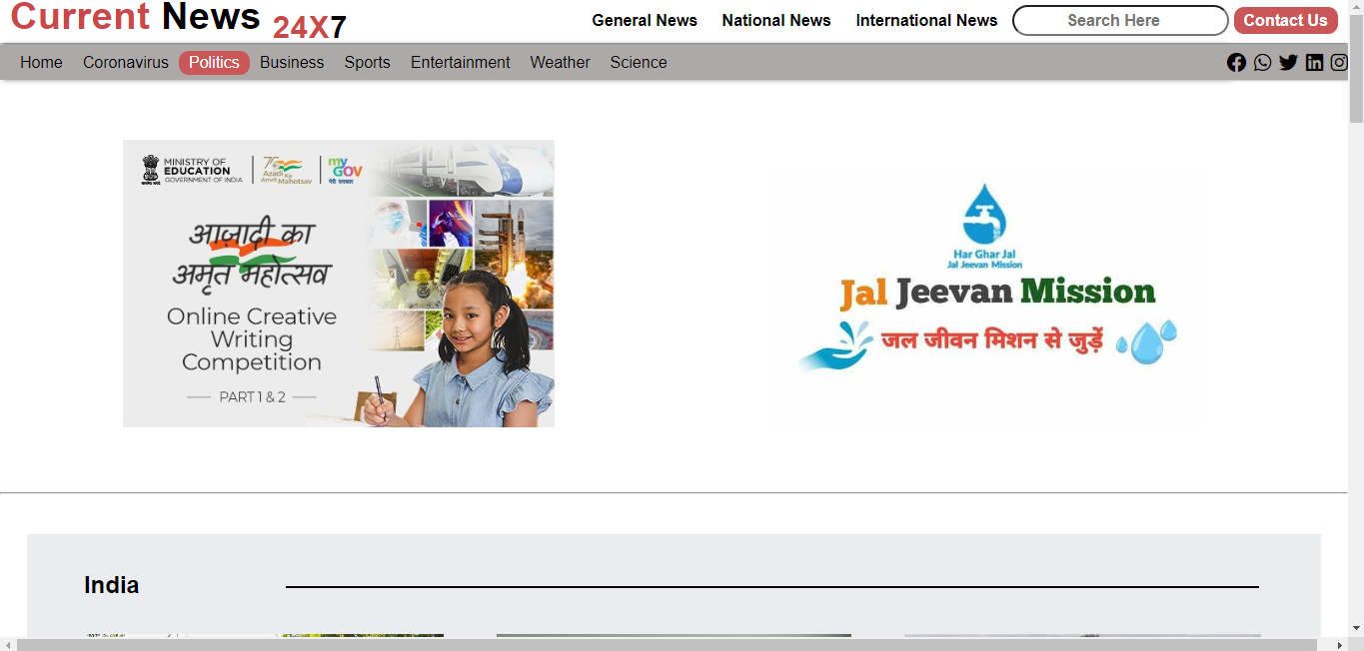

**Figure 2. Describes top view of another page**

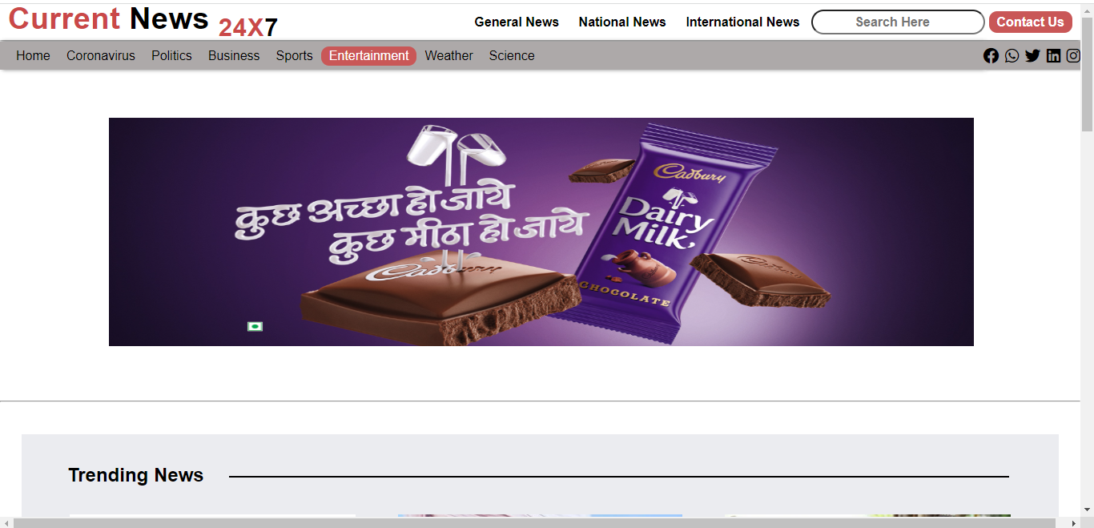

**Figure 3. Shows top view of another page**

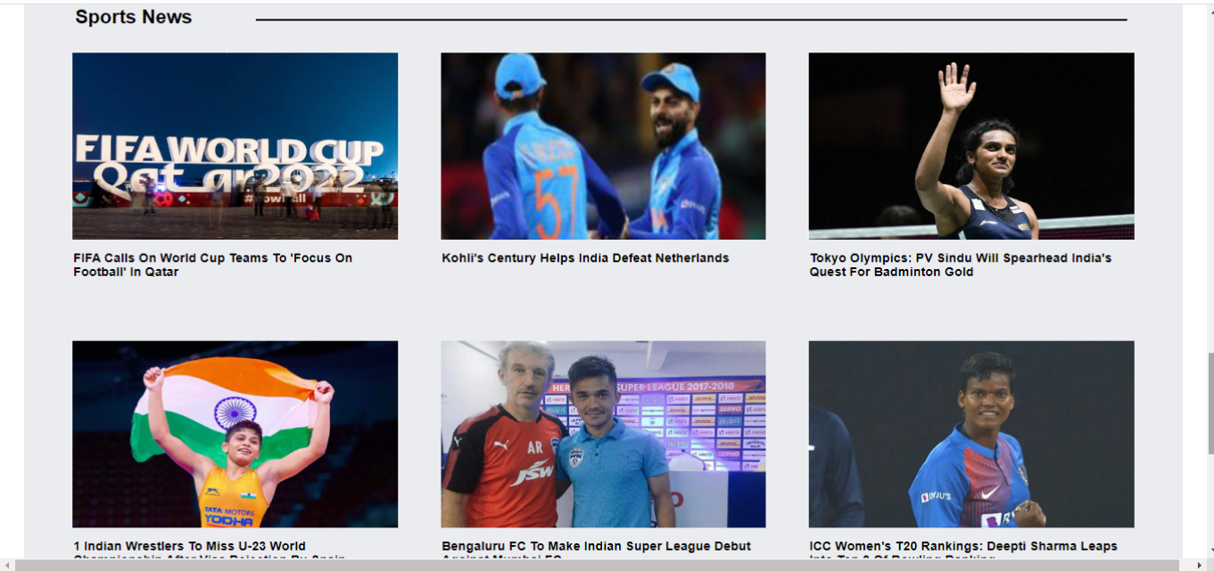

**Figure 4. Describes view of the content**

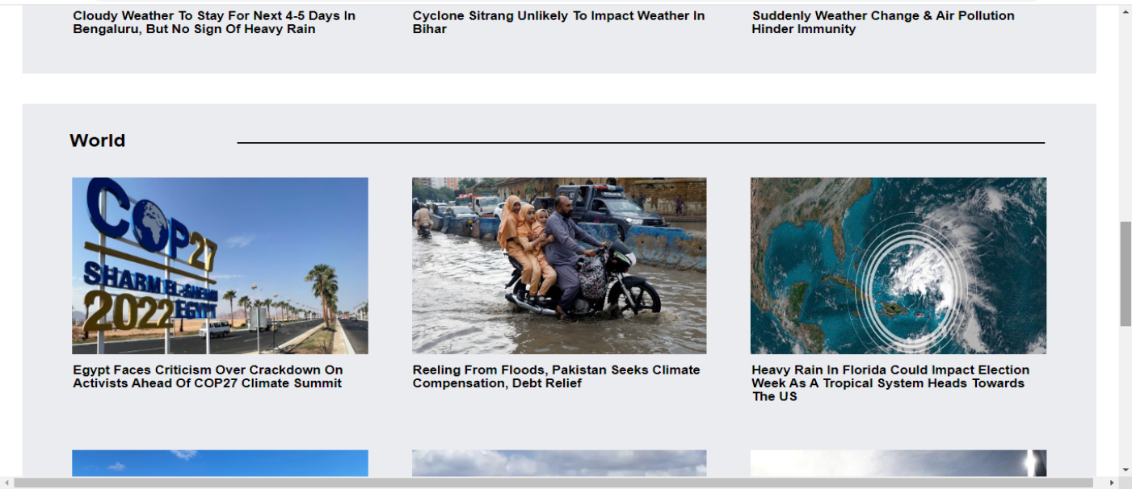

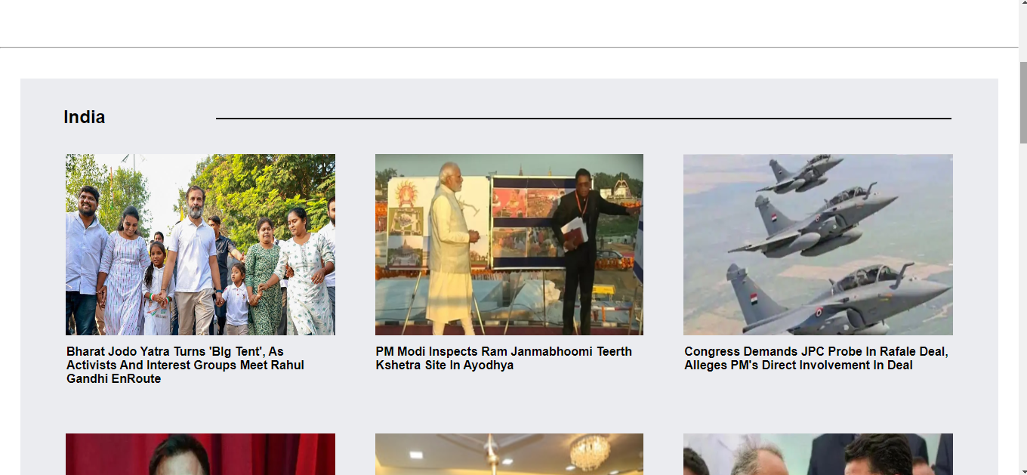

**Figure 5. Describes view of the content**

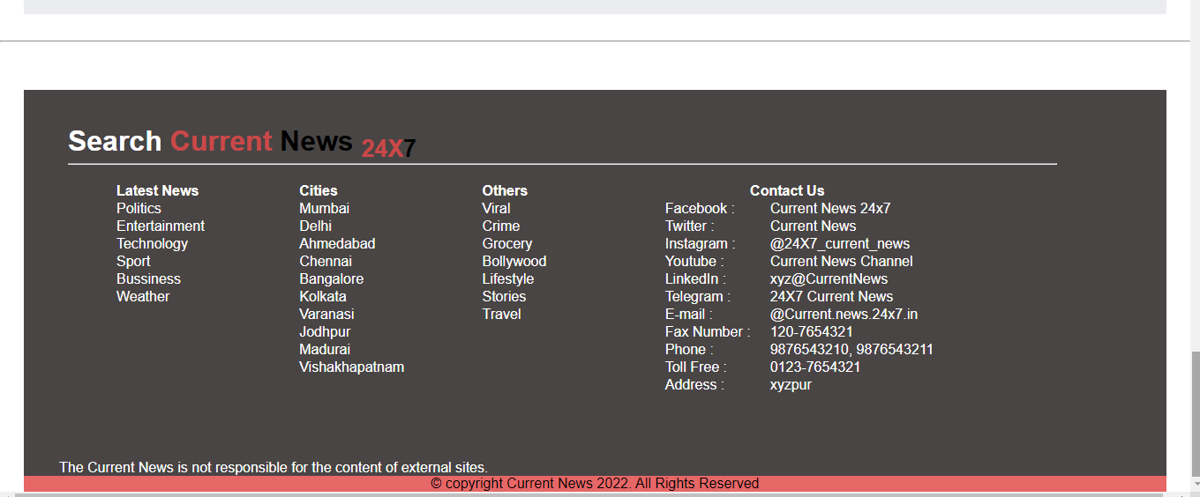

**Figure 6. Shows bottom view of the pages**

#### **Chapter-5**

**Future Scope Of Project:**

Today the world moves towards to be more digital, and digitization is the need of every business, every Industry. Online News Sites play a huge role in educating and informing people with latest updates, current situation. People don’t have much more time to read the Printed newspaper with yesterday’s happening, so they always follow web sites or Electronic Media for getting latest News.

In a nutshell, it can be summarized that the future scope of the project circles around maintaining information regarding:

* **We can add printer in future.**
* **We will host the platform on online servers to make it accessible worldwide.**
* **We can give more advance software for Current News including more facilities.**

When thinking about the future of news, a framework that considers the three general buckets below can provide a broad overview:

* **Consumption Experience**
* **Source**
* **Industry trends**

On the **experience** side, there is a huge opportunity in the 'live' notion of news, where the consumer is able to feel like they are there. The idea of a stream of relevant content, delivered in a cross-platform, simple-to-consume, simple-to-interact manner will continue to evolve.

As it relates to the **source** of my news, it is interesting to consider the continued expansion of the definition of 'publisher', particularly as it relates to the user as news creator. Emerging trends of online influence and web-elected subject area experts are becoming more legitimate as reputation is more solidly defined online.

Finally, on the topic of **industry trends**, the dramatically changing economics of the business will force those who survive to innovate in the monetization of these information experiences, rather than simply monetizing content. Those who 'get it' will be able to bring brands/advertisers not only into the publishing process ("brands as publishers"), but will allow them to connect with users in the information consumption process as well, which becomes very interesting.

The above mentioned points are the enhancements which can be done to increase the applicability and usage of this project.