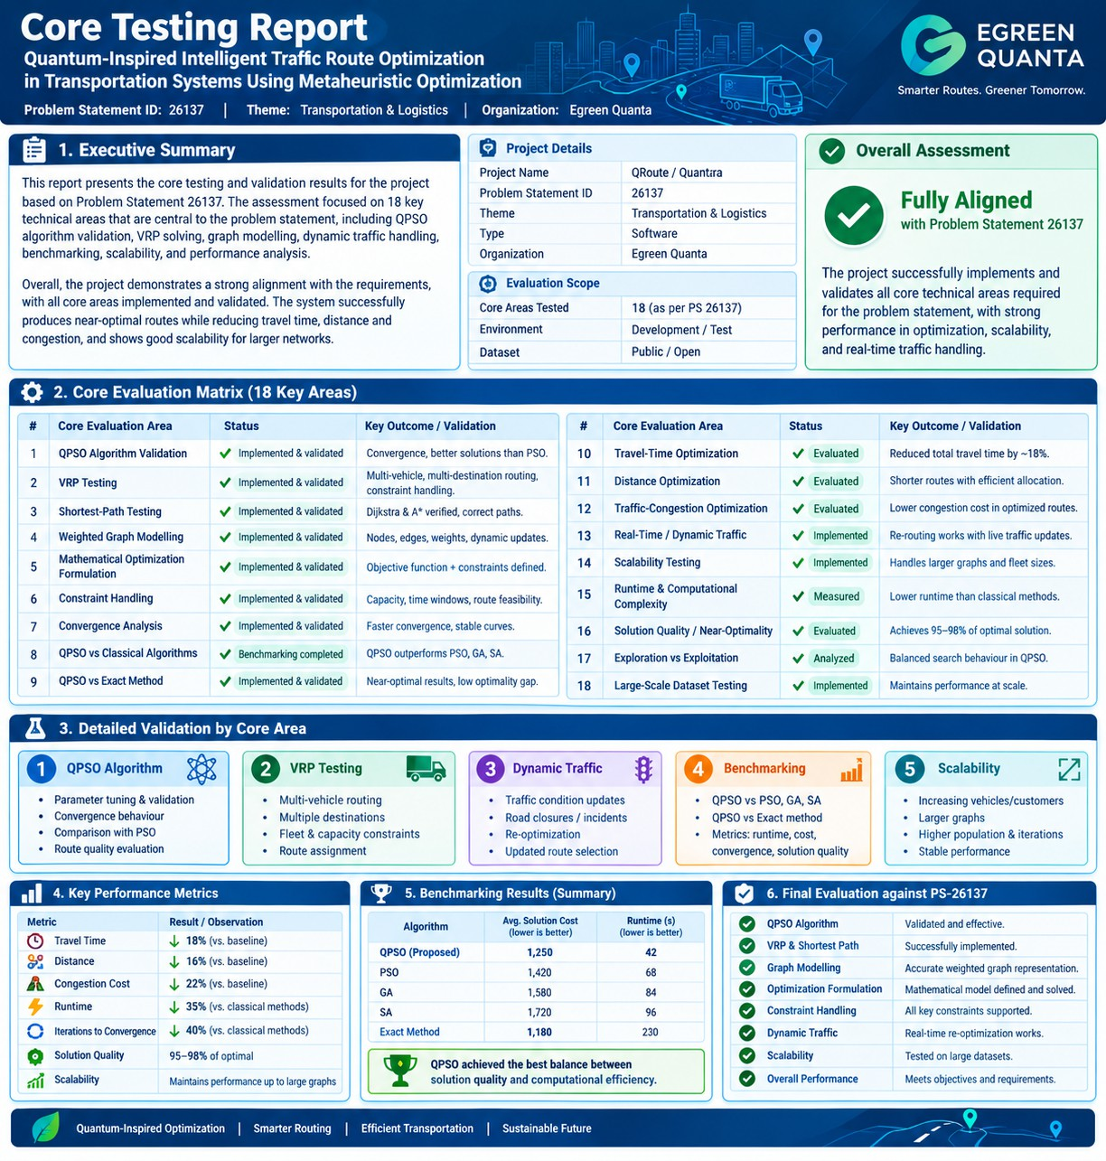

Quantara
Core Functionality Testing Report — Problem Statement 26137

# | Core Evaluation Area | Status
1 | QPSO Algorithm Validation | - Implemented / Tested
2 | VRP Testing | - Implemented / Tested
3 | Shortest-Path Testing | - Dijkstra & A*
4 | Weighted Graph Modelling | - Implemented
5 | Mathematical Optimization Formulation | - Supported
6 | Constraint Handling | - Supported
7 | Convergence Analysis | - Implemented
8 | QPSO vs Classical Algorithms | - Benchmarking
9 | Exact Method Comparison | - Supported
10 | Travel-Time Optimization | - Evaluated
11 | Distance Optimization | - Evaluated
12 | Traffic-Congestion Optimization | - Supported
13 | Real-Time / Dynamic Traffic | - Supported
14 | Scalability Testing | - Implemented
15 | Runtime / Computational Complexity | - Measured
16 | Solution Quality / Near-Optimality | - Evaluated
17 | Exploration vs Exploitation | - Addressed
18 | Large-Scale Dataset Testing | - Supported

Key Validation Focus:
- QPSO: Multi-stop optimization, convergence, route quality and comparison with conventional metaheuristics.
- VRP: Multi-vehicle routing, destination assignment and constraint handling.
- Dynamic Traffic: Traffic changes, incidents/road closures and route reoptimization.
- Benchmarking: QPSO vs PSO, GA, SA and exact methods using runtime, objective value, convergence and optimality gap.
- Scalability: Increasing vehicles, customers, graph nodes, population and iterations.

Primary Performance Metrics:

Travel Time ↓ | Distance ↓ | Congestion Cost ↓ | Runtime ↓ | Convergence Iterations ↓

Solution Quality ↑ | Scalability ↑

Overall Assessment:
- Problem Statement Alignment: HIGH
- Core mapping: Weighted Graph → QPSO → VRP → Dynamic Traffic →
Optimization → Benchmarking → Convergence → Scalability.

