iReACH Objective 1: Network Analysis
All_transfers as proxy for health information exchange
ED_ED, ED_ADM, ADM_ADM, ADM_ED, OP_OP
Aim:
All patients that were transferred from one hospital to another hospital as a proxy to infer the digital health exchange
Inclusions:
- NHS hospitals in England only
- Type 1 ED hospitals: Emergency departments are a CONSULTANT led 24 hour service with full resuscitation facilities
- Adult, child, maternity hospitals with T1ED
- Occurrence of transfer of patient between hospitals
- Between 1st April 2022 and 31st March 2025
- Multiple transfers of one patient also accepted
Exclusions:
- Next immediate transfers between emergency departments, inpatients and outpatient referrals. Not tracking multiple transfers

Assumptions:
- As there is no formal tracking number when patients are transferred. Transfer is assumed when patient leaves one hospital with a discharge destination set as ‘transfer to another healthcare provider’ (code 19712007) and arrives at the next hospital as a new presentation from a source of attendance as emergency department/UCC.

Initially only:
- ED to ED transfer analysis

Data source:
- ECDS HES dataset (dsa_778927_p3d9z.dars_nic_778927_p3d9z.ecds_dars_nic_778927_p3d9z) National emergency department presentations

Secondary tables created:
  - ED transfers out to another hospital: dsa_778927_p3d9z.dsa_778927_p3d9z_collab.out_ed2
  - ED receiving a transfer from ED: dsa_778927_p3d9z.dsa_778927_p3d9z_collab.in_ed2
  - ED to ED transfers within 48 hours: dsa_778927_p3d9z.dsa_778927_p3d9z_collab.ed_ed2(this was used for all figures)
Cleaning methodology:
Out_ED2 (outgoing ED transfers): total count 642,523
- Discharge destination
  - Code 19712007: Transfer to another healthcare professional
- Department type
  - Code 01: Type 1 ED
In_ed2 (incoming ED transfers): total count 2,104,237
- Attendance source
  - 1066431000000102: From ED of another hospital
  - 1066441000000106: From Urgent care centre of another hospital
- Department type
  - Code 01: Type 1 ED
Ed_ed2 (ED to ED transfers by combining out_ed2 and in_ed2): total count 42,904
- Out_ed2 Person ID (pseudonymised patient ID tracked) == in_ed2 Person ID
- Out_ed2 SITE (hospital) != in_ed2 SITE
- In_ed2 arrival date >= out_ed2 departure date
- In_ed2 arrival date in within 24 hours of out_ed2 departure date
- After departure date keep only the first (closest) arrival date
Ed_ed3(merging hospital codes with names)
- Ed_ed2 merge with reference table org_daily

Descriptive Statistics
1. Overall Transfer Summary
Counts | n
Total Transfers | 1,251,929
Unique sending hospitals (transferring out) | 125
Unique incoming hospitals (receiving in) | 125
Combined unique hospitals | 135
Unique hospital pairs | 5268
Total unique patient counts | 507,799
Possible Pairs (7x6) | 42
Network Density | 12542.86%

2. Transfer by Type
Transfer_Type (to another provider) | Count | Senders | Receivers | %
Outpatient Transfers from ED, inpatients and outpatients | 988,217 | 125 | 77 | 78.9
ED to ED transfers | 129,573 | 120 | 102 | 10.3
Inpatient to inpatient transfers | 110,235 | 123 | 123 | 8.8
ED to inpatient transfers | 22,475 | 118 | 115 | 1.8
Inpatient to ED transfers | 1432 | 103 | 71 | 0.1

3. Monthly Transfers (Linear regression)
Slope | 578.03/month
Annual rate | 6933.5/year
Intercept | 24086.59
R-sq | 0.81
p-value | <0.001

4. Key Metrics for Vulnerability Analysis
 | n
Total unique directed pairs | 5268
Reciprocal pairs | 3108
Reciprocal rate | 58.98%

5. Basic Network Statistics
 | n
Nodes (Unique hospitals) | 130
Edges remaining | 8789
Average Degree | 56.6

6. Transfer volumes
Summary | Total_transfers
Count | 8691
Mean | 137.2
Stddev | 980.8
Min | 1
25% | 1
50% | 3
75% | 12
p90th | 110
P95th | 418
P99th | 2761
Max | 27160
Outputs:

Transfer Duration Summary Figures (0-24hrs)
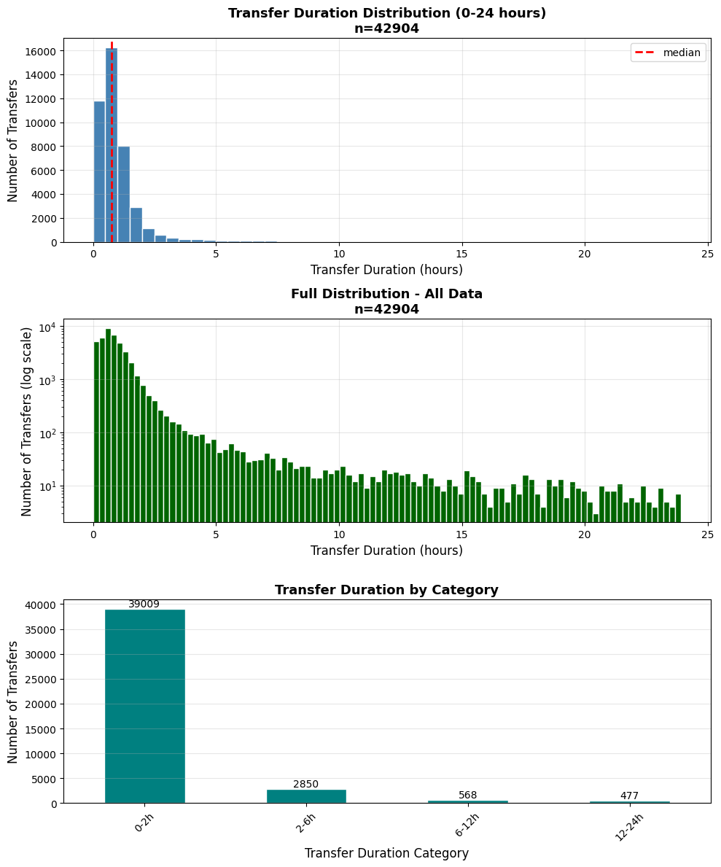

Hospital transfers month on month with regression line: ED_ED_MoM_transfers.png
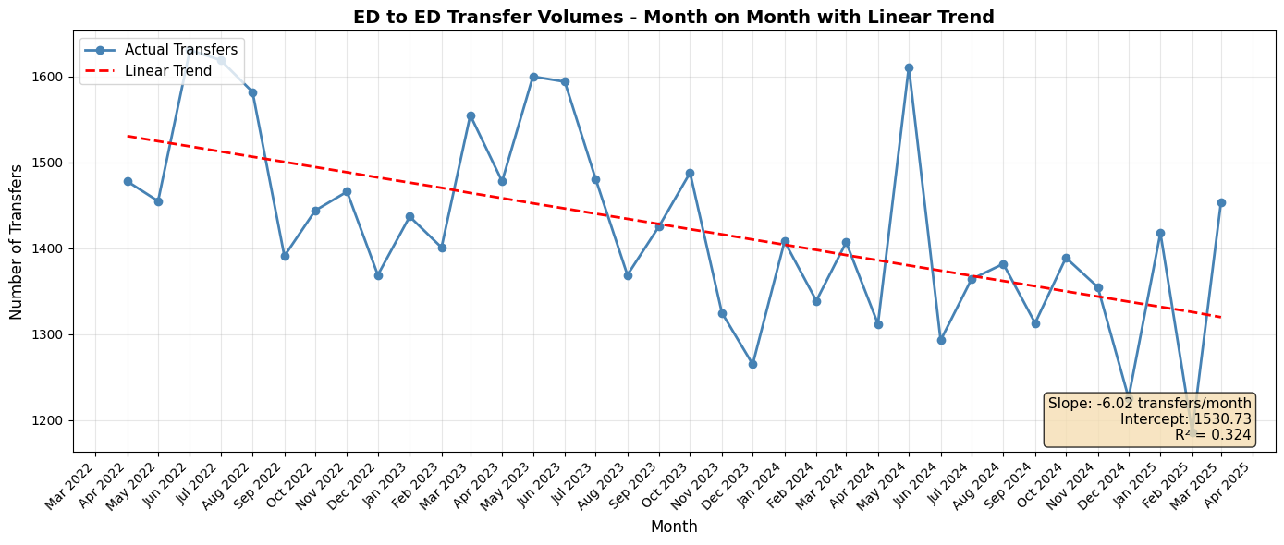

Normalised net hospital transfer balance: Hospital_transfer_balance.png
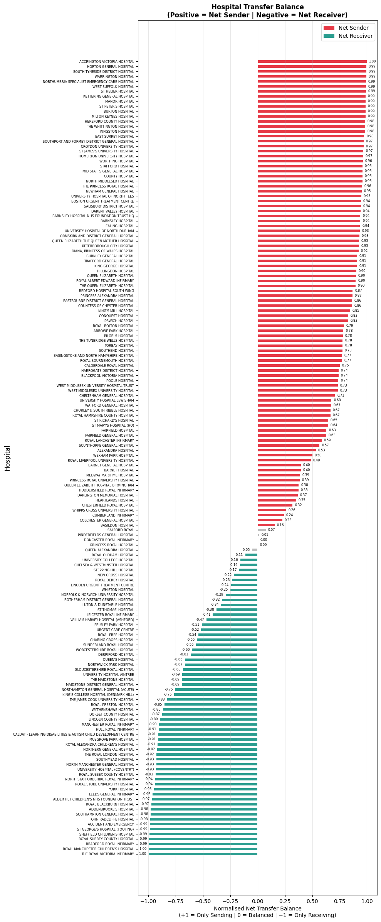

Network graphs: Network_graph_ED_ED
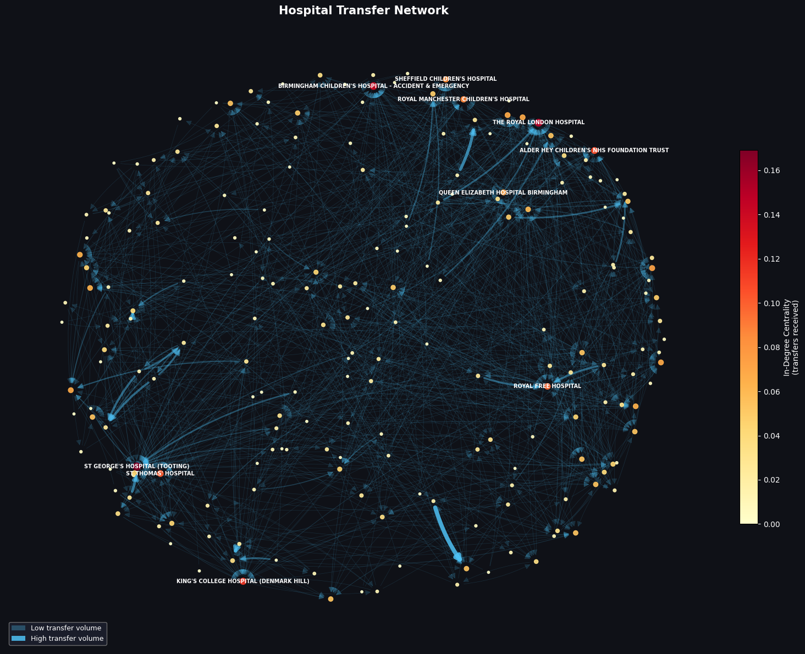

CENTRALITY: Top 10 hospitals by transfers received (critical nodes):
Hospital | Transferring hospitals | Centrality
St Georges Hospital | 35 | 0.169
The Royal London | 31 | 0.150
Birmingham Children’s Hospital | 29 | 0.140
King’s College Hospital | 24 | 0.116
Alder Hey Children’s Hospital | 22 | 0.106
St Thomas’ Hospital | 21 | 0.101
Royal Free Hospital | 20 | 0.097
Royal Manchester Children’s Hospital | 18 | 0.087
Sheffield Children’s Hospital | 17 | 0.082
Queen Elizabeth Hospital Birmingham | 15 | 0.073

NEXT STEPS
- APC (Admission dataset) and OP (outpatient dataset cleaning)
- Data sharing communities with Louvain modularity
- Geographical network map with distance calculations

