iReACH Objective 1: Network Analysis
ED to ED patient transfers as proxy for health information exchange

Aim:
All inpatients that were transferred from one hospital to another hospital as a proxy to infer the digital health exchange
Inclusions:
- NHS hospitals in England only
- Type 1 ED hospitals: Emergency departments are a CONSULTANT led 24 hour service with full resuscitation facilities
- Adult, child, maternity hospitals with T1ED
- Occurrence of transfer of patient between hospitals
- Between 1st April 2022 and 31st March 2025
- Multiple transfers of one patient also accepted
Exclusions:
- Next immediate transfers between emergency departments, inpatients and outpatient referrals. Not tracking multiple transfers
Assumptions:
As there is no formal tracking number when patients are transferred.
- Transfer is assumed when patient leaves one hospital with a discharge destination(DISDEST):
  - 51:NHS other hospital provider - ward for general PATIENTS or the younger physically disabled
  - 52:NHS other hospital provider - ward for maternity PATIENTS or Neonates)
- and arrives at the next hospital as a new presentation as admission method (ADMIMETH)
  - 2B:Transfer of an admitted patient from another Hospital Provider in an emergency
  - 81:Transfer of any admitted patient from other Hospital Provider other than in an emergency
- And arrival source (ADMISORC):
  - 51:NHS other hospital provider - ward for general PATIENTS or the younger physically disabled
  - 52:NHS other hospital provider - ward for maternity PATIENTS or Neonates)

Data source:
APC HES dataset
- (dsa_778927_p3d9z.dars_nic_778927_p3d9z.hes_apc_2223_dars_nic_778927_p3d9z)
- (dsa_778927_p3d9z.dars_nic_778927_p3d9z.hes_apc_2324_dars_nic_778927_p3d9z)
- (dsa_778927_p3d9z.dars_nic_778927_p3d9z.hes_apc_2425_dars_nic_778927_p3d9z)

Secondary tables created:
  - APC transfers out to another hospital: dsa_778927_p3d9z.dsa_778927_p3d9z_collab.out_apc
  - Receiving a transfer from APC: dsa_778927_p3d9z.dsa_778927_p3d9z_collab.in_apc
  - ED to ED transfers within 48 hours: dsa_778927_p3d9z.dsa_778927_p3d9z_collab.ed_ed2(this was used for all figures)
Cleaning methodology:
Out_ED2 (outgoing ED transfers): total count 642,523
- Discharge destination
  - Code 19712007: Transfer to another healthcare professional
- Department type
  - Code 01: Type 1 ED
In_ed2 (incoming ED transfers): total count 2,104,237
- Attendance source
  - 1066431000000102: From ED of another hospital
  - 1066441000000106: From Urgent care centre of another hospital
- Department type
  - Code 01: Type 1 ED
Ed_ed2 (ED to ED transfers by combining out_ed2 and in_ed2): total count 42,904
- Out_ed2 Person ID (pseudonymised patient ID tracked) == in_ed2 Person ID
- Out_ed2 SITE (hospital) != in_ed2 SITE
- In_ed2 arrival date >= out_ed2 departure date
- In_ed2 arrival date in within 24 hours of out_ed2 departure date
- After departure date keep only the first (closest) arrival date
Ed_ed3(merging hospital codes with names)
- Ed_ed2 merge with reference table org_daily

Descriptive Statistics
ED_ED (mins): total ED to ED transfers
ED_ED <=p95 (mins) = Transfers within 95 percentile of minutes (207mins)
Descriptive statistics | days
Count unique outgoing hospitals (transferring out) | 191
Count unique incoming hospitals (receiving in) | 190
Number of unique hospitals (combined) | 193
Total unique patient counts | 24963
Number of completed transfers | 27151
p95 hospital transfer | 0
MEAN | 0
MEDIAN | 0
STD_DEV | 0.2
MIN | 0
MAX | 1
RANGE (25% - 75%) | 0-1

Outputs:

Hospital transfers month on month with regression line: ED_ED_MoM_transfers.png
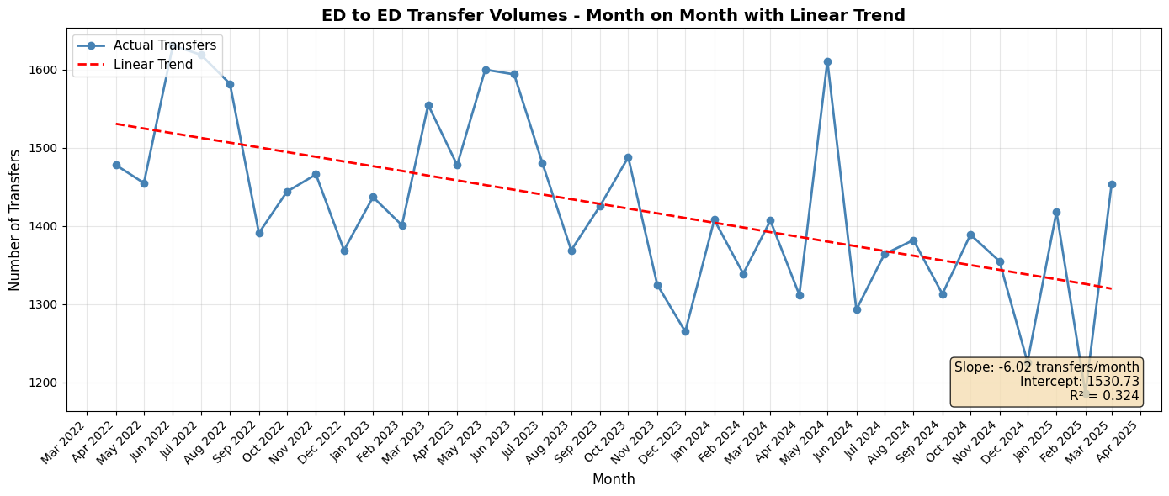

Normalised net hospital transfer balance: Hospital_transfer_balance.png
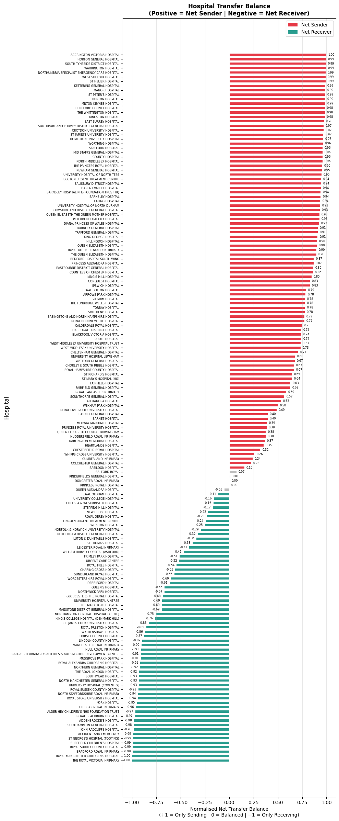

Network graphs: Network_graph_ED_ED
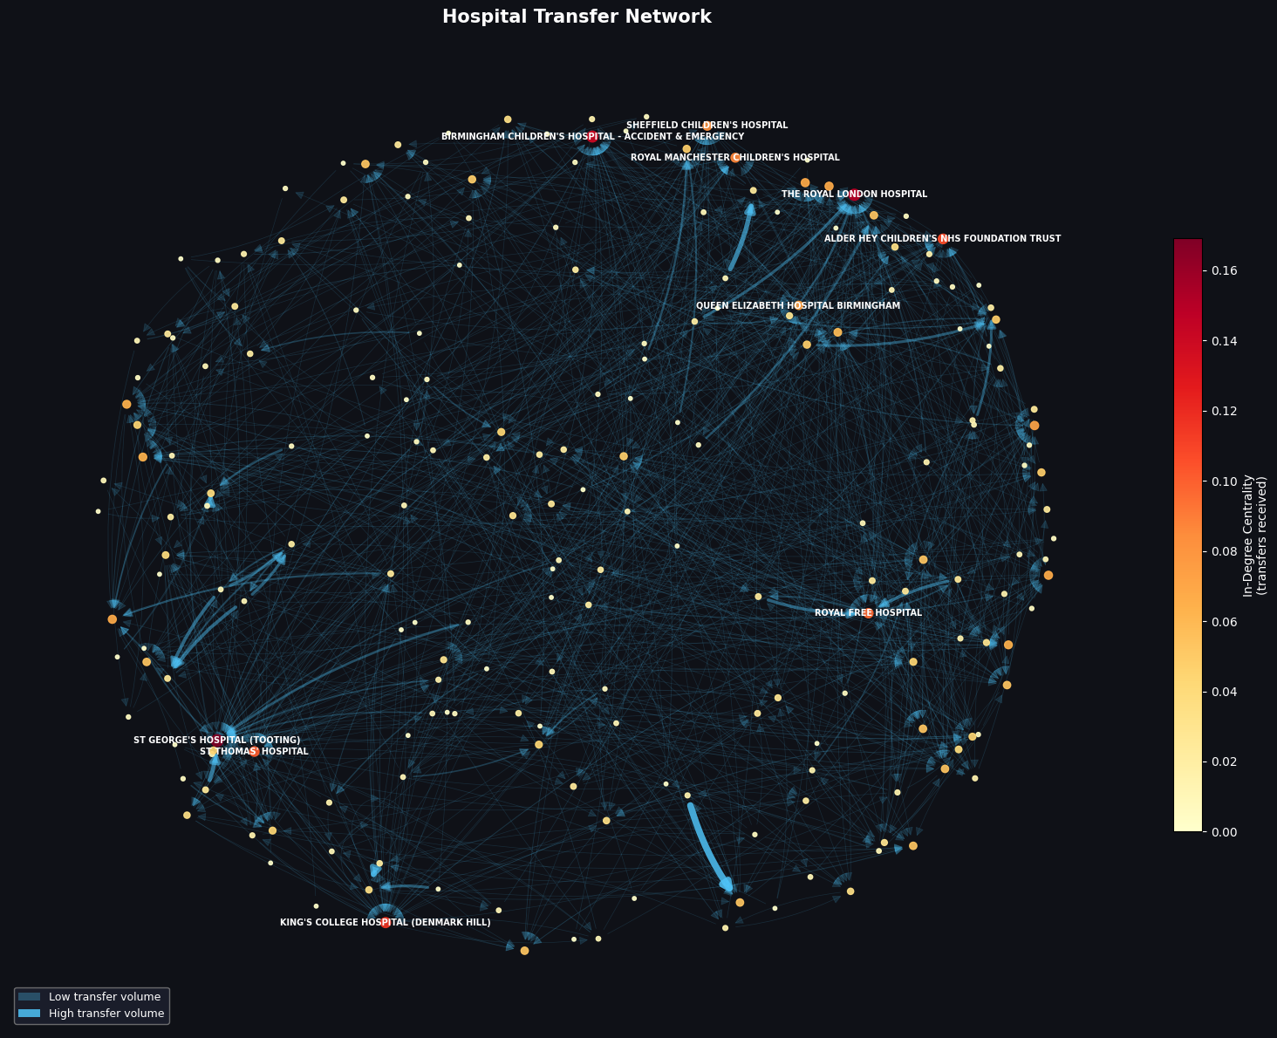

CENTRALITY: Top 10 hospitals by transfers received (critical nodes):
Hospital | Transferring hospitals | Centrality
St Georges Hospital | 35 | 0.169
The Royal London | 31 | 0.150
Birmingham Children’s Hospital | 29 | 0.140
King’s College Hospital | 24 | 0.116
Alder Hey Children’s Hospital | 22 | 0.106
St Thomas’ Hospital | 21 | 0.101
Royal Free Hospital | 20 | 0.097
Royal Manchester Children’s Hospital | 18 | 0.087
Sheffield Children’s Hospital | 17 | 0.082
Queen Elizabeth Hospital Birmingham | 15 | 0.073

NEXT STEPS
- APC (Admission dataset) and OP (outpatient dataset cleaning)
- Data sharing communities with Louvain modularity
- Geographical network map with distance calculations

