A
Project Report
On

“Government Office Asset Management System”

Submitted in partial fulfilment of the requirements for the degree of

Master of Computer Application

IV Semester

From
Pt. Ravishankar Shukla University, Raipur (C.G)

Year: 2025-26


Submitted By:
Akshat Dubey
Roll. No: 2510174004
Enrol. No: AJ/00382

Under The Guidance of

Internal Guide Project Guide
Dr. V. K. Patle Mr. Devendra Kumar
(Head & Professor) (DIO)
S.o.S. in Computer Science & IT, NIC Mahasamund
Pt. R.S.U, Raipur (C.G)

Submitted to
SCHOOL OF STUDIES IN COMPUTER SCIENCE & IT,

Pt. Ravishankar Shukla University Raipur (C.G.)


SCHOOL OF STUDIES IN COMPUTER SCIENCE & IT
Pt. Ravishankar Shukla University, Raipur [CG]
Website : www.prsu.ac.in
Phone : 91-771-2262658
Fax : 91-7712262583
Email : comp_science@prsu.org.in

Dr. V. K. Patle Professor & Head

Ref. No.: Date:

CERTIFICATE OF APPROVAL

This is to certify that the project work entitled “Government Office Asset Management System” is carried out by Akshat Dubey, student of MCA IV Semester at School of Studies in Computer Science and I.T. Pt. RSU, Raipur is hereby approved as a credible work in the discipline of Computer Science and Information Technology for the Master of Computer Application during the session 2025-2026 from Pt. Ravishankar Shukla University, Raipur (CG).

Dr. V. K. Patle (Professor and Head)


SCHOOL OF STUDIES IN COMPUTER SCIENCE & IT Pt. Ravishankar Shukla University, Raipur [CG]

Dr. V.K. Patle Website: www.prsu.ac.in
(Professor & Head) Phone: 91-771-2262658
Email: patlevinod@gmail.com

Ref. No. Date:

CERTIFICATE

This is to certify that the project work entitled “Government Office Asset Management System” submitted to the School of Studies in Computer Science and I.T., Pt. RSU, Raipur by Akshat Dubey Roll No. “2510174004” is in partial fulfilment for the requirements relating to nature and standard of the award of Master of Computer Application degree during the year 2025 from Pt. Ravishankar Shukla University, Raipur (CG).
This project work has been carried out under my guidance.

Dr. V.K. Patle
(Professor & Head)

CERTIFICATE OF EVALUATION

This is to certify that the project work entitled “Government Office Asset Management System” is carried out by Akshat Dubey, student of MCA-IV semester at School of Studies in Computer Science and I.T., Pt. RSU, Raipur after proper evaluation and examination, is hereby approved as a credible work in the discipline of Computer Applications and is done in a satisfactory manner for its acceptance as a requisite for the award of degree of Master of Computer Application during the session 2025-2026 from Pt. Ravishankar Shukla University, Raipur (CG).

[Internal Examiner] [External Examiner]

DECLARATION

This is to certify that the project report entitled “Government Office Asset Management System”, which is submitted by me in the partial fulfilment for the award of the degree of Master of Computer Application at School of Studies in Computer Science and I.T., Pt. RSU, Raipur, comprises the original work carried out by me.

I further declare that the work reported in this project has not been submitted and will not be submitted, either in part or in full for the award of any other degree or diploma in this Institute or any other Institute or University.

Date: Akshat Dubey
MCA-IV Semester
Roll No: 2510174004
Enroll No: AJ/00382

ACKNOWLEDGEMENT

The success and outcome of this project has been made possible by the guidance and support of many people. I would like to thank all peoples who gave me a golden opportunity to work on this project.
I express my gratitude to Mr. Devendra Kumar, DIO NIC Mahasamund, Chhattisgarh, India for their guidance and encouragement throughout the duration of my project development. With a deep sense of gratitude, I express my humble thanks to all the members of NIC Mahasamund. given me help & guidance to make this project.
I extend my sincere thanks and gratitude to our Head of the Department
Dr. V. K. Patle (Professor & Head, Pt. Rsu Raipur), for their valuable guidance and suggestions helped me in various phases of the completion of this project. I sincerely convey my gratitude for his support in accomplishment of the project. Without his active cooperation and guidance, it would have become very difficult to complete task in time.
While submission of the project, I also like to thank all the Professors for their continuous help and guidance throughout the course of MCA. It would have be a tough work without their help, support and guidance of these members of S.O.S in Computer Science and IT department, Pt. Ravishankar Shukla University Raipur (CG).
At the end, I also express my thanks to my friends, colleagues and all those persons who have helped me directly or indirectly in the successfully completion of the project work.
Akshat Dubey
MCA-IV Semester
Roll no.2310174001

ABSTRACT

The purpose of the Government Asset Management System (AMS) is to provide a secure, centralized, and scalable web-based platform for efficiently managing government assets across departments and organizational units. The system is designed to reduce manual effort, improve transparency, and streamline day-to-day asset-related operations by automating key processes such as asset registration, allocation, transfer, maintenance, disposal, and request handling.

This platform enables authorized users to manage assets and related workflows with greater accuracy and convenience. It supports the complete lifecycle of an asset, including record creation, department-wise assignment, tracking of current status, handling of maintenance requests, and processing of disposal actions when assets become unusable or obsolete. The system also includes approval-based workflows, allowing supervisors or responsible authorities to review and approve requests before actions are finalized. In addition, reporting features help users monitor asset usage, availability, and movement across the system.

The application is built with strong security mechanisms, including authentication and role-based access control, ensuring that only permitted users can perform specific operations. Different user roles such as administrators, managers, and government employees can access the system according to their responsibilities and permissions. The interface is designed to be responsive and user-friendly, allowing smooth interaction across devices while maintaining efficient navigation and data entry.

All data and operations are handled through backend validation and structured database management to ensure reliability, consistency, and accuracy. The system follows a modular and layered architecture, making it easier to maintain, extend, and scale in the future. Overall, the Government Asset Management System aims to modernize asset administration by improving control, accountability, and operational efficiency within government institutions.

INDEX

CONTENTS PAGE NO.
CHAPTER 1: INTRODUCTION 01 – 04
1.1) About the Organization 01
1.2) About the Project 02

CHAPTER 2: SYSTEM ANALYSIS 05 – 08
2.1) Introduction 05
2.2) Existing System 05
2.3) Drawback of Existing system 05
2.4) Proposed system 06
2.5) Advantages of Proposed system 07

CHAPTER 3: SYSTEM PLANNING 09 – 10
3.1) Introduction 09
3.2) PERT Chart 09
3.3) Cost & Benefit Analysis 10

CHAPTER 4: FEASIBILITY STUDY 11 – 12
4.1) Technical feasibility 11
4.3) Economical feasibility 11
4.4) Operational feasibility 11

CHAPTER 5: SYSTEM REQUIREMENT SPECIFICATION (SRS) 13 – 16
5.1) Requirement Analysis 13
5.2) Module description 13
5.3) Hardware & Software requirement 14
5.4) Technology description 14 - 15
CHAPTER 6: SYSTEM DESIGN 17– 22
6.1) Introduction 17
6.2) Agile model 17
6.3) Database design 17 - 20
6.4) E-R Model 21
6.5) Data Flow Diagram (DFD) 22

CHAPTER 7: SYSTEM IMPLEMENTATION 23 - 25
CHAPTER 8: SYSTEM TESTING 26 - 27
CHAPTER 9: SCREENSHOTS 28 - 34
CHAPTER 10: SYSTEM SECURITY 35 - 36
CHAPTER 11: LIMITATION & FUTURE ENHANCEMENT 37 - 38
CHAPTER 12: CONCLUSION 39
CHAPTER 13: REFERENCES 40

About the Organization

National Informatics Centre (NIC)
The National Informatics Centre (NIC) is a premier government organization functioning under the Ministry of Electronics and Information Technology (MeitY), Government of India. Established in 1976, NIC plays a vital role in supporting e-Governance initiatives by providing technological solutions to central, state, and district-level government departments.
NIC has been a key contributor to the Digital India mission by developing secure and scalable digital platforms that improve transparency, efficiency, and accessibility of public services. It provides infrastructure, software development, cloud services, and technical support for various government projects across the country.

NIC Mahasamund (Chhattisgarh)
The NIC District Centre at Mahasamund operates under the Chhattisgarh State Unit and provides IT support to the district administration and various government offices.
NIC Mahasamund is responsible for:
- Development and maintenance of government web applications
- Implementation of e-Governance services at district level
- Database management and digital record keeping
- Technical support for government departments
- Deployment and monitoring of digital platforms for public services

Role of NIC in E-Governance
NIC plays a major role in transforming traditional administrative processes into digital systems. Its contributions include:
- Development of government portals and dashboards
- Digitization of administrative workflows
- Secure data storage and management
- Providing cloud infrastructure and networking solutions
- Enabling real-time monitoring and reporting systems
These initiatives help improve transparency, reduce manual work, and enhance service delivery across government departments.

Internship Details
I completed my internship at NIC Mahasamund, where I worked on real-world government-based system development under professional guidance.
During the internship, I gained practical exposure to:
- Web application development using modern technologies
- Understanding real-world e-Governance workflows
- Backend system design and database management
- API development and integration
- Debugging, testing, and deployment of applications

Learning Experience
The internship provided valuable hands-on experience in a professional environment. It helped in:
- Understanding real project architecture
- Working with structured backend systems
- Handling real-time data and workflows
- Improving problem-solving and debugging skills
- Learning teamwork and professional development practices
This experience directly contributed to the development of the Government Asset Management System (AMS) project.

1.2 About the Project

Project Title:
Government Office Asset Management System (AMS)

Project Description
The Government Asset Management System (AMS) is a web-based application developed to manage and track government assets efficiently across departments and offices.
In many government organizations, asset management is still handled manually or through basic spreadsheets, which leads to inefficiencies, data inconsistencies, and lack of transparency. The AMS system aims to solve these issues by providing a centralized digital platform for managing the complete lifecycle of assets.
The system allows administrators, store managers, and officers to manage assets starting from procurement, inventory tracking, assignment, maintenance, and disposal. It ensures that all asset-related activities are recorded, monitored, and easily accessible in real time.
The application is built using modern technologies such as:
- React.js for frontend
- Node.js with Express.js for backend
- Firebase Firestore for database
- Firebase Authentication for secure login
The system follows a role-based architecture where each user has access to specific functionalities based on their role. It also maintains a detailed audit log of all actions performed in the system, ensuring accountability and traceability.

Objectives of the Government Asset Management System
The main objectives of the AMS project are:
- To digitize and centralize asset management processes
- To maintain accurate records of all assets across departments
- To automate asset assignment, maintenance, and disposal workflows
- To provide role-based access control for secure operations
- To ensure transparency through audit logs and tracking mechanisms
- To reduce manual errors and paperwork
- To provide real-time visibility of asset status and availability

Scope of the Project
The scope of the Government Asset Management System includes:
- Asset creation and categorization
- Inventory management for available assets
- Asset assignment to employees
- Maintenance tracking and worker management
- Disposal management of assets
- Vendor and purchase management
- Request handling system for officers
- Audit logs for all system activities
The system can be implemented in:
- Government departments
- Public sector organizations
- Large institutions with asset tracking requirements
It is scalable and can be extended in the future to include features like mobile applications, analytics dashboards, and AI-based asset prediction.

Features of the System

The AMS system provides several important features:

✔ Asset inventory management

✔ Role-based user system (Admin, Store Manager, Officer)

✔ Asset assignment and return tracking

✔ Maintenance management with worker tracking

✔ Disposal system with inventory adjustment

✔ Vendor and purchase management

✔ Request and approval system

✔ Real-time dashboard statistics

✔ Secure authentication using Firebase

✔ Complete audit logging system

Advantages of the System
- Reduces manual paperwork and errors
- Improves efficiency in asset tracking
- Provides real-time data visibility
- Ensures secure and role-based access
- Maintains complete audit history
- Enhances accountability in asset usage
- Supports better decision-making through centralized data

2.1 Introduction
System Analysis is an essential phase in the Software Development Life Cycle (SDLC) that involves studying the existing system, identifying its limitations, and understanding user requirements to design an improved system.
The main objective of system analysis is to examine how the current system operates, identify inefficiencies, and define the requirements for a more effective and automated solution.
In the context of the Government Asset Management System (AMS), system analysis focuses on:
- Understanding how asset management is currently handled in government offices
- Identifying challenges in manual or semi-digital asset tracking
- Analyzing workflows such as asset procurement, assignment, maintenance, and disposal
- Defining requirements for a centralized and secure digital system
This analysis forms the foundation for developing a system that improves efficiency, transparency, and accountability in asset management.

2.2 Existing System

The existing system for managing government assets is largely manual or semi-digital, relying on registers, spreadsheets, and disconnected tools.

Key Characteristics of the Existing System:
- Manual Record Keeping:
Asset details are maintained in physical registers or basic Excel sheets
- No Centralized Inventory:
Asset data is scattered across departments, making tracking difficult
- Manual Asset Assignment:
Allocation of assets to employees is done manually without proper tracking
- Lack of Maintenance Tracking:
Maintenance activities are not systematically recorded or monitored
- No Disposal Tracking System:
Disposed assets are often not updated properly in inventory records
- Limited Reporting:
Generating reports for audits or decision-making is time-consuming
- Poor Communication Flow:
Requests and approvals are handled through informal channels like calls or emails

2.3 Drawbacks of Existing System
The current system has several limitations that affect efficiency and accuracy:
- Time-Consuming Processes:
Manual handling of asset records leads to delays in operations
- Data Inconsistency:
Maintaining records in multiple places leads to duplication and errors
- Lack of Transparency:
No real-time visibility of asset status (assigned, available, maintenance, disposed)
- No Proper Tracking:
Difficulty in tracking asset lifecycle from purchase to disposal
- Inventory Mismatch Issues:
Assets disposed or assigned are not properly reflected in inventory
- No Audit Trail:
Actions are not logged, making accountability difficult
- Security Risks:
Manual systems lack proper access control and data protection
- Inefficient Maintenance Handling:
No clear tracking of assets under maintenance

2.4 Proposed System
The proposed system, Government Asset Management System (AMS), is a centralized web-based application designed to automate and streamline all asset-related processes.
The system manages the complete lifecycle of assets, including:
- Asset creation
- Inventory management
- Asset assignment
- Maintenance tracking
- Disposal handling
- Request and approval system

Key Features of Proposed System:
- Centralized Database:
All asset data is stored in a single system using Firebase Firestore
- Role-Based Access Control (RBAC):
Different dashboards and permissions for:
  - Admin
  - Store Manager
  - Officer
- Inventory Management System:
Tracks available assets and updates in real-time
- Asset Assignment System:
Assigns assets to employees with proper tracking and history
- Maintenance Module:
Tracks assets under maintenance along with worker details
- Disposal System:
Ensures inventory is reduced correctly when assets are disposed
- Request Management System:
Officers can raise requests for return, maintenance, or disposal
- Audit Logging System:
Every action is recorded for accountability and traceability
- Dashboard & Statistics:
Real-time insights into assets, inventory, and system usage

2.5 Advantages of Proposed System
The proposed AMS system offers several advantages over the existing system:
- Automation of Processes:
Eliminates manual paperwork and reduces human effort
- Improved Accuracy:
Ensures correct inventory tracking and asset lifecycle management
- Real-Time Data Access:
Users can view updated asset status instantly
- Transparency:
Audit logs provide complete visibility of all operations
- Better Inventory Control:
Prevents mismatches caused by improper disposal or assignment
- Enhanced Security:
Role-based authentication ensures controlled access
- Efficient Maintenance Tracking:
Assets under maintenance are clearly monitored
- Faster Decision Making:
Real-time dashboards and reports improve management efficiency

2.6 System Users
The system consists of the following users:

1. Admin
- Manages departments, offices, and users
- Has full control over the system

2. Store Manager
- Manages assets, inventory, purchases, maintenance, and disposal
- Handles assignment and approval of requests

3. Officer (Employee)
- Uses assigned assets
- Raises requests for return, maintenance, or disposal
- Views personal asset details

2.7 Conclusion of System Analysis
The system analysis clearly shows that the existing manual asset management system is inefficient, error-prone, and lacks transparency.
The proposed Government Asset Management System (AMS) addresses these issues by providing a centralized, automated, and secure platform for managing assets.
By implementing this system, organizations can achieve:
- Improved efficiency
- Better asset tracking
- Reduced errors
- Enhanced transparency
- Stronger accountability
This makes the system highly suitable for modern government operations and future scalability.

3.1 Introduction
System Planning is the initial phase of the Software Development Life Cycle (SDLC) where the foundation of the project is defined. It involves setting objectives, identifying system requirements, allocating resources, and designing the overall roadmap for development.
For the Government Asset Management System (AMS), system planning plays a crucial role in ensuring that all asset-related operations such as inventory management, assignment, maintenance, and disposal are implemented in a structured and efficient manner.
The planning phase ensures that the system is:
- Scalable for future expansion
- Secure with proper authentication and access control
- Efficient in handling real-time data
- Capable of supporting multiple user roles

Major Steps in System Planning of AMS:
- Defining project objectives and goals
- Identifying system users (Admin, Store Manager, Officer)
- Planning system modules (Assets, Inventory, Assignment, Maintenance, Disposal, Requests)
- Designing role-based access control
- Selecting appropriate technology stack
- Designing database structure and API flow
- Planning authentication and security mechanisms
- Creating testing and deployment strategies
- Ensuring future scalability and improvements

3.2 PERT Chart
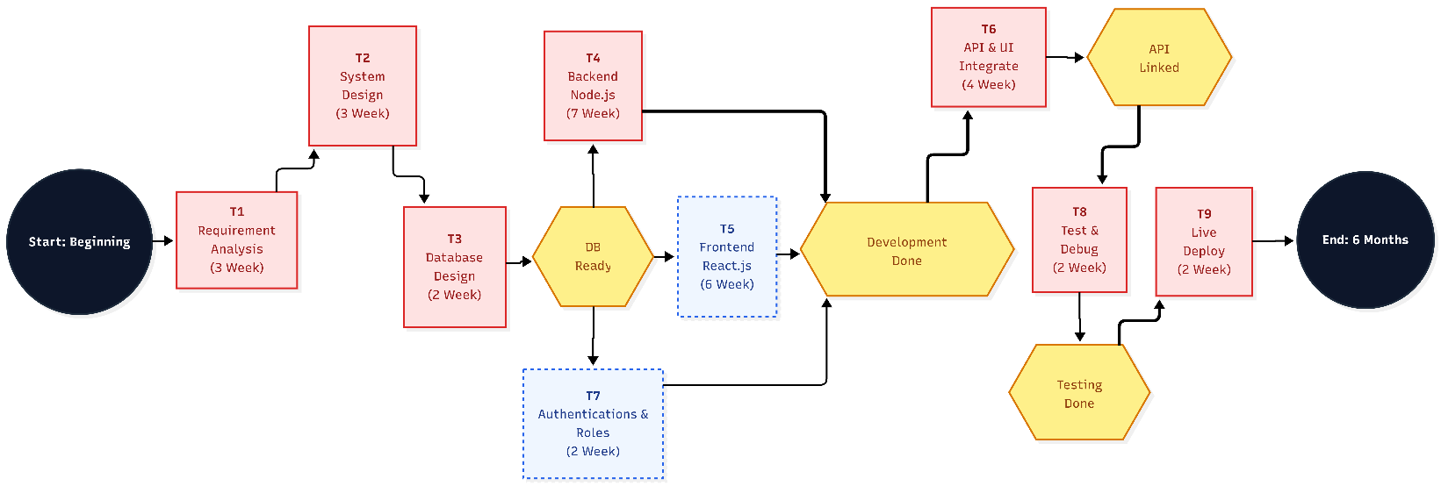
PERT (Program Evaluation and Review Technique) is a project management tool used to analyze and represent the tasks involved in completing a project along with their dependencies and time estimates.

3.3 Cost & Benefit Analysis
Cost-Benefit Analysis is used to evaluate the total cost involved in developing the system and the benefits gained after implementation.
For the Government Asset Management System, the goal is to achieve maximum efficiency with minimal cost.

Cost
- Hardware Cost:
The system was developed using an existing computer system. No additional hardware investment was required.
- Personnel Cost:
The project was developed by a single developer during internship. No additional staff was hired.
- Software Cost:
Open-source technologies such as React.js, Node.js, and Firebase were used, reducing software expenses.
- Facility Cost:
Basic electricity and internet usage during development were the only operational costs.

Benefit
- Reduced Manual Work:
Automation of asset management reduces paperwork and manual effort
- Improved Data Accuracy:
Centralized system minimizes duplication and errors
- Efficient Inventory Management:
Real-time tracking of assets improves control and monitoring
- Time Saving:
Faster processing of assignments, maintenance, and disposal
- Better Decision Making:
Dashboard statistics provide useful insights
- Enhanced Transparency:
Audit logs ensure accountability of every action
- Scalability:
System can be extended for larger departments or additional features

Conclusion of System Planning
System planning for the Government Asset Management System (AMS) establishes a clear roadmap for development and implementation.
The system ensures:
- Efficient use of resources
- Structured development process
- Reduced risks during implementation
- High system performance and scalability

4.1 Technical Feasibility
The Government Asset Management System (AMS) is technically feasible as it is developed using modern and widely used technologies.
- Frontend: React.js for responsive and dynamic UI
- Backend: Node.js with Express for handling APIs
- Database: Firebase for secure and scalable data storage
- Authentication: Firebase Authentication for secure login and role-based access
All required tools and technologies are easily available and were successfully used during development at NIC Mahasamund. The system does not require any special hardware or complex setup, making it easy to implement and maintain.

4.2 Operational Feasibility
The system is designed to be user-friendly and suitable for government staff.
- Provides role-based dashboards (Admin, Store Manager, Employee)
- Simplifies asset tracking, requests, and approvals
- Reduces manual paperwork and improves workflow
- Requires minimal training due to simple interface
The system improves transparency and efficiency, making it easy for users to adopt in real-world scenarios.

4.3 Economic Feasibility
The system is cost-effective and provides good returns compared to its cost.

Costs
- No additional hardware required
- Development done using existing resources
- Low hosting and maintenance cost

Benefits
- Reduces paperwork and manual effort
- Saves time in managing assets
- Improves data accuracy and reduces errors
- Requires fewer staff for operations
Overall, the benefits of the system are higher than the costs involved.

Legal Feasibility
The system is designed to comply with standard legal and government requirements:
- Data Privacy: All user data, including Treasury Codes and personal photos, is protected by encrypted authentication and strict database security rules.
- Audit Trails: Every approval, rejection, and forced-eviction is logged with a timestamp and officer ID, providing a digital audit trail for legal compliance.
- Software Licensing: All libraries used (React, Node, Express) are under permissive open-source licenses (MIT/Apache), ensuring no legal copyright issues.

4.5 Schedule Feasibility
The project was completed within the planned timeframe during the internship at NIC Mahasamund.
- Development was divided into phases (analysis, design, development, testing)
- Modern tools helped speed up the process
- No major delays occurred during implementation
The system can be developed and deployed within a reasonable time period.

5.1 Requirement Analysis
The requirement phase focuses on understanding the needs of the organization and defining what the system should do. It includes requirement analysis, specification, and validation.
For the Government Asset Management System (AMS), the goal is to replace manual asset tracking with a centralized digital system. The analysis was done by studying existing workflows and identifying issues like lack of transparency, manual errors, and inefficient tracking.
The system is designed to:
- Manage assets efficiently
- Track asset allocation and status
- Handle user roles (Admin, Store Manager, Employee)
- Provide real-time data and reports
This ensures improved efficiency, accuracy, and transparency in asset management.

5.2 Module Description
The AMS system consists of the following modules:

1. Authentication Module
- Handles secure login using Firebase Authentication
- Supports role-based access (Admin, Store Manager, Employee)

2. Asset Management Module
- Add, update, delete assets
- Track asset details like category, value, and status

3. Asset Allocation Module
- Assign assets to employees or departments
- Track issued and returned assets

4. Request Management Module
- Employees can request assets or maintenance
- Admin/Manager can approve or reject requests

5. Maintenance Module
- Track repair and maintenance activities
- Assign workers and monitor status

6. Dashboard Module
- Displays statistics like total assets, departments, and value
- Provides quick insights and reports

7. Profile Module
- Users can manage their profile details

5.3 Hardware & Software Requirements

5.3.1 Hardware Requirements
- Processor: Dual-core or higher
- RAM: Minimum 2 GB (4 GB recommended)
- Storage: 10 GB or more
- Internet: Stable connection
- Input Devices: Keyboard and Mouse
- Display: Monitor

5.3.2 Software Requirements
- Operating System: Windows 10/11 or above
- Frontend: React.js, HTML, CSS, JavaScript
- Backend: Node.js with Express
- Database: Firebase
- Tools: Visual Studio Code, Git
- Browser: Chrome / Firefox / Edge

5.4 Technology Description

Frontend (React.js)
React.js is used to build a dynamic and responsive user interface. It follows a component-based architecture, making the application modular and easy to maintain.
Key features:
- Reusable components
- Fast rendering using Virtual DOM
- Easy state management
- Responsive UI

Backend (Node.js & Express)
Node.js is used for backend development with Express framework for handling APIs.
Key features:
- Handles multiple requests efficiently
- Supports REST APIs
- Scalable and lightweight

Database (Firebase)
Used for storing asset data, user details, and transactions.
Key features:
- Secure data storage
- Scalable structure
- Real-time updates (Firebase)

Firebase Authentication
Used for secure login and user management.
Key features:
- Secure authentication
- Role-based access control
- Easy integration

Development Tool (VS Code)
Visual Studio Code is used for coding and development.
Key features:
- Lightweight and fast
- Supports extensions
- Integrated terminal

5.5 Functional Requirements
- User registration and login
- Role-based access control
- Asset creation, update, and deletion
- Asset allocation and tracking
- Request and approval system
- Maintenance tracking
- Dashboard with statistics

5.6 Non-Functional Requirements
- Security: Secure authentication and data protection
- Performance: Fast response and smooth UI
- Scalability: Can handle increasing data and users
- Reliability: System should work without failures
- Usability: Easy to use interface

5.7 Constraints
- Requires internet connection
- Dependent on browser compatibility
- Limited by hosting platform performance

5.8 Assumptions
- Users have basic knowledge of computers
- System will be used in a controlled environment
- Data entered will be accurate

6.1 Introduction
System design is the phase where the requirements gathered in the SRS are transformed into a structured solution. It focuses on how the system will be built and how different components will interact.
In the Government Asset Management System (AMS), the system is divided into modules like authentication, asset management, requests, and maintenance to ensure proper organization and scalability.

6.2 Agile Model
The Agile model is used for developing the system as it supports iterative and flexible development.
- Development is divided into smaller iterations
- Each iteration includes design, coding, and testing
- Continuous improvements are made based on feedback
- Helps in reducing risk and improving efficiency
This approach allowed different modules of the system to be developed and tested step-by-step.

6.3 Database Design
The database stores all important data such as users, assets, requests, and maintenance records.
AMS uses Firebase Firestore which is based on NoSQL, it includes –
- Collections: Representing entities like users, quarters, and bookings.
- Documents: Individual records within collections containing key-value pairs.
- Sub-collections: Used for nested data like notifications within a user's document to improve query performance.
The design ensures:
- Efficient storage and retrieval of data
- Reduced redundancy
- Data consistency

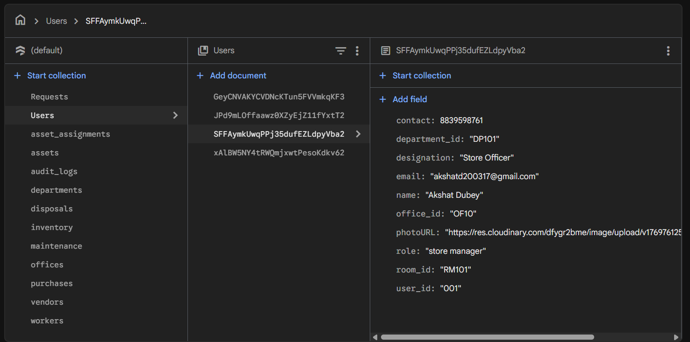
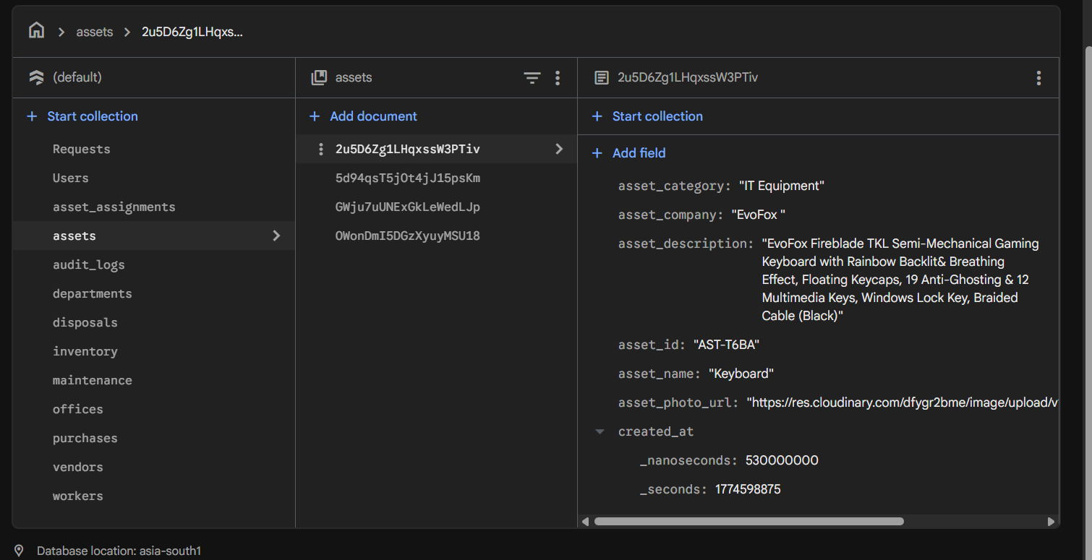
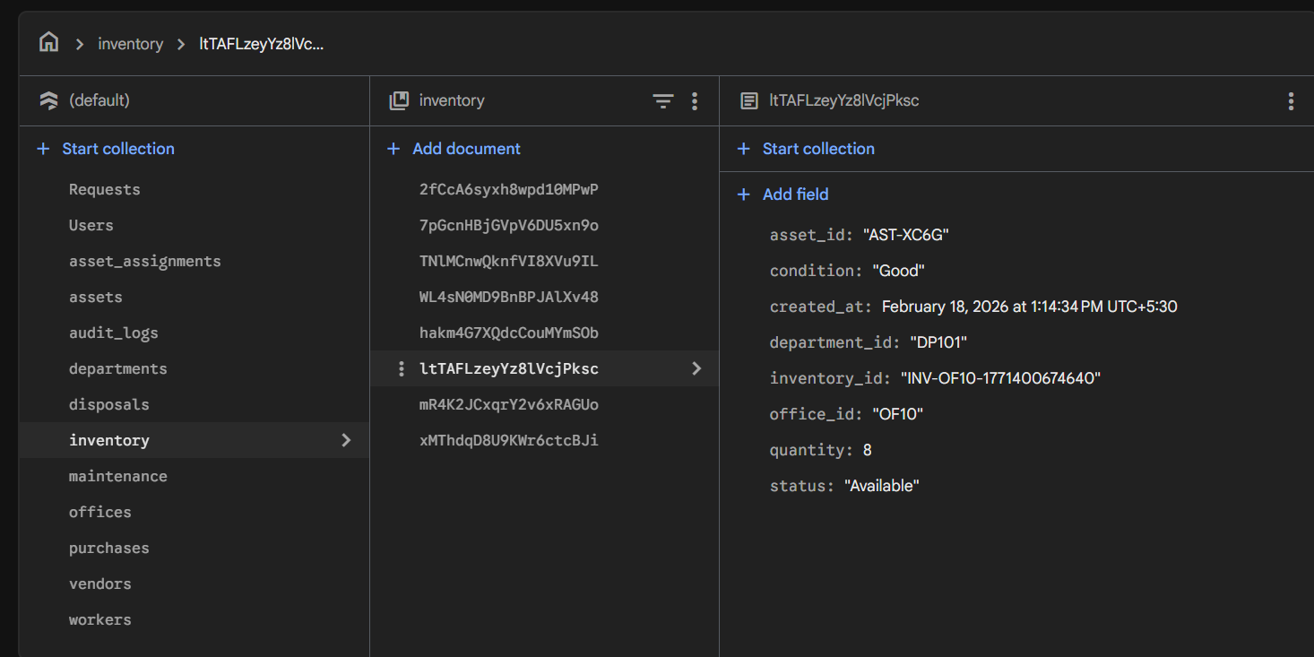
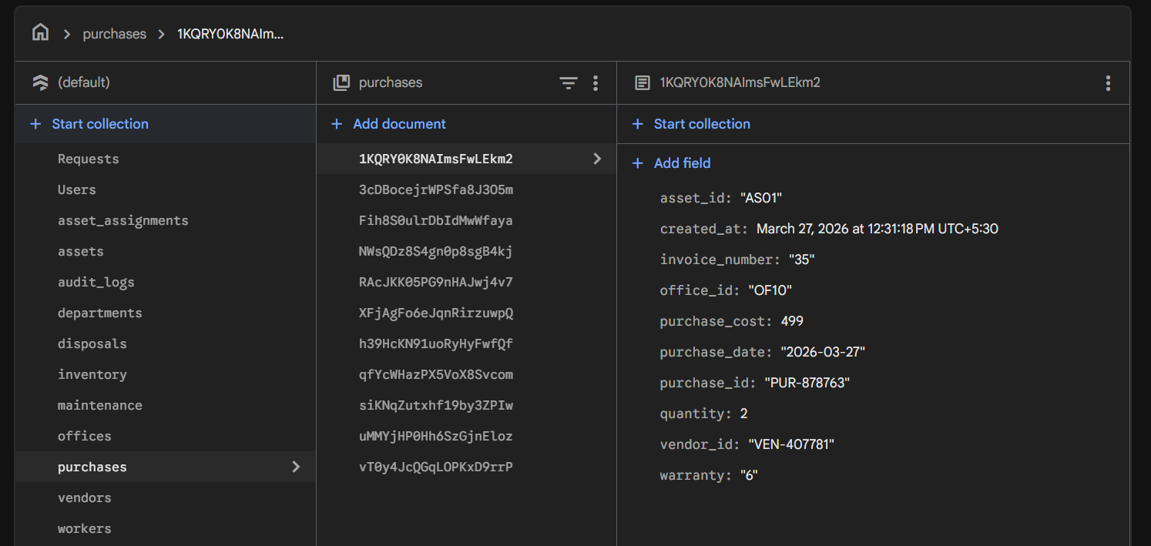
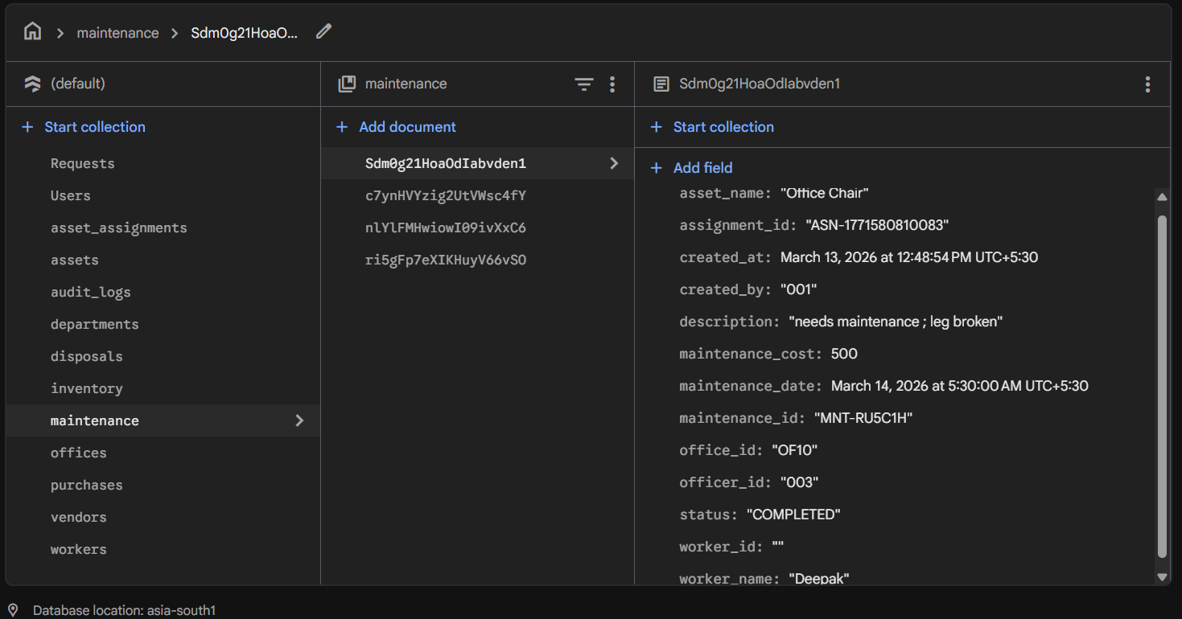
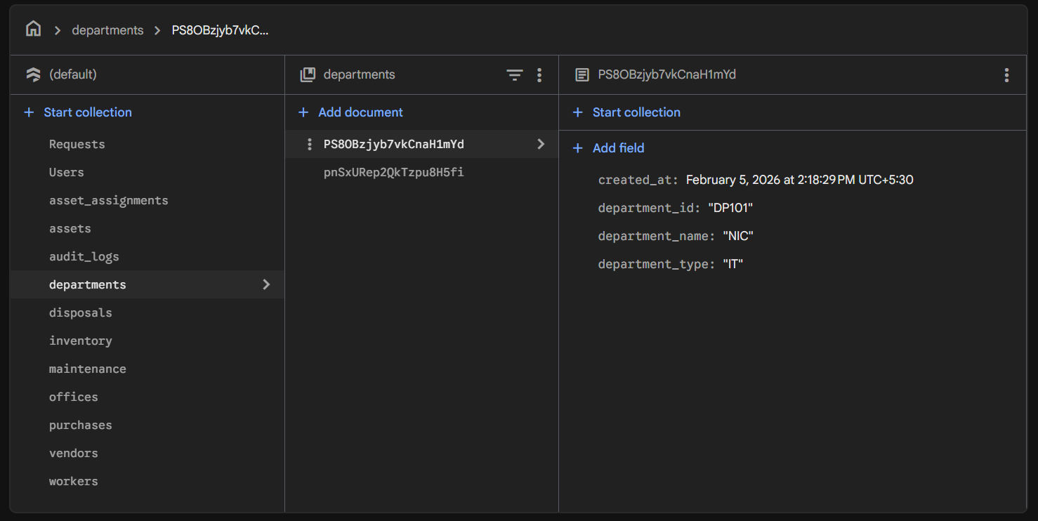
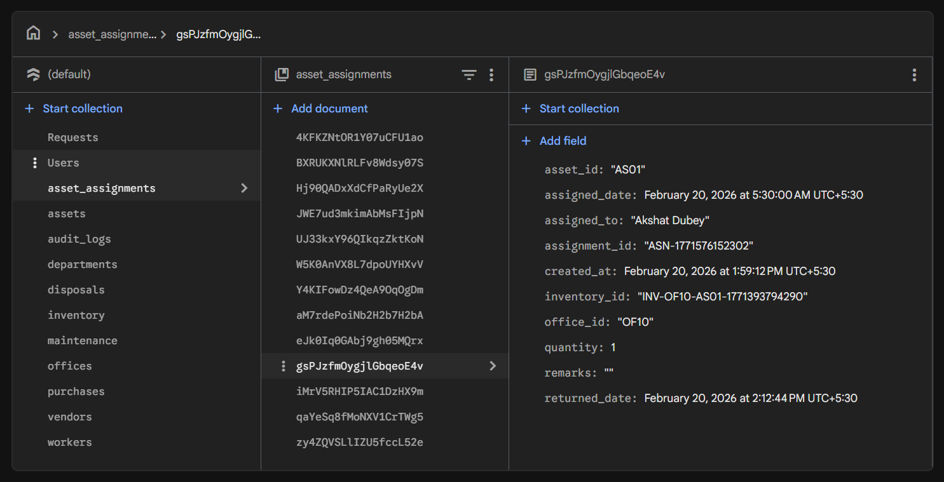
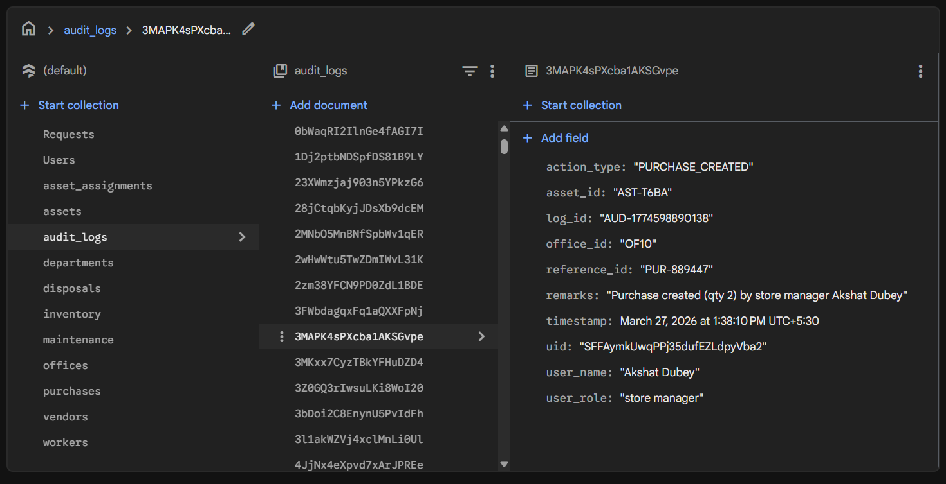
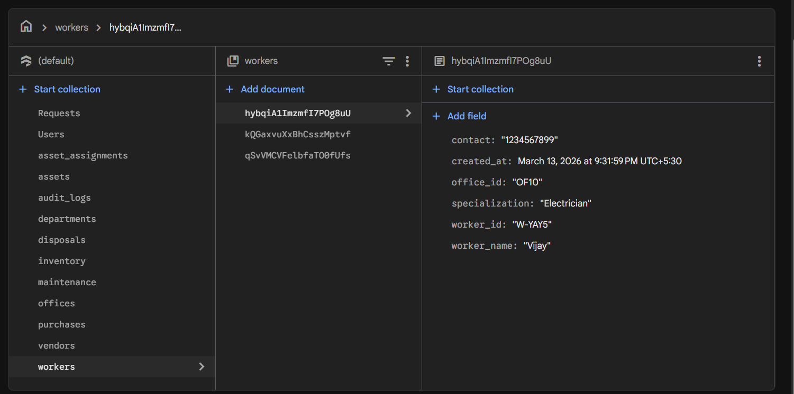

6.4 E-R Diagram
The E-R Diagram represents relationships between different entities in the system such as users, assets, and requests.
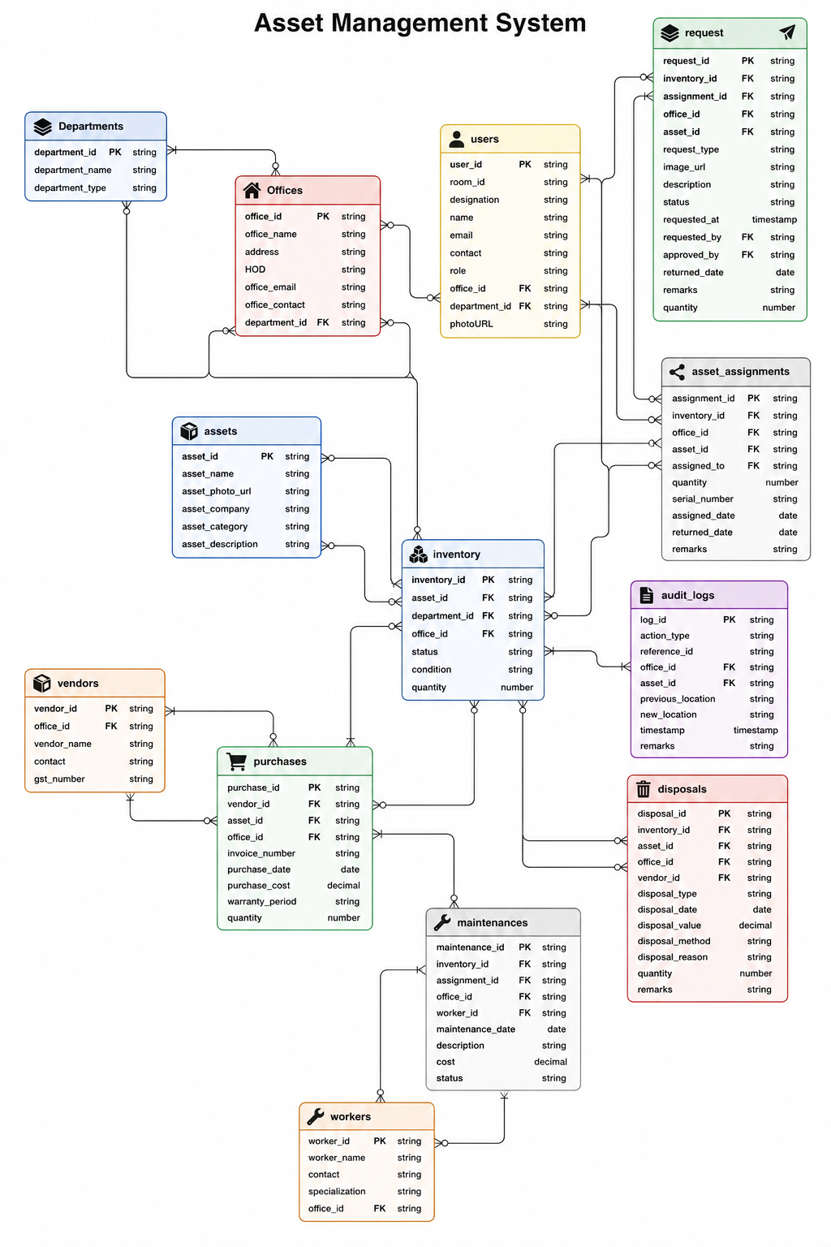

6.5 Data Flow Diagram (DFD)
A Data Flow Diagram shows how data moves through the system.

6.5.1 Context Level DFD (Level 0)
This diagram shows the overall system and its interaction with main entities:
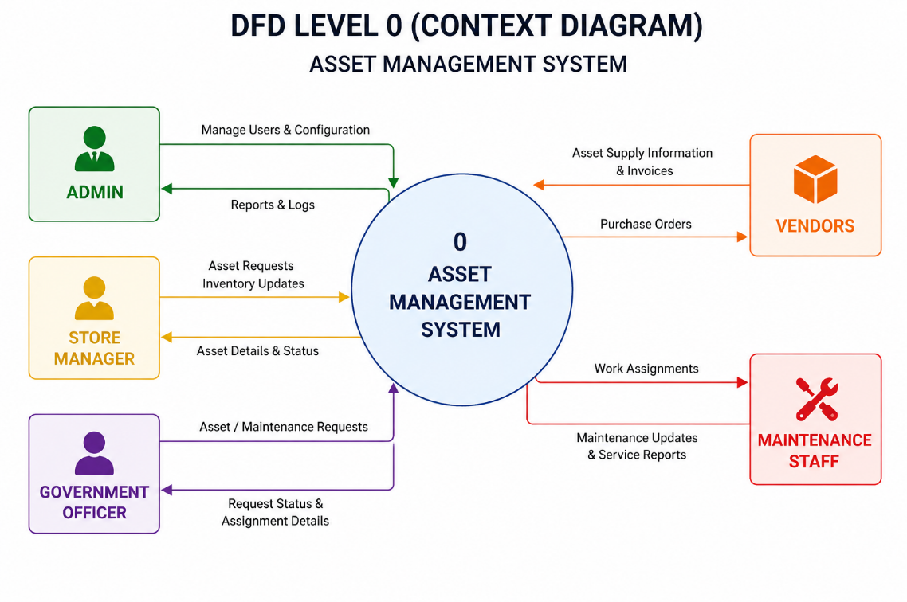

6.5.2 Level 1 DFD
This diagram breaks the system into major processes such as:
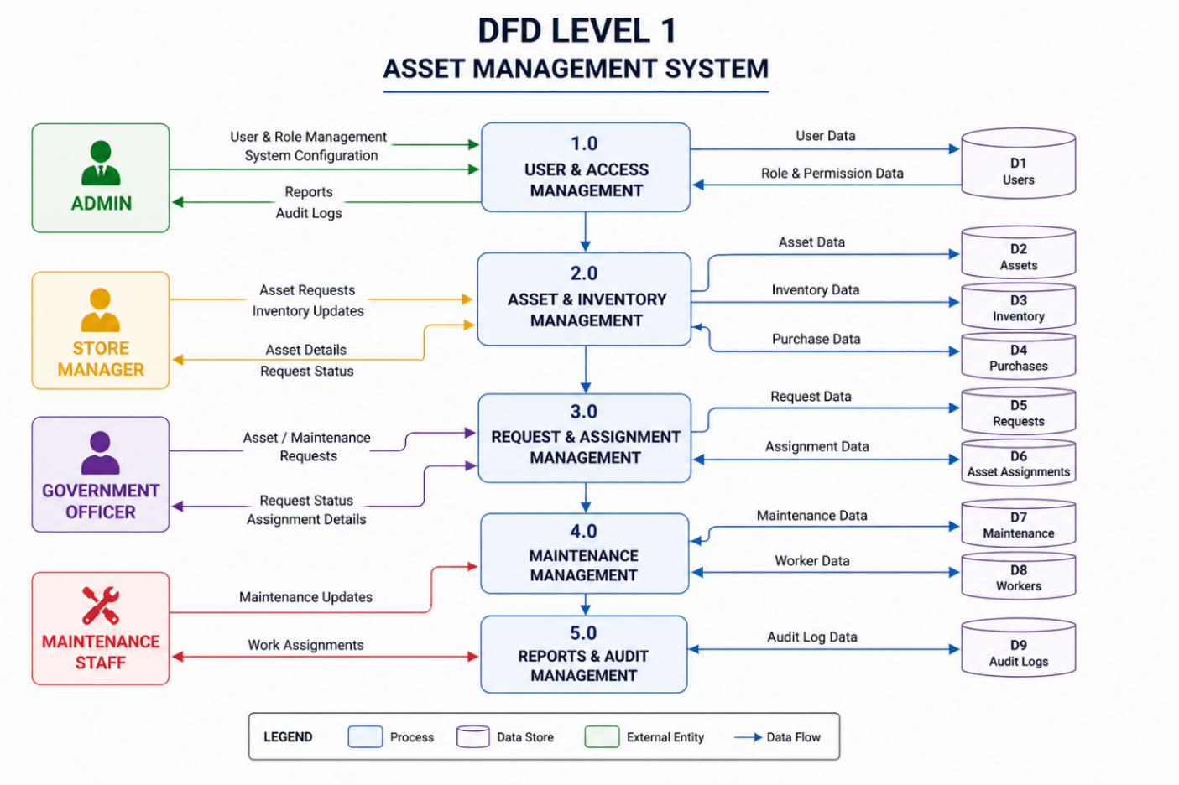

7.1 Introduction
System Implementation is the phase where the designed system is transformed into a fully functional application. In this phase, all modules of the Asset Management System are developed, integrated, tested, and deployed for real-world usage.
The implementation focuses on converting system design into executable code, ensuring that all functionalities such as asset tracking, inventory management, request handling, and maintenance operations work efficiently. This phase also ensures that the system is user-friendly, secure, and scalable.
The Asset Management System was implemented using a modern full-stack approach, enabling smooth interaction between frontend, backend, and database components.

7.2 Implementation Environment
The system was developed using the following environment:

Frontend
- React.js (Component-based UI development)
- CSS (Custom styling for responsive design)
- JavaScript (Dynamic functionality)

Backend
- Node.js with Express.js
- RESTful API architecture

Database
- Firebase Firestore

Other Tools & Services
- Firebase Authentication (User login & security)
- Visual Studio Code (Coding implementation)
- GitHub (Version control)
- Render (Backend deployment)
- Firebase Hosting (Frontend deployment)

7.3 Module-wise Implementation
The system is divided into multiple modules, each implemented independently and later integrated.

1. User & Role Management
- Secure login using Firebase Authentication
- Role-based access control (Admin, Store Manager, Government Officer)
- User data stored and managed through database

2. Asset & Inventory Management
- Admin/Store Manager can add and manage assets
- Inventory tracking based on department and office
- Real-time updates for asset availability and condition

3. Request Management
- Government officers can request assets or maintenance
- Store Manager reviews and approves/rejects requests
- Status tracking implemented for transparency

4. Asset Assignment
- Assets are assigned to users based on approval
- Assignment records maintained with issue and return dates
- Ensures accountability and tracking of asset usage

5. Maintenance Management
- Maintenance requests assigned to workers
- Workers update service status and cost
- Complete maintenance history maintained

6. Purchase & Vendor Management
- Assets procured from vendors
- Purchase records stored with invoice and warranty details
- Vendor information maintained for tracking

7. Disposal Management
- Damaged or outdated assets are removed from inventory
- Disposal records include method, value, and remarks

8. Audit & Reporting
- All system activities are logged
- Reports generated for assets, inventory, and transactions
- Helps in transparency and decision-making

7.4 System Integration
All modules were integrated through REST APIs, ensuring smooth communication between frontend and backend. The system follows a structured flow:
- User interacts with frontend
- Frontend sends request to backend API
- Backend processes request and interacts with database
- Response is returned and displayed to user
This integration ensures real-time updates and consistent data flow across the system.

7.5 Security Implementation
Security is an important aspect of the system. The following measures were implemented:
- Firebase Authentication for secure login
- Role-Based Access Control (RBAC)
- Protected API routes
- Input validation to prevent invalid data
- Secure environment variables for API keys

7.6 Deployment
The system was successfully deployed using cloud platforms:
- Frontend: Firebase Hosting
- Backend: Render
- Database: Cloud-based (Firebase)
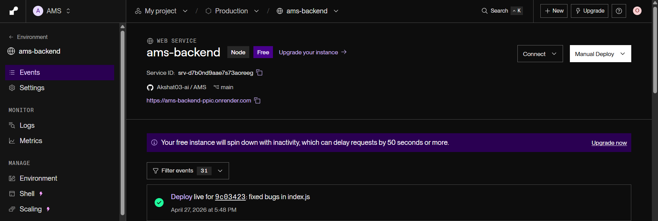
After deployment, the system was tested in a live environment to ensure stability and performance.

8.1 Introduction
System Testing is an essential phase in the Software Development Life Cycle (SDLC) where the developed system is verified and validated to ensure that it meets all specified requirements. The main objective of testing is to identify errors, ensure system reliability, and confirm that all modules function correctly.
In the Asset Management System, testing was carried out to ensure smooth functioning of modules such as asset management, request handling, inventory tracking, and maintenance operations. Both functional and non-functional aspects of the system were tested to guarantee accuracy, security, and performance.

8.2 Objectives of Testing
- To verify that all modules are working as expected
- To identify and fix bugs or errors
- To ensure proper data handling and validation
- To check system performance and responsiveness
- To validate role-based access control
- To ensure secure authentication and authorization

8.3 Types of Testing Performed

1. Unit Testing
Each module was tested individually to ensure correctness.
- Login functionality
- Asset creation and update
- Request submission
- Inventory updates

2. Integration Testing
After unit testing, modules were integrated and tested together.
- Request → Approval → Assignment flow
- Asset → Inventory → Maintenance linkage
- Backend API with frontend UI

3. System Testing
The complete system was tested as a whole.
- End-to-end workflow
- Role-based dashboards
- Data consistency across modules

4. User Acceptance Testing (UAT)
The system was tested from the user’s perspective.
- Admin managing users and assets
- Store Manager handling inventory and approvals
- Government Officer requesting assets

5. Performance Testing
- Checked response time of APIs
- Verified dashboard loading speed
- Ensured system works under normal usage

6. Security Testing
- Firebase authentication tested
- Role-based access restrictions verified
- Unauthorized access attempts blocked

8.4 Error Handling
During testing, various types of errors were identified and handled:
- Invalid input fields were restricted using validation
- API errors were handled with proper messages
- Null or missing data cases were managed
- Login failures handled securely

8.5 Result of Testing
All modules of the Asset Management System were tested successfully. The system performed as expected under normal conditions, and all identified bugs were resolved. The application is stable, secure, and ready for deployment.

8.6 Summary
System testing ensured that the application is reliable, efficient, and user-friendly. The testing process confirmed that all functionalities work correctly and meet the requirements of the system.

9.1 Home Page:
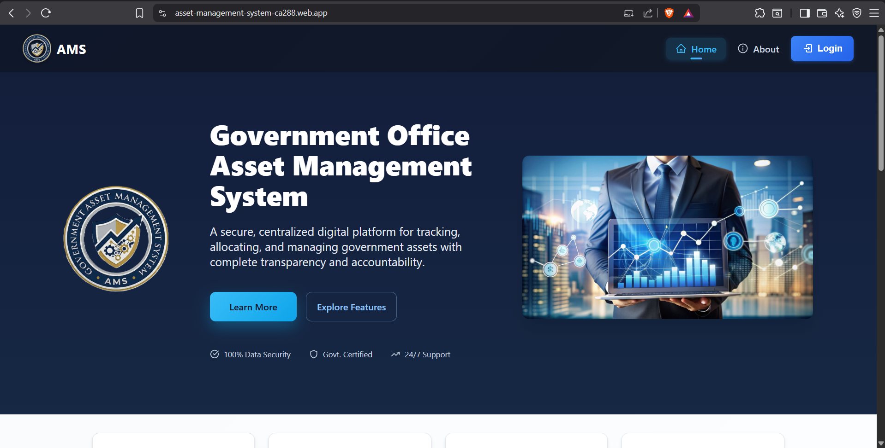
9.2 About Page:
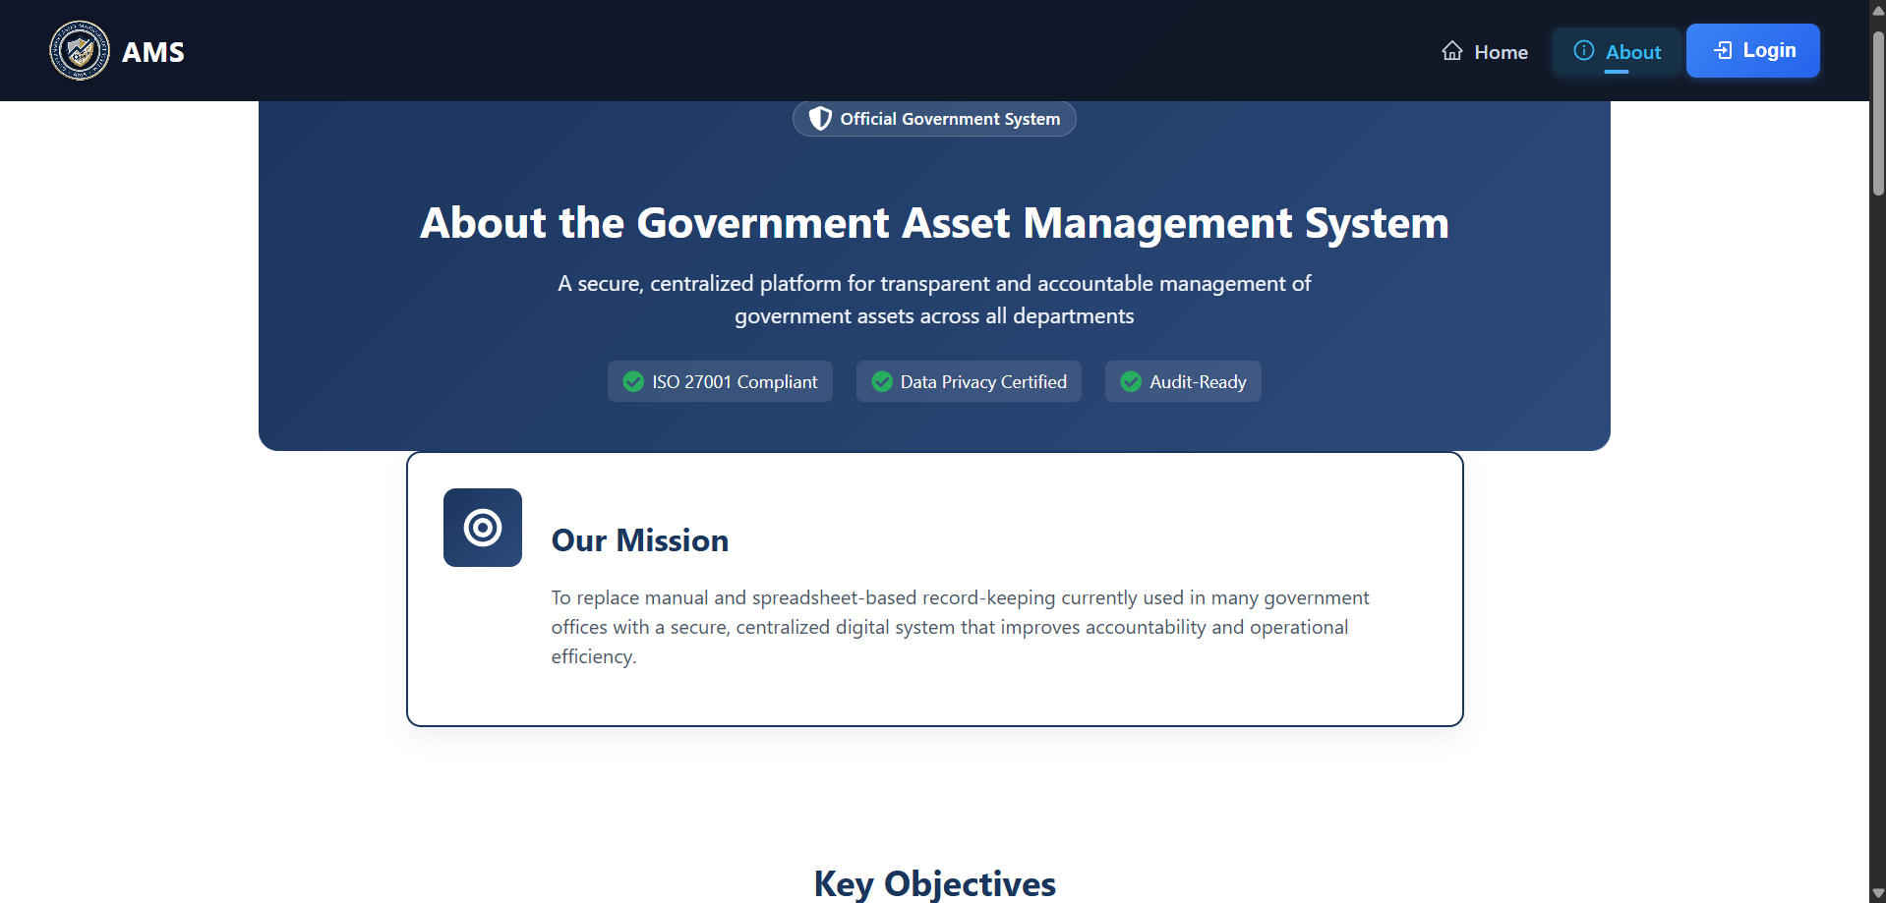
9.3 Login Page:
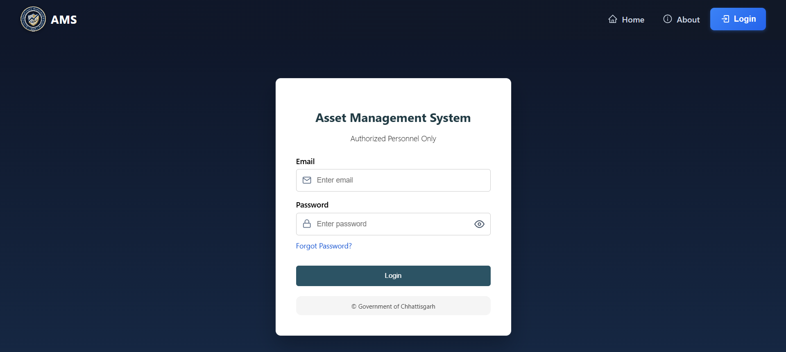
9.4 Admin Dashboard:
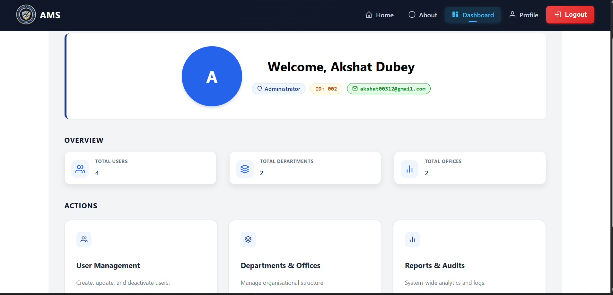
9.5 Admin – User Management:
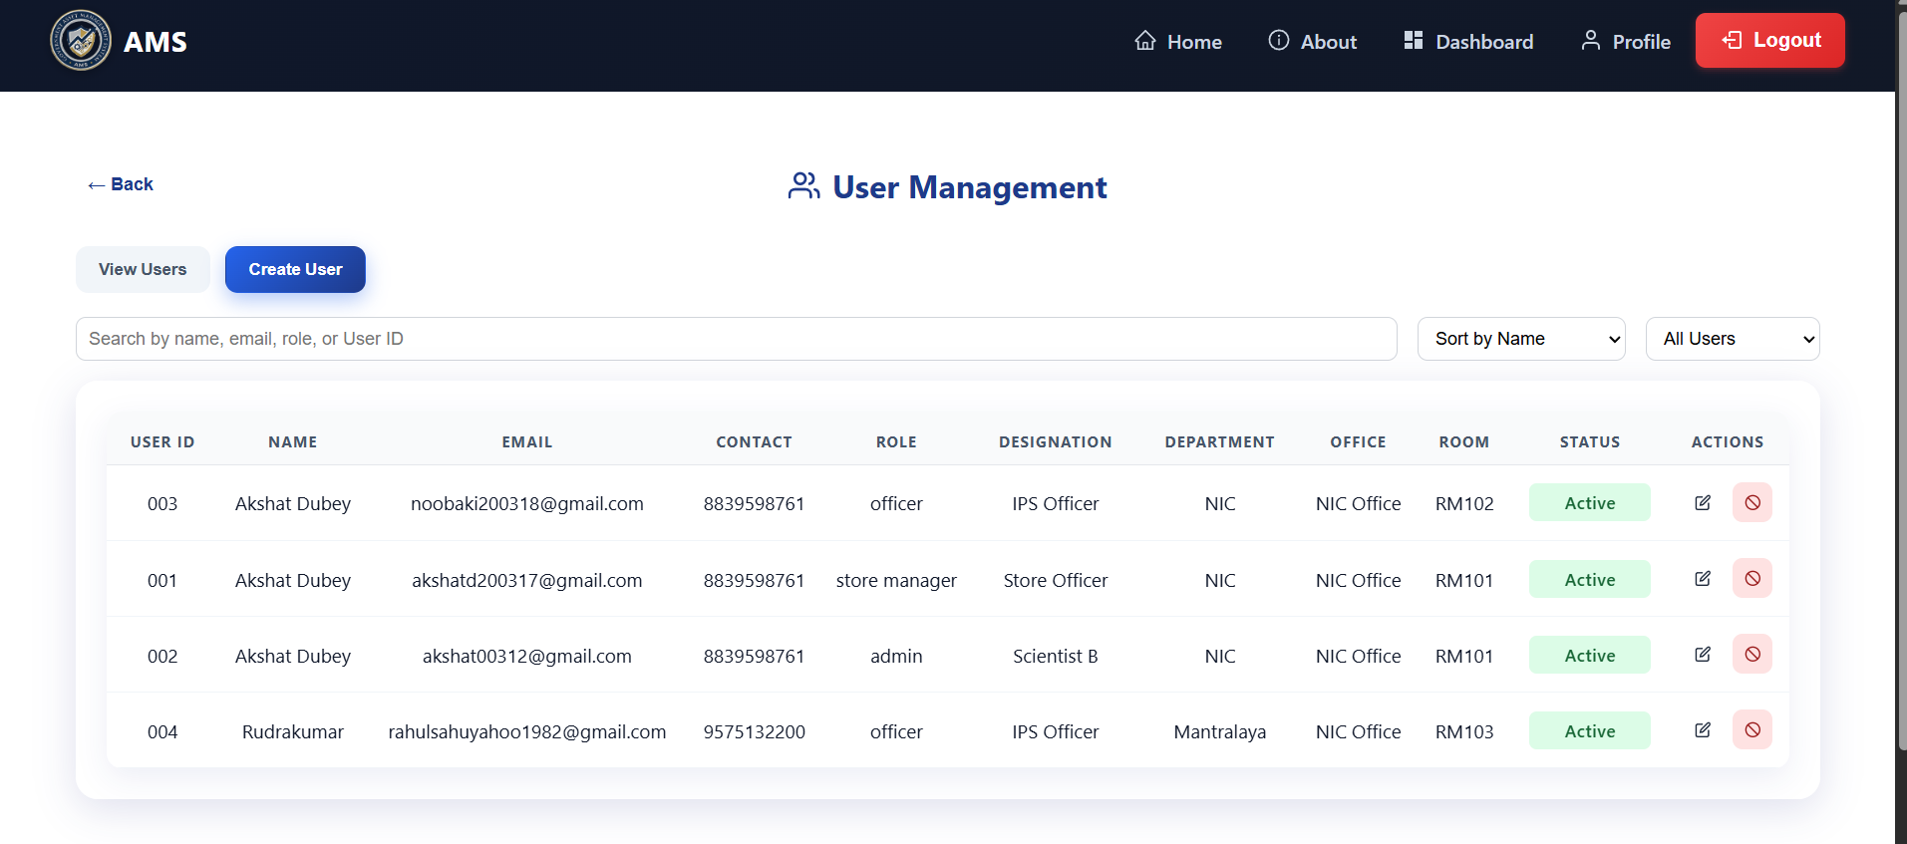
9.6 Admin – Department & Office:
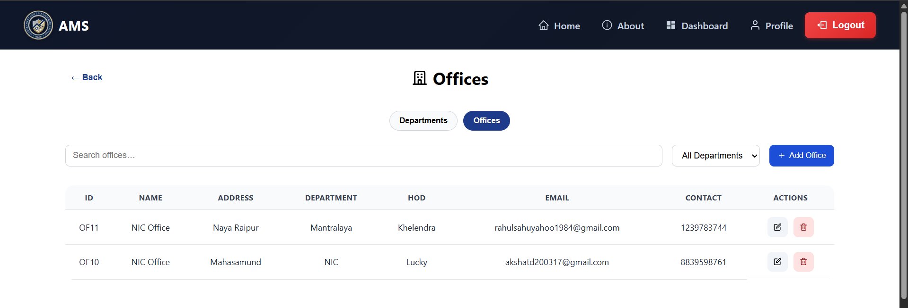

9.7 Admin – Audit Log:
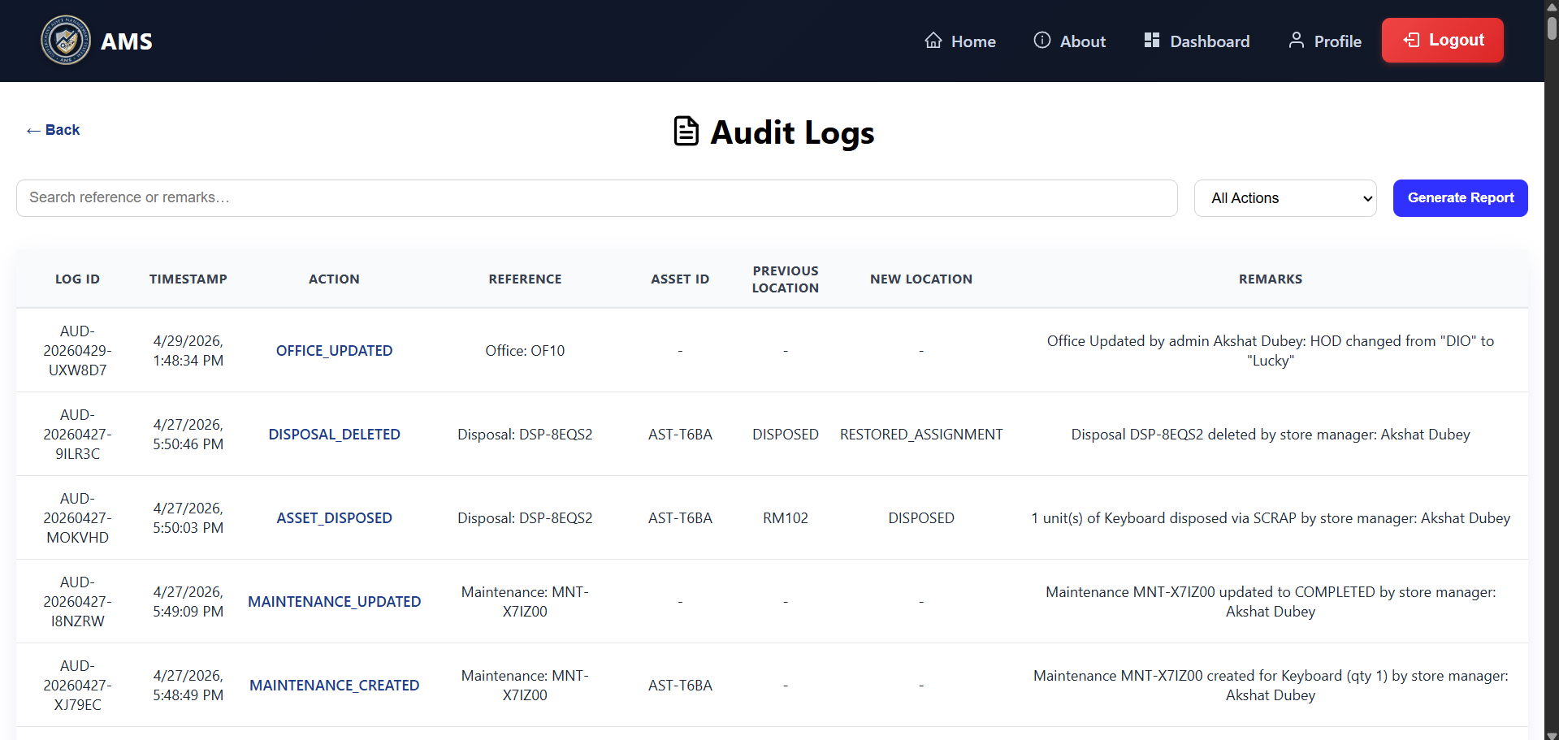
9.8 Store Manager Dashboard:
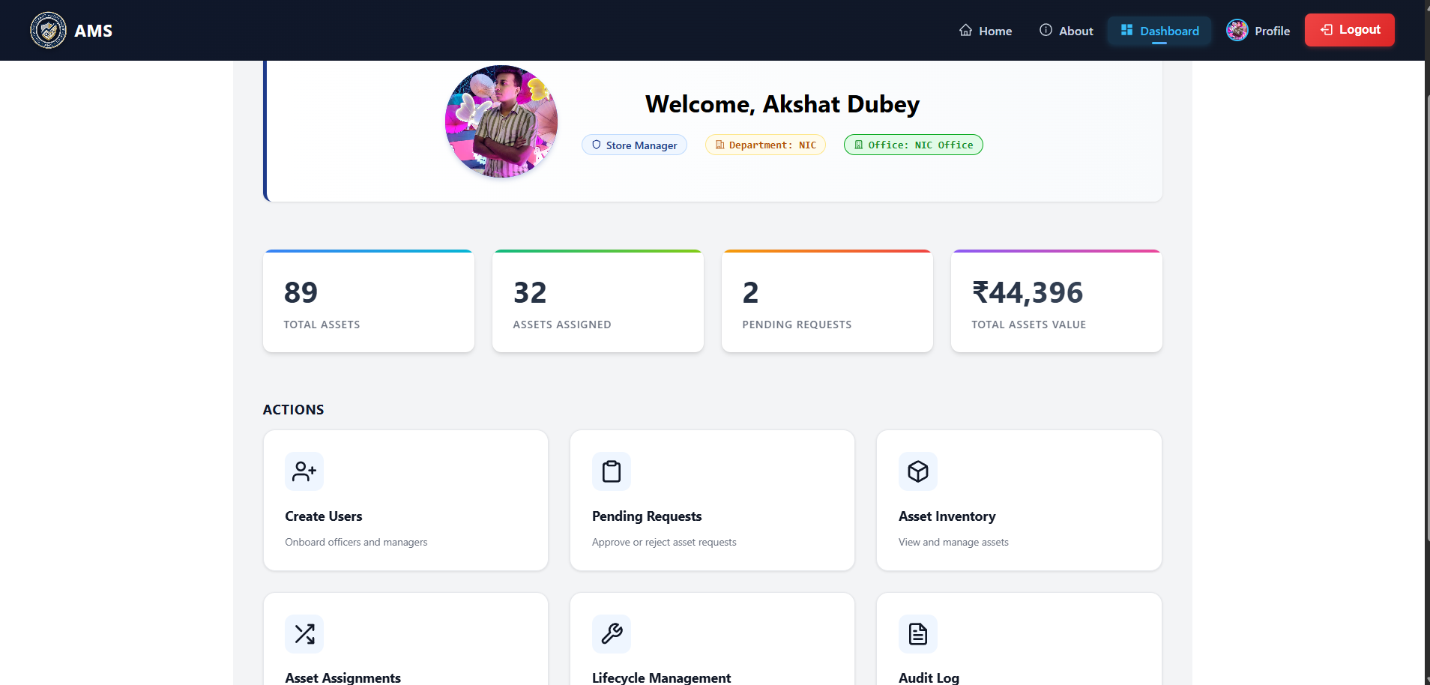
9.9 Store Manager – Create User:
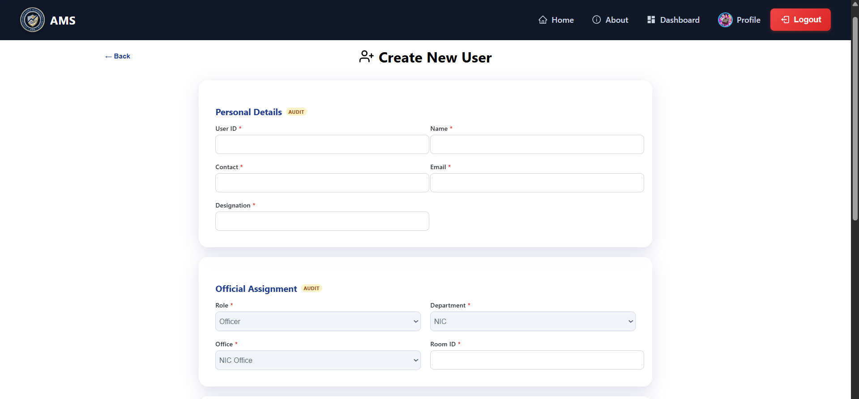
9.10 Store Manager – Asset Master
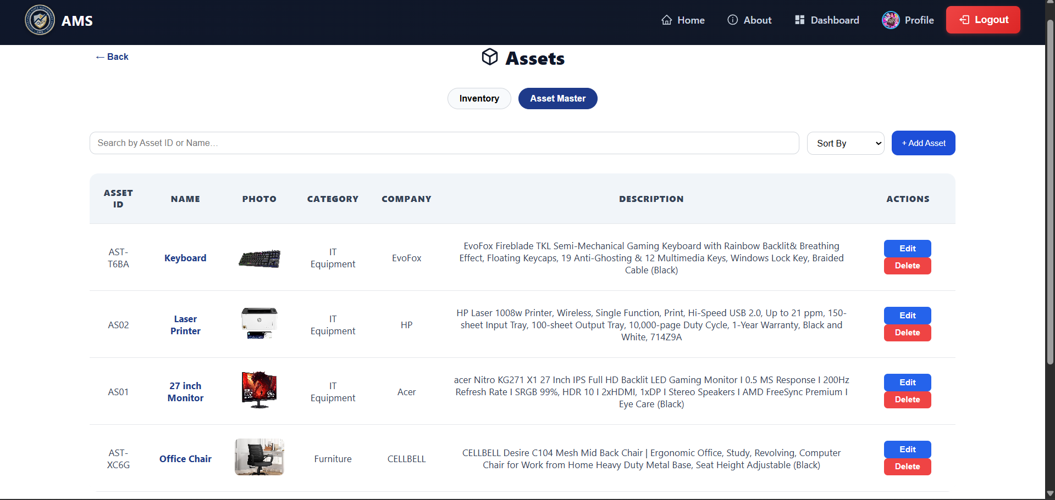
9.11 Store Manager – Inventory
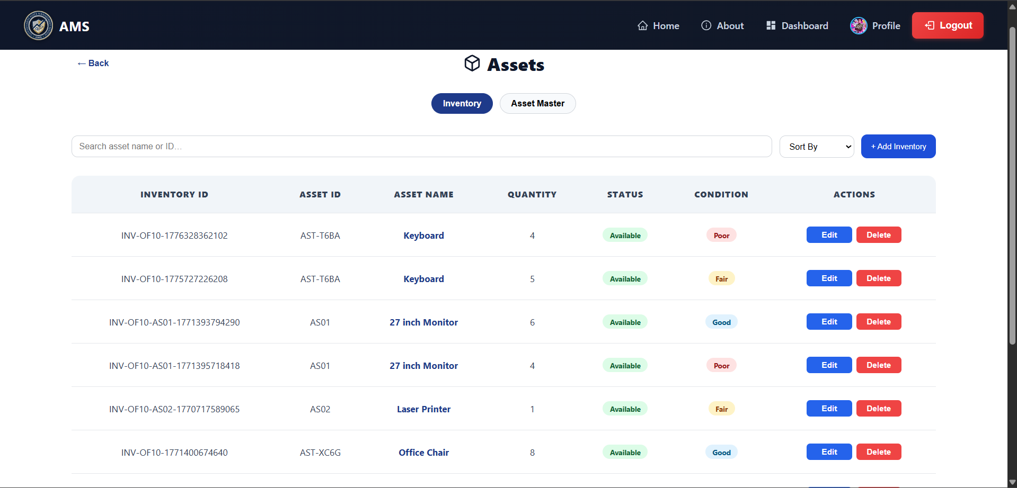
9.12 Store Manager – Asset Assignment
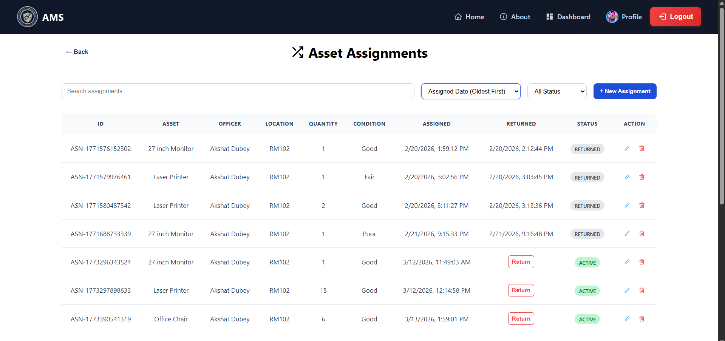
9.13 Store Manager – Purchases
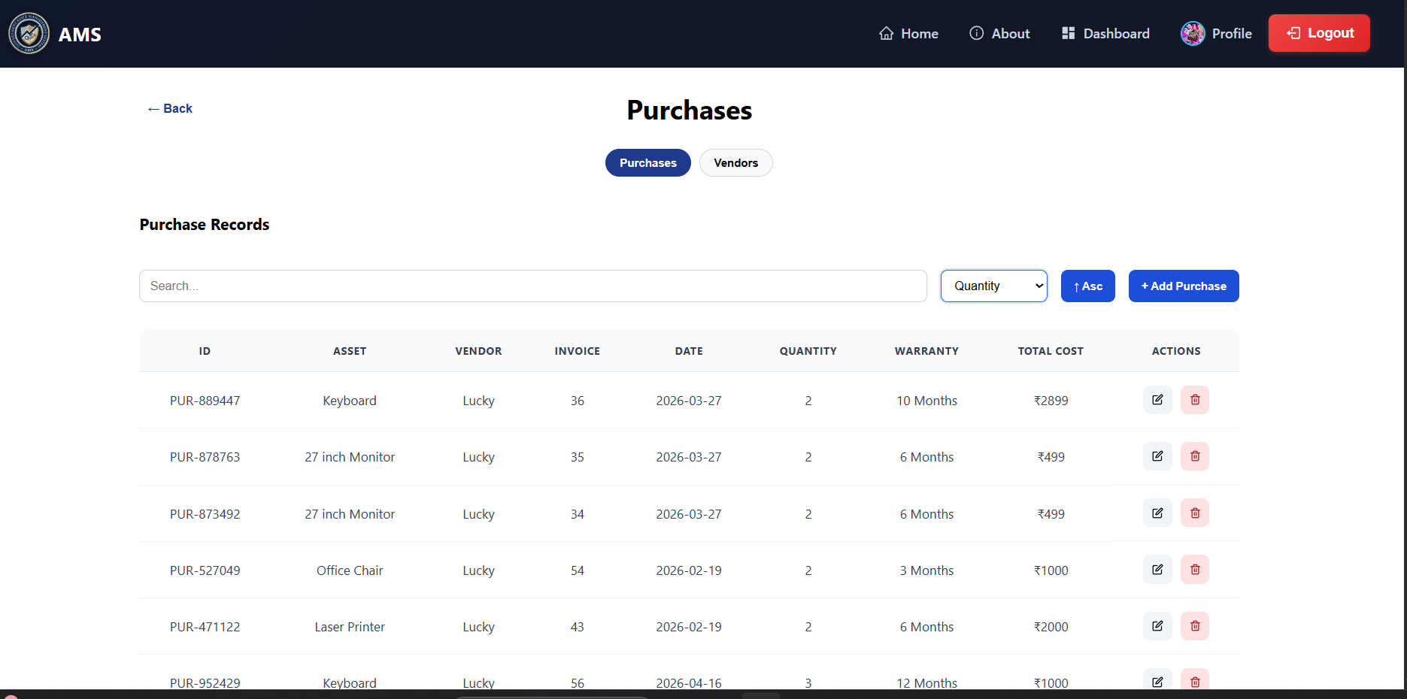
9.14 Store Manager – Maintenance
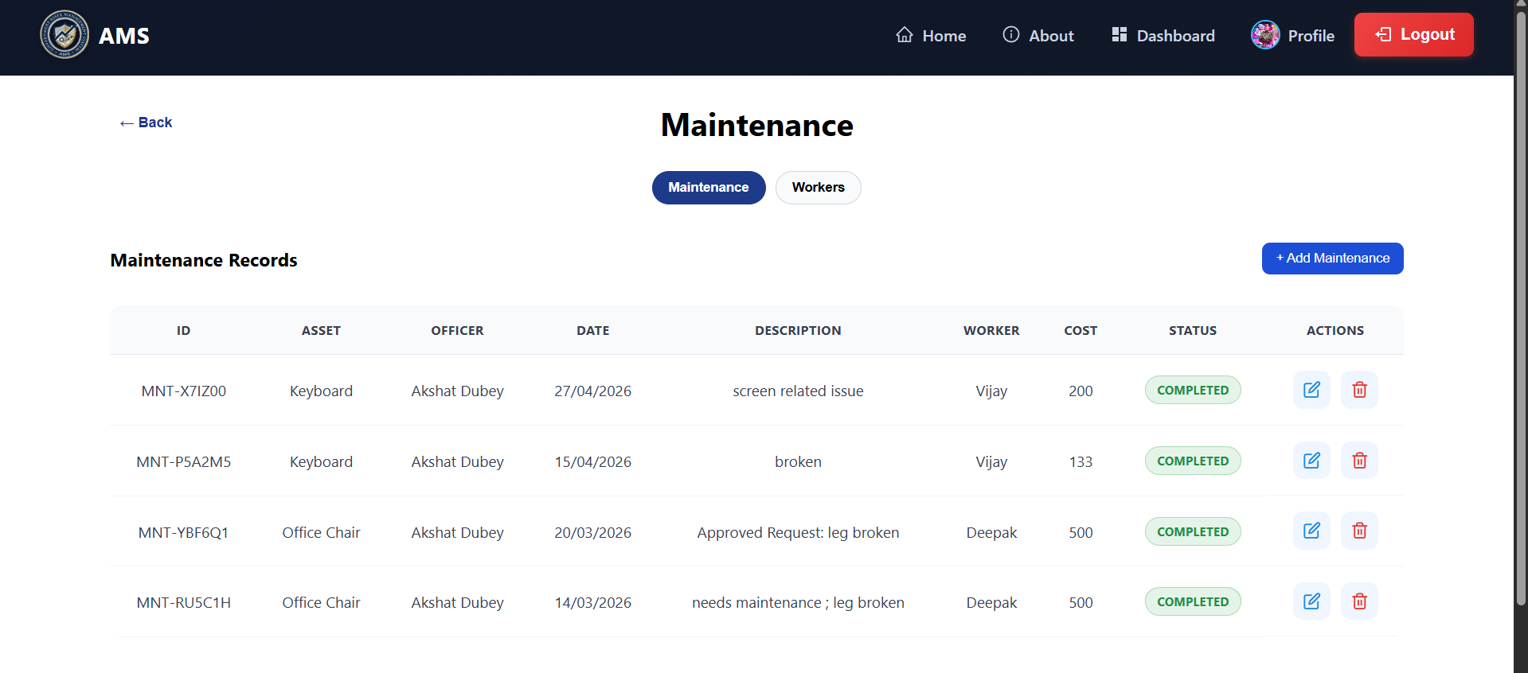
9.15 Store Manager – Disposal
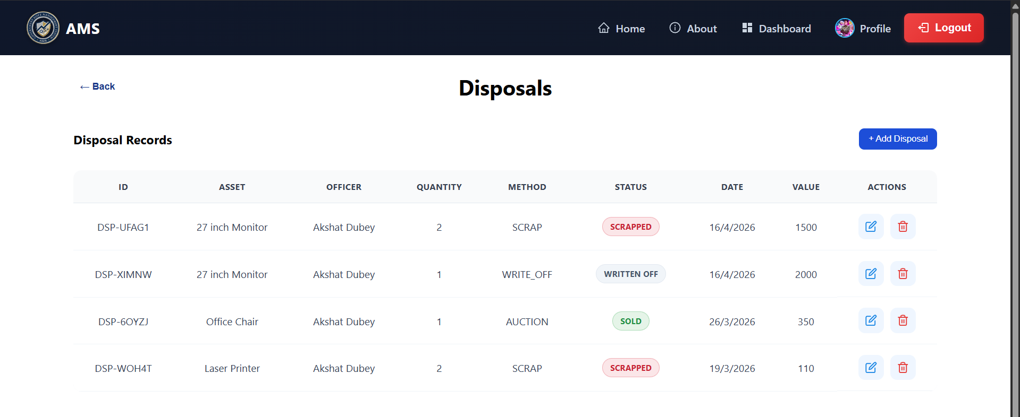
9.16 Store Manager – Pending Requests
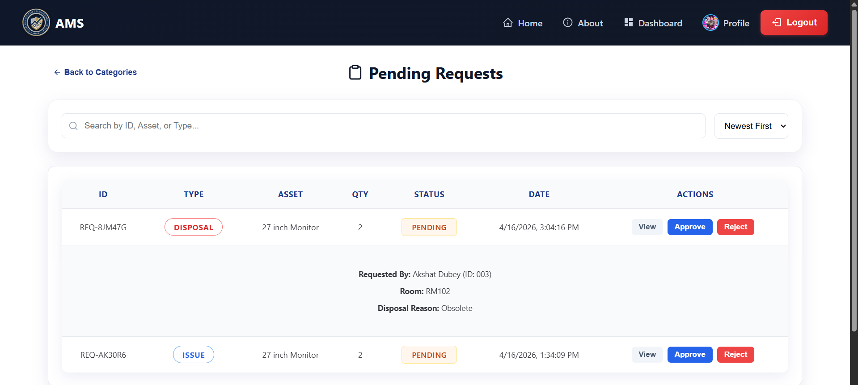
9.17 Store Manager – Processed Requests
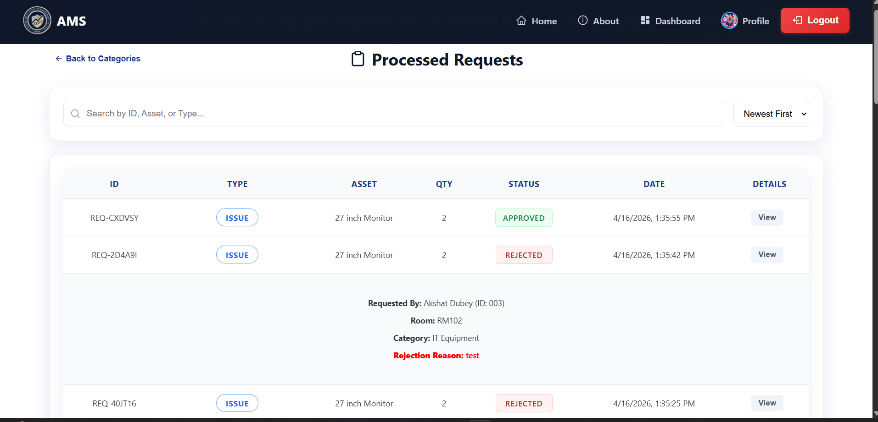
9.18 Officer Dashboard
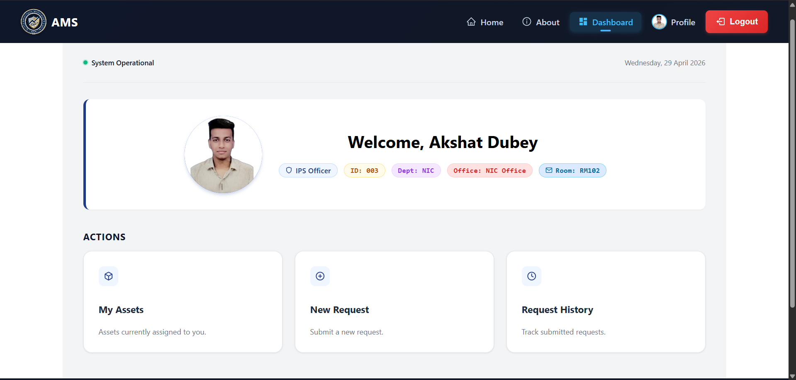
9.19 Officer – My Assets
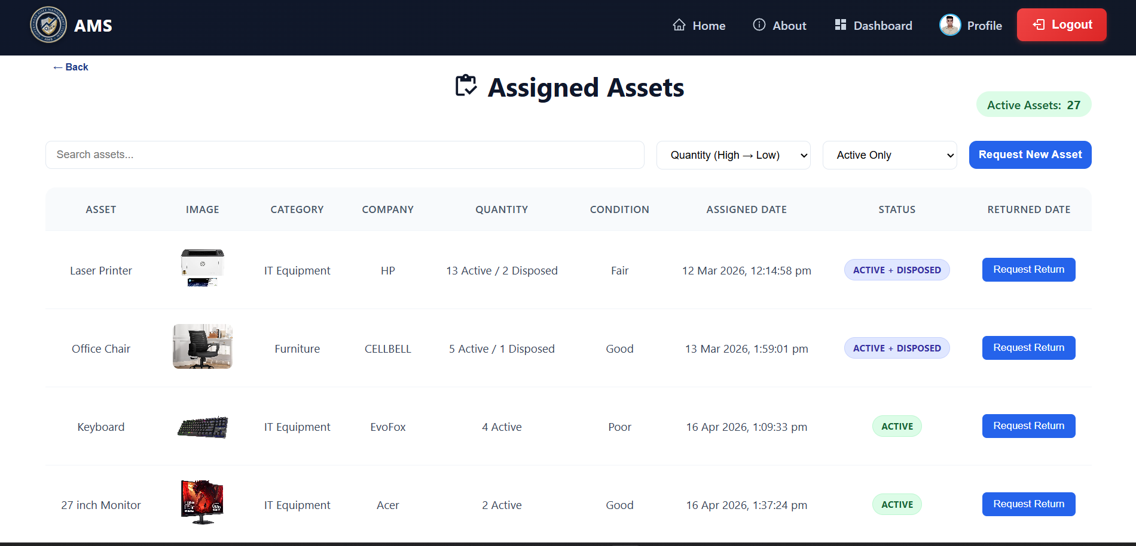
9.20 Officer – New Request
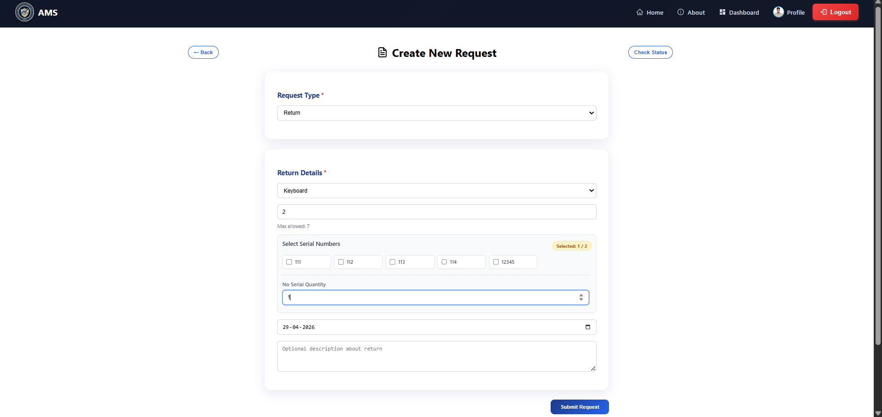
9.21 Officer – Requests History
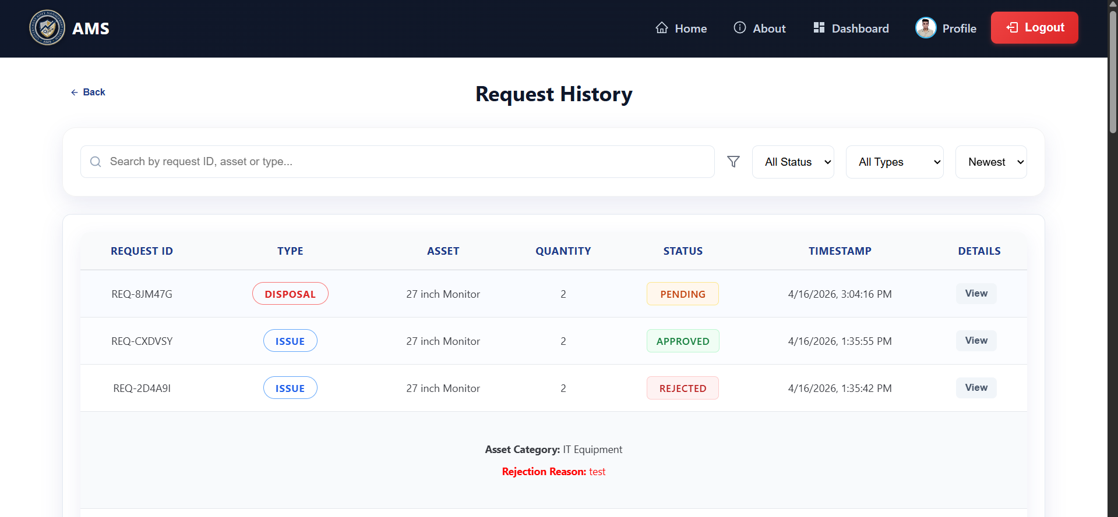

10.1 Introduction
System Security refers to the measures implemented to protect the application from unauthorized access, data breaches, and misuse. Since the Asset Management System handles sensitive data such as asset records, user details, and transaction logs, security is an important aspect of the system.
The system is designed with a secure architecture to ensure safe access, data integrity, and reliable operation for all users including Admin, Store Manager, and Government Officers.

10.2 Objectives of System Security
The main objectives of security in the system are:
- Confidentiality: Ensuring that data is accessible only to authorized users
- Integrity: Preventing unauthorized modification of data
- Availability: Ensuring the system is accessible when required
- Accountability: Tracking user actions through logs

10.3 Authentication and Authorization
The system uses secure authentication and role-based authorization:
- Authentication: Implemented using Firebase Authentication for secure login
- Authorization: Role-Based Access Control (RBAC) is applied
  - Admin → Full access
  - Store Manager → Asset & inventory management
  - Government Officer → Request and usage access
This ensures users can only access features permitted to their role.

10.4 Data Security
Data security is maintained through:
- Secure database storage (Firestore / MongoDB)
- Restricted database access using backend validation
- HTTPS encryption for all data transmission
- Protection of sensitive environment variables

10.5 Input Validation
To prevent invalid or harmful data:
- Client-side validation ensures correct input format
- Server-side validation ensures data integrity before processing
- Invalid or incomplete inputs are rejected with proper messages

10.6 Secure Communication
All communication between frontend and backend is performed using HTTPS protocol, ensuring that data such as login credentials and API requests are securely transmitted.

10.7 Session Management
- User sessions are handled securely using authentication tokens
- Sessions expire automatically after logout or inactivity
- Unauthorized access is prevented through protected routes

10.8 Protection Against Common Attacks
The system is protected against common vulnerabilities:
- Unauthorized Access: Restricted using role-based access
- Input Attacks: Prevented using validation and sanitization
- Brute Force Attempts: Controlled through authentication mechanisms
- CORS Protection: Only allowed domains can access APIs

10.9 File Handling Security
- Only valid file types (images) are allowed for uploads
- File size and format validation is applied
- Files are stored securely in cloud storage

10.10 Audit and Logging
- System activities are logged for tracking purposes
- Important actions such as asset assignment, request approval, and updates are recorded
- Logs help in monitoring and debugging system behavior

10.11 Summary
The Asset Management System incorporates multiple layers of security to ensure safe and reliable operation. By implementing authentication, authorization, data protection, and validation mechanisms, the system provides a secure environment for managing government assets efficiently.

11.1 Introduction
Every software system has certain limitations due to technical constraints and evolving user requirements. The Asset Management System developed in this project successfully automates asset tracking, inventory management, and request handling through a centralized platform.
While the system improves efficiency and reduces manual work, there are still areas where improvements can be made. This chapter highlights the current limitations of the system and suggests future enhancements to make it more efficient, scalable, and user-friendly.

11.2 Limitations of the System
Despite its functionality, the system has the following limitations:

1. Internet Dependency
The system is web-based and requires a stable internet connection. In case of network issues, users may face difficulty accessing the system.

2. Limited Browser Compatibility
The application is optimized for modern browsers. Older browsers may not fully support its features, affecting performance and layout.

3. Manual Asset Verification
Although asset records are maintained digitally, physical verification of assets still depends on manual inspection by staff.

4. Basic Reporting Features
The current reporting system is limited to basic data display and lacks advanced analytics such as charts and graphical insights.

5. No Dedicated Mobile Application
The system is primarily designed for web usage. Lack of a mobile application may reduce convenience for users on mobile devices.

6. Limited Notification System
The system does not fully support real-time notifications like SMS or push alerts, which may delay communication.

7. Manual Data Entry
Most operations rely on manual input, which increases the possibility of human errors and requires proper validation.

11.3 Future Enhancements
To improve the system further, the following enhancements can be implemented:

1. Mobile Application Development
Developing a mobile application would allow users to access the system more easily and perform operations on the go.

2. Advanced Reporting and Analytics
Adding dashboards with charts and visual reports would help administrators analyze data more effectively.

3. Real-Time Notifications
Integration of email, SMS, or push notifications would improve communication and provide instant updates.

4. QR Code / Barcode Integration
Assets can be assigned QR codes for quick scanning and tracking, reducing manual efforts.

5. Automated Maintenance Alerts
The system can generate automatic alerts for asset maintenance based on time or usage.

6. Multi-Language Support
Supporting multiple languages would make the system accessible to a wider range of users.

7. Enhanced Security
Implementation of features like multi-factor authentication would improve system security.

8. Scalability Improvements
The system can be optimized to handle a larger number of users and assets efficiently.

11.4 Summary
The Asset Management System provides an effective solution for managing assets digitally. However, addressing the current limitations and implementing the suggested enhancements will make the system more efficient, scalable, and user-friendly in the future.

12. Conclusion

The Asset Management System developed in this project provides a centralized and efficient solution for managing organizational assets. The system successfully replaces traditional manual processes with a digital platform that improves accuracy, transparency, and overall efficiency.
Through the implementation of various modules such as asset management, inventory tracking, request handling, maintenance management, and reporting, the system ensures smooth and structured handling of asset-related operations. Role-based access control allows different users such as Admin, Store Manager, and Government Officers to perform their respective tasks securely and efficiently.
The use of modern technologies such as React for the frontend, Node.js for the backend, and cloud-based services for authentication and data storage has enabled the development of a scalable and user-friendly application. The system ensures secure data handling, real-time updates, and ease of access across different user roles.
During the development process, key objectives such as reducing manual workload, improving data accuracy, and enhancing system transparency were successfully achieved. The testing phase confirmed that the system performs reliably under normal conditions and meets the required functional and security standards.
Although the system has certain limitations, it provides a strong foundation for future improvements. With the addition of advanced features such as mobile applications, real-time notifications, and enhanced analytics, the system can be further expanded to meet evolving requirements.
In conclusion, the Asset Management System serves as an effective and practical solution for managing assets in an organized and secure manner. It demonstrates how modern web technologies can be utilized to improve administrative processes and support better decision-making within an organization.

13. References

1. Official Documentation
- React.js:
Official Documentation: https://react.dev/
Used for building dynamic user interfaces, component-based architecture, and state management.
- Node.js:
Official Website: https://nodejs.org/
Used for backend development and handling asynchronous operations.
- Express.js:
Documentation: https://expressjs.com/
Used to create RESTful APIs and manage server-side routing.
- Firebase:
Documentation: https://firebase.google.com/docs
Used for authentication, Firestore database, and hosting services.

2. Development Tools & Platforms
- Visual Studio Code:
https://code.visualstudio.com/
Used as the primary source code editor for frontend and backend development.
- GitHub:
https://github.com/
Used for version control, collaboration, and project hosting.
- Render:
https://render.com/
Used for deploying backend services.

3. Learning Resources & Community Support
- Stack Overflow:
https://stackoverflow.com/
Used for troubleshooting errors and understanding real-world coding problems.
- MDN Web Docs:
https://developer.mozilla.org/
Used for understanding HTML, CSS, JavaScript, and web standards.
- W3Schools:
https://www.w3schools.com/
Used for quick references and beginner-friendly explanations.
- ChatGPT:
https://chat.openai.com/
Used for assistance in documentation writing, debugging logic, refining project structure, and explaining concepts.
- Google Gemini:
https://gemini.google.com/
Used for generating diagrams, improving content structure, and assisting in visualization tasks.

5. Additional References
- Academic materials on Software Engineering and System Design
- Online tutorials and YouTube resources related to React, Node.js, and full-stack development
- Official Firebase and API integration guides

