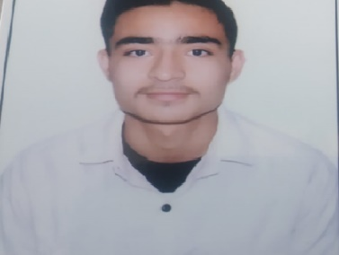  **RESUME**

**KUNAL SHARMA**

CONTACT:

+91 8982596078

+91 7027685696

EMAIL ID:

Kunalsharmamudgil70@gmail.com

**OBJECTIVE**

To work with an organization where can learn new skills and increase my abilities for the organizational goal as myself.

EDUCATIONAL QUALIFICATION

* Passed Bca 1st year from Shaheed Nandkumar Patel vishwavidalaya raigarh.

Marks : 61.85%

* Passed Bca 2nd year from Shaheed Nandkumar Patel vishwavidalaya raigarh.

Marks : 64.62%

* Passed out 12th from CBSE in 2022.

Marks: 54.2%

* Passed out in certificate course in computer basic and accounting in 2021.

Marks: 59.00%

* Passed out 10th from CBSE in 2020.

TECHNICAL SKILLS

* Basic knowlodge of computer.
* Basic knowledge of codding.
* Basic knowledge of computer fundamental.

WORK EXPERINCE

FRESHER

STRENGTH & HOBBIES

* Hard &smart working.
* Honest &punctual.
* Good communication skill.

PERSONAL DETAIL

Father’s Name :sh. Anil kumar

Date of Birth :10/08/2005

Address : H.no1225,ISRANA,PANIPAT

STATE : HARYANA,132107

MARITAL STATUS : UNMARRIED

(KUNAL SHARMA)