BLOOD BANK
MANAGEMENT SYSTEM
A Mini DBMS Project Report
Relational Design · SQL Automation · Desktop Application
DATABASE MANAGEMENT SYSTEMS | MINI PROJECT | ACADEMIC YEAR 2026
Submitted By: [Your Name]
Roll / Enrollment No.: [Your Roll Number]
Class / Semester: [Your Class]
Under the Guidance of: [Guide's Name]
Institution: [Your College / Institute Name]

Schema · Triggers · Stored Procedures · Tkinter Front End

TABLE OF CONTENTS

1. Introduction 3
2. Abstract 3
3. Objectives 3
4. Problem Statement 4
5. Scope of the System 4
6. System Requirements 4
7. Tools & Technologies Used 4
8. Entity-Relationship Diagram 5
9. Relational Schema 6
10. Normalization 8
11. Key SQL Implementation 8
12. Front-End Application & Screenshots 9
13. Testing 12
14. Limitations & Future Enhancements 13
15. Conclusion 13
16. References 13

1. Introduction
Blood is a critical, perishable medical resource, and coordinating its collection, storage, and distribution across donors, hospitals, and patients is a significant logistical challenge for any healthcare system. Manual record-keeping — paper registers or disconnected spreadsheets — makes it hard to know, at any given moment, exactly how much of each blood group is available, which units are close to expiry, and which donors are due and eligible to give again. Delays caused by this kind of uncertainty can be life-threatening in an emergency.
The Blood Bank Management System addresses this by centralizing donor, inventory, hospital, and request data in a single relational database, with automation — a trigger and a stored procedure — that keeps stock counts accurate without manual recalculation. This report documents the system's design, from entity-relationship modeling and normalization through to a working desktop application built on top of it.

2. Abstract
The Blood Bank Management System is a relational database application that manages the end-to-end operations of one or more blood banks: donor records and donation history, live blood inventory, hospitals and recipients, blood requests, and donation camps. The schema is normalized to Third Normal Form (3NF) and implemented in SQL with a view, a trigger, and a stored procedure that automate stock updates and request fulfilment. A Tkinter desktop front end, connected via mysql-connector-python, provides a working interface over the schema.

3. Objectives
● Maintain accurate donor records and donation history.
● Track live blood inventory (by blood group and expiry date) across multiple blood banks.
● Manage hospitals, recipients, and blood requests, with status tracking.
● Record blood donation camps and their organizers.
● Automate stock updates on donation and safe stock deduction on request fulfilment.
● Provide quick alerts for low-stock and soon-to-expire blood units.

4. Problem Statement
Blood banks that rely on manual registers or disconnected spreadsheets face recurring, avoidable problems:
Existing (Manual) System | Proposed System
Donor records kept on paper or in isolated spreadsheets, prone to loss and duplication. | Centralized relational database with referential integrity across donors, banks, and donations.
Stock levels updated by hand after each donation or issue, often lagging behind reality. | A database trigger updates inventory automatically the instant a donation is recorded.
No automatic warning when a blood group is running low or a unit is close to expiry. | A stock-summary view flags LOW and EXPIRING SOON batches in real time.
Fulfilling a request risks over-issuing blood that isn't actually in stock. | A stored procedure checks available units before deducting them, so stock can never go negative.
Cross-referencing a hospital's requests against bank inventory means checking multiple registers. | A single application ties recipients, hospitals, banks, and requests together with live dropdowns.

5. Scope of the System
The system covers donor management, inter-bank inventory tracking, hospital/recipient management, request processing, and camp scheduling. Payment/billing, staff payroll, and cross-bank blood transfer logistics are natural extensions but are out of scope for this mini project.

6. System Requirements

6.1 Software
Component | Specification
Operating System | Windows 10/11, Linux, or macOS
Database Server | MySQL 8.x or MariaDB 10.x
Language Runtime | Python 3.9 or later
Python Packages | mysql-connector-python; Tkinter (bundled with Python)
Documentation Tools | Microsoft Word / LibreOffice Writer

6.2 Hardware
Component | Specification
Processor | Dual-core CPU or better
RAM | 4 GB minimum (8 GB recommended)
Storage | 500 MB free disk space
Display | 1280×768 or higher

7. Tools & Technologies Used
● Database: MySQL / MariaDB 10.x
● Backend language: Python 3
● GUI toolkit: Tkinter (ttk widgets)
● Database connector: mysql-connector-python
● ER diagram generation: Graphviz
● Documentation: Microsoft Word (.docx)

8. Entity-Relationship Diagram
Nine entities model the system. Primary keys are underlined; foreign keys are marked (FK). Every relationship shown is one-to-many.
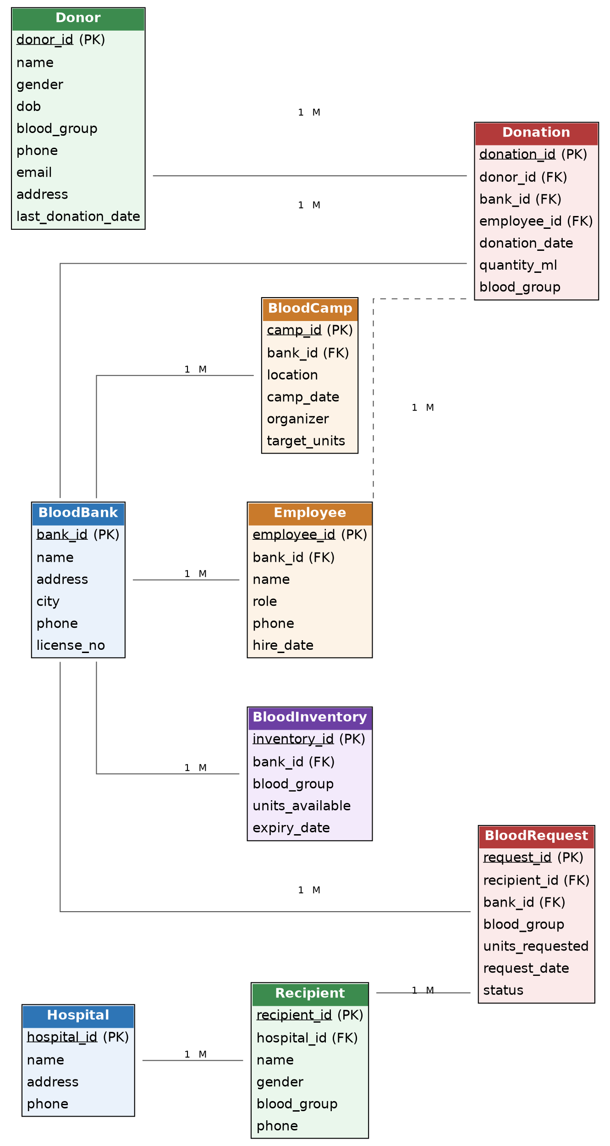
Figure 1: Entity-relationship diagram of the nine core tables

9. Relational Schema

9.1 BloodBank
Column | Type | Constraint | Description
bank_id | INT | PK, AUTO_INCREMENT | Unique bank identifier
name | VARCHAR(100) | NOT NULL | Blood bank name
address | VARCHAR(200) | NOT NULL | Street address
city | VARCHAR(50) | NOT NULL | City
phone | VARCHAR(15) | NOT NULL | Contact number
license_no | VARCHAR(30) | UNIQUE, NOT NULL | Government license number

9.2 Employee
Column | Type | Constraint | Description
employee_id | INT | PK, AUTO_INCREMENT | Unique employee identifier
bank_id | INT | FK → BloodBank | Bank the employee works at
name | VARCHAR(100) | NOT NULL | Employee name
role | VARCHAR(50) | NOT NULL | e.g., Manager, Lab Technician
phone | VARCHAR(15) | — | Contact number
hire_date | DATE | NOT NULL | Date of joining

9.3 Donor
Column | Type | Constraint | Description
donor_id | INT | PK, AUTO_INCREMENT | Unique donor identifier
name | VARCHAR(100) | NOT NULL | Donor name
gender | CHAR(1) | CHECK (M/F/O) | Gender
dob | DATE | NOT NULL | Date of birth
blood_group | VARCHAR(3) | CHECK (8 valid groups) | e.g., O+, AB-
phone | VARCHAR(15) | NOT NULL | Contact number
email | VARCHAR(100) | — | Email address
address | VARCHAR(200) | — | Residential address
last_donation_date | DATE | — | Used to check 90-day eligibility

9.4 Donation
Column | Type | Constraint | Description
donation_id | INT | PK, AUTO_INCREMENT | Unique donation record
donor_id | INT | FK → Donor | Who donated
bank_id | INT | FK → BloodBank | Where it was collected
employee_id | INT | FK → Employee | Who collected it
donation_date | DATE | NOT NULL | Date of donation
quantity_ml | INT | CHECK 200–500 | Volume collected
blood_group | VARCHAR(3) | NOT NULL | Blood group donated

9.5 BloodInventory
Column | Type | Constraint | Description
inventory_id | INT | PK, AUTO_INCREMENT | Unique stock batch
bank_id | INT | FK → BloodBank | Bank holding the stock
blood_group | VARCHAR(3) | CHECK (8 valid groups) | Blood group of the batch
units_available | INT | CHECK >= 0 | Units currently in stock
expiry_date | DATE | NOT NULL | Shelf-life expiry (42 days from donation)

9.6 Hospital
Column | Type | Constraint | Description
hospital_id | INT | PK, AUTO_INCREMENT | Unique hospital identifier
name | VARCHAR(100) | NOT NULL | Hospital name
address | VARCHAR(200) | NOT NULL | Address
phone | VARCHAR(15) | NOT NULL | Contact number

9.7 Recipient
Column | Type | Constraint | Description
recipient_id | INT | PK, AUTO_INCREMENT | Unique recipient identifier
hospital_id | INT | FK → Hospital | Hospital where admitted
name | VARCHAR(100) | NOT NULL | Recipient name
gender | CHAR(1) | CHECK (M/F/O) | Gender
blood_group | VARCHAR(3) | CHECK (8 valid groups) | Blood group needed
phone | VARCHAR(15) | — | Contact number

9.8 BloodRequest
Column | Type | Constraint | Description
request_id | INT | PK, AUTO_INCREMENT | Unique request identifier
recipient_id | INT | FK → Recipient | Who needs the blood
bank_id | INT | FK → BloodBank | Bank the request is raised at
blood_group | VARCHAR(3) | NOT NULL | Blood group requested
units_requested | INT | CHECK > 0 | Number of units needed
request_date | DATE | NOT NULL | Date raised
status | VARCHAR(20) | CHECK (4 values) | Pending/Approved/Fulfilled/Rejected

9.9 BloodCamp
Column | Type | Constraint | Description
camp_id | INT | PK, AUTO_INCREMENT | Unique camp identifier
bank_id | INT | FK → BloodBank | Organizing bank
location | VARCHAR(150) | NOT NULL | Camp venue
camp_date | DATE | NOT NULL | Date held
organizer | VARCHAR(100) | — | Organizing body
target_units | INT | — | Collection target

10. Normalization

10.1 First Normal Form (1NF)
Every table has a single-valued primary key and atomic columns; repeating groups (multiple donations per donor) live in their own Donation table rather than repeated columns.

10.2 Second Normal Form (2NF)
All tables use single-column surrogate keys, so there are no partial dependencies on a composite key — every non-key attribute depends on the whole primary key.

10.3 Third Normal Form (3NF)
Transitive dependencies are removed by keeping referenced details out of dependent tables — e.g. Hospital details are reached via hospital_id rather than duplicated inside Recipient, and BloodBank details are never repeated inside Donation, BloodInventory, BloodRequest, or BloodCamp.

11. Key SQL Implementation
Full DDL, sample data, and queries are in blood_bank_management_system.sql. Highlights:

11.1 Shortage-Alert Query
SELECT bb.name AS bank_name, bi.blood_group, bi.units_available
FROM BloodInventory bi JOIN BloodBank bb ON bb.bank_id = bi.bank_id
WHERE bi.units_available < 5 ORDER BY bi.units_available ASC;

11.2 View — Consolidated Stock Summary
CREATE OR REPLACE VIEW vw_stock_summary AS
SELECT bb.bank_id, bb.name AS bank_name, bi.blood_group,
bi.units_available, bi.expiry_date,
CASE WHEN bi.units_available < 5 THEN 'LOW'
WHEN bi.expiry_date <= CURDATE() + INTERVAL 15 DAY THEN 'EXPIRING SOON'
ELSE 'OK' END AS stock_flag
FROM BloodInventory bi JOIN BloodBank bb ON bb.bank_id = bi.bank_id;

11.3 Trigger — Auto-Update Inventory on Donation
CREATE TRIGGER trg_after_donation_insert AFTER INSERT ON Donation
FOR EACH ROW BEGIN
INSERT INTO BloodInventory (bank_id, blood_group, units_available, expiry_date)
VALUES (NEW.bank_id, NEW.blood_group, 1, DATE_ADD(NEW.donation_date, INTERVAL 42 DAY))
ON DUPLICATE KEY UPDATE units_available = units_available + 1;
END;

11.4 Stored Procedure — Safe Request Fulfilment
Checks available stock before deducting it, so inventory never goes negative, then updates the request status:
CALL sp_fulfill_request(2);

12. Front-End Application & Screenshots
A Python Tkinter desktop client (blood_bank_app.py) connects to the database via mysql-connector-python. It provides a Dashboard with live stock alerts, and list-plus-form tabs for Donors, Blood Banks, Donations, Hospitals & Recipients, and Blood Requests. Switching tabs auto-refreshes that tab's data and its dropdown lists; recording a donation exercises the database trigger, and 'Fulfill Selected' on a request calls the stored procedure directly.
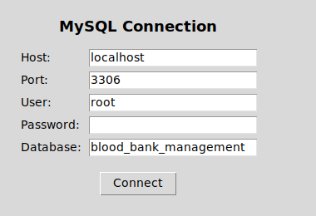
Figure 2: Login screen — connects to the MySQL database

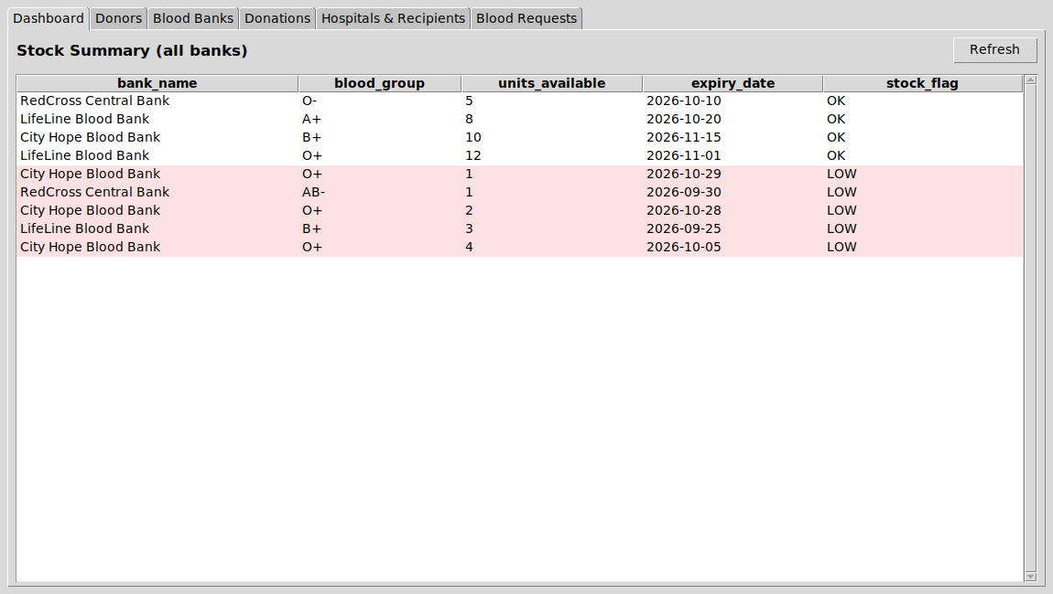
Figure 3: Dashboard — live stock summary with LOW/EXPIRING alerts

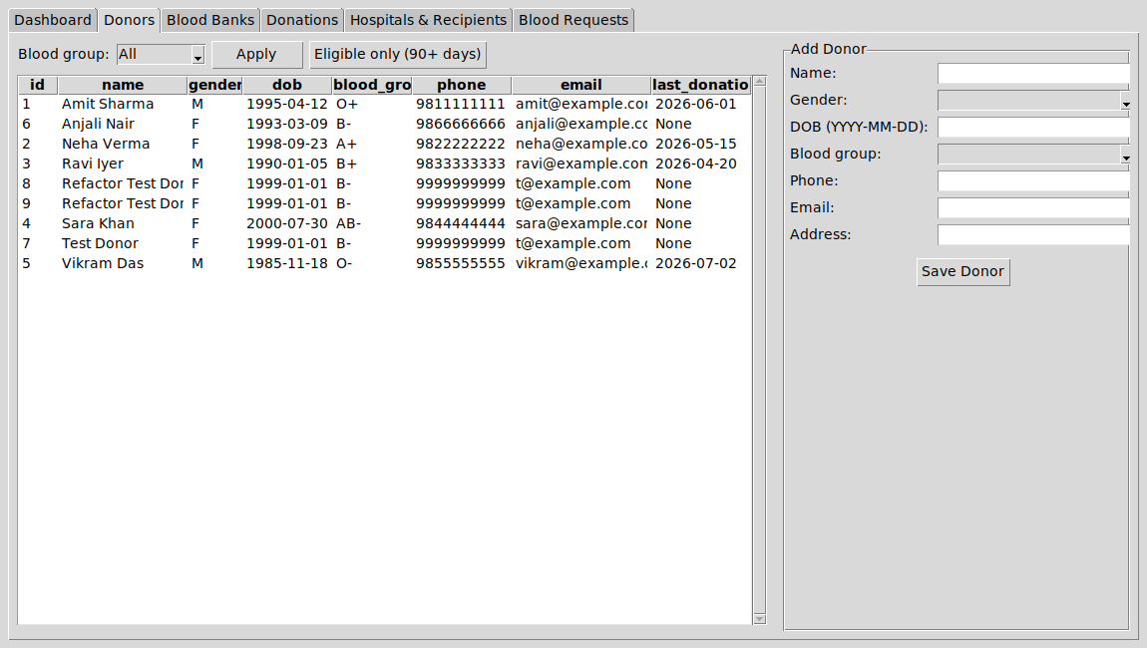
Figure 4: Donors tab — donor list with blood-group filter and eligibility check

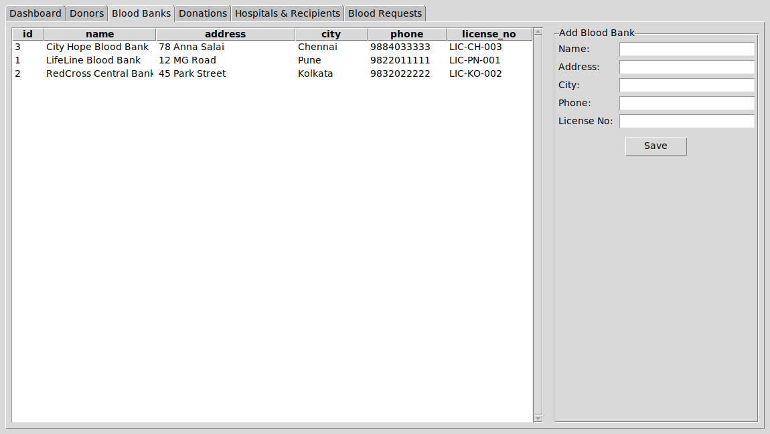
Figure 5: Blood Banks tab — registered banks

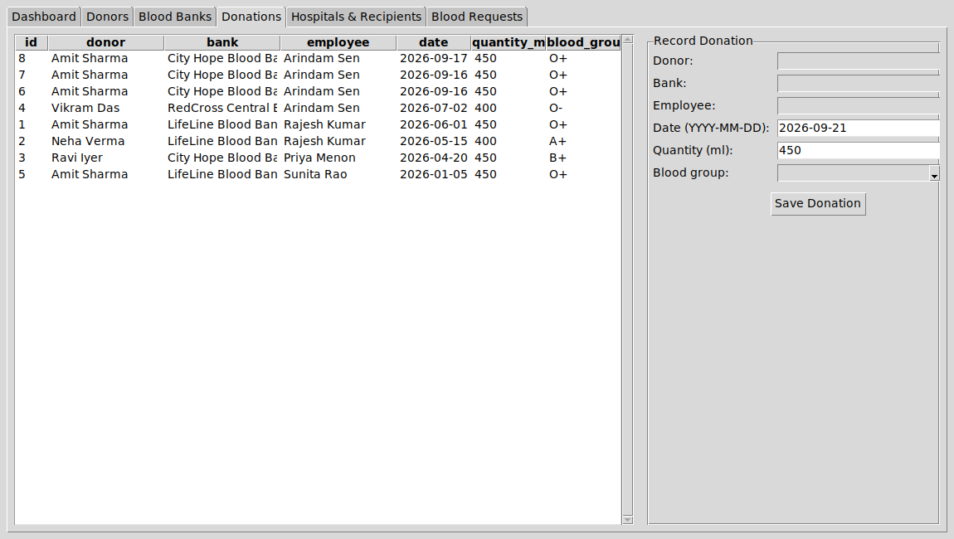
Figure 6: Donations tab — recording a donation fires the inventory trigger

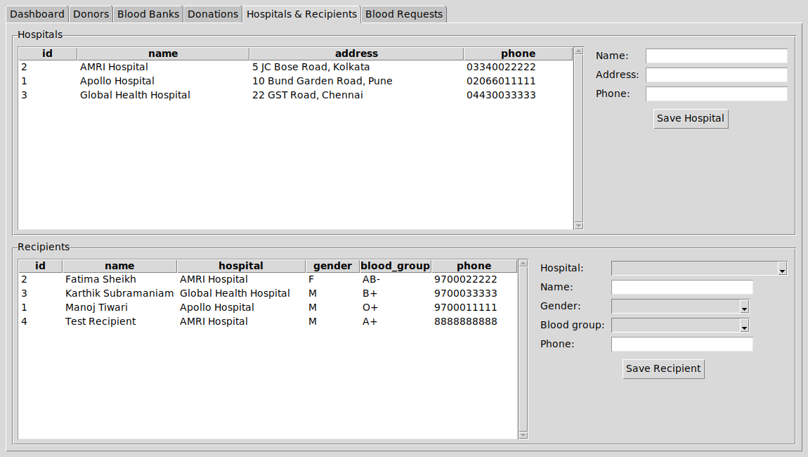
Figure 7: Hospitals & Recipients tab

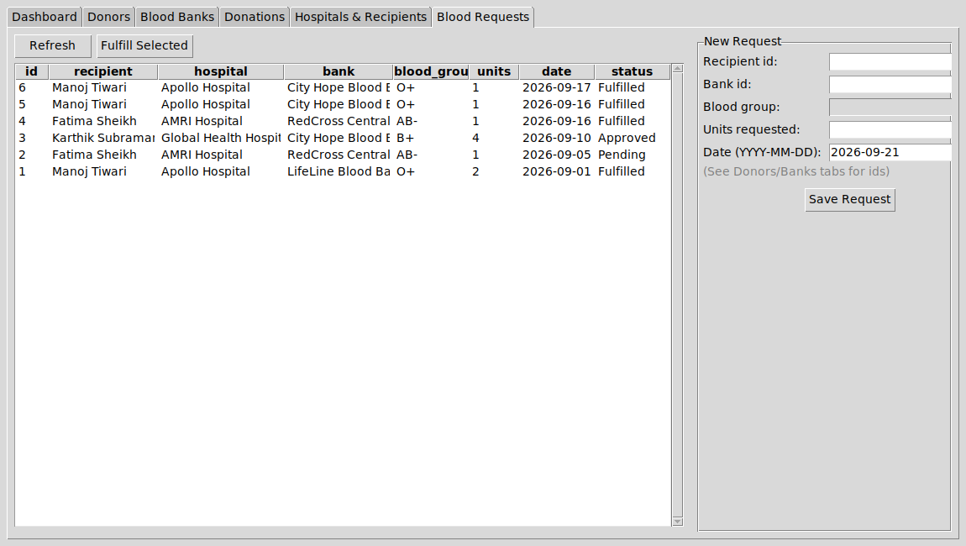
Figure 8: Blood Requests tab — 'Fulfill Selected' calls the stored procedure

13. Testing
The system was tested against representative scenarios covering constraints, the trigger, and the stored procedure:
ID | Test Case | Expected Result | Status
T01 | Insert a donor with an invalid blood group (e.g. 'X+') | Rejected by the blood_group CHECK constraint | Pass
T02 | Record a new donation | BloodInventory gains a matching batch automatically via the trigger | Pass
T03 | Call sp_fulfill_request on a request exceeding available stock | Request stays Pending; stock is not deducted | Pass
T04 | Call sp_fulfill_request on a request within available stock | Stock decreases and status changes to Fulfilled | Pass
T05 | Query vw_stock_summary | Batches under 5 units flagged LOW; batches expiring within 15 days flagged EXPIRING SOON | Pass
T06 | Insert a donation with quantity_ml outside 200–500 | Rejected by the quantity_ml CHECK constraint | Pass
T07 | Switch tabs in the desktop app after adding a new donor | Donor dropdown lists refresh automatically with the new entry | Pass

14. Limitations & Future Enhancements
● Add a donor eligibility engine that also checks medical history.
● Support inter-bank blood transfer requests when a bank is out of stock.
● Add role-based authentication (admin, staff, hospital).
● SMS/email alerts for donors due for re-donation and for shortages.

15. Conclusion
This project demonstrates a complete, normalized relational design combined with a working front end: ER modeling, normalization, constraints, joins, a view, a trigger, and a stored procedure, all exercised through a functioning Tkinter application. The result is a system that removes the manual bookkeeping burden identified in the problem statement, while remaining small enough to understand, extend, and present as a mini project.

16. References
● Silberschatz, Korth & Sudarshan — Database System Concepts.
● MySQL 8.0 Reference Manual — dev.mysql.com/doc
● Python 3 Documentation — docs.python.org
● Tkinter / ttk Documentation — docs.python.org/3/library/tkinter
● mysql-connector-python Developer Guide — dev.mysql.com/doc/connector-python

