**SOLENT UNIVERSITY**   
**Department of Science and Engineering**

MSc in Computer Engineering

**Software Design and Development**

**Academic Year 2023-2024**

**Kunal Singh**

**Q102131631**

**Travel Management System**

**Report –** Assignment 1

**Tutor: Taiwo Ayodele [07/05/2024]**

Contents

Introduction 3

Tools and techniques: 4

UML diagrams: 4

Class Diagram: 4

Use-case Diagram: 5

Robustness Diagram: 7

Code Explanation: 9

Conclusion 22

References 23

**Travel Management System**

# Introduction

In the ever-evolving landscape of technology, creating a digital solution for every field makes the work easy and efficient, like first people have to do something, they go to a specific place and make an appointment and then they can perform the task or any other things they have to do something else for their task. Just to reduce these factors, Solent Trips change the working mechanism of a traveling agency by developing a digital solution for the travel management system. Because of this digital solution work has become very efficient and people can take everything from any part of the world, and can manage their trips whether these trips are for business or any casual meetup. The main goal of Solent Trips is to change the paper-based systems for these kinds of travel management to online and build a centralized platform for the ease of their beloved customers.

The main objective of the travel management system is to provide the facilities that help customers in every aspect of booking a ride including trip planning, coordination, and execution of the task while also making sure that the journey of their customers becomes safe and good. By using these modern technologies, this travel management system automates various tasks including improving communication, reducing unnecessary paperwork from work, and handling various things. This travel management system includes all the important sections that an ordinary travel management system has including trip management and traveler management and also adds multiple capabilities of administration.

So this is the introduction to the whole travel management system, this management system is the task provided by Solent University and this task plays an important role in many ways working on such real-world tasks, the confidence of the developer increases and they can perform any other task when they are working on any industry or anything.

Lastly, this travel management system is built for people who are busy at work and don’t have much time to go through paperwork and all this type of stuff. This management system gives a user-friendly interface and scalable solutions for everything.

# Tools and techniques:

This is the main section of this comprehensive report. In this section, all the tools and techniques are defined which are used in developing this travel management system. Defining tools and techniques is important because if someone wants to understand and wants to read about this travel management system and is going to add some more functionality to it. They are already aware of all the work which is used in this management system. The language used for developing as per requirement is Python. Python is a high-level language that is famous and known for its user-friendly and easy syntax and also python is also known for its advanced machine learning and artificial intelligence-based tasks. The Integrated development environment IDE as suggested is PyCharm. The technique used for making this application is OOP, all the object-oriented pillars are applied in the code to make the code reusable and scalable (Hill. 2020).

## UML diagrams:

The Unified modeling language UML diagrams are sometimes considered the backbone because these diagrams are very helpful in understanding the project without coding. These diagrams help to understand how code is going to work and allow users or readers to understand the internal workflow of the system. These diagrams are also the main part of a software management system; without these diagrams the work is not considered good or professional. By using these types of UML diagrams, working on the next stages becomes easy and efficient.

For this project there are at least 4 UML diagrams drawn, the first one is the class diagram, the second one is a use-case diagram, the third is the robustness diagram and the last is also a use-case diagram with some requirements. Let’s see all these diagrams one by one and see how each diagram will work and display the project requirements (Koç et al., 2021).

### Class Diagram:

This diagram is very important when there is work in the code with the classes and methods. This diagram shows all the classes with their respective attributes and information displays all the classes and allows interaction between them. After seeing these classes, the user will understand how the internal system is going to work (Tiwari et al., 2021).

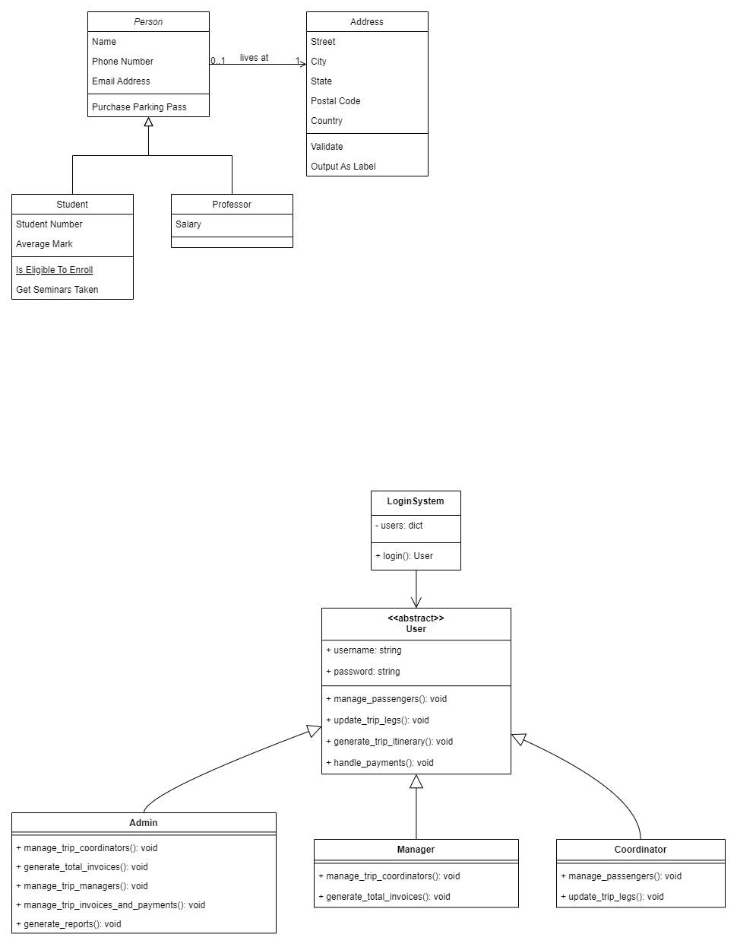

This class diagram shows all the 5 main classes with the respective attributes and shows all the relations between them. This class diagram helps to apply Object-oriented concepts because in object-oriented programming all the work revolves around these classes.

### Use-case Diagram:

This use-case diagram shows all the interactions between actors which are external end users who use the application and interact with the specific software or web application. This diagram shows all the possible workflow that happened between actors and the system. All the tasks are displayed in the use-case shapes and all the interactions between both are displayed with the help of a use-case diagram.

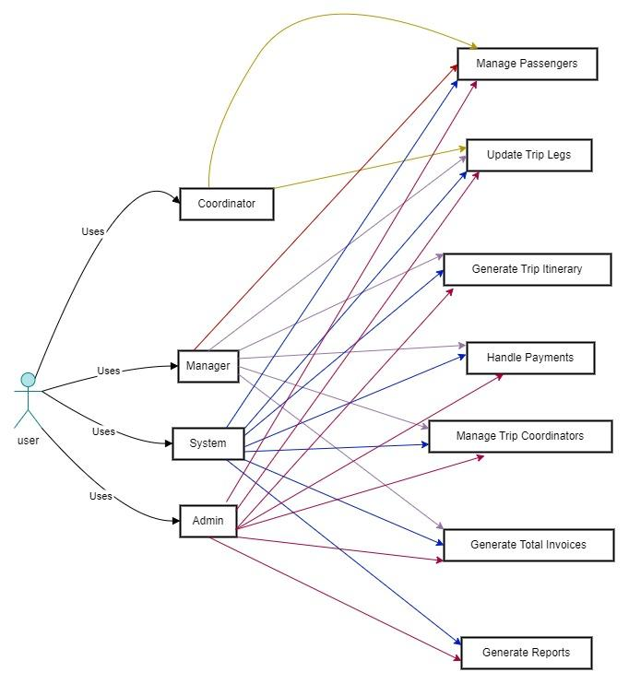

This is the use-case diagram for the travel management system. In this diagram there is an actor named used. First, visit the management system and add their login credential whether he/she is a manager, admin, or anything else can see their information and manage all the related tasks. All the relations between use cases and actors are displayed with arrows and all arrows are a different color for the reader. Now the reader can read every relation without any issues.

### Robustness Diagram:

Now the third diagram is the robustness diagram which is also known as the sequence diagram. This diagram shows all the tasks in a sequence like taking an example of any specific system. First the user visits the system and adds their login/register credential then performs their desired tasks which are needed, the user performs all the work in a sequence and this sequence is displayed with the help of this diagram.

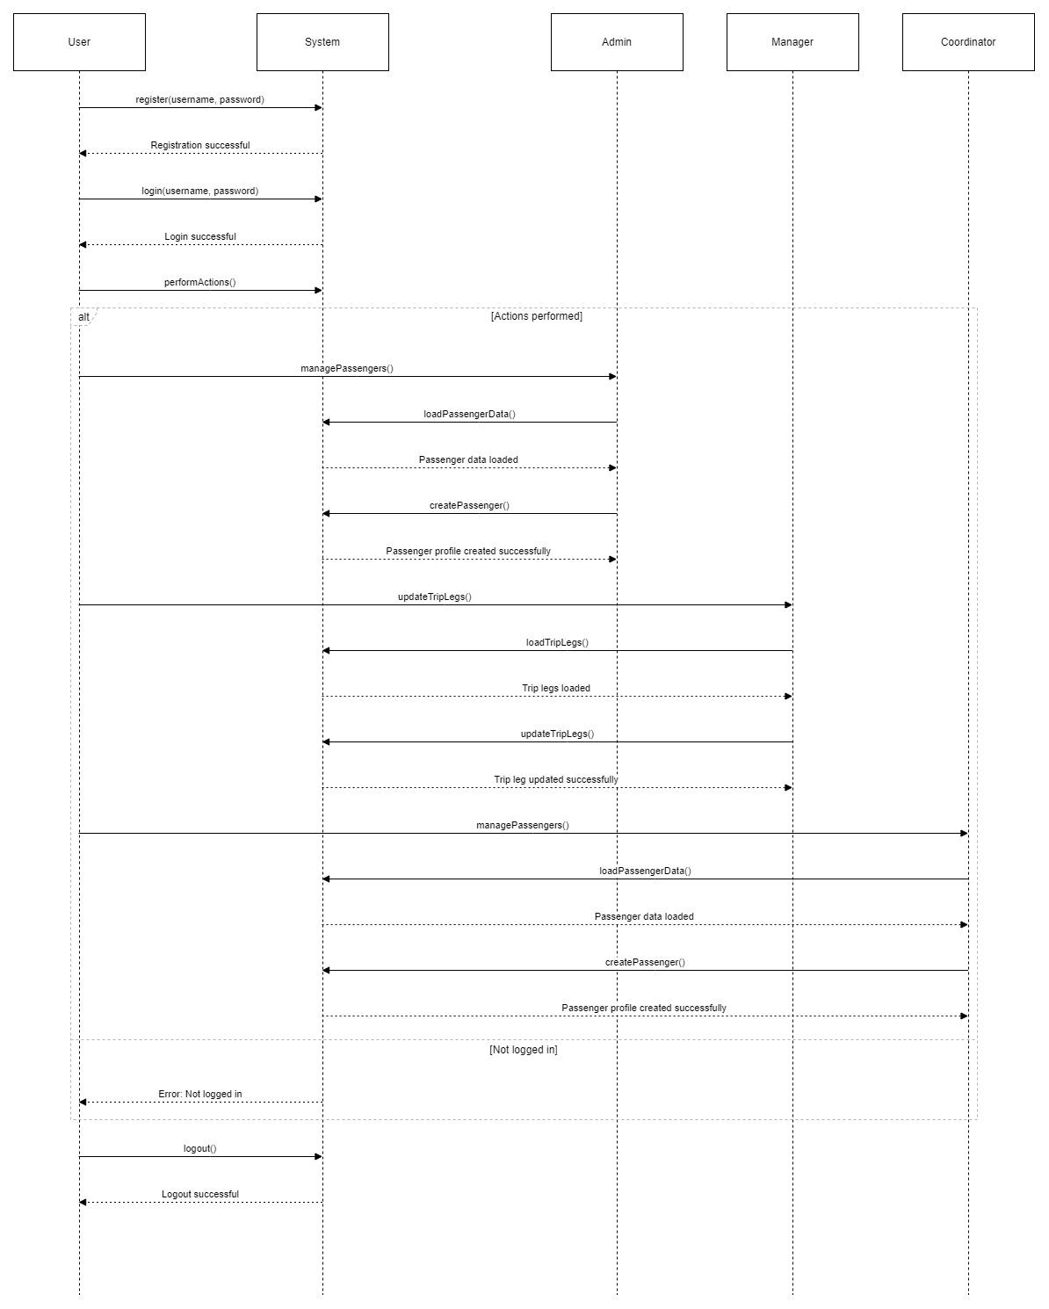

This sequence diagram shows all the workflow logic in a sequence from login to logout each and everything how the travel management system is going to work and how internal workflow occurs. All the actions in a sequence are displayed with the help of the diagram.

## Code Explanation:

In this section of the report there is defined all the code of the travel management system. This management system as discussed above developed with the help of python language. The whole code of the management system is based on object oriented programming. Lets see each of the code instructions for better understanding of the code.



These are the first instructions of the code, in these instructions importing some external libraries to work with, these libraries include csv for working with csv files and the next library is matplotlib, the matplotlib is one of the most famous libraries of python (Lemenkova, 2020). With the help of this matplotlib can create multiple graphs and different shapes for better understanding of the work.

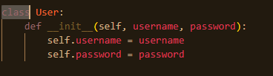

This is the first class of the code named USER, this class is used for storing and manipulating the user information including user email and user password (Nezdoyminov et al., 2020). This information is necessary for enabling the security of the system and also for various other functions.

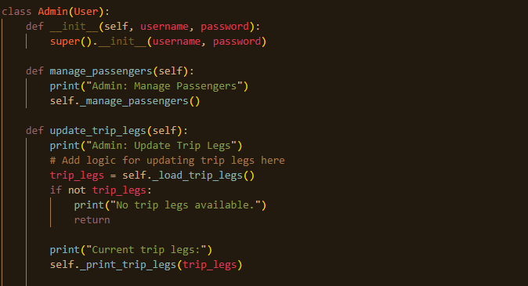

This is the admin class with their functions, the admin class allows the user to first add password and username for access then if the user adds correct information then the user can perform various tasks. Like in this code snippet the function is manage_passengers and update_trip_logs the admin handles all these functions.

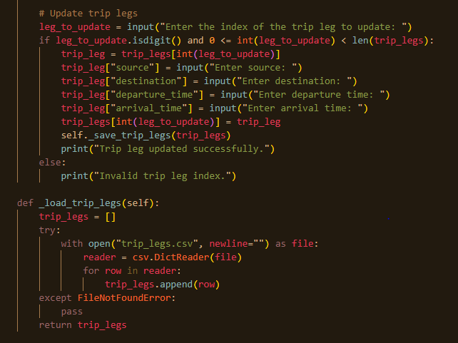

This is the next function of the admin class including a function related to legs. This function took some input values from the user and then on the basis of input store information. And last there is a function to load_trip_legs with some expectation handling to catch the errors to avoid program termination.

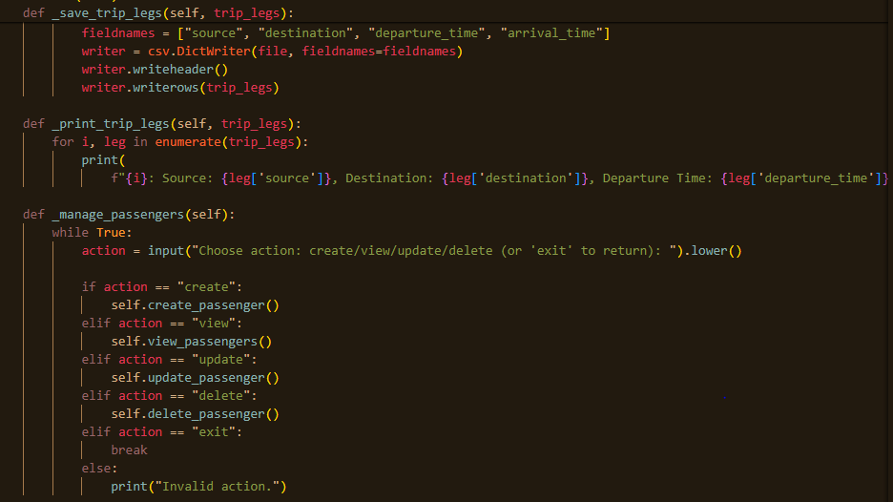

These are the other functions of the admin class, which handle all the passenger operations like create passengers, update passengers, view passengers and last delete passengers. All the information is stored in the program and whenever the admin wants to see the information and other things it is all stored within the program.

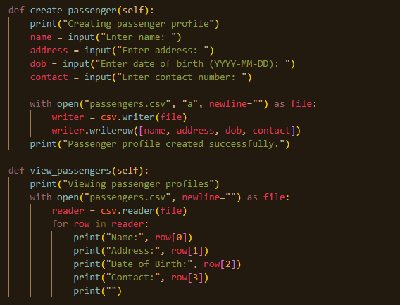

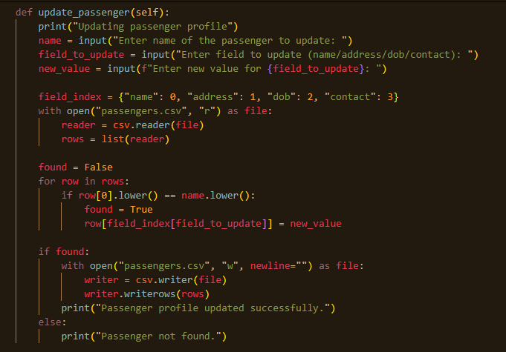

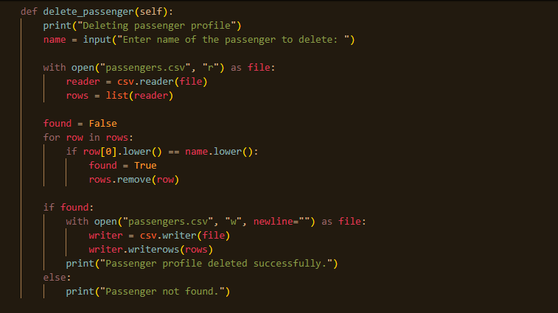

These are the crud functions which the application handles whenever the admin wants to create, update, read and delete all these operations. In this code snippet there are some loops which handle all the inputs one by one and all the actions are implemented and last when the user wants to update the record if user information is stored it is updated otherwise it gives in a console passenger not found.

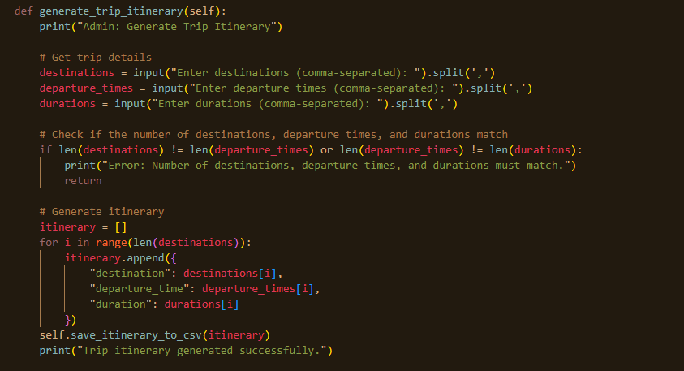

In this function of the code there is information related to generate_trip_litrarry all the information related to trip including location, departure time and duration are taken input from the user.

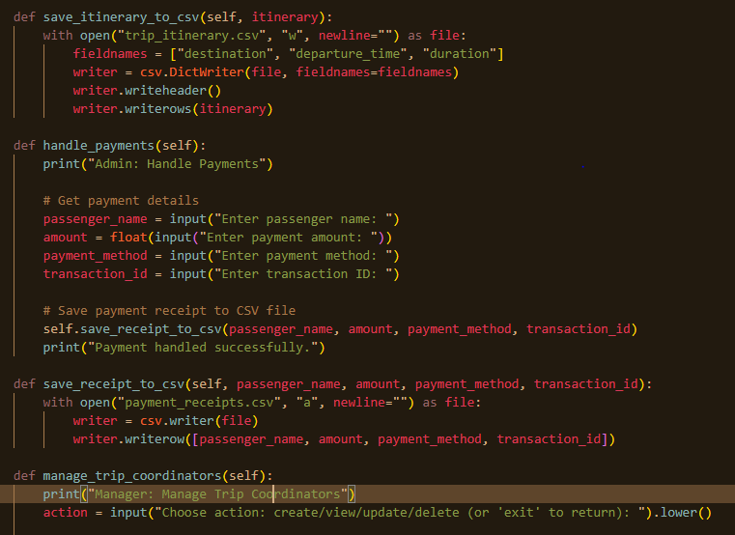

In these code lines all the information which is taken from the user related to trip information are stored in the separate csv files. In the above code snippet there are a lot more functions which handle payments and store information.

There are alot more functions related to coordinator view, update, delete, add and much more information, so keep in mind the maximum word count the admin main part of admin’s class are defined. Next step is to define the manager class.

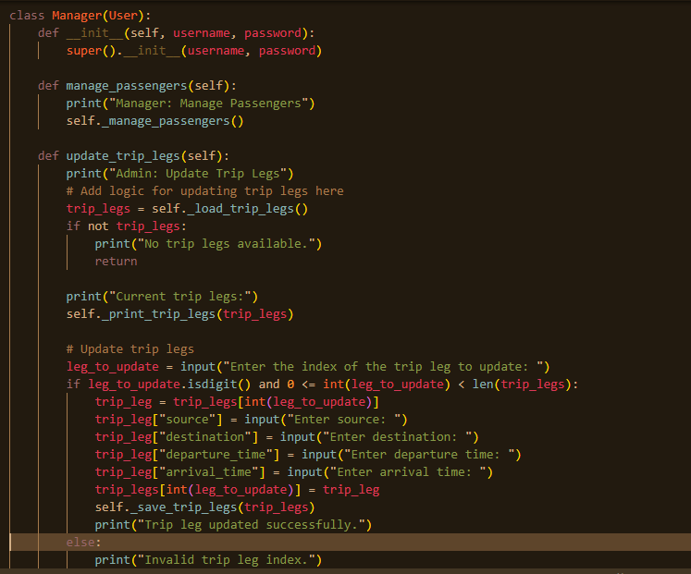

This is the next class of the travel management system. This class is the same as other classes. There is some login information. After successful login the user can enter the manager class and perform the manager’s functions. Like managing passengers, updating all the trip legs, etc.

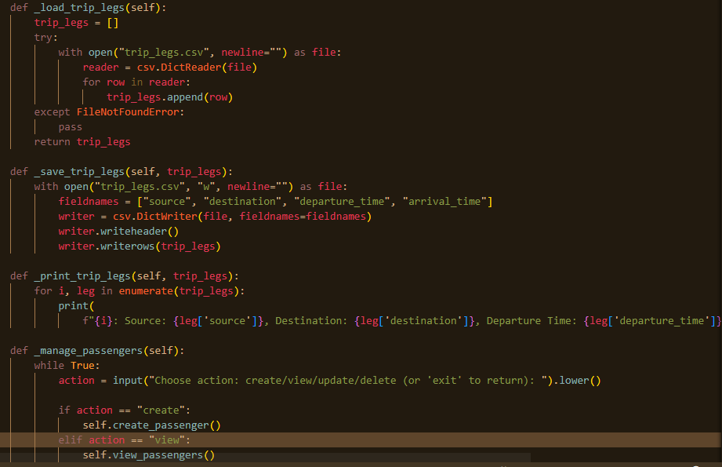

These manager’s functions are to handle all the information related to trips like save, print and load all the trip legs. And the manager also performs the same operation of update, create, read and delete functions to add and store the information of the user.

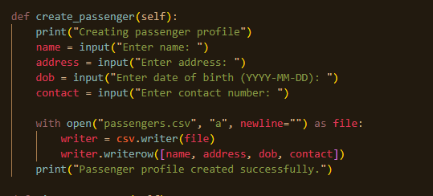

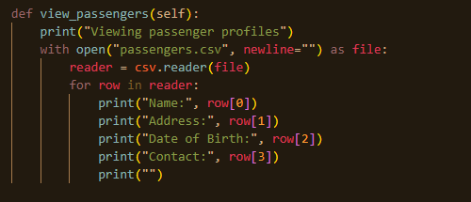

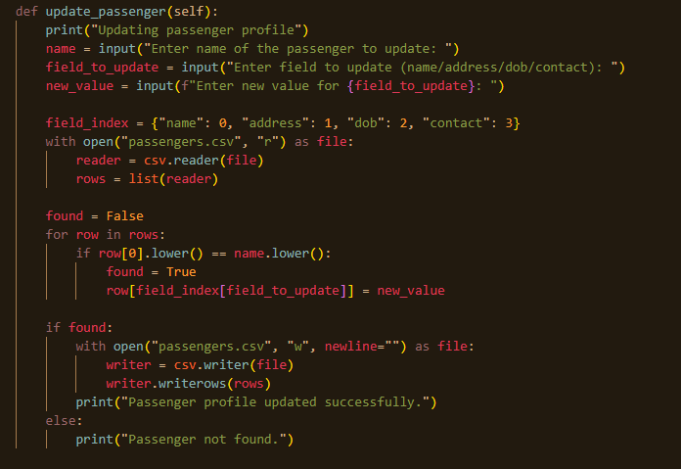

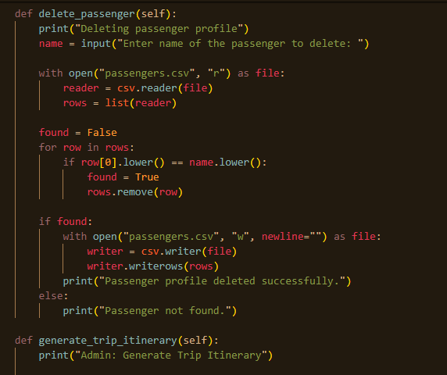

These are the crud functions which are implemented by the manager’s class. The manager can perform all the functions as needed for manipulating the data of the passengers. And perform these crud operations as needed.

Next all the trips related functions are implemented, trip information include generating trip literature, saving trip literature to csv, handling payments, saving receipts to csv, managing trips coordinator, creating trip coordination and much more. These all are functions are implemented.

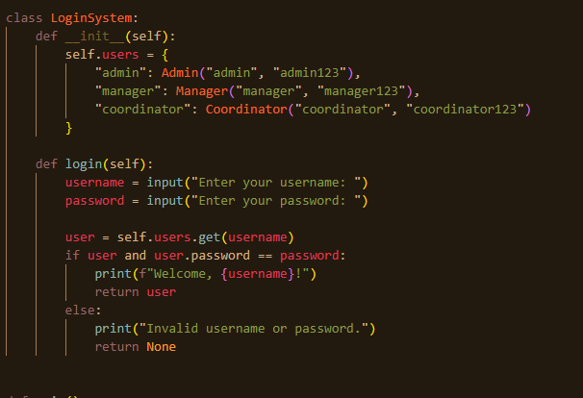

Now this is the last class login system, in this login system class first all the login information is stored without this information the user can’t access the class and can; perform any operation to the class. Then after the information there are input instructions which take input from the user and match the user input with the stored usernames and passwords. If username and password are matched and corrected, then the user can enter the management system and can perform all the related tasks. Like if a user enters username and password for admin, the user can perform admin’s related tasks same for other functions for manager and coordinator as well.

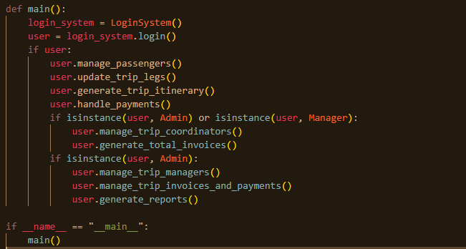

Last there is a main function, the main function is also known as the backbone of the whole management system. Because without this function the developer or programmer can't run the management system. In this main function, the first login system class is called for getting information from the user, whether the user is admin, coordinator, manager or someone else who tried to run the code, after successfully authentication and security the user can perform all the tasks which are written in the code.

# Conclusion

In this assessment the project is related to developing a system which can handle all the information of the travel agency and also can say it is a digital travel agency which handles all the passenger’s information, their data and multiple other tasks. This code defines all the necessary information which are important for the management system to be implemented. First there is admin class, then manager, then coordinator. These are the main actors of the class and for all these actors the create, delete, update and last view these crud operations are implemented. To make it easier for the customer, the university of Solent gave this project. To work with the real world mechanism and understand the logic behind these types of comprehensive management systems. Also in this report there are some UML diagrams which help users to understand the internal logic of the code. After reading this comprehensive report the reader can easily understand the travel management system which are built on the python language.

# References

Hill, C., 2020. Learning scientific programming with Python. Cambridge University Press.

Koç, H., Erdoğan, A.M., Barjakly, Y. and Peker, S., 2021, March. UML diagrams in software engineering research: a systematic literature review. In Proceedings (Vol. 74, No. 1, p. 13). MDPI.

Lemenkova, P., 2020. Python libraries matplotlib, seaborn and pandas for visualization geo-spatial datasets generated by QGIS. Analele stiintifice ale Universitatii" Alexandru Ioan Cuza" din Iasi-seria Geografie, 64(1), pp.13-32.

Nezdoyminov, S., Bedradina, G., Mikhailyuk, E. and Martynova, N., 2020. ASSESSMENT OF THE PROGRESS OF THE QUALITY MANAGEMENT SYSTEM IN TRAVEL COMPANIES. Revista Turismo Estudos e Práticas-RTEP/UERN, (5), pp.1-13.

Tiwari, R.G., Srivastava, A.P., Bhardwaj, G. and Kumar, V., 2021, April. Exploiting UML diagrams for test case generation: a review. In 2021 2nd international conference on intelligent engineering and management (ICIEM) (pp. 457-460). IEEE.