Kunal Kushwaha

## Entry No - 2023 B.Tech -Dr. A. P. J. Abdul Kalam Technical University , Lucknow

[Portfolio:- KunalKushwaha.vercel.app](https://rohitsengar.vercel.app/)

# Technical Skills

 Programming: JavaScript, TypeScript, HTML, CSS Frontend: React, Next.js, Redux, Tailwind CSS

 Backend: Node.js, Express.js, Firebase  Database: MongoDB, NeonDB

Tools: Git, GitHub, Postman, VS Code, Vercel, Jupyter



# Projects

+**91-8630498561**

kushwahakunal733[@gmail.com](https://www.linkedin.com/in/yogesh-sengar-982465232/)

## linkedin.com/in/kunal-kushwaha-a25810294

### URL Shortner

Role: Full Stack Developer | URL Shortner

Sep 2025 - Oct 2025

Developed NeuroFitness, an AI-powered fitness app with custom workouts, nutrition tracking, AI chat, shop, health tools, and community features. It includes personalized dashboards for users, trainers, and an admin panel for full platform management. Users track progress and generate AIbased diets, while trainers manage sessions, communities, and monetize plans.

### AI SAAS Application

Aug 2025 - Sep 2025

AI Course Creator lets users generate personalized courses by inputting a topic, level, and chapters. The AI

creates a full curriculum with descriptions and images, while users customize content and track progress via a dashboard. It offers interactive AI tutoring, quizzes, video resources, and real-time assistance for an immersive learning experience.

### [Volume](https://food-waste-reduction-eta.vercel.app/) Controller

Developed Food Share, a platform to sell or donate excess or near-expiry food. Users can create profilefse,bli2s0t24 - june 2024

items, and track food sharing stats. Encourages a community-driven approach to reduce food waste and support those in need.

# Work Experience

* CodSoft

 Web Development Intern

 Built a modern, user-friendly interface for Url Shortner using Next, tailwind, JavaScript ,

Firebase , Cloudnary.

 Leveraged Next.js for server-side rendering to create a fast, SEO-optimized NeuroFitness platform .

 Integrated JavaScript to enforce strict typing across neurofitness’s frontend and backend.

Education

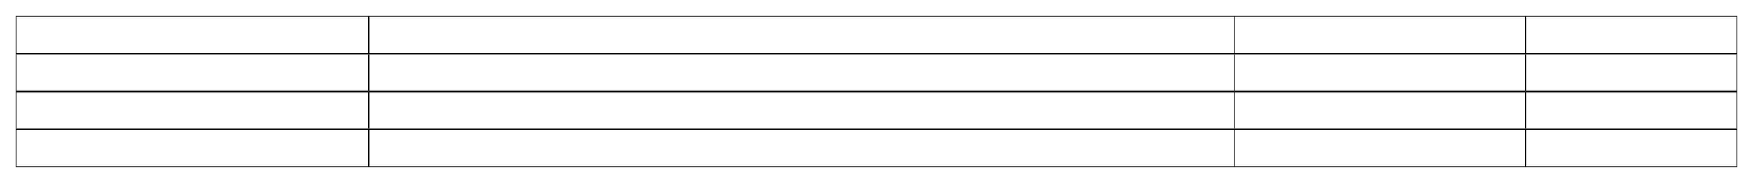

Degree Bachelor of Technology

Senior Secondary Secondary

Institute/Board

Dr. A. P. J. Abdul Kalam Technical University, Lucknow Central Board of Secondary Education

Central Board of Secondary Education

CGPA/Percentage

7.52/10 (Current) 89.6%

94.2%

Year 2023- Present 2023

2021

July 2024 - Sep 2024

# Key courses taken

 Full Stack Web Development

 Backend Development with Node.js and Express

 Database Design and Management (MongoDB, NeonDB)

# Miscellaneous

 Built and deployed 10+ full-stack web applications using React, Next.js, Node.js, and Firebase  Contributed to open-source repositories and collaborated with other developers on GitHub

 Experienced in deploying apps using Vercel, Render, and Firebase Hosting  Integrated secure authentication systems using JWT and Firebase Auth

 Built admin panels, dashboards, and custom CMS platforms for project and client use  Explored AI integration with web apps. (e.g., AI-powered fitness and course platforms)