HOSPITAL PATIENT CARE
ANALYTICS PIPELINE
An End-to-End ETL Data Engineering Solution
Case Study – Data Engineering Fundamentals

Submitted by | KUNAPULI BALA SRI SARVANI
Project Domain | Healthcare Data Engineering
Pipeline | Extract → Transform → Validate → Load → Analytics
Technology | Python • Pandas • MySQL • SQLAlchemy • SQL

Synthetic Data • Reproducible ETL Workflow

Contents

- 1. Problem Statement
- 2. Objectives and Scope
- 3. Understanding the Data Sources
- 4. Solution Architecture and Workflow
- 5. Project Structure
- 6. Step 1 – Extract
- 7. Step 2 – Transform and Integrate
- 8. Step 3 – Validate
- 9. Step 4 – Load
- 10. SQL Analytics
- 11. Pipeline Execution
- 12. Security, Privacy and Data Governance
- 13. Challenges and Solutions
- 14. Future Scope
- 15. Conclusion

1. Problem Statement
A multi-specialty hospital generates operational and patient-related data across several systems: patient registration, appointment scheduling, laboratory reports, vital-sign/wearable measurements, and doctor consultations. When these sources remain separate, it becomes difficult to create a unified view of patient activity and operational performance.
This project implements a practical end-to-end Data Engineering solution that extracts the five source datasets, integrates and transforms them, validates data quality, loads the resulting analytical dataset into MySQL, and enables SQL-based analysis of waiting times, departments, and analytical risk indicators.

2. Objectives and Scope
Objective | What the pipeline delivers
Reduce waiting-time visibility | Waiting time and waiting-category features for each patient visit
Improve data integration | One patient-level analytical view combining five hospital source datasets
Support risk-oriented analytics | Synthetic rule-based risk indicators using selected patient, lab and vital attributes
Ensure trustworthy data | Validation gate prevents invalid records from reaching the database
Enable analysis | MySQL storage and reusable SQL queries for operational KPIs

3. Understanding the Data Sources
Source | Format | Purpose
Patient registration | CSV | Demographics and patient master information
Appointment scheduling | CSV | Scheduled visits and timing information
Laboratory reports | CSV | Lab results/status used for analytical indicators
Vitals / wearable data | CSV | Blood pressure, SpO₂ and other vital measurements
Doctor consultations | CSV | Consultation timing and clinical visit context
All five source datasets use patient_id as the integration key. Synthetic data is used because real patient records are confidential and unsuitable for a classroom repository.

4. Solution Architecture and Workflow
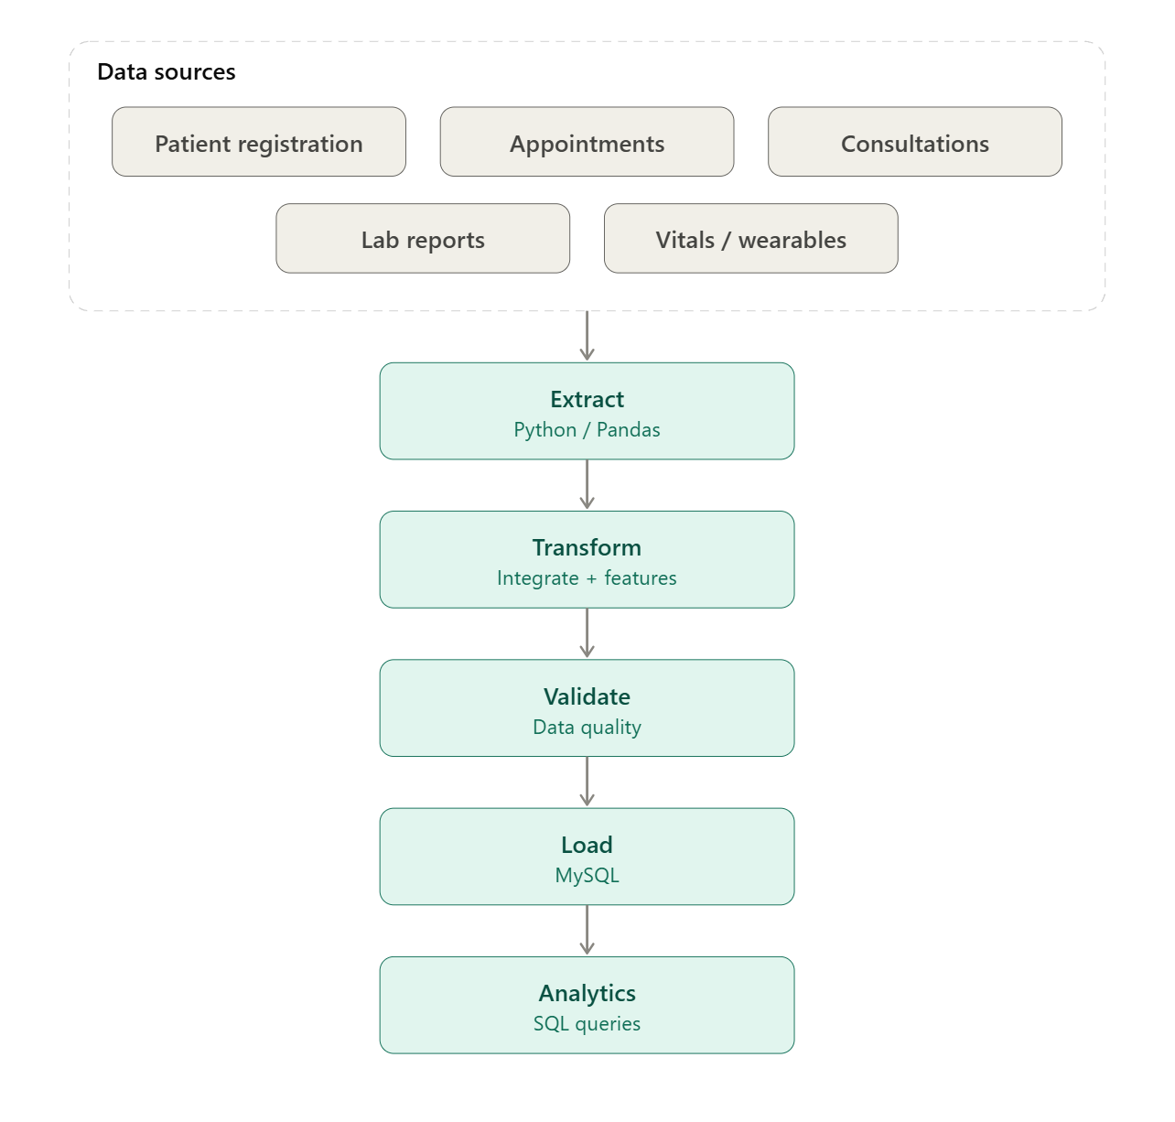
Figure 1. End-to-end architecture of the implemented hospital ETL pipeline.

5. Project Structure
Hospital Patient Care Analytics Pipeline/
├── patients.csv
├── appointments.csv
├── labs.csv
├── vitals.csv
├── consultations.csv
├── extract.py
├── Transform.py
├── Validation.py
├── Load.py
├── Config.py
├── pipeline.py
├── setup.sql
├── requirements.txt
├── README.md
└── Hospital_Patient_Care_Analytics_Report.docx

6. Step 1 – Extract
extract.py reads the five CSV source systems with Pandas and reports the number of records extracted from each source. The extraction stage preserves the source information for downstream transformation.
Expected source counts in the classroom dataset:
- Patients: 10 rows
- Appointments: 10 rows
- Labs: 10 rows
- Vitals: 10 rows
- Consultations: 10 rows

7. Step 2 – Transform and Integrate
Transform.py combines the source datasets using patient_id and prepares an analysis-ready patient-level dataset.
- Missing-value handling and standardisation
- Waiting-time calculation from appointment and consultation timing
- Waiting-time categorisation: Short, Moderate and Long
- Creation of risk_points from synthetic analytical indicators
- Creation of risk_flag categories for analytical grouping
- Generation of the final transformed dataset

8. Step 3 – Validate
Validation.py acts as a quality gate between transformation and loading. The pipeline continues only when the validation rules pass.
- No remaining null values
- Valid patient identifiers
- Valid age values
- Waiting time is not negative
- Valid analytical risk categories
- Expected transformed dataset structure
Validation result: Validation Passed

9. Step 4 – Load
Load.py uses SQLAlchemy/database connectivity to write the validated analytical dataset into MySQL.
Database | hospital_db
Target table | patient_care_analytics
The pipeline successfully loaded the transformed dataset into the target table during testing.

10. SQL Analytics
Once the data is stored in MySQL, SQL queries can answer the hospital's operational questions.
- Average waiting time by department
- Maximum waiting time by department
- Long waiting-time cases
- Risk-category distribution
- Medium/high analytical risk cases
- Department-level patient-care KPIs
Example department KPI query:
SELECT department,
COUNT(*) AS patients,
ROUND(AVG(waiting_minutes), 2) AS avg_wait_minutes,
SUM(CASE WHEN waiting_category = 'Long' THEN 1 ELSE 0 END) AS long_wait_cases,
SUM(CASE WHEN risk_flag = 'High' THEN 1 ELSE 0 END) AS high_risk_cases
FROM patient_care_analytics
GROUP BY department;

11. Pipeline Execution
The complete workflow is orchestrated by pipeline.py:
Extract → Transform → Validate → Load
Successful execution produced the following output:
Patients: 10 rows
Appointments: 10 rows
Labs: 10 rows
Vitals: 10 rows
Consultations: 10 rows
Transformed Shape: (10, 22)
Validation Passed
Loaded 10 rows into 'patient_care_analytics' table

12. Security, Privacy and Data Governance
- No real patient information is used; the repository uses synthetic classroom data.
- Database credentials should be supplied locally and must not be committed to GitHub.
- Generated Python cache files such as __pycache__ should not be uploaded.
- Production deployments would require role-based access control, encryption, auditing and stronger privacy controls.
This project demonstrates the engineering pattern; production healthcare systems require substantially stronger governance and security controls.

13. Challenges and Solutions
Challenge | Solution in this project
Multiple hospital source datasets | Separate extraction and transformation logic followed by patient_id-based integration
Missing/inconsistent values | Transformation layer handles cleaning before validation
Waiting-time visibility | Derived waiting_minutes and waiting_category features
Incorrect data reaching MySQL | Validation gate checks the transformed dataset before loading
Sensitive healthcare context | Synthetic data and credential-safety guidance

14. Future Scope
- Incremental ETL and scheduled orchestration with Airflow
- Cloud storage / data lake architecture using Bronze–Silver–Gold layers
- Data warehouse modelling with fact and dimension tables
- Real-time wearable ingestion using Kafka and stream processing
- Replacement of rule-based indicators with a properly trained ML model using validated historical data
- Dashboard integration with Power BI, Tableau or Streamlit
- Centralised logging, monitoring and alerting
These are future enhancements and are not claimed as implemented components of the current submission.

15. Conclusion
This project demonstrates a complete, reproducible end-to-end Data Engineering workflow for a hospital use case. Five synthetic source datasets are extracted, integrated and transformed, passed through a validation gate, loaded into MySQL, and made available for SQL analytics. The modular design follows the ETL concepts taught in Data Engineering Fundamentals while leaving a clear path toward cloud, streaming, warehouse, dashboard and machine-learning extensions.

