Name: k Yaswanth Kumar

Reg no: 192111187

1. Print the numbers and character variables, we use the same count object but without using quotation marks.

#include <iostream>

using namespace std;

int main() {

int num1 = 70;

double num2 = 256.783;

char ch = 'A';

cout << num1 << endl;

cout << num2 << endl;

cout << "character: " << ch << endl;

return 0;

}

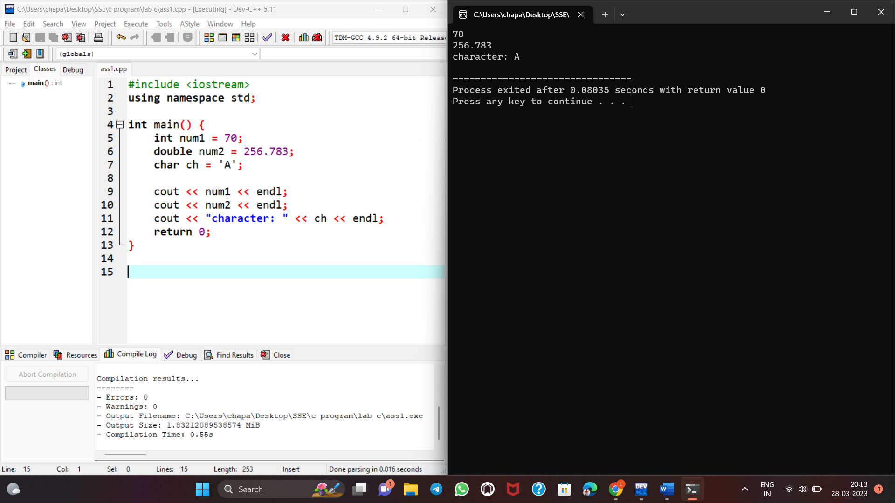

2.Print the numbers by taking input from keyboard using cin object.

#include <iostream>

using namespace std;

int main()

{

int num;

cout << "Enter an integer: ";

cin >> num;

cout << "The number is: " << num;

return 0;

}

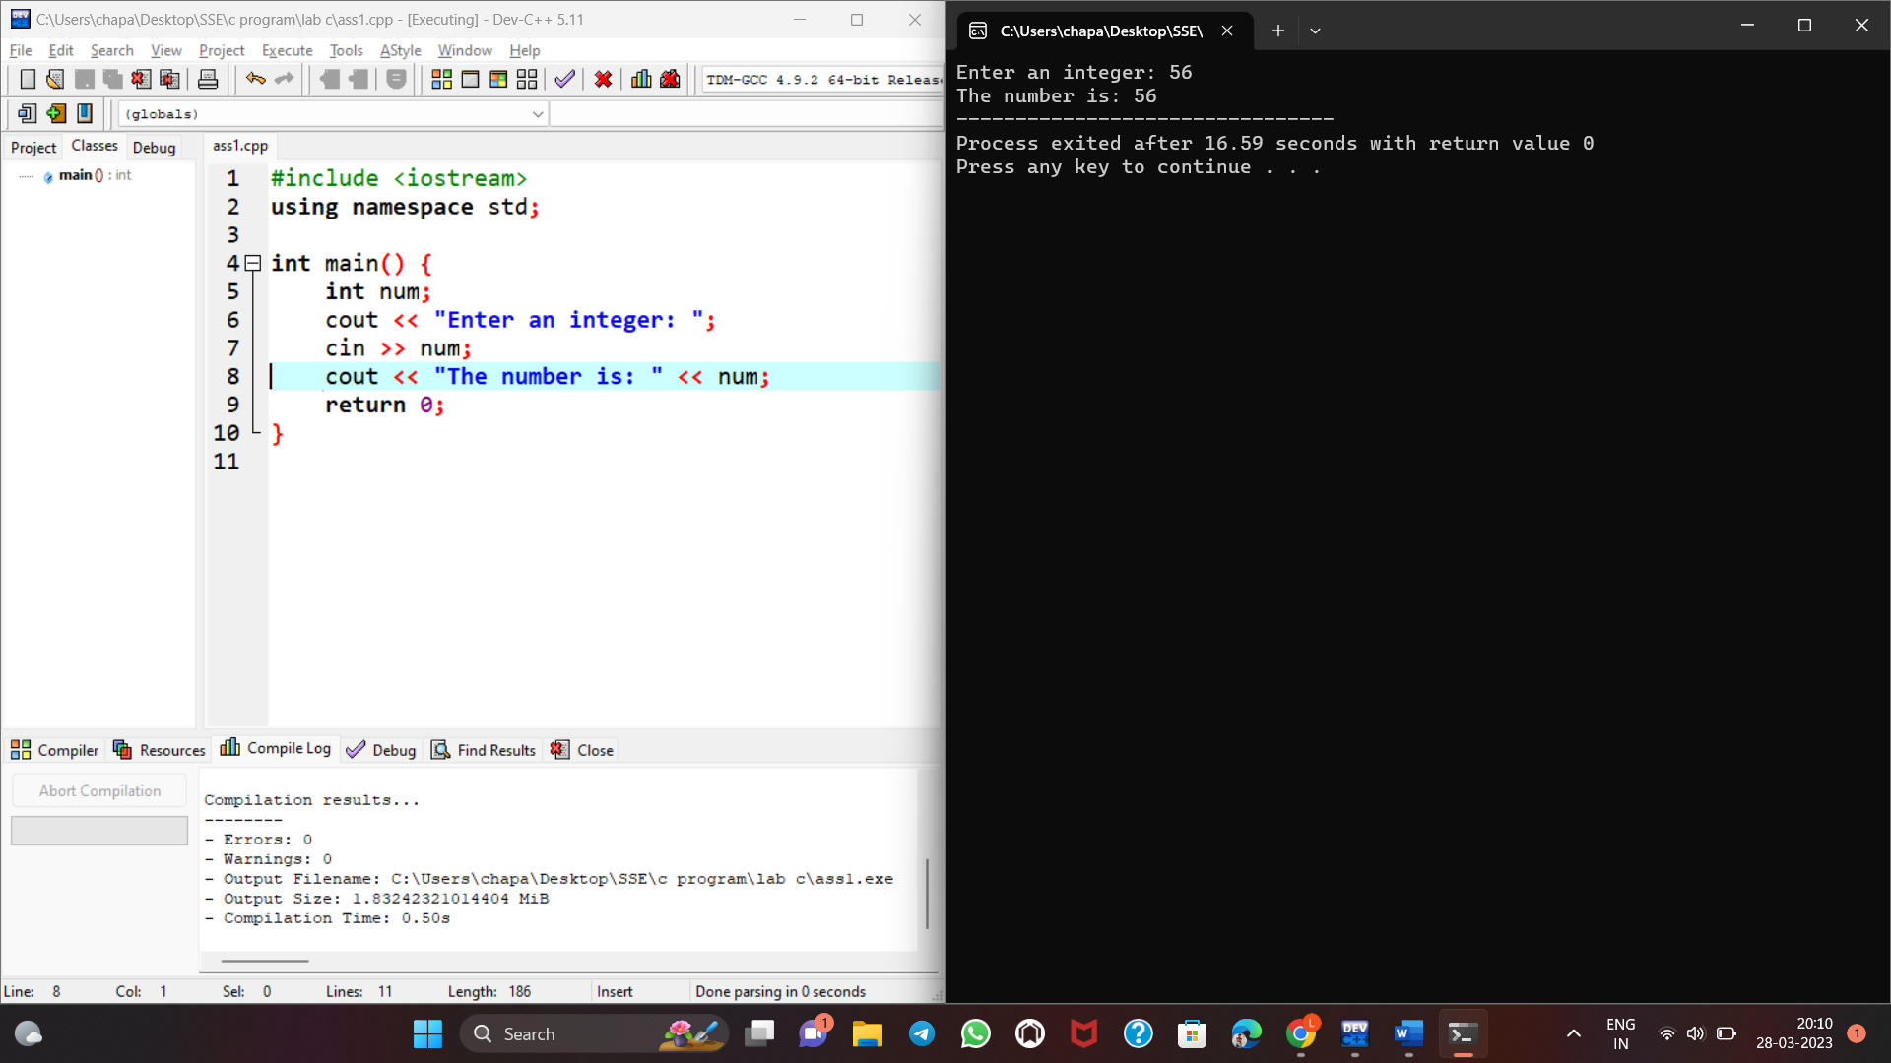

1. Write a program in c++ by taking multiple input from keyboard using cin object and cout object.

using namespace std;

#include<iostream>

int main()

{

char a;

int num;

cout << "Enter a character and an integer: ";

cin >> a >> num;

cout << "Character: " << a << endl;

cout << "Number: " << num;

return 0;

}

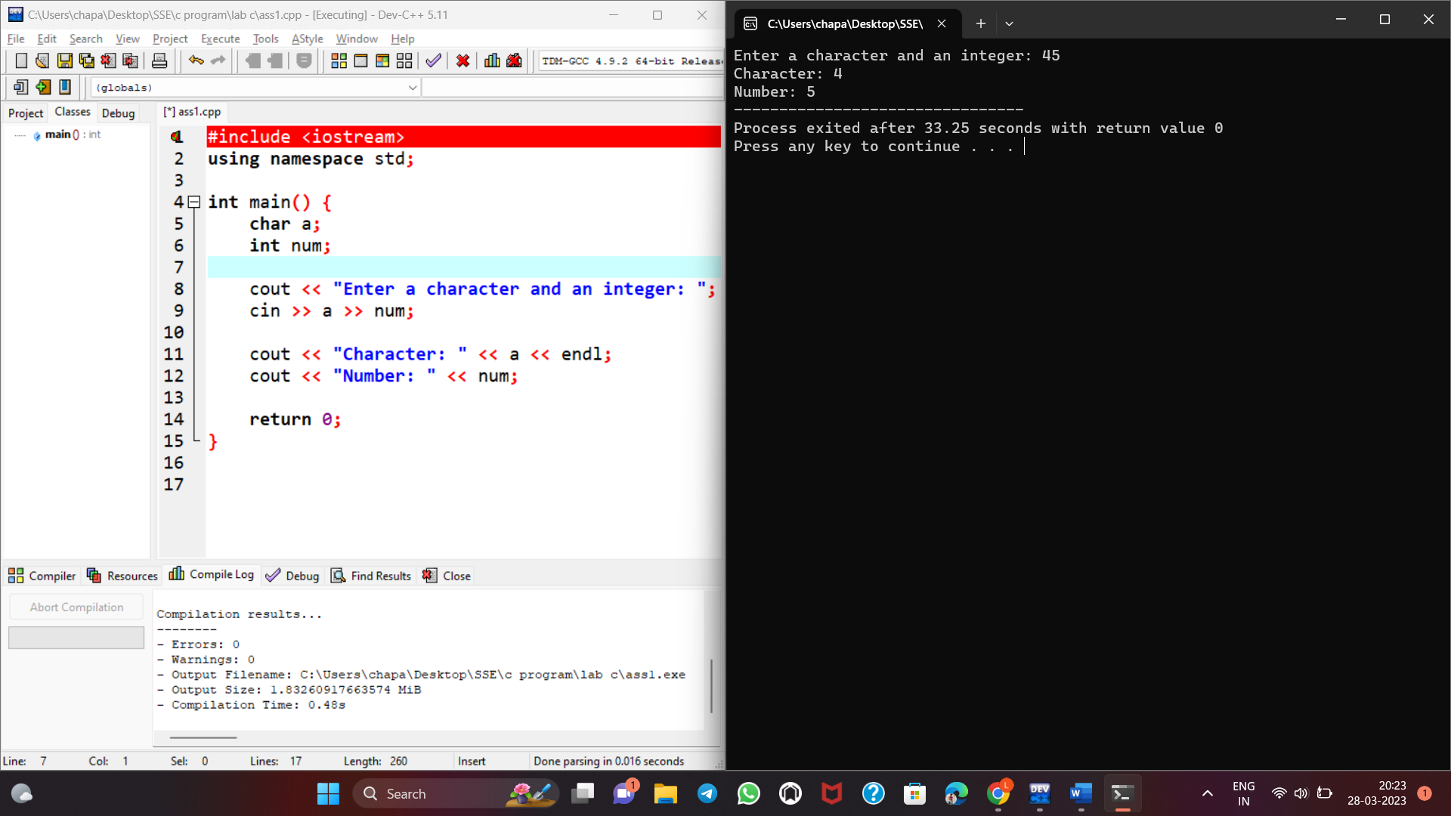

**4.Check if a number is even or odd.**

#include <iostream>

using namespace std;

int main() {

int a ;

cin>>a;

if(a%2 == 0)

cout<<"even";

else cout<<"odd";

return 0;

}

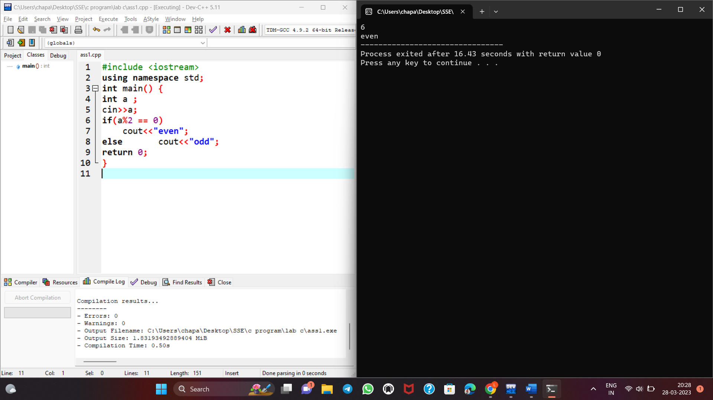

**5.find error in this program**

**#include  
#include  
Using namespace Std;  
int main();  
{  
int number;  
for(i=1; i<=6, i++)  
{  
cout<<"Value of variable i is: "<<number<<endl;  
getch();  
}**

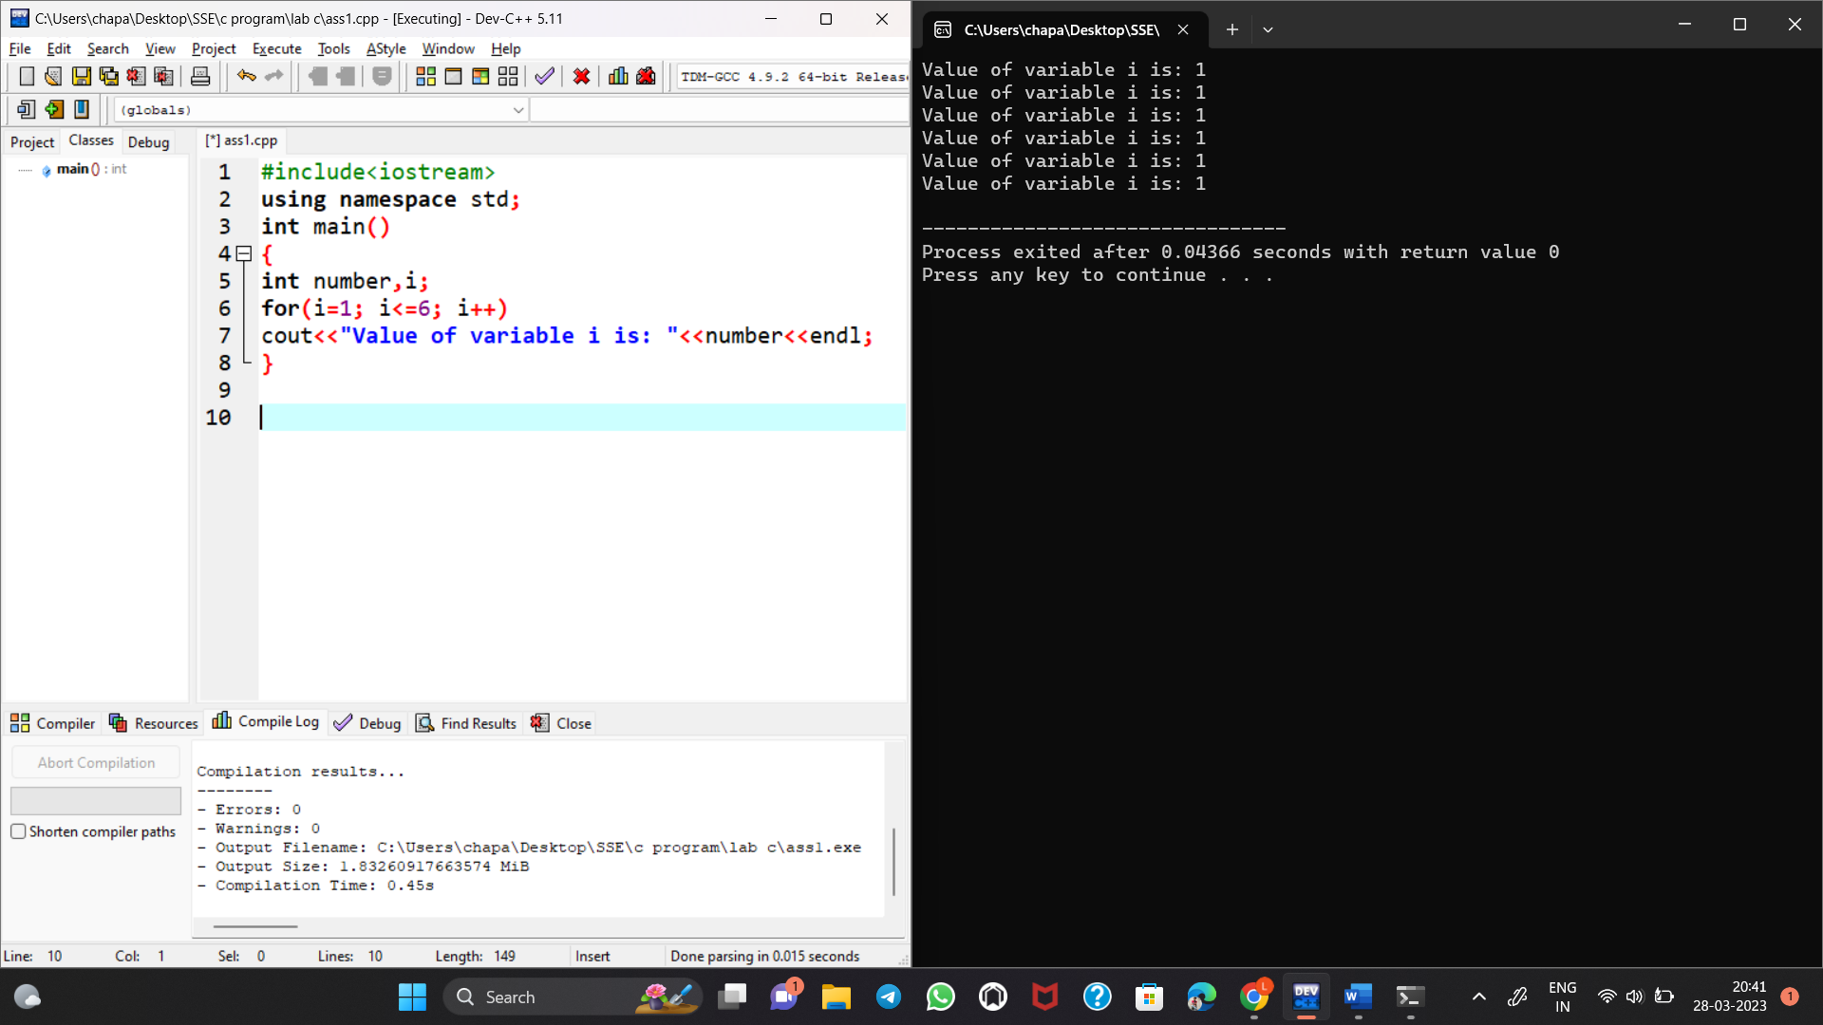

**6. #include  
void main()  
{ int public=10;  
cout<public;  
}**

**#include<iostream>**

**using namespace std;**

**int main()**

**{**

**int p=10;**

**cout<<p;**

**}**

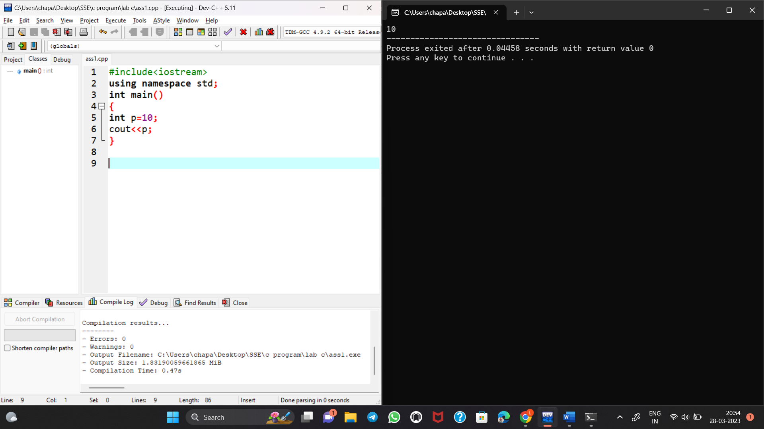

7.Write a c++ code for swapping of two numbers .

using namespace std;

#include<iostream>

int main()

{

int temp,a=40,b=50;

temp=a;

a=b;

b=temp;

cout<<"after swap a=\n"<<a;

cout<<"after swap b=\n"<<b;

}

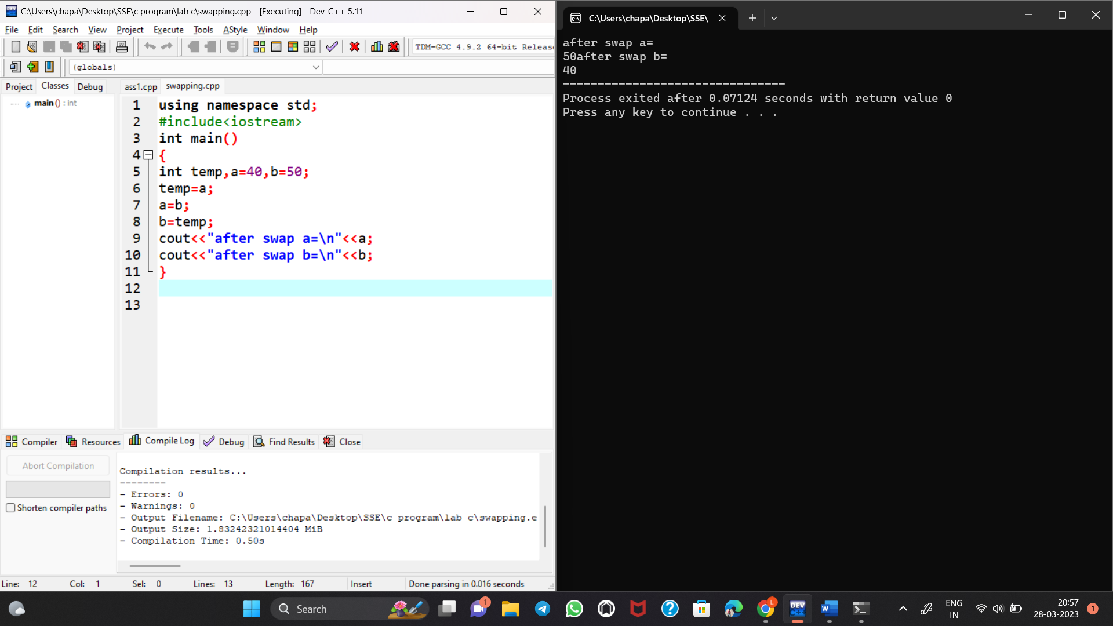

8.Wrapping data and its related functionality into a single entity is known as _____________  
a) Abstraction  
b) Encapsulation  
c) Polymorphism  
d) Modularity

**encapsulation**

**Explanation: In OOPs, the property of enclosing data and its related functions into a single entity(in C++ we call them classes) is called encapsulation**

**9. What happens if the following program is executed in C and C++?**

**#include<stdio.h>**

**int main()**

**{**

**foo();**

**}**

**int foo()**

**{**

**printf("Hello");**

**return 0;**

**}**

**Error in both C and C++  
b) Warning in both C and C++  
c) Error in C++ but Warning in C  
d) Error in C but Warning in C++**

**View Answer**

**Answer: c  
Explanation: In C++ all the functions should be declared before it is called otherwise the C++ compiler will give an error but in case of C the compiler just gives a warning and the program can be executed.**

10. Write a C++ code to area of circle and area of rectangle

#include <iostream>

using namespace std;

int main()

{

int length, breadth, area;

cout << "Enter the length of the rectangle: ";

cin >> length;

cout << "Enter the breadth of the rectangle: ";

cin >> breadth;

area = length * breadth;

cout << "Area of Rectangle: " << area;

return 0;

}

