Customer Churn Analysis Using Machine Learning and Power BI
Prepared By: Afzal Rangrej
Internship 1st Project Report
2026

Executive Summary
This project analyzes customer churn in a telecommunications company using machine learning and Power BI. The objective is to identify churn drivers, understand customer behavior, segment customers by value, and provide actionable business insights.

Project Objectives
• Analyze customer churn patterns.
• Identify major churn factors.
• Build predictive analytics workflows.
• Segment customers by value.
• Create interactive Power BI dashboards.
• Support customer retention strategies.

Dataset Overview
Dataset: Telco Customer Churn Dataset
Records: 7,032 customers
Target Variable: Churn
Key Features: Gender, Contract, Internet Service, Tenure, Monthly Charges, Total Charges, Tech Support, Online Security, Dependents, Senior Citizen.

Dashboard 1: Executive Summary

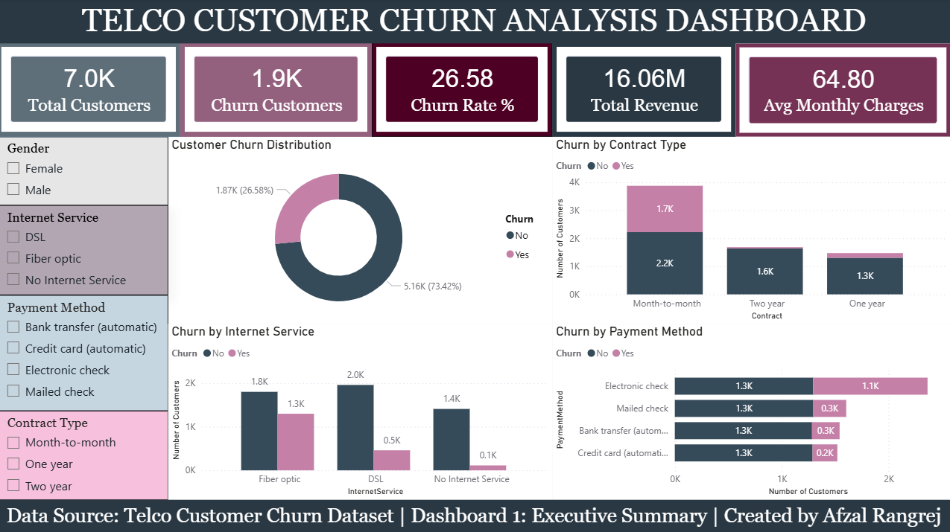
Dashboard 1 provides an executive overview of customer churn performance. It highlights Total Customers (7.0K), Churn Customers (1.9K), Churn Rate (26.58%), Total Revenue (16.06M), and Average Monthly Charges (64.80). Analysis by contract type, internet service, and payment method helps stakeholders quickly identify churn patterns.

Dashboard 2: Customer Insights

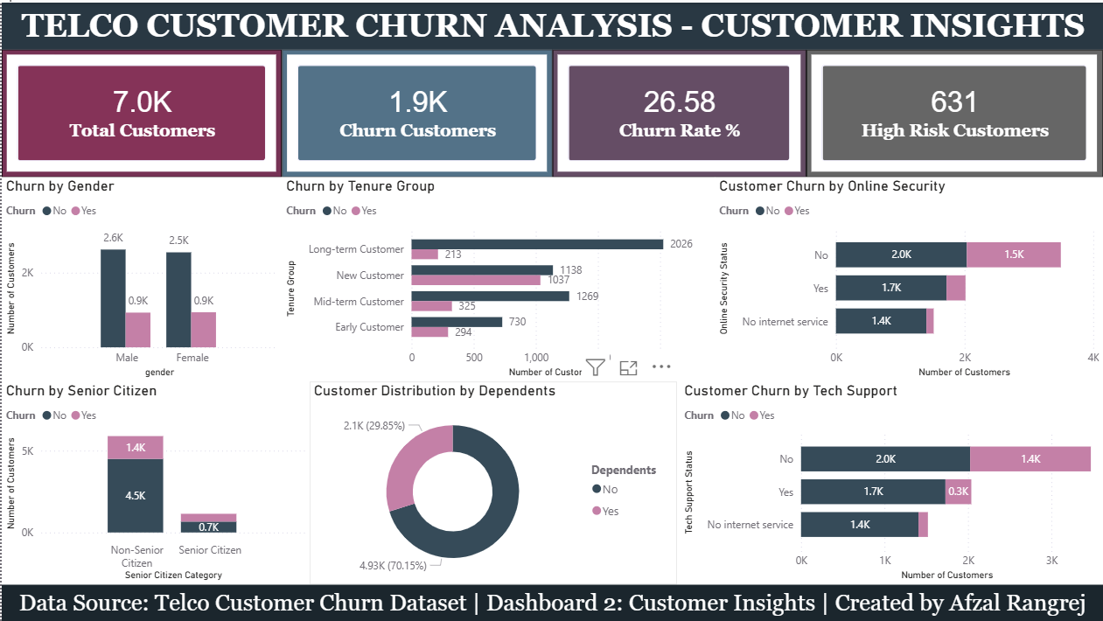
Dashboard 2 focuses on customer behavior and churn drivers. Key insights show that customers without Online Security and Tech Support have higher churn. New and short-tenure customers are more likely to churn, while gender has minimal impact. Senior citizens demonstrate a relatively higher churn proportion.

Dashboard 3: Customer Value & Segmentation Analysis

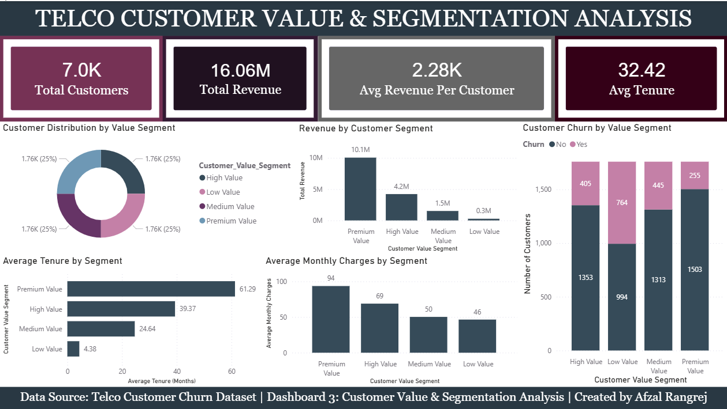
Dashboard 3 analyzes customer value segments. Premium Value customers generate the highest revenue, have the highest average tenure, and contribute the greatest monthly charges. Low Value customers exhibit the highest churn proportion, while Premium customers show stronger retention.

Dashboard 4: ML Model Performance & Feature Importance

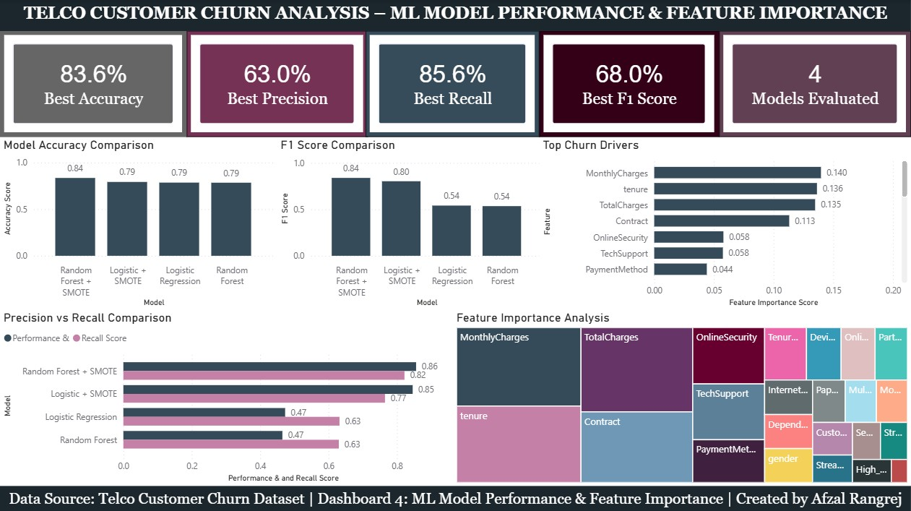

Dashboard 4 presents the performance comparison of four machine learning models used for customer churn prediction, highlighting the best accuracy (83.6%), precision (63.0%), recall (85.6%), and F1-score (68.0%).
The analysis shows that the Random Forest + SMOTE model achieved the strongest overall performance, while Logistic + SMOTE provided competitive results.
Feature importance analysis identifies MonthlyCharges, tenure, TotalCharges, and Contract type as the most influential factors driving customer churn.

Key Business Findings

- Overall churn rate is 26.58%.
- Month-to-month contracts have the highest churn.
- Customers without Online Security churn more frequently.
- Customers without Tech Support show increased churn.
- Premium customers generate the highest revenue.
- Low Value customers have the highest churn proportion.
- Customer tenure is strongly associated with retention.
- Random Forest + SMOTE achieved the best overall churn prediction performance (83.6% accuracy and 68.0% F1-score).
- Monthly Charges, Tenure, Total Charges, and Contract Type are the most influential factors driving churn.
- Higher recall (85.6%) indicates the model effectively identifies customers at risk of churning, supporting proactive retention strategies.

Tools & Technologies

- Python,
- Pandas,
- Scikit-Learn,
- SQL,
- FastAPI,
- Docker,
- Power BI,
- GitHub.

Conclusion

The project successfully delivered a customer churn analytics solution using machine learning and Power BI dashboards. The solution helps businesses understand churn behavior, identify high-risk customers, and improve retention strategies through data.

