Linux Commands Assignment

Name: Kundan Agrawal

# 1. Creating and Renaming Files/Directories

Commands Used:

mkdir test_dir  
cd test_dir  
touch example.txt  
mv example.txt renamed_example.txt  
cd ..

Explanation:

Created a directory named test_dir, created an empty file inside it, and renamed it.

Screenshot: 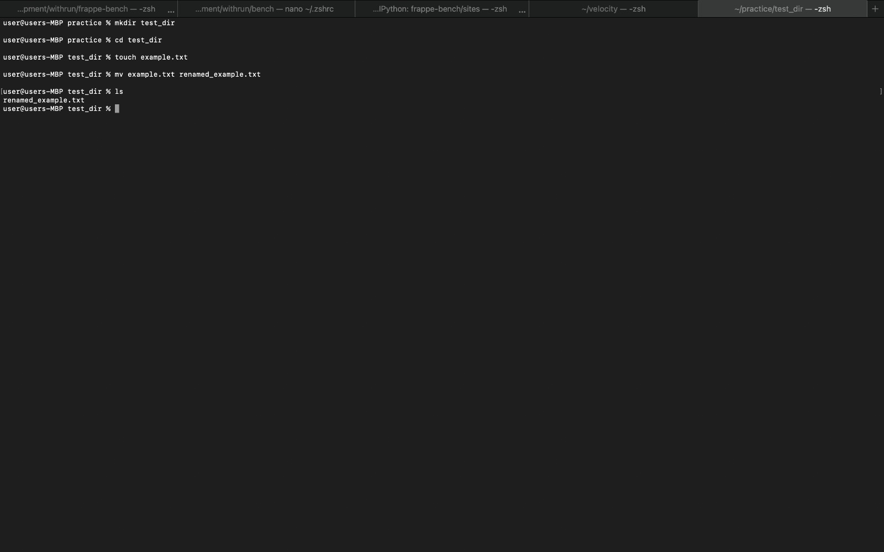

# 2. Viewing File Contents

Commands Used:

cat /etc/passwd  
head -n 5 /etc/passwd  
tail -n 5 /etc/passwd

Explanation:

Displayed the contents of /etc/passwd, then showed first and last 5 lines using head and tail.

Screenshot:   
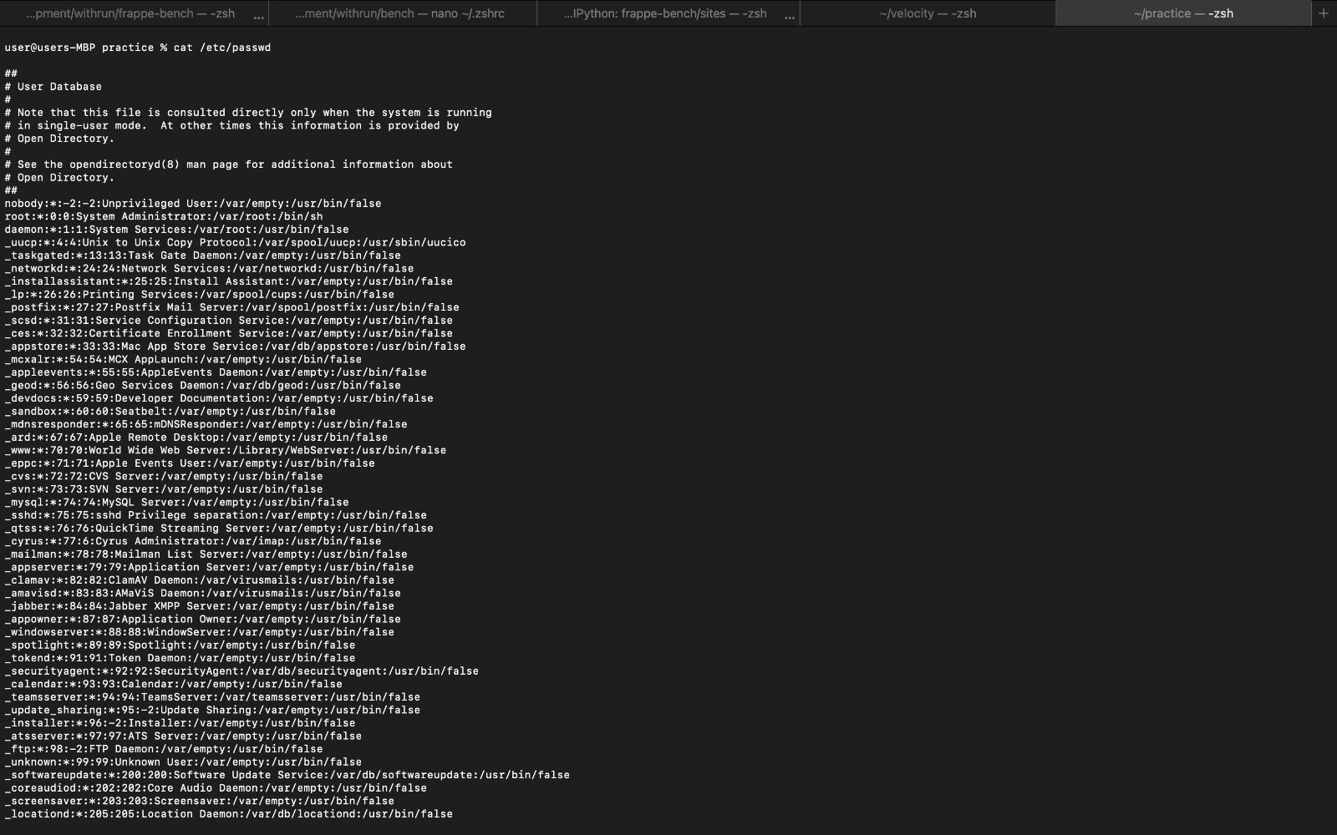

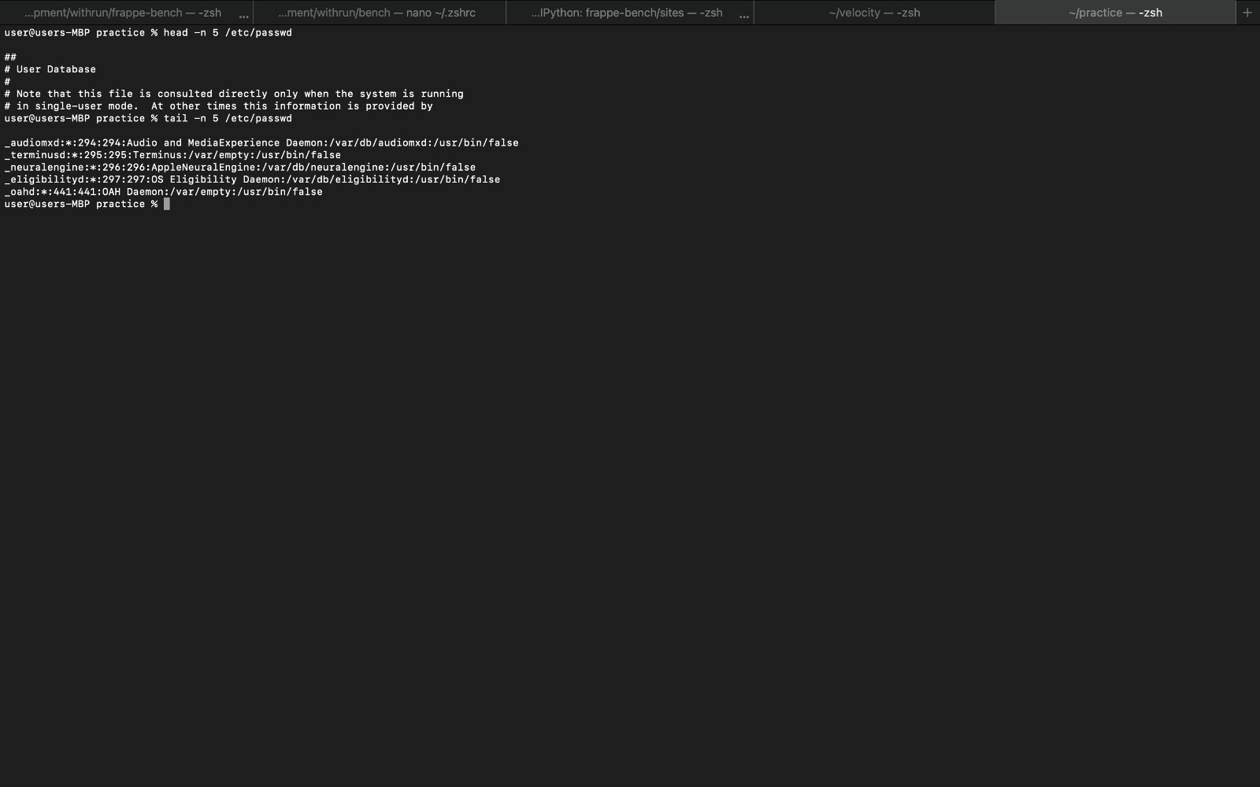

# 3. Searching for Patterns

Commands Used:

grep "root" /etc/passwd

Explanation:

Searched for lines containing the word "root" in the /etc/passwd file.

Screenshot:   
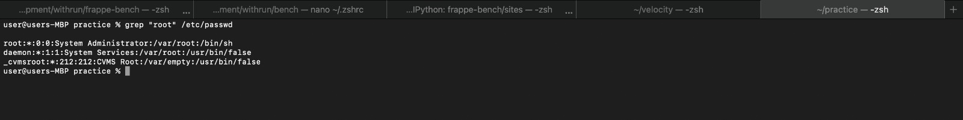

# 4. Zipping and Unzipping

Commands Used:

sudo apt update  
sudo apt install zip unzip -y  
zip -r test_dir.zip test_dir  
mkdir unzipped_dir  
unzip test_dir.zip -d unzipped_dir

Explanation:

Installed zip/unzip tools, zipped test_dir and extracted it into unzipped_dir.

Screenshot: 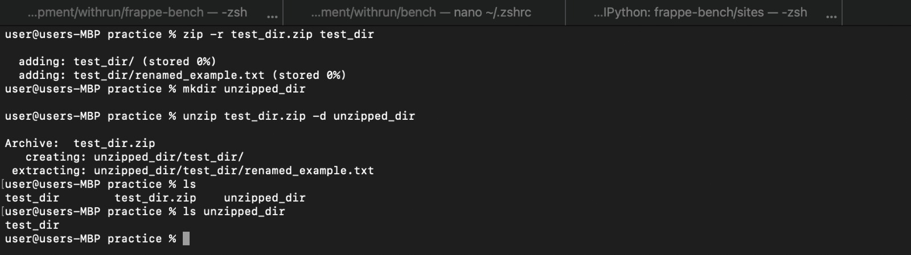

# 5. Downloading Files

Commands Used:  
wget https://example.com/sample.txt

Explanation:

downloaded a file using the wget.

Screenshot:

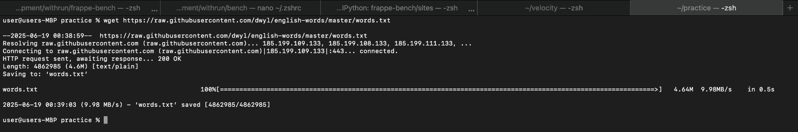

# 6. Changing Permissions

Commands Used:

touch secure.txt  
chmod 444 secure.txt  
ls -l secure.txt

Explanation:

Created a file and made it read-only for everyone using chmod.

Screenshot: 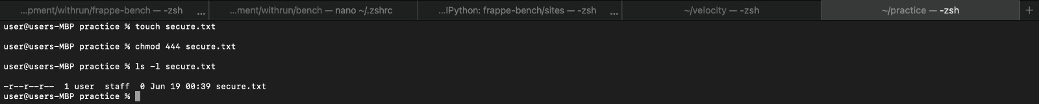

# 7. Working with Environment Variables

Commands Used:

export MY_VAR="Hello, Linux!"  
echo $MY_VAR

Explanation:

Set an environment variable and displayed its value using echo.

Screenshot: 

# GitHub Repository

https://github.com/Kundan1804/Devops/tree/main/linux_commands