HTTPS

**HTTPS** is an abbreviation of **Hypertext Transfer Protocol Secure**. It is a secure extension or version of [HTTP](https://www.javatpoint.com/computer-network-http)

. This protocol is mainly used for providing security to the data sent between a website and the web browser. It is widely used on the internet and used for secure communications. This protocol uses the 443 port number for communicating the data.

This protocol is also called **[HTTP](https://www.javatpoint.com/http-tutorial)**

**over SSL** because the HTTPS communication protocols are encrypted using the SSL (Secure Socket Layer).

By default, it is supported by various web browsers.

Those websites which need login credentials should use the HTTPS protocol for sending the data.

22.6M

490

C++ vs Java

It allows users to create a secured encrypted connection and helps them to protect their information from being stolen.

|  |  |
| --- | --- |
| **HTTP** | **HTTPS** |
| 1. It is an abbreviation of Hypertext Transfer Protocol | 1. It is an abbreviation of Hypertext Transfer Protocol Secure. |
| 2. This protocol operates at the application layer. | 2. This protocol operates at the transport layer. |
| 3. The data which is transferred in HTTP is plain text. | 3. The data which is transferred in HTTPS is encrypted, i.e., ciphertext. |
| 4. By default, this protocol operates on port number 80. | 4. By default, this protocol operates on port number 443. |
| 5. The URL (Uniform Resource Locator) of HTTP start with http:// | 5. The URL (Uniform Resource Locator) of HTTPS start with https:// |
| 6. This protocol does not need any certificate. | 6. But, this protocol requires an SSL (Secure Socket Layer) certificate. |
| 7. Encryption technique is absent in HTTP. | 7. Encryption technique is available or present in HTTPS. |
| 8. The speed of HTTP is fast as compared to HTTPS. | 8. The speed of HTTPS is slow as compared to HTTP. |
| 9. It is un-secure. | 9. It is highly secure. |
| 10. Examples of HTTP websites are Educational Sites, Internet Forums, etc. | 10. Examples of HTTPS websites are shopping websites, banking websites, etc. |

Difference between HTTP and HTTPS

Advantages of HTTPS

Following are the advantages or benefits of a [Hypertext Transfer Protocol Secure (HTTPS)](https://www.javatpoint.com/http-vs-https)

:

* The main advantage of HTTPS is that it provides high security to users.
* Data and information are protected. So, it ensures data protection.
* SSL technology in HTTPS protects the data from third-party or hackers. And this technology builds trust for the users who are using it.
* It helps users by performing banking transactions.

Disadvantages of HTTPS

Following are the disadvantages or limitations of a Hypertext Transfer Protocol Secure (HTTPS):

* The big disadvantage of HTTPS is that users need to purchase the SSL certificate.
* The speed of accessing the website is slow because there are various complexities in communication.
* Users need to update all their internal links.
* HTTPS established an encrypted link between the browser and the web server using the Secure Socket Layer (SSL) or Transport Layer Security (TLS) protocols. TLS is the new version of SSL.

Secure Socket Layer (SSL)

* SSL is the standard security technology for establishing an encrypted link between the two systems. These can be browser to server, server to server or client to server. Basically, SSL ensures that the data transfer between the two systems remains encrypted and private.
* The https is essentially http over SSL. SSL establishes an encrypted link using an SSL certificate which is also known as a digital certificate.
* [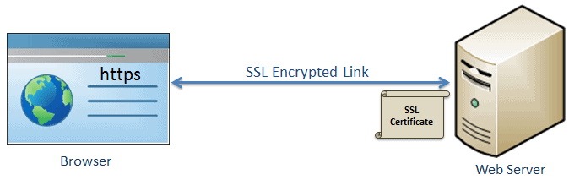](https://www.tutorialsteacher.com/Content/images/https/ssl-link.png) SSL