O F F E R L E T T E R Ref: TEST
Date: h July 2026
{{Date}}

Dear Kundana Talari
Nichebit Softech Private Limited (hereinafter referred to as 'the Company') is a professional IT Services company incorporated under the laws of India, delivering niche technology solutions specialising in Enterprise Integrations, Digital Process Automation, Business Analytics & Business Intelligence, and Product Life Cycle Management.

Based on your application and our subsequent discussions, we are pleased to offer you the position of
Software Engineer at the Company, subject to the following terms and conditions:

· Compensation & Engagement Details
Software Developer

  - Annual CTC: 350000 Rupees Three Lakh Fifty Thousand Only .
  - The detailed salary breakup is attached. Income tax will be applicable as per prevailing norms.
  - Designation: Software Developer
  - Probation Period: _{6 months} he Company reserves the right to extend probation by up to three additional months in specific cases, or to confirm employment prior to the end of probation.
  - Type of Engagement: Full time
  - Location: Hyderabad
  - Working Week: Monday to Friday
  - Date of Commencement: _{{{Jo}t inJ_{i}u_{ng}l_{D}y_{at}2_{e}}0} 26

· Terms of Employment

  - Notice Period - Probation: During the probation period, the Management may terminate services without notice or notice pay if performance is found unsatisfactory, or with cause. Should you choose to resign during probation, you will be liable to pay one month's basic salary or the cost incurred towards training and incidental expenses. The Company retains discretion to waive this obligation.
  - Notice Period - Post Confirmation: Following confirmation of employment, a 90-day notice period applies for resignation. No accrued leave may be utilised during the notice period.
  - Termination for Misconduct: In cases of termination due to misconduct, the employee shall not be entitled to notice period benefits.
  - Background Verification: The Company retains the right to conduct a background check using a professional agency. You agree to cooperate fully. An adverse report may result in immediate termination for cause.

  - Confidentiality: You are required to maintain strict confidentiality regarding all data, information, and know-how generated, procured, or learned, directly or indirectly - during and after your association with the Company. You shall not disclose such information to any person or entity involved in a similar business that could affect the Company's interests.
  - Disclosure Obligation: By accepting this offer, you confirm having disclosed all relevant facts that could adversely affect the working relationship, including but not limited to:

    - Any past or current cases of substance abuse
    - Any past or current cases of criminal history, activities, or offences entailing conviction
    - Any health or related limitations that could impact work, travel, or related responsibilities
    - Any other matters that could have a bearing on your work or deliverables

· Documents Required at Joining

Please furnish the following documents (self-attested copies) at the time of joining:

  - One recent passport-size colour photograph (digital format)
  - Photocopies of all relevant educational certificates
  - Digital copy of Aadhaar Card and PAN Card. If your current address differs from your Aadhaar address, please also provide proof of current address.
  - Letter of Relieving and Experience Certificate from previous employer(s), if applicable
  - Letter of Appointment, last 3 months' payslips, and 6-month bank account statement, if applicable
  - Any certificates or recognitions that support your candidature

· Conditions of this Offer

Acceptance Deadline: ^{h} July 2026
22-09-2026
  - Date of Joining: ^{t} July 2026
22-09-2026
  - Successful completion of the Background Verification process
  - Offer Validity: This offer is valid until ^{h} July 2026 and will become null and void if you do not join on or before this date.
22-09-2026

vbnm
Please note that this document does not constitute a contract of employment. By accepting this offer, you agree to abide by all Company rules and regulations in force as at the date of joining, which will be further detailed in your Appointment Letter and Company policies.

For any clarification, please feel free to reach out to us.

We look forward to a long-standing and mutually enriching association. Welcome to the Nichebit family!

    For Nichebit Softech Private Limited  Apparao Mutyala  Senior Manager — Human Resources | CANDIDATE ACCEPTANCE  I hereby accept the terms and conditions of this offer.  Signature:  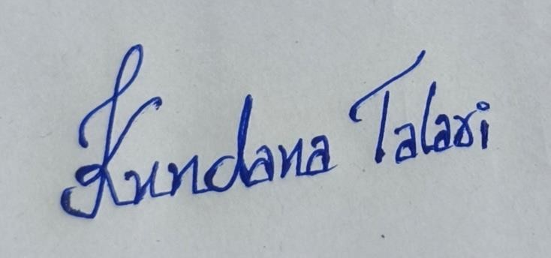  Full Name: Kundana Talari  Date: 22-09-2026

Compensation Breakdown · Cost to Company (CTC)
Employee Name
Designation
Total CTC
Software Developer
350000
Kundana Talari

Component | Per Month (INR) | Per Annum (INR)
Basic Components
Basic + Dearness Allowance | ₹15,000 | ₹1,80,000
Monthly Earnings
House Rent Allowance (HRA) | ₹1,500 | ₹18,000
Special Allowance | ₹9,478 | ₹1,13,736
Gross Monthly Salary | ₹25,978 | ₹3,11,736
Employer Statutory Contributions
Nichebit's Contribution to Provident Fund | ₹1,800 | ₹21,600
Gratuity (Accrual) | ₹722 | ₹8,664
Group Medical Insurance (₹3L) & Accidental Cover (₹10L) | — | ₹8,000
Total Fixed Compensation | ₹28,500 | ₹3,50,000
Variable Pay
Performance Bonus * | {{Per | formanceBonusMonthly}}
Total Cost to Company (CTC) | ₹28,500 | ₹3,50,000

manceBonusAnnual}}

}

* The Performance Bonus is paid at the end of each financial year, based on individual and Company performance, entirely at the discretion of the Company, and shall not exceed 15% of the employee's gross annual salary.

