CSCI 5333 – Database Management System
PROFESSOR: Dr. KHONDKER SHAJADUL HASAN

PROJECT DESIGN
ON
FRESH PRODUCT E-MART

Group name:
SMART HAWKS

Team Members:
Kundanapreethi Surepally (Team Lead) - 2249580
Naga Vennela Kandru - 2240712
Sri Sudha Kambhampati - 2248404
DESCRIPTION

E-Mart makes shopping way easier allowing people to order things from anywhere. Buyers can get products that are required without being concerned of waiting in long billing queues. The transactions are faster in e-commerce than in retail stores. The items required can be purchased in a single click and can be delivered to door step. Suppliers can show-off their products easily, quickly and creatively.

The availability of fresh fruits, vegetables or meat is always an issue and people travel miles and miles to get the fresh stock. The challenge lies in availability and timely dispatch to customers on demand. This Fresh Product e-mart solves the problem by allowing suppliers and customers come to a common platform. This e-mart maintains a supply chain of fresh goods and transfers the freshly harvested stuff from suppliers to a common go-down to each of the nearby cities and from there the orders are dispatched which can be delivered or can be picked up by the customer according to his/her convenient time slot. Proper measures need to be taken to maintain freshness at go-down. Delivery is maintained by DMC . Each supplier lets the e-mart on availability of items from them. Many suppliers will be collaborating with e-mart. Using this smart app, customer can pre-place the orders for a week so the issue of overstocking and understocking can be resolved.

UML Use-case diagram
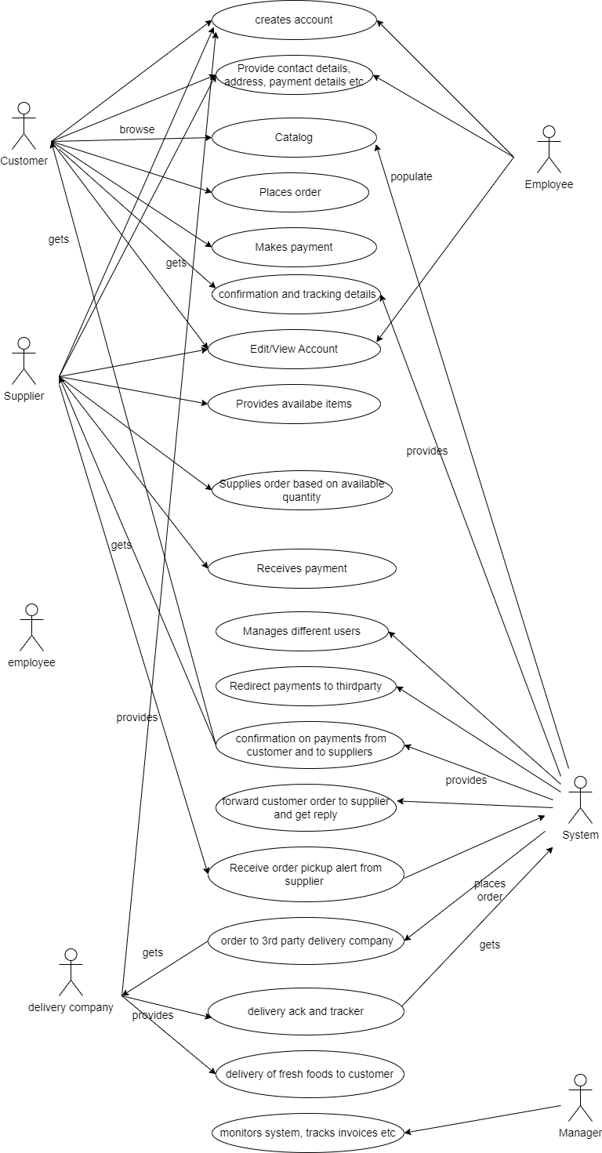

WORKFLOW Diagram

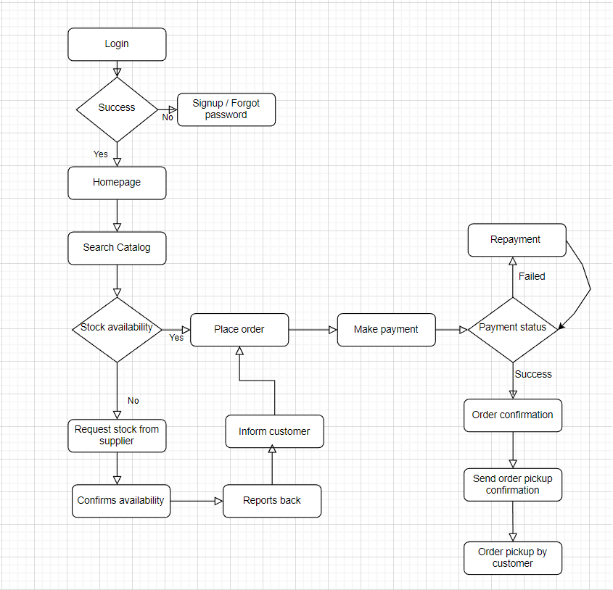

UML Sequence Diagram

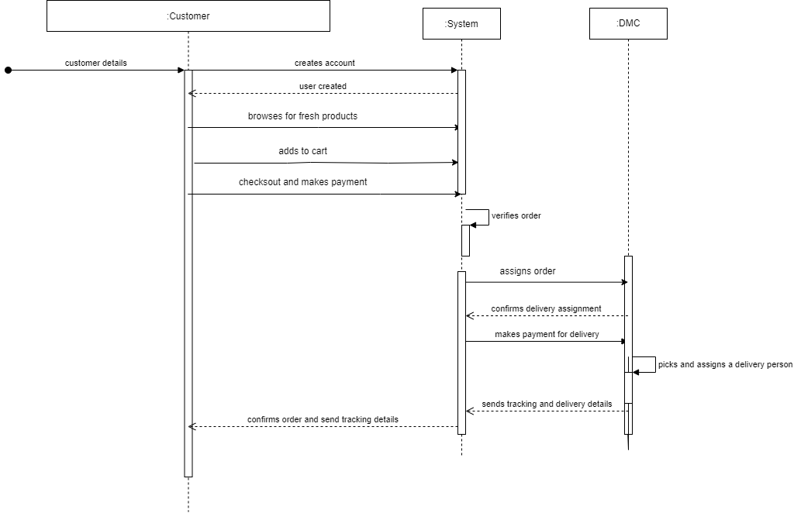

OVERALL SYSTEM’S DATA REQUIREMENTS
HARDWARE
• PC/Laptop with Intel/Amd processor.
• Hard disk size must be greater than 100 GB.
• NIC of 10 Mbps.
• RAM size must be greater than 256 MB.

SOFTWARE/TOOLS
Front End tools
• JavaScript (Angular)
• HTML.
• CSS
• Java (Eclipse)
Back End Tools
• Structured Query Language Server Management Studio (MYSQL).

Entity-set designation

- Person {{{name, Customer name},{email, Customer’s email address},{phone#, Customer’s Phone number},{DOB, Customer’s Date of Birth}, {address, Address of the person}}
- Customer {{cust_#,Customer ID}, {name, Customer name},{email, Customer’s email address},{phone#, Customer’s Phone number},{DOB, Customer’s Date of Birth}, {address, Customer’s delivery/shipping address}}
- Employee{{E_#,Employee ID},{name, Employee name},{email, Employee’s email address},{phone#, Employee’s Phone number},{DOB, Employee’s Date of Birth},{Salary, Employee’s Salary},{role, Employee’s role in a company},{address, Employee’s address}}
- Supplier{{S_#, Supplier ID},{name, Supplier name},},{email, Supplier’s email address},{phone#, Supplier’s Phone number},{address, Supplier’s Store address},{rating, Supplier’s rating},{year, Supplier’s year of establishment}}
- DMC(Delivery Management Company) {{DMC_#, DMC ID},{name, DMC name},},{email, DMC email address},{phone#, DMC’s Phone number},{address, DMC’s Store address},{rating, DMC’s rating},{year, DMC’s year of establishment}}
- Company{{name, Supplier name},{email, Supplier’s email address},{phone#, Supplier’s Phone number},{address, Supplier’s Store address},{rating, Supplier’s rating},{year, Supplier’s year of establishment}}
- Product{{P_#, Product’s unique identification number},{name, name of product},{price, cost of product}}
- Category{{Cat_#, Category Identification number},{name, Category name},{type, Category type}}
- Order{{order_#, unique order id no}, {date, date of order},{#_items, total no of items in order},{type, if it’s a delivery/pickup order}}
- Pickup_Order{{order_#, unique order id no}, {date, date of order},{#_items, total no of items in order},{type, if it’s a delivery/pickup order},{time, time_for_order_pickup}}
- DeliveryOrder{{order_#, unique order id no}, {date, date of order},{#_items, total no of items in order},{type, if it’s a delivery/pickup order},{status, delivery tracking status}}
- Cart{{p_#, Product’s unique identification no},{cat_#, Category identification no},{quantity, quantity of products added to cart}}
- Payment{{payment_#, unique payment number},{mode, mode of payment}, {amount, amount paid}}

Entity-set designation

Entities
- Person
- Employee
- Manager
- Worker
- Customer
- Cart
- Product
- Category
- Supplier
- Order
- DMC (Delivery Management Company)
- Payment
- Pickup Order
- Delivery Order
- Company

Relationships
- A Person can be an Employee or a Customer.
- An Employee can be a Manager or a Worker.
- A Customer can add one or more Product to cart.
- A Customer can choose one or more Product.
- A Product belongs to a one category.
- A Product is supplied by one or more Suppliers.
- Items in a Cart needs to be checked out in a single Order.
- An Order contains one or more Products.
- An Order can be a Pickup or Delivery order.
- Single payment must be done for a particular order.
- Payment goes to Supplier and DMC.
- One or more Delivery Orders can be managed by DMC.
- A given company in a system can be either Supplier or DMC.

Attributes
- Person {{{name, Customer name},{email, Customer’s email address},{phone#, Customer’s Phone number},{DOB, Customer’s Date of Birth}, {address, Address of the person}}
- Customer {{cust_#,Customer ID}, {name, Customer name},{email, Customer’s email address},{phone#, Customer’s Phone number},{DOB, Customer’s Date of Birth}, {address, Customer’s delivery/shipping address}}
- Employee{{E_#,Employee ID},{name, Employee name},{email, Employee’s email address},{phone#, Employee’s Phone number},{DOB, Employee’s Date of Birth},{Salary, Employee’s Salary},{role, Employee’s role in a company},{address, Employee’s address}}
- Company{{name, Supplier name},{email, Supplier’s email address},{phone#, Supplier’s Phone number},{address, Supplier’s Store address},{rating, Supplier’s rating},{year, Supplier’s year of establishment}}
- Supplier{{S_#, Supplier ID},{name, Supplier name},},{email, Supplier’s email address},{phone#, Supplier’s Phone number},{address, Supplier’s Store address},{rating, Supplier’s rating},{year, Supplier’s year of establishment}}
- DMC(Delivery Management Company) {{DMC_#, DMC ID},{name, DMC name},},{email, DMC email address},{phone#, DMC’s Phone number},{address, DMC’s Store address},{rating, DMC’s rating},{year, DMC’s year of establishment}}
- Product{{P_#, Product’s unique identification number},{name, name of product},{price, cost of product}}
- Category{{Cat_#, Category Identification number},{name, Category name},{type, Category type}}
- Order{{order_#, unique order id no}, {date, date of order},{#_items, total no of items in order},{type, if it’s a delivery/pickup order}}
- Pickup_Order{{order_#, unique order id no}, {date, date of order},{#_items, total no of items in order},{type, if it’s a delivery/pickup order},{time, time_for_order_pickup}}
- DeliveryOrder{{order_#, unique order id no}, {date, date of order},{#_items, total no of items in order},{type, if it’s a delivery/pickup order},{status, delivery tracking status}}
- Cart{{p_#, Product’s unique identification no},{cat_#, Category identification no},{quantity, quantity of products added to cart}}
- Payment{{payment_#, unique payment number},{mode, mode of payment}, {amount, amount paid}}

Primary keys
- Customer : Cust_# (auto-generated)
- Employee : E_# (auto-generated)
- Manager : Man_# (auto-generated)
- Category : Cat_# (auto-generated)
- Product : P_# (auto-generated)
- Order : Order_# (auto-generated)
- Supplier : S_# (auto-generated)
- DMC : DMC_# (auto-generated)
- Payment : Payment_#(auto-generated)

Relationship-set designation

- Adds_to{{date, date on which items added to cart}}
- Checks_out{{}}
- Chooses{{}}
- PAYMENT_goes_to_SUPPLIER{{ date, date when payment done to supplier}}
- PAYMENT_goes_to_DMC{{date, date when payment done to DMC}}
- PRODUCT_has_CATEGORY{{}}
- Supplied_by{{from_date, from when supplied has been supplying products}}
- Contains{{}}
- Managed_by{{date, date of assigning order to DMC}}

Relationship-set designation

Participation Constraints:
- Every Product must belong to a category.
- Every Product must be supplied by a Supplier and Every Supplier must supply at least one Product.
- Every Order must contain at least one Product.
- Every Order must have a Payment and Every Payment must include one Order.
- Every Delivery Order must be served by one DMC and DMC must serve at least one Delivery Order.

Descriptive Attributes:
- The relationship between Customer and Cart has date as additional attribute.
- The relationship between Order and Cart has no additional attribute.
- The relationship between Customer and Product has no additional attribute.
- The relationship between Payment and Supplier includes the payment date as additional attribute.
- The relationship between Payment and DMC includes the payment date as additional attribute.
- The relationship between Product and Category has no additional attribute.
- The relationship between Product and Order has no additional attribute.
- The relationship between Order and DMC has assigned date as additional attribute.
- The relationship between Order and Payment has no additional attribute.

E-R Diagram

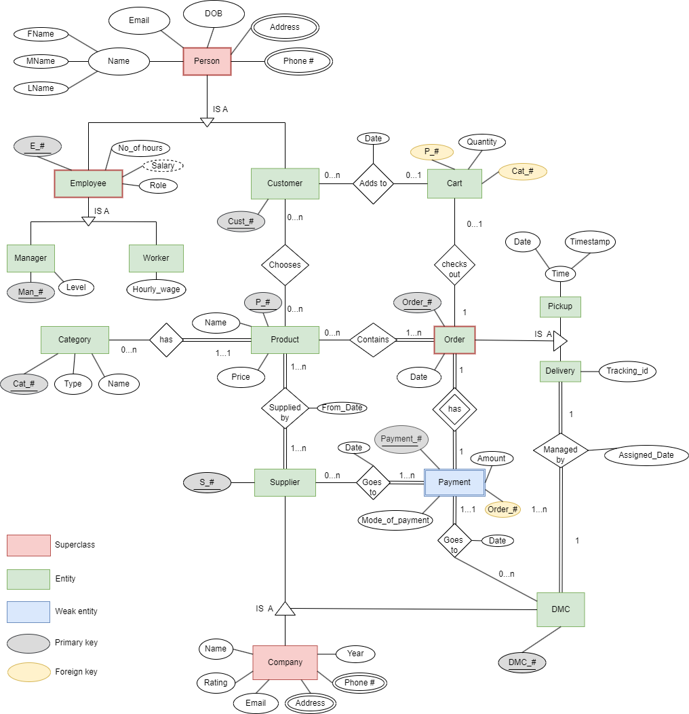

Assumptions

- Customer can just browse and leave.
- Product must be supplied by at least one Supplier, and a given Supplier must supply at least one Product.
- DMC must deliver at least one Order.
- Not all Orders are delivered as there can be pickup orders.
- Cart will be checked out and placed as a single Order.
- An Order might contain Products supplied by different Suppliers.
- An Order will be delivered by one DMC.
- A DMC can deliver multiple Orders and can get multiple Payments.
- A Payment can go to multiple Suppliers.

Reduce the E-R diagrams to tables and remove redundant tables

Relational Schema:
Manager_Employee_Person=(Manager-Id, E-id, Salary, Level, First Name, Middle Name, Last Name, E-mail, DOB, Address, Phone)
Worker_Employee_Person=(E-id, Salary, Hourly Wage First Name, Middle Name, Last Name, E-mail, DOB, Address, Phone)
Customer_Employee_Person=(Cus-id, Salary, Name, E-mail, DOB, Address, Phone)
Adds to=(Cus-id, Product id, Date)
Cart=(Cart_id, Cus-id, Quantity, Product Id)
Product=(P-id, Cus-id, Name, Price)
Category=(Name, Category-id, Type, name)
Supplier_Company=(S-id, Rating, phone, address, name, e-mail, year)
DMC_Company=(DMC-id, Rating, phone, address, name, e-mail, year)
Managed by=(Tracking id, DMC-id, Assigned Date)
Pickup_Order=(O-id, Date, Pickup Time)
Delivery_Order=(O-id, Date, Tracking id)
Goes to=(Supplier Id, Payment Id, Date)
Payment=(Payment-id, S-id, Mode of Payment, Amount, Order Id)

Reducing Tables:
Manager_Employee_Person
E-id | Man-Id | Salary | Level | Role | E-mail | First Name | Middle Name | Last Name | DOB

Worker_Employee_Person
E-id | Hourly wage | Salary | Role | E-mail | First Name | Middle Name | Last Name | DOB

Manager_Employee_Person_address:
E-id | Address

Worker_Employee_Person_address:
E-id | Address

Manager_Employee_Person_phone:
E-id | Phone

Worker_Employee_Person_phone:
E-id | Phone

Customer_Person:

Cus_id | E-mail | Name | DOB

Customer_Person_address:
Cus_id | address

Customer_Person_phone:
Cus_id | phone

Carts_Adds to:
Cart_id | Cus-id | Quantity | Product Id

Adds to:
Cust_id | Product_Id | Date

Product_Chooses:
P-id | Name | Price | Cus-id

Category_has:
Category_id | Type | Name | P-id

Supplier_Company:
S-id | Rating | Name | E-mail | year | P-id

Supplier_Company_Phone:
S-id | Phone

Supplier_Address:
S-id | Address

Supplier_Supplies
S-id | P-id

Goes to:
Supplier_id | Payment_id | Date

Payment_Goes to:
Payment-id | Mode_of_Payment | S-id | Amount | Order_id

Pickup_Order:
O id | Date | Pickup_time

Delivery_Order:
O id | Date | Tracking_id

Pickup_order_contains:
O id | Date | Pickup_time | P-id

Delivery_order_contains:
O id | Date | Pickup_time | P-id

Order_Checkout:
Cus-id | Cart-id | O-id | Order date

Payment_has:
Payment_id | Mode_of_Payment | O_id | Amount

Managed by:
Tracking_id | DMC_id | Assigned_Date

DMC_managed by:
DMC_id | O id

DMC_Company:
DMC-id | Name | e-mail | year | rating

DMC_Phone:
DMC-id | Phone

DMC_Address:
DMC-id | Address

DMC_Goes to:
DMC-id | Payment-id | S-id

The Schema Diagram:
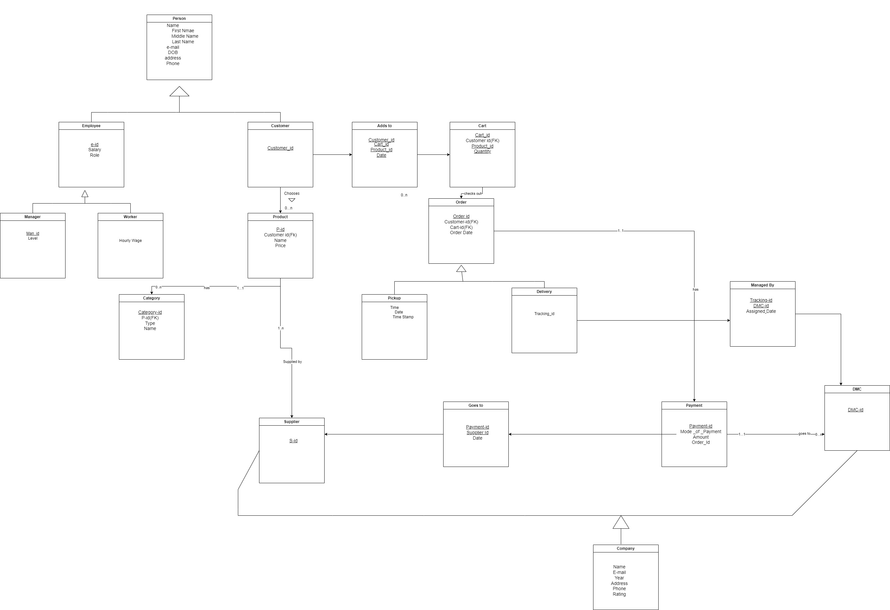
Conclusion
A Database Management System like this streamlines the process of buying and selling of fresh products in a timely manner. Fresh Product E-mart system acts as a common platform among suppliers, customers, and delivery managers. This system eases the access of fresh stock to Customers in a single click. The Suppliers can plan the distribution of their stock without any wastage. They can manage their product listings and track their sales. The system also plugins order tracking feature, which can help improve the overall efficiency of the business. Our E-mart system offers significant advantages over a manual process in terms of employees, working hours, and effort savings.
We have created an efficient database schema that can store and manage information about products, customers, orders, and suppliers The system will allow for the addition, updating, and deletion of fresh items. Overall, a well-designed DBMS for a Fresh product e-mart system would help streamline the e-commerce platform's operations, improve customer satisfaction, and provide valuable insights into customer behaviour and market trends. In conclusion, our DBMS project for the Fresh Product E-Mart system has been designed successfully.

