**TASK REPORT**

Name: Kundan Keshav Gawande

Batch Name :- 25VID1318_Infrasecurity

Topic Name: Malware check , Website Certificate Check

Student_id:- 28806

Email_id:- [kundankeshavgawande@gmail.com](mailto:kundankeshavgawande@gmail.com)

**SPAM EMAIL**

**WEBSITE NAME:- VIRUSTOTAL and MXTOOLBOX**

**1ST spam email:-**

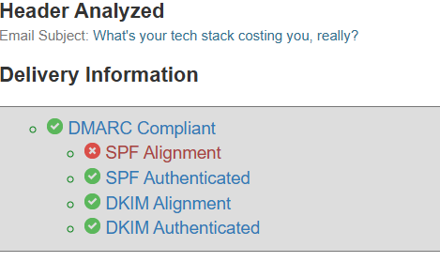

**Output of mxtoolbox**

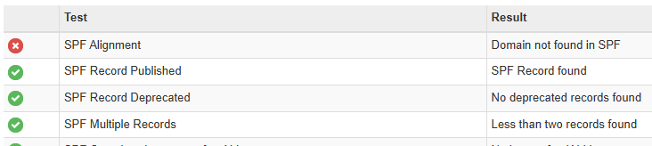

**C:\Users\Y\Desktop\TASK\2.PNG**

**IP ADDRESS**

**OUTPUT OF VIRUSTOTAL:**

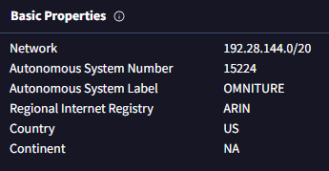

**Registration Data (RDAP)**

IP Version:

v4

Address Range:

192.28.144.0 - 192.28.191.255

Parent Network:

NET-192-0-0-0-0

CIDR(s):

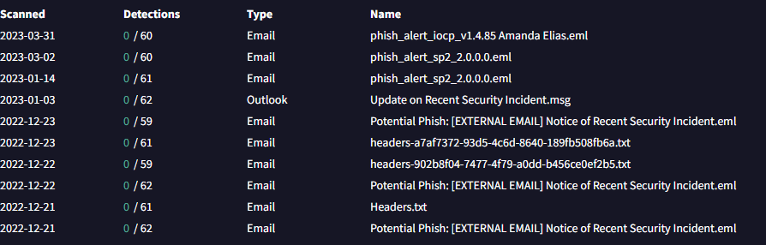

Analysis:- Phishing alert addressed in the scan

2nd spam mail:-

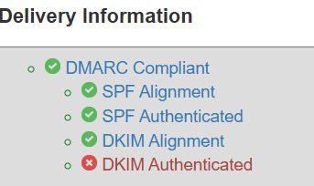

OUTPUT OF MXTOOLBOX

IPADDRESS:_ **72.167.172.32**

OUTPUTS OF VIRUSTOTAL:_

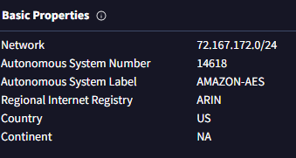

ANALYSIS:- NO MALWARE OR UNAUTHORIZATION DETECTED ALSO NO PHISHING DETECTED

3rd spam email:-

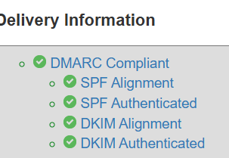

MXTOOLBOX OUTPUT

IPADDRESS:- 192.28.145.68

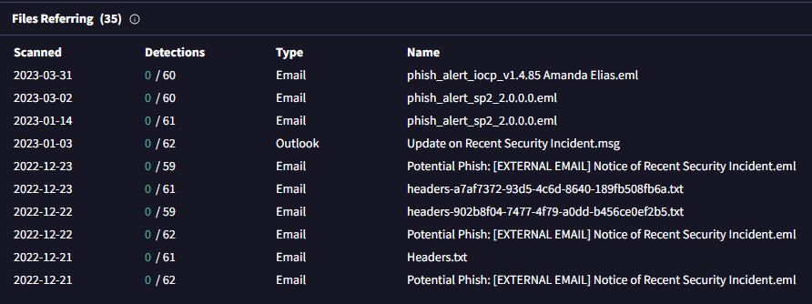

OUTOUT OF VIRUSTOTAL

ANALYSIS:- Phishing alert detected during scan

**LINKS**

1st links:- [www.hotstar.com/in](http://www.hotstar.com/in)

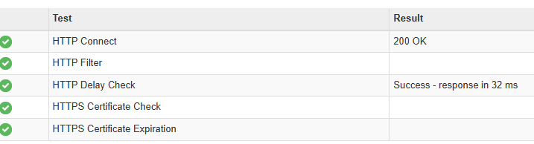

MXTOOLBOX OUTPUT

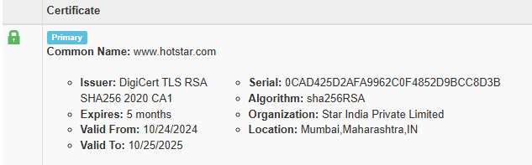

Details of hotstar

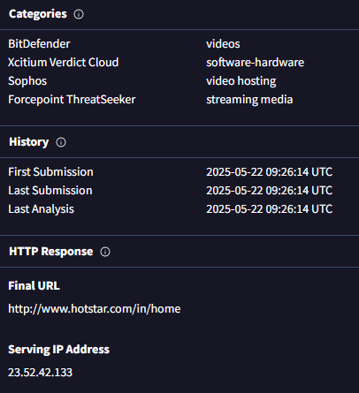

Output of virustotal

ANALYSIS: No phishing detected and no malware

**FILES**

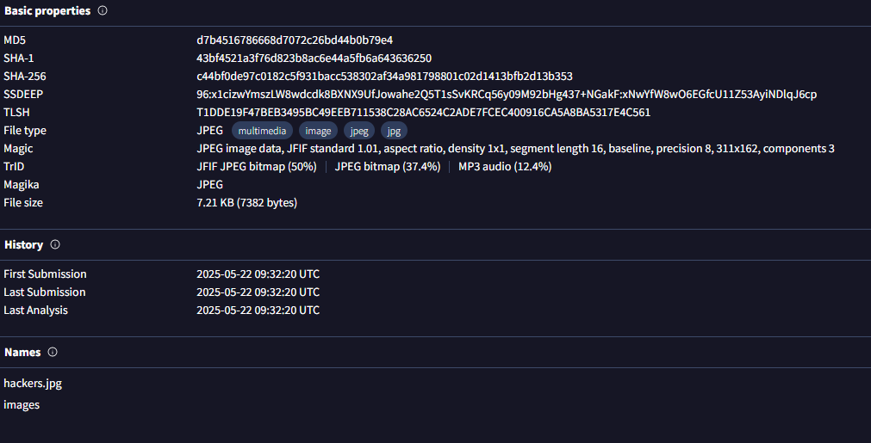

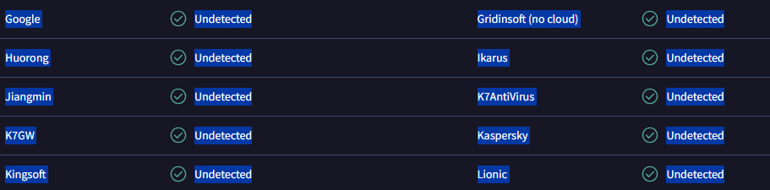

ANALYSIS:- No Phishing detected and no malware

**Website Certificate Check**

Website no. 1:- Hotstar

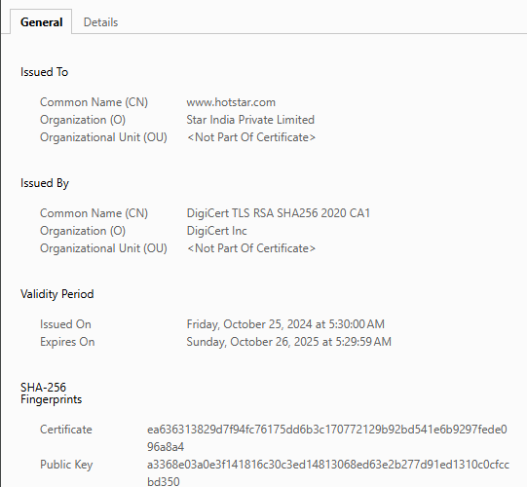

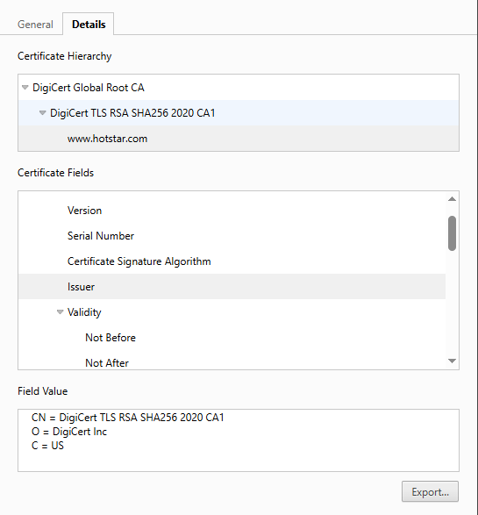

Website no. 2:- Flipkart

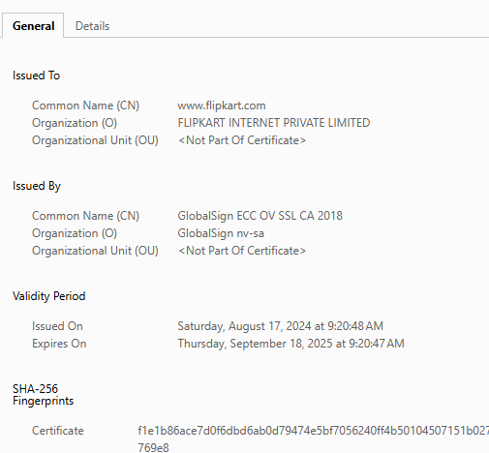

Website no.3:- Blinkit

