Before run the Solution see the below changes and needed URL for the CRUD operation and test cases also I have given with the snapshot:

Step 1: Connect the server name

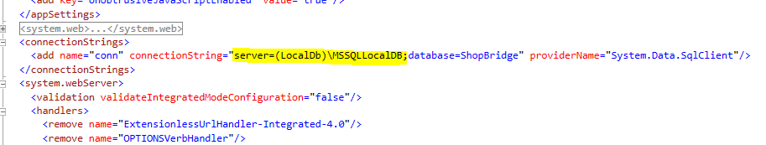

Step 2 : Run the Project, after run we will get the below error page, we are ready to do CRUD operation:

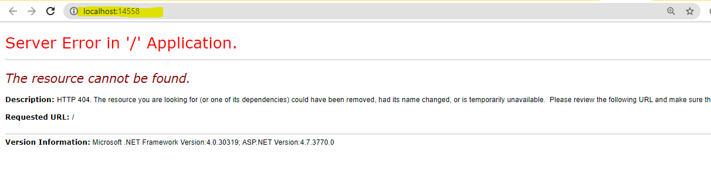

Testcase1: Set the below URL to get all the list which is stored in the database:

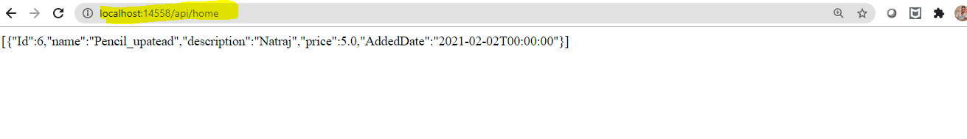

for CRUD Operation, you can use either Postman or Fiddler, I used the postman in my case:

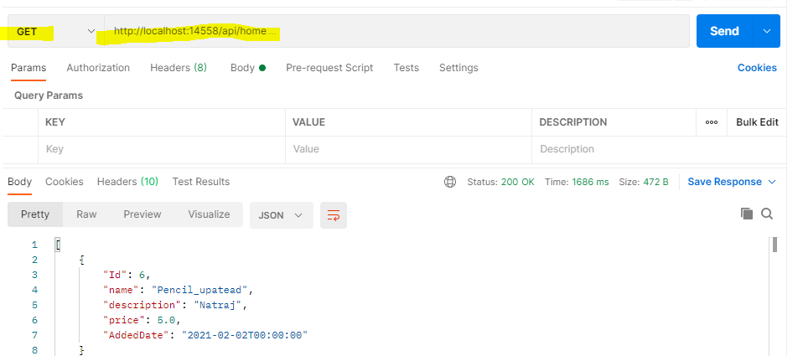

Testcases2: Adding new item to DB:

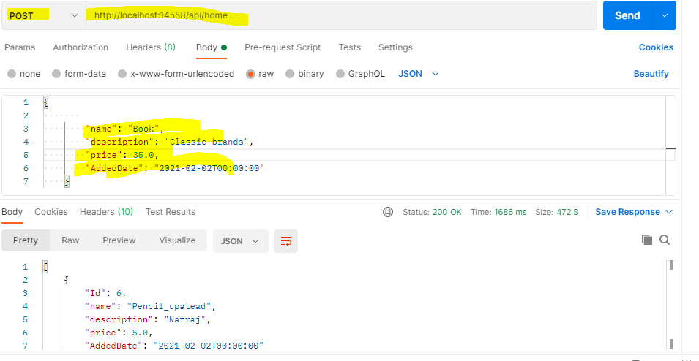

Testcases3: Saved above data into DB:

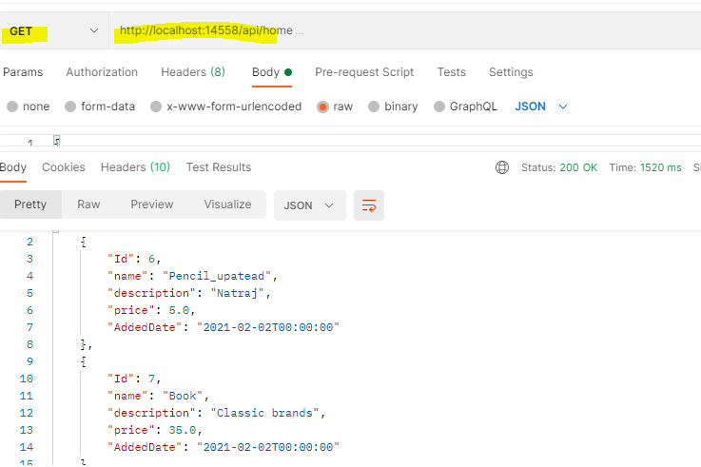

Testcases4: Updating Existing data :

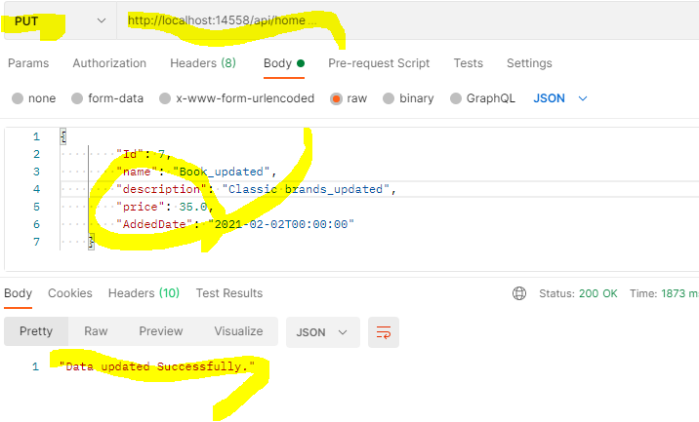

Updated data:

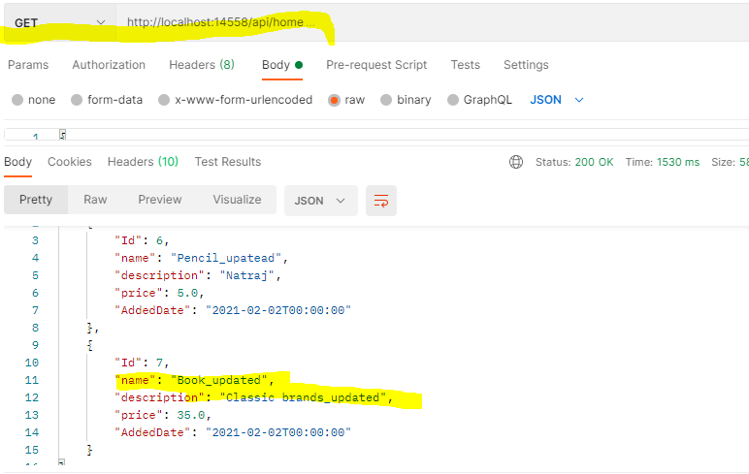

Testcases5: Deleting data from DB:

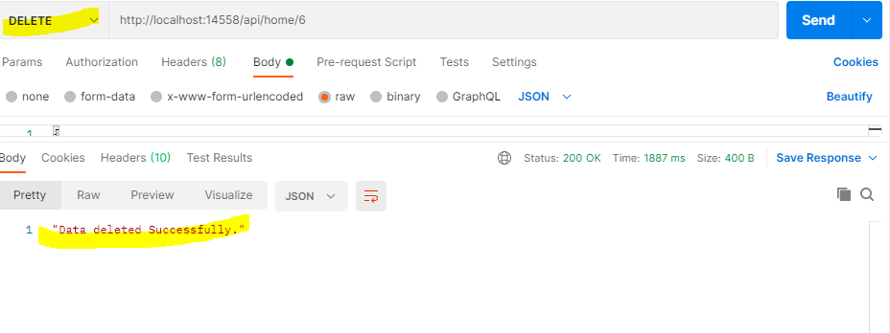

After delete data:

