Bachelor Thesis Notes

From the document Podrobný postup riešenia bakalarsk práce :
Link:
file:///C:/Users/vikto/Desktop/Univerzita/Bachelor_Thesis/BP_2027.pdf

Week 1:

Post - quantum cryptography :
All data on the internet is locked in safes. The lock is mathematical equations. To crack them, you have to try them one by one. Quantum paths find a quick way. Millions of years. a couple of hours.
Post - quantum Cryptography – the development and use of new mathematical locks (including ML - KEM ). These are difficult for both conventional and quantum computers. Post-quantum cryptography works on conventional computers. Hackers can't break into them using quantum computers now, but they might in a few years, so action is needed now.

Difference between quantum cryptography and post-quantum cryptography:
Quantum Cryptography – protection using quantum physics (photons of light, cool equipment).
Post - quantum Cryptography – protection using new mathematical problems (such as ML - KEM ), unsolvable by hackers and quantum supercomputers. Works on regular phones and computers. A software-based method for protecting against threats.

RSA :
Rivers–Shamir–Adleman algorithm.
A public-key encryption algorithm based on the factorization problem—the decomposition of a large number into two prime factors.
Example (factorization): Multiplying two huge prime numbers (say, hundreds of digits long) is very easy—a computer can do it in a split second. The result of the multiplication becomes the public key. But the inverse problem—taking this huge number and figuring out which two prime numbers it was derived from—is incredibly difficult.

Elliptic curve​ cryptography ( ECC ):
Public-key encryption algorithm using graphs.
Example (discrete logarithm): It's like a convoluted route. It's easy to follow a million steps according to a certain rule and arrive at point B. But if you give a regular computer only point B, it won't be able to guess exactly how many steps you took or which path you took.
As secure as RSA , but the keys are shorter.

Shor's algorithm:
Uses quantum properties (superposition and interference) to find hidden mathematical patterns (periods) within numbers. It causes incorrect answers to "cancel" each other, while the correct answer "amplifies."
Unlike regular computers, it breaks RSA and ECC in hours.

Symmetric cipher:
The same key is used for both encryption and decryption.
Analogy: Imagine you have a safe and two identical keys. You keep one key, and you gave the other to your friend Bob. You put a secret letter (message) in the safe, lock it with your key, and mail the safe to Bob. Bob receives the safe, takes his key (the same as yours), opens it, and reads the letter.
Works quickly.
How to securely transmit the key initially?
Encrypts the data itself, not the key.

KEM ( Key Encapsulation Mechanism ):
Create and distribute a shared symmetric key.
Allows two parties to securely agree on a shared secret key.
Analogy :
- Bob buys a padlock, keeps the key for himself (the Secret Key), and mails you the unlocked, unlatched padlock (the Public Key).
- You come up with a complex password (Symmetrical Key), put a piece of paper with it in an iron box and hang Bob's open lock on it. You snap it shut. his ! (This is a process encapsulation ).
- Bob 's key. you send her back .
- Bob receives the box, opens it with his private key and takes out a piece of paper with the password you created (This is the decanculation process).
Now you both have a shared secret password, and no hacker who intercepts the box along the way will be able to find it out!
Encrypts the key itself.
KEM is very long due to complex mathematics and is only used to encrypt keys.
KEM consists of KeyGen , Encaps and Decaps .
KEM is a type of asymmetric algorithm. The difference: with an asymmetric key, you create your own secret password, while with KEM, a function creates one for you.

As a rule, KEM and a symmetric key work in pairs (you put a symmetric key in the box and encrypt the box using KEM ).

ML - KEM parameter sets :
ML - KEM -512 (basic level):
Short keys, works quickly. Suitable for low-power devices. Matrix size A 2x2.
ML - KEM -768 (recommended standard):
Medium level of protection, slightly larger keys, longer life. Internet protection (browsers, instant messengers). A-weighted 3x3 matrix.
ML - KEM -1024 (maximum protection):
Long keys, slow operation. High-security data protection (bank archives). A-size matrix 4x4.
The degree of a polynomial is always $n=256$.
The module is always $q=3329$.
To switch between difficulties, simply change the matrix size.

Key generation KeyGen → ( pk , sk ):
Preparing the lock and key.
pk ( Public Key ) – a public key, an unlocked safe lock, can be sent to the interlocutor.
sk ( Secret Key ) – a secret key, the only key to the lock, which the recipient keeps for himself.

Encaps ( pk ) ( c , K ):
Creation and safe packaging of a secret.
The sender takes the public key (lock) and:
Generates a random shared secret K ( Key ) – a symmetric password.
Creates a ciphertext c ( Ciphertext ) – a box in which K is encrypted with pk .

Decaps ( sk , c ) → K :
Opening and extraction of secretion.
The receiver receives c and extracts K ' from it using his sk .
Ideally K = K'.

Now both Alice and Bob have the same secret K .

The recipient (Bob) is the one who needs the information and sends the safe.
Sender (Alice) is the one who sends the information in the safe.

ML - KEM & NIST :
CRYSTALS - Kyber algorithm won the worldwide competition for protection against quantum computers, was slightly modified and renamed to ML - KEM ( Module - Lattice - Based Key - Encapsulation Mechanism ), and is officially approved by NIST (US Institute, the world's leading cybersecurity organization) in a document numbered FIPS 203 ( Federal Information Processing Standards ).

ML-KEM was founded on task MLWE – Module Learning With Errors.

I won't be attacking the real ML - KEM , but rather its miniature toy prototype. This will need to be clearly stated in the bachelor's degree.

ML - KEM is designed to protect sensitive but unclassified U.S. government information.

Terminology:
Key roles and processes
- party (party) — a participant in the exchange (for example, Alice or Bob).
- key establishment (key establishment) is a procedure by which parties obtain shared secret material.
- key A pair (key pair) is a set of two keys: one can be made public, the other must be kept secret.
KEM keys
- encapsulation key (encapsulation key) - created during key generation and used in the encapsulation process. Can be public ( this is how " open " key ").
- decapsulation key (decapsulation key) - also created during generation, but must be kept secret and destroyed when no longer needed (it's like a "private key").
- ( KEM ) ciphertext - the bit string resulting from encapsulation and used as input for decapsulation.
Processes
- Encapsulation is the process by which a shared secret key and associated ciphertext are generated based on an encapsulation key and randomness.
- Decapsulation is the process by which a shared secret key is recovered from the ciphertext and the decapsulation key.
Keys for PKE (public key encryption, component K - PKE )
- encryption key (encryption key) - can be made public.
- decryption key (decryption key) - must be kept private and destroyed after use.
(Important: The document specifically avoids the terms " public key " / " private key " to avoid confusion—these more specific names are always used instead.)
Secrets
- shared secret (shared secret) - a secret value calculated during the key establishment process, known to both parties.
- shared secret key (shared secret key) - a shared secret that can be used directly as a cryptographic key (without additional processing).
Terms about safety
- destroy (destroy) - after the destruction of classified data, no information about it can be recovered.
- hash function (hash function) is a function with a fixed-length output that has the following properties:
  - one - way (unidirectional) - it is impossible to find an input that gives a given output;
  - collision - resistant - it is impossible to find two different inputs with the same output.
- pseudorandom (pseudo-random) is a process that is deterministic (that is, not actually random), but appears random if you don’t know its internal structure.
- public channel (open channel) - a communication channel that can be observed (and even interfered with) by third parties.
- input checking (input data verification) - checking that the input of the algorithm meets the requirements.
Other
- little - endian — the order of bytes/bits, where the leftmost (first) bit/byte is the least significant.
- security category / security strength (security category/degree) is a numerical characteristic of how many computing resources are needed to crack an algorithm.
- shall / should is an important distinction in the standard text:
  - shall = mandatory requirement ;
  - should = a strong recommendation, but not mandatory (ignoring it may lead to problems).

a real working circuit is constructed from the MLWE mathematical problem:
- Step 1: From the MLWE problem , a regular public-key encryption ( PKE ) scheme is constructed—it is called K - PKE .
- Step 2: This PKE scheme is "improved" using a special mathematical transformation— the Fujisaki - Okamoto ( FO ) transform . This transforms the standard encryption into full-fledged KEM with stronger security guarantees.

Random noise may cause decapsulation failure.

All intermediate classified data must be destroyed immediately after it is no longer needed.

Floating point calculations should not be used to avoid rounding errors that could compromise security.

Used material from:
https://nvlpubs.nist.gov/nistpubs/FIPS/NIST.FIPS.203.pdf
https://pq-crystals.org/kyber/

Week 2:

Arithmetic modulo q :
Calculation by module.
Can also be in negative numbers: x mod q = x + k ⋅ q (add 7 q while the number is negative), for example:
-1 mod 7:
-1 + 7 = 6 → -1 ≡ 6 (mod 7)
-2 mod 7:
-2 + 7 = 5 → -2 ≡ 5 (mod 7)
-7 mod 7:
-7 + 7 = 0 → -7 ≡ 0 (mod 7)
-8 mod 7:
-8 + 7 = -1 (still negative!) -1 + 7 = 6 → -8 ≡ 6 ( mod 7)
(that is, here k = 2: -8 + 2 7 = 6)

Centered modular representation :
Takes the usual remainder modulo q (a number in {0, ..., q - 1}) and then shifts it to the symmetric range around zero, for example:
Example : x = -8, q = 7
- Ordinary remainder : -8 mod 7 = 6
- 6 > 7//2 (=3) → yes , then subtract q: 6 - 7 = -1
Result: -8 ≡ -1 ( mod 7) in centralized form.

Vectors and matrices modulo q:
The same as ordinary vectors and matrices of linear algebra, only each element after any operation (addition, multiplication) is reduced modulo q .

Polynomial addition and multiplication:
A polynomial is expression type :
$$a\left(x\right)=a_{0}+a_{1}x+a_{2}x^{2}+…$$a(x) = a0​ + a1​x + a2​x^2 + …
where $a_{0},a_{1},a_{2},…$a 0 , a 1 , a 2 ,… are coefficients (numbers). A polynomial can be represented simply as a list of coefficients:
$$a\left(x\right)=4+5x ↔ \left[4 , 5\right]$$a(x) = 4 + 5x ↔ [4, 5]

The quotient ring Rq = Zq [x] /( xn + 1):
The key structure for ML is KEM and Module is LWE .
Zq​ — numbers modulo q (the coefficients of the polynomials "live" here)
$Z_{q}\left[x\right]$Zq ​[ x ] — all polynomials with coefficients modulo q , of any degree
$/\left(x^{n}+1\right)$/( xn +1) — "divide" by the polynomial $x^{n}+1$, that is, reduce it to the modulus of this polynomial. n determines the number of coefficients in the polynomials if they are reduced to a ring
x ^ n + 1 = 0 => x ^ n = -1 Just like for 7 = 0 mod 7.
For mod 7: …, 5, 6, 0 (would be 7), 1, 2, …
For mod ( x ^2 + 1) : … , x ^0 – 1, x ^1 = x , x ^2 = -1 (it would be = x ^2), x ^3 = - x , x ^4 = 1, …
The range of powers for mod ( x ^ n +1) is [0, 1, …, n – 1]
The sign changes on overflow (if the degree >= n ), with the regularity (for n = 2) every n = 2 degrees.
Example:
Let's take:
a ( x ) = 3 + 4 x , b ( x ) = 2 + 3 x
Step 1. Regular multiplication (open the brackets)
a(x)b(x) = 3 ⋅ 2 + 3 ⋅ 3x + 4x ⋅ 2 + 4x ⋅ 3x
$=6+9x+8x+12x^{2}$ = 6 + 9x + 8x + 12x^2
$=6+17x+12x^{2}$ = 6 + 17x + 12x^2
Step 2. Apply the ring rule ( $x^{2}=-1$) – this is where the sign changes!
The degree $x^{2}$has appeared - we replace it with$-1:$
$$12x^{2}=12⋅\left(-1\right)=-12$$
Means:
$$6+17x+\left(-12\right)=\left(6-12\right)+17x=-6+17x$$
Step 3. We reduce the coefficients modulo q = 7
-6 mod 7 = 1 (−6+7=1)
$$17 \text{mod}7=3 \left(17=2⋅7+3\right)$$
Result
$$a\left(x\right)⋅b\left(x\right)≡1+3x \left(mod , 7 x^{2}+1\right)$$

For ring problems, the input polynomials are usually already ring-reduced, but after multiplying the result, you must re-ring it yourself. The maximum power of the result is 2n – 2.
Why exactly x ^ n + 1? Because x ^ n would produce a lot of zeros, which is bad, and x ^ n – 1 could be factored, which is also bad.

Why multiplication by x^n = −1 produces negacyclic wrap-around:
Because the degree is looped in the ring [0, 1, …, n – 1] and the sign can change.

The basic LWE equation b = As + e (mod q):
A is a matrix (random numbers) - public
s - secret vector – secret
e - small noise vector (error) - secret
b - the result (what is published) - public
q - module - public
We take a known matrix A , multiply it by a secret vector s , then add some random noise e , and reduce all this modulo q .
The result b becomes public - anyone can see it, including the attacker.
It's difficult to crack due to the addition of the error e and the large number of possible secrets. NP is a hard problem. We can't ignore the error and round because we're working modulo, which completely changes the result when dividing or inverting the matrix modulo q .
Grover gives a quadratic speedup of the search ( $\sqrt{N}$instead of $N$), but even this does not help with the astronomical N of the real ML - KEM .
We always know what n is in quotient ring . This comes from creating A , s , e , b , the numbers in which are randomly generated from range ( n ).

W hy the small error vector e makes secret recovery nontrivial:
Because without an error, it is very easy to find a secret (one unknown), but if an unknown error appears, it forces you to try to find the secret, and the number of possible secrets in real ML - KEM is simply cosmic, the number of search algorithms grows like $2^{O\left(n\right)}$.
Used material from:
https://cims.nyu.edu/~regev/papers/qcrypto.pdf

Week 3:

LWE → Ring-LWE → Module-LWE → ML-KEM:
b = A*s + e transform to R… Module (that is, A , b (vector of polynomials), s , e are vectors/matrices) ML - KEM

Main Regev's theorem is a proof that breaking LWE is incredibly difficult.

Difference between ML - KEM and LWE :
LWE is a purely mathematical problem. It involves trying to find a secret vector $s$in the equation $t=As+e \left(mod q\right)$, where $e$is random noise. This problem itself doesn't encrypt anything; it's simply considered computationally intractable for classical and quantum computers.
ML - KEM is an application-specific cryptographic protocol ( NIST- approved standard FIPS 203). This is a specific algorithm that uses lattice mathematics to securely transmit a symmetric key over an open communication channel (such as the internet).
That is, ML - KEM is based on an improved LWE problem – Module - LWE (that is, with matrices/vectors).

Polynomial ring used by ML-KEM:
Rq = Z 3329[ X ] / ( X ^256 + 1)
This model is MUCH more complicated than the textbook model, for example: R 7 = Z 7[ x ] / ( x ^2 + 1) precisely because of the modulus and degree.

The high-level K-PKE and ML-KEM structure:
K - PKE :
The core, innermost layer of the algorithm. This encryption scheme works directly with the Module - LWE (with polynomials, matrices, and noise). It has three standard functions: K - PKE.KeyGen ( key generation), K - PKE.Encrypt ( message encryption) , and K - PKE.Decrypt ( decryption ) . It is not secure by itself, as it can be broken under active attacks and reveal the key.
ML - KEM :
Takes K - PKE and wraps it in the Fujisaki-Okamoto transform. The algorithm becomes resistant to active attacks; the system not only encrypts the key but also verifies that the ciphertext has not been modified along the way.
ML - KEM function calls the K - PKE math , adding checks and hashing to it:
ML - KEM.KeyGen : Simply calls the internal K-PKE.KeyGen function to generate matrices and polynomials , appending some security hashes to them.
ML - KEM.Encaps : First generates a completely random string (seed ) , runs it through a hash function to obtain a shared secret key , then uses the internal K - PKE.Encrypt to securely seal this seed into ciphertext and send it to the recipient .
ML - KEM . Decaps : This is the trickiest step. The recipient first calls K - PKE . Decrypt to get the seed. But they don't trust the result! They take the received seed and re-encrypt it for themselves. If the new ciphertext matches the one received over the network, everything is fine, and the key is returned. If the attacker has corrupted the data in any way, the verification will fail, and the algorithm will return garbage instead of a key.
I will attack the pure mathematical model $t=As+e$, that is, the very core of basic K - PKE , without the ML - KEM overlay , ignoring external cryptographic checks, which makes this model easy to break.
Where sampling of small coefficients occurs:
In the ML - KEM algorithm , sampling occurs every time a secret or noise vector needs to be generated. This is called within the K - PKE functions : during key generation (the secret vector $s$and the underlying noise vector are sampled $e$) and encapsulation (a temporary vector $r$to ensure each new encryption is unique and two additional noise vectors to securely obfuscate the message).

Why is the toy system not cryptographically secure:
Because of the tiny parameters. Such a system can be hacked in a split second by brute force.

Why is it still educationally useful:
It allows for visual tracking of the entire cryptanalysis process. Only on such small data sets can the Qiskit quantum simulator be physically run to construct Grover's algorithm.

Grover's algorithm is a quantum "haystack" search that uses physical reflections and state rotation to find the desired solution in approximately $\sqrt{N}$steps instead of the classical ones $N$. It offers only quadratic speedup and is limited by the complexity of constructing an oracle, rather than an instantaneous hack.

Which aspects of real ML-KEM are intentionally removed:
Removed KEM wrapper (encapsulation and de-encapsulation), standardized cryptographic strength parameters ( ML - KEM -512 or 1024) and random number and noise generation.

What does the word “module” mean in Module-LWE at a practical level:
What is in a regular LWE , what is in a Module - LWE A , s , e , and b are matrices and vectors, but in regular LWE they consist of ordinary numbers, while in Module LWE they consist of polynomials . The dimension of a module indicates the number of polynomials in the structure.

Used material from:
https :// nvlpubs . nist . gov / nistpubs / FIPS / NIST . FIPS .203. pdf

From the document ML-KEM, Module-LWE, and
Grover-Based Toy Cryptanalysis :
Link: file:///C:/Users/vikto/Desktop/Univerzita/Bachelor_Thesis/MLKEM_Grover_Comprehensive_Guide.pdf

Section 4:

Infinity norm:
For the vector r = ( r ₀, r ₁, ..., r ₙ₋₁) this is the coordinate with the largest absolute value.
Formula: ∥ r ∥ ∞ ≤ B

Geometric intuition:
The infinity norm condition can be represented as a square on the graph, while the condition for ordinary vector sizes (the Euclidean norm) would be a circle. For example, if a vector of two coordinates ( r ₀, r ₁) and the condition ∥ ( r ₀ , r ₁ ) ∥ ∞ ≤ 1, then geometrically This square : [−1, 1] × [−1, 1].

How this relates to the topic:
The attacker tries a candidate secret, calculates what error would be required, and if it is small enough (i.e., falls within the square of [− B , B ] × [− B , B ]), then the candidate is accepted as plausible.

Geometrical view of LWE :
Without error, e has the form of a modular hyperplane. The secret s necessarily lies at the intersection of all planes. With a small error, e blurs into noise. band . s now no longer lies exactly at the intersection of the planes, although it is quite close.

Section 6:

A new way to multiply polynomials of the same degree:
First, we multiply the polynomial by the basis vectors (1, 0) and (0, 1) and write the results into a matrix, column-wise. This matrix can then be multiplied by any polynomial vector of the same degree to obtain the solution polynomial vector.
Example:
Let the ring R ₇ = Z ₇[ x ] / ( x ² + 1), and a ( x ) = 4 + 6 x .
Step 1. Multiply a ( x ) by the standard "1":
(4 + 6 x ) · 1 = 4 + 6 x → pair of numbers: (4, 6) is the first column of the matrix
Step 2. Multiply a ( x ) by the standard " x ":
(4 + 6 x ) x = 4 x + 6 x²
We apply x ² ≡ −1:
= 4 x + 6·(−1) = −6 + 4 x
We reduce it modulo 7 (−6 mod 7 = 1):
= 1 + 4 x → pair of numbers: (1, 4) is the second column of the matrix
Step 3. Assembling the matrix:
$$M_{a}=\left(\begin{matrix}4 & 1 \\ 6 & 4\end{matrix}\right)$$
Step 4. Verification - multiply by a specific b ( x ) = 2 + 3 x , that is, the vector (2,3):
Through the matrix:
$$M_{a}\left(\begin{matrix}2 \\ 3\end{matrix}\right)=\left(\begin{matrix}4⋅2+1⋅3 \\ 6⋅2+4⋅3\end{matrix}\right)=\left(\begin{matrix}11 \\ 24\end{matrix}\right)=\left(\begin{matrix}4 \\ 3\end{matrix}\right) \left(mod 7\right)$$
By direct multiplication of polynomials (for verification):
(4 + 6 x )(2 + 3 x ) = 8 + 12 x + 12 x + 18 x² = 8 + 24 x + 18 x²
Replace x² ≡ −1: = 8 + 24 x − 18 = −10 + 24 x
Modulo 7: -10 mod 7 = 4, 24 mod 7 = 3 → 4 + 3 x
Matched the matrix answer (4, 3). ✓

A polynomial can be represented as a point in Zq ⁿ space.

Section 7:

Ring - LWE :
We replace ordinary numbers with polynomials. Matrix A now contains not arbitrary numbers, but the coefficients of a specific polynomial.

Module - LWE :
It consists of several polynomials. The number of polynomials is k , and the number of coefficients in the polynomials is n . The matrix Ma has p k x k . The matrix Ma has the number of coefficients ( k * n ) * ( k * n ) (a matrix of matrices, that is, the entire matrix consists of the coefficients of all the matrices included in it):
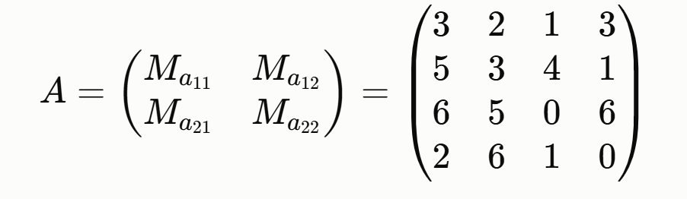
The total number of numerical coefficients in a secret is m = k · n . Since there are only m independent coefficients, and each of them can take 3 values (−1, 0, 1) (a specially chosen small range for a toy example), then the total number of all possible secrets that can in principle be tried is: N _ logical = 3^ m = 3^( k · n ).
This number represents the size of the search space—a rough estimate of how difficult a brute-force attack (trying all possible options) would be. In a toy example, 81 is negligible (a computer could try it in a fraction of a second). But in real ML — KEM k = 2,3 or 4, and n = 256 (not 2!) - then: N _ logical = 3^( k · 256).
That is, first we form the matrices Ma , applying the rule x ^ 2 = -1 in the process, and then we form a large matrix A from the numbers of the matrices Ma .

Section 8:

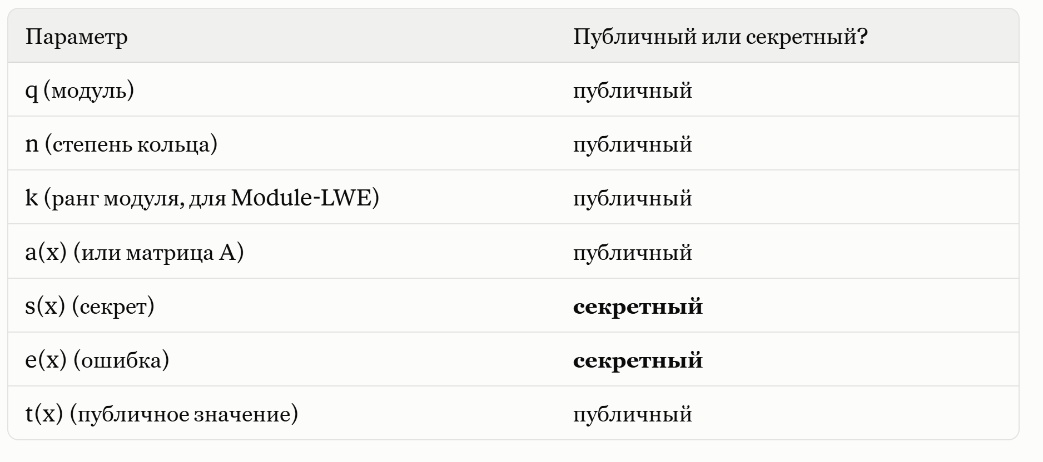
Range { -1, 0, 1 } – public,

The residual formula is: r ( x ) = t ( x ) − a ( x ) s '( x ) – what error would be required for s ' = s

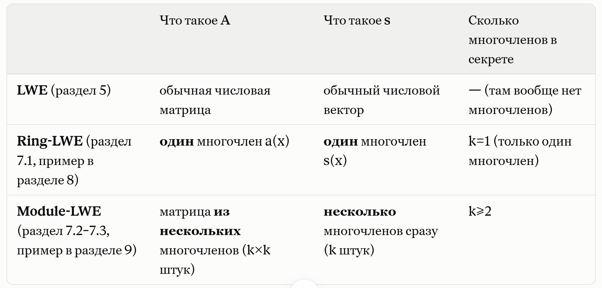

Ring - LWE Attack Strategy Sequence :
1) residual formula
2) create the matrix Ma (using basis vectors and applying the modulus)
3) multiply the matrix by the vector s '
s ' in turn :
- multiply the matrix by the vector s '
- center
- find r ( x )
- find || r ( x )|| ∞
- check if || r ( x )|| ∞ into a predetermined range (for us it is {-1, 0, 1})
- if yes, then candidate s ' is suitable, if not, we discard it

Important disclaimer:
Then I'll compare the brute-force method and Grover's algorithm. For Grover's algorithm to work, it's critical that there be only one suitable candidate. If there are more, Grover's algorithm simply doesn't know which one is correct, because the oracle marks all potentially suitable ones. In Module - LWE , unlike Ring - LWE , the matrix stores the coefficients of not just one polynomial, but several (that is, several equations), and for a candidate to be considered suitable, it must pass the constraints of all equations. The probability that several candidates will pass all the tests, rather than just one as in Ring - LWE, is low. For a toy experiment, there will always be only one suitable candidate.

Section 9:

From this example the domain is {-1, 0, 1}, k = 2, which means that N _ logical = 3^4 = 81
A qubit can have 2 states – 0 or 1. We need to encode the coefficients so that it is -1, 0, 1. The solution is to take 2 qubits per coefficient, and:
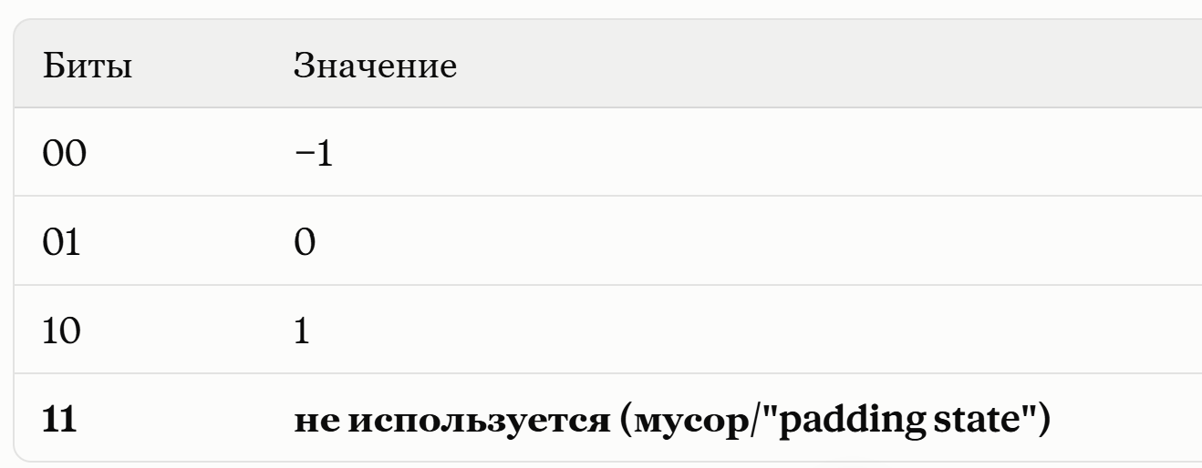

Rule: n qubits give 2^ n states. We have 2^8 = 256 possible states.
We actually have 81 possible secrets and 256 states, meaning 175 states are garbage. Using Grover's algorithm alone is inefficient, as it will iterate through all 256 states and mark the garbage ones as unsuitable, but that takes time. there will be custom preparation over valid ternary states, which will help .

Section 10:

Complexity of Grover's algorithm: O (3^ m ) (exponential growth).
A ternary coefficient is a number that is necessarily equal to -1, 0, or 1.
Real running time: T _ classical ≈ N · C _ pred , where C _ pred is the cost of one check (calculate the discrepancy + compare with the threshold B .

What needs to be recorded when conducting an experiment:
N is the total number of candidates (e.g. 9 or 81)
number of predicate evaluations - how many times the check was actually performed
execution time on a classic machine ( wall - clock) runtime )
M is the number of valid candidates, i.e. how many passed the test
Whether the initially guessed secret is among the valid ones is a test of the correctness of the experiment itself (if your own secret doesn't pass its own test, then there's a mistake somewhere!)
Is the solution unique ( M = 1?) - this is a direct link to section 8.5: if M > 1, the experiment needs to be rebuilt

k is the number of polynomials in the secret
n is the degree of the ring
m = k * n – the number of all coefficients in the entire secret

