PES University, Bengaluru
Department of Computer Science and Engineering
Database Management Systems · Experiential Learning Level 3 Project
Multi-Complex Apartment Management and Analytics System
A database-driven web application for apartments, owners, tenants, leases, payments, parking and maintenance across multiple complexes, with occupancy and financial dashboards and semantic search over maintenance requests
Submitted by
Name | SRN
Kundhan Vudutha | PES1UG24AM327
[Partner name] | [Partner SRN]
Section F
Course instructor: Dr. Nagasundari S
Source code: https://github.com/Kundhan73/DBMS_Project
October 2026

Contents
- Problem statement
- Objectives
- Scope
- Functional requirements
- ER diagram
- Relational schema
- Database choice and justification
- Data dictionary
- SQL and vector database implementation
- Important queries
- System architecture
- Application screenshots
- Testing results
- Conclusion and future enhancements
- Requirement checklist
- Individual contributions
- Appendix A. Data dictionary
- Appendix B. Relational schema
- Appendix C. Test results

1. Problem statement
Property management firms and resident welfare associations in Bengaluru commonly run several apartment complexes at once. Each complex has blocks and flats; each flat has one or more owners, may be rented to a tenant under an 11-month lease, may hold parking slots, and generates rent, maintenance and parking bills every month. Residents raise a steady stream of repair complaints written in free text.
In practice this information is spread across spreadsheets, WhatsApp groups and paper registers. The consequences are familiar:
- the same flat gets leased twice for overlapping periods, or a parking slot is promised to two cars;
- nobody can say quickly how much rent is overdue in which complex, or which tenants pay late every month;
- a manager handling a new complaint (“water dripping from the roof”) cannot find how the same problem was fixed last month, because it was written differently (“seepage from the bathroom ceiling”) and keyword search misses it;
- there is no record of who changed a lease or reversed a payment.
The system built here replaces those registers with a single database-backed web application that enforces the rules in the database itself, gives managers occupancy and collection analytics across complexes, gives owners and tenants a self-service portal, and lets staff search maintenance history by meaning rather than by exact words.

2. Objectives
- Model complexes, blocks, units, owners, tenants, leases, invoices, payments, parking and maintenance in a normalised relational schema (3NF).
- Enforce business rules at the database level: no overlapping leases or slot bookings, joint-ownership shares that never exceed 100%, payments that never exceed the balance, a valid maintenance workflow, and bcrypt-only password storage.
- Automate recurring operations with stored procedures and functions: monthly billing (idempotent, with proration), late fees, lease termination.
- Provide dashboards for occupancy, billed vs collected revenue, overdue dues and maintenance SLA compliance, scoped to what each user is allowed to see.
- Store vector embeddings of maintenance requests and support semantic, keyword and hybrid search, plus “similar past requests” for staff.
- Provide role-based access for four roles (Admin, Manager, Owner, Tenant) through a Next.js interface that talks to the database only through an API layer.
- Keep a complete audit trail of sensitive changes.

3. Scope

In scope
- Multiple complexes, each with blocks, floors and units (seed data: 3 complexes, 7 blocks, 160 units).
- Owner and tenant records, joint ownership and resale history.
- Lease lifecycle: pending, active, ended, early termination.
- Billing: rent (prorated), society maintenance, parking and late fees; part payments; payment reversal by an admin.
- Parking: CAR, BIKE and EV-charging slots, vehicle registration, allocation with monthly charges.
- Maintenance: request creation, vendor assignment, status workflow, costs, resident rating, status history.
- Semantic, keyword and hybrid search over maintenance requests; similar-request recommendations.
- Dashboards, nine analytical reports, audit log.
- Authentication and role-based authorisation.

Out of scope
- Real payment gateway integration (payments by residents are simulated and recorded as UPI/card/bank transfer).
- Email/SMS notifications, visitor management, amenity booking.
- Accounting ledgers and GST invoicing.

4. Functional requirements
# | Requirement | Roles
FR1 | Sign in with email and password; sessions expire after 8 hours; sign out | All
FR2 | View a dashboard of occupancy, billed vs collected (12 months), outstanding dues, open requests, SLA compliance and most overdue invoices, filterable by complex | Admin, Manager
FR3 | View a personal dashboard of own units, dues, billing history and requests | Owner, Tenant
FR4 | Browse complexes and a floor-by-floor unit map with occupancy colours | Admin, Manager
FR5 | Search and filter units by complex, status, type, owner or tenant; view unit detail (ownership, leases, parking, billing summary, requests) | All (scoped)
FR6 | Change a unit’s status (vacant, owner-occupied, under maintenance) | Admin, Manager
FR7 | Create a lease for a vacant unit; terminate an active lease early | Admin, Manager
FR8 | Run the monthly billing job and apply late fees | Admin
FR9 | View invoices with filters (status, type, month, overdue); record cash/cheque payments | Admin, Manager
FR10 | Pay own invoices (simulated online payment, part payments allowed) | Owner, Tenant
FR11 | Reverse a wrongly recorded payment | Admin
FR12 | View parking slot map, allocate and release slots | Admin, Manager
FR13 | Register and remove own vehicles; view own slots | Owner, Tenant
FR14 | Raise a maintenance request; see possible duplicates immediately | All
FR15 | Assign vendor, start, resolve, reopen, cancel requests | Admin, Manager
FR16 | Confirm a fix and rate it; cancel an unassigned request; edit an open request | Raiser
FR17 | Search requests by meaning (hybrid, semantic, keyword) | All (scoped)
FR18 | See similar past requests and how they were fixed | Admin, Manager
FR19 | Manage owners and tenants (create, search with typo tolerance, deactivate) | Admin, Manager (deactivate: Admin)
FR20 | Run analytical reports and view their SQL | Admin, Manager
FR21 | View the audit log | Admin
Visibility rules: an admin sees everything; a manager sees only the complexes assigned in complex_manager; an owner sees units they currently own and invoices billed to them; a tenant sees the units they lease and invoices billed to them.

5. ER diagram

5.1 Conceptual ER (Chen notation)
Entities are rectangles, relationships are diamonds, cardinalities are on the edges. OWNER and TENANT are specialisations (ISA) of APP_USER. REQUEST_EMBEDDING (double border) is the vector-side entity with a 1:1 relationship to MAINTENANCE_REQUEST.

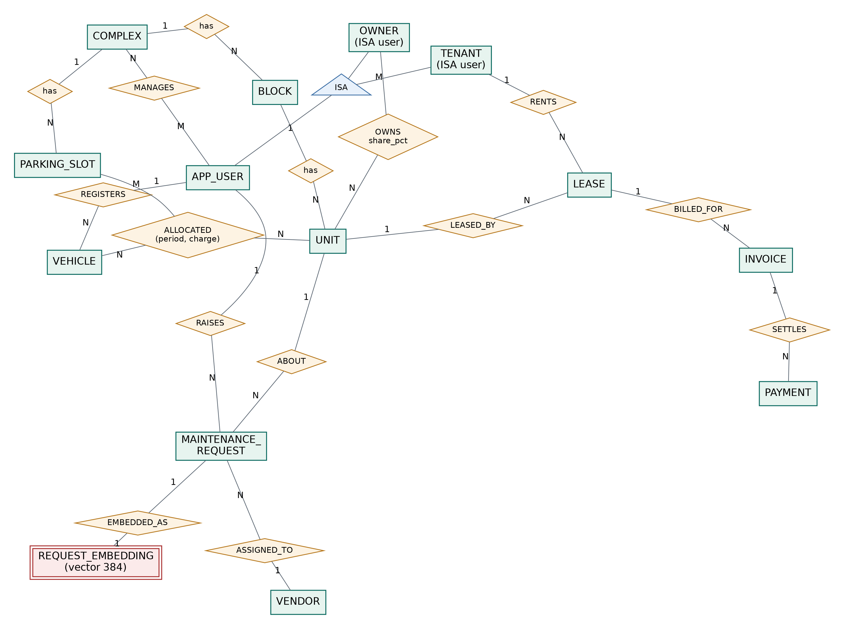
Figure 1. Conceptual ER diagram (Chen notation).

Key design decisions visible here:
- OWNS is M:N with attributes (share_pct, period), so it becomes the ownership table. This supports joint ownership and resale history.
- MANAGES is M:N (one manager can run two complexes, one complex can have two managers), so it becomes complex_manager.
- ALLOCATED is a ternary-style relationship between slot, vehicle and unit with a period and a charge, so it becomes parking_allocation.
- A lease belongs to exactly one unit and one tenant (1:N from each side).

5.2 Logical ER (crow’s-foot, generated from the live schema)
Every table with its columns, keys and nullability. Generated by docs/diagrams/gen_er.py from information_schema, so it always matches the database. A high-resolution copy is in the repository at docs/diagrams/er_diagram.png.

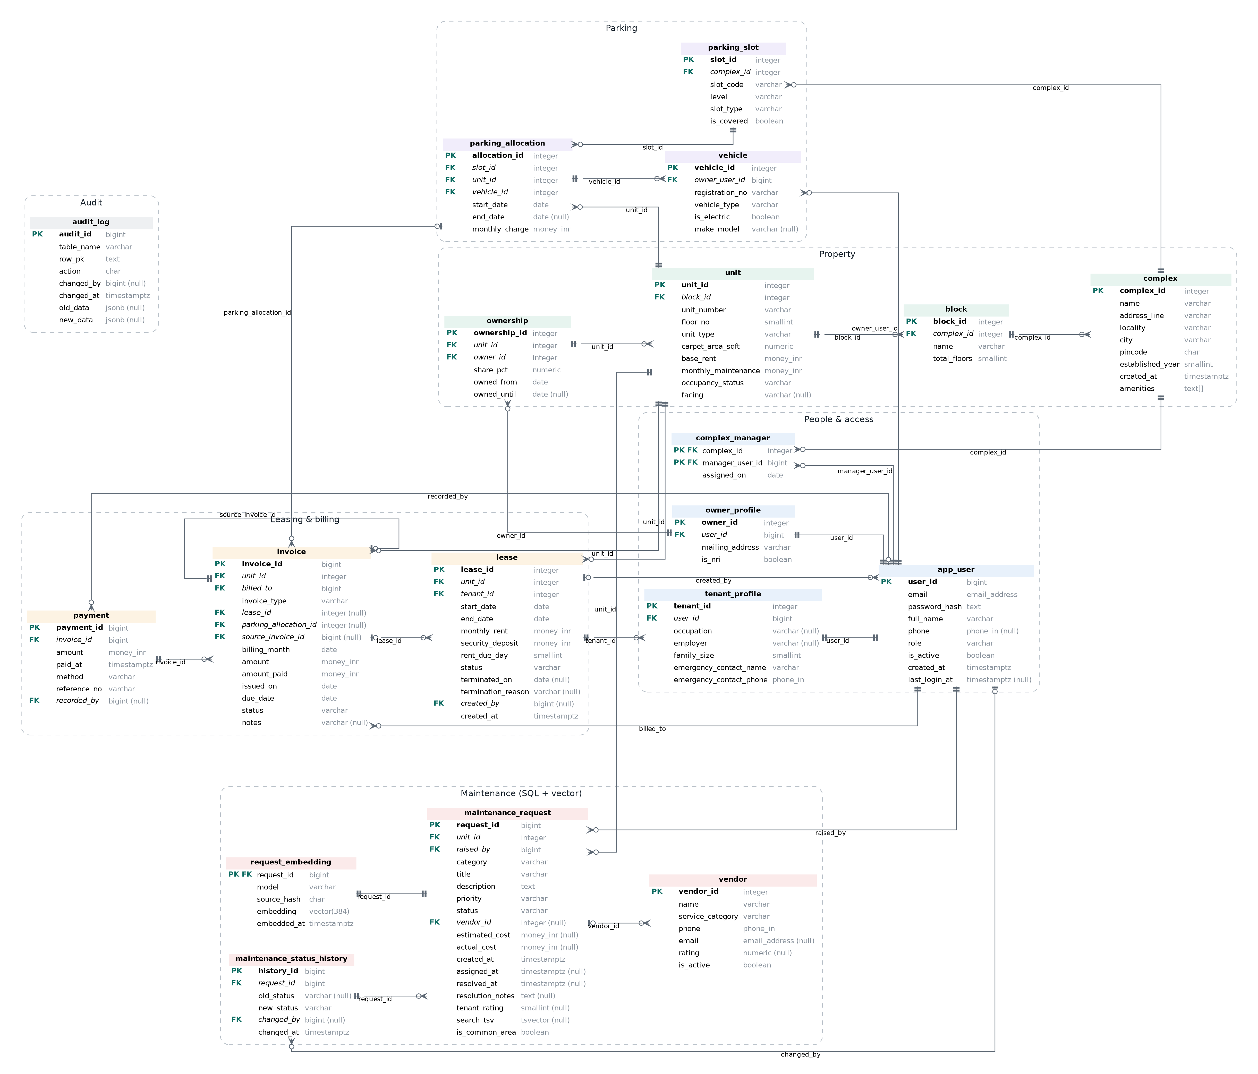
Figure 2. Logical ER diagram with every table, key and nullability (crow’s-foot notation).

6. Relational schema
The conversion from the ER model follows the standard rules:
ER construct | Mapping
Strong entity | Table with a surrogate identity primary key (GENERATED ALWAYS AS IDENTITY); natural keys kept as UNIQUE (e.g. (block_id, unit_number), registration_no, lower(email))
1:N relationship | Foreign key on the N side (block.complex_id, unit.block_id, lease.unit_id, invoice.lease_id, payment.invoice_id …)
M:N relationship with attributes | Separate table (ownership, complex_manager, parking_allocation)
ISA specialisation | app_user holds common attributes and role; owner_profile / tenant_profile hold role-specific attributes with a UNIQUE FK to app_user (1:1). A trigger checks the user’s role matches the profile table
1:1 weak-ish dependent | request_embedding.request_id is both PK and FK to maintenance_request
Multivalued attribute | complex.amenities as text[] (display-only list, never queried relationally)
Derived attribute | invoice.amount_paid and invoice.status are maintained by triggers from payment (controlled redundancy for fast dues queries); maintenance_request.search_tsv is a stored generated column
Full relational schema (generated): Appendix B. Summary:
app_user(user_id PK, email, password_hash, full_name, phone, role, is_active, created_at, last_login_at)
complex(complex_id PK, name, address_line, locality, city, pincode, established_year, created_at, amenities)
complex_manager(complex_id PK/FK→complex, manager_user_id PK/FK→app_user, assigned_on)
block(block_id PK, complex_id FK→complex, name, total_floors)
unit(unit_id PK, block_id FK→block, unit_number, floor_no, unit_type, carpet_area_sqft, base_rent,
monthly_maintenance, occupancy_status, facing)
owner_profile(owner_id PK, user_id FK→app_user UNIQUE, mailing_address, is_nri)
tenant_profile(tenant_id PK, user_id FK→app_user UNIQUE, occupation, employer, family_size,
emergency_contact_name, emergency_contact_phone)
ownership(ownership_id PK, unit_id FK→unit, owner_id FK→owner_profile, share_pct, owned_from, owned_until)
lease(lease_id PK, unit_id FK→unit, tenant_id FK→tenant_profile, start_date, end_date, monthly_rent,
security_deposit, rent_due_day, status, terminated_on, termination_reason, created_by FK→app_user, created_at)
parking_slot(slot_id PK, complex_id FK→complex, slot_code, level, slot_type, is_covered)
vehicle(vehicle_id PK, owner_user_id FK→app_user, registration_no UNIQUE, vehicle_type, is_electric, make_model)
parking_allocation(allocation_id PK, slot_id FK→parking_slot, unit_id FK→unit, vehicle_id FK→vehicle,
start_date, end_date, monthly_charge)
invoice(invoice_id PK, unit_id FK→unit, billed_to FK→app_user, invoice_type, lease_id FK→lease,
parking_allocation_id FK→parking_allocation, source_invoice_id FK→invoice, billing_month, amount,
amount_paid, issued_on, due_date, status, notes)
payment(payment_id PK, invoice_id FK→invoice, amount, paid_at, method, reference_no UNIQUE, recorded_by FK→app_user)
vendor(vendor_id PK, name UNIQUE, service_category, phone, email, rating, is_active)
maintenance_request(request_id PK, unit_id FK→unit, raised_by FK→app_user, category, title, description,
priority, status, vendor_id FK→vendor, estimated_cost, actual_cost, created_at, assigned_at,
resolved_at, resolution_notes, tenant_rating, search_tsv, is_common_area)
request_embedding(request_id PK/FK→maintenance_request, model, source_hash, embedding vector(384), embedded_at)
maintenance_status_history(history_id PK, request_id FK→maintenance_request, old_status, new_status,
changed_by FK→app_user, changed_at)
audit_log(audit_id PK, table_name, row_pk, action, changed_by, changed_at, old_data jsonb, new_data jsonb)
Normalisation. Every non-key attribute depends on the whole key and nothing but the key. Examples of decisions made to reach 3NF:
- Complex and block names are not repeated on unit; they are reached through block_id.
- Owner and tenant attributes are not columns on unit or lease; a unit’s owners are rows in ownership, so joint ownership needs no repeated columns.
- Tenant-specific fields (employer, emergency contact) live in tenant_profile, not as nullable columns on app_user.
- The one deliberate denormalisation is invoice.amount_paid/status, which could be derived from SUM(payment.amount). It is kept because the dues screens filter on it constantly, and it cannot drift: only the payment trigger writes it, and a CHECK (chk_inv_status_paid) rejects any row where status and paid amount disagree.

7. Database choice and justification
The guideline for this project asks that each database be chosen for the nature of the data. The data in this system falls into three kinds.
Data | Nature | Store | Why
Units, people, ownership, leases, invoices, payments, parking | Highly structured, heavily related, money involved, rules span rows and tables | PostgreSQL (relational) | Needs ACID transactions (a payment and its invoice update must succeed together), foreign keys, CHECK and EXCLUDE constraints (no overlapping leases), triggers and joins for reporting. A document store would push these rules into application code.
Maintenance request text (title + description) | Unstructured, short free text written by residents in their own words | pgvector (vector) | The useful question is “have we seen this problem before?”. Residents describe the same fault in different words (“lift not moving” vs “elevator stuck between floors”). Keyword search cannot match those; vector similarity on sentence embeddings can.
Same text, exact terms | Keywords, part names, codes (“MCB”, “RO membrane”) | PostgreSQL full-text search (tsvector + GIN) | Embeddings are weaker on exact rare terms. Combining both (hybrid search) gives the best ranking.
Why pgvector rather than a separate vector database (Qdrant, Pinecone, Chroma). The vectors describe rows that already live in PostgreSQL. Keeping them in the same database means:
- the embedding row has a real foreign key with ON DELETE CASCADE, so a deleted request can never leave an orphan vector;
- a new request and its embedding are inserted in one transaction, so the vector store is never ahead of or behind the relational data;
- a trigger drops the vector when the request text is edited, so stale vectors are impossible;
- a single query can combine vector distance with relational filters (complex, status, the user’s access rights) and full-text rank.
With a few thousand requests per year per complex, an HNSW index inside PostgreSQL is far below the scale where a dedicated vector service would pay for its extra operational cost and the two-phase consistency problem it introduces.
Why MiniLM embeddings computed locally. sentence-transformers/all-MiniLM-L6-v2 (384 dimensions) is a small general-purpose sentence model that runs on CPU in the Node.js server through transformers.js and ONNX Runtime. No external API key is needed and residents’ complaint text never leaves the server.

8. Data dictionary
The complete data dictionary (every column with type, nullability, key, default, and every constraint, index and trigger per table) is generated from the PostgreSQL catalogue: Appendix A.
Table summary:
Table | Purpose | Rows in seed
app_user | Accounts for all four roles, bcrypt hashes only | 412
complex / block / unit | Property hierarchy | 3 / 7 / 160
complex_manager | Which manager runs which complex | 4
owner_profile / tenant_profile | Role-specific attributes | 156 / 252
ownership | Owners per unit with share and period | 180
lease | Rental agreements | 315
invoice / payment | Billing history for 18 months | ~6,800 / ~6,700
parking_slot / vehicle / parking_allocation | Parking | 258 / 166 / 166
vendor | Service providers | 13
maintenance_request | Complaints and work orders | 340
request_embedding | 384-d vectors (vector side) | 340
maintenance_status_history | Workflow trail | ~1,500
audit_log | Change log | grows with use
Reusable validation domains:
Domain | Base type | Rule
email_address | varchar(120) | case-insensitive email pattern
phone_in | varchar(10) | Indian mobile: ^[6-9][0-9]{9}$
money_inr | numeric(12,2) | >= 0

9. SQL and vector database implementation
All DDL is in db/, applied in order by npm run db:setup:
File | Contents
00_extensions.sql | vector (pgvector), btree_gist (for EXCLUDE with = and &&), pg_trgm (fuzzy name search)
01_schema.sql | Domains, 19 tables, PK/FK/UNIQUE/CHECK/EXCLUDE constraints
02_indexes.sql | 30 indexes including partial, expression, GIN (tsvector, trigram) and HNSW (vector)
03_functions_triggers.sql | 14 trigger functions, 21 triggers
04_procedures.sql | Billing, late fees, payment, termination procedure, expiry job, vector search functions
05_views.sql | 7 views and 1 materialized view
06_migration_v2.sql | Schema evolution with ALTER TABLE ... ADD COLUMN / ADD CONSTRAINT / ALTER COLUMN, DROP TABLE, DROP VIEW
07_comments.sql | COMMENT ON catalogue documentation
99_teardown.sql | DROP of every object in dependency order

9.1 CREATE, ALTER, DROP
- CREATE DOMAIN, CREATE TABLE, CREATE INDEX, CREATE VIEW, CREATE MATERIALIZED VIEW, CREATE FUNCTION, CREATE PROCEDURE, CREATE TRIGGER.
- 06_migration_v2.sql is a realistic “version 2” migration: it adds unit.facing with a new CHECK constraint, complex.amenities, maintenance_request.is_common_area, changes a column default, creates a staging table for a bulk unit import and drops it afterwards, and drops a superseded view. It is written to be re-runnable (IF NOT EXISTS, DROP CONSTRAINT IF EXISTS).
- 99_teardown.sql drops materialized views, views, tables, functions, procedures and domains in dependency order.

9.2 Constraints (data validation at the database level)
Rule | Mechanism
Valid email, Indian phone number, non-negative money | Domains
Passwords must be bcrypt hashes; plain text is impossible | CHECK (password_hash ~ '^\$2[aby]\$...')
Case-insensitive unique email | Unique expression index on lower(email)
No two live leases on a unit with overlapping dates | EXCLUDE USING gist (unit_id WITH =, daterange(start_date, end_date) WITH &&) WHERE status IN ('PENDING','ACTIVE')
No double-booked parking slot, no car in two slots | Two EXCLUDE constraints on parking_allocation
Deposit at most 10 months’ rent; due day 1 to 28; end after start | CHECK on lease
Each invoice type references the right parent (rent → lease, parking → allocation, late fee → source invoice) | Multi-branch CHECK chk_inv_links
Invoice status agrees with the paid amount | CHECK chk_inv_status_paid
Vendor required once a request is assigned; resolved_at set iff resolved/closed; rating only after resolution | CHECKs on maintenance_request
Vehicle registration format (KA01AB1234) | CHECK regex
One rent invoice per lease per month, etc. (idempotent billing) | Partial unique indexes

9.3 Triggers
Trigger | Table | What it enforces or maintains
owner_profile_role, tenant_profile_role, complex_manager_role | profiles | The linked user has the matching role
unit_floor_check | unit | Floor number is within the block’s floor count
ownership_share_check | ownership | Live shares on a unit total at most 100% (locks the unit row to prevent races)
lease_validate | lease | Only an owned unit can be leased; closed leases cannot be reactivated
lease_sync_unit | lease | Keeps unit.occupancy_status in step with leases
payment_before_insert | payment | Locks the invoice (SELECT ... FOR UPDATE), rejects overpayment and payments on void invoices
payment_after_change | payment | Recomputes invoice.amount_paid and status on insert and delete
payment_block_update | payment | Payments are immutable
invoice_guard | invoice | An invoice with payments cannot be voided; a void invoice cannot be reopened
parking_allocation_check | parking_allocation | Same complex; slot type matches vehicle (EV slots only for electric cars); vehicle belongs to a resident or owner of the unit
mr_before_write | maintenance_request | Raiser must be connected to the unit; only legal status transitions; timestamps stamped by the database
mr_history | maintenance_request | Writes every status change to maintenance_status_history with the acting user
mr_invalidate_embedding | maintenance_request | Deletes the stored vector when title or description changes
audit_* | lease, payment, ownership, unit, app_user, invoice | Generic JSONB audit (password hashes stripped, password changes flagged)
The acting user is passed from the application with set_config('app.user_id', $1, true) at the start of each transaction (equivalent to SET LOCAL), so triggers know who made each change without trusting any client-supplied column.

9.4 Stored procedures and functions
Routine | Type | Purpose
fn_generate_monthly_invoices(month) | function | Creates RENT (prorated for partial months), MAINTENANCE (to the majority owner) and PARKING invoices. Idempotent via ON CONFLICT DO NOTHING against partial unique indexes; refuses future months
fn_apply_late_fees(as_of, rate, grace) | function | 2% of the balance (minimum Rs 100) on rent/maintenance invoices overdue beyond the grace period; one per invoice
fn_record_payment(...) | function | Records a payment and generates a reference; balance checks happen in the trigger
sp_terminate_lease(lease, date, reason) | procedure (CALL) | Locks the lease, validates, marks it TERMINATED, voids later unpaid rent, releases the tenant’s parking; unit status follows through the lease trigger. All or nothing
fn_close_expired_leases(as_of) | function | Nightly job: ACTIVE leases past their end date become ENDED
fn_refresh_unit_status(unit) | function | Derives unit status from leases
fn_recalc_invoice(invoice) | function | Recomputes paid amount and status
fn_similar_requests(request, k) | SQL function | k nearest requests by stored embedding
fn_hybrid_search(text, vector, complex, k) | SQL function | Reciprocal Rank Fusion of vector and full-text rankings

9.5 Transactions
- Every write from the API goes through withTransaction() (src/lib/db.ts): BEGIN, set app.user_id, run statements, COMMIT, or ROLLBACK on any error.
- Creating a maintenance request inserts the request and its embedding in one transaction.
- Creating a person inserts app_user and the profile in one transaction; a failing profile insert rolls back the user.
- sp_terminate_lease performs four dependent updates atomically.
- Concurrency: the payment trigger row-locks the invoice, and the ownership trigger row-locks the unit, so two concurrent requests cannot both pass a balance or share check.

9.6 Views and materialized view
View | Used by
v_user_complex_scope | Row-level scoping: which complexes each user may see (admin: all; manager: assigned; owner: owned; tenant: leased)
v_unit_directory | Unit lists and details: location, current owners (LATERAL + string_agg), current tenant (LATERAL + LIMIT 1)
v_complex_occupancy | Occupancy counts and percentage per complex (count(*) FILTER)
v_invoice_balance | Balance and days overdue per invoice
v_monthly_collections | Billed vs collected per complex per month
v_maintenance_sla | Average resolution time and % within SLA (24h / 72h / 7d / 14d by priority)
v_vendor_performance | Jobs, average cost, resident rating, turnaround per vendor
mv_complex_kpis (materialized) | Dashboard KPI strip; refreshed with REFRESH MATERIALIZED VIEW CONCURRENTLY (needs its unique index) after billing runs and on demand

9.7 Indexes
Each index backs a specific query (full list in the data dictionary):
- B-tree on every foreign key used in joins.
- Partial: idx_invoice_open_due ON invoice(due_date) WHERE status IN ('UNPAID','PARTIAL'). The dues screen reads only open invoices, a small fraction of the table. Verified with EXPLAIN: Bitmap Index Scan on idx_invoice_open_due.
- Partial unique indexes that make billing idempotent.
- Expression: lower(email) for case-insensitive login.
- GIN on search_tsv for full-text search; GIN trigram on full_name for typo-tolerant people search.
- HNSW on request_embedding.embedding with vector_cosine_ops (m = 16, ef_construction = 64) for nearest-neighbour search. A test asserts the planner uses it.

9.8 Vector database / semantic search
Question from the guidelines | Answer
What data is converted into embeddings | Each maintenance request’s title + ". " + description (for example “Water seeping through bathroom ceiling. There is a wet patch on the ceiling…”). Search queries typed by users are embedded the same way at query time
Embedding model | sentence-transformers/all-MiniLM-L6-v2 (ONNX build Xenova/all-MiniLM-L6-v2), run in-process with transformers.js on ONNX Runtime; mean pooling, L2-normalised, 384 dimensions
How vectors are stored | request_embedding(request_id PK/FK, model, source_hash, embedding vector(384), embedded_at). source_hash is the md5 of the embedded text so stale vectors are detectable; model records which model produced it so the store can be re-embedded after a model change (npm run db:embed re-embeds anything missing or stale)
Index | HNSW, vector_cosine_ops
Similarity metric | Cosine distance <=>; similarity shown to users as 1 - distance. Vectors are normalised, so cosine and inner product rank identically
Retrieval | Three modes. Semantic: ORDER BY embedding <=> $query LIMIT k with relational filters (complex, user access). Keyword: tsvector @@ tsquery ranked by ts_rank_cd. Hybrid (default): fn_hybrid_search takes the top 50 from each, fuses them with Reciprocal Rank Fusion (score = Σ 1/(60 + rank)), so a request ranked well by both signals rises to the top. Results the user may not see are filtered by the same access predicate as every other endpoint
Where it is used | (1) the search box on the Maintenance page; (2) “Similar past requests” on a request’s detail page (fn_similar_requests, uses the stored vector, no model call); (3) duplicate detection when a request is created (open requests in the same complex with similarity above 0.6 are shown straight away)
Example that motivates the design (from the tests): the query “water dripping from the roof” matches zero requests with PostgreSQL full-text search, because no request uses those words together. Semantic search returns five plumbing requests (“Water seeping through bathroom ceiling”, “Damp patch spreading on ceiling below toilet”, …). “insects in the kitchen” returns “Cockroaches in kitchen cabinets” first although “insect” and “cockroach” share no characters.

10. Important queries
Nine analytical queries are available on the Reports page, which shows the SQL beside the result (src/lib/reports.ts). A selection:
Repeat defaulters (JOIN via view, GROUP BY, HAVING, aggregates)
SELECT ib.billed_to_name AS resident, ib.complex_name AS complex,
count(*) AS overdue_invoices, sum(ib.balance) AS outstanding,
max(ib.days_overdue) AS oldest_days_overdue
FROM v_invoice_balance ib
WHERE ib.complex_id = ANY($1) AND ib.days_overdue > 0
GROUP BY ib.billed_to, ib.billed_to_name, ib.complex_name
HAVING count(*) >= 2
ORDER BY outstanding DESC;
Leases below market rent (correlated subquery)
SELECT d.complex_name, d.block_name || '-' || d.unit_number AS unit, d.unit_type, l.monthly_rent
FROM lease l JOIN v_unit_directory d ON d.unit_id = l.unit_id
WHERE l.status = 'ACTIVE'
AND l.monthly_rent < 0.9 * (SELECT avg(l2.monthly_rent)
FROM lease l2 JOIN v_unit_directory d2 ON d2.unit_id = l2.unit_id
WHERE l2.status = 'ACTIVE'
AND d2.complex_id = d.complex_id AND d2.unit_type = d.unit_type);
Leases expiring with no renewal lined up (NOT EXISTS)
SELECT d.complex_name, d.unit_number, au.full_name, l.end_date, l.end_date - current_date AS days_left
FROM lease l JOIN tenant_profile t USING (tenant_id) JOIN app_user au ON au.user_id = t.user_id
JOIN v_unit_directory d ON d.unit_id = l.unit_id
WHERE l.status = 'ACTIVE' AND l.end_date <= current_date + 60
AND NOT EXISTS (SELECT 1 FROM lease nxt WHERE nxt.unit_id = l.unit_id AND nxt.status = 'PENDING')
ORDER BY l.end_date;
Revenue with subtotals (GROUP BY ROLLUP, GROUPING())
SELECT CASE WHEN GROUPING(c.name) = 1 THEN 'ALL COMPLEXES' ELSE c.name END AS complex,
CASE WHEN GROUPING(i.invoice_type) = 1 THEN 'SUBTOTAL' ELSE i.invoice_type END AS invoice_type,
sum(i.amount) AS billed, sum(i.amount_paid) AS collected
FROM invoice i JOIN unit u USING (unit_id) JOIN block b USING (block_id) JOIN complex c USING (complex_id)
WHERE i.status <> 'VOID' AND i.billing_month >= date_trunc('month', current_date) - interval '5 months'
GROUP BY ROLLUP (c.name, i.invoice_type);
Collection-rate ranking (CTE, window functions RANK and LAG)
WITH m AS (SELECT complex_name, billing_month, collection_pct FROM v_monthly_collections)
SELECT billing_month, complex_name, collection_pct,
RANK() OVER (PARTITION BY billing_month ORDER BY collection_pct DESC) AS rank_in_month,
collection_pct - LAG(collection_pct) OVER (PARTITION BY complex_name ORDER BY billing_month) AS change
FROM m ORDER BY billing_month DESC, rank_in_month;
Hybrid semantic search (vector + full-text, RRF)
SELECT * FROM fn_hybrid_search('MCB tripping when geyser is on', $embedding::vector, NULL, 10);
Other reports: units with recurring problems (HAVING count >= 3), vendor scorecard (view), owners with multiple flats (GROUP BY/HAVING with LEFT JOIN), parking utilisation (LEFT JOIN + FILTER).
DML used by the application:
Statement | Where
INSERT | users + profiles, leases, payments, vehicles, parking allocations, maintenance requests + embeddings, invoices (billing function)
UPDATE | unit status/rent, lease termination, request workflow, invoice status (trigger), user activation
DELETE | payment reversal (admin), vehicle removal, erroneous parking allocation, stale embeddings (trigger)
SELECT | every list, dashboard and report; JOIN / GROUP BY / HAVING / ORDER BY / subqueries / window functions throughout

11. System architecture
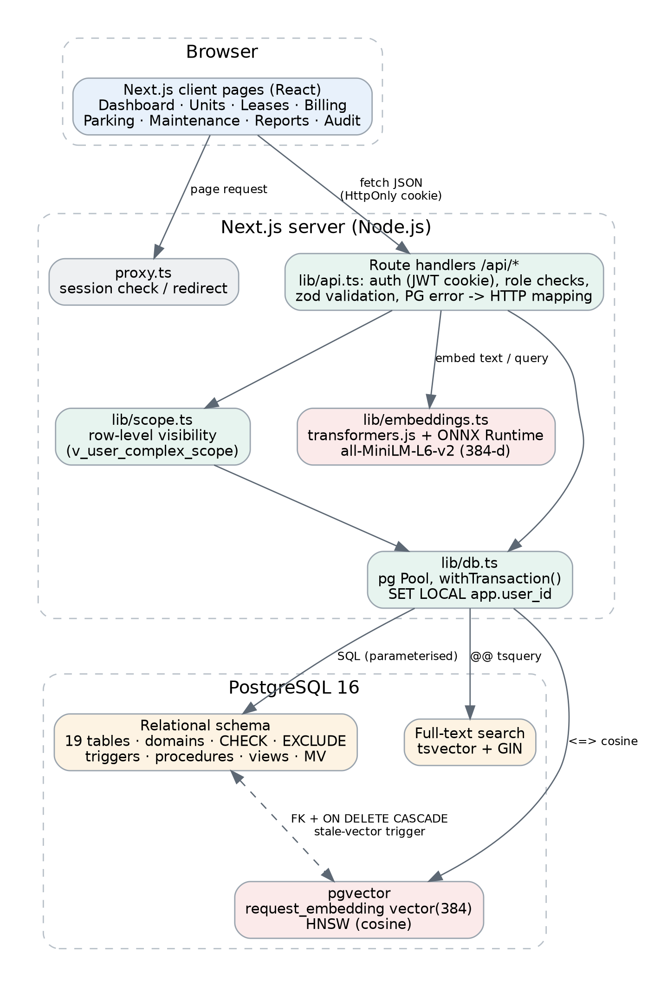
Figure 3. System architecture.
- Browser: Next.js client pages. They never touch the database; they call /api/* with fetch.
- Next.js server:
  - src/proxy.ts redirects unauthenticated page requests to /login.
  - Route handlers under src/app/api/ form the backend API (30 route files, 38 handlers). Each is wrapped by api() in src/lib/api.ts, which verifies the session JWT from an HttpOnly cookie, re-checks the account is active, enforces allowed roles, parses input with zod, and turns PostgreSQL errors into HTTP responses (unique violation → 409, EXCLUDE violation → 409, CHECK/trigger violation → 422 with the database’s message).
  - src/lib/scope.ts holds the row-visibility predicate used by every list query.
  - src/lib/embeddings.ts computes embeddings in-process.
  - src/lib/db.ts holds the connection pool and the transaction helper. All SQL is parameterised ($1, $2, ...); dynamic filters are built with a small Where helper that only ever appends placeholders.
- PostgreSQL 16 holds relational data, vectors and full-text indexes.

Interface design
The UI follows the visual language of apple.com, driven by a design-token set (colour ramps, spacing, type scale and hairline shadow) declared in src/app/globals.css with Tailwind v4 @theme: a light #f5f5f7 canvas, white tiles with 18px corners, a translucent 48px top navigation bar, pill-shaped buttons in action blue (#0071e3), iOS-style segmented controls for filters, large tightly tracked headlines, and the system SF Pro font (Inter is self-hosted as the fallback on non-Apple devices). Chart and status colours come from the same tokens (src/lib/palette.tsx). The product mark is an original building glyph; no Apple logos or assets are used.

Configuration and security
Practice | Implementation
No hard-coded credentials | DATABASE_URL, JWT_SECRET read from environment (.env.local, git-ignored); .env.example documents them
Passwords | bcrypt (cost 10); database CHECK rejects non-bcrypt values; audit log never stores hashes
Sessions | HS256 JWT, 8-hour expiry, HttpOnly; SameSite=Lax cookie (Secure in production)
Brute force | 5 failed logins per email per 15 minutes; unknown emails take the same time as wrong passwords
SQL injection | Parameterised queries only (tested with '; DROP TABLE unit; --)
CSRF | SameSite cookie plus JSON-only content type for state-changing requests (form posts get 415)
Authorisation | Role check per endpoint plus row-level scoping in SQL; deactivated accounts are rejected even with a valid token
Headers | X-Content-Type-Options, X-Frame-Options: DENY, Referrer-Policy
Deployment. The same code runs against a local PostgreSQL 16 or a hosted one. For the demo the database is hosted on Neon (managed PostgreSQL with pgvector) and the app runs either locally or on Render; schema setup and seeding go through the Node pg driver, so no database software is installed on the presenting laptop. Steps are in docs/DEMO_SETUP.md in the repository.

12. Application screenshots
All screenshots are from the running application on the seed data.
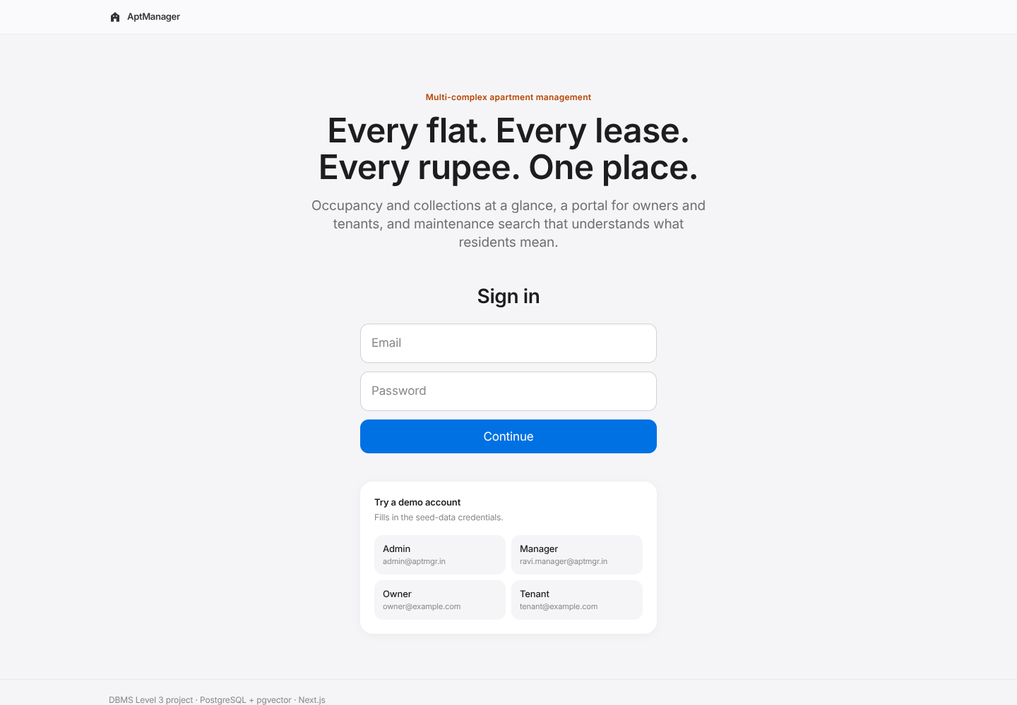
Figure 4. Login with demo accounts.
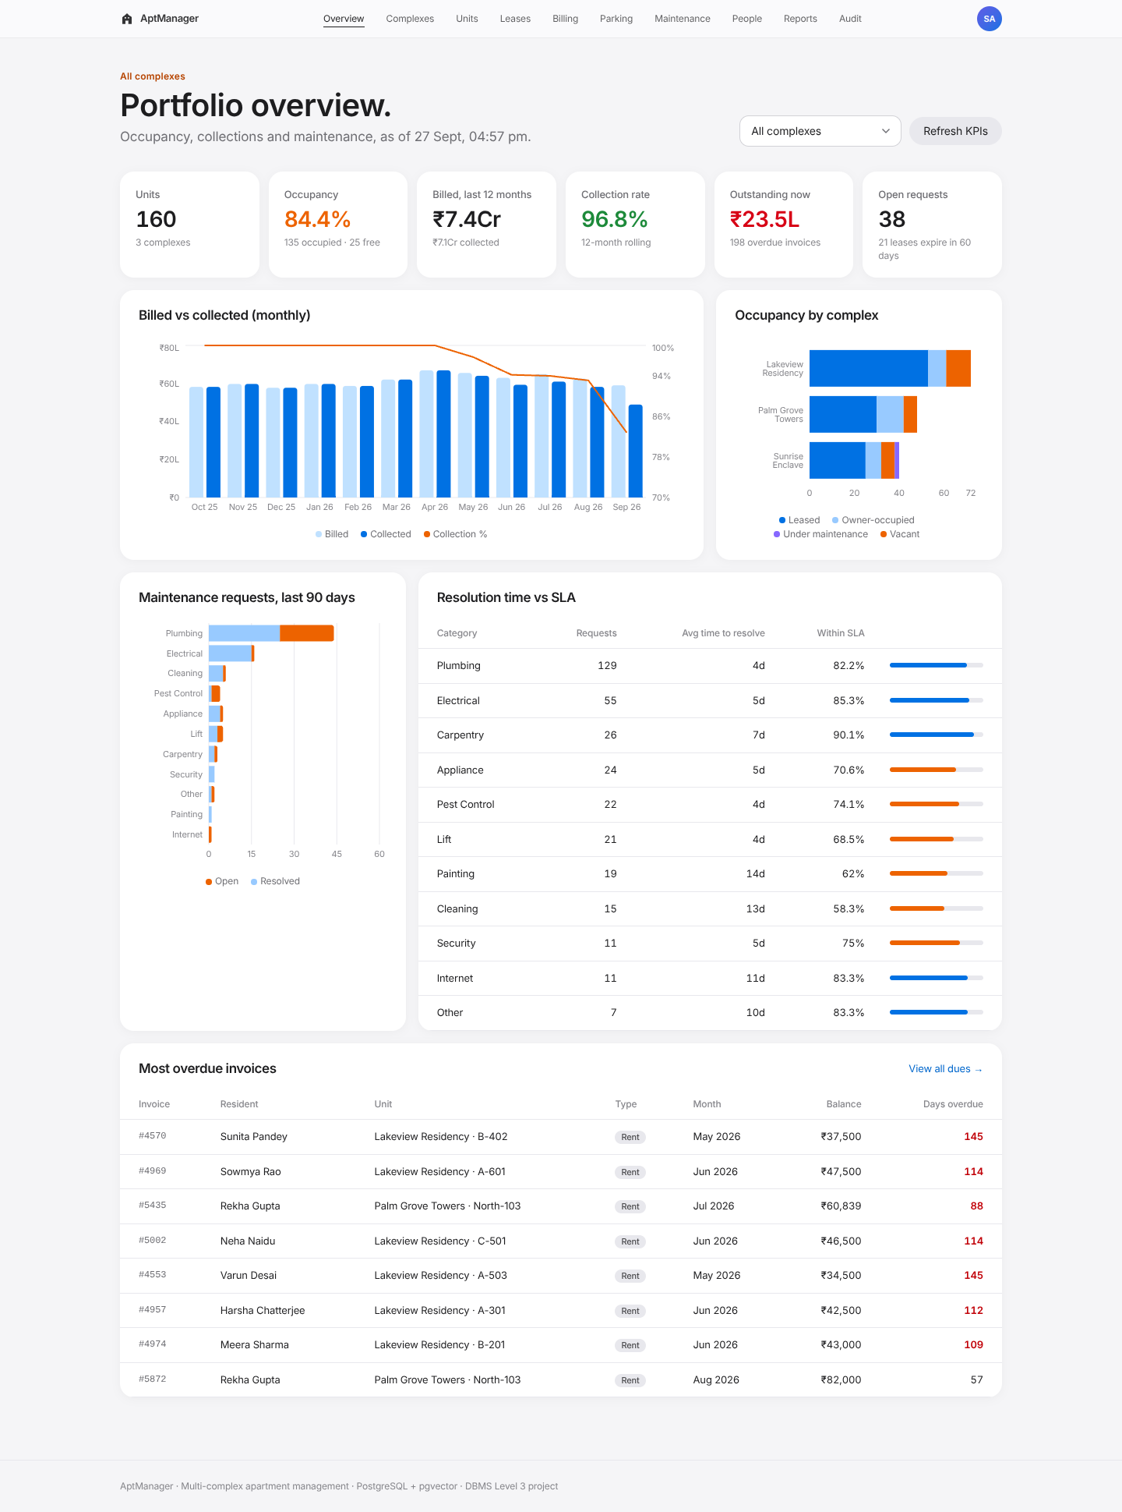
Figure 5. Admin dashboard: KPIs, billed vs collected, occupancy, maintenance by category, SLA, most overdue.
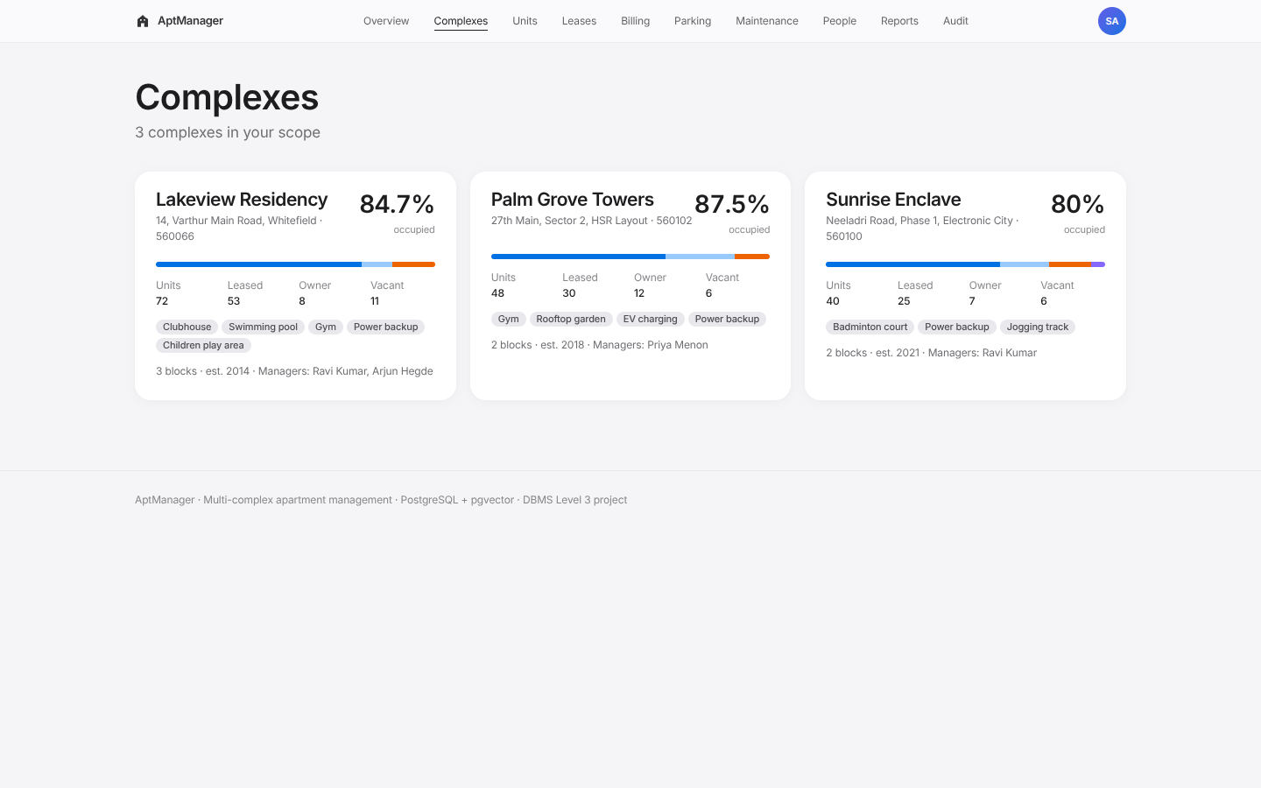
Figure 6. Complexes.
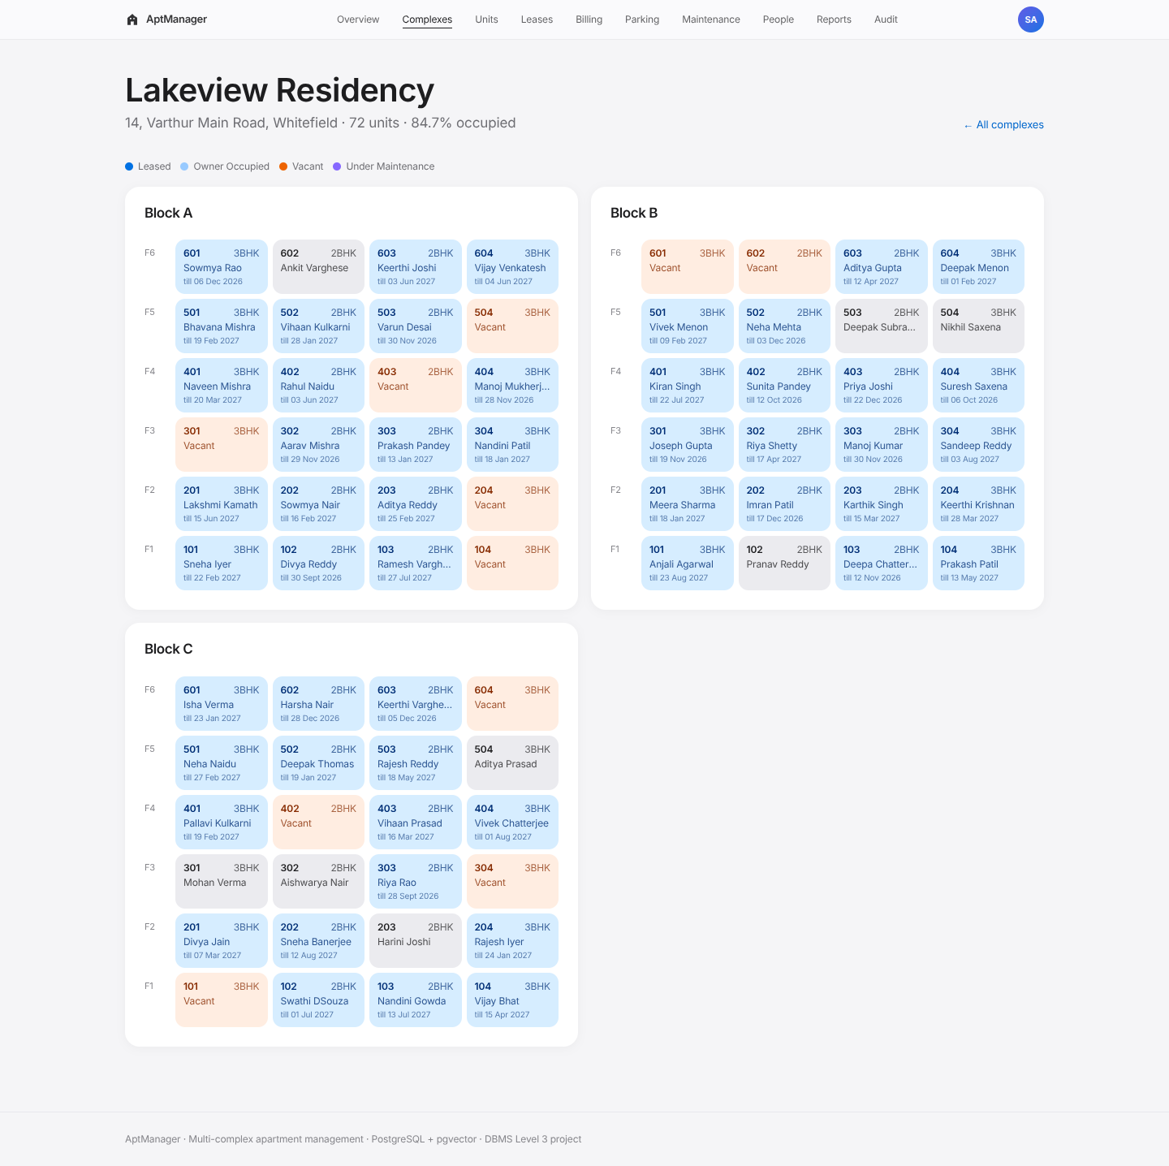
Figure 7. Floor-by-floor unit map.
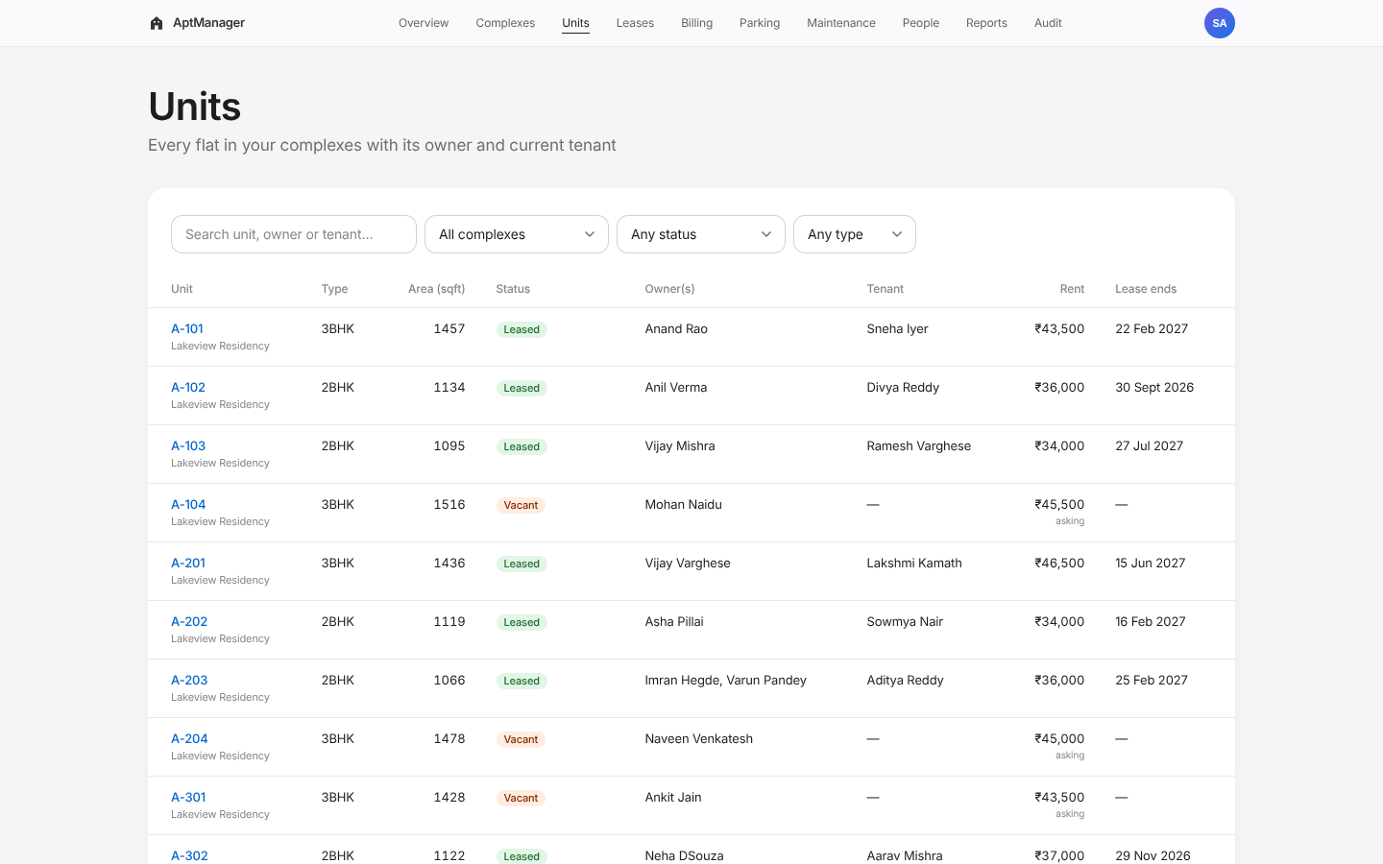
Figure 8. Units with filters.
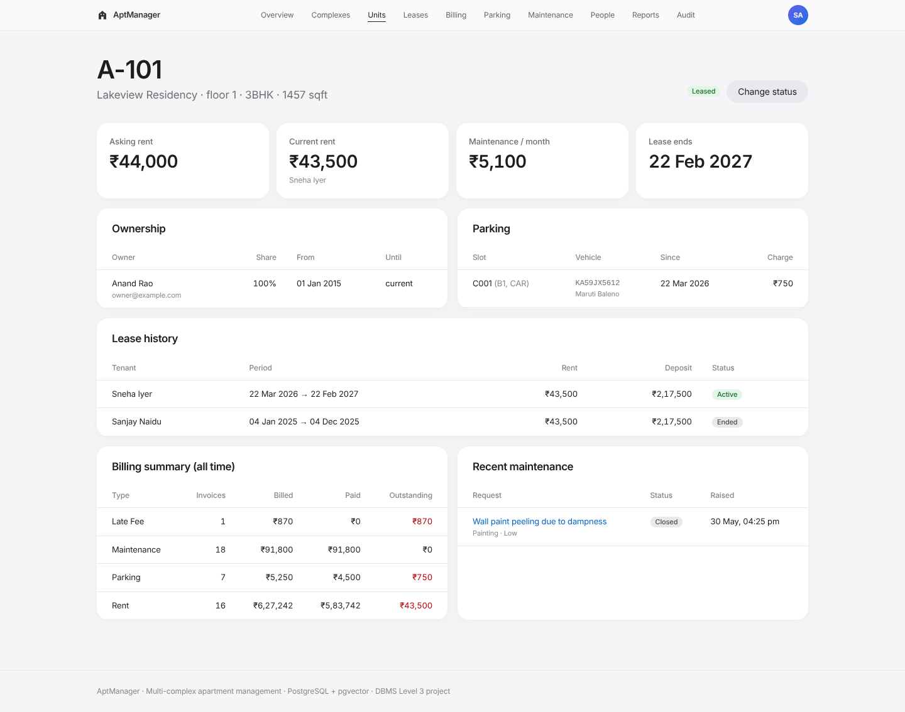
Figure 9. Unit detail.
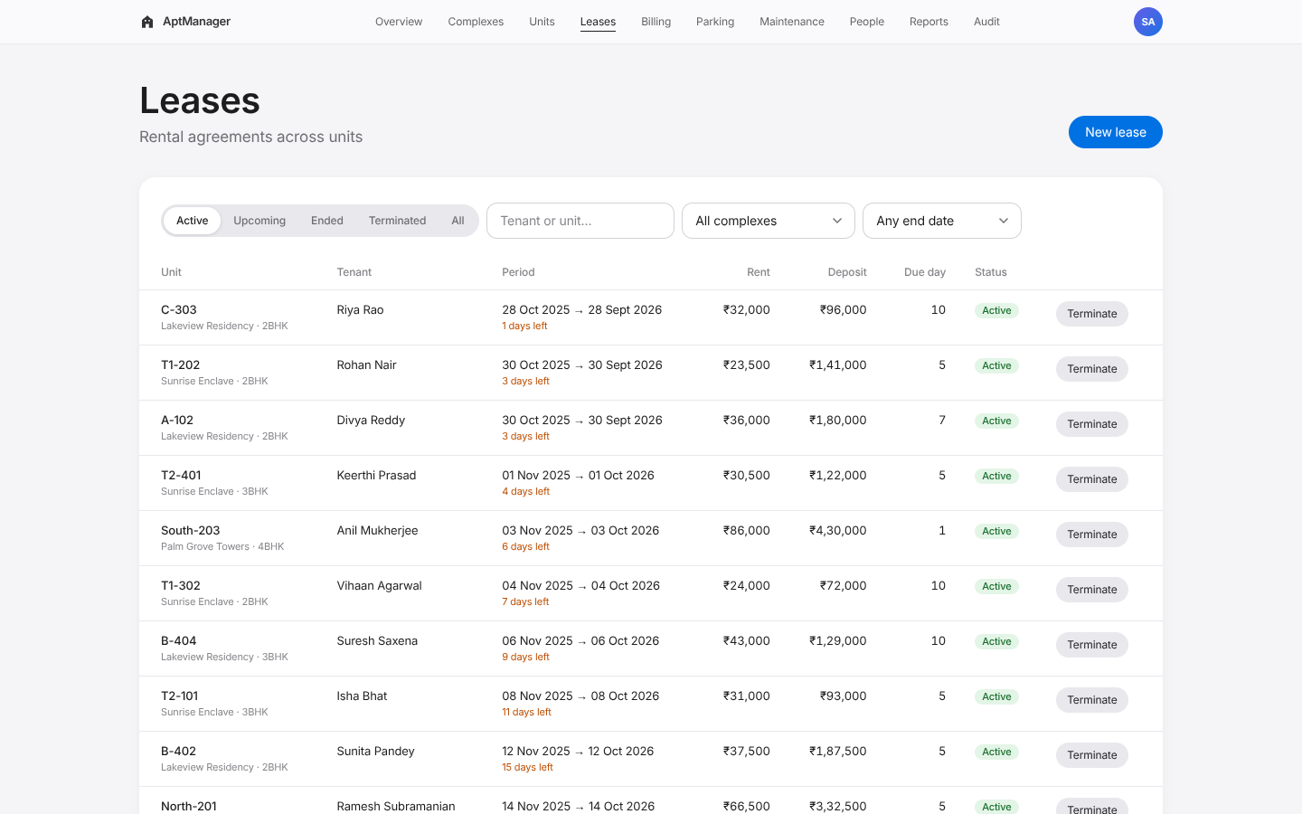
Figure 10. Leases.
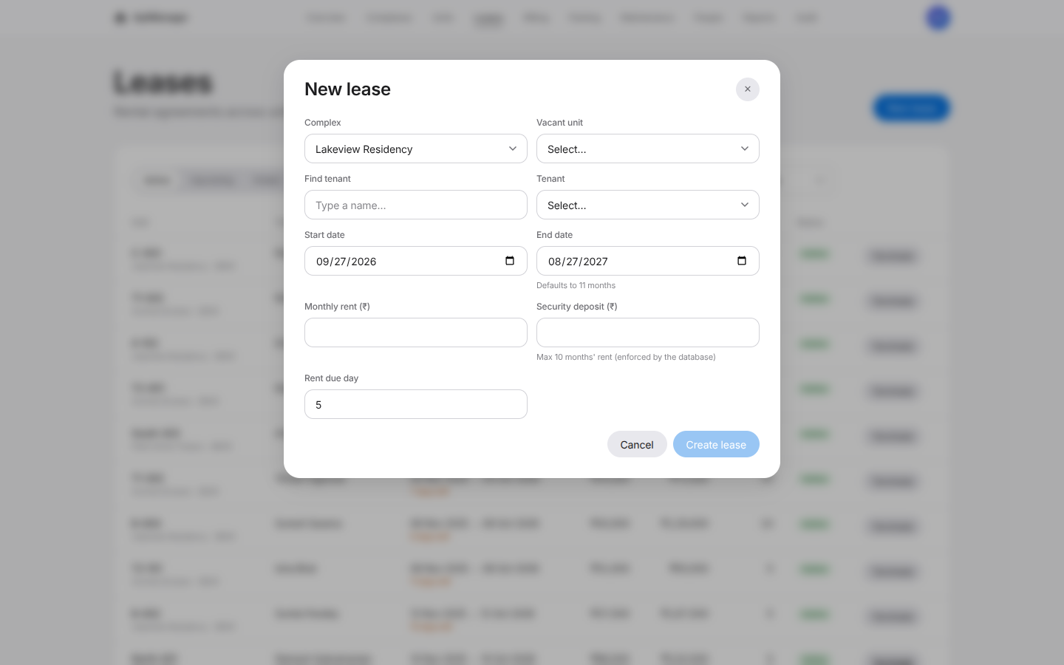
Figure 11. New lease form.
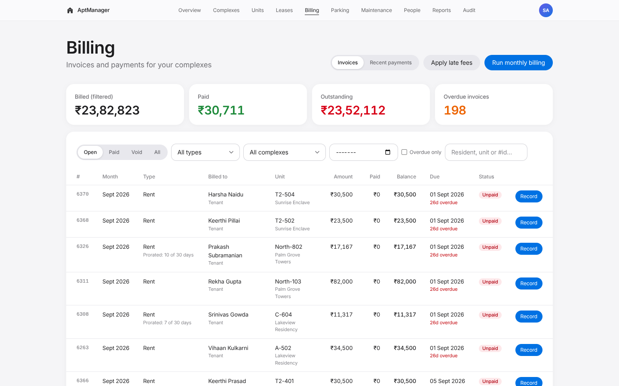
Figure 12. Invoices with totals and filters.
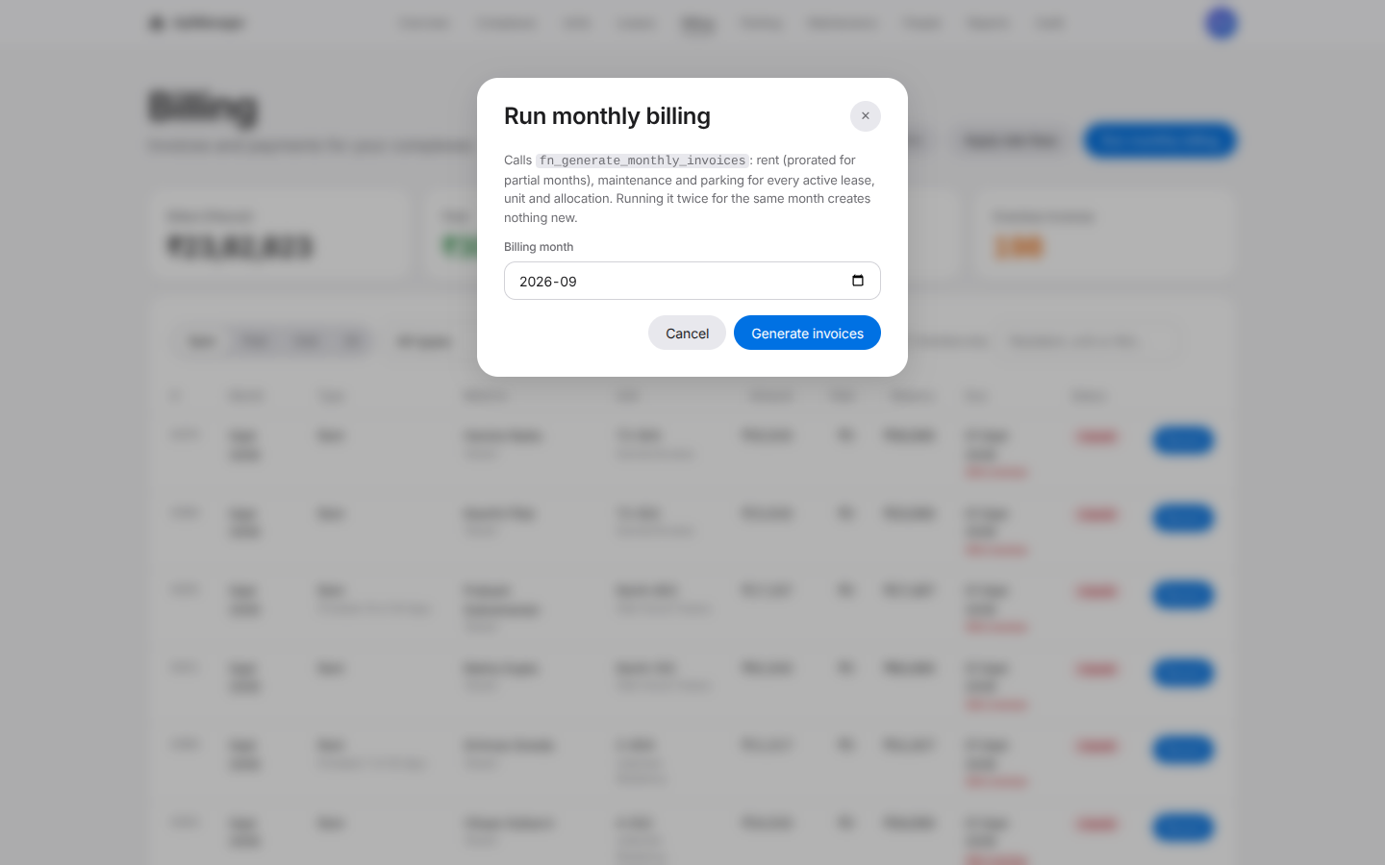
Figure 13. Monthly billing run (stored function).
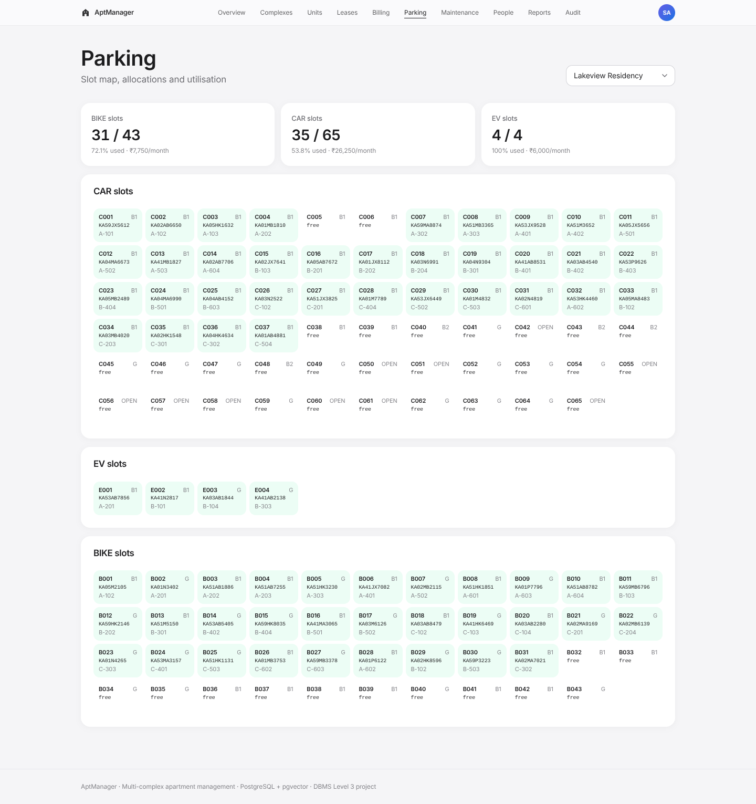
Figure 14. Parking slot map and utilisation.
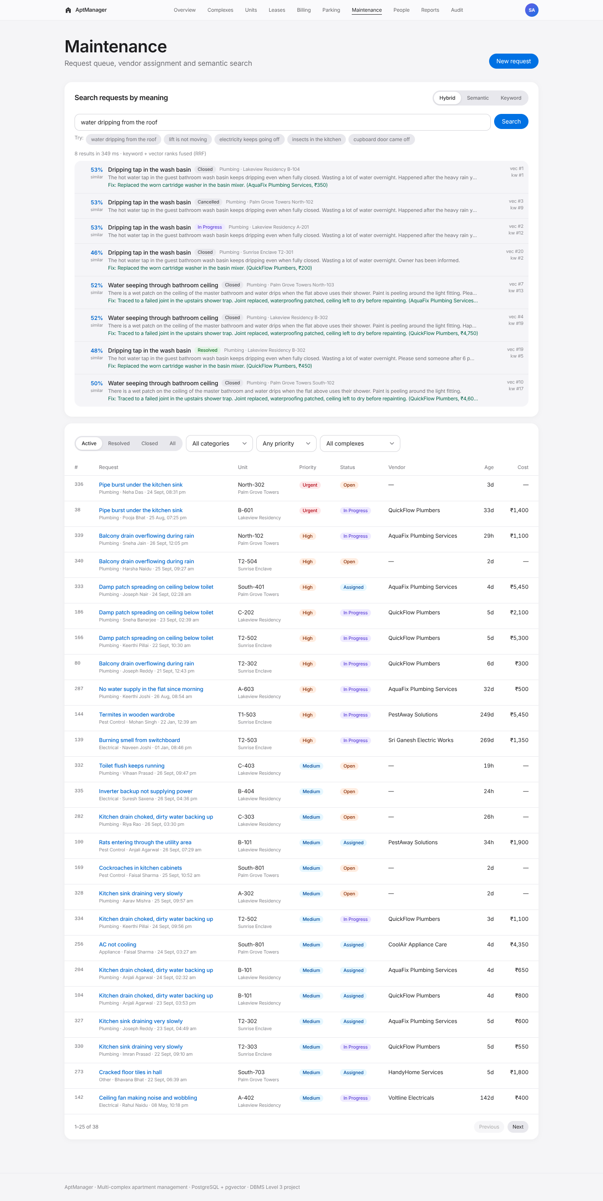
Figure 15. Hybrid search: “water dripping from the roof”.
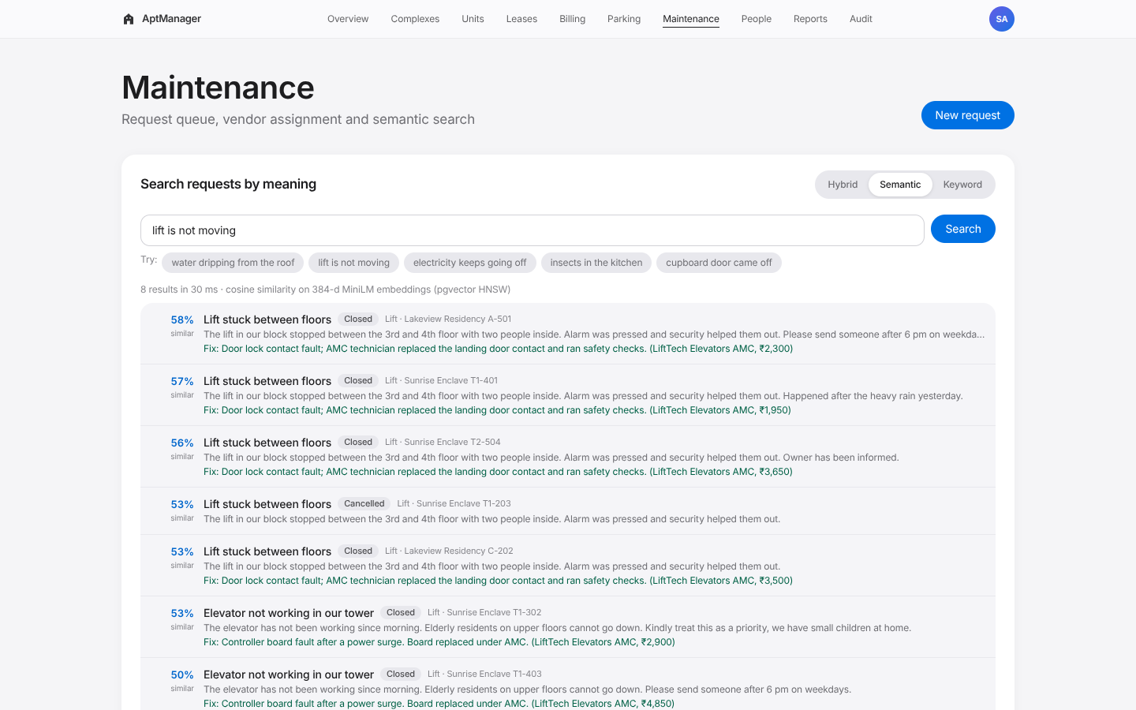
Figure 16. Semantic search: “lift is not moving”.
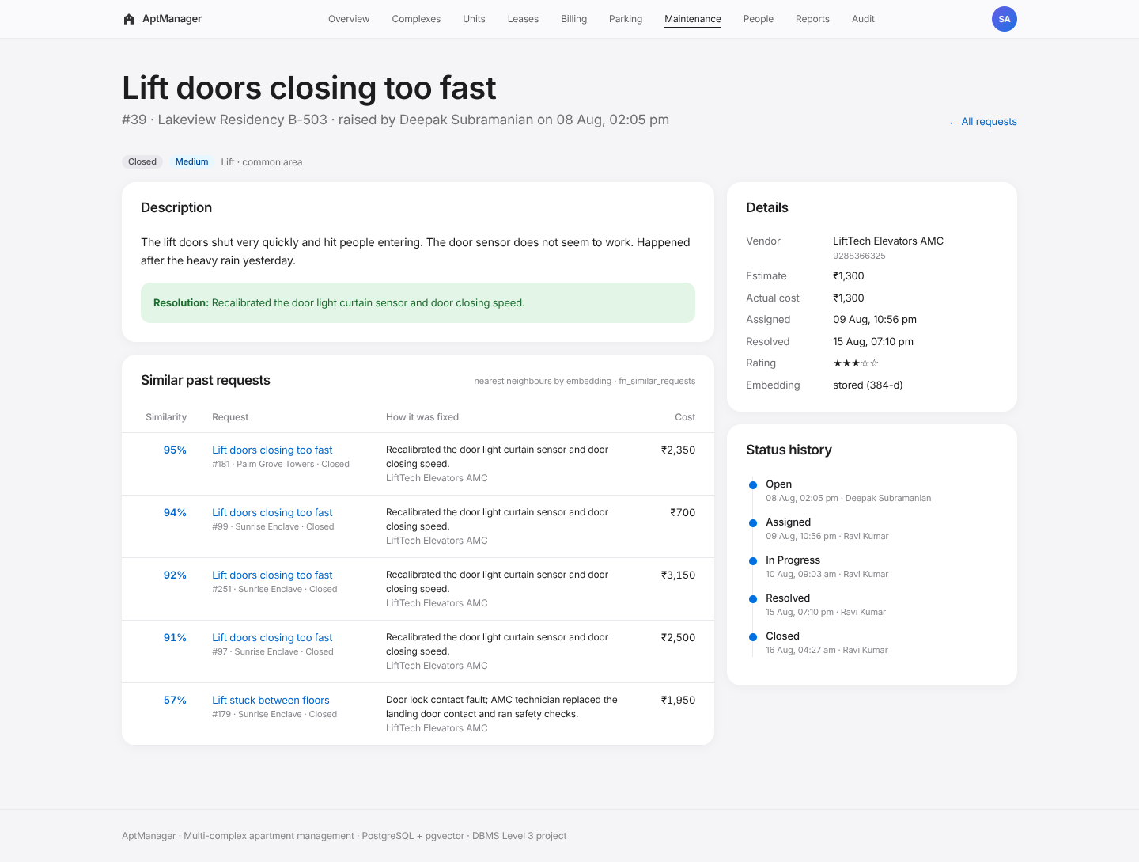
Figure 17. Request detail with similar past requests and status history.
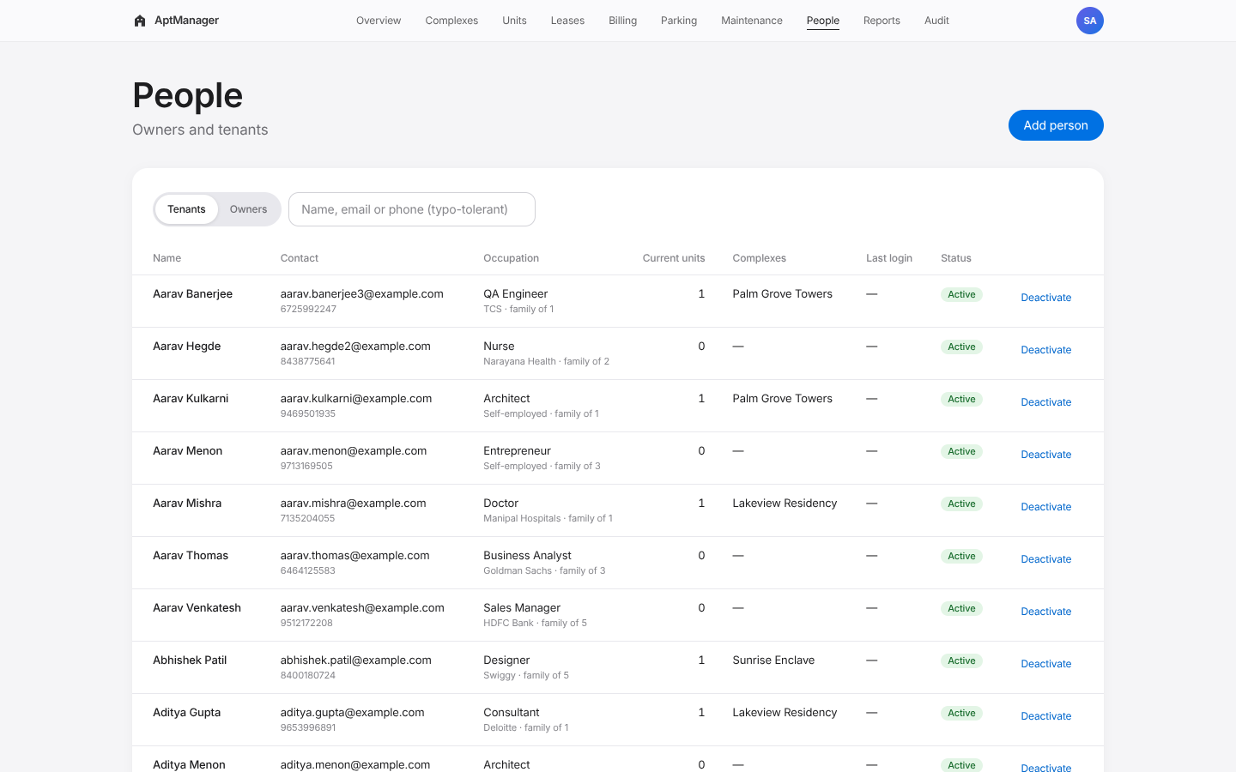
Figure 18. People (typo-tolerant search).
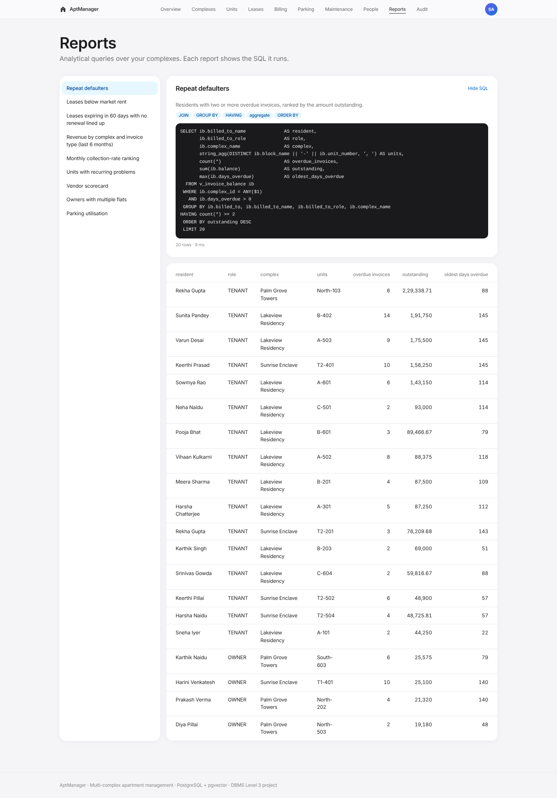
Figure 19. Reports with SQL shown.
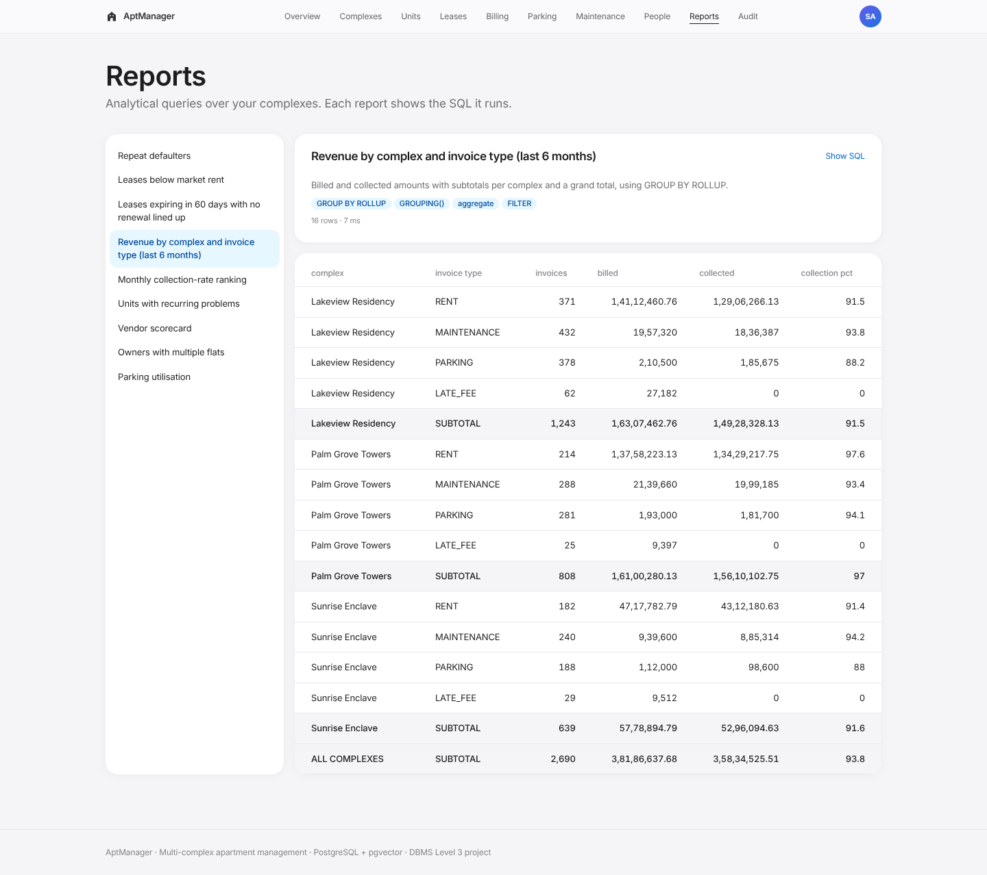
Figure 20. ROLLUP report.
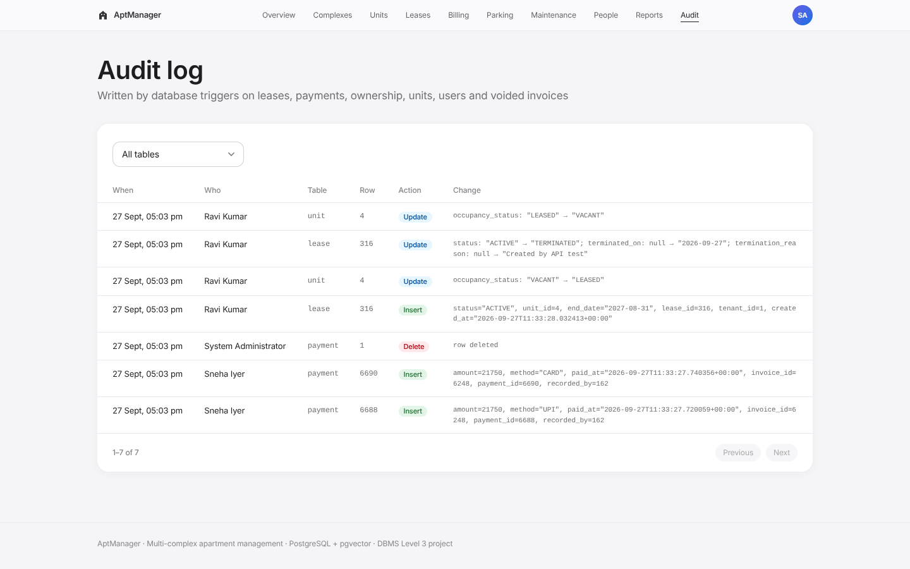
Figure 21. Audit log written by triggers.
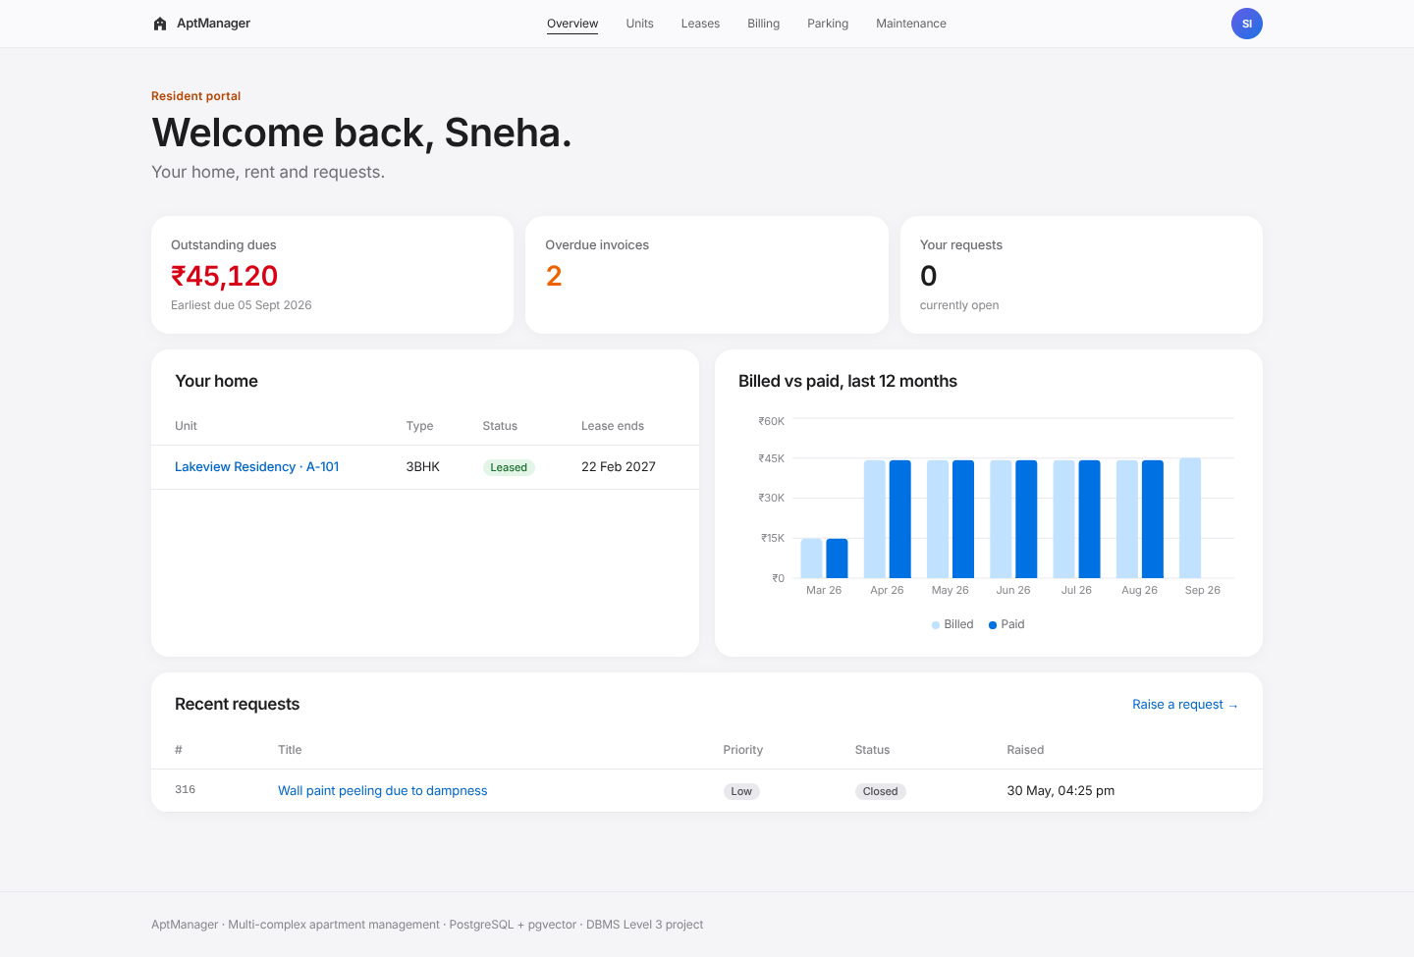
Figure 22. Tenant dashboard.
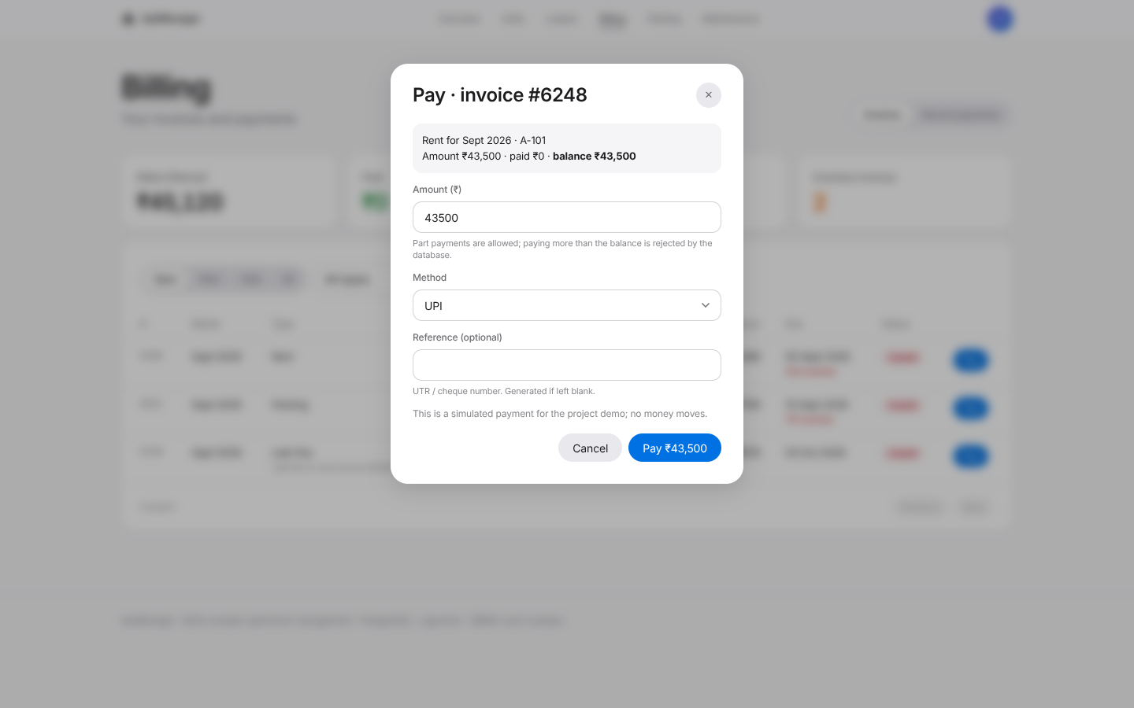
Figure 23. Tenant paying an invoice.
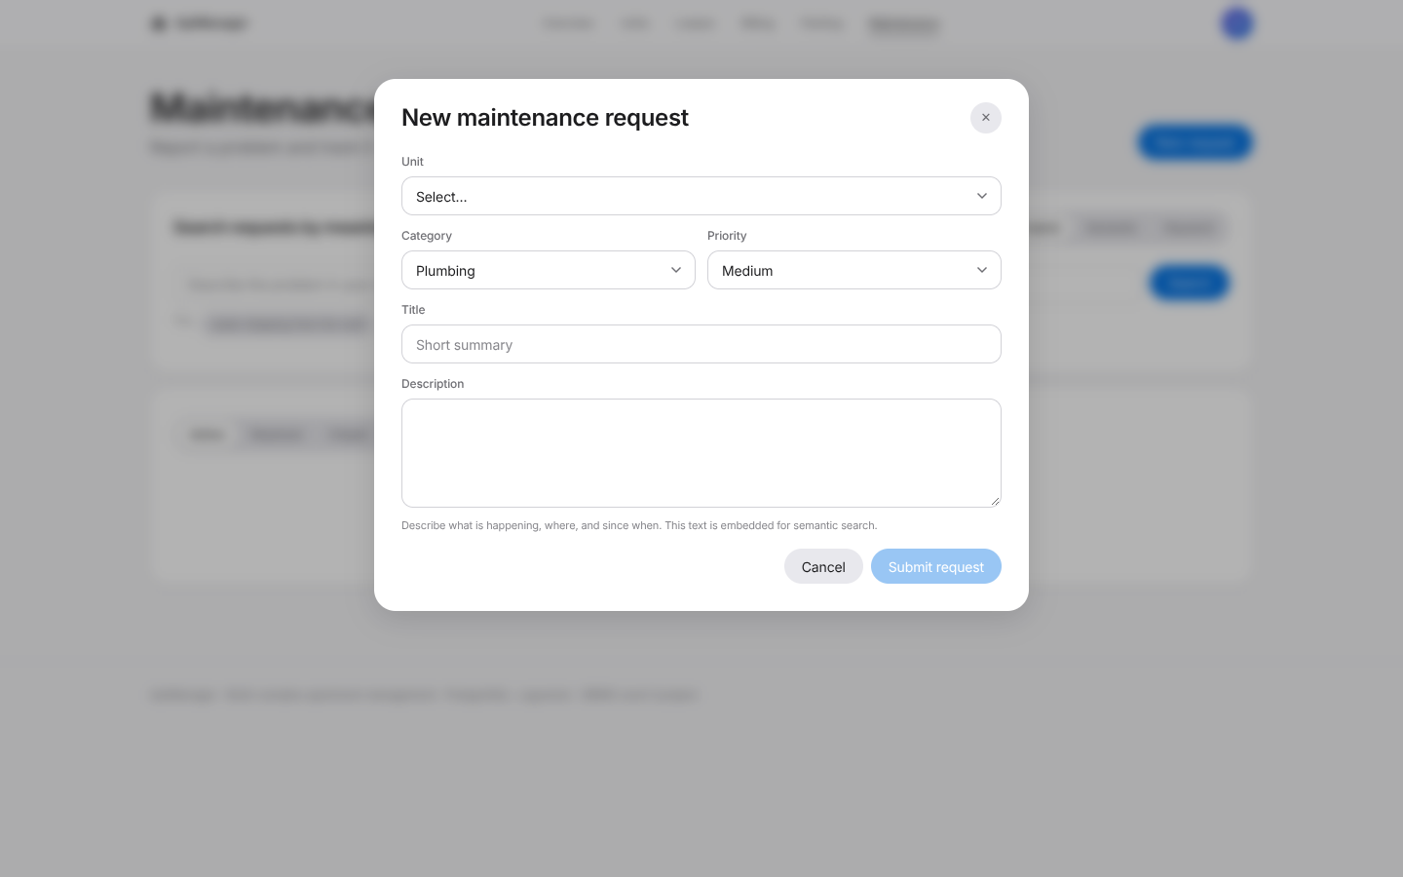
Figure 24. Tenant raising a request.
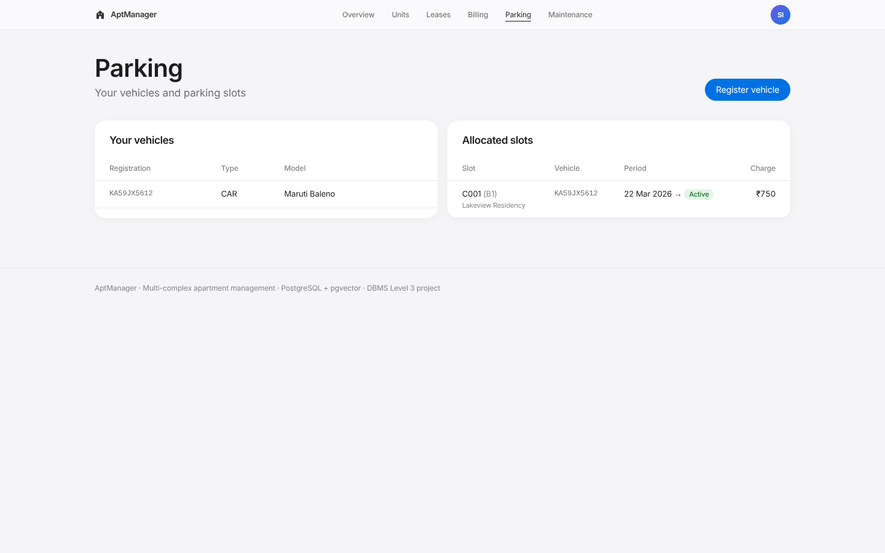
Figure 25. Tenant parking.
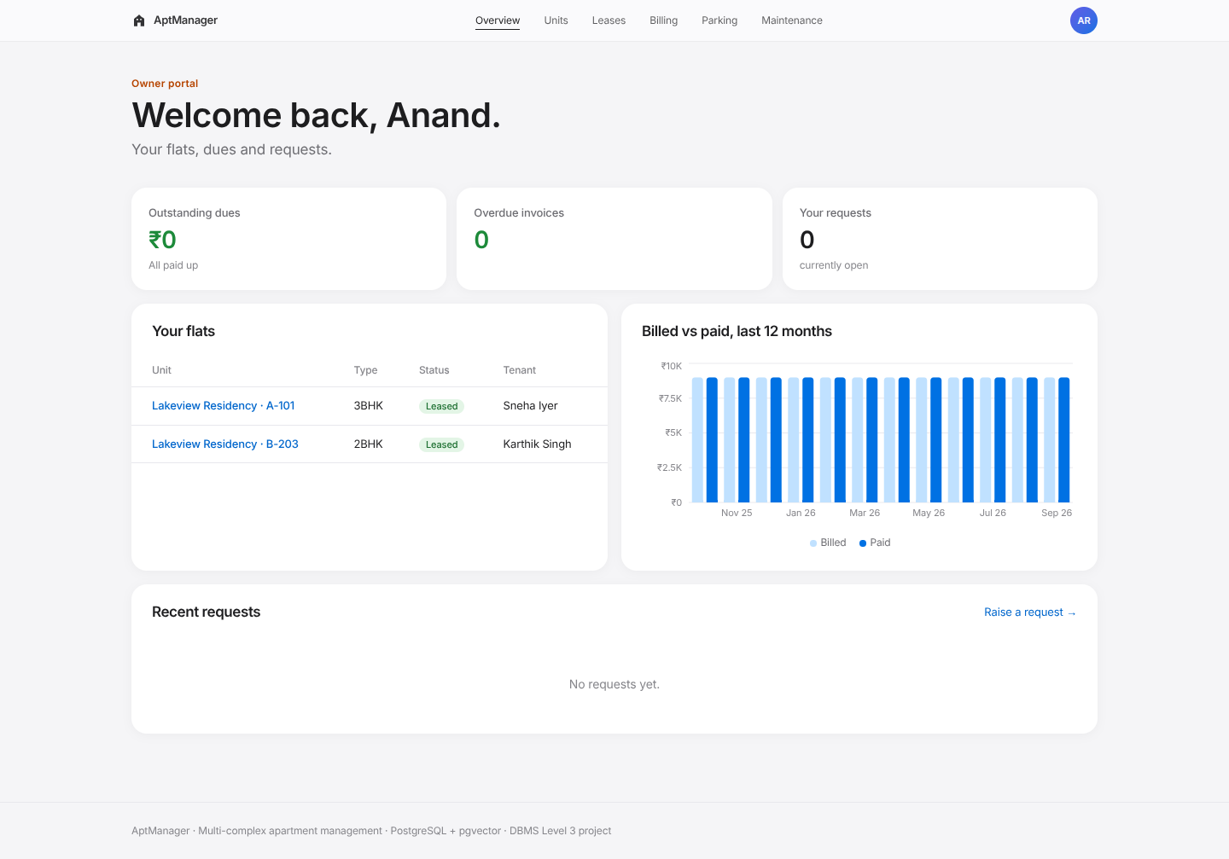
Figure 26. Owner dashboard.
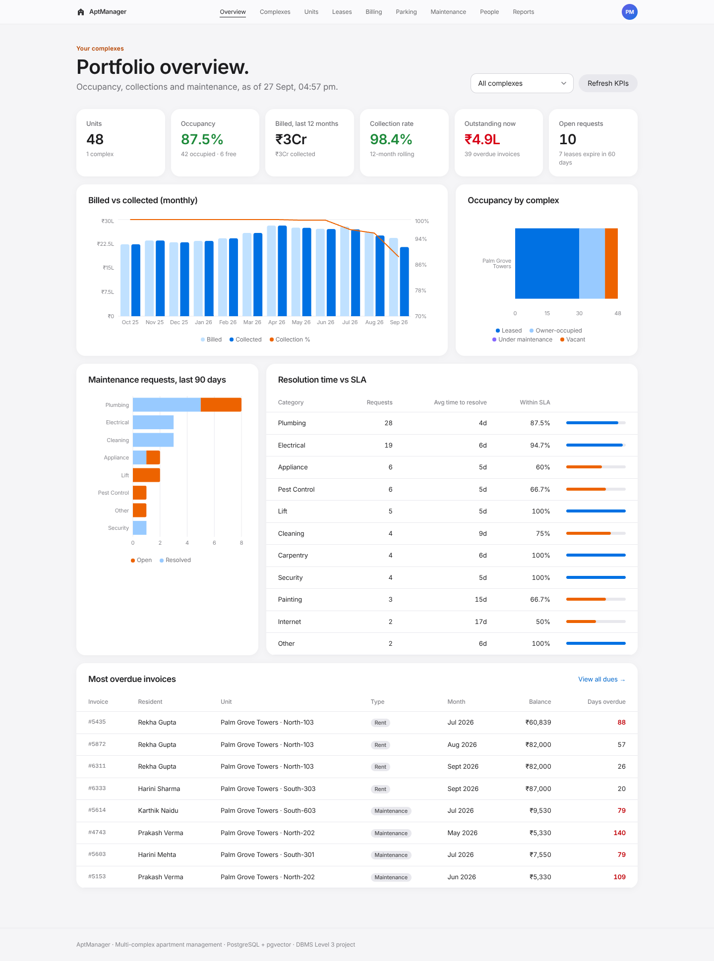
Figure 27. Manager dashboard scoped to one complex.

13. Testing results
75 automated tests, all passing. Full list: Appendix C.
Suite | What it covers | Tests
tests/db/integrity.test.ts | Domains, CHECK, EXCLUDE, role triggers, ownership shares, lease rules, termination procedure, billing idempotency and proration, payment triggers, late fees, parking rules, maintenance workflow, audit trail, views, materialized view refresh | 37
tests/db/vector.test.ts | Every request has a fresh embedding; 384 dimensions and unit norm; wrong dimension rejected; HNSW index used; paraphrase retrieval (“lift is not moving” → LIFT, “insects in the kitchen” → PEST_CONTROL, “cupboard door came off” → CARPENTRY); keyword search misses a paraphrase that vector search finds; hybrid fusion; complex filter; similar-request lookup | 12
tests/api/api.test.ts | Login, cookie flags, forged token, page redirect, role denial (403), manager scoping, tenant data isolation, zod validation (400), CSRF (415), SQL injection, constraint errors mapped to 409/422, part payment and overpayment, paying others’ invoices, idempotent billing, payment reversal with audit, request lifecycle with embedding and semantic retrieval, illegal transition, lease create/terminate, all reports | 26
Database tests run inside transactions that are always rolled back, so they never change the seed data. Expected failures use savepoints and assert the exact SQLSTATE (23514 check violation, 23P01 exclusion violation, 23505 unique violation, 22000 wrong vector dimension).
Representative test cases:
ID | Input | Expected | Result
T1 | Insert a lease overlapping an active lease on the same unit | Rejected by ex_lease_no_overlap (23P01); API returns 409 “overlaps” | Pass
T2 | Pay Rs 1 more than the invoice balance | Rejected by payment trigger; API 422 “exceeds outstanding balance” | Pass
T3 | Store password “hunter2” | Rejected by chk_password_bcrypt | Pass
T4 | Put a bike in a CAR slot | Rejected by parking trigger “cannot hold” | Pass
T5 | Move a request OPEN → RESOLVED | Rejected “Invalid status change” | Pass
T6 | Run billing for the current month twice | Second run creates 0 invoices | Pass
T7 | Lease starting on the 16th of a 30-day month | Rent invoice for 15 days, note “Prorated: 15 of 30 days” | Pass
T8 | Terminate a lease on 31 Aug | Lease TERMINATED, Sep rent VOID, parking released, unit VACANT | Pass
T9 | Tenant calls /api/reports | 403 | Pass
T10 | Search “leak from the ceiling in the washroom” | Returns the just-created “Bathroom ceiling is dripping” request | Pass

14. Conclusion and future enhancements
The project shows a working link between database concepts and a usable application. The database is not a passive store: it refuses overlapping leases and double-booked slots, keeps invoice balances consistent under concurrent payments, drives unit status from leases, records every status change and sensitive edit, and makes the monthly billing run safe to repeat. The vector side is justified by a concrete failure of keyword search on resident-written text, and it is kept consistent with the relational data by living in the same database, inside the same transactions.
Future enhancements:
- PostgreSQL row-level security policies keyed on app.user_id, so scoping is enforced even for ad-hoc SQL clients.
- Scheduled jobs with pg_cron for fn_generate_monthly_invoices, fn_apply_late_fees and fn_close_expired_leases.
- Payment gateway (UPI intent / Razorpay test mode) with webhooks writing to payment.
- Automatic category and priority suggestion for new requests from their nearest neighbours’ labels (k-NN classification over the existing vectors).
- Notifications (email/WhatsApp) for dues and request updates.
- Table partitioning of invoice and payment by billing month once history grows to several years.
- Multilingual embeddings (e.g. a Kannada/Hindi capable model) so residents can write complaints in their own language.

15. Requirement checklist
Guideline requirement | Where it is met
Unique, non-CRUD real-world problem | Sections 1 and 2; billing engine, analytics, semantic search
2-member team with defined responsibilities | Section 16
SQL (mandatory) + second paradigm | PostgreSQL + pgvector (Option 2), plus full-text search
ER diagram → relational schema; entities, attributes, PK, FK, relationships, constraints | Sections 5, 6, 8
Vector component: data model, indexes, embeddings, metadata, retrieval strategy | Section 9.8
DDL: CREATE, ALTER, DROP, keys, constraints, indexes, views | Section 9.1 to 9.7; db/
DML: INSERT, UPDATE, DELETE, SELECT with JOIN, GROUP BY, HAVING, ORDER BY, aggregates, subqueries | Section 10
At least four advanced concepts | Transactions, views + materialized view, stored procedures/functions, triggers, indexing (partial, GIN, HNSW), full-text search, vector similarity search, window functions, ROLLUP, EXCLUDE constraints
Next.js web interface with forms, tables, search, filtering, dashboards | Section 12
Backend/API layer; no hard-coded credentials; environment variables | Section 11; src/app/api, .env.example
Authentication, at least 2 roles | 4 roles: Admin, Manager, Owner, Tenant
Validation at database level; consistency and integrity | Sections 9.2, 9.3, 9.5
Security; no plain-text passwords or credentials | Section 11
Documentation sections | This report (14 sections) plus data dictionary, schema, test results
Git/GitHub with README | Repository root README.md
Test cases | Section 13
Justification of database choice per data type | Section 7

16. Individual contributions
Area | Kundhan Vudutha | [Partner name]
Database design | ER model, property / leasing / billing tables, domains and constraints | Parking, people and maintenance tables, indexes
Database logic | Billing function, late fees, payment triggers, sp_terminate_lease | Parking and maintenance triggers, audit trigger, views and materialized view
Vector search | Embedding pipeline, request_embedding, hybrid search function | Similar-request lookup, duplicate detection, search evaluation tests
Application | API layer, auth and role scoping, dashboard, billing and maintenance pages | Units, leases, parking, people, reports and audit pages
Testing and docs | Database integrity tests, report sections 5 to 10 | API tests, screenshots, report sections 1 to 4 and 11 to 14

Appendix A. Data dictionary
Generated from the PostgreSQL system catalogue. Types shown are the declared types; email_address, phone_in and money_inr are validating domains (see db/01_schema.sql).

app_user
Login accounts for every role (ADMIN, MANAGER, OWNER, TENANT). Passwords stored only as bcrypt hashes.
Column | Type | Null | Key | Default / notes
user_id | bigint |  | PK | identity
email | email_address
password_hash | text |  |  | bcrypt hash (cost 10); CHECK rejects anything else
full_name | character varying(100)
phone | phone_in | yes
role | character varying(10)
is_active | boolean |  |  | default true
created_at | timestamp with time zone |  |  | default now()
last_login_at | timestamp with time zone | yes
Constraints
- chk_password_bcrypt (CHECK): CHECK ((password_hash ~ '^\$2[aby]\$[0-9]{2}\$[./A-Za-z0-9]{53}$'::text))
- chk_user_name (CHECK): CHECK ((length(btrim((full_name)::text)) >= 2))
- chk_user_role (CHECK): CHECK (((role)::text = ANY ((ARRAY['ADMIN'::character varying, 'MANAGER'::character varying, 'OWNER'::character varying, 'TENANT'::character varying])::text[])))
Indexes
- idx_app_user_name_trgm: gin (full_name gin_trgm_ops)
- idx_app_user_role: btree (role) WHERE is_active
- uq_app_user_email_lower: btree (lower((email)::text))
Triggers: audit_app_user

complex
An apartment complex (gated community) managed by the system.
Column | Type | Null | Key | Default / notes
complex_id | integer |  | PK | identity
name | character varying(80)
address_line | character varying(200)
locality | character varying(80)
city | character varying(60) |  |  | default ‘Bengaluru’::character varying
pincode | character(6)
established_year | smallint
created_at | timestamp with time zone |  |  | default now()
amenities | text[] |  |  | default ‘{}’::text[]
Constraints
- chk_complex_pincode (CHECK): CHECK ((pincode ~ '^[1-9][0-9]{5}$'::text))
- chk_complex_year (CHECK): CHECK (((established_year >= 1950) AND (established_year <= 2100)))
- complex_name_key (UNIQUE): UNIQUE (name)
Indexes
- complex_name_key: btree (name)

complex_manager
M:N assignment of MANAGER users to complexes; drives data scoping for staff.
Column | Type | Null | Key | Default / notes
complex_id | integer |  | PK FK→complex
manager_user_id | bigint |  | PK FK→app_user
assigned_on | date |  |  | default CURRENT_DATE
Triggers: complex_manager_role

block
A tower/block inside a complex.
Column | Type | Null | Key | Default / notes
block_id | integer |  | PK | identity
complex_id | integer |  | FK→complex
name | character varying(20)
total_floors | smallint
Constraints
- chk_block_floors (CHECK): CHECK (((total_floors >= 1) AND (total_floors <= 60)))
- uq_block_name (UNIQUE): UNIQUE (complex_id, name)
Indexes
- idx_block_complex: btree (complex_id)
- uq_block_name: btree (complex_id, name)

unit
A flat. occupancy_status is maintained by triggers from leases.
Column | Type | Null | Key | Default / notes
unit_id | integer |  | PK | identity
block_id | integer |  | FK→block
unit_number | character varying(10)
floor_no | smallint
unit_type | character varying(6)
carpet_area_sqft | numeric(7,1)
base_rent | money_inr
monthly_maintenance | money_inr
occupancy_status | character varying(20) |  |  | default ‘VACANT’::character varying; VACANT
facing | character varying(2) | yes
Constraints
- chk_unit_area (CHECK): CHECK (((carpet_area_sqft >= (200)::numeric) AND (carpet_area_sqft <= (10000)::numeric)))
- chk_unit_facing (CHECK): CHECK (((facing IS NULL) OR ((facing)::text = ANY ((ARRAY['N'::character varying, 'S'::character varying, 'E'::character varying, 'W'::character varying, 'NE'::character varying, 'NW'::character varying, 'SE'::character varying, 'SW'::character varying])::text[]))))
- chk_unit_floor (CHECK): CHECK ((floor_no >= 0))
- chk_unit_status (CHECK): CHECK (((occupancy_status)::text = ANY ((ARRAY['VACANT'::character varying, 'OWNER_OCCUPIED'::character varying, 'LEASED'::character varying, 'UNDER_MAINTENANCE'::character varying])::text[])))
- chk_unit_type (CHECK): CHECK (((unit_type)::text = ANY ((ARRAY['STUDIO'::character varying, '1BHK'::character varying, '2BHK'::character varying, '3BHK'::character varying, '4BHK'::character varying])::text[])))
- uq_unit_number (UNIQUE): UNIQUE (block_id, unit_number)
Indexes
- idx_unit_block: btree (block_id)
- idx_unit_status: btree (occupancy_status)
- uq_unit_number: btree (block_id, unit_number)
Triggers: audit_unit, unit_floor_check

owner_profile
Owner-specific attributes (ISA specialisation of app_user).
Column | Type | Null | Key | Default / notes
owner_id | integer |  | PK | identity
user_id | bigint |  | FK→app_user
mailing_address | character varying(200)
is_nri | boolean |  |  | default false
Constraints
- owner_profile_user_id_key (UNIQUE): UNIQUE (user_id)
Indexes
- owner_profile_user_id_key: btree (user_id)
Triggers: owner_profile_role

tenant_profile
Tenant-specific attributes (ISA specialisation of app_user).
Column | Type | Null | Key | Default / notes
tenant_id | integer |  | PK | identity
user_id | bigint |  | FK→app_user
occupation | character varying(80) | yes
employer | character varying(100) | yes
family_size | smallint |  |  | default 1
emergency_contact_name | character varying(100)
emergency_contact_phone | phone_in
Constraints
- chk_tenant_family (CHECK): CHECK (((family_size >= 1) AND (family_size <= 15)))
- tenant_profile_user_id_key (UNIQUE): UNIQUE (user_id)
Indexes
- tenant_profile_user_id_key: btree (user_id)
Triggers: tenant_profile_role

ownership
M:N owners-units with share_pct and ownership period (supports joint ownership and resale history).
Column | Type | Null | Key | Default / notes
ownership_id | integer |  | PK | identity
unit_id | integer |  | FK→unit
owner_id | integer |  | FK→owner_profile
share_pct | numeric(5,2) |  |  | default 100
owned_from | date
owned_until | date | yes
Constraints
- chk_ownership_dates (CHECK): CHECK (((owned_until IS NULL) OR (owned_until > owned_from)))
- chk_ownership_share (CHECK): CHECK (((share_pct > (0)::numeric) AND (share_pct <= (100)::numeric)))
- ex_ownership_overlap (EXCLUDE): EXCLUDE USING gist (unit_id WITH =, owner_id WITH =, daterange(owned_from, owned_until, '[)'::text) WITH &&)
Indexes
- ex_ownership_overlap: gist (unit_id, owner_id, daterange(owned_from, owned_until, '[)'::text))
- idx_ownership_owner: btree (owner_id)
- idx_ownership_unit_live: btree (unit_id) WHERE (owned_until IS NULL)
Triggers: audit_ownership, ownership_share_check

lease
Rental agreement between a tenant and a unit; no two live leases may overlap on a unit.
Column | Type | Null | Key | Default / notes
lease_id | integer |  | PK | identity
unit_id | integer |  | FK→unit
tenant_id | integer |  | FK→tenant_profile
start_date | date
end_date | date
monthly_rent | money_inr
security_deposit | money_inr |  |  | default 0
rent_due_day | smallint |  |  | default 5; Day of month rent falls due (1-28)
status | character varying(10) |  |  | default ‘ACTIVE’::character varying
terminated_on | date | yes
termination_reason | character varying(300) | yes
created_by | bigint | yes | FK→app_user
created_at | timestamp with time zone |  |  | default now()
Constraints
- chk_lease_dates (CHECK): CHECK ((end_date > start_date))
- chk_lease_deposit (CHECK): CHECK (((security_deposit)::numeric <= ((monthly_rent)::numeric * (10)::numeric)))
- chk_lease_due_day (CHECK): CHECK (((rent_due_day >= 1) AND (rent_due_day <= 28)))
- chk_lease_rent (CHECK): CHECK (((monthly_rent)::numeric > (0)::numeric))
- chk_lease_status (CHECK): CHECK (((status)::text = ANY ((ARRAY['PENDING'::character varying, 'ACTIVE'::character varying, 'ENDED'::character varying, 'TERMINATED'::character varying])::text[])))
- chk_lease_termination (CHECK): CHECK (((((status)::text = 'TERMINATED'::text) = (terminated_on IS NOT NULL)) AND ((terminated_on IS NULL) OR ((terminated_on >= start_date) AND (terminated_on <= end_date)))))
- ex_lease_no_overlap (EXCLUDE): EXCLUDE USING gist (unit_id WITH =, daterange(start_date, end_date, '[)'::text) WITH &&) WHERE (((status)::text = ANY ((ARRAY['PENDING'::character varying, 'ACTIVE'::character varying])::text[])))
Indexes
- ex_lease_no_overlap: gist (unit_id, daterange(start_date, end_date, '[)'::text)) WHERE ((status)::text = ANY ((ARRAY['PENDING'::character varying, 'ACTIVE'::character varying])::text[]))
- idx_lease_tenant: btree (tenant_id)
- idx_lease_unit_status: btree (unit_id, status)
Triggers: audit_lease, lease_sync_unit, lease_validate

invoice
A bill: RENT, MAINTENANCE, PARKING or LATE_FEE. amount_paid/status kept in sync by payment triggers.
Column | Type | Null | Key | Default / notes
invoice_id | bigint |  | PK | identity
unit_id | integer |  | FK→unit
billed_to | bigint |  | FK→app_user
invoice_type | character varying(12)
lease_id | integer | yes | FK→lease
parking_allocation_id | integer | yes | FK→parking_allocation
source_invoice_id | bigint | yes | FK→invoice | For LATE_FEE: the overdue invoice it penalises
billing_month | date |  |  | First day of the month being billed
amount | money_inr
amount_paid | money_inr |  |  | default 0
issued_on | date |  |  | default CURRENT_DATE
due_date | date
status | character varying(8) |  |  | default ‘UNPAID’::character varying
notes | character varying(200) | yes
Constraints
- chk_inv_amount (CHECK): CHECK ((((amount)::numeric > (0)::numeric) AND ((amount_paid)::numeric <= (amount)::numeric)))
- chk_inv_due (CHECK): CHECK ((due_date >= billing_month))
- chk_inv_links (CHECK): CHECK (((((invoice_type)::text = 'RENT'::text) AND (lease_id IS NOT NULL) AND (parking_allocation_id IS NULL) AND (source_invoice_id IS NULL)) OR (((invoice_type)::text = 'MAINTENANCE'::text) AND (lease_id IS NULL) AND (parking_allocation_id IS NULL) AND (source_invoice_id IS NULL)) OR (((invoice_type)::text = 'PARKING'::text) AND (parking_allocation_id IS NOT NULL) AND (source_invoice_id IS NULL)) OR (((invoice_type)::text = 'LATE_FEE'::text) AND (source_invoice_id IS NOT NULL))))
- chk_inv_month (CHECK): CHECK ((billing_month = (date_trunc('month'::text, (billing_month)::timestamp with time zone))::date))
- chk_inv_status (CHECK): CHECK (((status)::text = ANY ((ARRAY['UNPAID'::character varying, 'PARTIAL'::character varying, 'PAID'::character varying, 'VOID'::character varying])::text[])))
- chk_inv_status_paid (CHECK): CHECK ((((status)::text = 'VOID'::text) OR (((status)::text = 'UNPAID'::text) AND ((amount_paid)::numeric = (0)::numeric)) OR (((status)::text = 'PARTIAL'::text) AND ((amount_paid)::numeric > (0)::numeric) AND ((amount_paid)::numeric < (amount)::numeric)) OR (((status)::text = 'PAID'::text) AND ((amount_paid)::numeric = (amount)::numeric))))
- chk_inv_type (CHECK): CHECK (((invoice_type)::text = ANY ((ARRAY['RENT'::character varying, 'MAINTENANCE'::character varying, 'PARKING'::character varying, 'LATE_FEE'::character varying])::text[])))
Indexes
- idx_invoice_billed_to: btree (billed_to, billing_month DESC)
- idx_invoice_open_due: btree (due_date) WHERE ((status)::text = ANY ((ARRAY['UNPAID'::character varying, 'PARTIAL'::character varying])::text[]))
- idx_invoice_unit_month: btree (unit_id, billing_month)
- uq_invoice_late_fee: btree (source_invoice_id) WHERE (((invoice_type)::text = 'LATE_FEE'::text) AND ((status)::text <> 'VOID'::text))
- uq_invoice_maint: btree (unit_id, billing_month) WHERE (((invoice_type)::text = 'MAINTENANCE'::text) AND ((status)::text <> 'VOID'::text))
- uq_invoice_parking: btree (parking_allocation_id, billing_month) WHERE (((invoice_type)::text = 'PARKING'::text) AND ((status)::text <> 'VOID'::text))
- uq_invoice_rent: btree (lease_id, billing_month) WHERE (((invoice_type)::text = 'RENT'::text) AND ((status)::text <> 'VOID'::text))
Triggers: audit_invoice_void, invoice_guard

payment
Money received against an invoice. Immutable; reversal = delete (audited).
Column | Type | Null | Key | Default / notes
payment_id | bigint |  | PK | identity
invoice_id | bigint |  | FK→invoice
amount | money_inr
paid_at | timestamp with time zone |  |  | default now()
method | character varying(13)
reference_no | character varying(40)
recorded_by | bigint | yes | FK→app_user
Constraints
- chk_pay_amount (CHECK): CHECK (((amount)::numeric > (0)::numeric))
- chk_pay_method (CHECK): CHECK (((method)::text = ANY ((ARRAY['UPI'::character varying, 'CARD'::character varying, 'BANK_TRANSFER'::character varying, 'CASH'::character varying, 'CHEQUE'::character varying])::text[])))
- payment_reference_no_key (UNIQUE): UNIQUE (reference_no)
Indexes
- idx_payment_invoice: btree (invoice_id)
- idx_payment_paid_at: btree (paid_at)
- payment_reference_no_key: btree (reference_no)
Triggers: audit_payment, payment_after_change, payment_before_insert, payment_block_update

parking_slot
A parking slot in a complex (CAR, BIKE or EV charging).
Column | Type | Null | Key | Default / notes
slot_id | integer |  | PK | identity
complex_id | integer |  | FK→complex
slot_code | character varying(10)
level | character varying(4)
slot_type | character varying(4)
is_covered | boolean |  |  | default true
Constraints
- chk_slot_level (CHECK): CHECK (((level)::text = ANY ((ARRAY['B2'::character varying, 'B1'::character varying, 'G'::character varying, 'OPEN'::character varying])::text[])))
- chk_slot_type (CHECK): CHECK (((slot_type)::text = ANY ((ARRAY['CAR'::character varying, 'BIKE'::character varying, 'EV'::character varying])::text[])))
- uq_slot_code (UNIQUE): UNIQUE (complex_id, slot_code)
Indexes
- idx_parking_slot_complex: btree (complex_id, slot_type)
- uq_slot_code: btree (complex_id, slot_code)

vehicle
A vehicle registered by an owner or tenant.
Column | Type | Null | Key | Default / notes
vehicle_id | integer |  | PK | identity
owner_user_id | bigint |  | FK→app_user
registration_no | character varying(12)
vehicle_type | character varying(4)
is_electric | boolean |  |  | default false
make_model | character varying(60) | yes
Constraints
- chk_vehicle_reg (CHECK): CHECK (((registration_no)::text ~ '^[A-Z]{2}[0-9]{2}[A-Z]{0,3}[0-9]{4}$'::text))
- chk_vehicle_type (CHECK): CHECK (((vehicle_type)::text = ANY ((ARRAY['CAR'::character varying, 'BIKE'::character varying])::text[])))
- vehicle_registration_no_key (UNIQUE): UNIQUE (registration_no)
Indexes
- idx_vehicle_owner: btree (owner_user_id)
- vehicle_registration_no_key: btree (registration_no)

parking_allocation
Assignment of a slot to a vehicle of a unit for a period, with a monthly charge.
Column | Type | Null | Key | Default / notes
allocation_id | integer |  | PK | identity
slot_id | integer |  | FK→parking_slot
unit_id | integer |  | FK→unit
vehicle_id | integer |  | FK→vehicle
start_date | date
end_date | date | yes
monthly_charge | money_inr |  |  | default 0
Constraints
- chk_alloc_dates (CHECK): CHECK (((end_date IS NULL) OR (end_date > start_date)))
- ex_slot_overlap (EXCLUDE): EXCLUDE USING gist (slot_id WITH =, daterange(start_date, end_date, '[)'::text) WITH &&)
- ex_vehicle_overlap (EXCLUDE): EXCLUDE USING gist (vehicle_id WITH =, daterange(start_date, end_date, '[)'::text) WITH &&)
Indexes
- ex_slot_overlap: gist (slot_id, daterange(start_date, end_date, '[)'::text))
- ex_vehicle_overlap: gist (vehicle_id, daterange(start_date, end_date, '[)'::text))
- idx_alloc_unit: btree (unit_id)
Triggers: parking_allocation_check

vendor
Service provider (plumber, electrician, lift AMC, …).
Column | Type | Null | Key | Default / notes
vendor_id | integer |  | PK | identity
name | character varying(100)
service_category | character varying(14)
phone | phone_in
email | email_address | yes
rating | numeric(2,1) | yes |  | default 3.5
is_active | boolean |  |  | default true
Constraints
- chk_vendor_rating (CHECK): CHECK (((rating IS NULL) OR ((rating >= (0)::numeric) AND (rating <= (5)::numeric))))
- vendor_name_key (UNIQUE): UNIQUE (name)
Indexes
- vendor_name_key: btree (name)

maintenance_request
A complaint/work order raised for a unit, with workflow status and costs. search_tsv powers full-text search.
Column | Type | Null | Key | Default / notes
request_id | bigint |  | PK | identity
unit_id | integer |  | FK→unit
raised_by | bigint |  | FK→app_user
category | character varying(14)
title | character varying(120)
description | text
priority | character varying(6) |  |  | default ‘MEDIUM’::character varying
status | character varying(11) |  |  | default ‘OPEN’::character varying
vendor_id | integer | yes | FK→vendor
estimated_cost | money_inr | yes
actual_cost | money_inr | yes
created_at | timestamp with time zone |  |  | default now()
assigned_at | timestamp with time zone | yes
resolved_at | timestamp with time zone | yes
resolution_notes | text | yes
tenant_rating | smallint | yes
search_tsv | tsvector | yes |  | generated (stored); Generated tsvector: title weight A, description weight B
is_common_area | boolean |  |  | default false
Constraints
- chk_mr_category (CHECK): CHECK (((category)::text = ANY ((ARRAY['PLUMBING'::character varying, 'ELECTRICAL'::character varying, 'CARPENTRY'::character varying, 'APPLIANCE'::character varying, 'PEST_CONTROL'::character varying, 'LIFT'::character varying, 'SECURITY'::character varying, 'CLEANING'::character varying, 'PAINTING'::character varying, 'INTERNET'::character varying, 'OTHER'::character varying])::text[])))
- chk_mr_desc (CHECK): CHECK ((length(btrim(description)) >= 15))
- chk_mr_priority (CHECK): CHECK (((priority)::text = ANY ((ARRAY['LOW'::character varying, 'MEDIUM'::character varying, 'HIGH'::character varying, 'URGENT'::character varying])::text[])))
- chk_mr_rating (CHECK): CHECK (((tenant_rating IS NULL) OR (((tenant_rating >= 1) AND (tenant_rating <= 5)) AND ((status)::text = ANY ((ARRAY['RESOLVED'::character varying, 'CLOSED'::character varying])::text[])))))
- chk_mr_resolved (CHECK): CHECK ((((status)::text = ANY ((ARRAY['RESOLVED'::character varying, 'CLOSED'::character varying])::text[])) = (resolved_at IS NOT NULL)))
- chk_mr_status (CHECK): CHECK (((status)::text = ANY ((ARRAY['OPEN'::character varying, 'ASSIGNED'::character varying, 'IN_PROGRESS'::character varying, 'RESOLVED'::character varying, 'CLOSED'::character varying, 'CANCELLED'::character varying])::text[])))
- chk_mr_times (CHECK): CHECK (((resolved_at IS NULL) OR (resolved_at >= created_at)))
- chk_mr_title (CHECK): CHECK ((length(btrim((title)::text)) >= 5))
- chk_mr_vendor (CHECK): CHECK ((((status)::text <> ALL ((ARRAY['ASSIGNED'::character varying, 'IN_PROGRESS'::character varying, 'RESOLVED'::character varying, 'CLOSED'::character varying])::text[])) OR (vendor_id IS NOT NULL)))
Indexes
- idx_mr_raised_by: btree (raised_by)
- idx_mr_search_tsv: gin (search_tsv)
- idx_mr_status_created: btree (status, created_at DESC)
- idx_mr_unit: btree (unit_id)
- idx_mr_vendor: btree (vendor_id)
Triggers: mr_before_write, mr_history, mr_invalidate_embedding

request_embedding
Vector store: 384-d MiniLM embedding of each request’s title + description (pgvector, HNSW cosine index).
Column | Type | Null | Key | Default / notes
request_id | bigint |  | PK FK→maintenance_request
model | character varying(80)
source_hash | character(32) |  |  | md5 of the embedded text; a mismatch means the vector is stale
embedding | vector(384) |  |  | L2-normalised 384-d vector (sentence-transformers/all-MiniLM-L6-v2)
embedded_at | timestamp with time zone |  |  | default now()
Indexes
- idx_request_embedding_hnsw: hnsw (embedding vector_cosine_ops) WITH (m='16', ef_construction='64')

maintenance_status_history
Every status change of a request, written by trigger.
Column | Type | Null | Key | Default / notes
history_id | bigint |  | PK | identity
request_id | bigint |  | FK→maintenance_request
old_status | character varying(11) | yes
new_status | character varying(11)
changed_by | bigint | yes | FK→app_user
changed_at | timestamp with time zone |  |  | default now()
Indexes
- idx_mr_history_request: btree (request_id, changed_at)

audit_log
Generic change log written by triggers (who, when, old/new row as JSONB).
Column | Type | Null | Key | Default / notes
audit_id | bigint |  | PK | identity
table_name | character varying(40)
row_pk | text
action | character(1)
changed_by | bigint | yes
changed_at | timestamp with time zone |  |  | default now()
old_data | jsonb | yes
new_data | jsonb | yes
Constraints
- chk_audit_action (CHECK): CHECK ((action = ANY (ARRAY['I'::bpchar, 'U'::bpchar, 'D'::bpchar])))
Indexes
- idx_audit_table_time: btree (table_name, changed_at DESC)

Appendix B. Relational schema
Underlined = primary key, italic = foreign key (→ referenced table). Generated from the live database.
- app_user(user_id, email, password_hash, full_name, phone, role, is_active, created_at, last_login_at)
- complex(complex_id, name, address_line, locality, city, pincode, established_year, created_at, amenities)
- complex_manager(complex_id → complex, manager_user_id → app_user, assigned_on)
- block(block_id, complex_id → complex, name, total_floors)
- unit(unit_id, block_id → block, unit_number, floor_no, unit_type, carpet_area_sqft, base_rent, monthly_maintenance, occupancy_status, facing)
- owner_profile(owner_id, user_id → app_user, mailing_address, is_nri)
- tenant_profile(tenant_id, user_id → app_user, occupation, employer, family_size, emergency_contact_name, emergency_contact_phone)
- ownership(ownership_id, unit_id → unit, owner_id → owner_profile, share_pct, owned_from, owned_until)
- lease(lease_id, unit_id → unit, tenant_id → tenant_profile, start_date, end_date, monthly_rent, security_deposit, rent_due_day, status, terminated_on, termination_reason, created_by → app_user, created_at)
- invoice(invoice_id, unit_id → unit, billed_to → app_user, invoice_type, lease_id → lease, parking_allocation_id → parking_allocation, source_invoice_id → invoice, billing_month, amount, amount_paid, issued_on, due_date, status, notes)
- payment(payment_id, invoice_id → invoice, amount, paid_at, method, reference_no, recorded_by → app_user)
- parking_slot(slot_id, complex_id → complex, slot_code, level, slot_type, is_covered)
- vehicle(vehicle_id, owner_user_id → app_user, registration_no, vehicle_type, is_electric, make_model)
- parking_allocation(allocation_id, slot_id → parking_slot, unit_id → unit, vehicle_id → vehicle, start_date, end_date, monthly_charge)
- vendor(vendor_id, name, service_category, phone, email, rating, is_active)
- maintenance_request(request_id, unit_id → unit, raised_by → app_user, category, title, description, priority, status, vendor_id → vendor, estimated_cost, actual_cost, created_at, assigned_at, resolved_at, resolution_notes, tenant_rating, search_tsv, is_common_area)
- request_embedding(request_id → maintenance_request, model, source_hash, embedding, embedded_at)
- maintenance_status_history(history_id, request_id → maintenance_request, old_status, new_status, changed_by → app_user, changed_at)
- audit_log(audit_id, table_name, row_pk, action, changed_by, changed_at, old_data, new_data)

Appendix C. Test results
Run on the seeded database (npm run db:reset, then npm test with the production build running on port 3000).
Suite | Tests | Result
Database integrity (tests/db/integrity.test.ts) | 37 | passed
Vector / semantic search (tests/db/vector.test.ts) | 12 | passed
API end-to-end (tests/api/api.test.ts) | 26 | passed
Total | 75 | 75 passed, 0 failed

Individual test cases
- PASS · tests/db/vector.test.ts · Embeddings storage › every maintenance request has an up-to-date embedding
- PASS · tests/db/vector.test.ts · Embeddings storage › vectors are 384-dimensional and unit length (normalised for cosine)
- PASS · tests/db/vector.test.ts · Embeddings storage › rejects a vector with the wrong dimension
- PASS · tests/db/vector.test.ts · Embeddings storage › query plan uses the HNSW index for nearest-neighbour search
- PASS · tests/db/vector.test.ts · Semantic search finds paraphrases that share no keywords › “lift is not moving” -> LIFT requests
- PASS · tests/db/vector.test.ts · Semantic search finds paraphrases that share no keywords › “insects in the kitchen” -> PEST_CONTROL requests (no shared words with “cockroaches”)
- PASS · tests/db/vector.test.ts · Semantic search finds paraphrases that share no keywords › “electricity keeps going off” -> ELECTRICAL requests
- PASS · tests/db/vector.test.ts · Semantic search finds paraphrases that share no keywords › “cupboard door came off” -> CARPENTRY requests
- PASS · tests/db/vector.test.ts · Semantic search finds paraphrases that share no keywords › keyword search alone misses “water dripping from the roof”; vector search finds leak requests
- PASS · tests/db/vector.test.ts · Hybrid search and similar-request lookup › fn_hybrid_search fuses keyword and vector ranks
- PASS · tests/db/vector.test.ts · Hybrid search and similar-request lookup › fn_hybrid_search respects the complex filter
- PASS · tests/db/vector.test.ts · Hybrid search and similar-request lookup › fn_similar_requests returns neighbours in descending similarity, excluding itself
- PASS · tests/db/integrity.test.ts · Domains and CHECK constraints › rejects a malformed email (email_address domain)
- PASS · tests/db/integrity.test.ts · Domains and CHECK constraints › rejects a phone number that is not a 10-digit Indian mobile
- PASS · tests/db/integrity.test.ts · Domains and CHECK constraints › refuses to store a plain-text password
- PASS · tests/db/integrity.test.ts · Domains and CHECK constraints › treats emails case-insensitively for uniqueness
- PASS · tests/db/integrity.test.ts · Domains and CHECK constraints › rejects negative money values (money_inr domain)
- PASS · tests/db/integrity.test.ts · Domains and CHECK constraints › rejects an invalid vehicle registration number
- PASS · tests/db/integrity.test.ts · Structural triggers › blocks a unit on a floor its block does not have
- PASS · tests/db/integrity.test.ts · Structural triggers › only lets TENANT users have a tenant profile
- PASS · tests/db/integrity.test.ts · Structural triggers › keeps joint ownership shares at or below 100%
- PASS · tests/db/integrity.test.ts · Leases › marks the unit LEASED when an active lease is created
- PASS · tests/db/integrity.test.ts · Leases › rejects overlapping live leases on the same unit (EXCLUDE constraint)
- PASS · tests/db/integrity.test.ts · Leases › caps the deposit at ten months of rent
- PASS · tests/db/integrity.test.ts · Leases › refuses to lease a unit that has no owner
- PASS · tests/db/integrity.test.ts · Leases › sp_terminate_lease closes the lease, voids later rent, releases parking and frees the unit
- PASS · tests/db/integrity.test.ts · Leases › sp_terminate_lease rejects a date outside the lease period
- PASS · tests/db/integrity.test.ts · Billing › fn_generate_monthly_invoices is idempotent
- PASS · tests/db/integrity.test.ts · Billing › refuses to bill a future month
- PASS · tests/db/integrity.test.ts · Billing › prorates rent for a lease that starts mid-month
- PASS · tests/db/integrity.test.ts · Billing › tracks partial and full payments through the payment trigger
- PASS · tests/db/integrity.test.ts · Billing › rejects overpayment
- PASS · tests/db/integrity.test.ts · Billing › rejects payments on a void invoice
- PASS · tests/db/integrity.test.ts · Billing › makes payments immutable and recalculates the invoice when one is deleted
- PASS · tests/db/integrity.test.ts · Billing › will not void an invoice that has payments
- PASS · tests/db/integrity.test.ts · Billing › applies at most one late fee per overdue invoice, minimum Rs 100
- PASS · tests/db/integrity.test.ts · Parking rules › does not let a bike take a car slot, or a petrol car an EV slot
- PASS · tests/db/integrity.test.ts · Parking rules › does not allocate a slot from a different complex
- PASS · tests/db/integrity.test.ts · Parking rules › blocks double-booking a slot (EXCLUDE constraint)
- PASS · tests/db/integrity.test.ts · Parking rules › rejects a vehicle whose owner does not live in the unit
- PASS · tests/db/integrity.test.ts · Maintenance workflow › rejects an illegal status jump (OPEN -> RESOLVED)
- PASS · tests/db/integrity.test.ts · Maintenance workflow › requires a vendor before a request can be assigned
- PASS · tests/db/integrity.test.ts · Maintenance workflow › stamps timestamps and writes history for every transition
- PASS · tests/db/integrity.test.ts · Maintenance workflow › refuses a request from someone unconnected to the unit
- PASS · tests/db/integrity.test.ts · Maintenance workflow › drops the stored embedding when the request text changes
- PASS · tests/db/integrity.test.ts · Audit trail › records who changed a lease, and never copies password hashes
- PASS · tests/db/integrity.test.ts · Views and materialized view › v_complex_occupancy categories add up to the unit count
- PASS · tests/db/integrity.test.ts · Views and materialized view › v_invoice_balance balance equals amount minus paid
- PASS · tests/db/integrity.test.ts · Views and materialized view › mv_complex_kpis can be refreshed concurrently
- PASS · tests/api/api.test.ts · Authentication › rejects a wrong password with 401
- PASS · tests/api/api.test.ts · Authentication › issues an HttpOnly, SameSite session cookie
- PASS · tests/api/api.test.ts · Authentication › requires a session for API calls
- PASS · tests/api/api.test.ts · Authentication › rejects a forged token
- PASS · tests/api/api.test.ts · Authentication › redirects page requests without a session to /login
- PASS · tests/api/api.test.ts · Role-based access › tenants cannot open staff-only endpoints
- PASS · tests/api/api.test.ts · Role-based access › managers cannot run admin-only actions
- PASS · tests/api/api.test.ts · Role-based access › a manager only sees the complexes assigned to them
- PASS · tests/api/api.test.ts · Role-based access › a tenant only sees invoices billed to them
- PASS · tests/api/api.test.ts · Role-based access › a tenant cannot view another unit
- PASS · tests/api/api.test.ts · Role-based access › an owner sees only units they own
- PASS · tests/api/api.test.ts · Validation and security › returns 400 with a readable message for invalid input
- PASS · tests/api/api.test.ts · Validation and security › rejects state-changing requests that are not JSON (CSRF defence)
- PASS · tests/api/api.test.ts · Validation and security › treats SQL in search parameters as data
- PASS · tests/api/api.test.ts · Validation and security › surfaces database constraint violations as 409/422 with the rule explained
- PASS · tests/api/api.test.ts · Billing flow › a tenant pays part of an invoice, then the rest
- PASS · tests/api/api.test.ts · Billing flow › a tenant cannot pay someone else’s invoice, or pay in cash
- PASS · tests/api/api.test.ts · Billing flow › the admin billing run is idempotent
- PASS · tests/api/api.test.ts · Billing flow › an admin can reverse a payment and the invoice reopens
- PASS · tests/api/api.test.ts · Maintenance flow with semantic search › a tenant raises a request; it is stored together with its embedding
- PASS · tests/api/api.test.ts · Maintenance flow with semantic search › staff can find it with a paraphrase that shares almost no words
- PASS · tests/api/api.test.ts · Maintenance flow with semantic search › staff move it through the workflow and residents rate it
- PASS · tests/api/api.test.ts · Maintenance flow with semantic search › an illegal transition is refused by the database trigger (422)
- PASS · tests/api/api.test.ts · Maintenance flow with semantic search › hybrid search reports both keyword and vector ranks
- PASS · tests/api/api.test.ts · Leases › a manager creates a lease on a vacant unit and the unit becomes LEASED
- PASS · tests/api/api.test.ts · Reports › every report runs and returns its SQL

