PES University, Bengaluru
UE24CS341A Software Engineering | Jackfruit Mini-Project
Software Architecture and Design Specification
Student Attendance Management System (SAMS)
Project: Student Attendance Management System (SAMS)
Version: 1.1
Authors: Kundhan Vudutha (PES1UG24AM327), Tarun J (PES1UG24AM304), Tejaswini S (PES1UG25AM815), Anish (PES1UG24AM348)
Section: AIML 2024, Section F
Date: 30-09-2026
Status: Draft for review

Revision History
Version | Date | Author | Change Summary
1.0 | 30-09-2026 | Kundhan Vudutha, Tarun J, Tejaswini S, Anish | Initial architecture and component design, derived from SAMS SRS v1.0
1.1 | 01-10-2026 | Kundhan Vudutha | Updated team list and division of work for the four-member team

Approvals
Role | Name | Signature / Date
Course Coordinator | Prof. Rajeshwari Adrakatti
Team Lead | Kundhan Vudutha
Team Member | Tarun J
Team Member | Tejaswini S
Team Member | Anish

Table of Contents
Revision History
Approvals
1. Introduction
1.1 Purpose
1.2 Scope
1.3 Audience
1.4 Definitions
2. Document Overview
2.1 How to use this document
2.2 Related Documents
3. Architecture
3.1 Goals & Constraints
3.2 Stakeholders & Concerns
3.3 Component (UML) Diagram
3.4 Component Descriptions
3.5 Chosen Architecture Pattern and Rationale
3.6 Technology Stack & Data Stores
3.7 Risks & Mitigations
3.8 Traceability to Requirements
3.9 Security Architecture
4. Design
4.1 Design Overview
4.2 UML Sequence Diagrams
4.3 API Design
4.4 Error Handling, Logging & Monitoring
4.5 UX Design
4.6 Open Issues & Next Steps
5. Appendices

1. Introduction

1.1 Purpose
This document specifies the software architecture and component-level design of the Student Attendance Management System (SAMS). It turns the requirements in the SAMS SRS v1.0 into a concrete structure: the components the system is made of, the responsibilities and interfaces of each, how they collaborate at runtime, and the technology used to build and deploy them.

1.2 Scope
The design covers every function listed in SRS section 2.2: authentication and role-based access, course/section/timetable setup, per-session attendance marking, the correction workflow, reports and the defaulter list, notifications, administration, and the attendance audit log. Fee management, examinations, biometric hardware and ERP integration are out of scope, as in the SRS.

1.3 Audience
The development team, the course faculty and evaluators, testers writing the System Test Plan, and anyone maintaining SAMS after the course.

1.4 Definitions
Term | Meaning
SAMS | Student Attendance Management System
DRF | Django REST Framework, the library used to build the JSON API
RBAC | Role-Based Access Control (Student, Faculty, Admin)
JWT | JSON Web Token used for stateless API authentication
ORM | Object-Relational Mapping (Django ORM over PostgreSQL)
Session | One scheduled occurrence of a class on a specific date, generated from a timetable slot
OD | On Duty: an excused absence that counts as present
Defaulter | A student whose attendance in a course is below the configured threshold
ADR | Architecture Decision Record
STRIDE | Threat model categories: Spoofing, Tampering, Repudiation, Information disclosure, Denial of service, Elevation of privilege

2. Document Overview

2.1 How to use this document
Section 3 describes the architecture: goals, stakeholders, the component diagram, each component, the chosen pattern, the technology stack, risks, traceability back to the SRS, and the security architecture. Section 4 describes the design: the class model, sequence diagrams for the main flows, the REST API contract, error handling and logging, UX decisions and open issues. Section 5 holds the glossary, references and tools.

2.2 Related Documents
- SAMS Software Requirements Specification (SRS) v1.0, 05-09-2026
- SAMS Software Test Plan (STP) v1.0, 02-10-2026
- Requirements Traceability Matrix (SRS section 8, extended in section 3.8 of this document)
- Jira project SAM, pes1ug24am327.atlassian.net (product backlog, epics and sprints)

3. Architecture

3.1 Goals & Constraints
Goals
- Correctness of attendance data: a submitted session can never be silently changed (SAMS-F-007, SAMS-SR-005).
- Speed for faculty: a 60-student roll call saved in under one minute, server save under 2 seconds (SAMS-F-006).
- Pages render in 3 seconds or less at the 95th percentile (SAMS-NF-001).
- 99% availability during college hours, 8am to 6pm Monday to Saturday (SAMS-NF-002).
- Modular, testable code so each team member owns complete features and unit tests can reach high branch coverage.
Constraints
- One semester, four-person team: the architecture must stay simple to build, explain and demo.
- Open-source stack only, deployable on lab hardware or a free cloud tier (SRS 2.5).
- Course tooling: Git/GitHub, Jira, Jenkins CI/CD, Docker, pytest, SonarQube.
- Student personal data must never reach unauthenticated users (institutional privacy policy).

3.2 Stakeholders & Concerns
Stakeholder | Primary concerns | How the architecture addresses them
Students | Accurate, current attendance; easy correction requests; privacy | Read-only student endpoints scoped to own records; correction workflow; dashboard refresh within 5 minutes
Faculty | Fast marking between classes; no double entry; simple approvals | Timetable-driven roll list; one-screen bulk save; duplicate-submission guard; pending-request queue
Admin (department) | Setup of courses/timetables/users; threshold config; audit | Admin console over CourseModule and AuthModule; SystemConfig; append-only AuditModule
Course evaluators | Modular design, traceability, CI/CD, security validation | Layered Django apps with clear interfaces; RTM; Jenkins pipeline with tests and SonarQube
Developers (team) | Clear ownership, low coupling, testability | One Django app per module, service functions separate from views, pytest per app

3.3 Component (UML) Diagram
Figure 1 shows the major components and their dependencies. Arrows point from a component to the component it calls. Every service module persists through the Django ORM to a single PostgreSQL database; email is sent asynchronously through a Celery worker.
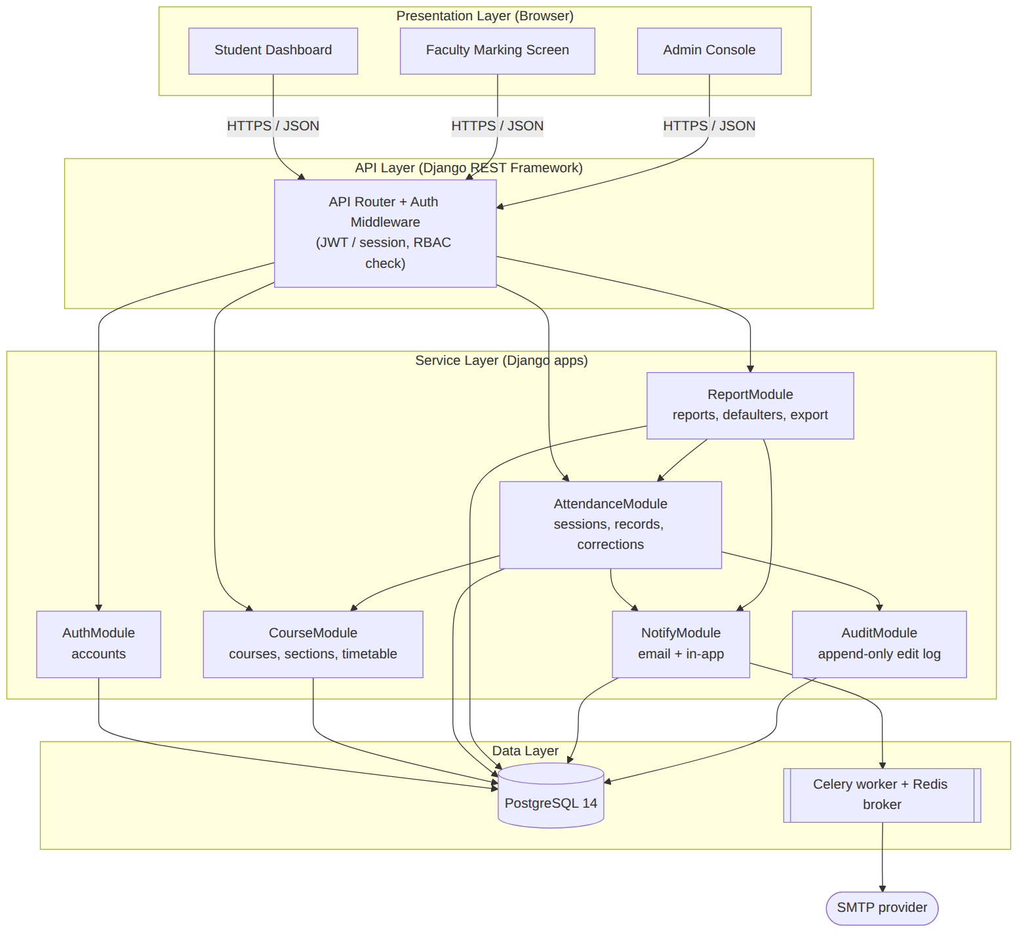
Figure 1: SAMS component diagram (layered)
Figure 2 is the UML class diagram of the domain model that the service layer operates on.
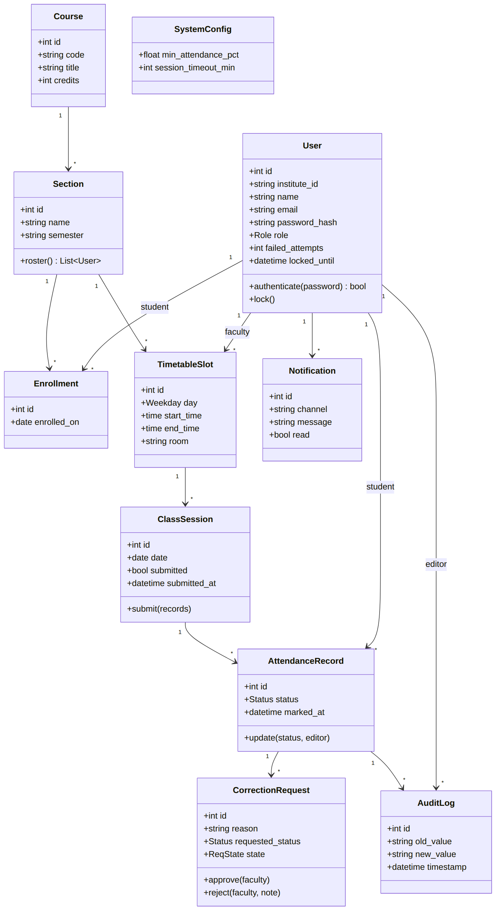
Figure 2: SAMS domain class diagram

3.4 Component Descriptions
Component | Responsibility | Provided interface | Depends on | SRS IDs
Web UI (Student / Faculty / Admin) | Role-specific responsive screens; client-side validation; calls REST API | Browser pages | API Router | SAMS-NF-005, 3.1
API Router + Auth Middleware | URL routing, JWT/session validation, server-side RBAC permission classes on every endpoint, rate limiting on login | /api/* REST endpoints | All service modules | SAMS-F-002, SR-003, SR-004
AuthModule (accounts) | User model, login, lockout after 5 failures, password reset by email link, token issue/refresh/blacklist | authenticate(), lock(), issue_tokens(), reset_password() | PostgreSQL, NotifyModule | SAMS-F-001 to F-004, SR-002
CourseModule (courses) | Courses, sections, enrollments, weekly timetable slots, faculty assignment; generates the roll list for a session | slots_for(faculty, date), roster(section) | PostgreSQL | SAMS-F-005, F-014 to F-016
AttendanceModule (attendance) | Class sessions, bulk marking, duplicate guard, authorised edits, correction requests and decisions, per-student percentages | submit(), edit(), percentage(), create_request(), decide() | CourseModule, AuditModule, NotifyModule | SAMS-F-006 to F-009
ReportModule (reports) | Per-student, per-course and date-range summaries, defaulter list, CSV/PDF export | student_report(), course_report(), defaulters(), export() | AttendanceModule, SystemConfig | SAMS-F-010 to F-013
NotifyModule (notifications) | In-app notifications and queued email for low attendance and pending corrections; nightly defaulter scan | notify(user, msg), nightly_scan() | Celery/Redis, SMTP | SAMS-F-017, F-018
AuditModule (audit) | Append-only log of every attendance create/edit with editor, timestamp, old and new value; read-only query API for Admin | log(), query() | PostgreSQL | SAMS-F-021, SR-005, NF-004
Admin / SystemConfig | User and role management, minimum-attendance threshold, session timeout | Admin endpoints | AuthModule | SAMS-F-019, F-020
PostgreSQL 14 | System of record for all entities; constraints enforce uniqueness of (session, student) | SQL via ORM | - | SRS 2.4
Celery worker + Redis | Background email dispatch and scheduled jobs (nightly reports) | Task queue | Redis, SMTP | SRS 3.4

3.5 Chosen Architecture Pattern and Rationale
SAMS uses a layered architecture (presentation, API, service, data) implemented as a modular monolith: one Django project split into self-contained Django apps, one per component in Figure 1. Views only handle HTTP and permissions; business rules live in service functions inside each app; persistence goes through the ORM.
Architecture Decision Records:
ADR | Decision | Alternatives considered | Rationale
ADR-01 | Layered modular monolith in Django | Microservices; plain MVC without service layer | Microservices add network calls, deployment and data consistency work that a four-person, one-semester team cannot justify at 2,000 users. A service layer keeps business rules unit-testable without HTTP.
ADR-02 | Django + Django REST Framework | Flask, Spring Boot, Node/Express | Built-in auth, admin, ORM and migrations cover a large share of SAMS for free; Python matches the team skill set; SRS 2.4 already fixes Django.
ADR-03 | PostgreSQL | MySQL, SQLite | Transactional integrity and unique constraints for the duplicate-marking rule; SQLite is used only for fast unit tests.
ADR-04 | JWT (SimpleJWT) with refresh-token blacklist | Server sessions only | Works for the SPA and any future mobile client; blacklist gives real logout (SAMS-SR-003).
ADR-05 | Celery + Redis for email and nightly jobs | Synchronous email in request | Keeps attendance save under 2 seconds even if the mail server is slow.
ADR-06 | Append-only audit table, no update/delete API | Django simple-history | Satisfies SAMS-SR-005 explicitly and is easy to verify in tests.

3.6 Technology Stack & Data Stores
Layer | Technology
Frontend | Django templates + HTMX and Bootstrap 5 (responsive, 360px and up, WCAG 2.1 AA colours)
API | Python 3.12, Django 5, Django REST Framework, djangorestframework-simplejwt, drf-spectacular (OpenAPI/Swagger)
Data store | PostgreSQL 14+ (production), SQLite (unit tests)
Async jobs | Celery 5 with Redis 7 broker, Celery beat for nightly defaulter scan
Reports | Python csv module; WeasyPrint for PDF export
Web server | Gunicorn behind Nginx with TLS 1.2+
Packaging and deploy | Docker, docker-compose
CI/CD | GitHub repository, Jenkins pipeline (lint, pytest with coverage, SonarQube scan, Docker build, deploy)
Testing | pytest, pytest-django, coverage.py, Postman/Newman for API, Selenium for UI flows, Locust for load
Project management | Jira Scrum board (epics, stories, sprints), GitHub pull requests for code review
Figure 3 shows the deployment view.
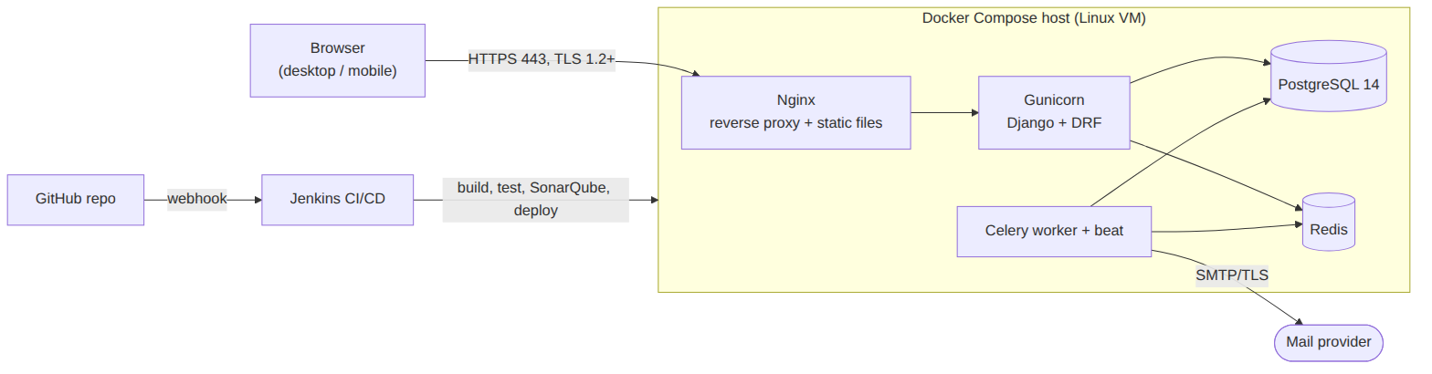
Figure 3: Deployment diagram
Figure 4 is the entity-relationship view of the database.
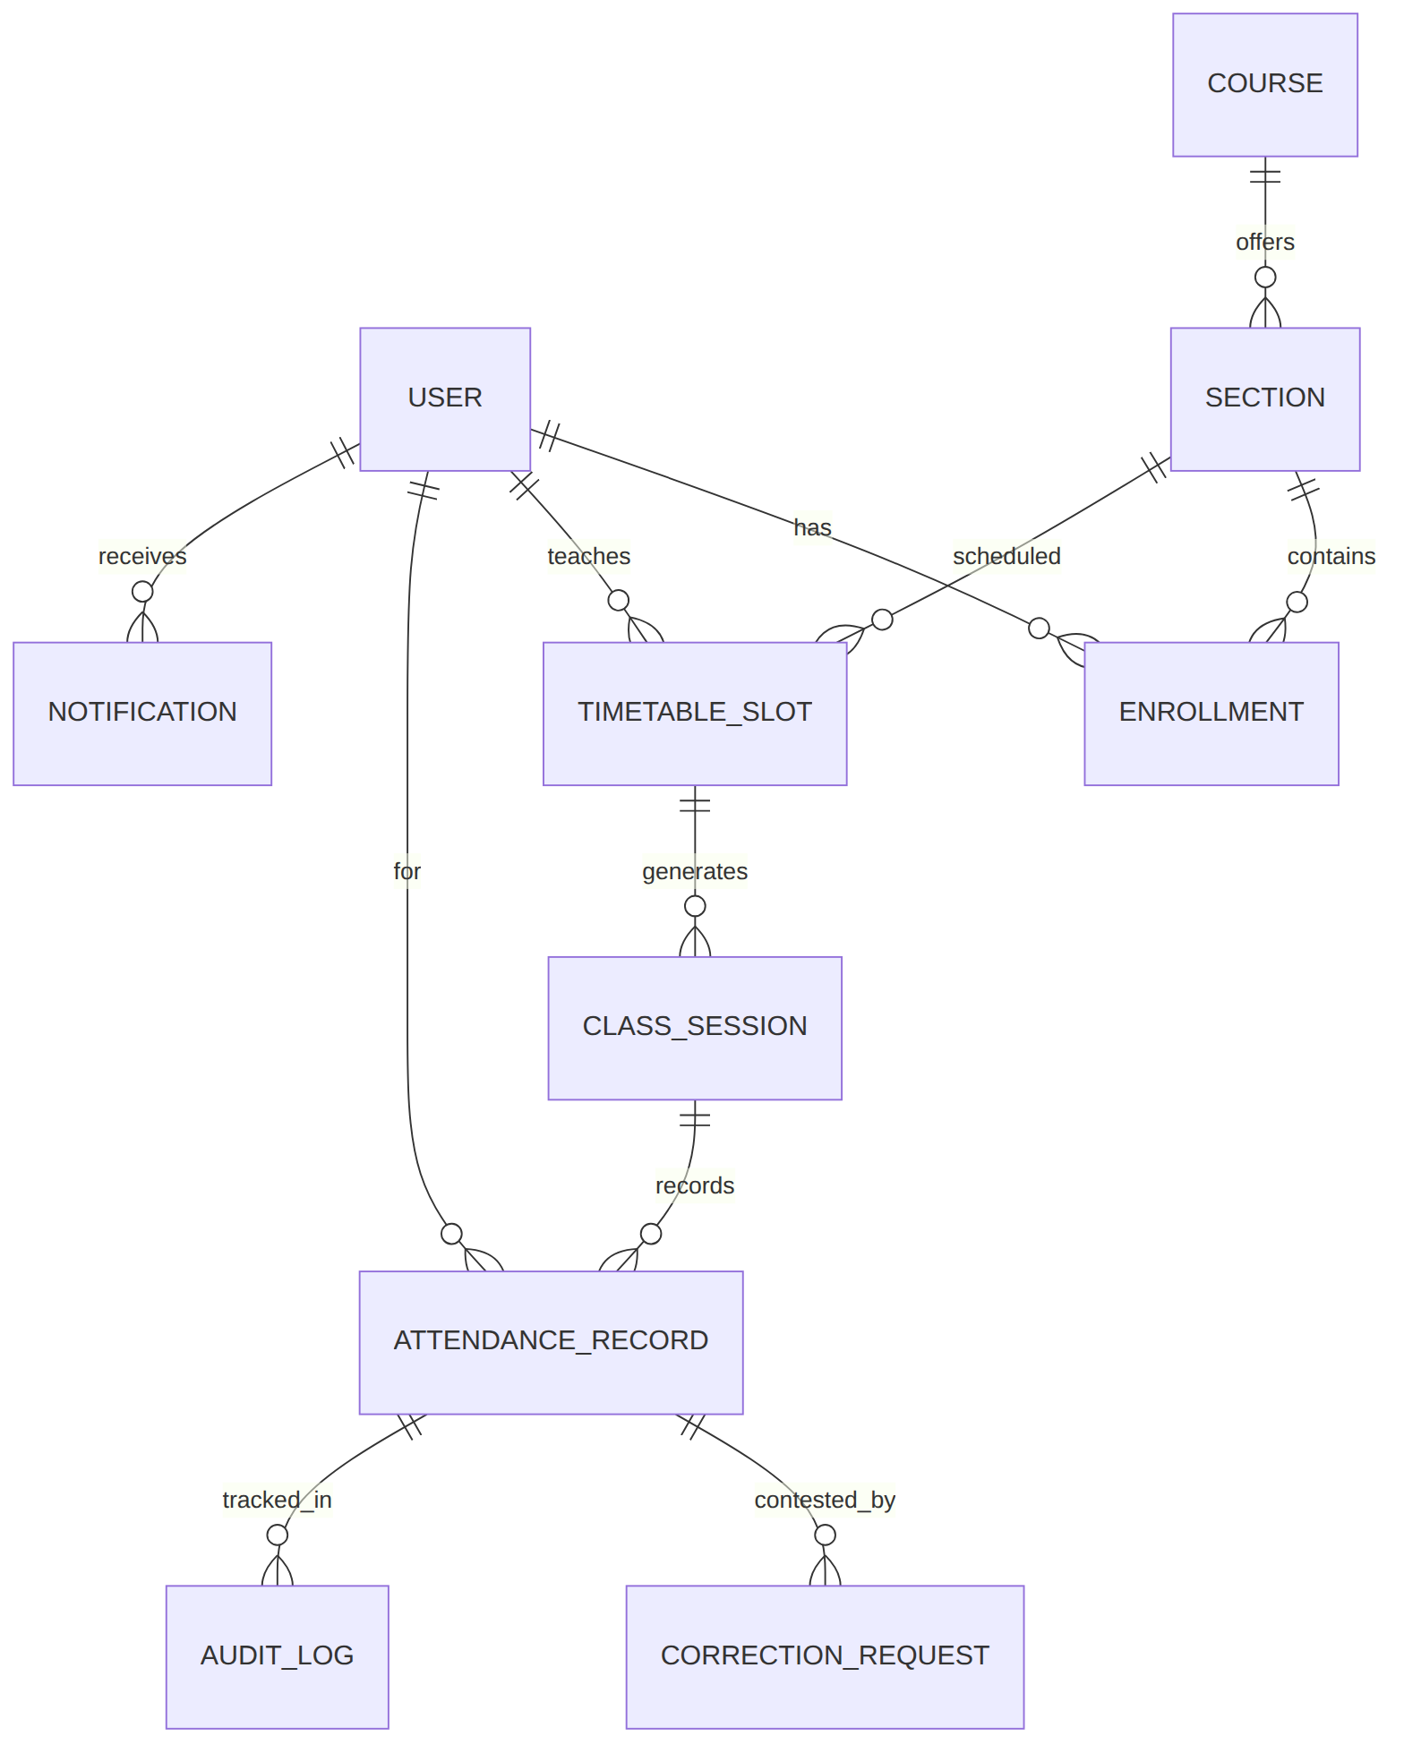
Figure 4: Entity-relationship diagram

3.7 Risks & Mitigations
Risk | Impact | Mitigation
Concurrent submissions for the same session (two tabs, double click) | Duplicate or conflicting records | Unique constraint on (session_id, student_id); submit runs in one DB transaction; 409 Conflict on repeat
Peak load at the start of each period when all faculty mark at once | Slow saves, timeouts | Bulk insert in one query; index on session/date; Locust load test against SAMS-NF-001/NF-006
Mail server outage | Notifications lost or request latency | Celery retry with backoff; in-app notification is written first and does not depend on email
Timetable changes mid-semester | Wrong roll lists | Sessions keep a reference to the slot they were created from; slot edits only affect future sessions
Small team, one member unavailable | Feature slips | Modules have clear interfaces; both members review each other's pull requests; Jira tracks ownership
Leaked or stolen token | Unauthorised access | Short access-token lifetime, refresh blacklist on logout, HTTPS only, HttpOnly cookies

3.8 Traceability to Requirements
Requirement | Architecture element | Design element | Planned code location
SAMS-F-001 Authenticate | AuthModule | Seq. diagram Fig. 7, POST /api/auth/login/ | accounts/services.py, accounts/views.py
SAMS-F-002 Role restriction | API Router (RBAC) | Permission classes IsStudent/IsFaculty/IsAdmin | core/permissions.py
SAMS-F-003 Lockout | AuthModule | User.failed_attempts, locked_until | accounts/services.py
SAMS-F-004 Password reset | AuthModule, NotifyModule | Signed one-time token, 30 min expiry | accounts/reset.py
SAMS-F-005 Roll list | CourseModule | slots_for(), roster() | courses/services.py
SAMS-F-006 Mark attendance | AttendanceModule | Seq. diagram Fig. 5, POST /api/sessions/{id}/attendance/ | attendance/services.py
SAMS-F-007 No duplicate marking | AttendanceModule, AuditModule | Unique constraint, 409 path, edit endpoint | attendance/models.py
SAMS-F-008 Student view | AttendanceModule | GET /api/students/me/attendance/ | attendance/selectors.py
SAMS-F-009 Correction request | AttendanceModule, NotifyModule | Seq. diagram Fig. 6, /api/corrections/ | attendance/corrections.py
SAMS-F-010 to F-013 Reports, defaulters | ReportModule | GET /api/reports/*, export | reports/services.py
SAMS-F-014 to F-016 Course & timetable | CourseModule | Admin CRUD endpoints | courses/views.py
SAMS-F-017, F-018 Notifications | NotifyModule | Celery tasks, Notification model | notifications/tasks.py
SAMS-F-019 to F-021 Admin & audit | Admin, AuditModule | Append-only AuditLog, GET /api/audit/ | audit/models.py
SAMS-NF-001, NF-006 Performance, scale | Deployment, DB indexes | Bulk insert, pagination | settings, migrations
SAMS-NF-003, SR-001 to SR-005 Security | Security architecture 3.9 | TLS, bcrypt, JWT, RBAC, audit | nginx.conf, settings.py

3.9 Security Architecture
Threat model (STRIDE) for SAMS:
Threat | Example in SAMS | Control
Spoofing | Student logs in as faculty using a guessed password | bcrypt-hashed passwords, lockout after 5 failures (F-003), login rate limiting, JWT signature check
Tampering | Student edits their own attendance through a crafted API call | Server-side RBAC on every endpoint (SR-004); only faculty of that section can write records; DB constraints
Repudiation | Faculty denies changing a mark | Append-only AuditLog with editor ID, timestamp, old/new value (SR-005); no update/delete API
Information disclosure | Student reads another student's attendance | Queries scoped to request.user; object-level permission checks; HTTPS only (SR-001); no passwords in logs (SR-002)
Denial of service | Login brute force or report export flood | Nginx and DRF throttling, pagination, async report export
Elevation of privilege | Faculty promotes self to Admin | Role changes only via Admin endpoints; role field read-only in profile serializer; tested in TC-Sec-05
Additional controls: CSRF protection for cookie-based requests, secure/HttpOnly/SameSite cookies, Django security middleware headers (HSTS, X-Frame-Options, CSP), secrets in environment variables, dependency scanning (pip-audit) and SonarQube in the Jenkins pipeline.

4. Design

4.1 Design Overview
Each component in section 3 is a Django app with the same internal layout, so any team member can navigate any module:
sams/
core/ settings, permissions.py (RBAC), exceptions.py, pagination
accounts/ models.py, services.py, views.py, serializers.py, tests/
courses/ Course, Section, Enrollment, TimetableSlot
attendance/ ClassSession, AttendanceRecord, CorrectionRequest
reports/ report services and CSV/PDF exporters
notifications/ Notification model, Celery tasks
audit/ AuditLog (append-only)
templates/, static/ UI
docker/, Jenkinsfile, docker-compose.yml

Design rules: views call services, services call models and other modules' services (never other modules' views); cross-module calls go through the public functions listed in 3.4; every write to attendance goes through AttendanceModule so the audit log cannot be bypassed.
Division of work (each member owns full features, front to back):
Member | Owned modules / features | Quality attribute owned
Kundhan Vudutha (PES1UG24AM327) | AuthModule (login, lockout, password reset, RBAC permission layer), Administration and AuditModule (users, roles, threshold config, append-only audit log) | Security validation (STRIDE controls, TC-Sec suite); CI/CD pipeline owner
Tarun J (PES1UG24AM304) | CourseModule (courses, sections, enrollments, weekly timetable, roll-list generation), NotifyModule (in-app and email notifications, nightly low-attendance scan) | Reliable notification delivery (retries, dead-letter handling)
Tejaswini S (PES1UG25AM815) | AttendanceModule (session marking P/A/OD, duplicate-submission guard, authorised edits, correction request and approval workflow) | Marking-screen speed: 60-student roll call in under one minute
Anish (PES1UG24AM348) | Student attendance view (percentages, threshold flag), ReportModule (per-student, per-course, date-range reports, defaulter list, CSV/PDF export) | Report performance and dashboard accessibility
All members | Docker setup, unit tests for own modules, code review on every pull request (each PR reviewed by one other member) | -

4.2 UML Sequence Diagrams
Flow 1: faculty marks attendance for a scheduled session (SAMS-F-005, F-006, F-007).
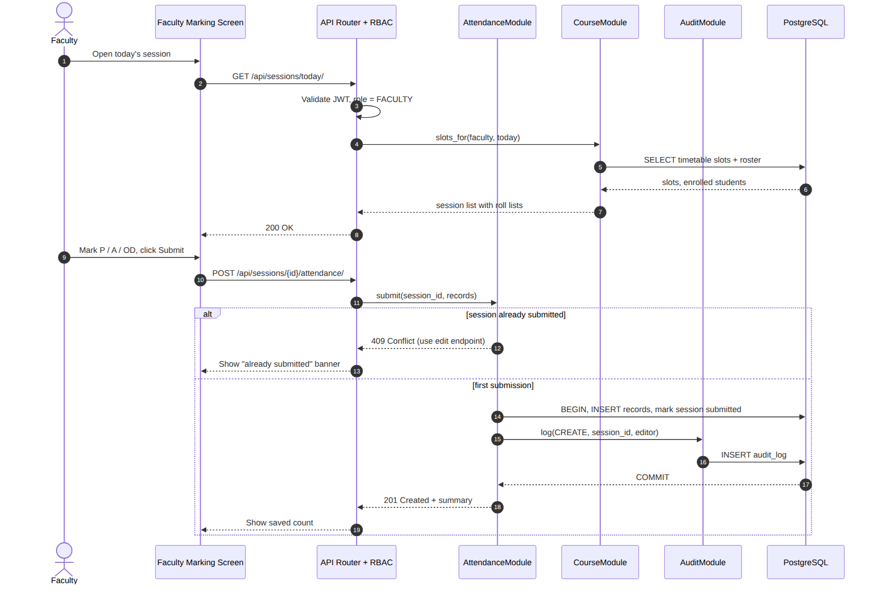
Figure 5: Mark attendance
Flow 2: student raises a correction request and faculty decides it (SAMS-F-009, F-018, SR-005).
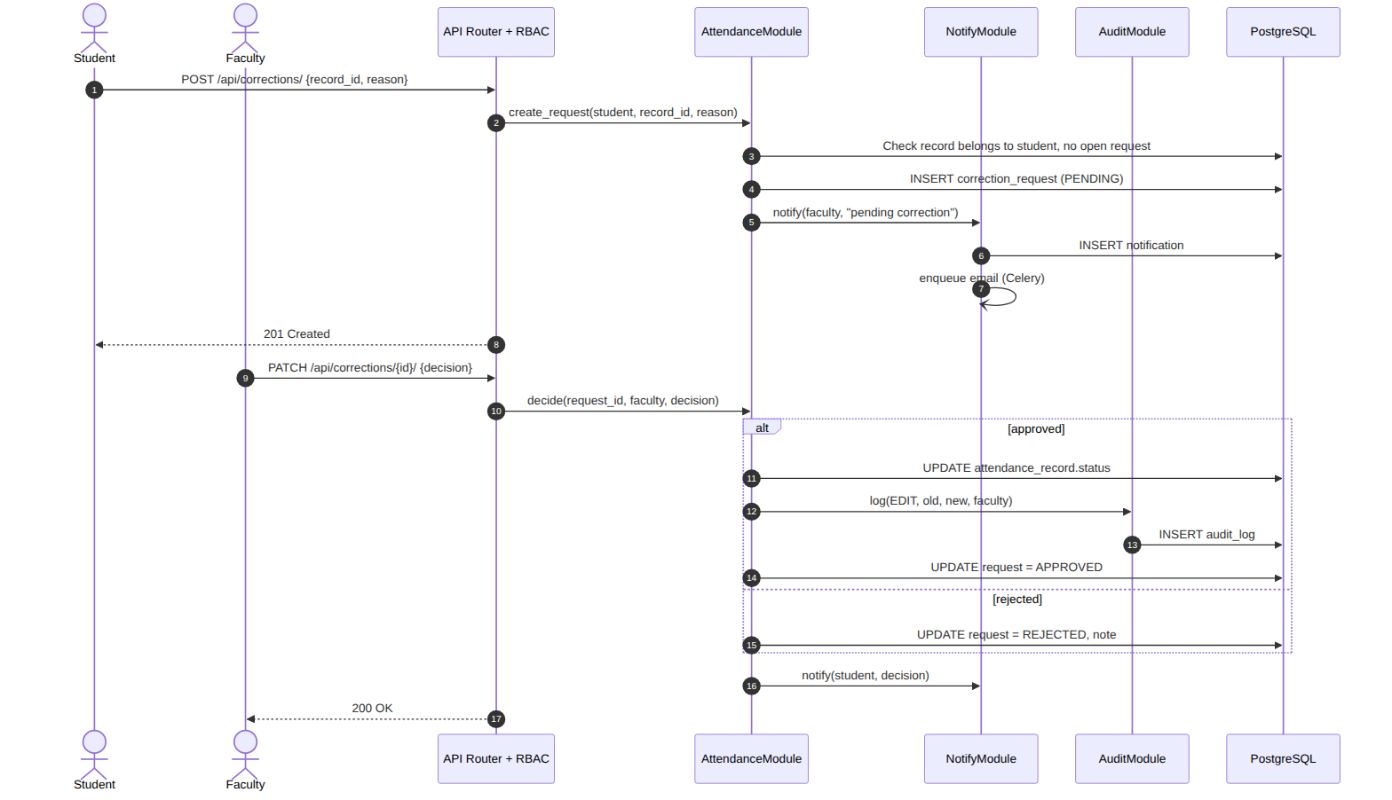
Figure 6: Attendance correction request
Flow 3: login with lockout (SAMS-F-001, F-003).
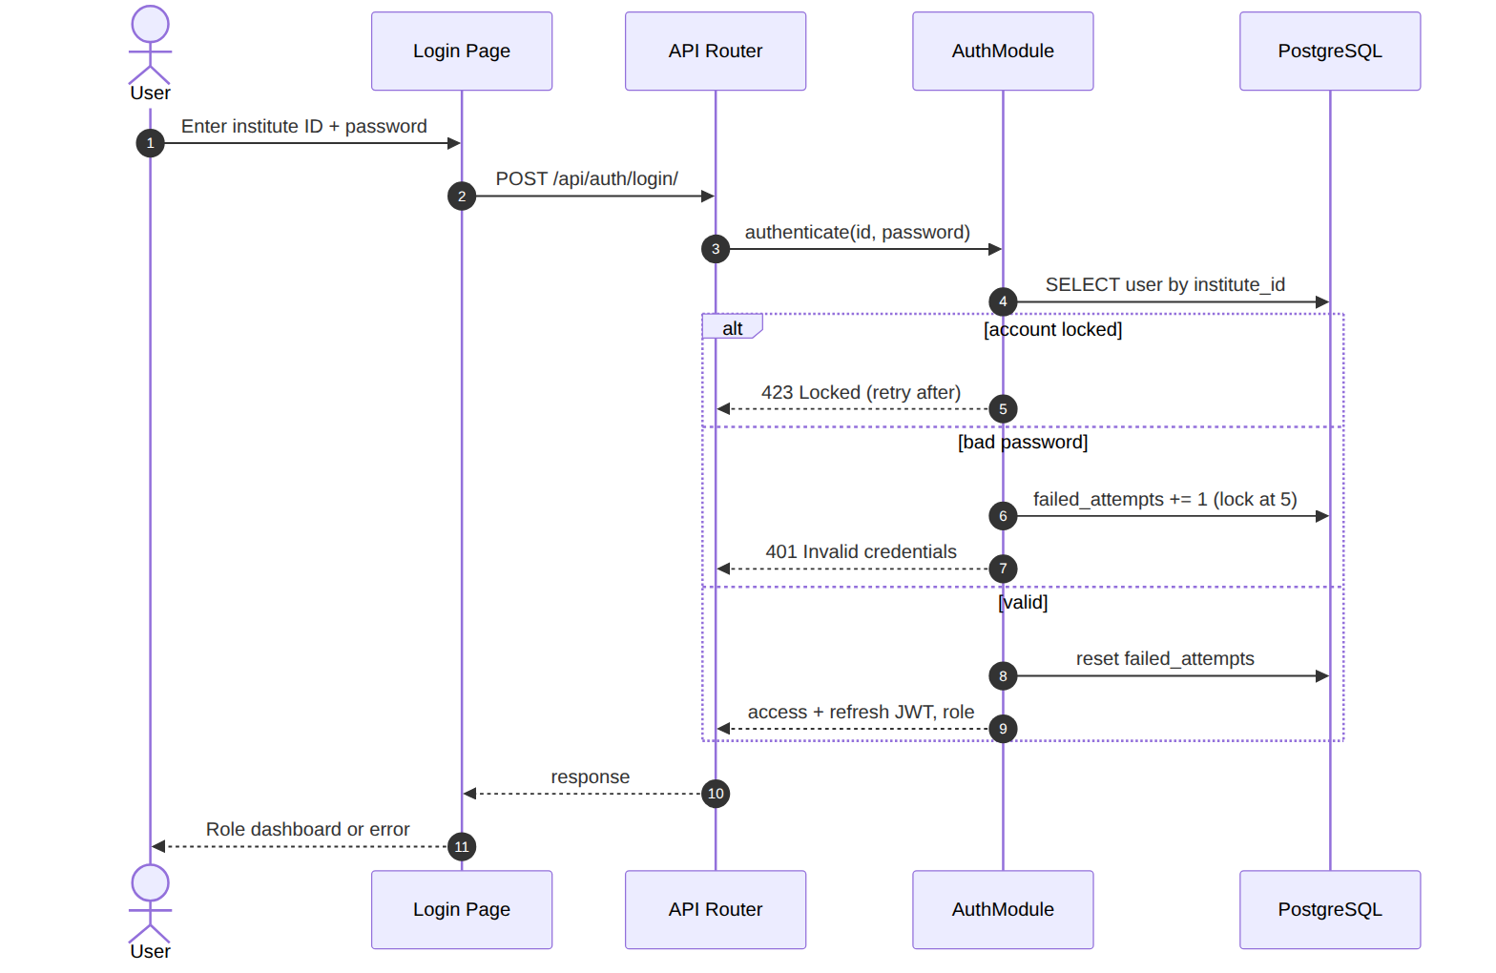
Figure 7: Login and account lockout

4.3 API Design
All endpoints are JSON over HTTPS under /api/, documented with OpenAPI (Swagger UI at /api/docs/). Authentication is a Bearer JWT unless noted. Errors use one shape: {"error": {"code": "...", "message": "...", "details": {...}}}.

4.3.1 AuthModule: Login
Field | Value
Endpoint | /api/auth/login/
Method | POST
Allowed role(s) | Public
Request | { "institute_id": "PES1UG24AM327", "password": "..." }
Response | 200 { "access": "<jwt>", "refresh": "<jwt>", "role": "STUDENT", "name": "..." }
Errors | 400 missing fields; 401 INVALID_CREDENTIALS; 423 ACCOUNT_LOCKED { "retry_after_s": 900 }; 429 throttled

4.3.2 AuthModule: Logout
Field | Value
Endpoint | /api/auth/logout/
Method | POST
Allowed role(s) | Any authenticated
Request | { "refresh": "<jwt>" }
Response | 205 Reset Content (refresh token blacklisted)
Errors | 401 token invalid or expired

4.3.3 AuthModule: Password reset
Field | Value
Endpoint | /api/auth/password-reset/ and /api/auth/password-reset/confirm/
Method | POST
Allowed role(s) | Public
Request | { "email": "..." } then { "token": "...", "new_password": "..." }
Response | 202 Accepted (same response whether or not the email exists); 200 on confirm
Errors | 400 weak password; 410 TOKEN_EXPIRED_OR_USED

4.3.4 CourseModule: Today's sessions
Field | Value
Endpoint | /api/sessions/today/
Method | GET
Allowed role(s) | Faculty
Request | -
Response | 200 [ { "session_id": 412, "course": "UE24CS341A", "section": "F", "start": "09:00", "submitted": false, "roster": [ { "student_id": 1, "srn": "...", "name": "..." } ] } ]
Errors | 401; 403 NOT_FACULTY

4.3.5 AttendanceModule: Submit attendance
Field | Value
Endpoint | /api/sessions/{session_id}/attendance/
Method | POST
Allowed role(s) | Faculty assigned to the session
Request | { "records": [ { "student_id": 1, "status": "P" }, { "student_id": 2, "status": "A" }, { "student_id": 3, "status": "OD" } ] }
Response | 201 { "session_id": 412, "saved": 60, "present": 54, "absent": 5, "on_duty": 1 }
Errors | 400 INVALID_STATUS or student not in roster; 403 NOT_SESSION_FACULTY; 404 session; 409 ALREADY_SUBMITTED

4.3.6 AttendanceModule: Edit a submitted record
Field | Value
Endpoint | /api/records/{record_id}/
Method | PATCH
Allowed role(s) | Faculty of the session, Admin
Request | { "status": "P", "reason": "Late entry verified" }
Response | 200 updated record (audit entry written)
Errors | 400 reason missing; 403; 404

4.3.7 AttendanceModule: My attendance
Field | Value
Endpoint | /api/students/me/attendance/?course=UE24CS341A
Method | GET
Allowed role(s) | Student
Request | -
Response | 200 [ { "course": "UE24CS341A", "held": 30, "attended": 26, "percentage": 86.67, "below_threshold": false } ]
Errors | 401; 403

4.3.8 AttendanceModule: Correction requests
Field | Value
Endpoint | /api/corrections/ and /api/corrections/{id}/
Method | POST / PATCH
Allowed role(s) | Student (create), Faculty (decide)
Request | Create: { "record_id": 9001, "requested_status": "OD", "reason": "Hackathon, letter attached" } Decide: { "decision": "APPROVE" | "REJECT", "note": "..." }
Response | 201 { "id": 77, "state": "PENDING" }; 200 { "id": 77, "state": "APPROVED" }
Errors | 400 reason empty; 403 not own record / not section faculty; 409 OPEN_REQUEST_EXISTS or ALREADY_DECIDED

4.3.9 ReportModule: Defaulter list
Field | Value
Endpoint | /api/reports/defaulters/?course=&section=&threshold=75&format=json|csv|pdf
Method | GET
Allowed role(s) | Faculty (own sections), Admin
Request | -
Response | 200 JSON list or file download { srn, name, course, held, attended, percentage }
Errors | 400 threshold out of 0-100; 403

4.3.10 AuditModule: Audit log
Field | Value
Endpoint | /api/audit/?record=&editor=&from=&to=
Method | GET
Allowed role(s) | Admin
Request | -
Response | 200 paginated [ { "record_id", "editor", "old", "new", "timestamp" } ]
Errors | 403 for non-admin; 405 for PUT/PATCH/DELETE

4.4 Error Handling, Logging & Monitoring
- A custom DRF exception handler maps every error to the standard error shape with a stable machine-readable code and a user-safe message. Stack traces are never returned to clients (DEBUG off in production).
- Structured JSON logs (request ID, user ID, endpoint, status, latency). Passwords, tokens and reset links are filtered from logs (SAMS-SR-002).
- Security events logged at WARNING: failed logins, lockouts, 403 responses, audit-log access.
- Health endpoint /api/health/ checks DB and Redis for uptime monitoring (SAMS-NF-002).
- Metrics: request latency p95, error rate, attendance saves per minute, Celery queue length, failed emails. Alerts if p95 exceeds 3 s or error rate exceeds 2% for 5 minutes.
- Celery tasks retry 3 times with exponential backoff; permanent failures are written to a dead-letter table shown to Admin.

4.5 UX Design
- Faculty marking screen: all students default to Present; faculty taps only the exceptions, so a 60-student roll call is a few taps. Large touch targets, sticky Submit button, counts shown before submit.
- Student dashboard: one card per course with percentage and a colour plus text label (OK / At risk / Below threshold), never colour alone.
- Admin console: tables with search and filters for users, courses, timetable and audit log; CSV import for bulk enrollment.
- Responsive from 360px width; keyboard navigable; WCAG 2.1 AA contrast on core screens (SAMS-NF-005).
- Errors are shown inline next to the field, in plain language, with the API error code available for support.

4.6 Open Issues & Next Steps
- Decide whether OD requires an uploaded proof document in v1 or only a reason text.
- Confirm the institute's default threshold (75% assumed) and whether it varies per course.
- Choose the SMTP provider for the demo environment.
- Future: QR-code self check-in, ERP integration over the existing REST API, mobile app reusing the JWT API.

5. Appendices

5.1 Glossary
See section 1.4. Additional terms: HTMX (HTML-over-the-wire library for partial page updates), Celery (Python distributed task queue), Gunicorn (Python WSGI HTTP server).

5.2 References
- SAMS SRS v1.0, Kundhan Vudutha and Tarun J, 05-09-2026
- ISO/IEC/IEEE 42010:2022, Architecture description
- OWASP Top 10 (2021) and OWASP ASVS 4.0
- NIST SP 800-160 Vol. 1, Systems Security Engineering
- Django 5 and Django REST Framework documentation

5.3 Tools
Mermaid (UML diagrams), draw.io, Swagger / drf-spectacular (API documentation), Jira (backlog), GitHub (version control and reviews), Jenkins, Docker, SonarQube.

