Lab 1: Requirements Engineering & UML Use-Case Modelling

Warehouse Inventory & Pallet Location Tracker

1. Requirements Table
Req ID | Type | Description | Priority | Acceptance Criteria | Rationale
FR-001 | Functional | The system shall validate proposed pallet placement coordinates against the rack maximum load capacity before confirming storage. | High | Pass: Pallet assigned to a valid rack. Fail: Placement permitted on a rack where total weight exceeds its rated structural limit. | Prevents structural failure and safety hazards from overloaded racks.
FR-002 | Functional | The system shall allow a Warehouse Operator to scan a pallet's barcode or RFID tag to capture its unique Pallet ID before any storage or retrieval action. | High | Pass: A single scan populates the Pallet ID field with 100% read accuracy within 2 seconds. Fail: Pallet ID is not captured, or capture takes longer than 2 seconds. | Accurate identification is a prerequisite for location tracking and load validation.
FR-003 | Functional | The system shall log every stock movement event (inbound, outbound, relocation) with Pallet ID, timestamp, source coordinate, and destination coordinate. | High | Pass: Querying the movement history for any pallet returns a complete, chronological record of all movements. Fail: Any movement event is missing from the log. | Full traceability is required for inventory audits and loss prevention.
FR-004 | Functional | The system shall allow a Logistics Supervisor to retrieve the current 3D shelf coordinates (aisle, rack, shelf) of any pallet by SKU or Pallet ID. | Medium | Pass: Query returns the aisle/rack/shelf coordinate matching the pallet's last confirmed placement. Fail: Query returns a stale or incorrect coordinate. | Enables efficient retrieval planning and reduces manual search time.
FR-005 | Functional | The system shall allow a Warehouse Operator to request an override of a rejected pallet placement, routing the request to a Logistics Supervisor for approval before storage is confirmed. | Medium | Pass: A rejected placement cannot be confirmed without a recorded Supervisor-approval entry. Fail: A pallet is stored on an over-limit rack without an approval record. | Provides controlled flexibility for edge cases while preserving accountability.
NFR-001 | Nonfunctional (Performance & Security) | The warehouse item lookup service must locate any SKU pallet coordinate across 100,000 bins in under 100 ms. | High | Pass: Benchmark tests confirm the target latency and security standards under simulated peak load. Fail: Median lookup latency exceeds 100 ms, or the endpoint is reachable without authentication. | Fast, secure lookup is required to keep operator workflows productive during peak throughput.
NFR-002 | Nonfunctional (Security & Compliance) | The system shall retain an immutable, tamper-evident audit log of all stock-movement and placement-override records for a minimum of 24 months, viewable only by authenticated Logistics Supervisor accounts. | High | Pass: Log entries cannot be edited or deleted, and access attempts by non-Supervisor roles are denied and recorded. Fail: Any log entry is alterable, or is accessible without proper role authentication. | Supports regulatory compliance and dispute resolution for inventory discrepancies.

2. UML Use-Case Diagram

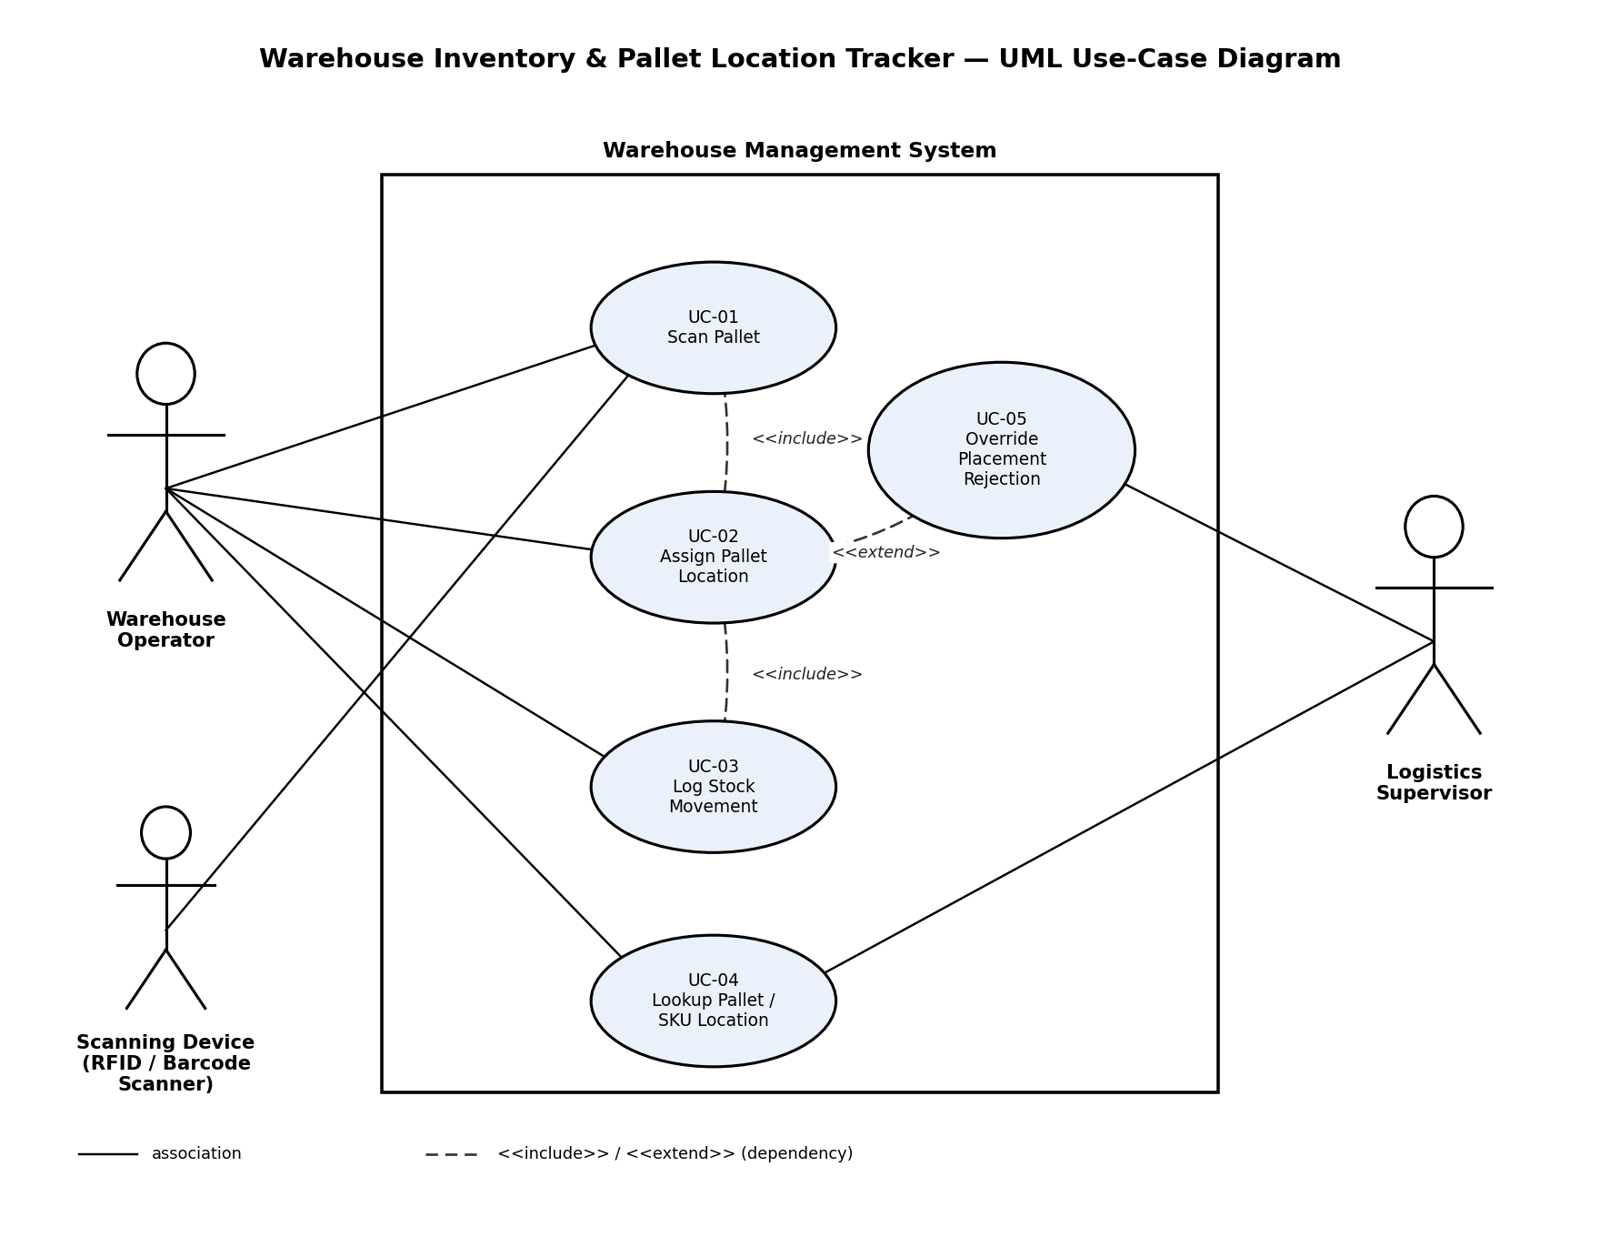

3. Use-Case Flow Specification

Use Case: UC-02 — Assign Pallet Location

Primary Actor: Warehouse Operator

Secondary Actors: Logistics Supervisor (approval), Scanning Device (RFID/Barcode Scanner, supporting)

Preconditions

• The Warehouse Operator is authenticated in the system.

• The pallet is physically present at the staging/receiving area.

Rack capacity and current occupancy data in the system are up to date.

Postconditions (on success)

• The pallet's 3D coordinate (aisle, rack, shelf) is recorded and searchable.

• The destination rack's cumulative load is updated to include the new pallet's weight.

A stock-movement log entry exists for the placement (FR-003).

Main Success Scenario

1. Warehouse Operator selects "Assign Pallet Location" from the system menu.

2. System prompts the Operator to identify the pallet (includes UC-01: Scan Pallet).

3. Operator scans the pallet's barcode/RFID tag; the Scanning Device returns the Pallet ID and recorded weight to the system.

4. Operator enters or selects a proposed storage coordinate (aisle, rack, shelf).

5. System validates the proposed coordinate against the rack's maximum load capacity (FR-001).

6. System confirms the placement is within the rated limit.

7. System updates the rack's occupancy record and the pallet's shelf coordinate.

8. System logs the stock-movement event with Pallet ID, timestamp, and destination coordinate (includes UC-03: Log Stock Movement).

9. System displays a confirmation screen showing the assigned coordinate.

10. Use case ends successfully.

Alternate Flow — 5a. Placement Exceeds Rack Capacity

5a1. System rejects the proposed coordinate and displays a "Capacity Exceeded" message showing current load vs. rated limit.

5a2. System suggests one or more alternate valid rack locations with available capacity.

5a3. Operator either selects a suggested alternate location, or requests an override.

5a4. If an override is requested, the "Override Placement Rejection" use case is invoked (extends UC-02) and a Logistics Supervisor is notified for approval.

5a5. If the Supervisor approves, flow resumes at Main Success Scenario step 6. If denied, or if the Operator accepts a suggested alternate instead, flow resumes at step 4 with the new coordinate.

5a6. If no alternate is accepted and no override is approved, the use case ends without a placement being recorded.

