**William Sung**

**Design Document**

**Project:** Coffee Shop Inventory System

**Description:** Application will provide client with the ability to track inventory of coffee shop stock. The application will take log inventory with item name, type, quantity, location, and date received. The item name is an identifier for the item, type is a choice between item types such as coffee or food, quantity is amount in stock, location is the shelf ID, and expiration date is the date the item is expected to expire (only required on perishable items). Finally, the item types shall be extendable to accommodate future incorporation of different items.

**User Stories:**

1. As a manager, I want to be able to add future item types, so that I can expand my inventory.
2. As a manager, I want to be able to update my stock, so that I have an accurate count of items.
3. As a manager, I want to view expiration dates, so that I know which stock is close to expiration or needs to be removed from storage.
4. As a manager, I want to see out of stock items, so that I can update my menu to reflect what is available.
5. As a manager, I want to be able to filter by category, so that I can easily sort for the information I want.
6. As a manager, I want to be able to update item location, so that I can move items around storage if changes are needed.
7. As a manager, I want to be able to have duplicate items, so that I can store a single item in multiple locations.
8. As an employee, I want to see item locations, so that I don’t have to search around the storage for it.
9. As an employee, I want to see if an item is in stock, so that I know if I can find it in the back or not.
10. As an employee, I want to be able to update items, so that I can perform weekly inventory audits.

**UML/Domain Class Model**

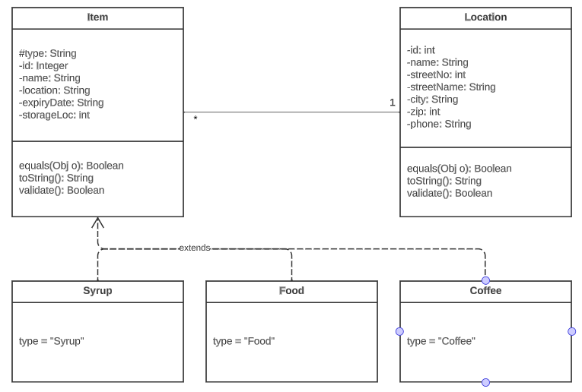

**Sequence Diagram**

