# Open APC Sweden - Statistics

This is a sample of statistics from the pilot project Open APC Sweden, aiming at gathering data about article processing charges (APC's) paid by Swedish universities. The statistics covers journal articles from a few pilot contributors. Please see the [project wiki](https://github.com/Kungbib/openapc-se/wiki) for more information about the project and instructions on how to contribute.

## Contributing organisations

|  |  |
| --- | --- |
| Acronym | Contributing organisation |
| gu | University of Gothenburg |
| ki | Karolinska Institutet |
| kth | KTH Royal Institute of Technology |
| ltu | Luleå Technical University |
| lu | Lund University |
| liu | Linköping University |
| mah | Malmö University College |
| sh | Södertörn University |
| slu | Swedish University of Agricultural Sciences |
| su | Stockholm University |
| umu | Umeå University |
| uu | Uppsala University |

## Dataset

Information on both open access journal articles and open access publication of articles in toll-access journals ("hybrid") are provided. You may view the dataset at the [project page in GitHub](https://github.com/Kungbib/openapc-se/blob/master/data/apc_se.csv).

In total, **272 626 €** for **205 articles** were paid by the **9 universities** that have delivered APC data so far. The **average APC is 1 330 €** and the **median is APC 1 383 €**.

|  |  |  |  |  |
| --- | --- | --- | --- | --- |
| Universities | Publications | Total APC (€) | Average APC (€) | Median APC (€) |
| 9 | 205 | 272 626 | 1 330 | 1 383 |

## Open Access Articles (Total: both "gold" and "hybrid" OA)

At the moment, the dataset contains the following information:

* Number of articles: **205**
* Total expenditure: **272 626 €**
* Average fee: **1 330 €**
* Median fee: **1 383 €**

Articles and APC costs per institution:

|  |  |  |  |  |
| --- | --- | --- | --- | --- |
|  | Articles | Fees paid (€) | Mean APC (€) | Median APC (€) |
| Karolinska Institutet | 5 | 3 775 | 755 | 755 |
| KTH Royal Institute of Technology | 165 | 224 049 | 1 358 | 1 505 |
| Linköping University | 1 | 755 | 755 | 755 |
| Lund University | 1 | 755 | 755 | 755 |
| Malmö University College | 6 | 11 432 | 1 905 | 2 256 |
| Stockholm University | 16 | 25 858 | 1 616 | 1 608 |
| Umeå University | 4 | 3 850 | 962 | 755 |
| University of Gothenburg | 4 | 1 510 | 378 | 378 |
| Uppsala University | 3 | 642 | 214 | 321 |

## Articles in Open Access journals ("gold OA")

At the moment, the dataset contains the following information on articles in open access journals:

* Number of articles: **151**
* Total expenditure: **166 554 €**
* Average fee: **1 103 €**
* Median fee: **982 €**

Articles and APC costs per institution:

|  |  |  |  |  |
| --- | --- | --- | --- | --- |
|  | Articles | Fees paid (€) | Mean APC (€) | Median APC (€) |
| Karolinska Institutet | 5 | 3 775 | 755 | 755 |
| KTH Royal Institute of Technology | 118 | 134 389 | 1 139 | 1 021 |
| Linköping University | 1 | 755 | 755 | 755 |
| Lund University | 1 | 755 | 755 | 755 |
| Malmö University College | 3 | 3 539 | 1 180 | 1 311 |
| Stockholm University | 12 | 17 339 | 1 445 | 1 448 |
| Umeå University | 4 | 3 850 | 962 | 755 |
| University of Gothenburg | 4 | 1 510 | 378 | 378 |
| Uppsala University | 3 | 642 | 214 | 321 |

## OA articles in toll-access journals ("hybrid OA")

In many toll-access journals some of the articles are open access after a fee has been paid. This model is often called "hybrid open access". The dataset covers the following data on hybrid open access articles:

* Number of articles: **54**
* Total expenditure: **106 072 €**
* Average fee: **1 964 €**
* Median fee: **1 905 €**

The following institutions have contributed its expenditures for hybrid open access.

|  |  |  |  |  |
| --- | --- | --- | --- | --- |
|  | Articles | Fees paid (€) | Mean APC (€) | Median APC (€) |
| KTH Royal Institute of Technology | 47 | 89 660 | 1 908 | 1 905 |
| Malmö University College | 3 | 7 893 | 2 631 | 2 631 |
| Stockholm University | 4 | 8 519 | 2 130 | 2 190 |

## Distribution over publishers

### All types of OA articles

APC fees paid per publisher with indication of contribution from each university.

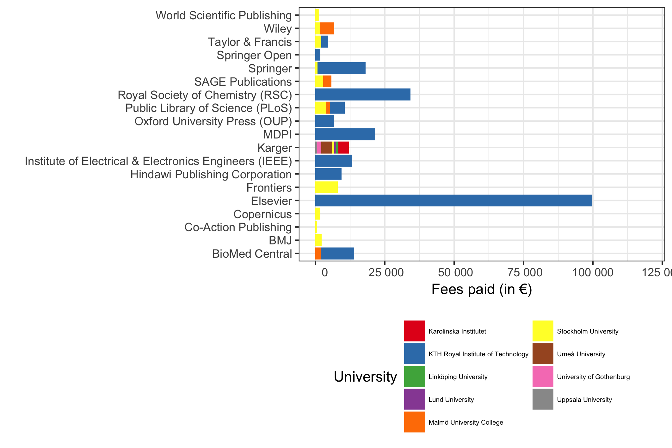

### OA journal articles

APC fees paid per publisher with indication of contribution from each university.

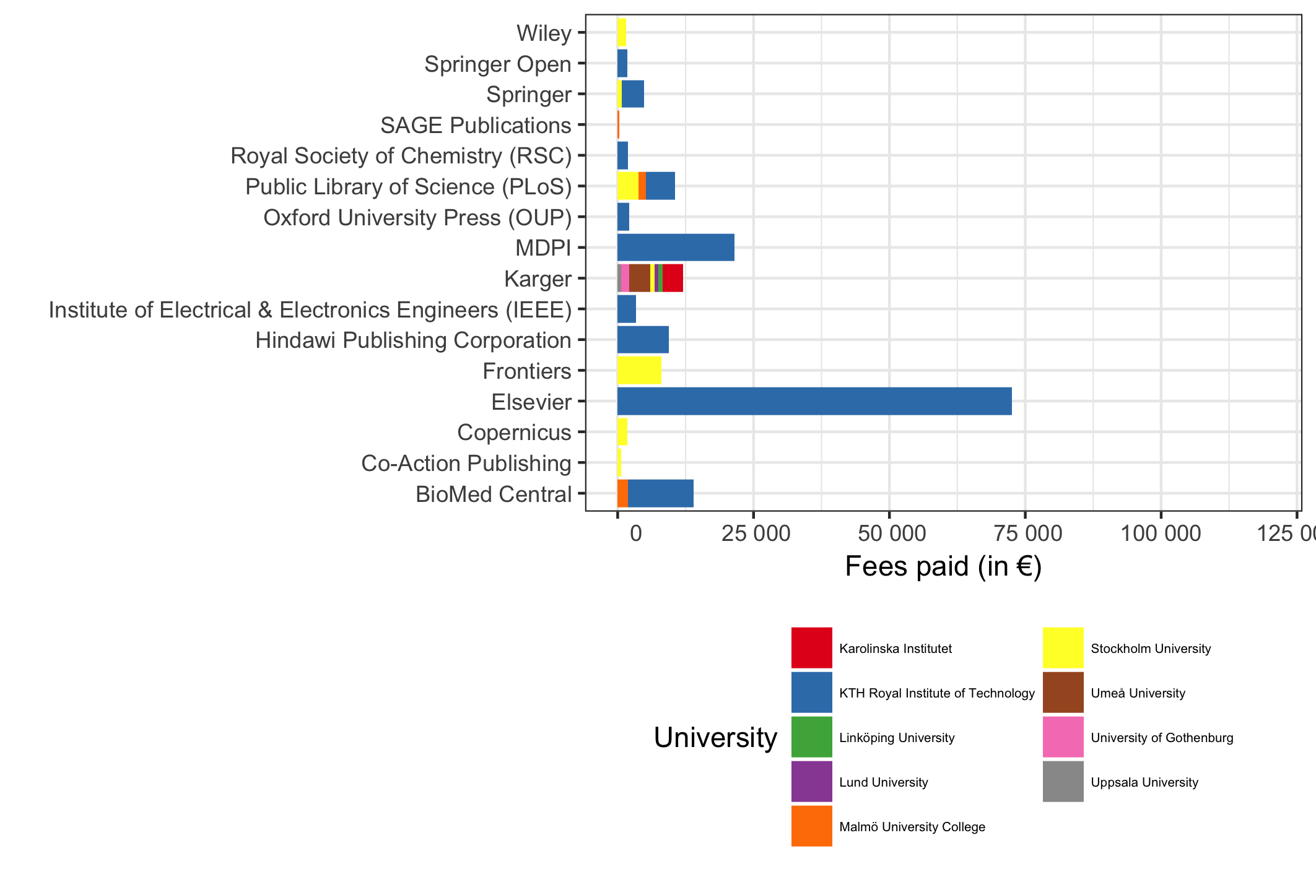

### Hybrid OA articles in toll access journals

APC fees paid per publisher with indication of contribution from each university.

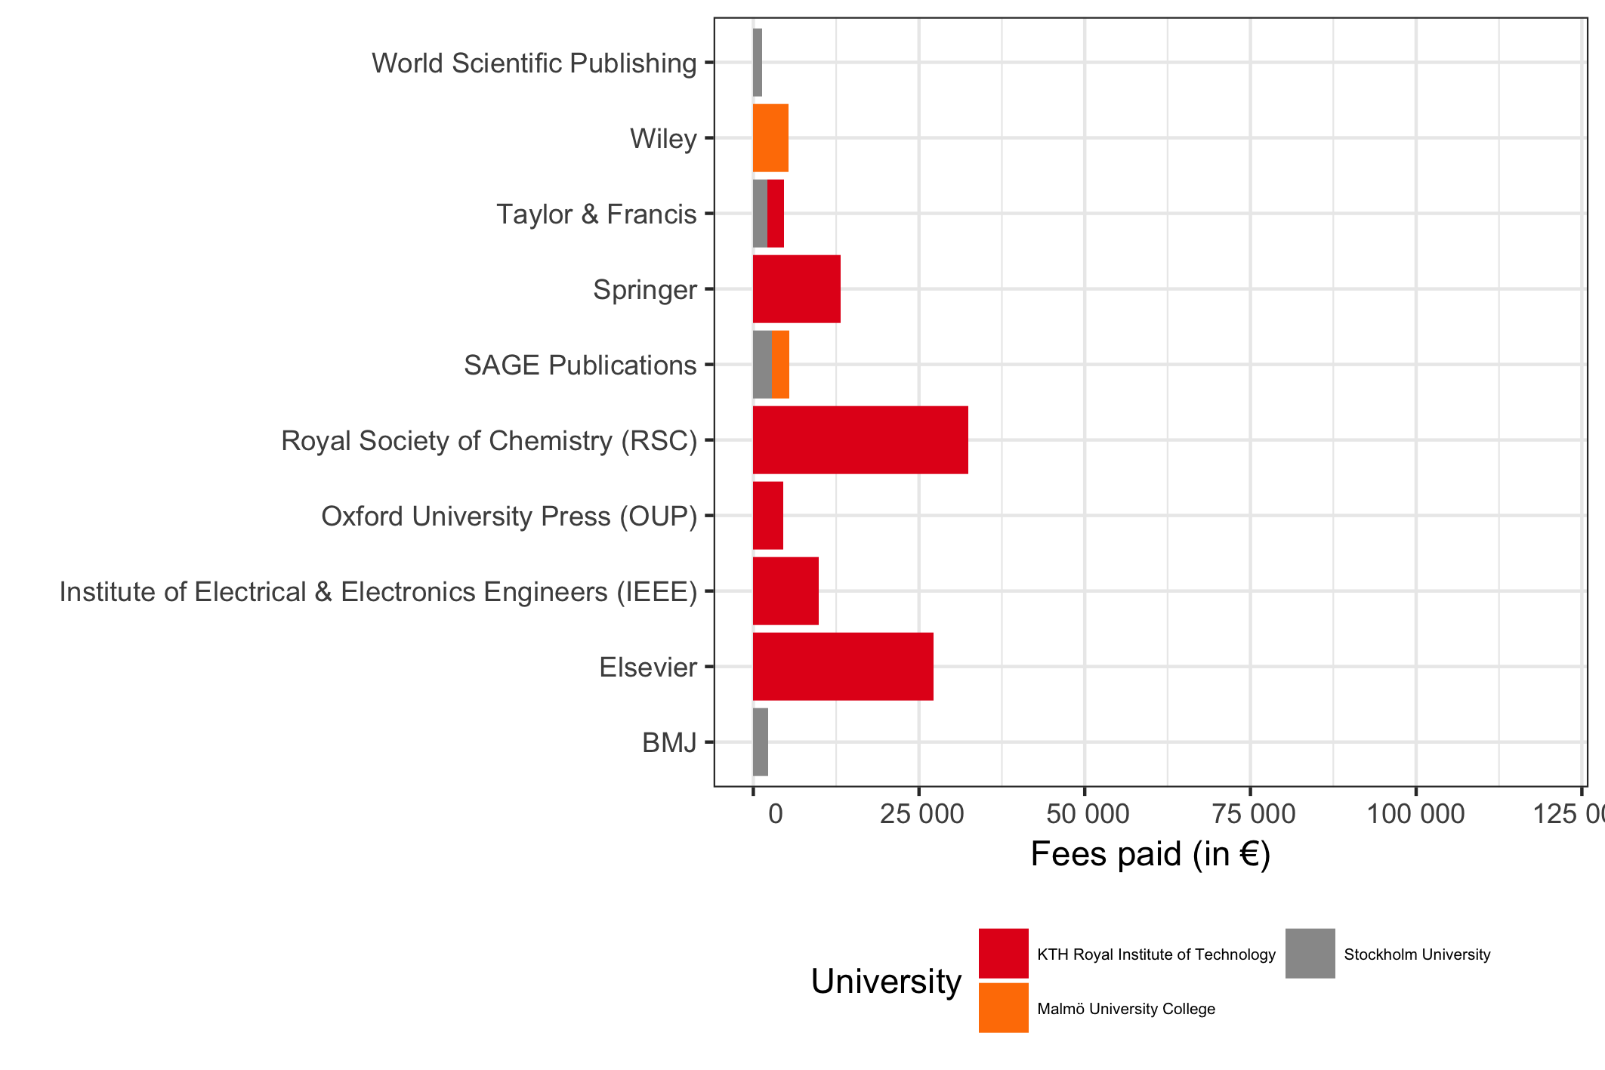

## Fees paid per university

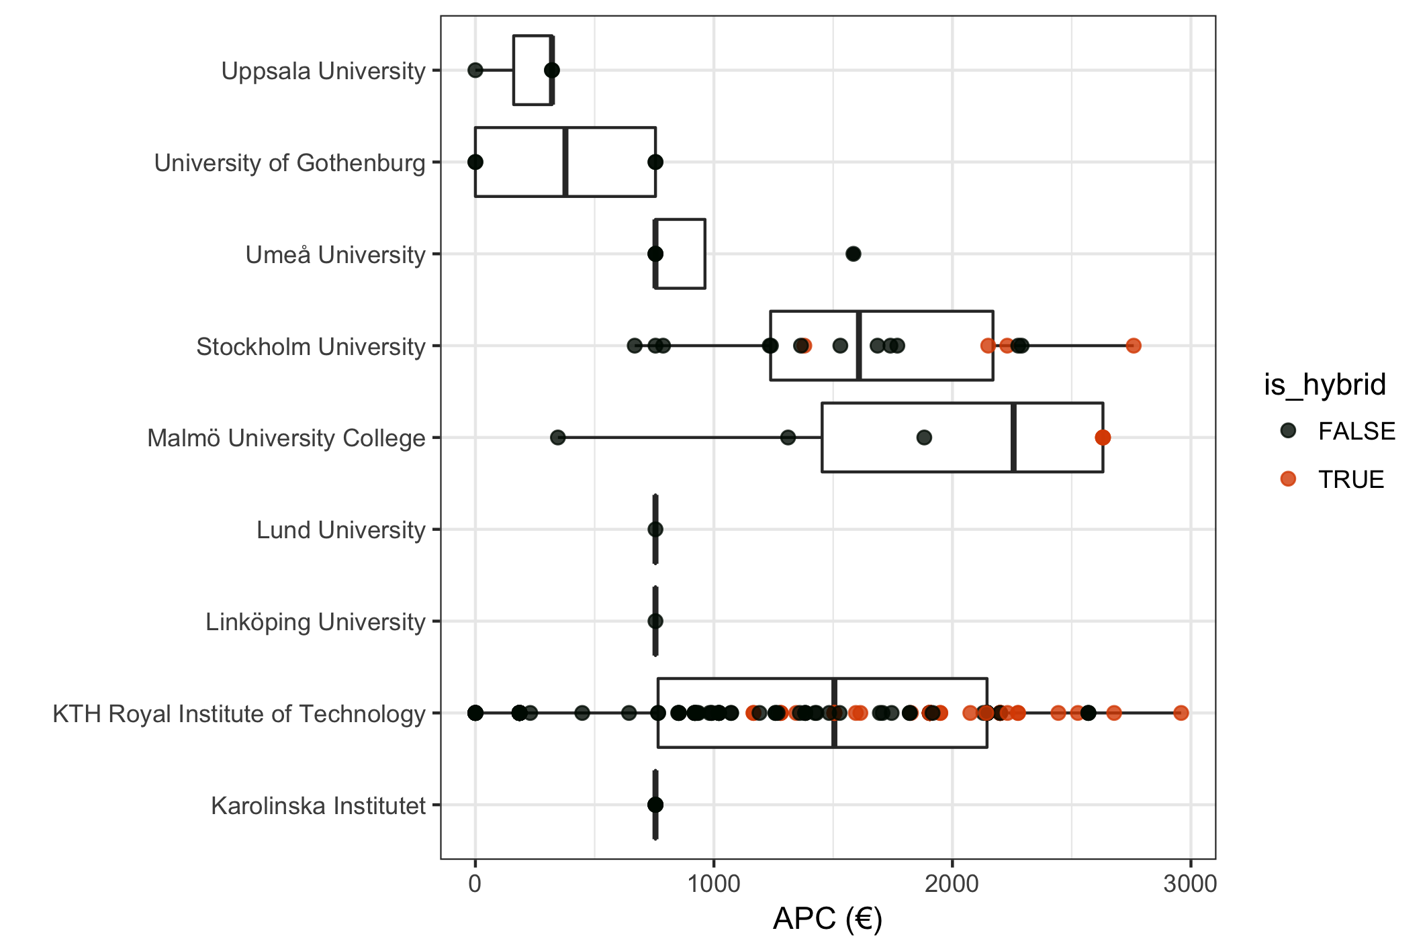

## Average fee per publisher

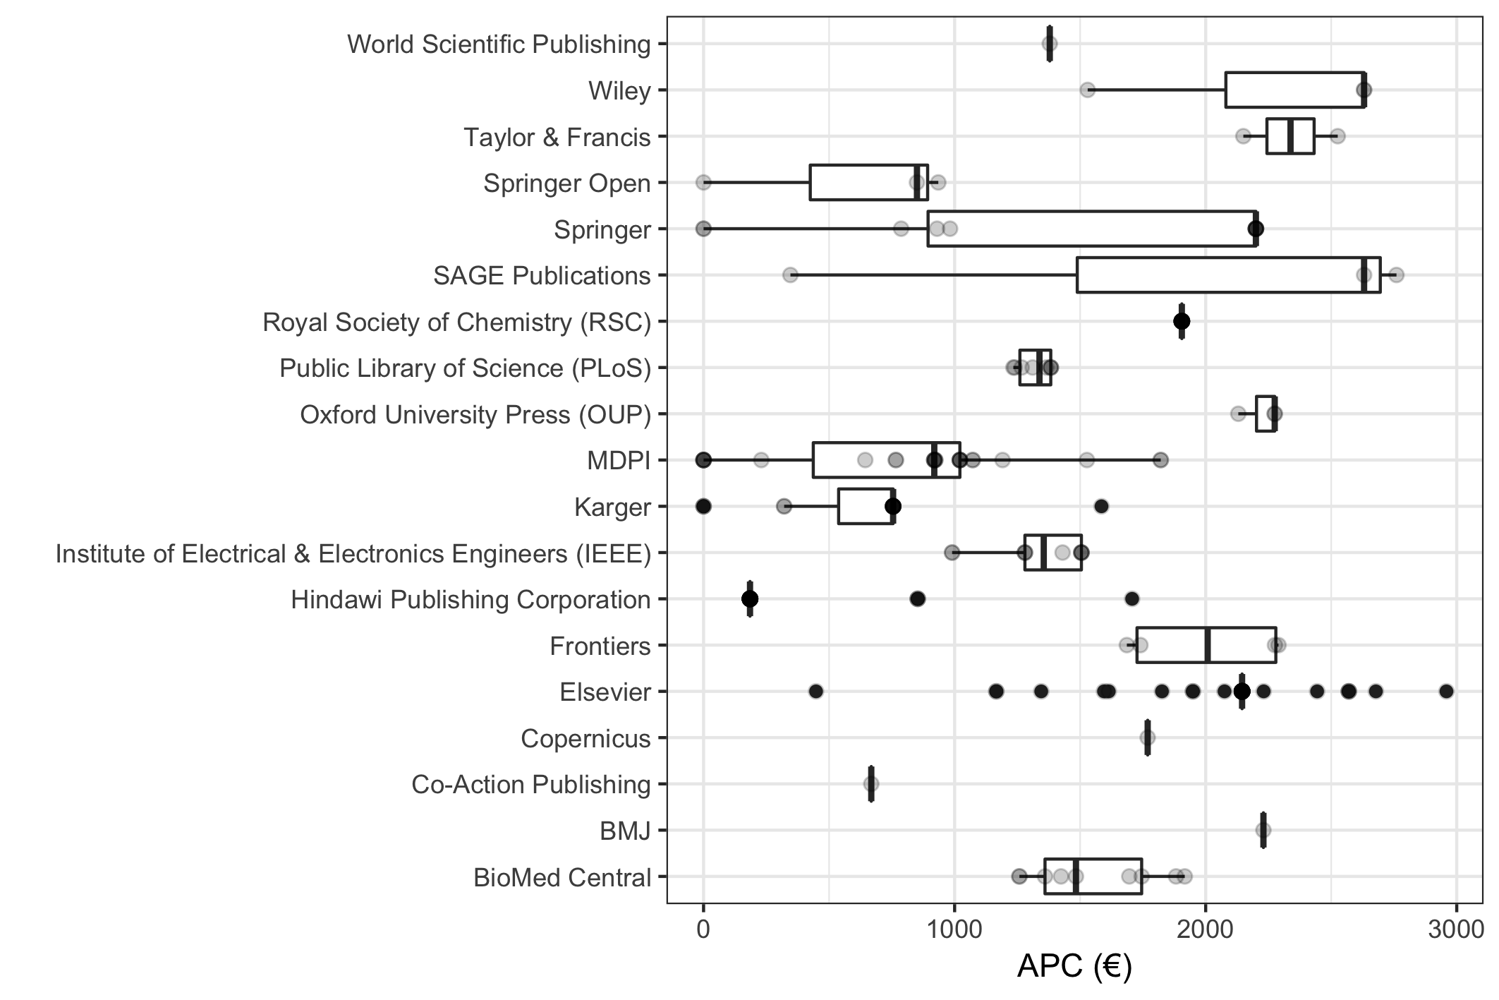

## Average and distribution of APC's by year

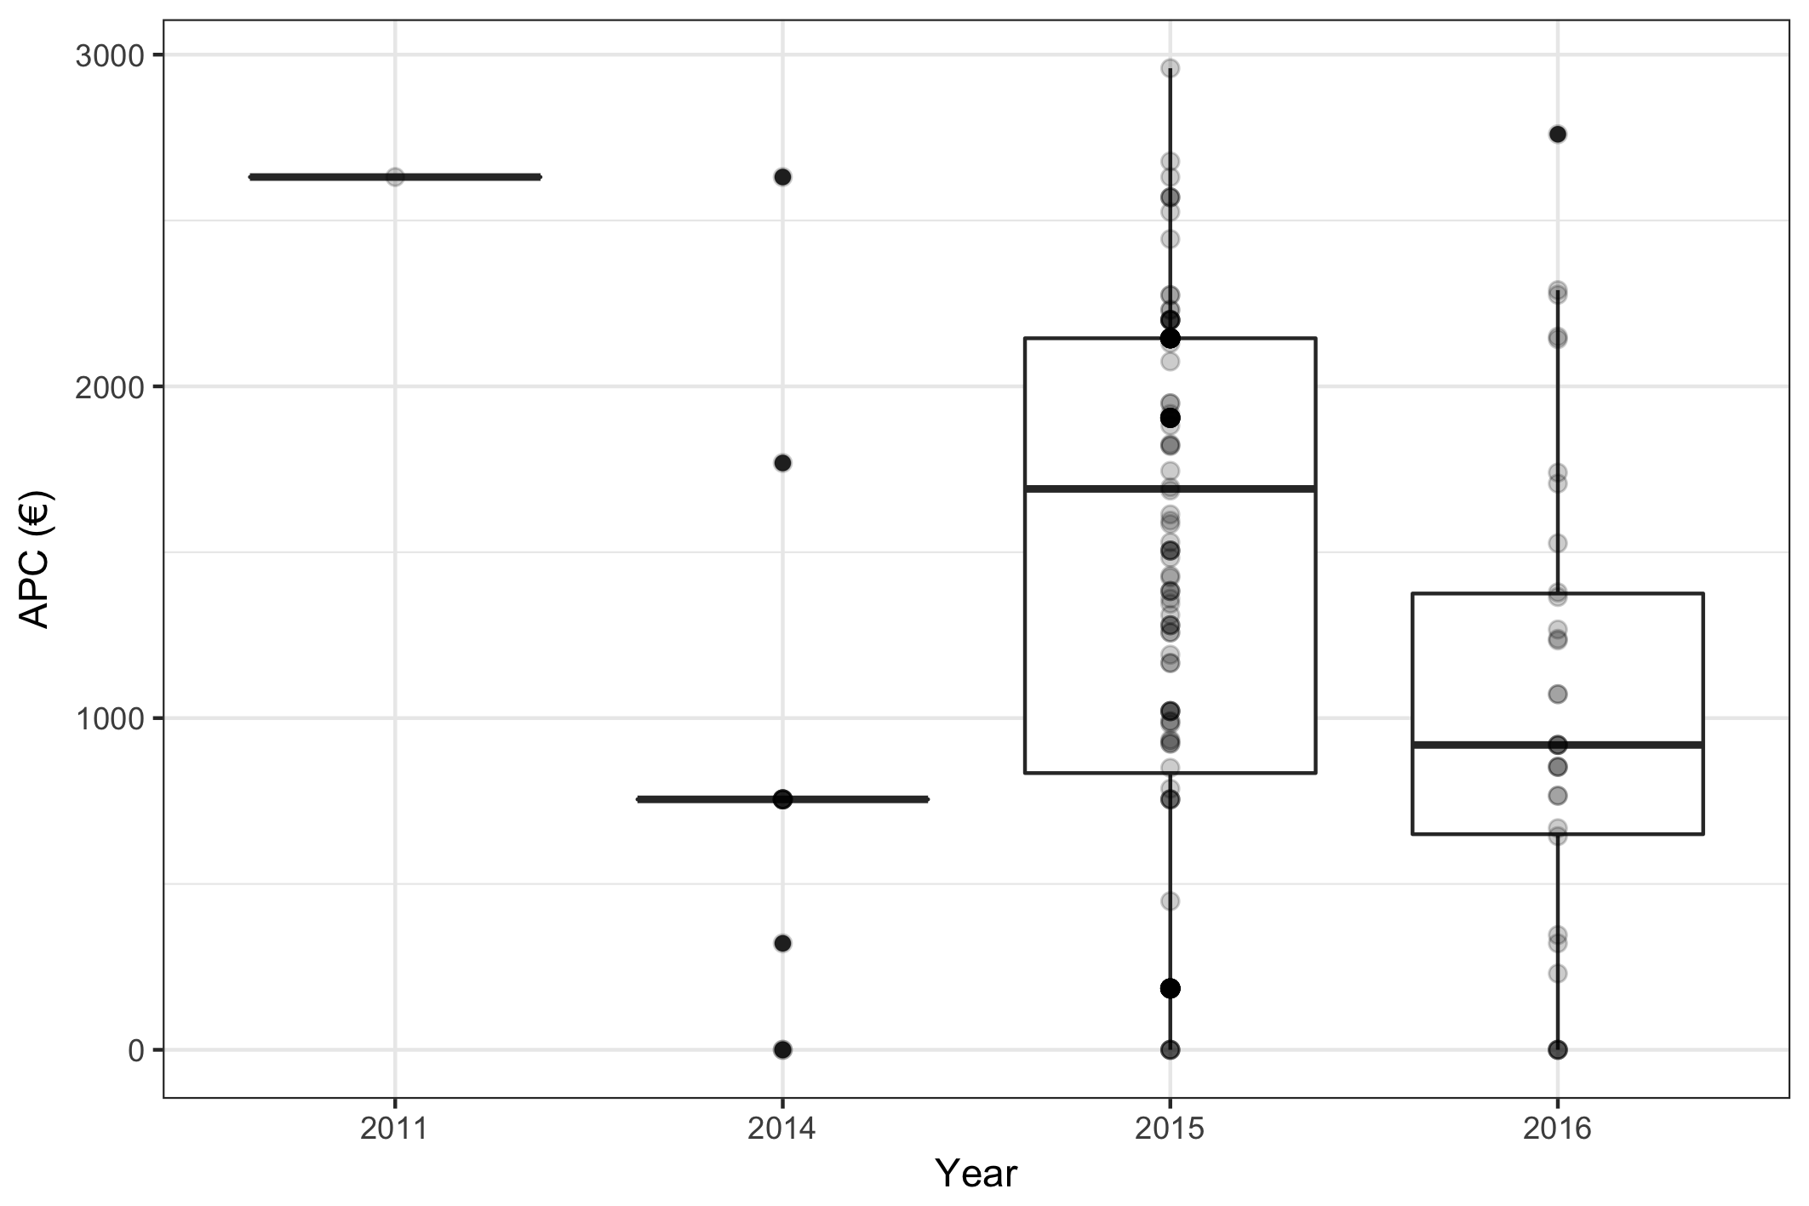

## Acknowledgement

This project follows the [Open APC Initiative](https://github.com/OpenAPC/openapc-de) to share data on paid APCs. It recognises efforts from [JISC](https://www.jisc-collections.ac.uk/Jisc-Monitor/APC-data-collection/) and [FWF](https://figshare.com/articles/Austrian_Science_Fund_FWF_Publication_Cost_Data_2014/1378610) to standardise APC reporting.

## Contact

For general comments, email Beate Eellend at the National Library of Sweden: **beate.eellend [at] kb.se**

For technical issues, email Ulf Kronman at the National Library of Sweden: **ulf.kronman [at] kb.se**