Spring JDBC and JPA (Hibernate)

Step 01 - Setting up a project with JDBC, JPA, H2 and Web Dependencies

Step 02 - Launching up H2 Console

SpringBoot will automatically create a connection to H2 database with the help of the below dependency.

<dependency>

<groupId>com.h2database</groupId>

<artifactId>h2</artifactId>

<scope>runtime</scope>

</dependency>

To enable H2 console, (in application.properties):

spring.h2.console.enabled=true

Restart the application and check the console for below log;

Servlet webServlet mapped to [/h2-console/*]

H2 console is accessible at the below URL:  
<http://localhost:8080/h2-console>

Use defaults entries in the H2 console for now. In-memory database is only live as long as the application is running.

Step 03 - Creating a Database Table in H2

create a data.sql file in source/main/resources folder. Write queries in data.sql for table creation.

Step 04 - Populate data into Person Table

If you insert some data into H2 table by instantiating the entity objects, after application restart all the data will be lost. Just to counter this, enter the insert statement in data.sql so that every time the application is restarted, insert query runs automatically.

Step 05 - Implement findAll persons Spring JDBC Query Method

PersonJbdcDao.java

PersonJbdcDao.java will talk to the database and get the values. Annotate this class with @Repository as it talks to the database.

@Repository  
public class PersonJbdcDao {

// JdbcTemplate is spring's way to provide database connection  
 @Autowired  
 JdbcTemplate jdbcTemplate;  
  
 public List<Person> findAll() {  
 // This will get the resultset and map individual rows to the Person class  
 return jdbcTemplate.query("select * from person",   
 new BeanPropertyRowMapper(Person.class));  
 }  
}

Step 06 - Execute the findAll method using CommandLineRunner

To fire the finalAll() method at the start of the application.When we implement CommandLineRunner interface, the code inside run() method will launch as soon as the ApplicationContext is ready.

@SpringBootApplication  
public class DatabaseDemoApplication implements CommandLineRunner {  
  
 private Logger logger = LoggerFactory.getLogger(this.getClass());  
  
 @Autowired  
 PersonJbdcDao dao;  
  
 public static void main(String[] args) {  
 SpringApplication.run(DatabaseDemoApplication.class, args);  
 }  
  
 @Override  
 public void run(String... args) throws Exception {  
 logger.info("All users -> {}", dao.findAll());  
 }  
}

O/P:

All users -> [com.personal.kunj.database.databasedemo.entity.Person@51fc862e, com.personal.kunj.database.databasedemo.entity.Person@a7cf42f, [com.personal.kunj.database.databasedemo.entity.Person@fe09383](mailto:com.personal.kunj.database.databasedemo.entity.Person@fe09383)]

How to avoid the above Hashcode output? → Override toString() in Person.java (Entity class)

O/P:

All users -> [Person [id=10001, name=Ranga, location=Hyderabad, birthDate=2018-09-05 10:52:53.274], Person [id=10002, name=James, location=New York, birthDate=2018-09-05 10:52:53.29], Person [id=10003, name=Pieter, location=Amsterdam, birthDate=2018-09-05 10:52:53.29]]

**Note:** The bean on which BeanPropertyRowMapper is defined should have a default constructor. So Person class should have a default constructor. Otherwise we will get below exception:

Caused by: java.lang.NoSuchMethodException: com.personal.kunj.database.databasedemo.entity.Person.<init>()

Step 07 - A Quick Review - JDBC vs Spring JDBC

|  |  |
| --- | --- |
| JDBC | Spring JDBC |
| More lines of code | Less lines of code |
| ResultSet to object mapping difficult | Easy (using RowMapper classes) |
|  | No need to handle connection, statement etc, JdbcTemplate takes care of these. |
|  | If an Exception occurs then JdbcTemplate closes connections automatically. |

Step 08 – What is in the background? Understanding Spring Boot Autoconfiguration

How is JdbcTemplate getting autowired in?

How is JdbcTemplate knowing connection to the in-memory database?

Ans: SpringBoot auto configuration

Set root logging level to debug. logging.level.root=debug.

To see how spring boot auto configuration works, go to eclipse console log and

Look for ============================

CONDITIONS EVALUATION REPORT

============================ in the console log and see the positive matches (auto configuration). Spring Boot looks for the available classes on the classpath and it would automatically configure things based on that. If it sees an in-memoty database on the classpath it automatically creates a connection to it. If web app on the classpath, it automatically configures a DispatcherServlet. If JPA on the classpath, it configures EntityManagerFactory and TransactionManager.

Step 09 - Implementing findById Spring JDBC Query Method

PersonJbdcDao.java

public Person findById(int id) {  
 return jdbcTemplate.queryForObject  
 ("select * from person where id=?", new Object[] { id },  
 new BeanPropertyRowMapper<Person>(Person.class));  
 }

DatabaseDemoApplication.java

@Override

public void run(String... args) throws Exception {

logger.info("All users -> {}", dao.findAll());

logger.info("User id 10001 -> {}", dao.findById(10001));

}

Step 10 - Implementing deleteById Spring JDBC Update Method

In case of update and delete operations, we need to use jdbcTemplate.update().

PersonJbdcDao.java

public int deleteById(int id) {

// It returns no of rows rows affected by the query

return jdbcTemplate.update

("delete from person where id=?", new Object[] { id });

}

DatabaseDemoApplication.java

@Override

public void run(String... args) throws Exception {

logger.info("All users -> {}", dao.findAll());

logger.info("User id 10001 -> {}", dao.findById(10001));

logger.info("Deleting 10002 -> No of Rows Deleted - {}", dao.deleteById(10002));

}

Console o/P: Deleting 10002 -> No of Rows Deleted – 1

Step 11 - Implementing insert and update Spring JDBC Update Methods

Console O/P:

All users -> [Person [id=10001, name=Ranga, location=Hyderabad, birthDate=2018-09-05 11:53:25.747], Person [id=10002, name=James, location=New York, birthDate=2018-09-05 11:53:25.762], Person [id=10003, name=Pieter, location=Amsterdam, birthDate=2018-09-05 11:53:25.762]]  
User id 10001 -> Person [id=10001, name=Ranga, location=Hyderabad, birthDate=2018-09-05 11:53:25.747]  
Deleting 10002 -> No of Rows Deleted - 1  
Inserting 10004 -> 1  
Update 10003 -> 1

Step 12 - Creating a custom Spring JDBC RowMapper

PersonJbdcDao.java

package com.personal.kunj.database.databasedemo.jdbc;  
import java.sql.ResultSet;  
import java.sql.SQLException;  
import java.sql.Timestamp;  
import java.util.List;  
import org.springframework.beans.factory.annotation.Autowired;  
import org.springframework.jdbc.core.BeanPropertyRowMapper;  
import org.springframework.jdbc.core.JdbcTemplate;  
import org.springframework.jdbc.core.RowMapper;  
import org.springframework.stereotype.Repository;  
  
import com.personal.kunj.database.databasedemo.entity.Person;  
  
@Repository  
public class PersonJbdcDao {  
 // JdbcTemplate is spring's way to provide database connection  
 @Autowired  
 JdbcTemplate jdbcTemplate;

//Creating inner class bcz this PersonRowMapper will only be used inside PersonJbdcDao class.  
 class PersonRowMapper implements RowMapper<Person> {  
 @Override  
 public Person mapRow(ResultSet rs, int rowNum) throws SQLException {  
 Person person = new Person();  
 person.setId(rs.getInt("id"));  
 person.setName(rs.getString("name"));  
 person.setLocation(rs.getString("location"));  
 person.setBirthDate(rs.getTimestamp("birth_date"));  
 return person;  
 }  
 }  
 public List<Person> findAll() {  
 return jdbcTemplate.query("select * from person", new PersonRowMapper());  
 }  
 public Person findById(int id) {  
 return jdbcTemplate.queryForObject  
 ("select * from person where id=?", new Object[] { id },  
 new BeanPropertyRowMapper<Person>(Person.class));  
 }  
 public int deleteById(int id) {  
 // It returns how many rows are affected by the query  
 return jdbcTemplate.update  
 ("delete from person where id=?", new Object[] { id });  
 }  
 public int insert(Person person) {  
 return jdbcTemplate.update("insert into person (id, name, location, birth_date) " + "values(?, ?, ?, ?)", new Object[] { person.getId(), person.getName(), person.getLocation(), new Timestamp(person.getBirthDate().getTime()) });  
 }  
  
 public int update(Person person) {  
 return jdbcTemplate.update("update person " + " set name = ?, location = ?, birth_date = ? " + " where id = ?", new Object[] { person.getName(), person.getLocation(), new Timestamp(person.getBirthDate().getTime()), person.getId() });  
 }  
  
}

O/P:

All users -> [Person [id=10001, name=Ranga, location=Hyderabad, birthDate=2018-09-05 12:36:01.952], Person [id=10002, name=James, location=New York, birthDate=2018-09-05 12:36:01.967], Person [id=10003, name=Pieter, location=Amsterdam, birthDate=2018-09-05 12:36:01.967]]

Step 13 - Quick introduction to JPA

Why do you map a query and try and map values and get the data back? Why don’t you map the entity? Why don’t you map an object to a row in the table?

In JPA we define entity and relationship between entities.

We will map a field in the object to a column in the database.

If a Person can have multiple addresses, you can define a relationship between Person and address as well.

The JPA will take care of identifying the entities and creating the right queries for you based on the operations you would want to perform.

The job of writing the query shifts from the developer to JPA implementation framework.

Step 14 - Defining Person Entity

package com.personal.kunj.database.databasedemo.entity;  
import java.util.Date;  
import javax.persistence.Entity;  
import javax.persistence.GeneratedValue;  
import javax.persistence.Id;  
  
@Entity  
public class Person {  
 @Id  
 @GeneratedValue  
 private int id;  
 private String name;  
 private String location;  
 private Date birthDate;  
 // The bean on which BeanPropertyRowMapper is defined should have a default constructor.  
 public Person() {  
 }  
  
 public Person(int id, String name, String location, Date birthDate) {  
 super();  
 this.id = id;  
 this.name = name;  
 this.location = location;  
 this.birthDate = birthDate;  
 }  
 public Person(String name, String location, Date birthDate) {  
 super();  
 this.name = name;  
 this.location = location;  
 this.birthDate = birthDate;  
 }  
  
 public int getId() {  
 return id;  
 }  
  
 public void setId(int id) {  
 this.id = id;  
 }  
  
 public String getName() {  
 return name;  
 }  
  
 public void setName(String name) {  
 this.name = name;  
 }  
  
 public String getLocation() {  
 return location;  
 }  
  
 public void setLocation(String location) {  
 this.location = location;  
 }  
  
 public Date getBirthDate() {  
 return birthDate;  
 }  
  
 public void setBirthDate(Date birthDate) {  
 this.birthDate = birthDate;  
 }  
  
 @Override  
 public String toString() {  
 return "Person [id=" + id + ", name=" + name + ", location=" + location + ", birthDate=" + birthDate + "]";  
 }  
  
}

Step 15 - Implementing findById JPA Repository Method

Person.java

@Entity

public class Person {

……...……..

}

PersonJpaRepository.java

// This is a repository. We will do all person related operations here.

@Repository

// we will do transaction management in here

// whenever we do insert, delete, update rows (or do database transaction). If you do 3-4 transaction at a time, you would want all of them to be successful or all of them to fail together.

// For now we will implement transaction at the level of repository. Ideally transaction have to be implemented around your business services.

@Transactional

public class PersonJpaRepository {

//connect to the database

// Entity Manager manages the entities. All the operations that you are performing inside a session are stored in PersistenceContext. EntityManager is the interface to the PersistenceContext. All operations have to be going through EntityManager.

@PersistenceContext

EntityManager entityManager;

public Person findById(int id) {

return entityManager.find(Person.class, id); // JPA

}

}

**Note:** SpringBoot auto configuration knows that we are using in-memory database, it knows that JPA is in the classpath. It knows that I am defining entities as well. What it does is that it triggers a schema update (one of the hibernate features). It creates schema for us. So from now on we do not need to create table bcz the table would be created by schema update.

How to see automatically generated query?

spring.jpa.show-sql=true

Console O/P:

Hibernate: select person0_.id as id1_0_0_, person0_.birth_date as birth_da2_0_0_, person0_.location as location3_0_0_, person0_.name as name4_0_0_ from person person0_ where person0_.id=?

2018-09-06 07:53:13.547 INFO 2992 --- [main] ication$$EnhancerBySpringCGLIB$$c54dca3e : User id 10001 -> Person [id=10001, name=Ranga, location=Hyderabad, birthDate=2018-09-06 07:53:12.766]

Step 16 - Implementing insert and update JPA Repository Methods

entityManager.merge(Entity entity) → In update/insert operations. Merge() method knows whether the id is set inside person or not. If id is already set it will update that person, if not, it will insert it in.

Step 17 - Implementing deleteById JPA Repository Method

public void deleteById(int id) {s

Person person = findById(id);

entityManager.remove(person);

}

Step 18 - Implementing findAll using JPQL Named Query

Use JPQL (Java Persistence Query Language)

@Entity

// NamedQuery is defined on the entity for which it is used

// JPQL does not use database table to fetch data. It uses entities. Query=”JPQL query”

@NamedQuery(name="find_all_persons", query="select p from Person p")

public class Person {

….

}

PersonJpaRepository.java

public List<Person> findAll() {

// createNamedQuery will take; 1. Name of the Query 2. What kind of entity it would return

TypedQuery<Person> namedQuery = entityManager.createNamedQuery("find_all_persons", Person.class);

return namedQuery.getResultList();

}

Chapter 5 : JPA & Hibernate in Depth

Step 01 - Create a JPA Project with H2 and Spring Boot

dependency added: H2, Web, JPA, DevTools

Step 02 - Create JPA Entity Course

@Entity

public class Course {

// To define primary key

@Id

@GeneratedValue // want JPA to generate id for us

private Long id;

private String name;

// Default constructor will be used by JPA to create bean

protected Course() {

}

// We want others only to provide the name, not id

public Course(String name) {

this.name = name;

}

//Getters and setters

}

If you run application at this point, ‘course’ table will be created in H2 database.

Step 03 - Create findById using JPA Entity Manager

Create CourseRepository.java. In any repository class we will try to talk to the EntityManager.

Step 04 - Configuring application.properties to enable H2 console and additional logging

application.properties

# Enabling H2 Console

spring.h2.console.enabled=true

#Turn Statistics on

# "generate_statistics" will tell no of queries fired

spring.jpa.properties.hibernate.generate_statistics=true

# keep logging level for "org.hibernate.stat" as trace

logging.level.org.hibernate.stat=trace

# Show all queries (automatically generated by hibernate)

spring.jpa.show-sql=true

# Format the queries

spring.jpa.properties.hibernate.format_sql=true

# What parameters are being set to the queries

logging.level.org.hibernate.type=trace

Step 05 - Writing Unit Test for findById method

CourseRepositoryTest.java

package com.personal.Kunj.jpa.advancedjpa.repository;  
  
import static org.junit.Assert.assertEquals;  
import org.junit.Test;  
import org.junit.runner.RunWith;  
import org.slf4j.Logger;  
import org.slf4j.LoggerFactory;  
import org.springframework.beans.factory.annotation.Autowired;  
import org.springframework.boot.test.context.SpringBootTest;  
import org.springframework.test.context.junit4.SpringRunner;  
import com.personal.Kunj.jpa.advancedjpa.AdvancedJpaApplication;  
import com.personal.Kunj.jpa.advancedjpa.entity.Course;  
  
// Used to launch SpringContext in unit test  
@RunWith(SpringRunner.class)  
/*  
 * The SpringContext that we would want to launch is a 'SpringBootTest'. We  
 * would want to launch entire SpringBootContext which is present  
 * in'AdvancedJpaApplication'. (classes=AdvancedJpaApplication.class) will  
 * launch the entire context  
 */  
@SpringBootTest(classes = AdvancedJpaApplication.class)  
public class CourseRepositoryTest {  
  
 private Logger logger = LoggerFactory.getLogger(this.getClass());  
  
 @Autowired  
 CourseRepository repository;  
  
 /*  
 * If we do right click on contextLoads(), it will launch the entire context, ie  
 * it will do the same thing as what is done at the application run.  
 */  
  
 // After the above it will run the code present in @Test method  
 // Then context is killed.  
 // Unit test is run between the Context Launch and Destroy.  
 @Test  
 public void contextLoads() {  
 logger.info("Test is running");  
 }  
 // These JUnit tests will run as part of your build  
  
 @Test  
 public void findById_basic() {  
 Course course = repository.findById(10001L);  
 assertEquals("JPA in 50 Steps", course.getName());  
  
 }  
  
}

Step 06 - Writing a deleteByID method to delete an Entity

Exception:

Caused by: org.springframework.dao.InvalidDataAccessApiUsageException: No EntityManager with actual transaction available for current thread - cannot reliably process 'remove' call; nested exception is javax.persistence.TransactionRequiredException: No EntityManager with actual transaction available for current thread - cannot reliably process 'remove' call

Fix: Annotate CourseRepository.java with @Transactional

Step 07 - Writing Unit Test for deleteById method

@Test

// This unit test is modifying the database. By using @DirtiesContext, spring will automatically reset the data after the test is run. Data will remain consistent even after this unit test execution.

@DirtiesContext

**public** **void** deleteById_basic() {

repository.deleteById(10002L);

*assertNull*(repository.findById(10002L));

}

Step 08 - Writing a save method to update and insert an Entity

Step 09 - Writing Unit Test for save method

@Test

@DirtiesContext

**public** **void** save_basic() {

// get a course

Course course = repository.findById(10001L);

*assertEquals*("JPA in 50 Steps", course.getName());

// update details

course.setName("JPA in 50 Steps - Updated");

repository.save(course);

// check the value

Course course1 = repository.findById(10001L);

*assertEquals*("JPA in 50 Steps - Updated", course1.getName());

}

Step 10 - Quick Review and Debugging Tips

Step 11 - Playing with Entity Manager

@Repository

@Transactional

**public** **class** CourseRepository {

@Autowired

EntityManager em;

public void playWithEntityManager() {

Course course = **new** Course("Web Services in 100 Steps");

// persist() is used to create a new entity

em.persist(course);

/*

* An update query is fired bcz of the below statement without even asking for a

* save. HOW?

*

* BCZ OF @Transactional annotation, this entire method is in a

* single transaction. And while we are within the scope of a transaction,

* EntityManager keeps track of all the things that were updated/modified

* through it. In this example Course is updated/inserted through the

* EntityManager. So changes made to the course are tracked by the

* EntityManager.

*/

course.setName("Web Services in 100 Steps - Updated");

}

}

Step 12 - Entity Manager Methods - clear and detach

// both the courses course1 and course2 will be updated.

public void playWithEntityManager() {

Course course1 = **new** Course("Web Services in 100 Steps");

em.persist(course1);

course1.setName("Web Services in 100 Steps - Updated");

Course course2 = **new** Course("Angular JS in 100 Steps");

em.persist(course2);

course2.setName("Angular Js in 100 Steps - Updated");

}

**public** **void** playWithEntityManager() {

Course course1 = **new** Course("Web Services in 100 Steps");

em.persist(course1);

// The changes done until that point is sent out to the database

em.flush();

course1.setName("Web Services in 100 Steps - Updated");

em.flush();

Course course2 = **new** Course("Angular JS in 100 Steps");

em.persist(course2);

em.flush();

// Let's say I do not want course2 changes to be going to the database after this step.

// The changes to course2 will no longer be tracked after this stage

//em.detach(course2);

// The other way of detaching the entity is by clearing everything up. This will clear everything that is there in the EntityManager.

em.clear();

course2.setName("Angular Js in 100 Steps - Updated");

em.flush();

}

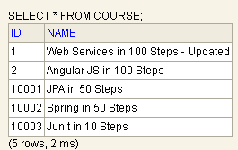

Step 13 - Entity Manager Methods – refresh

public void playWithEntityManager() {

Course course1 = **new** Course("Web Services in 100 Steps");

em.persist(course1);

Course course2 = **new** Course("Angular JS in 100 Steps");

em.persist(course2);

em.flush();

course1.setName("Web Services in 100 Steps - Updated");

course2.setName("Angular Js in 100 Steps - Updated");

/*

* Refresh course1 with the content that is there in the database. Take

* course1 details as it is in the database. I do not want the updated data of

* course1 to go through.

*/

em.refresh(course1);;

// Only course2 changes will go the database

em.flush();

}

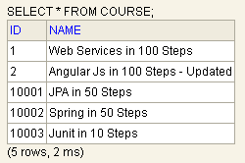

Step 14 - A Quick Review of Entity Manager

EntityManager is an interface to PersistenceContext.

All the entities that are saved through EntityManager are saved through PersistenceContext.

PersistenceContext keeps track of all the entities which are changes during a specific transaction and also keeps track of the changes that neds to be stored back to the database.

Step 15 - JPQL – Basics

**JPQL →** Java Persistence Query language

In SQL we query from the database table, whereas in JPQL we query from entities. Whatever JPQL query we write are converted into SQL query by JPA implementation.

SQL → Select * from course

JPQL → select c from course c

**package** com.personal.Kunj.jpa.advancedjpa.repository;

**import** java.util.List;

**import** javax.persistence.EntityManager;

**import** javax.persistence.Query;

**import** javax.persistence.TypedQuery;

**import** org.junit.Test;

**import** org.junit.runner.RunWith;

**import** org.slf4j.Logger;

**import** org.slf4j.LoggerFactory;

**import** org.springframework.beans.factory.annotation.Autowired;

**import** org.springframework.boot.test.context.SpringBootTest;

**import** org.springframework.test.context.junit4.SpringRunner;

**import** com.personal.Kunj.jpa.advancedjpa.AdvancedJpaApplication;

**import** com.personal.Kunj.jpa.advancedjpa.entity.Course;

@RunWith(SpringRunner.**class**)

@SpringBootTest(classes = AdvancedJpaApplication.**class**)

**public** **class** JPQLTest {

**private** Logger logger = LoggerFactory.*getLogger*(**this**.getClass());

@Autowired

EntityManager em;

@Test

**public** **void** jpql_basic() {

Query query = em.createQuery("Select c From Course c");

List resultList = query.getResultList();

logger.info("Select c From Course c -> {}",resultList);

}

@Test

**public** **void** jpql_typed() {

// Returning a Course back. typed queries are always better as they make your program clear

TypedQuery<Course> query =

em.createQuery("Select c From Course c", Course.**class**);

List<Course> resultList = query.getResultList();

logger.info("Select c From Course c -> {}",resultList);

}

@Test

**public** **void** jpql_where() {

TypedQuery<Course> query =

em.createQuery("Select c From Course c where name like '%100 Steps'", Course.**class**);

List<Course> resultList = query.getResultList();

logger.info("Select c From Course c where name like '%100 Steps'-> {}",resultList);

//[Course[Web Services in 100 Steps], Course[Spring Boot in 100 Steps]]

}

}

Step 16 - JPA and Hibernate Annotations - @Table

@Entity

// To define the name of the table

@Table(name="CourseDetails")

public class Course {

..........…......…..…

}

Step 17 - JPA and Hibernate Annotations - @Column

// Set all the constraints here that you have in your data in dB to prevent bad data from entering into DB

@Column(name="fullname", nullable=**false**)

**private** String name;

Step 18 - JPA and Hibernate Annotations - @UpdateTimestamp and @CreationTimestamp

**Sometime** some of the applications have the requirement that I want to store when this specific row is updated/inserted last time.

I would like to store created time and updated time of a particular row.

This is not a solution provided by JPA. It is provided by hibernate.

Course.java

@Entity

// To define the name of the table

@Table(name="CourseDetails")

public class Course {

// To define primary key

@Id

@GeneratedValue // want JPA to generate for us

**private** Long id;

// Set all the constraints here that you have in your data in dB to prevent bad data from entering into DB

@Column(name="fullname", nullable=**false**)

**private** String name;

@UpdateTimestamp

**private** LocalDateTime lastUpdatedDate;

@CreationTimestamp

private LocalDateTime createdDate;

// Getters and setters, contructors

}

Step 19 - JPA and Hibernate Annotations - @NamedQuery and @NamedQueries

JPQLTest.java

package com.personal.Kunj.jpa.advancedjpa.repository;

**import** java.util.List;

**import** javax.persistence.EntityManager;

**import** javax.persistence.Query;

**import** javax.persistence.TypedQuery;

**import** org.junit.Test;

**import** org.junit.runner.RunWith;

**import** org.slf4j.Logger;

**import** org.slf4j.LoggerFactory;

**import** org.springframework.beans.factory.annotation.Autowired;

**import** org.springframework.boot.test.context.SpringBootTest;

**import** org.springframework.test.context.junit4.SpringRunner;

**import** com.personal.Kunj.jpa.advancedjpa.AdvancedJpaApplication;

**import** com.personal.Kunj.jpa.advancedjpa.entity.Course;

@RunWith(SpringRunner.**class**)

@SpringBootTest(classes = AdvancedJpaApplication.**class**)

**public** **class** JPQLTest {

**private** Logger logger = LoggerFactory.*getLogger*(**this**.getClass());

@Autowired

EntityManager em;

@Test

**public** **void** jpql_basic() {

Query query = em.createQuery("Select c From Course c");

List resultList = query.getResultList();

logger.info("Select c From Course c -> {}",resultList);

}

@Test

**public** **void** jpql_typed() {

/*

* Here we are hard coding the query. If we need to use the same query again,

* we need to write the query again. @NamedQuery can help us here where we can give

* name to a query.

*

* @NamedQuery is always defined on the entity class to which it is directed.

*/

//TypedQuery<Course> query = em.createQuery("Select c From Course c", Course.class);

TypedQuery<Course> query = em.createNamedQuery("query_get_all_courses", Course.**class**);

List<Course> resultList = query.getResultList();

logger.info("Select c From Course c -> {}",resultList);

}

@Test

**public** **void** jpql_where() {

TypedQuery<Course> query =

em.createNamedQuery("query_get_100_step_courses", Course.**class**);

List<Course> resultList = query.getResultList();

logger.info("Select c From Course c where name like '%100 Steps'-> {}",resultList);

//[Course[Web Services in 100 Steps], Course[Spring Boot in 100 Steps]]

}

}

Course.java

@Entity

// To define the name of the table

@Table(name="CourseDetails")

// we can either use multiple @NamedQuery or @NamedQueries

@NamedQueries(value = { @NamedQuery(name = "query_get_all_courses", query = "Select c From Course c"),

@NamedQuery(name = "query_get_100_step_courses", query = "Select c From Course c where name like '%100 Steps'") })

/*@NamedQuery(name="query_get_all_courses", query="Select c From Course c")

@NamedQuery(name="query_get_100_step_courses", query="Select c From Course c where name like '%100 Steps'")*/

public class Course {

….

}

Step 20 - Native Queries - Basics

Native Queries is sending native sql directly from JPA.

Situations where we have to go NativeQuery.

1) Setting tuning parameters

2) Using some DB specific features that are not supported by JPA

3) While doing a mass update. Ex; suppose we want to update all the wows of a table in a specific query. In this situation if you use JPA, you have to et the row and update and repeat. You cannot do a mass update using JPA.

Note: Whenever you are making use of Native Query, you are not making use of PersistenceContext. So, if you have all the entities directly present in your PersistenceContext, then you will have to make sure that you will refresh them so that you get the latest data from the database.

NativeQueriesTest.java

**package** com.personal.Kunj.jpa.advancedjpa.repository;

**import** java.util.List;

**import** javax.persistence.EntityManager;

**import** javax.persistence.Query;

**import** org.junit.Test;

**import** org.junit.runner.RunWith;

**import** org.slf4j.Logger;

**import** org.slf4j.LoggerFactory;

**import** org.springframework.beans.factory.annotation.Autowired;

**import** org.springframework.boot.test.context.SpringBootTest;

**import** org.springframework.test.context.junit4.SpringRunner;

**import** org.springframework.transaction.annotation.Transactional;

**import** com.personal.Kunj.jpa.advancedjpa.AdvancedJpaApplication;

**import** com.personal.Kunj.jpa.advancedjpa.entity.Course;

@RunWith(SpringRunner.**class**)

@SpringBootTest(classes = AdvancedJpaApplication.**class**)

**public** **class** NativeQueriesTest {

**private** Logger logger = LoggerFactory.*getLogger*(**this**.getClass());

@Autowired

EntityManager em;

@Test

**public** **void** native_queries_basic() {

Query query = em.createNativeQuery("SELECT * FROM COURSE", Course.**class**);

List resultList = query.getResultList();

logger.info("SELECT * FROM COURSE -> {}", resultList);

//SELECT * FROM COURSE -> [Course[Web Services in 100 Steps], Course[JPA in 50 Steps - Updated], Course[Spring in 50 Steps], Course[Spring Boot in 100 Steps]]

}

@Test

**public** **void** native_queries_with_parameter() {

Query query = em.createNativeQuery("SELECT * FROM COURSE where id = ?", Course.**class**);

query.setParameter(1, 10001L);

List resultList = query.getResultList();

logger.info("SELECT * FROM COURSE where id = ? -> {}", resultList);

//[Course[JPA in 50 Steps - Updated]]

}

@Test

**public** **void** native_queries_with_named_parameter() {

Query query = em.createNativeQuery("SELECT * FROM COURSE where id = :id", Course.**class**);

query.setParameter("id", 10001L);

List resultList = query.getResultList();

logger.info("SELECT * FROM COURSE where id = :id -> {}", resultList);

//[Course[JPA in 50 Steps - Updated]]

}

// Mass update where Native SQL queries are handy

@Test

@Transactional // Bcz we are trying to change the data

**public** **void** native_queries_to_update() {

Query query = em.createNativeQuery("Update COURSE set last_updated_date=sysdate()");

**int** noOfRowsUpdated = query.executeUpdate();

logger.info("noOfRowsUpdated -> {}", noOfRowsUpdated);

//SELECT * FROM COURSE -> [Course[Web Services in 100 Steps], Course[JPA in 50 Steps - Updated], Course[Spring in 50 Steps], Course[Spring Boot in 100 Steps]]

}

}

Establishing Relationships with JPA and Hibernate – OneToOne

Step 21 - Entities and Relationships - An overview

Tables envolved;

course, student, passport, review

A course can have multiple students enrolling for it. A student can enroll in multiple courses at a time. Course and student have many to many relationship.

A course can have multiple reviews from different students. On student giving a 5 star review, other giving a 4 star review. A review is always associated with a single course. The relationship between course and review is many to one.

A student can have only one passport and passport is associated with only one student. The relation between student and passport is one to one.

Step 22 - Defining Entities - Student, Passport and Review

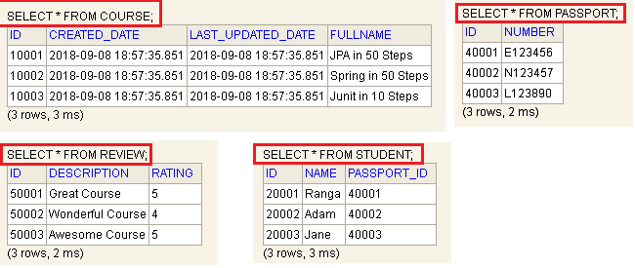

Step 23 - Introduction to One to One Relationship

student – passport → one to one

We can either create a student_id column in passport table or create a passport_id column in student table. **Here student table is** owning the passport_id relationship. Similarly passport table is owning the student_Id relationship.

Now, define the above relationship in the code.

@Entity

**public** **class** Student {

@Id

@GeneratedValue

**private** Long id;

@Column(nullable = **false**)

**private** String name;

**@OneToOne** // one to one relationship from student to passport

private Passport passport;

// …....…........….......…..

}

Step 24 - OneToOne Mapping - Insert Student with Passport

StudentRepository.java

package com.personal.Kunj.jpa.advancedjpa.repository;

**import** javax.persistence.EntityManager;

**import** org.slf4j.Logger;

**import** org.slf4j.LoggerFactory;

**import** org.springframework.beans.factory.annotation.Autowired;

**import** org.springframework.stereotype.Repository;

**import** org.springframework.transaction.annotation.Transactional;

**import** com.personal.Kunj.jpa.advancedjpa.entity.Passport;

**import** com.personal.Kunj.jpa.advancedjpa.entity.Student;

@Repository

@Transactional

**public** **class** StudentRepository {

**private** Logger logger = LoggerFactory.*getLogger*(**this**.getClass());

@Autowired

EntityManager em;

**public** **void** saveStudentWithPassport() {

Passport passport = **new** Passport("Z123456");

/*

* passport has to be there in the database before you want to create a

* relationship between student and passport.

*/

/*

* Caused by: org.springframework.dao.InvalidDataAccessApiUsageException:

* org.hibernate.TransientPropertyValueException: object references an unsaved

* transient instance - save the transient instance before flushing :

* com.personal.Kunj.jpa.advancedjpa.entity.Student.passport ->

* com.personal.Kunj.jpa.advancedjpa.entity.Passport; nested exception is

* java.lang.IllegalStateException:

* org.hibernate.TransientPropertyValueException: object references an unsaved

* transient instance - save the transient instance before flushing :

* com.personal.Kunj.jpa.advancedjpa.entity.Student.passport ->

* com.personal.Kunj.jpa.advancedjpa.entity.Passport

*/

/*

* Before we are creating a student we have to create a passport (create an id

* for it) as student is at the owning side of the relationship

*/

/*

* Note: Hibernate is Lazy! it will wait as long as it can before inserting the

* passport in.

*/

// Here hibernate will just generate the next sequence. Query will not go the DB

em.persist(passport);

Student student = **new** Student("Mike");

student.setPassport(passport);

em.persist(student);

// At the end of the transaction, hibernate will send the changes down to the database

}

}

Step 25 - OneToOne Mapping - Retrieving Student with Passport and Eager Fetch

Any one to one relation is always eager fetch ie, if you have one to one relationship , the student details as well as passport details are retrieved.

**package** com.personal.Kunj.jpa.advancedjpa.repository;

**import** javax.persistence.EntityManager;

**import** org.junit.Test;

**import** org.junit.runner.RunWith;

**import** org.slf4j.Logger;

**import** org.slf4j.LoggerFactory;

**import** org.springframework.beans.factory.annotation.Autowired;

**import** org.springframework.boot.test.context.SpringBootTest;

**import** org.springframework.test.context.junit4.SpringRunner;

**import** org.springframework.transaction.annotation.Transactional;

**import** com.personal.Kunj.jpa.advancedjpa.AdvancedJpaApplication;

**import** com.personal.Kunj.jpa.advancedjpa.entity.Student;

@RunWith(SpringRunner.**class**)

@SpringBootTest(classes = AdvancedJpaApplication.**class**)

**public** **class** StudentRepositoryTest {

**private** Logger logger = LoggerFactory.*getLogger*(**this**.getClass());

@Autowired

StudentRepository repository;

@Autowired

EntityManager em;

@Test

**public** **void** retrieveStudentAndPassportDetails() {

// em.find() will fetch the student as well as passport (eager fetch)

Student student = em.find(Student.**class**, 20001L); // **(1)**

logger.info("student -> {}", student);

logger.info("passport -> {}",student.getPassport());

}

}

Query fired in case of eager fetch **(1)**:

Hibernate:

select

student0_.id as id1_3_0_,

student0_.name as name2_3_0_,

student0_.passport_id as passport3_3_0_,

passport1_.id as id1_1_1_,

passport1_.number as number2_1_1_

from

student student0_

left outer join

passport passport1_

on student0_.passport_id=passport1_.id

where

student0_.id=?

Step 26 - OneToOne Mapping - Lazy Fetch

**In some cases,** eager fetch can give you performance issues bcz I might want to only retrieve student, not passport. How to avoid eager fetch?

@Entity

**public** **class** Student {

@Id

@GeneratedValue

**private** Long id;

@Column(nullable = **false**)

**private** String name;

@OneToOne(fetch=FetchType.***LAZY***) // one to one relationship from student to passport

**private** Passport passport;

// ….…

}

StudentRepositoryTest.java

@Test

**public** **void** retrieveStudentAndPassportDetails() {

Student student = em.find(Student.**class**, 20001L); // **(2)**

logger.info("student -> {}", student);

logger.info("passport -> {}",student.getPassport()); //**(3)**

}

Query fired in case of lazy fetch **(2)**:

Hibernate:

select

student0_.id as id1_3_0_,

student0_.name as name2_3_0_,

student0_.passport_id as passport3_3_0_

from

student student0_

where

student0_.id=?

Statement (3) throws below exceptioin. Why?

org.hibernate.LazyInitializationException: could not initialize proxy [com.personal.Kunj.jpa.advancedjpa.entity.Passport#40001] - no Session

**Reason:** By the time em.find() is run, the transaction ends right then and there. Transaction is needed for us to get the details of passport (student.getPassport()). We need to have a session. Bcz we are not having any transaction here, the session gets ended as soon as em.find() gets executed.

Solution: Put @Transactional annotation on retrieveStudentAndPassportDetails() method. Now the Hibernate session is only killed at the end of the test ie, at the end of the method.

StudentRepositoryTest.java

@Test

@Transactional

**public** **void** retrieveStudentAndPassportDetails() {

Student student = em.find(Student.**class**, 20001L); // **(2)**

logger.info("student -> {}", student);

logger.info("passport -> {}",student.getPassport()); //**(3)**

}

Query fired in case of lazy fetch **(statement (3))**:

Hibernate:

select

passport0_.id as id1_1_0_,

passport0_.number as number2_1_0_

from

passport passport0_

where

passport0_.id=?

Lazy Fetch → You get the details only when they are needed.

Step 27 - Transaction, Entity Manager and Persistence Context

StudentRepositoryTest.java

@Test

@Transactional

**public** **void** someTest() {

//Database Operation 1 - Retrieve student

Student student = em.find(Student.**class**, 20001L);

//Database Operation 2 - Retrieve passport

// As we already have student object, we are not using EntityManager to het data.

Passport passport = student.getPassport();

//Database Operation 3 - update passport

passport.setNumber("E123457");

//Database Operation 4 - update student

student.setName("Ranga - updated");

}

Let us assume that student.setName("Ranga – updated") failed.Should the while thing succeed or fail? What should be the state of the database after the above transaction? Ideally when we are talking about a transaction, everything should succeed or nothing should succeed. So if student.setName("Ranga – updated") fails, all the changes done to the database before this should be rolled back. This is the reason we use the concept called @Transactional.

In JPA, whenever you define a @Transactional, you also create PersistenceContext. PersistenceContext is a place where all the entities that you are operating upon are being stored.

public void someTest() {

//Database Operation 1 - Retrieve student

Student student = em.find(Student.class, 20001L);

// PersisitenceContext will store student after the above statement execution

//Persistence Context (student)

//Database Operation 2 - Retrieve passport

Passport passport = student.getPassport();

// PersistenceContext will store student and passport after the above statement execution

//Persistence Context (student, passport)

//Database Operation 3 - update passport

passport.setNumber("E123457");

// Status of PersistenceContext

//Persistence Context (student, passport++)

//Database Operation 4 - update student

student.setName("Ranga – updated");

// Status of PersistenceContext

//Persistence Context (student++ , passport++)

// Only after the entire transaction is completed, the database changes are sent out to the database

}

The way we interact with PersistenceContext is by using EntityManager. Whenever we call a method on EntityManager, we are actually playing with PersistenceContext. PersistenceContext is created at the start of the transaction and killed as soon as the transaction is ended.

If there is no @Transactional at the method, each call will act as its own transaction. For ex, at the start of em.find(Student.class, 20001L) a transaction will be opened and at the end of the execution of the em.find() the transaction will be closed. So in this case student.getPassport() will generate an exception as there is no transaction/persistencecontext opened as this is not called by EntityManager.

In Hibernate terminology Session= Persistence Context.

So far we have @Transactional annotation on all the repository methods. What if we remove it from StudentrepositoryTest.java method.

StudentRepositoryTest.java

**package** com.personal.Kunj.jpa.advancedjpa.repository;

**import** javax.persistence.EntityManager;

**import** org.junit.Test;

**import** org.junit.runner.RunWith;

**import** org.slf4j.Logger;

**import** org.slf4j.LoggerFactory;

**import** org.springframework.beans.factory.annotation.Autowired;

**import** org.springframework.boot.test.context.SpringBootTest;

**import** org.springframework.test.context.junit4.SpringRunner;

**import** org.springframework.transaction.annotation.Transactional;

**import** com.personal.Kunj.jpa.advancedjpa.AdvancedJpaApplication;

**import** com.personal.Kunj.jpa.advancedjpa.entity.Passport;

**import** com.personal.Kunj.jpa.advancedjpa.entity.Student;

@RunWith(SpringRunner.**class**)

@SpringBootTest(classes = AdvancedJpaApplication.**class**)

**public** **class** StudentRepositoryTest {

**private** Logger logger = LoggerFactory.*getLogger*(**this**.getClass());

@Autowired

StudentRepository repository;

@Autowired

EntityManager em;

//Session & Session Factory

//EntityManager & Persistence Context

//Transaction

@Test

// Let us remove @Transactional and move the method body to a new method in StudentRepository.java

/*

* After removing @Transactional, the transaction support will be provided by

* StudentRepository.java and all the queries in

* someOperationToUnderstandPersistenceContext() will run fine.

*/

//@Transactional

**public** **void** someTest() {

repository.someOperationToUnderstandPersistenceContext();

}

@Test

/*

* If @Transactional is not here, student.getPassport() will throw below

* exception in case of lazy fetch:

* org.hibernate.LazyInitializationException: could not initialize proxy

* [com.personal.Kunj.jpa.advancedjpa.entity.Passport#40001] - no Session

*/

@Transactional

**public** **void** retrieveStudentAndPassportDetails() {

Student student = em.find(Student.**class**, 20001L);

logger.info("student -> {}", student);

logger.info("passport -> {}",student.getPassport());

}

}

StudentRepository.java

**package** com.personal.Kunj.jpa.advancedjpa.repository;

**import** javax.persistence.EntityManager;

**import** org.slf4j.Logger;

**import** org.slf4j.LoggerFactory;

**import** org.springframework.beans.factory.annotation.Autowired;

**import** org.springframework.stereotype.Repository;

**import** org.springframework.transaction.annotation.Transactional;

**import** com.personal.Kunj.jpa.advancedjpa.entity.Passport;

**import** com.personal.Kunj.jpa.advancedjpa.entity.Student;

@Repository

@Transactional

**public** **class** StudentRepository {

**private** Logger logger = LoggerFactory.*getLogger*(**this**.getClass());

@Autowired

EntityManager em;

**public** Student findById(Long id) {

**return** em.find(Student.**class**, id);

}

**public** Student save(Student student) {

**if** (student.getId() == **null**) {

em.persist(student);

} **else** {

em.merge(student);

}

**return** student;

}

**public** **void** deleteById(Long id) {

Student student = findById(id);

em.remove(student);

}

**public** **void** saveStudentWithPassport() {

Passport passport = **new** Passport("Z123456");

/*

* passport has to be there in the database before you want to create a

* relationship between student and passport.

*/

/*

* Caused by: org.springframework.dao.InvalidDataAccessApiUsageException:

* org.hibernate.TransientPropertyValueException: object references an unsaved

* transient instance - save the transient instance before flushing :

* com.personal.Kunj.jpa.advancedjpa.entity.Student.passport ->

* com.personal.Kunj.jpa.advancedjpa.entity.Passport; nested exception is

* java.lang.IllegalStateException:

* org.hibernate.TransientPropertyValueException: object references an unsaved

* transient instance - save the transient instance before flushing :

* com.personal.Kunj.jpa.advancedjpa.entity.Student.passport ->

* com.personal.Kunj.jpa.advancedjpa.entity.Passport

*/

/*

* Before we are creating a student we have to create a passport (create an id

* for it) as student is at the owning side of the relationship

*/

/*

* Note: Hibernate is Lazy! it will wait as long as it can before inserting the

* passport in.

*/

// Here hibernate will just generate the next sequence. Query will not go the DB

em.persist(passport);

Student student = **new** Student("Mike");

student.setPassport(passport);

em.persist(student);

// At the end of the transaction, hibernate will send the changes down to the database

}

**public** **void** someOperationToUnderstandPersistenceContext() {

// Database Operation 1 - Retrieve student

Student student = em.find(Student.**class**, 20001L);

// Persistence Context (student)

// Database Operation 2 - Retrieve passport

Passport passport = student.getPassport();

// Persistence Context (student, passport)

// Database Operation 3 - update passport

passport.setNumber("E123457");

// Persistence Context (student, passport++)

// Database Operation 4 - update student

student.setName("Ranga - updated");

// Persistence Context (student++ , passport++)

}

}

PersistenceContext acts as 2 things:

1) It acts as store for different entities that are being managed. All the changes done to entities are tracked by PersistenceContext.

2) PersistenceContext also gives you access to the database. If you do student.getPassport(), PersistenceContext ensures that the queries are fires to the DB.

Hibernare uses Session and SessionFactory. If you want to use JPA you do not need to worry about Session and SessionFactory.

Step 28 - OneToOne Mapping - Bidirectional Relationship - Part 1

Get the passport using EntityManager and get the details of the student the passport is associated with. Previously we went to passport from student, now we wan to achieve the opposite.

@Entity

**public** **class** Passport {

@Id

@GeneratedValue

**private** Long id;

@Column(nullable = **false**)

**private** String number;

@OneToOne(fetch=FetchType.*LAZY*)

private Student student;

// ..

}

@Entity

**public** **class** Student {

@Id

@GeneratedValue

**private** Long id;

@Column(nullable = **false**)

**private** String name;

@OneToOne(fetch=FetchType.*LAZY*)

private Passport passport;

// …

}

Note: The two @OneToOne mapping will create data duplication in the DB.

Solution: Make one of these (Student or Passport) above 2 entities the owning side of the relationship, ie, either student should have the passport_id or passport should have the student_id. If student has the passport_id, then student is the owning side of the relationship.

For now make Student owning side of the relationship.The way we can do this by adding a mappedBY=”What is the name of the variable” to the non-owning side of the relationship.

@Entity

**public** **class** Passport {

@Id

@GeneratedValue

**private** Long id;

@Column(nullable = **false**)

**private** String number;

**@OneToOne**(fetch=FetchType.***LAZY***, mappedBy="passport")

private Student student;

// ..

}

You will see that the Student table has a passport_id column but Passport table does not have a student_id column.

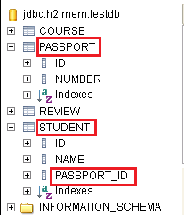

Step 29 - OneToOne Mapping - Bidirectional Relationship - Part 2

To get the details of a student associated with psspport.

Passport.java

@Entity

**public** **class** Passport {

@Id

@GeneratedValue

**private** Long id;

@Column(nullable = **false**)

**private** String number;

/*

* Even though there is no studnt_id column associated with passport, this gives

* us a way to navigate from passport to student. This is Bidirectional

* relationship

*/

@OneToOne(fetch=FetchType.***LAZY***, mappedBy="passport")

**private** Student student;

//..….

}

StudentRepositoryTest.java

@Test

@Transactional

**public** **void** retrievePassportAndAssociatedStudent() {

Passport passport = em.find(Passport.**class**, 40001L);

logger.info("passport -> {}", passport);

logger.info("student -> {}", passport.getStudent());

}

7. FAQ’s about Hibernate and JPA

FAQ 1) When does Hibernate send updates to the database?

@Transactional

void someMethodWithChange() {

// The transaction starts here

// create objects

// Only queries for sequence generation (ids) get fired here. Only id’s are assigned to the users

em.persist(user1);

em.persist(user2);

// em.flush(); → All the above transaction gets sent to the DB

// Persistence context recognizes the changes made to users. It does not even fire update queries here

// change user1 → If this fails, even though we have done em.flush(), Hibernate will rollback entire changes done before this point.

// change user2

// Persistence context keeps track of all the above changes

// Hibernate waits until the last possible moment before it would start persisting the changes. (Bcz if something fails, since all the changes are part of one transaction, it can be rolled back)

} // The transaction ends here. All changes are saved to DB.

**Note:** If you want to send some changes to DB in the meanwhile, you can use em.flush().

FAQ 2) When do we need @Transactional in an unit test

**Whenever** we are making a change to DB, we need **@Transactional.** Whenever we put **@Transactional on a method.** The entire logic in that method and the method it calls are within the boundaries of transaction.

If from a unit test we are calling a repository and the repository makes use of EntityMAnager, then we do not have to annotate the method in unit test with @Transactional. If we are directly making changes from unit test (directly using EntityManager to insert/update row), we need to add @Transactional on the unit test method.

If you want to do any change to the DB, you need a transaction.

FAQ 3) Do read only method need a transaction

Let us take 2 entities: User, Comment. User is posting lot of comments. A single comment is always associated with one user.

// Assume there is no @Transactional here

List<Comment> someReadOnlyMethod() {

// This line executes fine. In EntityManager there is a default transaction that you will make use of.

**User user = em.find(User.class, 1);** // This transaction will end as soon as this method is executed.

// This line will throw exception.As we are not making use of EntityManager here, there is nothing to provide a transaction here. Suppose comments are Lazily loaded. So we need to fire a query to DB to get comments. If we need to fire a query to DB, we need a connection to DB, we need a transaction.

List<Comment> comments = user.getComments();

return comments;

}

FAQ 4) Why do we use @DirtiesContext in an unit test

To roll back the changes made to the DB by unit tests.

8. Establishing relationships with JPA and hibernate – OneToMAny and ManyToMany

Step 30 - ManyToOne Mapping - Designing the database

Course, Review

Each course can have multiple or no review present.

A review can only be associated with one course.

**The** best possible design for ManyToOne relationship is to go to the one side (Review : one review is associated with one course). We will have a course_id column in the review table to store the relationship between course and review.

Step 30 - Part 2 - ManyToOne Mapping - Implementing the Mapping

Review will have the course_id. Review is the owning side of the relationship. MappedBy will be on the non-owning side (Course) of the relationship.

Change data.sql to accommodate the new column in review table.

Note: There is no change in the course table but review table has an additional column ‘ course_id’. course_id is a foreign key on table course.

Course.java

package com.personal.Kunj.jpa.advancedjpa.entity;

**import** java.time.LocalDateTime;

**import** java.util.List;

**import** javax.persistence.Column;

**import** javax.persistence.Entity;

**import** javax.persistence.GeneratedValue;

**import** javax.persistence.Id;

**import** javax.persistence.OneToMany;

**import** org.hibernate.annotations.CreationTimestamp;

**import** org.hibernate.annotations.UpdateTimestamp;

@Entity

public class Course {

@Id

@GeneratedValue

**private** Long id;

@Column(name="fullname", nullable=**false**)

**private** String name;

@OneToMany(mappedBy="course")

**private** List<Review> reviews;

**public** List<Review> getReviews() {

**return** reviews;

}

/*

* I do not want others to set reviews. I want others to add one review at a

* time.I do not want somebody to take the list of the revies and manipulate it

* and then give me the complete list.

*/

**public** **void** addReview(Review review) {

**this**.reviews.add(review);

}

**public** **void** removeReview(Review review) {

**this**.reviews.remove(review);

}

@UpdateTimestamp

**private** LocalDateTime lastUpdatedDate;

@CreationTimestamp

**private** LocalDateTime createdDate;

// Default constructor will be used by JPA to create bean

**protected** Course() {

}

// WE want others only to provide the name , not id

**public** Course(String name) {

**this**.name = name;

}

**public** String getName() {

**return** name;

}

**public** **void** setName(String name) {

**this**.name = name;

}

**public** Long getId() {

**return** id;

}

// Override toString() to get rid of hashcode being printed

@Override

**public** String toString() {

**return** "Course [id=" + id + ", name=" + name + "]";

}

}

package com.personal.Kunj.jpa.advancedjpa.entity;

import javax.persistence.Entity;

import javax.persistence.GeneratedValue;

import javax.persistence.Id;

import javax.persistence.ManyToOne;

Review.java

@Entity

public class Review {

@Id

@GeneratedValue

private Long id;

private String rating;

private String description;

@ManyToOne

private Course course;

public Course getCourse() {

return course;

}

public void setCourse(Course course) {

this.course = course;

}

protected Review() {

}

public Review(String rating, String description) {

this.rating = rating;

this.description = description;

}

public String getDescription() {

return description;

}

public void setDescription(String description) {

this.description = description;

}

public String getRating() {

return rating;

}

public void setRating(String rating) {

this.rating = rating;

}

public Long getId() {

return id;

}

@Override

public String toString() {

return String.format("Review[%s %s]", rating, description);

}

}

Hibernate:

create table course (

id bigint not null,

created_date timestamp,

last_updated_date timestamp,

fullname varchar(255) not null,

primary key (id)

)

Hibernate: s

create table review (

id bigint not null,

description varchar(255),

rating varchar(255),

course_id bigint,

primary key (id)

)

Hibernate:

alter table review

add constraint FKprox8elgnr8u5wrq1983degk

foreign key (course_id)

references course

Step 31 - ManyToOne Mapping - Retrieving and inserting Reviews for Course

**We are** getting a couple of reviews for the course ‘Spring Boot in 100 Steps’ and we would like to insert them in.

CourseRepository.java

**public** **void** addReviewsForCourse() {

//get the course 10003

Course course = findById(10003L);

logger.info("course.getReviews() -> {}", course.getReviews());

//add 2 reviews to it

Review review1 = **new** Review("5", "Great Hands-on Stuff.");

Review review2 = **new** Review("5", "Hatsoff.");

//setting the relationship

course.addReview(review1);

review1.setCourse(course);

course.addReview(review2);

review2.setCourse(course);

//save it to the database. Mind here that we are only persisting Review, not course

em.persist(review1);

em.persist(review2);

}

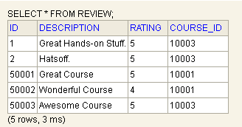

Step 32 - ManyToOneMapping - Generalizing Insert Reviews

CourseRepository.java

**public** **void** addReviewsForCourse(Long courseId, List<Review> reviews) {

Course course = findById(courseId);

logger.info("course.getReviews() -> {}", course.getReviews());

**for**(Review review:reviews)

{

//setting the relationship

course.addReview(review);

review.setCourse(course);

// Only persisting the review, not the course

em.persist(review);

}

}

Step 33 - ManyToOne Mapping - Wrapping up

NOTE: ***ToOne → Default is eager fetching

***ToMany → Default is lazy fetching

CourseRepositoryTest.java

// Test for @OneToMany side of the relationship

@Test

@Transactional // In the below method by default Lazy fetch will take place

// by default on @OneToMany side of the relationship, fetch strategy is Lazy

// In every @OneToMany side of the relationship, you have to decide which type of fetching you want to go for

**public** **void** retrieveReviewsForCourse() {

Course course = repository.findById(10001L);

// The below statement will throw "exception" if we do not have @Transactional

logger.info("{}",course.getReviews());

}

// Test for @ManyToOne side of the relationship

@Test

@Transactional

**public** **void** retrieveCourseForReview() {

// On the @ManyToOne side of the relationship The fetching is always EAGER

Review review = em.find(Review.**class**, 50001L);

logger.info("{}",review.getCourse());

}

Step 34 - ManyToMany Mapping - Table Design

Entities: Course, Student

A course can have multiple student. A student can enroll into multiple courses.

Creating student_id in course and course_id in student will have multiple entries which is not a good design. This is where concept of JoinTable comes into picture. We will create a join table (course_student or student_course) and have columns student_id and course_id stored.

ManyToMany should always be established using a join table.

Step 35 - ManyToMany Mapping - Adding Annotations on Entities

package com.personal.Kunj.jpa.advancedjpa.entity;

**import** java.time.LocalDateTime;

**import** java.util.ArrayList;

**import** java.util.List;

**import** javax.persistence.Column;

**import** javax.persistence.Entity;

**import** javax.persistence.GeneratedValue;

**import** javax.persistence.Id;

**import** javax.persistence.ManyToMany;

**import** javax.persistence.OneToMany;

**import** org.hibernate.annotations.CreationTimestamp;

**import** org.hibernate.annotations.UpdateTimestamp;

@Entity

public class Course {

@Id

@GeneratedValue

**private** Long id;

@Column(name="fullname", nullable=**false**)

**private** String name;

@UpdateTimestamp

**private** LocalDateTime lastUpdatedDate;

@CreationTimestamp

**private** LocalDateTime createdDate;

@OneToMany(mappedBy="course")

**private** List<Review> reviews = **new** ArrayList<>();

@ManyToMany

**private** List<Student> students = **new** ArrayList<>();

// Default constructor will be used by JPA to create bean

**protected** Course() {

}

// We want others only to provide the name , not id

**public** Course(String name) {

**this**.name = name;

}

**public** List<Review> getReviews() {

**return** reviews;

}

/*

* I do not want others to set reviews. I want others to add one review at a

* time.I do not want somebody to take the list of the revies and manipulate it

* and then give me the complete list.

*/

**public** **void** addReview(Review review) {

**this**.reviews.add(review);

}

**public** **void** removeReview(Review review) {

**this**.reviews.remove(review);

}

**public** List<Student> getStudents() {

**return** students;

}

**public** **void** addStudent(Student student) {

**this**.students.add(student);

}

**public** String getName() {

**return** name;

}

**public** **void** setName(String name) {

**this**.name = name;

}

**public** Long getId() {

**return** id;

}

// Override toString() to get rid of hashcode being printed

@Override

**public** String toString() {

**return** "Course [id=" + id + ", name=" + name + "]";

}

}

package com.personal.Kunj.jpa.advancedjpa.entity;

import java.util.ArrayList;

import java.util.List;

import javax.persistence.Column;

import javax.persistence.Entity;

import javax.persistence.FetchType;

import javax.persistence.GeneratedValue;

import javax.persistence.Id;

import javax.persistence.ManyToMany;

import javax.persistence.OneToOne;

@Entity

public class Student {

@Id

@GeneratedValue

private Long id;

@Column(nullable = false)

private String name;

@OneToOne(fetch=FetchType.LAZY)

private Passport passport;

@ManyToMany

private List<Course> courses = new ArrayList<>();

protected Student() {

}

public List<Course> getCourses() {

return courses;

}

public void addCourse(Course course) {

this.courses.add(course);

}

public Passport getPassport() {

return passport;

}

public void setPassport(Passport passport) {

this.passport = passport;

}

public Student(String name) {

this.name = name;

}

public String getName() {

return name;

}

public void setName(String name) {

this.name = name;

}

public Long getId() {

return id;

}

@Override

public String toString() {

return String.format("Student[%s]", name);

}

}

DB:

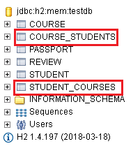

**Note:** In the above screenshot, a separate relationship table is created for both the tables. 2 tables with the same design are created to establish a single relationship.

Step 36 - ManyToMany Mapping - Fixing two join tables problem

Solution of the step 35 : Make one of the entities the owning side of the relationship. In ManyToMany it does not matter which entity is a t the owning side of the relationship unlike @ManyToOne and @OneToMany.

Let us make student owning side of the relationship.

@Entity

public class Course {

@ManyToMany(mappedBy="courses")

**private** List<Student> students = **new** ArrayList<>();

// ….

}

@Entity

**public** **class** Student {

@ManyToMany

private List<Course> courses = new ArrayList<>();

//.....…......…

}

DB:

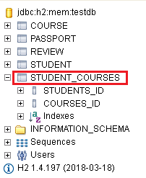

How to change the join table and it’s column’s name?

Step 37 - ManyToMany Mapping - Customizing the Join Table

At the owning side of the relationship (Student) we can add an annotation @JoinTable.

Student.java

@ManyToMany

// JoinColumn for this entity is Student_id.

// InverseJoinColumn is course_id

@JoinTable(name = "STUDENT_COURSE",

joinColumns = @JoinColumn(name = "STUDENT_ID"),

inverseJoinColumns = @JoinColumn(name = "COURSE_ID")

)

DB:

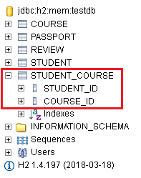

Step 38 - ManyToMany Mapping - Insert Data and Write Join Query

Populate Student_course table.

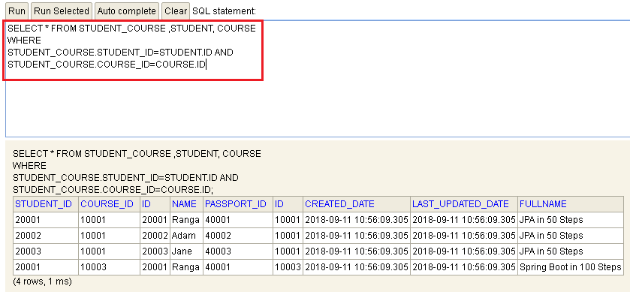How to get the above data without using query?

Step 39 - ManyToMany Mapping - Retrieve Data using JPA Relationships

StudentRepositoryTest.java

@Test

@Transactional

**public** **void** retrieveStudentAndCourses() {

// Executes only the student query (Lazy fetch)

// ManyToMany by default uses lazy fetch

Student student = em.find(Student.**class**, 20001L);

logger.info("student -> {}", student);

// It will run join query on student_course and course table

logger.info("courses -> {}", student.getCourses());

}

Step 40 - ManyToMany Mapping - Insert Student and Course

Inserting Student, course and their relationship

StudentRepository.java

**public** **void** insertHardcodedStudentAndCourse(){

Student student = **new** Student("Jack");

Course course = **new** Course("Microservices in 100 Steps");

em.persist(student);

em.persist(course);

// Persisting the relationship between student and course

student.addCourse(course);

course.addStudent(student);

em.persist(student); // Persisting the owning side

}

**public** **void** insertStudentAndCourse(Student student, Course course){

student.addCourse(course);

course.addStudent(student);

em.persist(student);

em.persist(course);

}

Step 41 - Relationships between JPA Entities - A summary

Use fetch type judiciously.

Always think of the fetch type whrn you are thinking about the relationships.

Designing table in case of various (OneToOne, ManyToOne etc) relations

9. Inheritance Hierarchies with JPA and Hibernate

Step 42 - Introduction to Inheritance Hierarchies and Mappings

In OOPS inheritance is an imp concept.

PartTimeEmployee → inheriting from → FullTimeEmployee → inheriting from → Employee

The Employee class has all the common attributes. Attribute which are specific to FullTimeEmployee is salary and for PartTimeEmployee hourlyWage. How do we map this relation to DB table?

Step 43 - JPA Inheritance Hierarchies and Mappings - Setting up entities

@Entity

public abstract class Employee {

@Id

@GeneratedValue

**private** Long id;

@Column(nullable = **false**)

**private** String name;

// ….

}

@Entity

**public** **class** FullTimeEmployee **extends** Employee {

**private** BigDecimal salary;

//..……....…..…..

}

@Entity

**public** **class** PartTimeEmployee **extends** Employee {

**private** BigDecimal hourlyWage;

// .......…

}

Step 44 - JPA Inheritance Hierarchies and Mappings - Setting up a Repository

@Repository

@Transactional

**public** **class** EmployeeRepository {

**private** Logger logger = LoggerFactory.*getLogger*(**this**.getClass());

@Autowired

EntityManager em;

**public** **void** insert(Employee employee) {

em.persist(employee);

}

**public** List<Employee> retrieveAllEmployees() {

**return** em.createQuery("select e from Employee e", Employee.**class**).getResultList();

}

}

Step 45 - JPA Inheritance Hierarchies and Mappings - Single Table

We would like to store FullTimeEmployee and PartTimeEmployee as different tables.

Single table strategy is the default strategy.

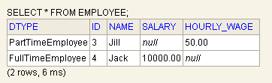

Both the **FullTimeEmployee and PartTimeEmployee** are stored in single table.

From the performance perspective this is good bcz we are quering from a single table. But from data integrity perspective, we have to define both the columns (salary, hourly_wage) as nullable. If there is a defect in code, there is a chance that an invalid data can come in. Somebody enters null in hourly_wage for PartTimeEmployee, that is a bad data. My database is allowing bad data.

The problem with single table hierarchy is that you will have lot of nullable columns.

In the Employee table there is an additional coulumn DTYPE that will say what kind of employee is being stored.

You can even give a name to DTYPE column by @DiscriminatorColumn.

@Entity

@Inheritance(strategy=InheritanceType.***SINGLE_TABLE***)

@DiscriminatorColumn(name="EmployeeType")

public abstract class Employee {

// …...…...….......…..

}

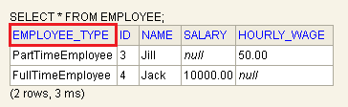

Step 46 - JPA Inheritance Hierarchies and Mappings - Table Per Class

TABLE_PER_CLASS → A table per concrete entity class

Employee is an abstract class.FullTimeEmployee and PartTimeEmployee are concrete classes, so individual tables will be created for them as soon as we enter data in to table.

The good thing about JPA is that insertion and retrieval style is irrespective of what inheritance type we are using.

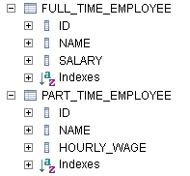

A union will be done on bothFullTimeEmployee and PartTimeEmployee

to get the details of Employee.

The problems:

1) with this strategy is that the common columns (name) are repeated.

2) If we have 10 different classes, we will have as many no of tables. This is not good.

3) Retrieval is done using union. This is OK

Step 47 - JPA Inheritance Hierarchies and Mappings – Joined

JOINED: /**

* A strategy in which fields that are specific to a

* subclass are mapped to a separate table than the fields

* that are common to the parent class, and a join is

* performed to instantiate the subclass.

*/

Separate table created for super as well as sub class. Whenever we are trying to get the details of sub class, there will be a join performed.

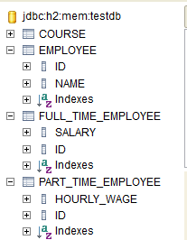

Joined strategy is good in terms of the database design. However from performance perspective it not the best as it has to join columns to fetch the data.

Hibernate:

select

employee0_.id as id1_1_,

employee0_.name as name2_1_,

employee0_1_.salary as salary1_2_,

employee0_2_.hourly_wage as hourly_w1_3_,

case

when employee0_1_.id is not null then 1

when employee0_2_.id is not null then 2

when employee0_.id is not null then 0

end as clazz_

from

employee employee0_

left outer join

full_time_employee employee0_1_

on employee0_.id=employee0_1_.id

left outer join

part_time_employee employee0_2_

on employee0_.id=employee0_2_.id

Step 48 - JPA Inheritance Hierarchies and Mappings - Mapped Super Class

This strategy is about not to use inheritance at all, rather use @MappedSuperClass.

// Employee is a mapped super class which is present just for the sake of mapping.

@MappedSuperclass

/*

* When a class is a mapped super class, it cannot be an entity. There will not

* be any table for this class.

*/

@Entity

// @Inheritance(strategy = InheritanceType.JOINED)

public abstract class Employee {

//.

}

If you have a class annotated with both @MappedSuperclass and @Entity, you will get below exception.

Caused by: org.hibernate.AnnotationException: An entity cannot be annotated with both @Entity and @MappedSuperclass: com.personal.Kunj.jpa.advancedjpa.entity.Employee

@MappedSuperclass :

* <p> A class designated with the <code>MappedSuperclass</code>

* annotation can be mapped in the same way as an entity except that the

* mappings will apply only to its subclasses since no table

* exists for the mapped superclass itself. When applied to the

* subclasses the inherited mappings will apply in the context

* of the subclass tables. Mapping information may be overridden

* in such subclasses by using the <code>AttributeOverride</code> and

* <code>AssociationOverride</code> annotations or corresponding XML elements.

*

As there is no Employee class, application will throw below error bcz we are trying to use an instance of Employee class in the code:

java.lang.Error: Unresolved compilation problem:

The method retrieveAllEmployees() is undefined for the type EmployeeRepository

FIXED CODE:

**package** com.personal.Kunj.jpa.advancedjpa.repository;

**import** java.util.List;

**import** javax.persistence.EntityManager;

**import** org.slf4j.Logger;

**import** org.slf4j.LoggerFactory;

**import** org.springframework.beans.factory.annotation.Autowired;

**import** org.springframework.stereotype.Repository;

**import** org.springframework.transaction.annotation.Transactional;

**import** com.personal.Kunj.jpa.advancedjpa.entity.Employee;

**import** com.personal.Kunj.jpa.advancedjpa.entity.FullTimeEmployee;

**import** com.personal.Kunj.jpa.advancedjpa.entity.PartTimeEmployee;

@Repository

@Transactional

**public** **class** EmployeeRepository {

**private** Logger logger = LoggerFactory.*getLogger*(**this**.getClass());

@Autowired

EntityManager em;

**public** **void** insert(Employee employee) {

em.persist(employee);

}

// Will work no more as There is no Employee entity anymore

/*

* public List<Employee> retrieveAllEmployees() { return

* em.createQuery("select e from Employee e", Employee.class).getResultList(); }

*/

**public** List<PartTimeEmployee> retrieveAllPartTimeEmployees() {

**return** em.createQuery("select e from PartTimeEmployee e", PartTimeEmployee.**class**).getResultList();

}

**public** List<FullTimeEmployee> retrieveAllFullTimeEmployees() {

**return** em.createQuery("select e from FullTimeEmployee e", FullTimeEmployee.**class**).getResultList();

}

}

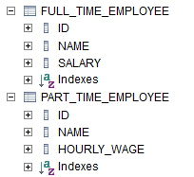

Hibernate:

select

fulltimeem0_.id as id1_1_,

fulltimeem0_.name as name2_1_,

fulltimeem0_.salary as salary3_1_

from

full_time_employee fulltimeem0_

Hibernate:

select

parttimeem0_.id as id1_2_,

parttimeem0_.name as name2_2_,

parttimeem0_.hourly_wage as hourly_w3_2_

from

part_time_employee parttimeem0_

Step 49 - JPA Inheritance Hierarchies and Mappings - How to Choose

Single Table

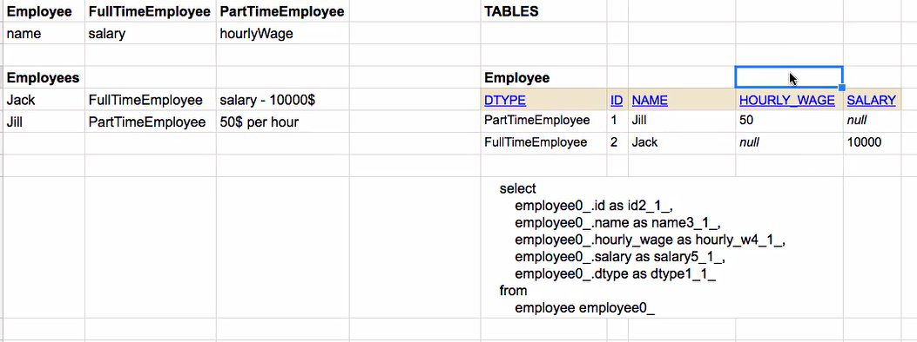

Table Per Class

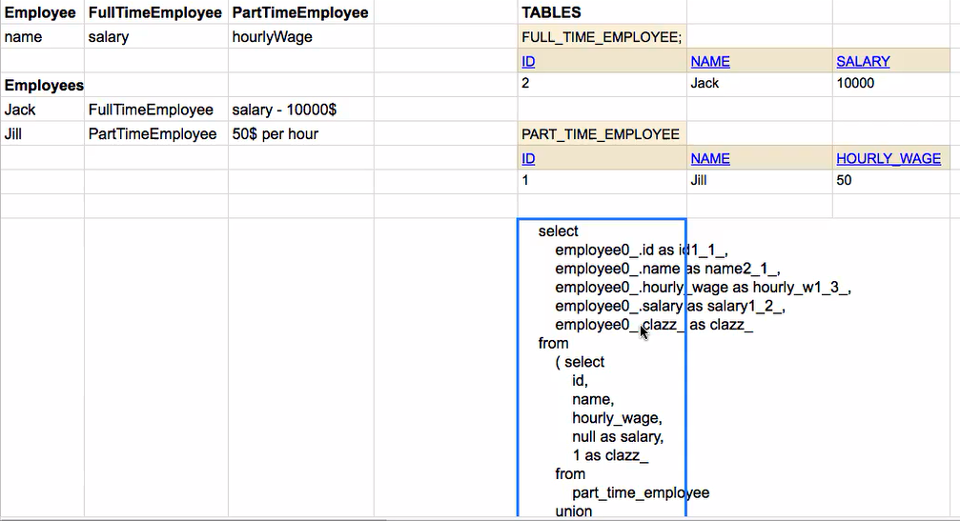

Joined

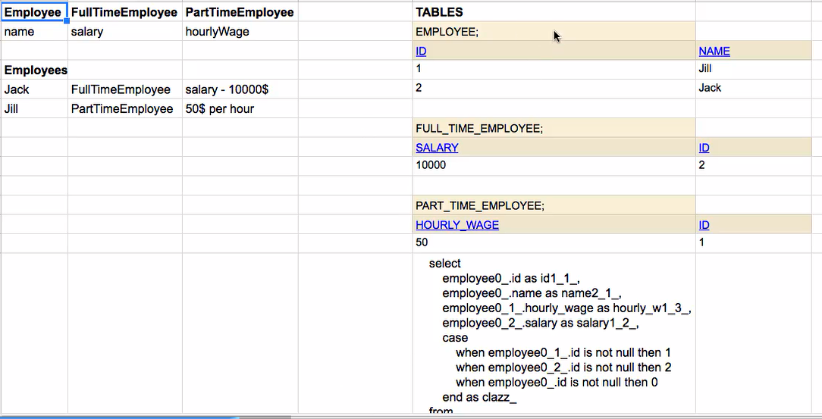

MappedSuperClass

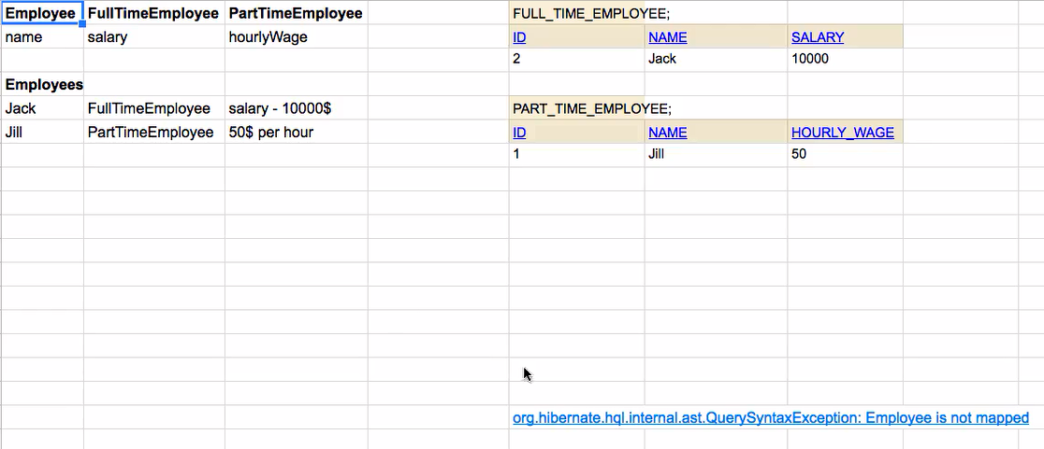

How to choose?

If you are concerned about data integrity.

Choose JOINED.

If you really worried about performance.

Single Table

10. Queries with Entities using JPQL

Step 50 - JPQL - Courses without Students

Find out the courses which do not have the students.

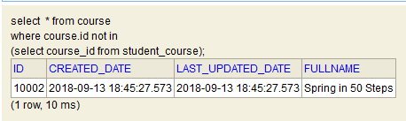

To do the above kind of stuff we used to like query in jdbc/ spring jdbc like above. With JPA we are not needed to write such a complex query.

We have already mapped course and student as ManyToMany. We will use this relationship to write query.

JPQLTest.java

@Test

**public** **void** jpql_courses_without_students() {

// Here we are refering to the entities and relation behind them.

// We are not really worried about the tables.

// In c.students below, students is the variable defined in the course class

TypedQuery<Course> query = em.createQuery("Select c from Course c where c.students is empty", Course.**class**);

List<Course> resultList = query.getResultList();

logger.info("Results -> {}", resultList);

// [Course[Spring in 50 Steps]]

}

Step 51 - JPQL - Courses with atleast 2 Students and order by

JPQLTest.java

@Test

**public** **void** jpql_courses_with_atleast_2_students() {

TypedQuery<Course> query = em.createQuery("Select c from Course c where size(c.students) >= 2", Course.**class**);

List<Course> resultList = query.getResultList();

logger.info("Results -> {}", resultList);

// [Course[JPA in 50 Steps]]

}

@Test

**public** **void** jpql_courses_ordered_by_students() {

TypedQuery<Course> query = em.createQuery("Select c from Course c order by size(c.students) desc",

Course.**class**);

List<Course> resultList = query.getResultList();

logger.info("Results -> {}", resultList);

}

Step 52 - JPQL - Courses like 100 Steps

Student has passport. We want to find those students whose passport numbers are in a certain pattern (containing 1234).

JPQLTest.java

@Test

**public** **void** jpql_students_with_passports_in_a_certain_pattern() {

TypedQuery<Student> query = em.createQuery("Select s from Student s where s.passport.number like '%1234%'",

Student.**class**);

List<Student> resultList = query.getResultList();

logger.info("Results -> {}", resultList);

}

You can also use JPQL for the below operations:

//like

//BETWEEN 100 and 1000

//IS NULL

//upper, lower, trim, length

Step 53 - JPQL - Using Joins

/*

* We are not worried about the tables. We look for entities. In c.students,

* students is the field decalred in the course class

*/

//JOIN => Select c, s from Course c JOIN c.students s

//LEFT JOIN => Select c, s from Course c LEFT JOIN c.students s

//CROSS JOIN => Select c, s from Course c, Student s

//3 and 4 =>3 * 4 = 12 Rows

JPQLTest.java

@Test

**public** **void** join() {

// Cannot use a typed query as the result does not only contain student

Query query = em.createQuery("Select c, s from Course c JOIN c.students s");

List<Object[]> resultList = query.getResultList();

logger.info("Results Size -> {}", resultList.size());

**for** (Object[] result : resultList) {

logger.info("Course{} Student{}", result[0], result[1]);

}

}

@Test

**public** **void** left_join() {

Query query = em.createQuery("Select c, s from Course c LEFT JOIN c.students s");

List<Object[]> resultList = query.getResultList();

logger.info("Results Size -> {}", resultList.size());

**for** (Object[] result : resultList) {

logger.info("Course{} Student{}", result[0], result[1]);

}

}

@Test

**public** **void** cross_join() {

Query query = em.createQuery("Select c, s from Course c, Student s");

List<Object[]> resultList = query.getResultList();

logger.info("Results Size -> {}", resultList.size());

**for** (Object[] result : resultList) {

logger.info("Course{} Student{}", result[0], result[1]);

}

}

11. Queries using Java API - Criteria Queries

Step 54 - Criteria Query - Retrieving all courses

In JPQL, the queries are very similar to SQL. Some java developers feel it complex to write JPQL queries. Instead of writing a query, why not write a java api for doing JPQL stuff also? There comes CriteriaAPI.

Step 55 - Criteria Query - Courses like 100 Steps

Step 56 - Criteria Query - Courses without Students

Step 57 - Criteria Query - Using Joins

@RunWith(SpringRunner.**class**)

@SpringBootTest(classes = AdvancedJpaApplication.**class**)

**public** **class** CriteriaQueryTest {

**private** Logger logger = LoggerFactory.*getLogger*(**this**.getClass());

@Autowired

EntityManager em;

@Test

**public** **void** all_courses() {

// "Select c From Course c" --> to be done in java

/*

* 1. Use Criteria Builder to create a Criteria Query returning the expected

* result object.

*

* 2. To build a Criteria Query we also define the expected result

*/

CriteriaBuilder cb = em.getCriteriaBuilder();

CriteriaQuery<Course> cq = cb.createQuery(Course.**class**);

// 2. Define roots for tables which are involved in the query

Root<Course> courseRoot = cq.from(Course.**class**);

// 3. Define Predicates etc using Criteria Builder

// 4. Add Predicates etc to the Criteria Query

// 5. Build the TypedQuery using the entity manager and criteria query

TypedQuery<Course> query = em.createQuery(cq.select(courseRoot));

List<Course> resultList = query.getResultList();

logger.info("Typed Query -> {}", resultList);

// [Course[JPA in 50 Steps], Course[Spring in 50 Steps], Course[Spring

// Boot in 100 Steps]]

}

@Test

**public** **void** all_courses_having_100Steps() {

// "Select c From Course c where name like '%100 Steps' "

// 1. Use Criteria Builder to create a Criteria Query returning the

// expected result object

CriteriaBuilder cb = em.getCriteriaBuilder();

CriteriaQuery<Course> cq = cb.createQuery(Course.**class**);

// 2. Define roots for tables which are involved in the query

Root<Course> courseRoot = cq.from(Course.**class**);

// 3. Define Predicates etc using Criteria Builder

Predicate like100Steps = cb.like(courseRoot.get("name"), "%100 Steps");

// 4. Add Predicates etc to the Criteria Query

cq.where(like100Steps);

// 5. Build the TypedQuery using the entity manager and criteria query

TypedQuery<Course> query = em.createQuery(cq.select(courseRoot));

List<Course> resultList = query.getResultList();

logger.info("Typed Query -> {}", resultList);

// [Course[Spring Boot in 100 Steps]]

}

@Test

**public** **void** all_courses_without_students() {

// "Select c From Course c where c.students is empty"

// 1. Use Criteria Builder to create a Criteria Query returning the

// expected result object

CriteriaBuilder cb = em.getCriteriaBuilder();

CriteriaQuery<Course> cq = cb.createQuery(Course.**class**);

// 2. Define roots for tables which are involved in the query

Root<Course> courseRoot = cq.from(Course.**class**);

// 3. Define Predicates etc using Criteria Builder

Predicate studentsIsEmpty = cb.isEmpty(courseRoot.get("students"));

// 4. Add Predicates etc to the Criteria Query

cq.where(studentsIsEmpty);

// 5. Build the TypedQuery using the entity manager and criteria query

TypedQuery<Course> query = em.createQuery(cq.select(courseRoot));

List<Course> resultList = query.getResultList();

logger.info("Typed Query -> {}", resultList);

// [Course[Spring in 50 Steps]]

}

@Test

**public** **void** join() {

// "Select c From Course c join c.students s"

// 1. Use Criteria Builder to create a Criteria Query returning the

// expected result object

CriteriaBuilder cb = em.getCriteriaBuilder();

CriteriaQuery<Course> cq = cb.createQuery(Course.**class**);

// 2. Define roots for tables which are involved in the query

Root<Course> courseRoot = cq.from(Course.**class**);

// 3. Define Predicates etc using Criteria Builder

Join<Object, Object> join = courseRoot.join("students");

// 4. Add Predicates etc to the Criteria Query

// 5. Build the TypedQuery using the entity manager and criteria query

TypedQuery<Course> query = em.createQuery(cq.select(courseRoot));

List<Course> resultList = query.getResultList();

logger.info("Typed Query -> {}", resultList);

// [Course[JPA in 50 Steps], Course[JPA in 50 Steps], Course[JPA in 50

// Steps], Course[Spring Boot in 100 Steps]]

}

@Test

**public** **void** left_join() {

// "Select c From Course c left join c.students s"

// 1. Use Criteria Builder to create a Criteria Query returning the

// expected result object

CriteriaBuilder cb = em.getCriteriaBuilder();

CriteriaQuery<Course> cq = cb.createQuery(Course.**class**);

// 2. Define roots for tables which are involved in the query

Root<Course> courseRoot = cq.from(Course.**class**);

// 3. Define Predicates etc using Criteria Builder

Join<Object, Object> join = courseRoot.join("students", JoinType.***LEFT***);

// 4. Add Predicates etc to the Criteria Query

// 5. Build the TypedQuery using the entity manager and criteria query

TypedQuery<Course> query = em.createQuery(cq.select(courseRoot));

List<Course> resultList = query.getResultList();

logger.info("Typed Query -> {}", resultList);

// [Course[JPA in 50 Steps], Course[JPA in 50 Steps], Course[JPA in 50

// Steps], Course[Spring in 50 Steps], Course[Spring Boot in 100 Steps]]

}

}

12. Transaction Management

Step 58 - Introduction to Transaction Management

13. Spring Data JPA & Spring Data REST

Step 64 - Introduction to Spring Data JPA

CourseRepository.java and StudentRepository.java have exactly the same code apart from the fact that they are just managing the different entities.

The other problem is the proliferation of data stores. Earlier there were just relational data bases, but now we have varieties of big data databases.

Spring data aims to provide simple abstraction to be able to access any kind of data. Spring Data JPA is the JPA specific implementation of Spring Data.

**public** **interface** CourseSpringDataRepository **extends** JpaRepository<Course, Long> {

}

JpaRepository<Course, Long> 🡪 Arguments are : Name of the class, data type of the primary key

Step 65 - Testing the Spring Data JPA Repository with findById.

Step 66 - Spring Data JPA Repository - CRUD Methods

Step 67 - Sorting using Spring Data JPA Repository

Step 68 - Pagination using Spring Data JPA Repository

CourseSpringDataRepositoryTest.java

**package** com.personal.Kunj.jpa.advancedjpa.repository;

**import** **static** org.junit.Assert.*assertFalse*;

**import** **static** org.junit.Assert.*assertTrue*;

**import** java.util.Optional;

**import** org.junit.Test;

**import** org.junit.runner.RunWith;

**import** org.slf4j.Logger;

**import** org.slf4j.LoggerFactory;

**import** org.springframework.beans.factory.annotation.Autowired;

**import** org.springframework.boot.test.context.SpringBootTest;

**import** org.springframework.data.domain.Page;

**import** org.springframework.data.domain.PageRequest;

**import** org.springframework.data.domain.Pageable;

**import** org.springframework.data.domain.Sort;

**import** org.springframework.test.context.junit4.SpringRunner;

**import** com.personal.Kunj.jpa.advancedjpa.AdvancedJpaApplication;

**import** com.personal.Kunj.jpa.advancedjpa.entity.Course;

@RunWith(SpringRunner.**class**)

@SpringBootTest(classes = AdvancedJpaApplication.**class**)

**public** **class** CourseSpringDataRepositoryTest {

**private** Logger logger = LoggerFactory.*getLogger*(**this**.getClass());

@Autowired

CourseSpringDataRepository repository;

@Test

**public** **void** findById_CoursePresent() {

/*

* Spring data JPA returns Optional back. repository.findById(10001L) will not

* return a Course object, rather it will return an Optional.

*

* Optional provides a way to check if course exists or not.

*

* Optional eliminates the need for a null value. Suppose we pass a course id

* which is not present then courseOptional will be a proper object but it would

* not contain a course so isPresent() will return false.

*/

Optional<Course> courseOptional = repository.findById(10001L);

*assertTrue*(courseOptional.isPresent());

}

@Test

**public** **void** findById_CourseNotPresent() {

Optional<Course> courseOptional = repository.findById(20001L);

*assertFalse*(courseOptional.isPresent());

}

@Test

**public** **void** playingAroundWithSpringDataRepository() {

// Same method repository.save(course) is doing save as well as update.

// Course course = new Course("Microservices in 100 Steps");

// repository.save(course);

// course.setName("Microservices in 100 Steps - Updated");

// repository.save(course);

logger.info("Courses -> {} ", repository.findAll());

logger.info("Count -> {} ", repository.count());

}

@Test

**public** **void** sort() {

// Sort criteria can be added by doing .sort().

Sort sort = **new** Sort(Sort.Direction.***ASC***, "name");

logger.info("Sorted Courses -> {} ", repository.findAll(sort));

}

@Test

**public** **void** pagination() {

// Want to divide the result in the pages of 3 result

PageRequest pageRequest = PageRequest.*of*(0, 3);

Page<Course> firstPage = repository.findAll(pageRequest);

logger.info("First Page -> {} ", firstPage);

// To get the second page data

Pageable secondPageable = firstPage.nextPageable();

Page<Course> secondPage = repository.findAll(secondPageable);

logger.info("Second Page -> {} ", secondPage.getContent());

}

}

Step 69 - Custom Queries using Spring Data JPA Repository

CourseSpringDataRepository.java

**package** com.personal.Kunj.jpa.advancedjpa.repository;

**import** java.util.List;

**import** org.springframework.data.jpa.repository.JpaRepository;

**import** org.springframework.data.jpa.repository.Query;

**import** com.personal.Kunj.jpa.advancedjpa.entity.Course;

**public** **interface** CourseSpringDataRepository **extends** JpaRepository<Course, Long> {

// Defining custom methods

// Methods can start with find/retrieve/query for select statements

List<Course> findByNameAndId(String name, Long id);

List<Course> findByName(String name);

List<Course> countByName(String name);

List<Course> findByNameOrderByIdDesc(String name);

List<Course> deleteByName(String name);

@Query("Select c From Course c where name like '%100 Steps'")

List<Course> courseWith100StepsInName();

@Query(value = "Select * From Course c where name like '%100 Steps'", nativeQuery = **true**)

List<Course> courseWith100StepsInNameUsingNativeQuery();

@Query(name = "query_get_100_Step_courses")

List<Course> courseWith100StepsInNameUsingNamedQuery();

}

CourseSpringDataRepositoryTest.java

@Test

**public** **void** findUsingName() {

logger.info("FindByName -> {} ", repository.findByName("JPA in 50 Steps"));

}

@Test

**public** **void** findUsingStudentsName() {

logger.info("findUsingStudentsName -> {} ", repository.findByName("Ranga"));

}

Step 70 - Spring Data JPA REST

I want to expose restful services around CourseSpringDataRepository.java to be able to operate on the course.

Either you can use your typical Spring MVC to create restful web services or you can use Spring Data JPA Rest.

To use Spring Data JPA Rest add the below dependency to pom.xml.

<dependency>

<groupId>org.springframework.boot</groupId>

<artifactId>spring-boot-starter-data-rest</artifactId>

</dependency>

There will be lot of mapping created after the above dependency addition.

Q.) How to make use of the above added dependency?

Ans: Annotate CourseSpringDataRepository.java with @RepositoryRestResource(path = "course"). All the resources will be exposed on /course url.

Spring Data JPA Rest is not recommended for production.

14. Caching with Hibernate & JPA

Step 71 - Introduction to Caching

Cache only the data that does not frequently changes.

In Hibernate, we have 2 levels of cache.

First level cache

Second level cache

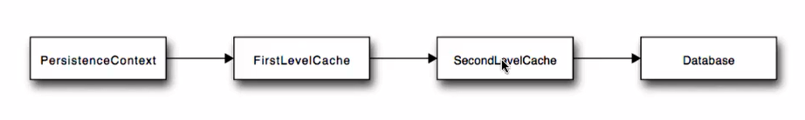

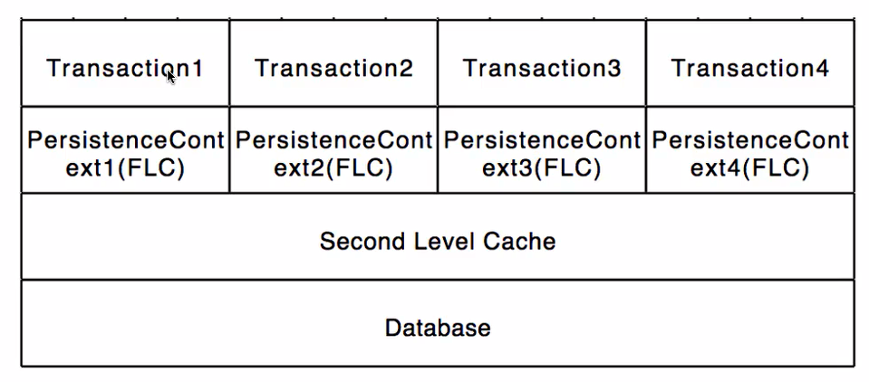

In a typical application, there are multiple transactions going on in parallel.

Here there are 4 transactions running. Each transaction is associated with PeristenceContext of its own where all the entities that are being modified during that transaction are tracked.

Let us say during transaction 1 I am retrieving the details of the same course again and again. In this case hibernate will not go the database all the 3 times. The first time it will go to the DB, retrieve the details, and it will have it inside the persistenceContext. The next time you ask for the same course details, hibernate will return it back from the persistenceContext, it will not talk to the DB. It will pull the data from the cache and return it back. Here First Level cache comes into picture. First level cache is within the boundary of a single transaction.

The second level cache comes into picture across multiple transactions. Let us say you have one instance of an application deployed on an application server and multiple users using this application. Irrespective of the users, the list of states/countries are same (these things generally do not change with user). We can store such info in second level cache. Second level cache will typically store the common info for all the users of an application. Let us say the application has just launched up and there is a request for list of countries, transaction 1 goes to the PersistenceContext and we would go to the second level cache, if details are not in the second level cache , we will go to the DB, get the details, put in the second level cache and from then on any of the request from any of the transaction thereafter the data will be retrieved from the second level cache.

Step 72 - Hibernate and JPA Caching - First Level Cache

If you want to make best use of first level cache then the boundary of the transaction should start with the service method. Starting with the service method, all the calls to the data layer should be within the scope of the single transaction then the first level cache will be efficient.

CourseRepositoryTest.java

@Test

@Transactional

**public** **void** findById_firstLevelCacheDemo() {

Course course = repository.findById(10001L);

logger.info("First Course Retrieved {}", course);

/*

* It will not fire a separate DB query if the method is annotataed with

*

* @Transactional.

*/

Course course1 = repository.findById(10001L);

logger.info("First Course Retrieved again {}", course1);

*assertEquals*("JPA in 50 Steps", course.getName());

*assertEquals*("JPA in 50 Steps", course1.getName());

}

Hibernate:

select

course0_.id as id1_0_0_,

course0_.created_date as created_2_0_0_,

course0_.last_updated_date as last_upd3_0_0_,

course0_.fullname as fullname4_0_0_

from

course course0_

where

course0_.id=?

2018-09-14 20:48:12.581 TRACE 3624 --- [ main] o.h.type.descriptor.sql.BasicBinder : binding parameter [1] as [BIGINT] - [10001]

2018-09-14 20:48:12.600 TRACE 3624 --- [ main] o.h.type.descriptor.sql.BasicExtractor : extracted value ([created_2_0_0_] : [TIMESTAMP]) - [2018-09-14T20:48:06.766]

2018-09-14 20:48:12.600 TRACE 3624 --- [ main] o.h.type.descriptor.sql.BasicExtractor : extracted value ([last_upd3_0_0_] : [TIMESTAMP]) - [2018-09-14T20:48:06.766]

2018-09-14 20:48:12.601 TRACE 3624 --- [ main] o.h.type.descriptor.sql.BasicExtractor : extracted value ([fullname4_0_0_] : [VARCHAR]) - [JPA in 50 Steps]

2018-09-14 20:48:12.608 TRACE 3624 --- [ main] org.hibernate.type.CollectionType : Created collection wrapper: [com.personal.Kunj.jpa.advancedjpa.entity.Course.reviews#10001]

2018-09-14 20:48:12.609 TRACE 3624 --- [ main] org.hibernate.type.CollectionType : Created collection wrapper: [com.personal.Kunj.jpa.advancedjpa.entity.Course.students#10001]

**2018-09-14 20:48:12.609 INFO 3624 --- [ main] c.p.K.j.a.r.CourseRepositoryTest : First Course Retrieved Course [id=10001, name=JPA in 50 Steps]**

**2018-09-14 20:48:12.609 INFO 3624 --- [ main] c.p.K.j.a.r.CourseRepositoryTest : First Course Retrieved again Course [id=10001, name=JPA in 50 Steps]**

**Step 73 - Hibernate and JPA Caching - Basics of Second Level Cache with EhCache**

First level cache was active by default.

2nd level cache needs configuration. You cannot cache all the data at the second level cache bcz hibernate does not know what data is going to change. You need to tell hibernate about the data which is not going to change between multiple transactions. What is the data which is common to multiple users? One you specify that, we can use 2nd level cache framework for ex: ehCache to cache all the common data.

Pom.xml

<dependency>

<groupId>org.hibernate</groupId>

<artifactId>hibernate-ehcache</artifactId>

</dependency>

Now, configure the cache.

Application.properties

# Second Level Cache - Ehcache

#1. enable second level cache

spring.jpa.properties.hibernate.cache.use_second_level_cache=true

#2. specify the caching framework - EhCache

spring.jpa.properties.hibernate.cache.region.factory_class=org.hibernate.cache.ehcache.EhCacheRegionFactory

#3. Only cache what I tell to cache.

spring.jpa.properties.javax.persistence.sharedCache.mode=ENABLE_SELECTIVE

logging.level.net.sf.ehcache=debug

#4. What data to cache?

# By enabling caching on entities

**Step 73 - Hibernate and JPA Caching - Basics of Second Level Cache with EhCache**

Let us pick course entity for caching.

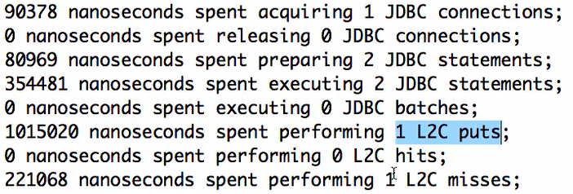

@Entity

@Cacheable

**public** **class** Course {

//…………

}

**15. Hibernate & JPA Tips**

**Step 75 - Hibernate Tips - Hibernate Soft Deletes - @SQLDelete and @Where**

EntityManager.remove() will delete a record completely from the database. You will not have any history of it. In some of the circumstances you will want to keep history of the rows. We can do this by implementing soft delete. Soft delete is done by adding a column to the database to track whether it is deleted or not.

In Course.java we will use another attribute ‘isDeleted’ . If a row is deleted, we will update this indicator to ‘true’. Whenever we create a new data in table, this indicator will be ‘false’.

Data.sql

insert into course(id, name, created_date, last_updated_date,is_deleted)

values(10001,'JPA in 50 Steps', sysdate(), sysdate(),false);

insert into course(id, name, created_date, last_updated_date,is_deleted)

values(10002,'Spring in 50 Steps', sysdate(), sysdate(),false);

insert into course(id, name, created_date, last_updated_date,is_deleted)

values(10003,'Spring Boot in 100 Steps', sysdate(), sysdate(),false);

Now we will want to set isDeleted column true whenever we delete a row.

@Entity

@Cacheable

// On the delete of a row I want this SQL to be called

@SQLDelete(sql = "update course set is_deleted=true where id=?")

**public** **class** Course {

// ….

}

If we execute the below test at this point in time, the test fails but we can see the update statement fired for the DB.

JUnit test failure message:

java.lang.AssertionError: expected null, but was:<Course [id=10002, name=Spring in 50 Steps]>

**CourseRepositoryTest.java**

@Test

// To reset the database status

@DirtiesContext

**public** **void** deleteById_basic() {

repository.deleteById(10002L); // (1)

*assertNull*(repository.findById(10002L)); // (2)

}

Hibernate:

update

course

set

is_deleted=true

where

id=?

In deleteById_basic() method we are deleting a course (1). But when we try to retrieve the data in (2), the row is coming back bcz the row is still in the database.

If we look at the query fired to DB by (2);

Hibernate:

select

course0_.id as id1_0_0_,

course0_.created_date as created_2_0_0_,

course0_.is_deleted as is_delet3_0_0_,

course0_.last_updated_date as last_upd4_0_0_,

course0_.name as name5_0_0_

from

course course0_

where

course0_.id=?

This query is not using the fact that now there is a ‘is_Deleted’ column and if the ‘is_Deleted’ column has the value ‘true’ then I would not need to fetch that row bcz that is not an active row.

Now we have to tell Course entity to add a specific condition to all the select query. This can be done by adding @Where to the entity.

@Entity

@Cacheable

// On the delete of a row I want this SQL to be called

@SQLDelete(sql = "update course set is_deleted=true where id=?")

**@Where(clause = "is_deleted = false")**

**public** **class** Course {

// …………..

}

Now unit test succeeds.

In console we can see the changes select query to include the where clause specified on the entity.

Hibernate:

select

course0_.id as id1_0_0_,

course0_.created_date as created_2_0_0_,

course0_.is_deleted as is_delet3_0_0_,

course0_.last_updated_date as last_upd4_0_0_,

course0_.name as name5_0_0_

from

course course0_

where

course0_.id=?

and (

course0_.is_deleted = 0

)

**Step 76 - Hibernate Soft Deletes - Part 2**

2 Caveats associated with soft delete.

(1)

If you run this unit test,

NativeQueriesTest.java

@Test

**public** **void** native_queries_basic() {

Query query = em.createNativeQuery("SELECT * FROM COURSE", Course.**class**);

List resultList = query.getResultList();

logger.info("SELECT * FROM COURSE -> {}", resultList);

//SELECT * FROM COURSE -> [Course[Web Services in 100 Steps], Course[JPA in 50 Steps - Updated], Course[Spring in 50 Steps], Course[Spring Boot in 100 Steps]]

}

Hibernate:

SELECT

*

FROM

COURSE

We should note that the @Where condition that we added in the previous step does not apply to the native query. So yiu yourself have to add the where clause like the below:

Query query = em.createNativeQuery("SELECT * FROM COURSE where is_Deleted=0", Course.**class**);

(2) Hibernate does not know what is happening inside **@Where(clause = "is_deleted = false")**

Whenever you are deleting a course entity we provided a where clause and this where clause is just appended to the query. Hibernate does not know that is_Deleted column is being set to false.

CourseRepository.java

**public** **void** deleteById(Long id) {

Course course = findById(id);

em.remove(course);

}

What is happening when we try to remove the course in the above method?

Bcz there is @SQLDelete(sql = "update course set is_deleted=true where id=?") annotation on course, The sql inside this is getting fired. Is_Deleted is being set to true. If you look at the attribute isDeleted inside Course.java, the value will still be false bcz hibernate has no idea about the fact that you are actually setting inDeleted to false bcz that is done in a query **@Where(clause = "is_deleted = false").**

The solution to the above will be to set isDeleted attribute on the course to true whever we call the em.remove(course). But that is a little bit risky thing to do bcz that would mean whenever we try to delete a course using the EntityManager we will need to remember that course.isDeleted has to be set to true otherwise if any other thing is trying to retrieve the course in that specific transaction it would get the non updated course entity.

Or the other option is to use one of the entity life cycle methods. Whenever a row of a specific entity is deleted there is a method that gets fired (method annotated with @PreRemove).

Course.java

@PreRemove

**private** **void** preRemove() {

LOGGER.info("Setting isDeleted to True");

**this**.isDeleted = **true**;

}

See in the log that this method is being called.

Console:

c.p.Kunj.jpa.advancedjpa.entity.Course : Setting isDeleted to True

**Step 77 - JPA Entity Life Cycle Methods**

The important annotations related to life cycle methods in an entity are:

@PostLoad 🡪 If you mark a method in an entity with this annotation, it will be called as soon as the entity is retrieved and loaded. If there is a select query fired and that specific entity is being loaded , this specific method on this entity would be called.

@PostPersist 🡪 Method is called after the entity is persisted.

@PostRemove

@PostUpdate

@PrePersist

@PreRemove

@PreUpdate

**Step 78 - Using Embedded and Embeddable with JPA**

Let us say we have an address for an object. There is one address for a student.

In this step we will look at the scenarios where we would like address’s fields to be directly present in the student. I do not want to create a relationship between student and address.

If we want address to be embedded in student entity, we need to add @Embeddable on the address. We need to annotate address var in student class with @Embedded.

Not just for entity, even for embedded object you need a default constructor.

@Entity

**public** **class** Student {

@Id

@GeneratedValue

**private** Long id;

@Column(nullable = **false**)

**private** String name;

**@Embedded**

**private Address address;**

@OneToOne(fetch = FetchType.***LAZY***)

**private** Passport passport;

@ManyToMany

// JoinColumn for this entity is Student_id.

// InverseJoinColumn is course_id

@JoinTable(name = "STUDENT_COURSE", joinColumns = @JoinColumn(name = "STUDENT_ID"), inverseJoinColumns = @JoinColumn(name = "COURSE_ID"))

**private** List<Course> courses = **new** ArrayList<>();

// ……………………….

}

@Embeddable

**public** **class** Address {

**private** String line1;

**private** String line2;

**private** String city;

**protected** Address() {

}

**public** Address(String line1, String line2, String city) {

**super**();

**this**.line1 = line1;

**this**.line2 = line2;

**this**.city = city;

}

}

StudentRepositoryTest.java

@Test

@Transactional

**public** **void** setAddressDetails() {

Student student = em.find(Student.**class**, 20001L);

student.setAddress(**new** Address("No 101", "Some Street", "Hyderabad"));

em.flush();

}

**Step 79 - Using Enums with JPA**

In Review .java, we declared field review as String. This is not good practice as there are only 5 ratings possible. There is a chance that bad data gets stored in review entity

@Entity

**public** **class** Review {

@Id

@GeneratedValue

**private** Long id;

// @Enumerated --> To say that rating is an ENUM

// By default a numeric column will be created that accepts ORDINAL (ie 1,2,3,4,5). 1 for the first enum constant and 2 for the 2nd and so on

@Enumerated

**private** ReviewRating rating;

**private** String description;

@ManyToOne

**private** Course course;

// ..

}

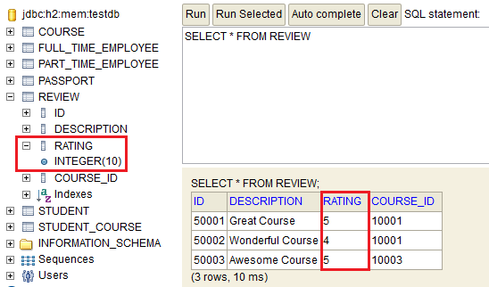

If we are changing ordinals then it is better to make it as string bcz the ordinal values will keep on changing if we insert constant in enum.

@Enumerated(EnumType.***STRING***)

**private** ReviewRating rating;

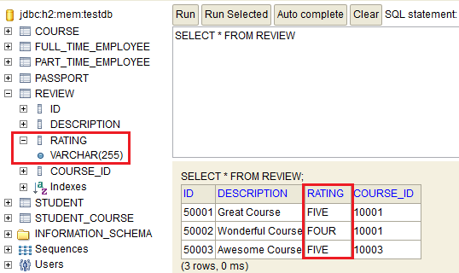

**Step 80 - JPA Tip - Be cautious with toString method implementations**

Let us say we define toString() of Course.java as :

@Override

**public** String toString() {

**return** String.*format*("Course[%s] Review[%s]", name, reviews);

}

In CouseRepository.java a developer logs course,

**public** Course findById(Long id) {

Course course = em.find(Course.**class**, id);

logger.info("Course -> {}");

**return** course;

}

The logger in findById(Long id) will print both Course and review details. 2 select queries will be fired to the database to fetch course as well as review details. But we were asking just for course details.

**Step 81 - JPA Tip - When do you use JPA**

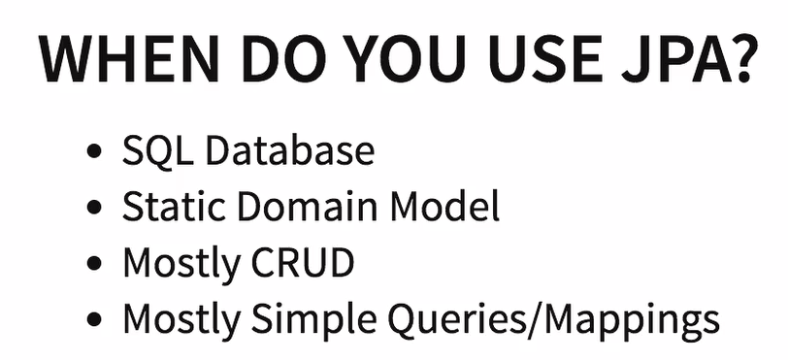

If you have a batch oriented application, do not go for JPA.

**16. Performance Tuning Tips with Hibernate & JPA**

**Step 82 - Performance Tuning - Measure before Tuning**

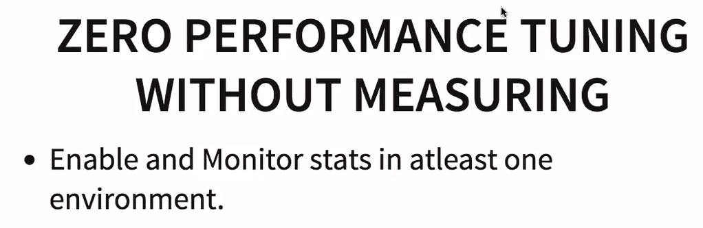

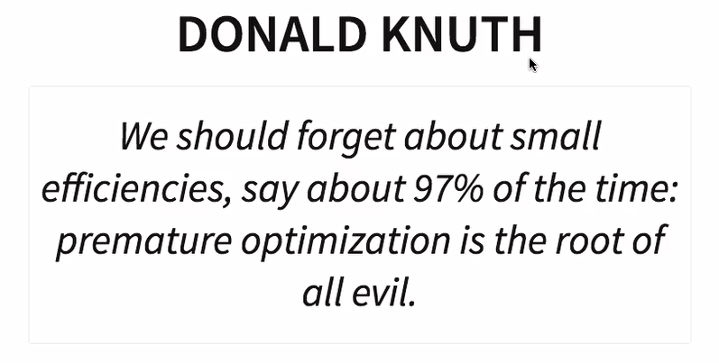

#Turn Statistics on

# "generate_statistics" will tell no of queries fired

spring.jpa.properties.hibernate.generate_statistics=true

# keep logging level for "org.hibernate.stat" as debug

logging.level.org.hibernate.stat=trace

Step 83 - Performance Tuning – Indexes

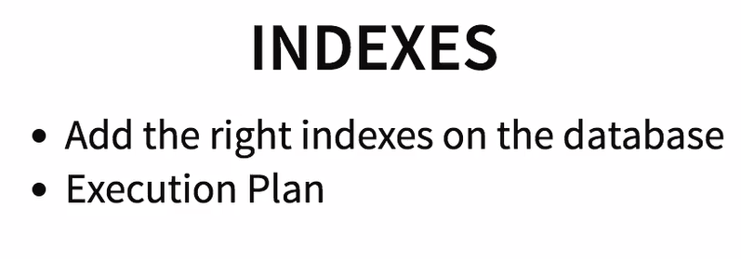

Any relational database need to have right indexes on table.

One of the ways to identify the right indexes is to look at the execution plans of your queries. For ex if students are often searched using name, then create index for the name in the student table.

Step 84 - Performance Tuning - Use Appropriate Caching

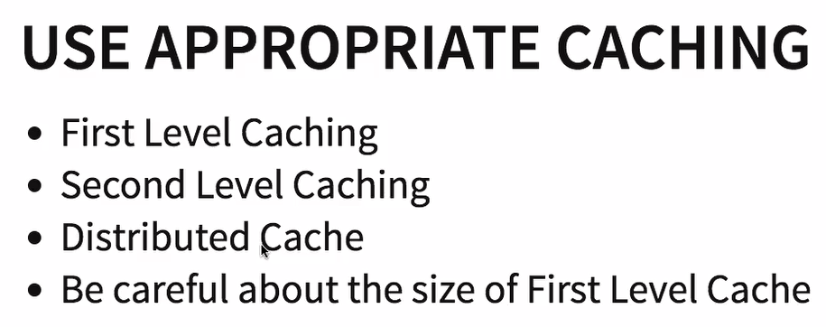

First level cache is within a single transaction and is automatically enabled. Make sure that you do not make first level cache too big. If you are storing 1000’s of entities in 1st level cache, regularly clear using the entitymanager. If the size of 1st level cache grows then searching through it will also become inefficient.

Second level caching is useful to make sure that different transaction on the same server or the same instance of the application can share the common data. For ex things like country and state (drop down values) which will be common for all the users.

The second level cache is specific to an instance of the application, but if you are running a lot of applications in parallel. You are expecting a huge amount of load and one application is not sufficient to handle that. In that case you would be distributing your load among multiple application instances. The distributed cache is useful to cache things across all the multiple instances. A good example of distributed cache is hazzlecast.

**Step 85 - Performance Tuning - Eager vs Lazy Fetch**

Depending on the situation, any of the fetch might be a good choice. We have to evaluate it by our use cases.

**Step 86 - Performance Tuning - Avoid N+1 Problems**



@NamedQueries(value = { @NamedQuery(name = "query_get_all_courses", query = "Select c From Course c"),

@NamedQuery(name = "query_get_all_courses_join_fetch", query = "Select c From Course c JOIN FETCH c.students s"),

@NamedQuery(name = "query_get_100_Step_courses", query = "Select c From Course c where name like '%100 Steps'") })

@Entity

@Cacheable

// On the delete of a row I want this SQL to be called

@SQLDelete(sql = "update course set is_deleted=true where id=?")

@Where(clause = "is_deleted = false")

**public** **class** Course {

// …

}

PerformanceTuningTest.java

**package** com.personal.Kunj.jpa.advancedjpa.repository;

**import** java.util.List;

**import** javax.persistence.EntityGraph;

**import** javax.persistence.EntityManager;

**import** javax.persistence.Subgraph;

**import** javax.transaction.Transactional;

**import** org.junit.Test;

**import** org.junit.runner.RunWith;

**import** org.slf4j.Logger;

**import** org.slf4j.LoggerFactory;

**import** org.springframework.beans.factory.annotation.Autowired;

**import** org.springframework.boot.test.context.SpringBootTest;

**import** org.springframework.test.context.junit4.SpringRunner;

**import** com.personal.Kunj.jpa.advancedjpa.AdvancedJpaApplication;

**import** com.personal.Kunj.jpa.advancedjpa.entity.Course;

@RunWith(SpringRunner.**class**)

@SpringBootTest(classes = AdvancedJpaApplication.**class**)

**public** **class** PerformanceTuningTest {

**private** Logger logger = LoggerFactory.*getLogger*(**this**.getClass());

@Autowired

EntityManager em;

@Test

@Transactional

**public** **void** creatingNPlusOneProblem() {

List<Course> courses = em.createNamedQuery("query_get_all_courses", Course.**class**).getResultList();

/*

* 4 queries will be fired. One for courses and 3 for the students for

* individual courses. this is N+1 problem.

*/

/*

* One solution is to make the students eager fetch in Course.java. but the

* problem is that anytime you want to retrieve a course, all the students of

* the course will be retrieved

*/

**for** (Course course : courses) {

logger.info("Course -> {} Students -> {}", course, course.getStudents());

}

}

/*

* Second option to solves the N+1 problem.

*

* In this we will not change the course entity but when we are retrieving

* course and student entity together, we can add a hint in that method.

*

* Just one JDBC statement will be fired in this case.

*/

@Test

@Transactional

**public** **void** solvingNPlusOneProblem_EntityGraph() {

EntityGraph<Course> entityGraph = em.createEntityGraph(Course.**class**);

Subgraph<Object> subGraph = entityGraph.addSubgraph("students");

List<Course> courses = em.createNamedQuery("query_get_all_courses", Course.**class**)

.setHint("javax.persistence.loadgraph", entityGraph).getResultList();

**for** (Course course : courses) {

logger.info("Course -> {} Students -> {}", course, course.getStudents());

}

}

// Third option to solve N+1 problem.

@Test

@Transactional

**public** **void** solvingNPlusOneProblem_JoinFetch() {

List<Course> courses = em.createNamedQuery("query_get_all_courses_join_fetch", Course.**class**).getResultList();

**for** (Course course : courses) {

logger.info("Course -> {} Students -> {}", course, course.getStudents());

}

}

}

**17. Few more FAQ**

FAQ 5 - How to connect to a different database with Spring Boot

FAQ 6 - Approach to design great applications with JPA

Start thinking from the perspective of your database then jump into creating your entities and relationships.

FAQ 7 - Good Practices for developing JPA Applications

(1)

Fields in the entities to be private.

Member variables in the component to be private.

@Autowired

Private EntityManager entityManager;

(2) Use in-memory database for unit test

(3) Use data.sql to initialize your data for testing

(4) Use assert in your course