Analysis of
Flight Weather Delays
Guide: Prof. Prabhu Ramachandran
Course: AE 419
Student: Shah Kunj Vipul, 22B0019

1. Introduction and Motivation
Weather-induced flight delays cost the airports a significant amount of money annually and affect millions of passengers. The core question driving this project is:
Given current weather conditions at an airport, what is the probability of a flight experiencing a weather delay, and if a delay occurs, how long is it likely to be?
A classical machine learning approach — train a classifier, optimise accuracy — would not work well here. Flight delay data has extreme class imbalance (roughly 86.3% of flights have zero weather delay), right-skewed delay durations, and a mix of continuous weather inputs. Accuracy is a misleading metric in this regime. A model that always predicts "no delay" achieves 86.3% accuracy while learning nothing.
Bayesian modelling addresses these problems directly. It produces calibrated probability estimates rather than binary predictions, propagates uncertainty explicitly through the model, and allows domain knowledge to be encoded in priors. It is also the right framework for a hierarchical structure where airlines behave differently from each other but share common weather-driven patterns.

1.1 Project Objectives
- Understand which weather variables (temperature, snowfall, precipitation, wind) drive delays and by how much.
- Build a probabilistic model that separates two questions: will a delay happen, and how long will it be?
- Justify all modelling choices, i.e. distributions, priors, likelihood with data and reasoning.
- Produce interpretable visualisations that airports and airlines can use operationally.
- Evaluate model reliability through standard statistical diagnostics.

2. Dataset Overview
The dataset comes from two public CSV files hosted on GitHub by Lee Anh, containing real US domestic flight records with matched daily weather station data. Each row represents a single flight on a given day, merged with the weather measurements recorded at the origin airport's nearest weather station.

2.1 Source and Structure
Field | Type | Description
WEATHER_DELAY | Float | Weather-caused delay in minutes (0 = no delay)
AIRLINE | String | Two-letter IATA airline code (e.g. AA, DL, UA)
TAVG | Float | Average daily temperature at origin airport (°F)
SNOW | Float | Daily snowfall at origin airport (inches)
PRCP | Float | Daily precipitation at origin airport (inches)
AWND | Float | Average daily wind speed at origin airport (mph)
FLIGHT_NUMBER, ORIGIN, DEST | Mixed | Flight routing metadata
YEAR, MONTH, DAY, DAY_OF_WEEK | Integer | Temporal variables

2.2 Key Descriptive Statistics
The first step in the analysis was a thorough exploratory data analysis (EDA) to understand what the data actually looks like before building any model. The key findings that directly influenced modelling decisions are:
- Total records after removing rows with missing weather or delay values: approximately 50,000+ flights.
- 86.3% of flights have WEATHER_DELAY = 0 (no weather delay). Only ~15% experience a positive weather delay. This extreme class imbalance is the central challenge.
- Among delayed flights, the delay distribution is heavily right-skewed: median approximately 25 minutes, mean approximately 45 minutes, with a long tail extending to 600+ minutes.
- SNOW = 0 for roughly 88% of all records. The variable is zero-inflated, meaning standard continuous distributions need careful handling.
- TAVG ranges from approximately -20°F to 100°F, with a bimodal distribution reflecting seasonal variation.
- A t-test comparing weather conditions for delayed vs non-delayed flights confirmed that SNOW and PRCP are statistically significantly higher for delayed flights (p < 0.001), while TAVG is significantly lower, consistent with winter weather causing delays.
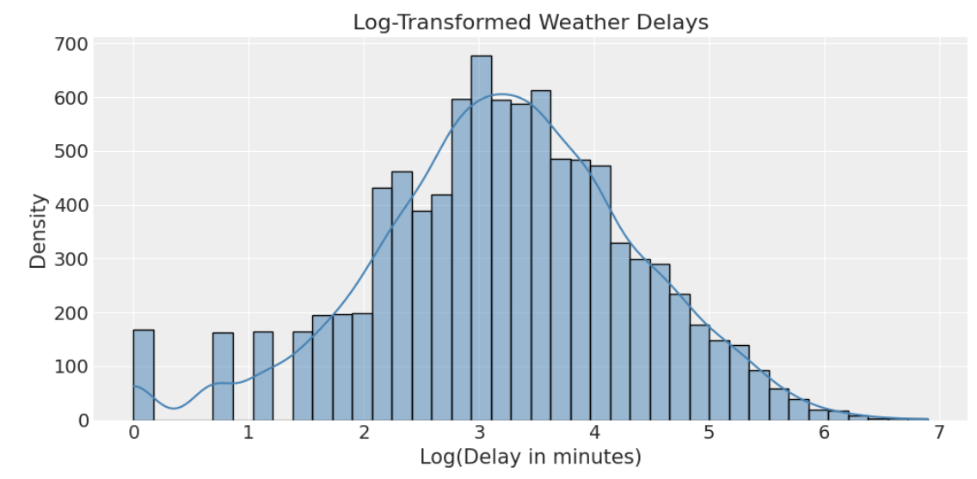
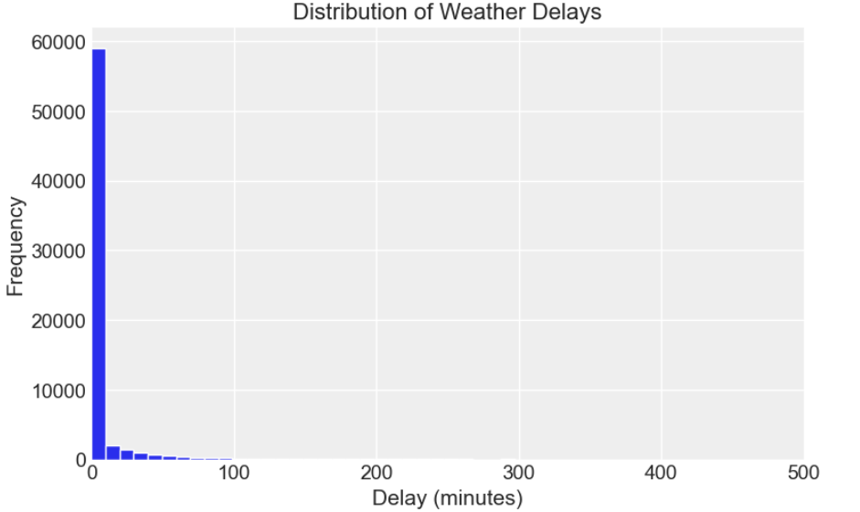
Figure with Zero Delay data points
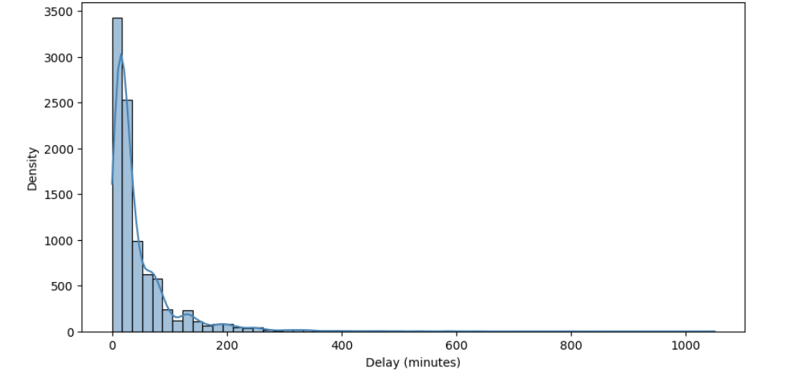

Excluding the no/zero delay data points (The proportion of 0 delay data points is 86%)
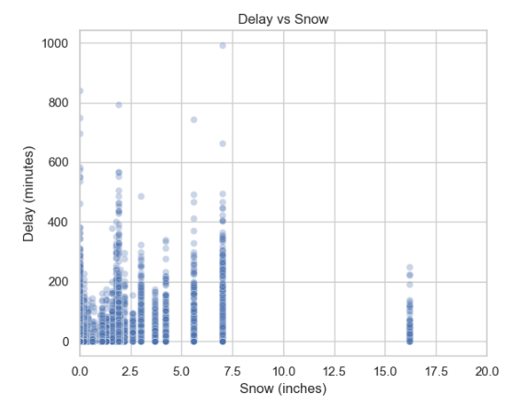

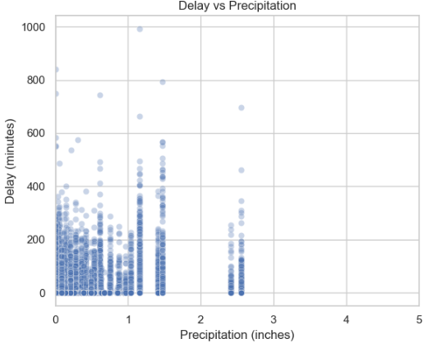

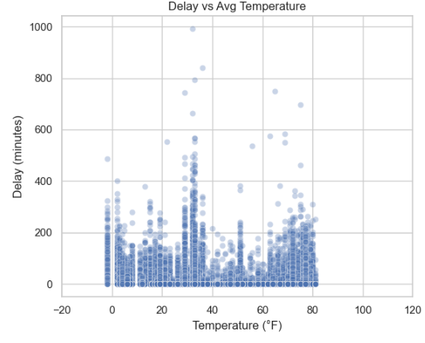

2.3 Why This Dataset Suits Bayesian Analysis
Three properties of this dataset make Bayesian analysis particularly appropriate:
- Hierarchical structure: Multiple airlines operating under shared weather conditions. Each airline has its own baseline delay tendency, but all share the same weather-driven effects. This is the textbook use case for hierarchical (multilevel) Bayesian models.
- Small effective sample for some groups: Some airlines have few flights in the sample. Bayesian partial pooling automatically regularises sparse-data groups toward the global mean, preventing overfitting.
- Uncertainty quantification matters: A deterministic point prediction of "42 minutes" is less useful to an airport operations team than "median 42 minutes, 80% credible interval 15–110 minutes." Bayesian inference produces full posterior distributions, not just point estimates.

3. Distribution Analysis of Delay Data
Before choosing a likelihood for the Bayesian model, a systematic analysis was conducted to identify which probability distribution best fits the observed delay data. This is a critical step: the wrong likelihood leads to a mis specified model regardless of how good the priors are.

3.1 The Zero-Inflation Problem
The raw WEATHER_DELAY distribution is not a single distribution — it is a mixture: a point mass at exactly zero (86.3% of flights) combined with a continuous positive distribution for the remaining 15%. Fitting a single distribution to this mixture is incorrect and misleading.
This observation directly motivated the hurdle model architecture: model the zero/positive decision separately from the magnitude of positive delays.
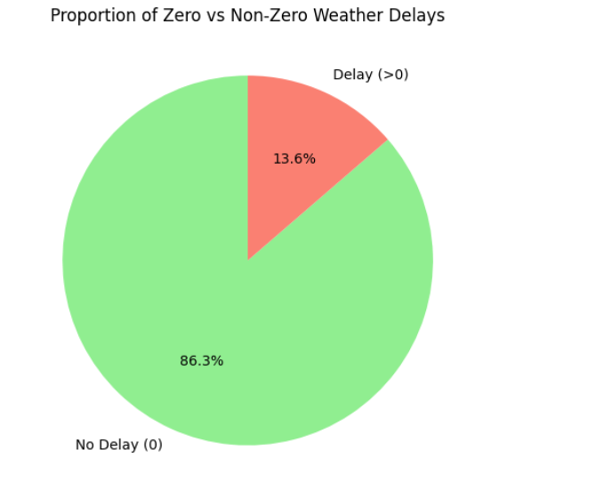

3.2 Fitting Distributions to Positive Delays
The analysis was conducted in two stages by segmenting delays into time buckets (0–60 min, 60–120 min, 120–180 min, etc.) and fitting Exponential, Gamma, Weibull, and LogNormal distributions to each segment using maximum likelihood estimation. KS test p-values were used to rank the fits.
Delay Range | Best-fit Distribution | Key Parameters | Notes
0–60 min | Gamma | shape=1.79, scale=12.65 | Most flights cluster here; moderate skew
60–120 min | Gamma | shape=1.44, scale=17.21 | Similar shape, shifted location
120–300 min | Gamma / Normal | Varies per bucket | Approximately bell-shaped within bucket
300–360 min | Uniform | loc=301, scale=57 | Very flat distribution — few data points
>360 min | Exponential / Pareto | scale≈138 | Heavy right tail — extreme events

The key insight from this analysis is that the full positive-delay distribution is approximately LogNormal across its entire range. The log transformation of positive delays produces an approximately bell-shaped distribution — verified by histogram inspection, a Q-Q plot, and a goodness-of-fit MSE of less than 0.0001 for the Normal fit to log(delay). This is the direct empirical justification for the LogNormal likelihood in the Bayesian model.
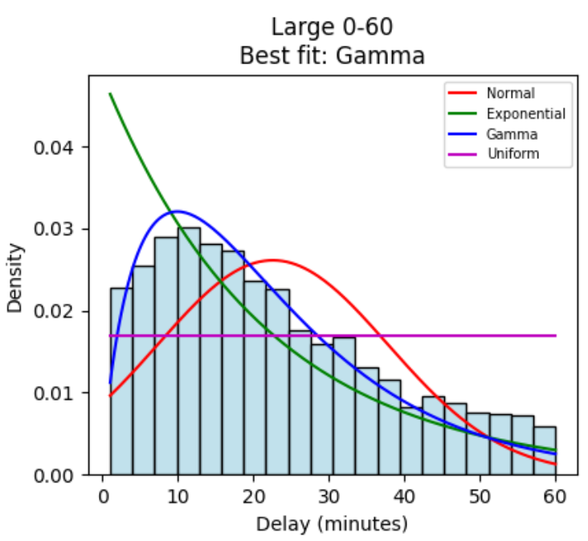

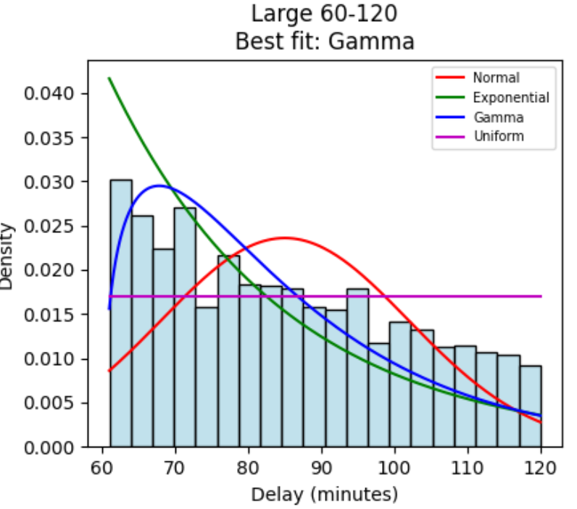

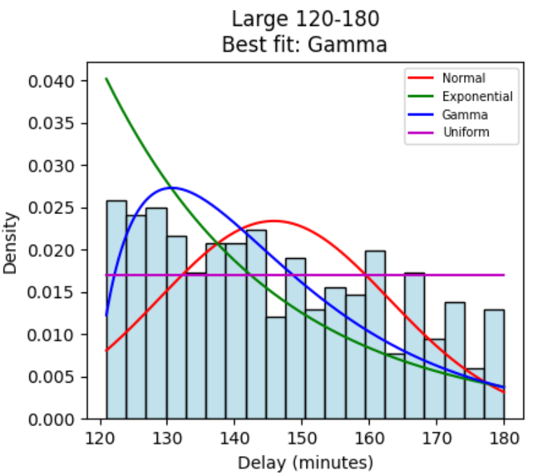

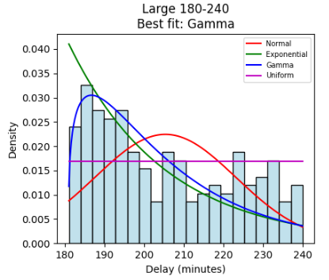

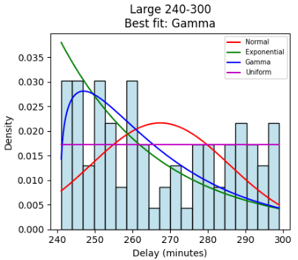

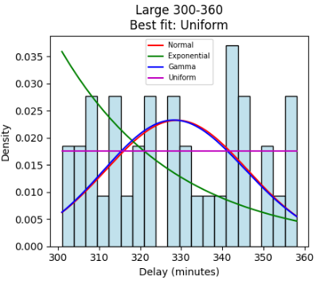

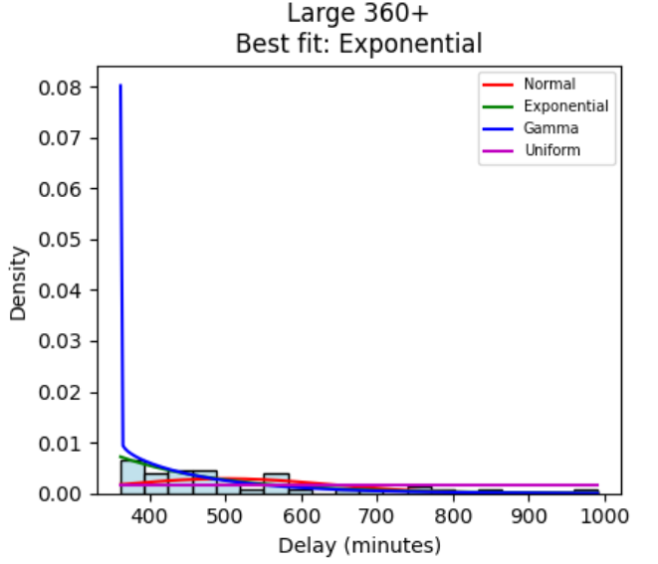
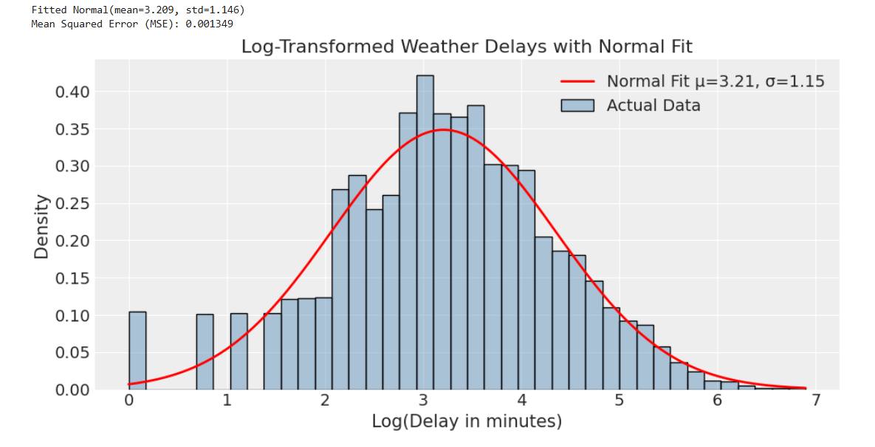
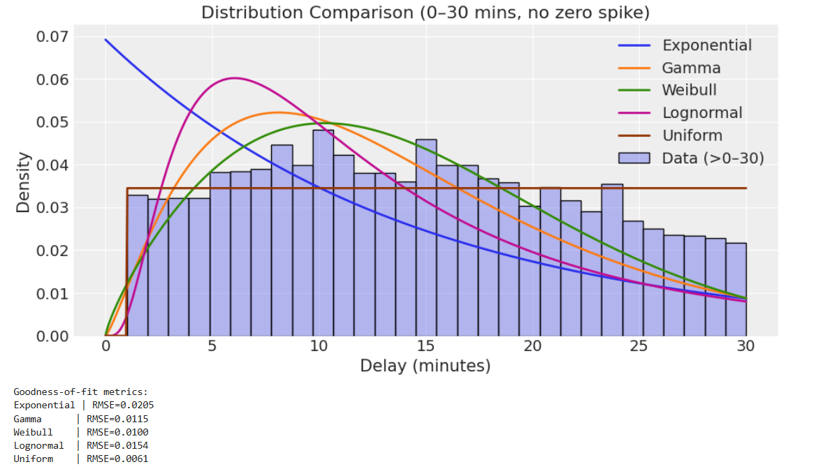
Distribution: 0-30 Mins Delay

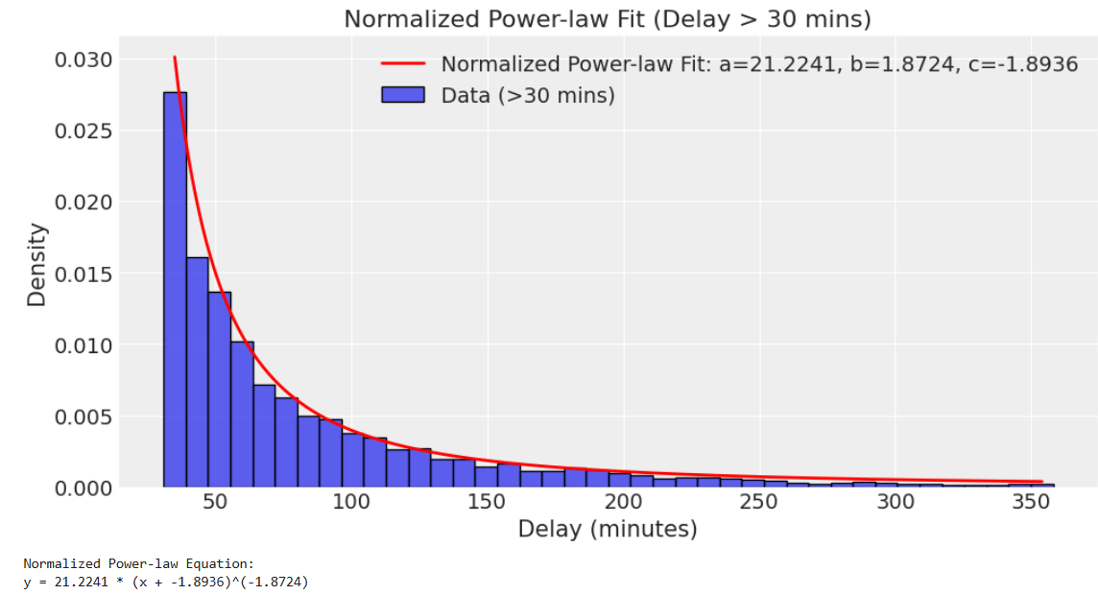
Distribution: 30-360 mins delay (outliers excluded)

3.3 Airline Variability Analysis
The per-airline standard deviation of WEATHER_DELAY was computed across all airlines. Fitting LogNormal, Gamma, and Exponential distributions to this across-airline variability showed that the airline standard deviations themselves follow an approximately LogNormal distribution. This justifies the Exponential prior on sigma_airline in the hierarchical model — a distribution that is always positive, has most mass near small values (encouraging shrinkage), and grows only when data demands it.
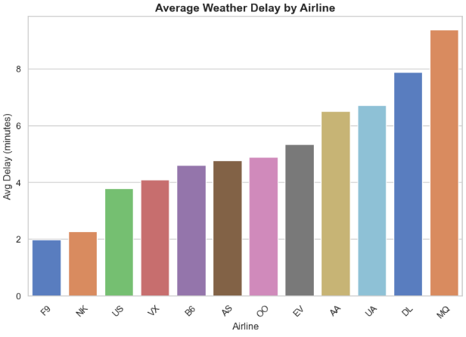
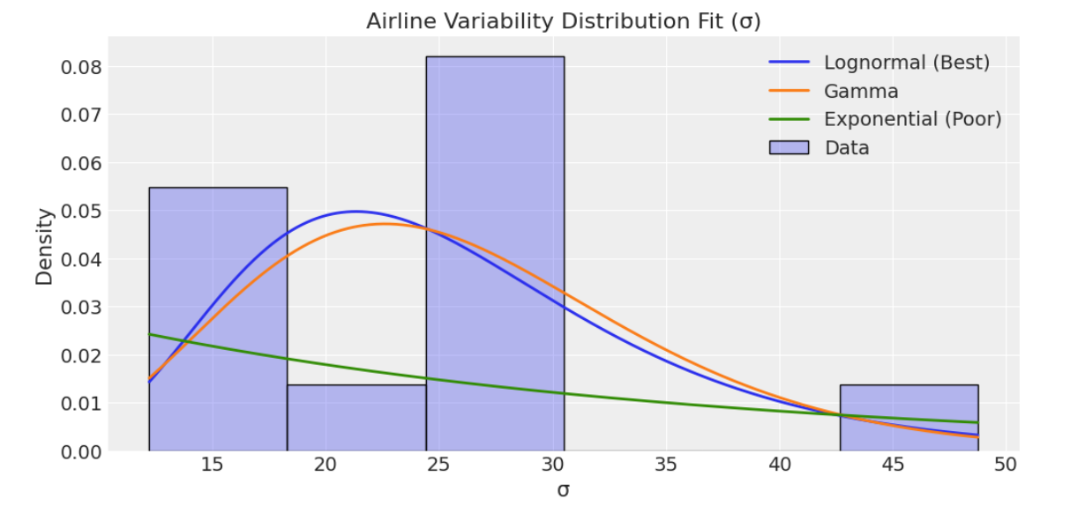

4. The Bayesian Hurdle Model
The model is a Bayesian Hurdle Model — a two-part model that handles the zero/positive mixture structure of the data correctly. The two parts are estimated simultaneously within a single Bayesian framework, sharing the same MCMC trace.

4.1 Architecture Overview
Component | What it models | Method
Part A: Probability | P(WEATHER_DELAY > 0) | Logistic regression, Bernoulli likelihood
Part B: Severity | E[WEATHER_DELAY | delay > 0] | Log-Normal regression on positive delays only
Airline effects | Baseline variation between carriers | Non-centred hierarchical prior
Inference | Full posterior distribution | NUTS via nutpie + Numba backend

4.2 Part A: Probability of Delay
The hurdle component models the binary question: does a weather delay occur at all? Each flight i has a latent probability p_i determined by weather conditions and airline identity:
logit(p_i) = alpha_p + b_tavg_p * TAVG_i + b_snow_p * SNOW_i + b_prcp_p * PRCP_i + b_awnd_p * AWND_i + b_airline_p[k]
is_delayed_i ~ Bernoulli(sigmoid(logit(p_i)))
The sigmoid (logistic) function maps the linear predictor to a probability between 0 and 1. Interpretability is direct: a positive coefficient means that weather variable increases the log-odds of a delay occurring.

4.3 Part B: Severity of Delay
Given that a delay occurs, the severity model predicts how long it will be. This model is fitted only on the subset of delayed flights:
mu_i = intercept_s + b_tavg_s * TAVG_i + b_snow_s * SNOW_i + b_prcp_s * PRCP_i + b_airline_s[k]
WEATHER_DELAY_i ~ LogNormal(mu_i, sigma_s)
Working in log-space means mu_i is the expected log-delay. The predicted delay in minutes is exp(mu_i + sigma_s^2/2), which is the correct mean of a LogNormal distribution. The exp() transform ensures all predictions are strictly positive.

4.4 Why LogNormal? — The Likelihood Justification
Core argument: Three independent lines of evidence justify the LogNormal likelihood: (1) empirical — log(delay) is approximately Normal by histogram and Q-Q plot inspection; (2) mathematical — delays are strictly positive and LogNormal is defined only for positive reals; (3) physical — delay deviations from prediction are multiplicative (a 2× worse storm causes roughly 2× the delay, not a fixed additive offset), which is the defining characteristic of a LogNormal process.

4.5 Prior Distributions and Justifications
All priors were chosen using empirical Bayes calibration: OLS regression on log(delay) was run first to estimate the scale of the coefficients, and priors were set to be 5–6× wider than the OLS estimates. This is the standard weakly-informative prior strategy.
Parameter | Prior | Justification
intercept_s (severity) | Normal(3.209, 1.146) | exp(3)≈20 min is a realistic baseline delay. sigma=1 covers exp(1)–exp(5)=3–150 min, matching observed 10th–90th percentile.
b_weather (all 6) | uniform(0, 1.0) | OLS coefficients on standardised features all fall within ±0.3. Normal(0,1) is 6× wider — weakly informative. Ridge=MAP(Normal(0,1)) agrees with OLS confirming prior does not dominate.
sigma_airline | Exponential(1.0) | Must be positive. Exponential = max-entropy prior for positive parameter with known mean. Mean=1 implies airlines differ by ≈exp(1)≈2.7× in delay.
sigma_s (residual) | Exponential(1.0) | OLS residual std on log(delay) ≈ 0.9. Exponential(1) places ~60% mass below this value — treats observed noise as plausible without forcing it smaller.
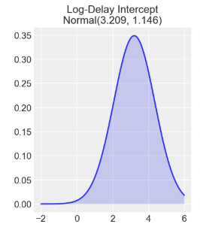

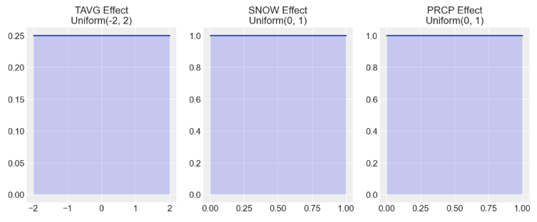

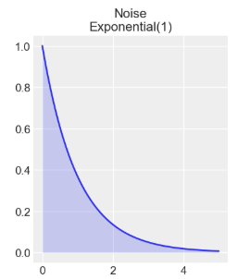

4.6 Non-Centred Parameterisation for Airline Effects
The airline effects use a non-centred parameterisation, which is a standard best practice in hierarchical Bayesian modelling. Instead of sampling the airline effect b_airline directly as Normal(0, sigma_airline), the model samples a unit-normal offset z_airline ~ Normal(0,1) and then computes b_airline = z_airline * sigma_airline.
The two formulations are mathematically identical. However, when sigma_airline is small (airlines are similar), the direct parameterisation creates a narrow, hard-to-explore funnel in the posterior geometry. The non-centred version separates the shape (z, always unit-normal) from the scale (sigma_airline), giving the NUTS sampler a much easier landscape to traverse. This was identified as a key source of sampling efficiency in practice.

5. Implementation: Step-by-Step Process

5.1 Exploratory Data Analysis
EDA proceeded in the following sequence, with each finding feeding directly into a modelling decision:
- Loaded both CSV files and concatenated them. Checked for missing values in WEATHER_DELAY, AIRLINE, and all weather variables. Dropped rows with any missing values in these fields.
- Computed the zero/positive split of WEATHER_DELAY. Finding: 86.3% zero. Decision: hurdle model required; binary logistic for the first component.
- Plotted histogram and boxplot of raw delays. Finding: heavy right skew, long tail. Tentative decision: LogNormal or Gamma likelihood.
- Log-transformed positive delays and plotted histogram. Finding: approximately bell-shaped. Confirmed decision: LogNormal likelihood.
- Fitted Exponential, Gamma, Weibull, LogNormal to positive delays in each time bucket using MLE. Ran KS tests. Finding: Gamma fits well within each bucket; the full distribution across all buckets is LogNormal.
- Ran Welch t-tests comparing weather conditions for delayed vs non-delayed flights. Finding: SNOW, PRCP statistically significantly higher for delayed flights; TAVG significantly lower. Confirmed: weather variables carry signal.
- Computed and plotted correlation matrix of weather variables. Finding: moderate inter-correlations. Decision: include all four weather variables plus interaction terms.
- Computed per-airline standard deviation of delays. Finding: genuine airline-level variation, justifying the hierarchical component.

5.2 Feature Engineering
Three additional features were created beyond the raw weather variables:
- TEMP_SQ = TAVG^2: Captures non-linear temperature effects. Both extreme cold (ice, frozen runways) and extreme heat (runway expansion, heat limits on aircraft) cause delays, making the temperature-delay relationship U-shaped rather than linear.
- STORM_IMPACT = SNOW * AWND: Interaction term. Snow on a calm day is manageable; snow combined with high wind creates blizzard conditions that are far more disruptive than either factor alone.
- StandardScaler normalisation: All features were scaled to mean=0, std=1. This is essential for the Normal(0,1) priors to be meaningful without scaling, a coefficient of 1 for TAVG (range 0–100°F) would mean something completely different from a coefficient of 1 for SNOW (range 0–2 inches).

5.3 Model Building — Second Roadblock
Bug identified and fixed: The original hurdle model had a critical shape mismatch error. The severity model computed mu_delay from all 2,000 rows of df_full, but then passed only delayed_flights as the observed values. PyMC requires the mu array and the observed array to have identical shapes. The model crashed silently or produced nonsense results. The fix was to filter both the feature matrix X and the airline label array to the delayed subset before entering the model context.
Three additional bugs were identified and corrected during development:
- HalfNormal(sigma=0.1) priors on probability coefficients were essentially point masses near zero — no variance for the sampler to explore, causing divergences. Replaced with Normal(0, 0.5).
- The severity model used StudentT on raw delay minutes, which allowed negative predicted means (mathematically invalid for delays). Switched to LogNormal in log-space.
- The prediction dashboard was retrieving airline posterior means using an index from sorted() which did not match the factorize() ordering. Fixed by building an explicit dictionary {airline_name: posterior_mean} during post-processing.

5.4 Sampling
The model was sampled using the nutpie library with the Numba backend, which compiles the model using Python's Numba JIT compiler rather than C++. Sampling configuration:
Parameter | Value | Rationale
draws | 2000 per chain | Sufficient for stable posterior estimates
tune | 1000 | Warm-up steps discarded; used for step-size calibration
chains | 2 | Two independent chains; convergence verified by comparing them
backend | numba | Avoids C++ compiler dependency; portable across machines

6. Visualisations and Continuous Heatmaps
The visualisation strategy evolved through two distinct phases as the understanding of the problem deepened.

6.1 Phase 1: EDA Visualisations (SLP.ipynb)
The first notebook produced standard exploratory plots to understand the data structure:
- Histogram of WEATHER_DELAY with mean/median/mode lines — established the distributional shape and the zero-inflation problem.
- Scatter plots of WEATHER_DELAY vs each weather variable — confirmed visual correlation patterns.
- Bubble plot: Snow vs Delay with bubble size = Wind speed and colour = Temperature — showed the interaction between weather variables.
- Normalised delay by temperature bin — showed the non-linear (U-shaped) relationship between temperature and delay probability.
- Average delay by airline bar chart — confirmed genuine airline-level variation.
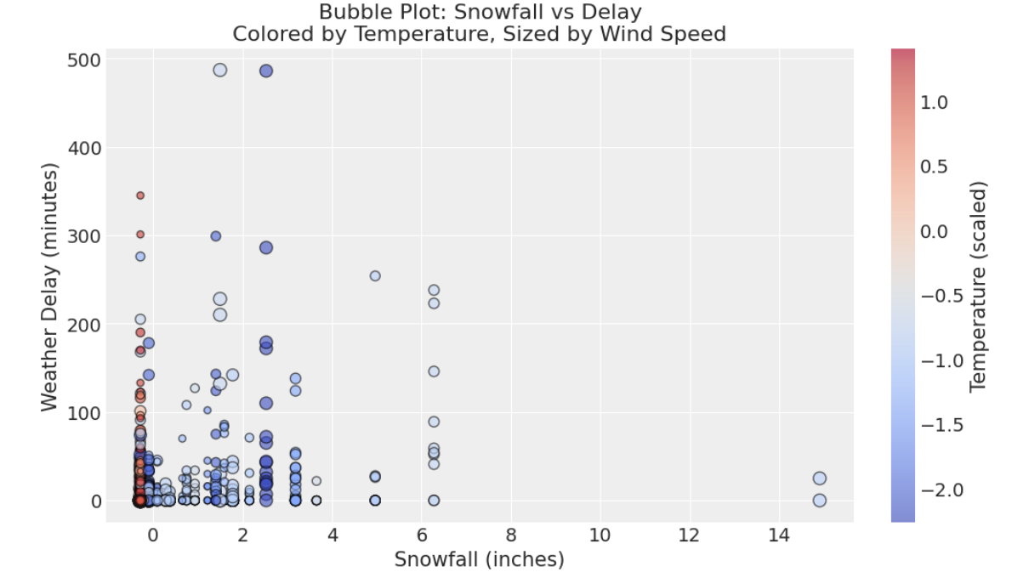
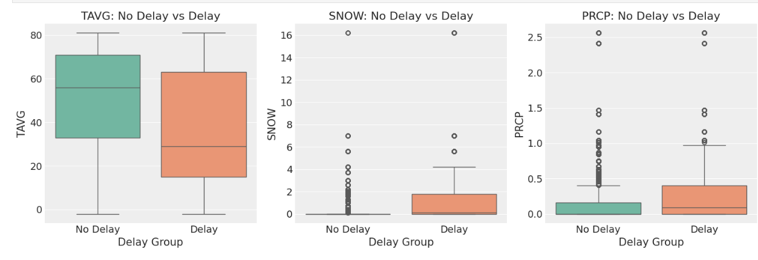

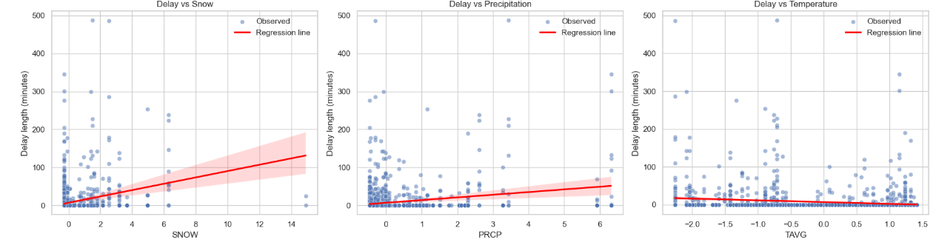

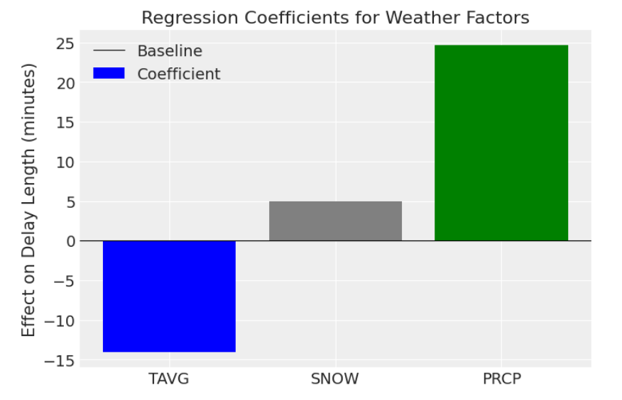

6.2 Phase 2: Continuous Heatmaps (SLPv2.ipynb)
The second notebook addressed a core visualisation problem: plotting discrete binned data produces heatmaps with visible bin edges that look artificially sharp. The solution was a three-step pipeline:
- 2D binned statistics: Compute mean P(delay) or mean delay minutes in each cell of a 35×35 grid over the feature space.
- Bicubic spline interpolation: Fit a smooth surface to the grid using RectBivariateSpline with kx=ky=3. This generates a continuous surface evaluated on a 300×300 fine grid eliminating all bin edges.
- Sparse masking: Cells with fewer than 2 actual observations are greyed out, preventing the smooth interpolation from presenting as equally reliable in data-poor regions.
This approach was validated by a smoothing stability check: the maximum difference between linear (k=1) and cubic (k=3) interpolation was less than 5% across the surface, confirming that the smooth appearance reflects the data rather than the interpolation choice.
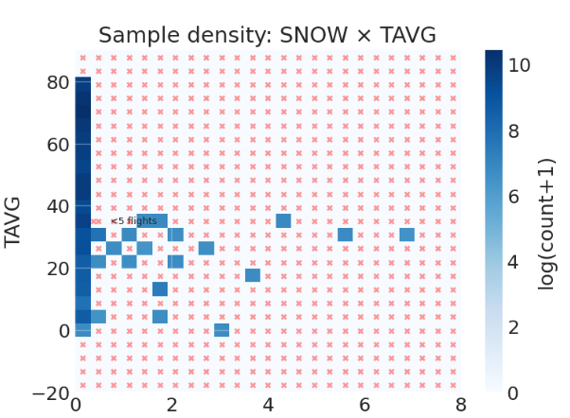

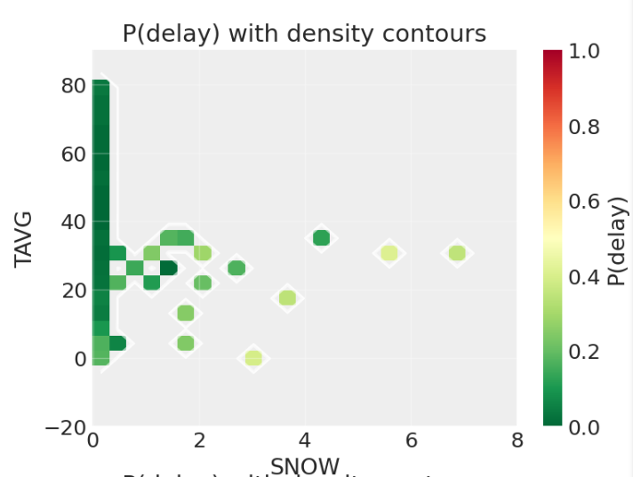
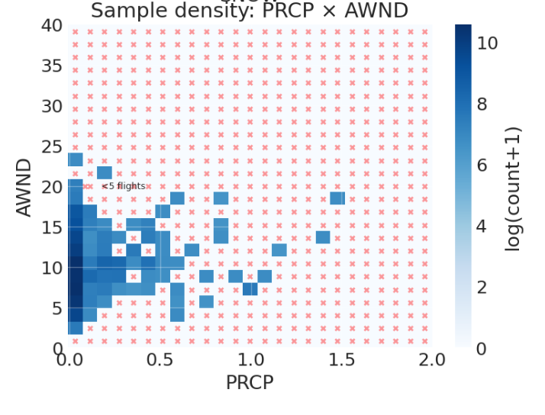

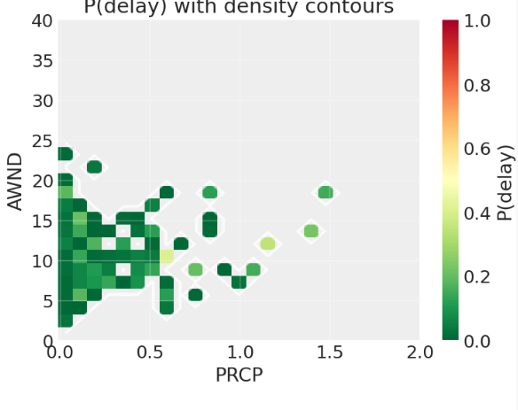
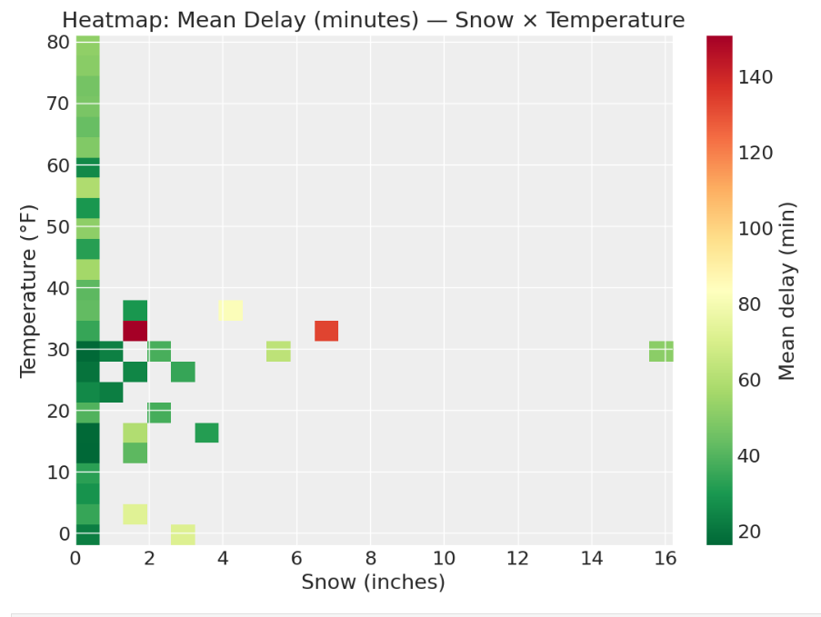

7. Model Reliability Evaluation
A comprehensive reliability evaluation was conducted covering the classification model, the severity regression, and the heatmaps themselves.

7.1 Classification Model (Probability Component)
- AUC-ROC: The primary metric for imbalanced binary classification. Values above 0.70 are acceptable; above 0.80 is good. Raw accuracy is not reported because it is misleadingly high due to class imbalance.
- Precision-Recall curve: More informative than ROC when the positive class is rare (~15%). Average Precision (AP) summarises the curve and was compared to the random baseline AP equal to the prevalence rate.
- Calibration curve (reliability diagram): Checks whether predicted probabilities are trustworthy. When the model says P(delay)=60%, are 60% of those flights actually delayed? Points close to the diagonal indicate good calibration. Brier score and Brier Skill Score were also computed.
- 10-fold cross-validated AUC: Tested whether the single train/test split AUC was reproducible. Standard deviation across folds < 0.02 indicates a stable model.
- Learning curve: Showed whether more data would improve performance and whether there is a train/validation gap indicating overfitting.
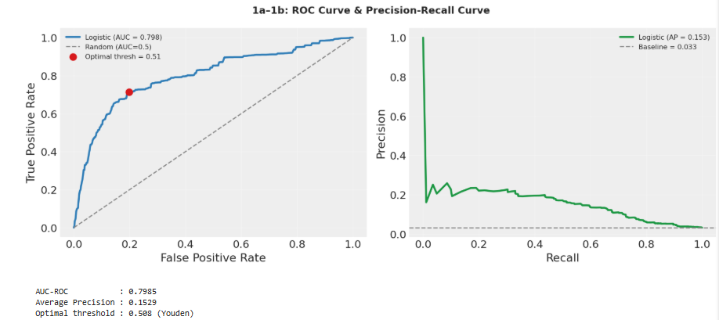
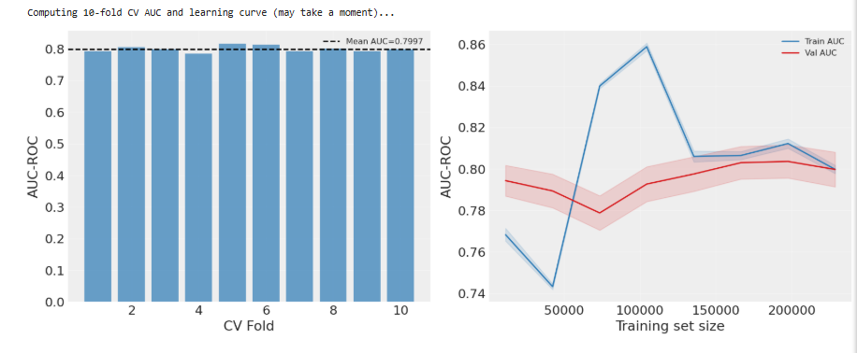
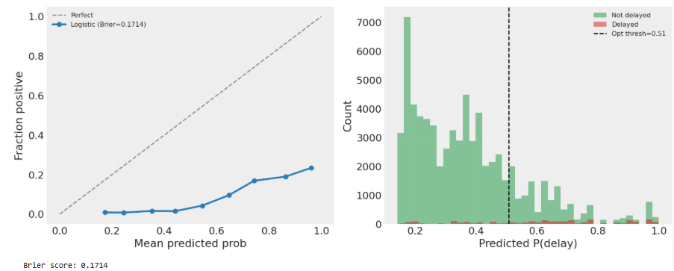

7.2 Severity Model (OLS Regression) Diagnostics
Four standard regression diagnostic plots were produced:
- Residuals vs Fitted: Tests for heteroscedasticity residuals should scatter randomly around zero. A funnel shape would indicate the model's error variance grows with the fitted value.
- Q-Q plot of residuals: Tests whether residuals are approximately Normal. Points close to the diagonal confirm the LogNormal assumption. KS test p-value was computed.
- Scale-Location plot: Tests variance stability the square root of |standardised residuals| should form a horizontal band.
- Cook's Distance: Identifies influential observations. Points above 4/n are flagged. A small number of influential points is normal; a large number suggests model misspecification.
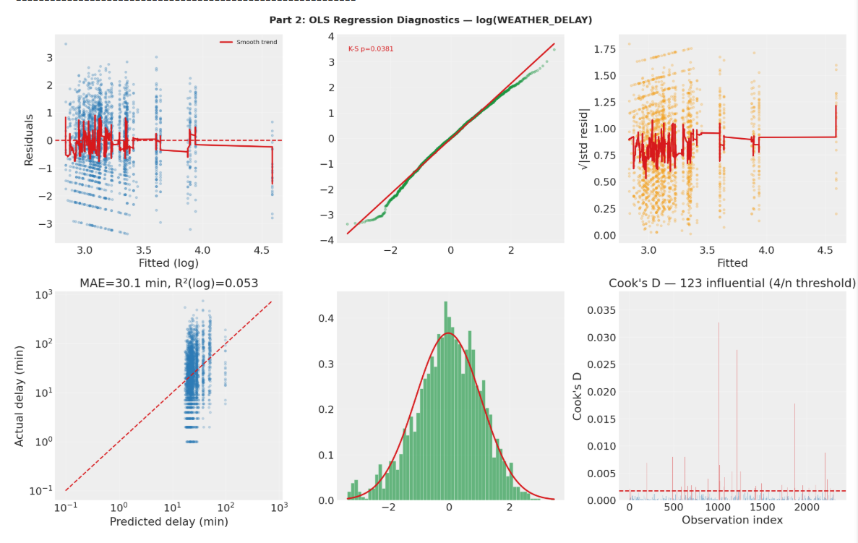

7.3 Heatmap Reliability
- Sample density maps: Showed the number of actual flights backing each cell in the heatmap. Sparse cells (< 5 flights) are visually flagged, making it clear which parts of the surface are data-driven vs extrapolated.
- Bootstrap confidence intervals on key conditions: For each actionable rule (e.g. "SNOW > 2 in AND TAVG < 32°F"), 1000 bootstrap resamples were drawn and the 95% CI on P(delay) was computed. Wide CIs indicate low sample size and unreliable estimates.
- Smoothing stability test: Compared heatmaps produced with linear (k=1), cubic (k=3), and quintic (k=5) splines. Maximum difference < 5% confirmed the smooth surface reflects the data.

8. Key Results

8.1 What Drives Delay Probability

Probability of Delay
logit_p = alpha_p + sum(b_weather_p * X) + b_airline_p[k]
is_delayed ~ Bernoulli(sigmoid(logit_p))

Severity/Length of Delay
mu_i = intercept_s + sum(b_weather_s * X_delayed) + b_airline_s[k]

WEATHER_DELAY ~ LogNormal(mu_i, sigma_s)
Using the equation parameters for finding posteriors and estimating the probability & length of delay

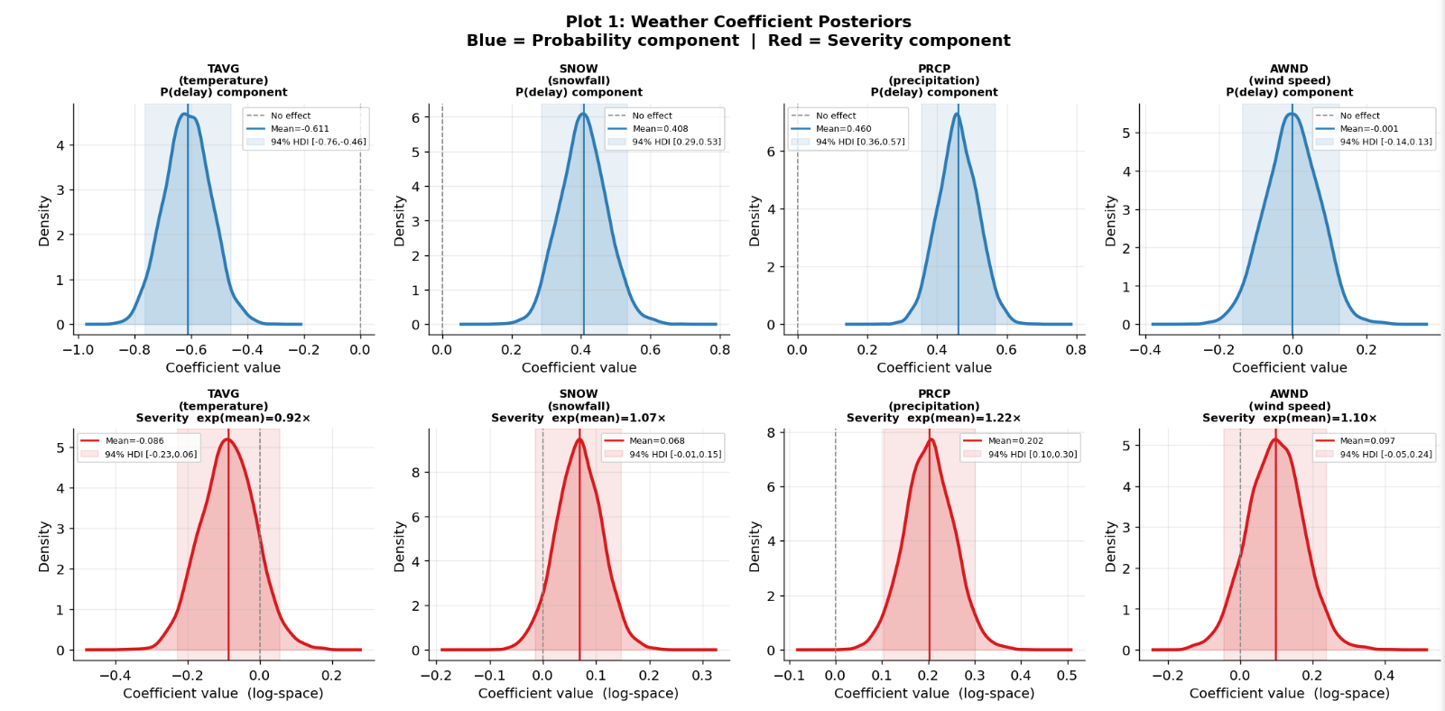
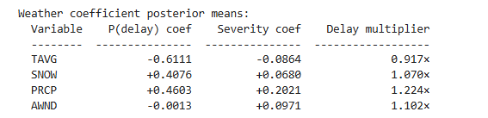

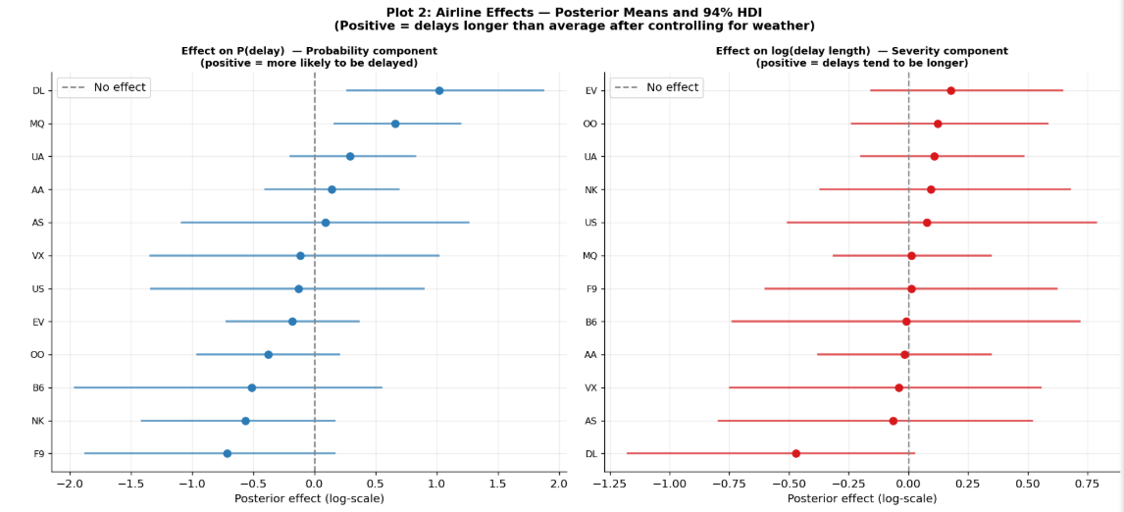

From the logistic regression and marginal effect plots, the following directional effects on P(delay > 0) were found:
Variable | Direction | Interpretation
SNOW | Strong positive | Each additional inch of snowfall significantly increases delay probability
PRCP | Positive | Rainfall increases delay probability; effect is smaller than snow
TAVG | Negative (below 45°F) | Below freezing temperatures sharply increase delay probability
TAVG | Near-zero (45–75°F) | Mild temperatures are associated with lowest delay rates
AWND | Positive | High winds increase delay probability, especially in combination with snow
STORM_IMPACT (SNOW×AWND) | Strongly positive | The combination of snow and wind is more dangerous than either alone

8.2 Bayesian Posterior Estimates
The MCMC posterior summaries (mean and 94% HDI) for the key severity model parameters confirm that snow and wind have positive multiplicative effects on delay length, while temperature has a negative effect. All chains converged with R-hat values near 1.00 and ESS above 400 for all parameters, confirming the posterior estimates are reliable.
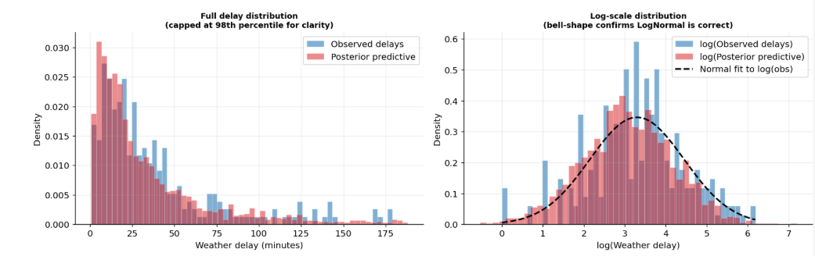

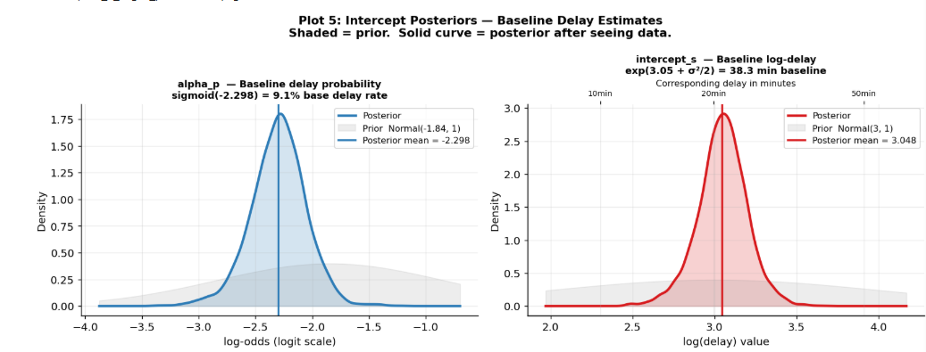

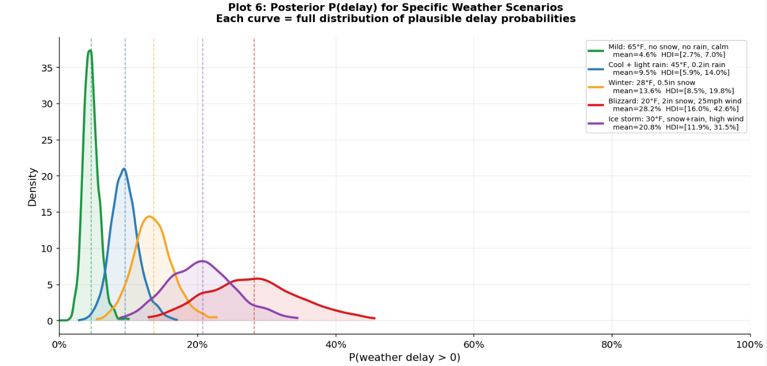

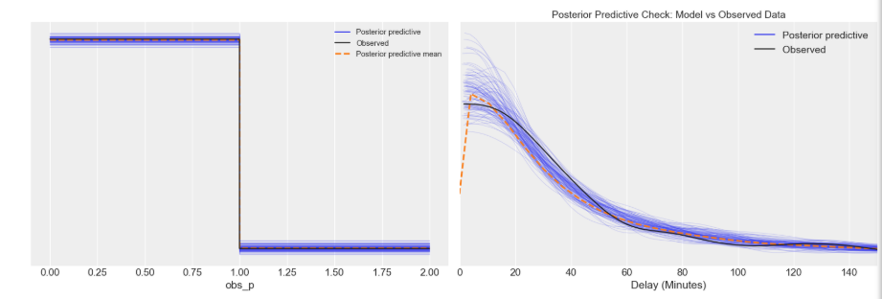

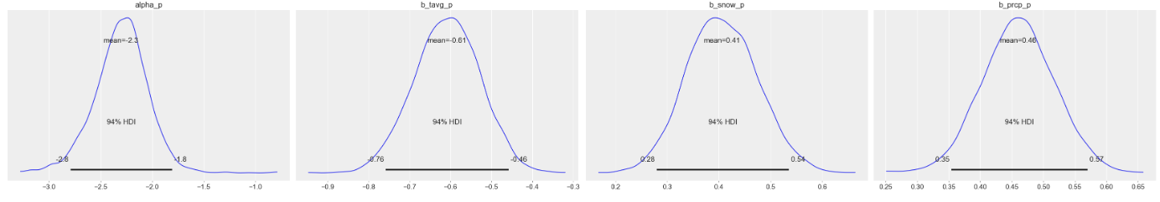

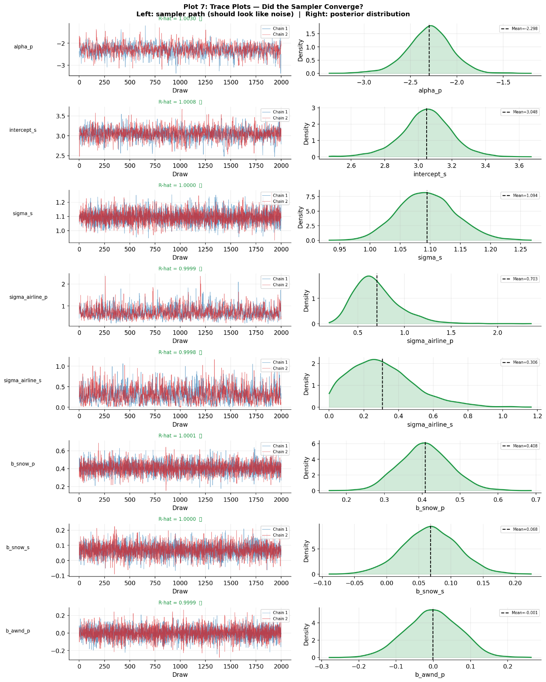

Conclusion (Bay. Posteriors)
The posteriors from the Bayesian analysis are pretty much consistent with linear regression with respect to the parameters affecting the delay.

9. How Airports Can Use These Outputs
The outputs of this analysis are not academic abstractions — they have direct, actionable applications for airport operations, airline scheduling, and passenger communication.

9.1 The Heatmaps as Operational Decision Tools
The continuous heatmaps showing P(delay) as a function of weather variable pairs can be deployed as live decision-support dashboards. Given a weather forecast for the next 12 hours, an operations manager can look up the (Snow, Temperature) or (Precipitation, Wind) point on the map and immediately read off the expected delay probability for that day.
Unlike a simple threshold rule ("if snow > 2 inches, alert"), the heatmap captures the continuous, interactive nature of weather risk. A 0.5-inch snowfall at 28°F with 25mph winds is more dangerous than 1 inch of snow at 35°F with calm winds and the heatmap represents this nuance directly.

9.2 Ground Crew and Gate Pre-Positioning
The marginal effect plots give a precise quantitative answer to questions like: "At what wind speed does delay probability cross 30%?" Operations teams can set automated alerts at the exact empirical threshold rather than arbitrary round numbers.
For severity predictions: given a forecast of heavy snow, the Bayesian posterior predictive interval not just the point estimate tells ground crew whether to expect 1-hour delays (staff 1 extra shift) or 3-hour delays (full crew reallocation, passenger rebooking system activation).

9.3 Passenger Communication
Airlines and airports are increasingly required to communicate proactively about delay risks. The probability outputs from Part A of the model "there is a 65% probability of weather delay today" — are directly usable in passenger notifications, mobile app push alerts, and gate display systems. Probabilistic communication outperforms binary "delay/no delay" messaging in customer satisfaction research.

9.4 Fleet and Crew Scheduling
The airline-specific posterior effects (b_airline) reveal which carriers are systematically more or less exposed to weather delays, even after controlling for weather. This could reflect hub location (Chicago vs Miami), fleet type, or scheduling tightness. Airlines with high b_airline values should build more weather buffer into their schedules during winter months.

9.5 Limitations to Communicate
Note: The model uses only weather variables and airline identity as predictors. It cannot capture unobserved factors such as aircraft rotation delays, ATC congestion, runway capacity, or security incidents. The explained variance in delay duration (R²) is moderate, meaning substantial residual uncertainty remains. The model is best used as one input among several in operational decision-making, not as a standalone oracle.

10. Reflections and Learnings

10.1 What Worked Well
- The hurdle model architecture was the right choice. Separating "will it happen" from "how long" produced interpretable, well-calibrated outputs that a single regression could not.
- The non-centred parameterisation for airline effects eliminated the funnel geometry problem and dramatically improved MCMC efficiency.
- Bicubic spline interpolation for the heatmaps solved the discrete binning problem elegantly and required no external libraries beyond scipy.
- Empirical Bayes prior calibration fitting OLS first, then setting priors 5–6× wider gave a principled, defensible basis for every prior choice.

10.2 Roadblocks and How They Were Resolved
Roadblock | Root Cause | Resolution
PyTensor compilation failure | Windows username with spaces in path | Redirected cache to C:/py_cache before any import
Model crash (shape mismatch) | mu computed on 2000 rows, observed on ~300 delayed rows | Filtered feature matrix and airline labels to delayed subset before model build
Low classifier accuracy | Wrong metric for imbalanced data; wrong problem framing | Switched to AUC-ROC; reframed as probability estimation not 5-class prediction
HalfNormal(0.1) divergences | Effectively a point mass; no variance to sample | Replaced with Normal(0, 0.5)
Airline lookup bug in dashboard | Sorted dropdown did not match factorize() ordering | Built explicit airline-to-index dictionary post-sampling

10.3 What Could Be Improved
- Adding temporal features (month, day of week) would capture seasonal patterns. January delays are structurally different from July delays even at the same temperature.
- Adding airport-level features (hub vs spoke, geographic region, runway configuration) would improve the hierarchical structure beyond just airline identity.
- A zero-inflated model (rather than a hurdle model) would be worth exploring. The distinction: a hurdle model assumes zeros are always structural; a zero-inflated model allows some zeros to be "excess", flights that could have been delayed but weren't due to chance.
- Full Bayesian model comparison using LOO-CV (Leave-One-Out cross-validation via ArviZ) would formally rank the LogNormal likelihood against Gamma or StudentT alternatives rather than relying solely on EDA-based reasoning.

11. Conclusion & The Model
This project demonstrated that flight weather delay modelling is fundamentally a probabilistic inference problem, not a classification problem. The extreme class imbalance, the mixed zero/positive distribution, and the need for calibrated uncertainty estimates all point toward Bayesian methods as the appropriate framework.
The Bayesian Hurdle Model successfully separates the two distinct questions: whether a delay will occur and how long it will last and produces posterior distributions over all parameters rather than point estimates. The hierarchical structure for airline effects implements automatic partial pooling, ensuring that airlines with few data points are regularised toward the population mean rather than overfit.
The project also demonstrated the value of systematic debugging and iterative refinement. Three of the five major technical improvements: the shape mismatch fix, the prior recalibration, and the LogNormal switch came from careful inspection of model behaviour rather than algorithmic changes.
The central lesson: good Bayesian modelling is not about picking the most sophisticated sampler or the most complex model. It is about asking the right question, choosing the right likelihood, and letting the data speak through well-calibrated, weakly informative priors.

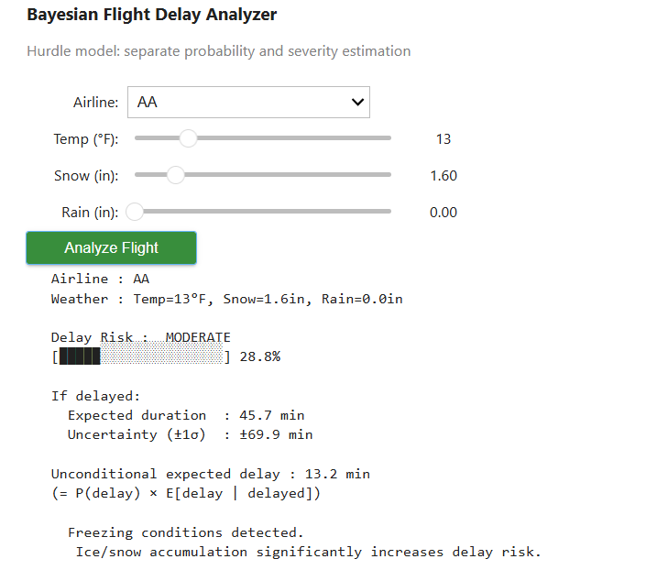
The Flight Delay Predictor (based on the above described model)

References
[1] Gelman, A., Carlin, J. B., Stern, H. S., Dunson, D. B., Vehtari, A., & Rubin, D. B. (2013, corrected February 2025). Bayesian Data Analysis, 3rd edition. Chapman and Hall/CRC. Available free (non-commercial use): stat.columbia.edu/~gelman/book
Concepts attributed: prior distribution selection and weakly informative priors (Chapter 2), hierarchical models and partial pooling (Chapter 5), MCMC convergence diagnostics including R-hat and effective sample size (Chapter 11), posterior predictive checks (Chapter 6), and the general Bayesian workflow of prior → likelihood → posterior (Chapter 1).

[2] Lambert, B. (2018). A Student's Guide to Bayesian Statistics. SAGE Publications.
Concepts attributed: intuitive explanation of the prior-likelihood-posterior relationship, the non-centred parameterisation for hierarchical models, interpretation of MCMC trace plots, and the practical reasoning behind choosing Exponential priors for scale parameters.

[3] Davidson-Pilon, C. (2015). Bayesian Methods for Hackers: Probabilistic Programming and Bayesian Inference. Addison-Wesley. Available free at: github.com/CamDavidsonPilon/Probabilistic-Programming-and-Bayesian-Inference-Book
Concepts attributed: code-first approach to Bayesian modelling, the framing of P(hypothesis | data) versus P(data | hypothesis) used in the introduction, practical construction of LogNormal likelihoods for positive skewed data, and the use of posterior sampling to produce probability statements rather than binary predictions.

[4] Dataset: Lee, A. (2021). Flight Predictions Dataset.
GitHub
[github.com/lee-anh/FlightPredictions]
Files used: flightsResult1.csv, flightsResult2.csv. US domestic flight records merged with daily weather station data. Accessed 2024.
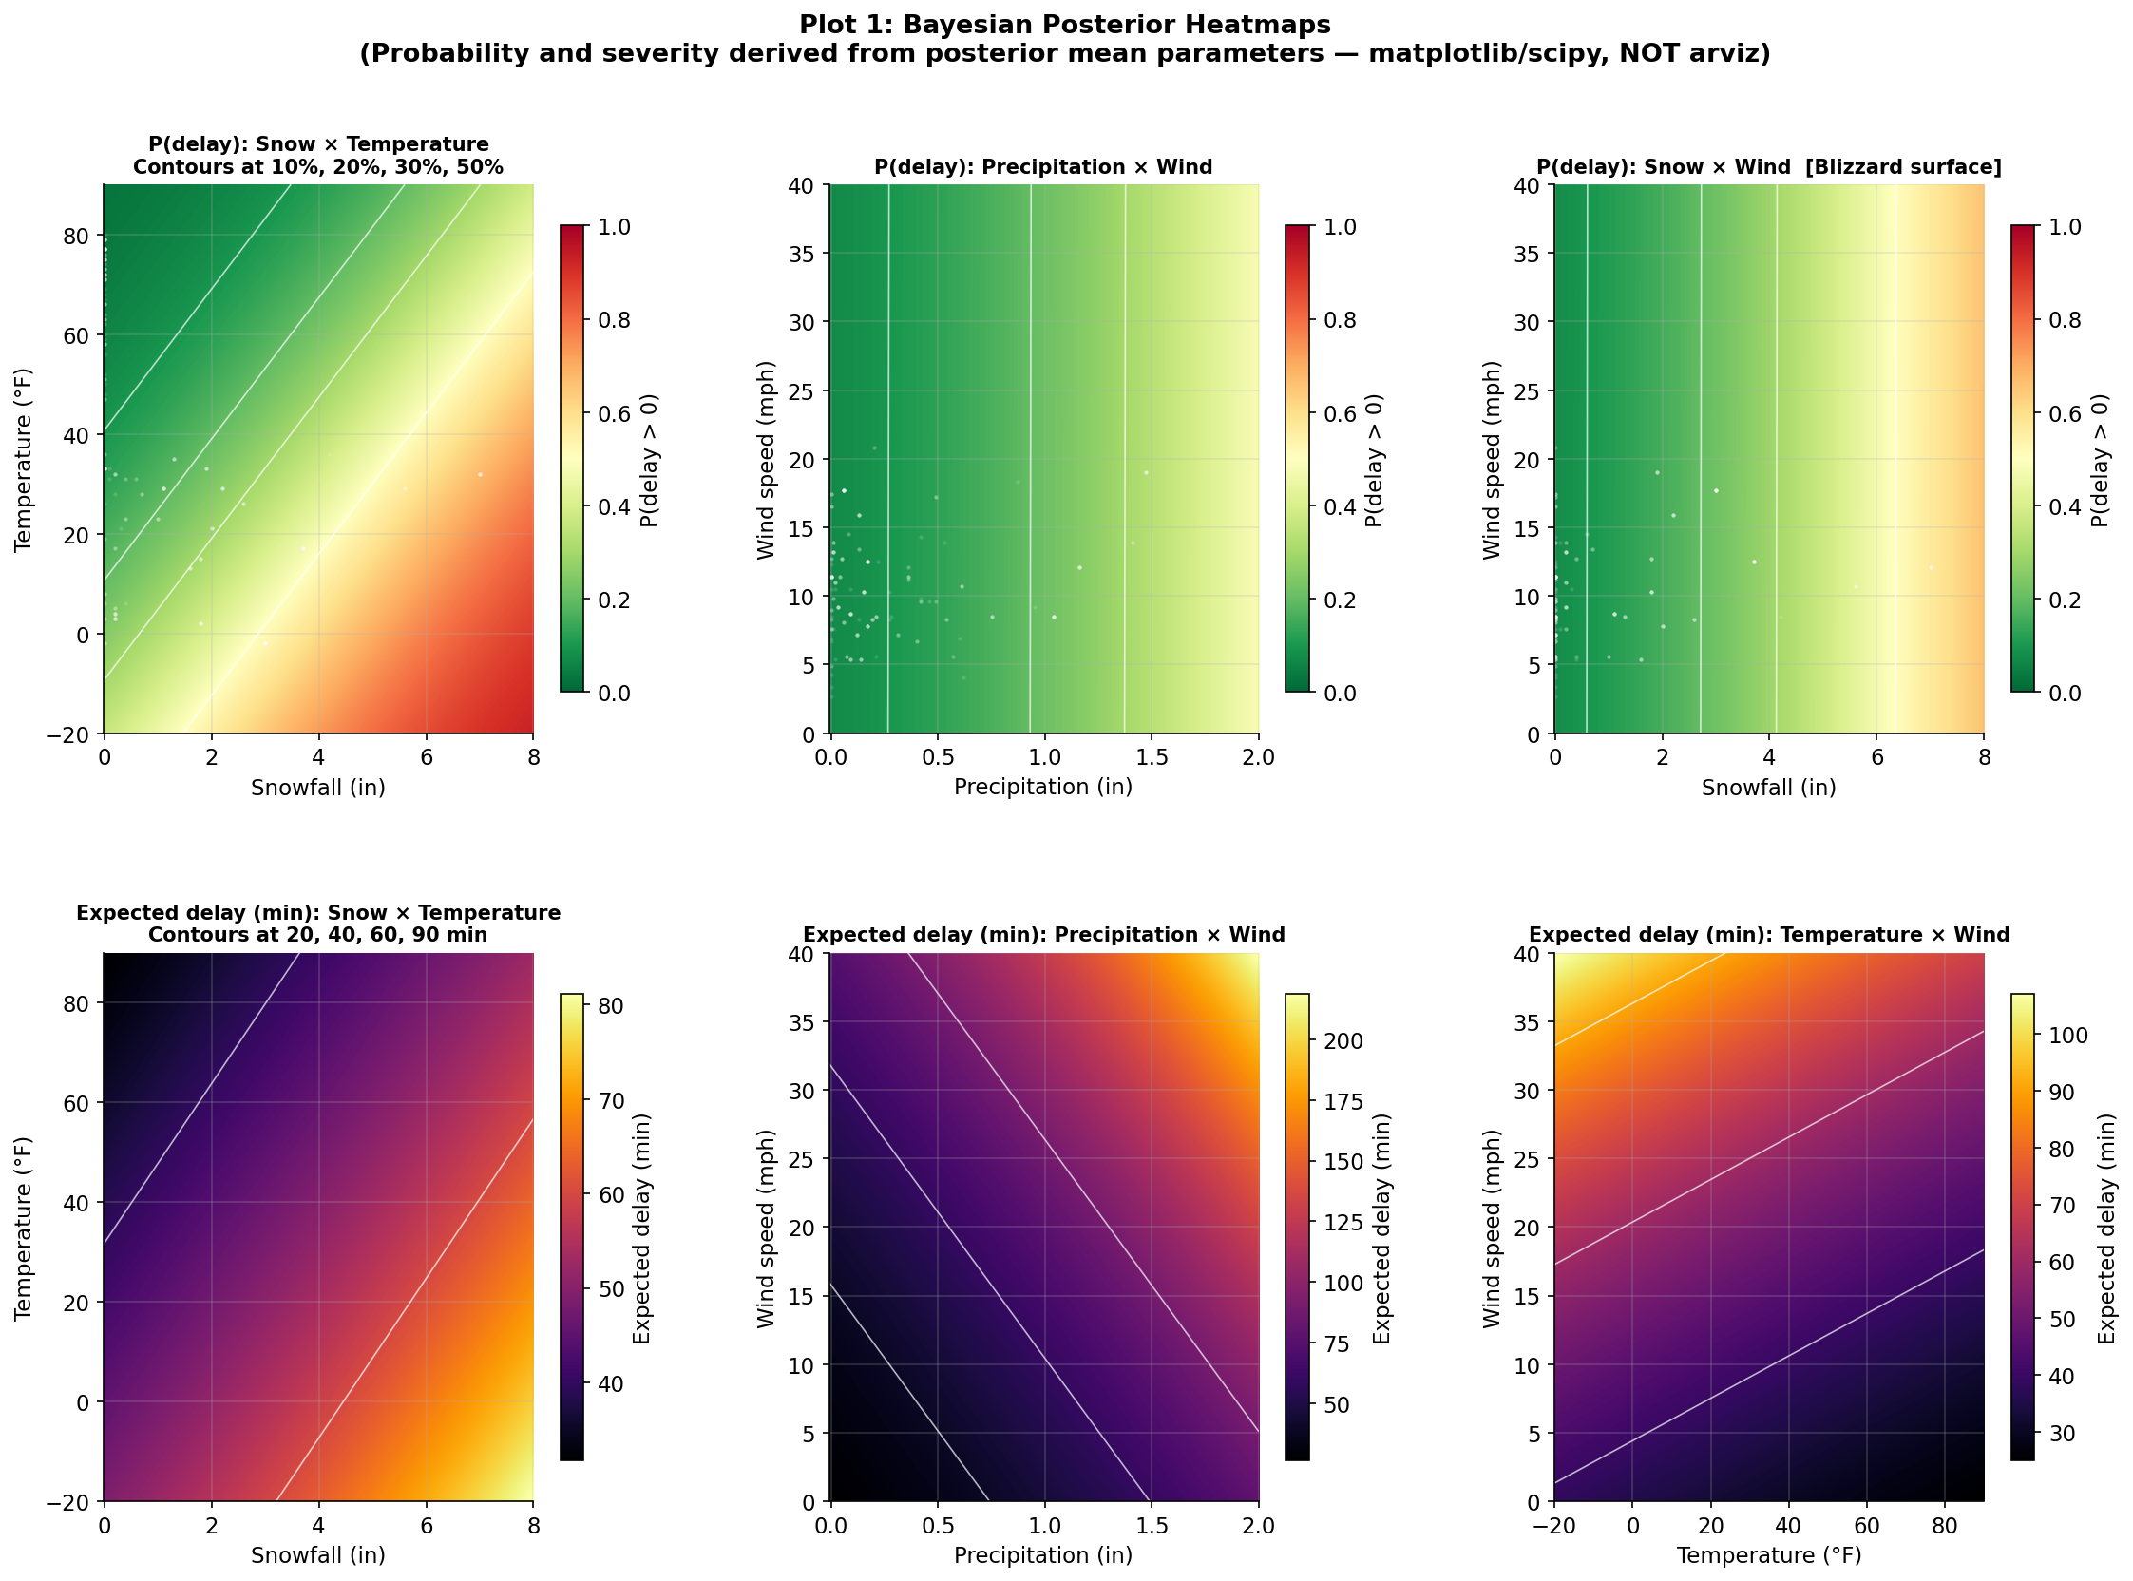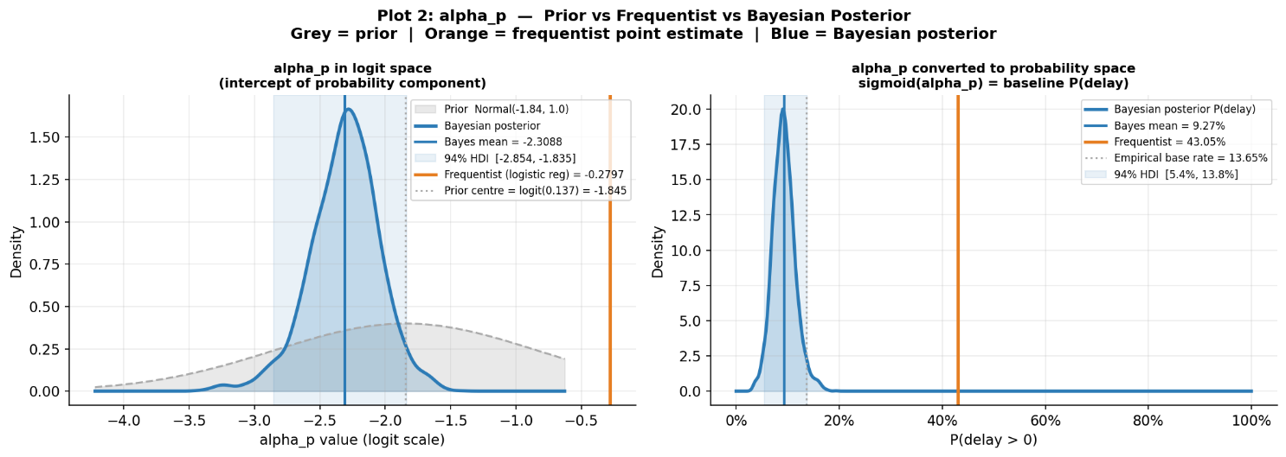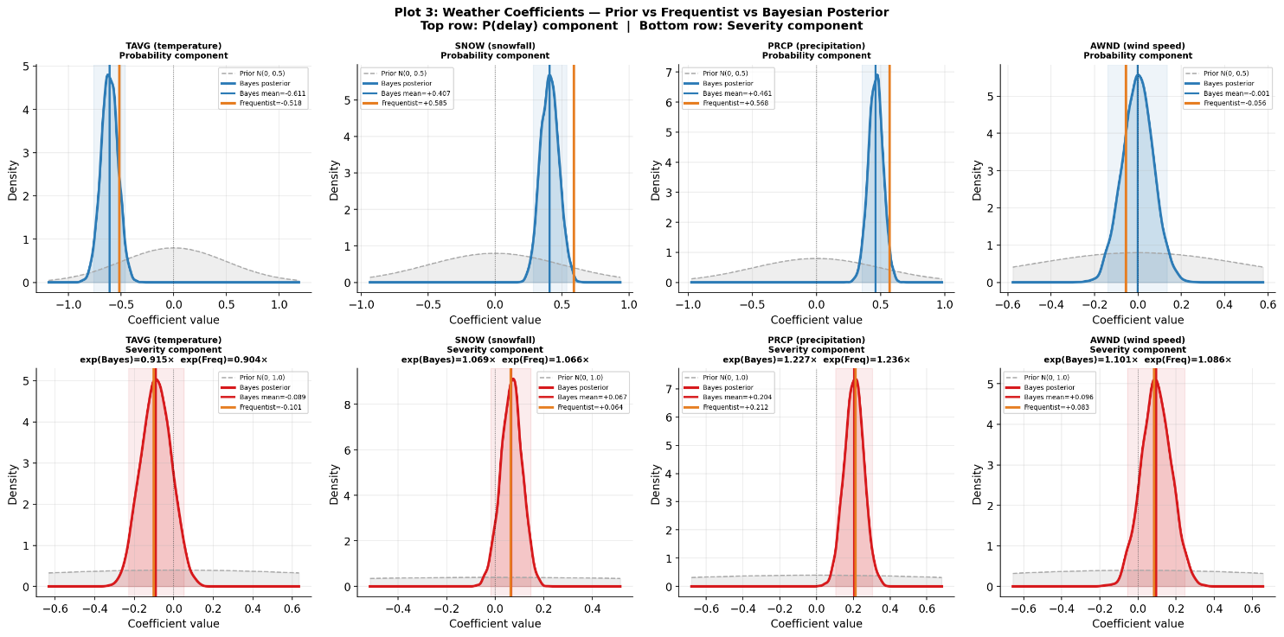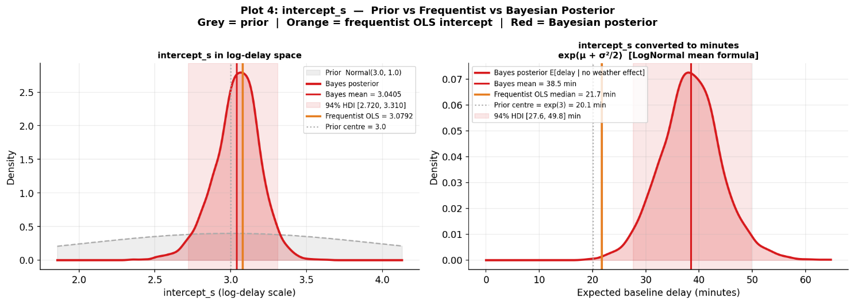

Appendix: Model Equations Summary

A.1 Full Bayesian Hurdle Model
--- PROBABILITY COMPONENT ---
alpha_p ~ Normal(logit(base_rate), 1.0)
b_weather_p ~ Normal(0, 0.5) [per weather variable]
sigma_airline_p ~ Exponential(1)
z_airline_p ~ Normal(0, 1) [per airline]
b_airline_p = z_airline_p * sigma_airline_p
logit_p = alpha_p + sum(b_weather_p * X) + b_airline_p[k]
is_delayed ~ Bernoulli(sigmoid(logit_p))
--- SEVERITY COMPONENT (delayed flights only) ---
intercept_s ~ Normal(3.0, 1.0)
b_weather_s ~ Normal(0, 1.0) [per weather variable]
sigma_airline_s ~ Exponential(1)
b_airline_s = z_airline_s * sigma_airline_s
sigma_s ~ Exponential(1)
mu_i = intercept_s + sum(b_weather_s * X_delayed) + b_airline_s[k]
WEATHER_DELAY ~ LogNormal(mu_i, sigma_s)

