CanSat 2026 — Final Project Report
Team CAN-Team-25 · Physics Club, SVNIT
Report date: 12 September 2026
Repository: github.com/KunjSorathiya/CanSat-Team-Singularity

A note on what this report claims.
This project keeps one rule, and this report is written under it: nothing is described as done unless there is evidence, and the evidence is named. Owning a component is not integration. A passing test suite is not flight verification. A simulation is not a drop test.
Where something has been measured, the measurement and its date are given. Where something is a model, it is labelled a model and the file that computes it is named. Where something has not been done, this report says so plainly rather than leaving it out — including in the sections where that is unflattering.
Nothing in this project has flown.

Contents
- Executive summary
- Mission and requirements
- Concept of operations
- System architecture
- Components
- Electrical design
- Mechanical design and the as-built vehicle
- Structural simulation
- Descent simulation and the parachute
- Flight software
- Telemetry protocol and the radio link
- Onboard logging
- Ground station
- Verification and testing
- Bring-up measurements
- Findings register
- Project timeline
- Scoring assessment
- Open questions for the organizers
- Lessons learned
- Appendix A — pin assignment
- Appendix B — flight configuration constants
- Appendix C — repository map

1. Executive summary
The CanSat is a can-sized satellite that is lifted to 100 ft by a drone, released, deploys a parachute, descends at no more than 5 m/s, protects an egg chamber through landing, and streams telemetry continuously from power-on through recovery.
Where the project stands on 12 September 2026:
Layer | State
Software | Complete and passing 6088 automated checks on the host — flight core, telemetry protocol, ground station, web console, simulations and documentation claims
Firmware drivers | Every driver has run on real silicon: IMU, barometer, GPS, radio and microSD. The flight image itself has been flashed and run
Electronics | The vehicle board is built and every device on it works. The radio link has closed end to end. Missing: the ON/OFF switch, the power LED and a Schottky diode
Structure | Printed in white PETG, assembled, and weighed at 280 g — the first mechanical measurement this project has had
Recovery | The canopy is sized at 80.0 cm and not sewn. Nothing has been dropped
Flight | Nothing has flown. No range test under a canopy, no descent-rate measurement, and the vehicle has never run on its own battery

The three numbers that matter most
Assembled mass, no parachute | 280 g | Weighed 2026-09-12. Against a 450–550 g band — 105 to 135 g short
Telemetry rate | 1.43 Hz, rising to 3.11 Hz on command | Measured at the ground station. The rulebook floor is 1 Hz
Descent under the sized canopy | 3.66 m/s over 8.59 s at the as-built mass | Modelled. The cap is 5 m/s; nothing has been dropped

What changed most recently, and why it matters
The structure came back from the printer on 12 September and the vehicle became a physical object. The print came in at ≈ 128.7 g against a 193 g solid-volume upper bound — 33 % under — and it carried the egg chamber, which the estimate did not include at all.
That inverted the project's largest open risk and then roughly doubled it. Three days earlier the projection was 414–479 g and merely straddled the 450 g floor. The measured article projects to 315–345 g, entirely below it.
Whether that is a problem is genuinely unresolved, and it is the single most consequential open question in the project. GEN-005 states "500 g (±10%)", which reads as a band the vehicle must land inside. GEN-006's disqualification condition is worded one-sidedly, about exceeding the limit. Under the first reading this vehicle needs 105–135 g added and the structure re-printed; under the second it is comfortably compliant and its lightness is an advantage. The answer costs the organizers one sentence and decides days of work, which is why it is question 1 of section 19 rather than buried in it.

2. Mission and requirements

2.1 The mission
The CanSat is powered on at ground level and begins transmitting immediately. A drone lifts it to 100 ft (30.48 m) and releases it. It deploys a parachute, descends at no more than 5 m/s, transmits continuously throughout, keeps transmitting for at least five seconds after impact, and is then recovered.
Flight is autonomous. There is no launch command, no arming button and no manual trigger anywhere in the firmware: the vehicle powers on, calibrates itself, arms itself, detects its own launch and its own landing, and keeps talking through every failure it can survive.

2.2 Requirements
Thirty requirements were extracted from the rulebook and each was given an implementation, a verification method and a status. The full traceable table is in documentation/requirements/requirements.md. The rulebook's own hard numbers:
Quantity | Value | Requirement
Body envelope | 21 cm × 12 cm, +7 cm for the egg chamber | GEN-004
Mass | 500 g ± 10 % — 450 g to 550 g | GEN-005
Release altitude | 100 ft / 30.48 m, from a drone | MIS-001
Descent rate | ≤ 5 m/s | REC-005
Telemetry rate | ≥ 1 packet per second | TEL-004
Post-impact telemetry | ≥ 5 s | REC-008
Radio | 433 MHz LoRa, sync 0xF3 test / 0xA5 launch | TEL-020

Exceeding size or mass by more than 10 % is a disqualification, not a deduction. It sits on a closed list alongside unsafe deployment, no attempt at a communication system, arriving late, and code-of-conduct violations.

2.3 Two rulebook contradictions, both resolved
The original guidelines contradicted themselves on dimensions and on launch altitude. Neither was guessed at locally; both were escalated, and the 2026 revision settled both:
Was contradictory | Now stated
Dimensions | 21 cm (+7 cm for the egg chamber) × 12 cm, stated identically on pages 4 and 10
Launch altitude | 100 ft, released from a drone, stated identically in both places

A third ambiguity — whether "12 cm across" meant a width or a diameter — was put to the organizers directly, because for a prismatic body the two give different answers and the difference was disqualification-class rather than a scored margin. They confirmed on 2026-09-09 that a 12 cm sided box is acceptable. That written confirmation must travel with the submission; it is currently recorded only in this repository.

3. Concept of operations
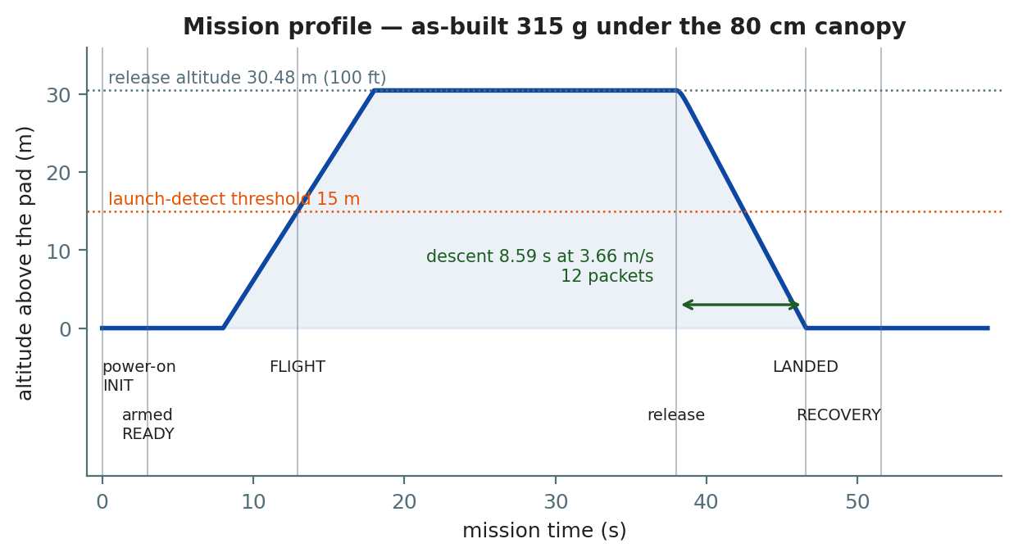
Figure 1 — the mission from power-on to recovery, at the as-built mass under the sized canopy. The descent segment is the model's closed-form solution, not height ÷ rate.
Milestone | When | Where the number comes from
Telemetry begins | Immediately at power-on | No trigger exists in the firmware
Calibration acceptable | ~2.7 s | 80 samples at 30 Hz
Armed | 3.0 s, and calibration settled | arming_delay_ms
Calibration times out best-effort | 20.0 s | calib_timeout_ms
READY → FLIGHT | 15 m above the pad, held 300 ms | launch_altitude_gain_m
Release altitude | 30.48 m | Rulebook, MIS-001
Descent duration | 8.59 s as-built, 6.45 s at the sizing mass | simulations/descent.py
Landing detected | 3 s at rest, after an observed descent | landing_confirm_ms
Post-impact window | 5.0 s | post_impact_transmission_ms
Telemetry period throughout | 700 ms — 1.43 Hz | kTelemetryPeriodMs

The whole mission is a couple of minutes, and the part that is actually a flight is under fifteen seconds of it.

3.1 The five-minute command window, and the one operational constraint it creates
The sealed flight image opens an uplink window for five minutes from power-on, during which the vehicle transmits at 1.43 Hz so that a command can be heard in the gap between packets. When the window closes — or when a MAX_RATE command closes it early — the vehicle goes to its max-rate pattern by itself, recalibrates on the pad, and arms.
The drone must not lift off until the vehicle has armed. Launch detection is disabled for the whole of the command window, so a lift that begins inside it is never detected and the vehicle stays in READY through the entire flight. Wait for the arming blink — 400 ms on, 400 ms off — or for the status field to read armed.
Once armed the uplink is closed for the whole of flight, landing and recovery — which is every state holding a log that cannot be recreated.

3.2 The hover problem, and the guard that closed it
Writing the concept of operations found a defect that no test had: the vehicle declared a landing while hanging under the drone, up to twelve seconds before release.
Landing detection asked two questions — is acceleration within 2.5 m/s² of 1 g, and is vertical speed below 1 m/s? A vehicle hovering under a drone answers yes to both. Held for three seconds, that is a landing. Run against the real state machine with a 3 m/s climb and a 20 s hover:
t= 10362 ms alt= 16.1 m rate= +3.0 m/s READY -> FLIGHT
t= 18018 ms alt= 30.0 m rate= +0.0 m/s FLIGHT -> LANDED <-- still under the drone
t= 23034 ms alt= 30.0 m rate= +0.0 m/s LANDED -> RECOVERY <-- 12 s before release
The existing guard did not catch it because min_flight_ms suppresses landing detection only for the first 3 s of FLIGHT, and on a drone lift FLIGHT is entered at 15 m during the ascent — so those three seconds are spent long before the hover.
The fix is a descent gate: a vehicle cannot land without descending first. The state machine latches descent_observed_ once the vertical rate has been below −2 m/s for one second, and refuses FLIGHT → LANDED until it is set. The latch belongs to one FLIGHT and clears on any state change, so a descent seen earlier cannot authorise a landing later. The same reproduction now lands three seconds after touchdown.

4. System architecture
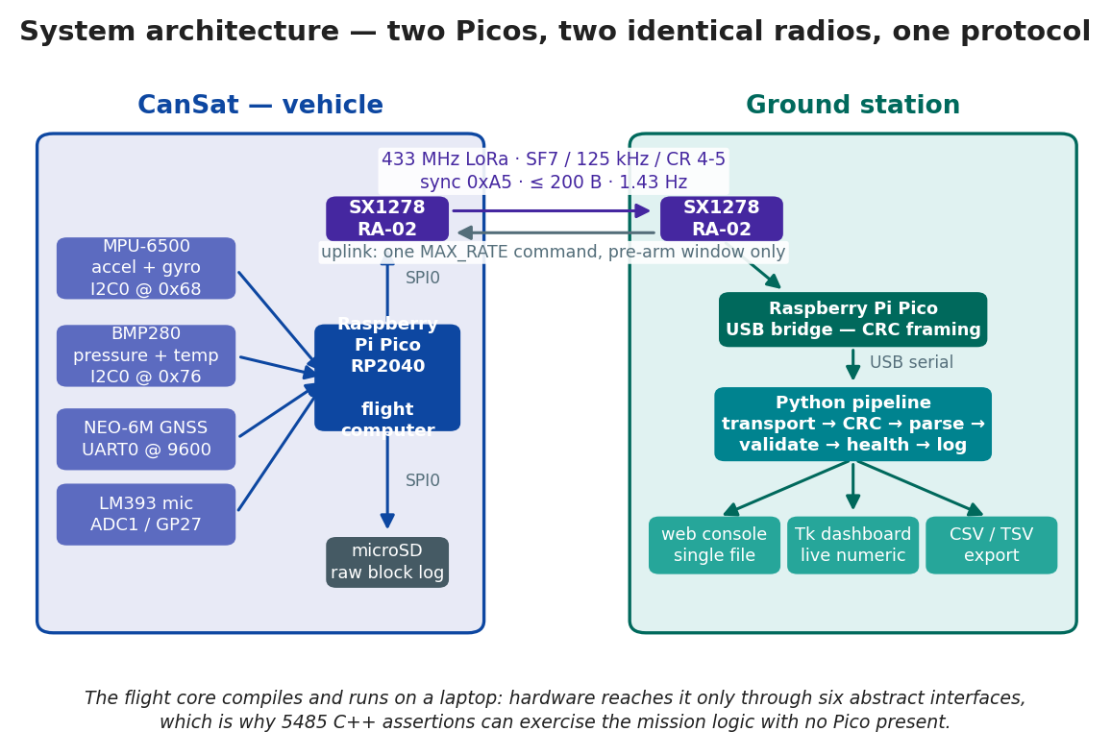
Figure 2 — two Raspberry Pi Picos and two identical radios. The vehicle Pico runs the mission; the ground Pico is a pure bridge that frames every received payload onto USB with a CRC, so the PC can tell transport corruption apart from a malformed packet.

4.1 The dependency rule
The system is layered, and each layer depends only on the one beneath it:
main.cpp watchdog, clock, configuration
|
flight::pico hardware — mpu9250, bmp280, neo6m, sd_card, pico_radio
|
flight:: flight core — controller, state machine, scheduler, orientation,
calibration, faults, telemetry builder, block log
|
cansat:: shared — telemetry format and parser, SX1278 driver
|
ground:: bridge firmware and USB CRC framing
|
Python / JS ground pipeline and interfaces
The flight core never includes a Pico SDK header. Hardware reaches it only through six abstract interfaces — Imu, Barometer, Gps, Radio, SdLogger, BoardIo. Tests substitute mocks; the vehicle substitutes flight::pico::*.
That single rule is why 5485 C++ assertions can exercise the entire mission logic on a laptop with no hardware present, and it is the reason the software was complete and tested before any component had been unpacked.

4.2 End-to-end data path
sensors -> controller -> plausibility gate -> bias correction -> orientation
-> AGL and vertical rate
-> TelemetryBuilder (nothing is built if any mandatory field is invalid)
-> packet string -> SX1278 -> 433 MHz LoRa -> SX1278 -> bridge Pico
-> CRC-framed USB serial
-> transport -> CRC check -> parse -> validate -> health -> log
-> dashboard, web console, CSV export
A packet becomes a telemetry point only if it survives every stage, and each stage's rejection is counted separately — so a transport fault is never mistaken for a sensor fault.

5. Components

5.1 Bill of materials
Subsystem | Component | Qty | Purpose | Status
Flight computer | Raspberry Pi Pico (RP2040) | 2 | Vehicle + ground bridge | Both built and running
Telemetry | SX1278 RA-02 433 MHz LoRa | 2 | Vehicle + ground radio | Link closed 2026-09-07, 66 packets, 0 % loss
Telemetry | 433 MHz SMA antenna | 2 | Radio antennas | Mated and radiating
Telemetry | 10 cm IPEX-to-SMA RG1.13 | 2 | Radio to antenna | Fitted
Sensors | MPU-6500 (sold as MPU-9250) | 1 | Acceleration, angular rate | Working, but the wrong part — see below
Sensors | GY-BMP280-3.3 | 1 | Pressure, altitude, temperature | Verified at 0x76, 83.0 Hz
Sensors | NEO-6M GPS with EEPROM | 1 | Position and timing | Talking, all six NMEA sentences, 0 checksum errors. No fix acquired outdoors yet
Sensors | LM393 sound module, 4-pin | 1 | Additional sensor — acoustic level | Fitted, logged, and transmitted as SN-
Storage | microSD card reader (3.3 V) | 1 | Onboard logging | Writes 100/100, sustains ~300 writes/s
Power | Orange 3.7 V 1500 mAh 25C 1S LiPo | 1 | Primary power | Held and charged. Never yet used to power the vehicle
Structure | Cansat_D1, white PETG, 3D printed | 1 | Airframe and egg chamber | Printed, assembled, weighed
Prototyping | 10 × 10 cm universal PCB | 2 | Electronics mounting | One built, one spare

Still to fit: the manual ON/OFF switch (PWR-001, mandatory), the visible power LED (PWR-002, mandatory), and a Schottky diode. Still to build: the parachute.

5.2 The IMU is not the part that was ordered
The module sold as an MPU-9250 answers WHO_AM_I with 0x70 — an MPU-6500. Six axes, no magnetometer. Address 0x0C never appears on the bus, in either scan, with or without the pass-through bridge enabled. There is nothing behind it.
The consequence is that this vehicle has no absolute yaw reference. Yaw is gyro-integrated and drifts without bound; roll and pitch are unaffected, because they are referenced to gravity through the accelerometer. Every packet declares which kind of yaw it carries: YR-M for an absolute magnetic yaw, YR-G for a relative gyro integration whose zero is arbitrary. On this vehicle it reads YR-G and always will.
The nine-axis path — the AK8963 driver, the axis rotation, the calibration, the YR-M declaration — is implemented and tested and would work on a genuine MPU-9250. It has no source. This is a procurement item, not a software change, and whether a declared relative yaw is acceptable for the mandatory Ya- field is an open organizer question.
The firmware was written for exactly this case: it accepts 0x70 as a six-axis part and reports degraded attitude rather than refusing to boot, or — worse — inventing a heading from a bus that is not answering.

5.3 The additional sensor, and why a microphone
Sensor integration is capped at 25 points: 15 for the mandatory set, +5 for GPS, +5 for one more. The second +5 is taken by an analogue microphone on GP27, and the choice is defensible rather than opportunistic.
A microphone on a descending probe is a flight-proven atmospheric instrument. Mars 2020 Perseverance carried one dedicated to entry, descent and landing. The Huygens probe carried an acoustic sensor through Titan's atmosphere in 2005. Venera 13 and 14 recorded wind noise on the surface of Venus. Acoustics is one of the cheapest ways to instrument a descent, which is why it keeps being flown.
What it measures here, in order of confidence:
Use | Confidence | Why
Landing detection | High | Impact is an impulsive transient tens of dB above anything else in the flight
Flow noise against descent rate | Good | Unshielded electrets are extremely sensitive to airflow. On a descending body that is normally a defect; here it is the measurement
Canopy oscillation | Good | Canopy modes are 0.5–3 Hz, comfortably inside the 30 Hz sampling
Deployment transient | Moderate | The crack is sharp and loud, but it happens exactly when flow noise is highest
Absolute sound pressure level | None | No calibration, no reference, and an unrecorded gain trimpot
Frequency spectra | None | A 0.5 ms window resolves ~2 kHz upward, which is not where the content is

Two channels are recorded, deliberately. sound_mv_pp is how loud; sound_gate_pct is what fraction of the window was loud. A sharp crack and a steady roar can reach the same peak and mean opposite things, and the duty cycle is what separates them.
What it does not measure, stated before a judge asks: the level is a relative peak-to-peak envelope in millivolts, not a sound pressure level. Reporting decibels would need a calibrated reference source and a record of the module's gain trimpot position, and this project has neither. Values are comparable within one flight at one gain setting and with nothing else. That limitation is written into the firmware comments, the requirements row, and the log column name.

6. Electrical design

6.1 The power question, answered by measurement
Three hardware blockers held the design up for days. All three are closed, and how they closed is more useful than the fact that they did.
No external regulator is needed. An AMS1117-3.3 was assessed and rejected — a full cell at ≈ 4.2 V does not clear its high-load dropout. The Pico's own regulator was then measured carrying every load on the vehicle:
Condition | Rail voltage
45 back-to-back radio transmits | 3.28–3.29 V
100 % microSD write duty | 3.28–3.30 V

One rail, no external part. The microSD reader turned out to be a 3.3 V board with no regulator and no level shifter — its supply pin is printed 3V3 and its entire parts list is four 10 kΩ pull-ups and two capacitors. The listing that described a 4.5–5.5 V board described a different product.

6.2 The power path
LiPo --[ ON/OFF switch ]--[ Schottky ]--> Pico VSYS --> Pico 3V3(OUT) --> everything
| |
+--[ 1 kOhm ]--> power LED +-- MPU-6500, BMP280 (I2C0)
+-- SX1278 RA-02 (SPI0)
+-- microSD reader (SPI0)
+-- NEO-6M (UART0)
+-- LM393 microphone (ADC)
The power LED hangs off the switched rail through a series resistor, not off a GPIO. PWR-003 requires it to light immediately on power-up, and a firmware-driven LED would wait for boot. The firmware separately drives a status LED on GP14 whose blink rate encodes the mission state.
The Schottky diode is the only outstanding purchase in the project — about ₹10. Without it, USB back-powers the LiPo, so the battery switch must be OFF whenever a cable is connected, which is most of bring-up.

6.3 Bus discipline
Two shared buses, and a lesson from each:
- I2C0 (GP4/GP5) carries the IMU at 0x68 and the barometer at 0x76. Both verified together on the soldered board; 0x0C correctly absent.
- SPI0 (GP16/GP18/GP19) carries the radio and the microSD, with separate chip selects on GP17 and GP6. This bus produced the single most instructive defect in the project — see F-16 in section 16.
The netlist at electrical/schematics/vehicle-netlist.tsv is generated from BoardPins in the firmware, and the generator refuses to run if the two disagree. The wiring diagrams are generated from the same source. A pin cannot drift between the code and the documentation.

7. Mechanical design and the as-built vehicle

7.1 The design
Cansat_D1 is modelled in Fusion 360 and exported to STEP. Every dimension quoted in this project is read out of the STEP file by tools/cad_dimensions.py, and the build fails if the documentation and the model disagree.
Solids | one, Body1, 56 faces
Bounding box | 118.5 × 115.0 × 110.0 mm
Cross-section diagonal | 159.1 mm
Height against the 210 mm allowance | 91.5 mm unused
Clearance per side against the 120 mm section | 2.5 and 5.0 mm

It is an open box frame: two solid side panels, two faces opened out with large arched cutouts, a central vertical spine, harness slots top and bottom, and a rectangular cutout for the switch with two LED holes beside it.
The board fits flat. A 100 × 100 mm perfboard sits inside a 115 × 110 mm section with 15 and 10 mm to spare for walls and standoffs. An earlier version of the design reasoning said it could not and should be mounted edge-on as a spine; that was reasoned against a 120 mm circular section, before there was a design, and it is withdrawn.

7.2 Material — white PETG
The rulebook permits any outer material and offers a bonus for sustainable or unconventional materials. PETG was chosen and the reasoning recorded, because section D expects the reasoning as much as the choice:
- Tougher than PLA and far easier than ABS. PETG does not go brittle the way PLA does, which matters for a part whose job is to survive exactly one impact.
- Prints without an enclosure, with little warping. ABS's toughness comes with warping and fumes a school workshop usually cannot manage.
- Impact energy goes into deformation rather than fracture — a bent frame is a recovered vehicle, a shattered one is not.
Print orientation was decided before printing and recorded: as modelled, sitting on its base. It was the single free variable that changes the part's strength, it costs nothing at slicing time, and it cannot be changed afterwards. Layers stack vertically, so the weak directions are tension normal to the layers and interlayer shear.
White was a finish decision: it shows a clean print rather than hiding a poor one, it is the easiest colour to photograph against any background for the mandatory views, and it runs cooler in sunlight on a pad than a dark part would.

7.3 The mass budget — measured
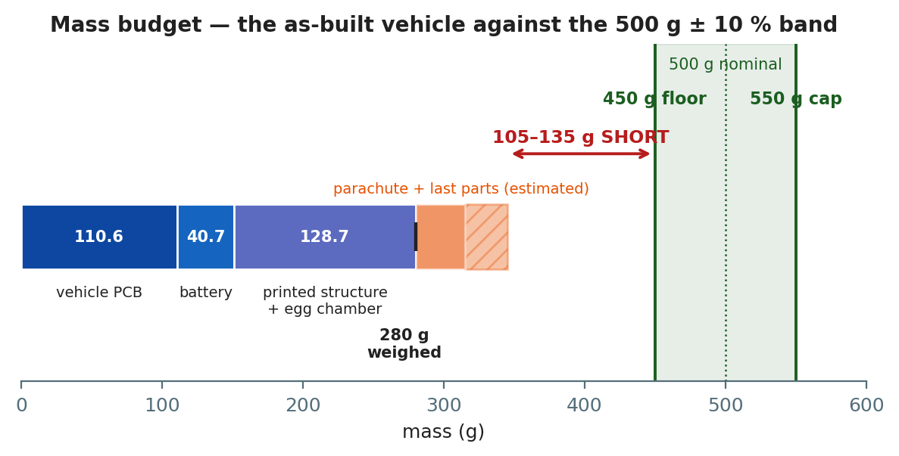
Figure 3 — the as-built vehicle against the 500 g ± 10 % band.
Item | Mass | How
Assembled vehicle PCB, no battery | 110.573 g | Weighed 2026-09-09
Battery — Orange 1500 mAh 1S LiPo | 40.726 g | Weighed 2026-09-09
Electronics, all-up | 151.299 g | Sum
Printed structure + egg chamber | ≈ 128.7 g | By difference
As-built vehicle, no parachute | 280 g | Weighed 2026-09-12
Parachute, lines, harness | 30–55 g | Not built
Switch, LEDs, Schottky, divider | 5–10 g | Not fitted
Projected all-up | 315–345 g
Budget | 450–550 g | GEN-005

What was measured and what was derived. The scale figure is the 280 g assembled vehicle. The electronics inside it were weighed separately three days earlier. The structure line is therefore arithmetic on two measurements, not a third one: 280 − 151.299 = 128.701 g, quoted as ≈ 128.7 g because the 280 g came off a scale reading whole grams.

7.4 The estimate was 33 % high, and that is the interesting part
Predicted, solid volume × 1.27 g/cm³ | 193.0 g
Printed — and that includes an egg chamber the estimate did not | ≈ 128.7 g
Error | −64 g, −33 %

Infill is the whole of it. The 193 g assumed no infill saving at all; a real slice of a thin-walled open frame is mostly perimeter and air. The estimate was labelled an upper bound and behaved like one — but the size of the gap matters, because it is mass the design can spend on purpose.

7.5 The risk, and the two routes out of it
As-built, no parachute | 280 g
Projected all-up | 315–345 g
To reach the 450 g floor | +105 to +135 g needed
To stay under the 550 g cap | +205 to +235 g available

Route 1 — re-print heavier, and prefer it. The printed part is ≈ 128.7 g against a 152.0 cm³ solid volume that would weigh 193 g. Raising infill and wall count moves the part up that range at no cost but print time, and it adds material exactly where a printed part is weakest — buying strength margin and mass in the same change. It is a slicer setting, not a redesign.
Route 2 — ballast. Cruder, earns nothing, and section D scores effective use of volume.
Route 1 alone may not close the gap, since the body has only ~64 g of headroom to solid. The likely answer is both: re-print at high infill for the strength, then ballast the remainder — low and central, which also helps descent stability under REC-006. The 91.5 mm of unused permitted height is where it should go, since compactness scores effective use of the volume the rules allow, and the design currently uses 56 % of the height it is permitted. One change answers a scored line and a disqualification risk together.

7.6 What is still to do mechanically
- Sew the 80 cm canopy. Nothing blocks it, and it does not depend on the mass decision.
- Drop-test it. The only thing that measures the drag coefficient the descent model rests on, and the only thing section C actually scores.
- Check the printed envelope with calipers. Every dimension held here is read from the STEP, and a printed part is not its model. 2.5 mm per side is the whole clearance.
- Photograph it. Mandatory for section F, and section D's 15 aesthetics-and-build-quality points are judged from those images.

8. Structural simulation
Three static-stress studies were run in Fusion 360 on Cansat_D1.
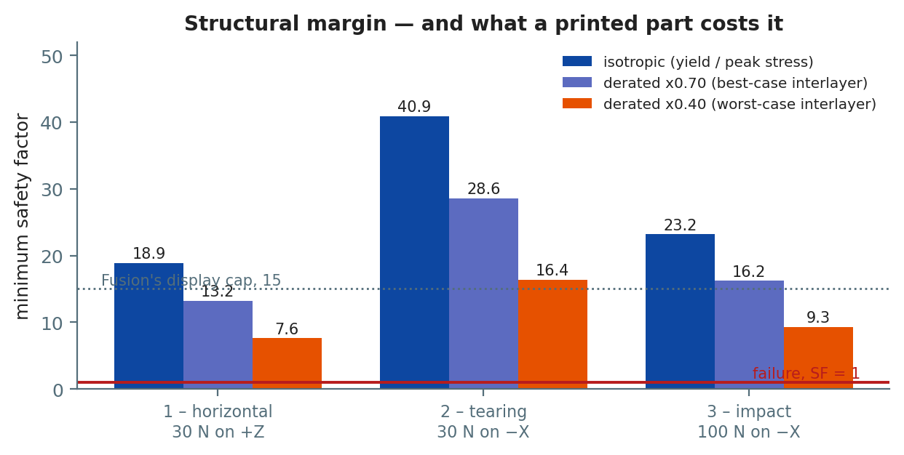
Figure 4 — safety factor per load case, isotropic and derated for the anisotropy of a printed part.
Study | Load | Mesh | Max von Mises | Yield ÷ stress
1 · Horizontal | 30 N on +Z | 5838 nodes | 2.885 MPa | 18.9
2 · Tearing | 30 N on −X | 5838 nodes | 1.330 MPa | 40.9
3 · Impact | 100 N on −X | 7148 nodes | 2.345 MPa | 23.2

The structure is nowhere near failing in any of the three. Four caveats, none of them small, and all of them stated because the numbers are useless without them.

8.1 The report says the design breaks. It does not.
All three exports contain the sentence "the design is expected to bend permanently or break." It is template text. The sentence sits above a block containing both the "Below Safety Factor Target" and "Above Safety Factor Limit" advice lists — which is what a template emits when it renders every branch rather than the one that applied.
And the reported minimum of 15 is a display cap, not a result. All three studies report exactly 15 while their peak stresses differ by more than a factor of two, and three different load cases cannot all minimise at exactly the same value. Fusion's safety-factor legend caps at 15 by default, so "15" means at or above the cap, everywhere on the part — which is consistent with the yield-derived figures above and is the stronger statement of the two.

8.2 The simulation material is PET, not PETG
Property | In the study (PET) | Typical bulk PETG
Density | 1.541 g/cm³ | ~1.27 g/cm³
Young's modulus | 2757.9 MPa | ~2000–2100 MPa
Yield strength | 54.40 MPa | ~50 MPa

PET is stiffer, denser and slightly stronger, so the studies are mildly optimistic on strength and materially wrong on mass. The mass error turned out larger than density alone: the printed part weighs ≈ 128.7 g where the PET density implies 234.2 g and the ×0.82 density correction implies 192.0 g. The remainder is infill, which the studies do not model at all.

8.3 A printed part is not isotropic, and this is the bigger caveat
Inter-layer adhesion in Z is typically 40–70 % of in-plane strength. With the orientation decided — printed on its base, layers stacking vertically — the derating is arithmetic:
Study | Isotropic | ×0.70 | ×0.40
Horizontal | 18.9 | 13.2 | 7.6
Tearing | 40.9 | 28.6 | 16.4
Impact | 23.2 | 16.2 | 9.3

Even at the pessimistic 40 %, and even taking the capped 15 rather than the yield-derived figure, the effective safety factor is 6. That is a structure with margin, not one being argued into compliance.

8.4 The 100 N impact load is an assumption — and the as-built mass makes it conservative
100 N came from a 500 g vehicle at 5 m/s arrested in 25 ms. The as-built vehicle is lighter and descends more slowly, so it has less than half the momentum the study assumed:
Case | Mass | Rate | Momentum | Force at 25 ms | at 10 ms
Study 3's assumption | 500 g | 5.00 m/s | 2.50 N·s | 100 N | 250 N
As-built, unballasted | 315 g | 3.66 m/s | 1.15 N·s | 46 N | 115 N
Ballasted to 500 g | 500 g | 4.61 m/s | 2.31 N·s | 92 N | 231 N

So the structure is analysed against a harder landing than the one it is likely to have, and that stays true in both mass cases.
It does not retire the caveat. All three studies load horizontally, and a vehicle under a canopy lands base-first — along the build axis, which is the print's weak direction. Lower force in the wrong direction is still the wrong direction. The vertical impact case is the one load case never run, and the part is now printed, so the answer will most likely arrive from a drop test rather than from a re-run.

9. Descent simulation and the parachute
simulations/descent.py sizes the canopy and models the fall. It runs in the host test suite, so a change that breaks the physics fails the same build as a change that breaks the firmware, and it is pinned to closed-form limits that can be checked by hand.

9.1 What it computes
- Canopy area and flat diameter for a target descent rate, from S = 2mg / (ρ·Cd·v²).
- The descent rate a canopy you already have will produce.
- Descent time, from the closed-form solution of m·dv/dt = mg − ½ρCdSv² rather than height ÷ rate — the vehicle starts at rest and accelerates into terminal, and over a 30 m drop that transient is a third of a second.
- The number of telemetry packets the descent yields.
- Air density from the gas law, using pressure and temperature the vehicle itself measures. A 35 °C launch day is ~6.5 % thinner than ISA, which is ~7 % more canopy.
What it does not compute: canopy opening dynamics, oscillation, the drag of the bare vehicle before deployment, or wind drift. Deployment delay is modelled as free fall, which is pessimistic on altitude and therefore safe.

9.2 The canopy, and why it is sized at 550 g
Case | Flat diameter | Rate | Time
500 g, ISA 15 °C, vented flat circular | 73.7 cm | 5.00 m/s | 6.45 s
550 g, 35 °C — size to this | 80.0 cm | 5.00 m/s | 6.45 s

Size at the top of the mass tolerance, not at the nominal mass. Canopy area is linear in mass, so ±10 % of mass is ±10 % of area but only ~5 % of diameter. A canopy sized at 500 g and flown at 550 g breaks the 5 m/s cap; one sized at 550 g is compliant across the whole band and costs 6 cm of cloth. A test asserts exactly this.

9.3 The as-built mass does not change the canopy
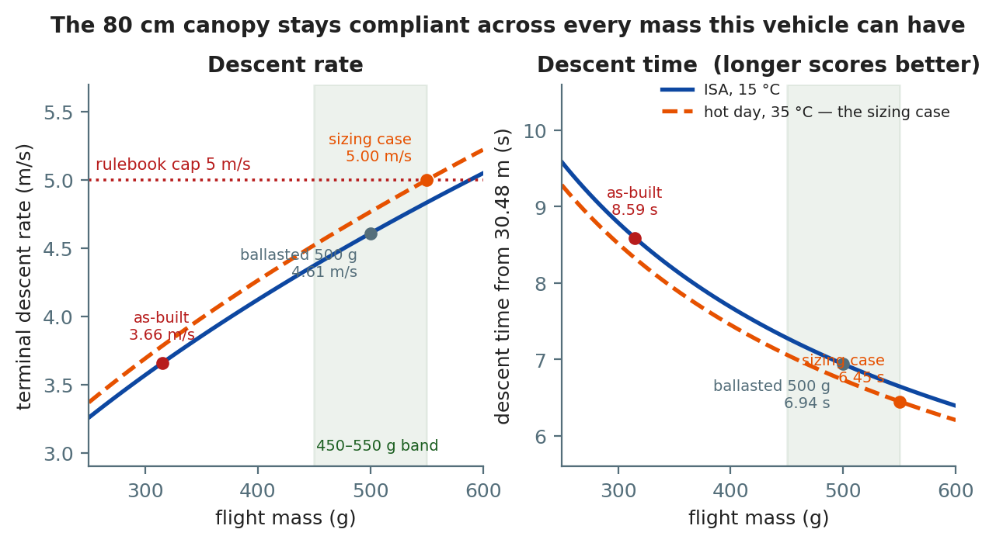
Figure 5 — the 80 cm canopy across every mass this vehicle can plausibly have.
Flight mass | Rate | Descent time | Packets at 1.43 Hz
315 g — as-built, unballasted | 3.66 m/s | 8.59 s | 12
500 g — ballasted to nominal | 4.61 m/s | 6.94 s | 9
550 g, 35 °C — the sizing case | 5.00 m/s | 6.45 s | 9

All three clear the cap, so the canopy does not have to be re-sized whatever the ballast decision turns out to be — and it can therefore be sewn now, before the organizers answer.
Two things follow that are worth having:
- Flying light descends a third slower and yields a third more descent telemetry. Section C scores descent time comparatively across teams, subject to the 5 m/s cap — so a slower descent scores better. 8.59 s against 6.45 s is a real difference.
- If 450 g does not bind, staying light is the better flight. If it does, ballasting to 450 rather than 500 keeps some of that advantage. This is an unusual thing for a mass problem to be.

9.4 Three constraints on the canopy that are not the diameter
- It must not be tightly packed — external or semi-exposed, so it deploys immediately on release (REC-003, REC-004). A chute stuffed inside the body risks the 5 deployment points and a disqualification for unsafe deployment.
- Descent must be stable, without tumbling or spinning (REC-006), scored comparatively. An unvented flat circular canopy oscillates. A central vent of roughly 10 % of the diameter costs a little drag and buys a great deal of stability; a cruciform is better still and is easy to sew.
- The structure must be intact after landing (REC-007) and telemetry must continue for at least 5 s (REC-008) — which means the antenna and the battery connection have to survive the arrival.

9.5 The uncertainty paper cannot close
Drag coefficient is the dominant term, and the spread between canopy types is larger than every other term in the model combined:
Canopy | Cd | Diameter at 500 g
Cruciform | 0.85 | 69.3 cm
Flat circular | 0.80 | 71.4 cm
Vented flat | 0.75 | 73.7 cm
Hemispherical | 1.40 | 54.0 cm

Only a drop test closes it: a known mass, a known height, a stopwatch, and the measured rate fed back into the model.

10. Flight software
The vehicle runs a single non-blocking loop on a 2 ms tick. Nothing waits on hardware, nothing allocates, and every recovery path is bounded.

10.1 The flight loop
poll(now_ms)
|-- capture epoch on first call; mission_ms = now_ms - epoch_ms
|-- gps.poll() bounded UART drain — never blocks on a fix
|-- every 33 ms acquire_sensors()
|-- every tick run_calibration()
|-- every tick feed_state_machine()
|-- every 700 ms emit_telemetry()
|-- every 2000 ms logger.flush()
|-- every 1000 ms sample_battery()
|-- every 1000 ms refresh_health()
+-- every tick update_led() blink rate encodes mission state
The ordering is deliberate. GPS is drained first so a full UART buffer can never back up — at 9600 baud the RP2040's 32-byte FIFO fills in 33 ms, and validate_config() enforces that the tick is short enough. Calibration and the state machine run before telemetry, so every packet carries the state that matches the samples inside it.
PeriodicTask self-corrects after a stall: if the loop falls behind by more than one period, the next due time re-anchors to now + period rather than firing a catch-up burst.

10.2 Sensor acquisition
acquire_sensors()
imu.read()
|-- not valid or not finite? ------------> stale check: 2000 ms without a good read
| raises imu_stale + orientation_invalid
|-- outside datasheet bounds? -----------> reject the sample, DROP the previous value,
| (accel > 170 m/s2, gyro > 2200 dps) raise sensor_implausible
+-- good --------------------------------> feed the calibrator with the RAW sample,
subtract bias, orientation.update(dt)
baro.read()
|-- outside 30-115 kPa or -50..95 C? ----> stale check, baro_stale after 2000 ms
+-- good --------------------------------> AGL = altitude - ground baseline
vertical rate EWMA (0.7 old, 0.3 new)
gps.latest() + last_fix_ms
+-- a fix is used only while it is being renewed

10.3 The mission state machine
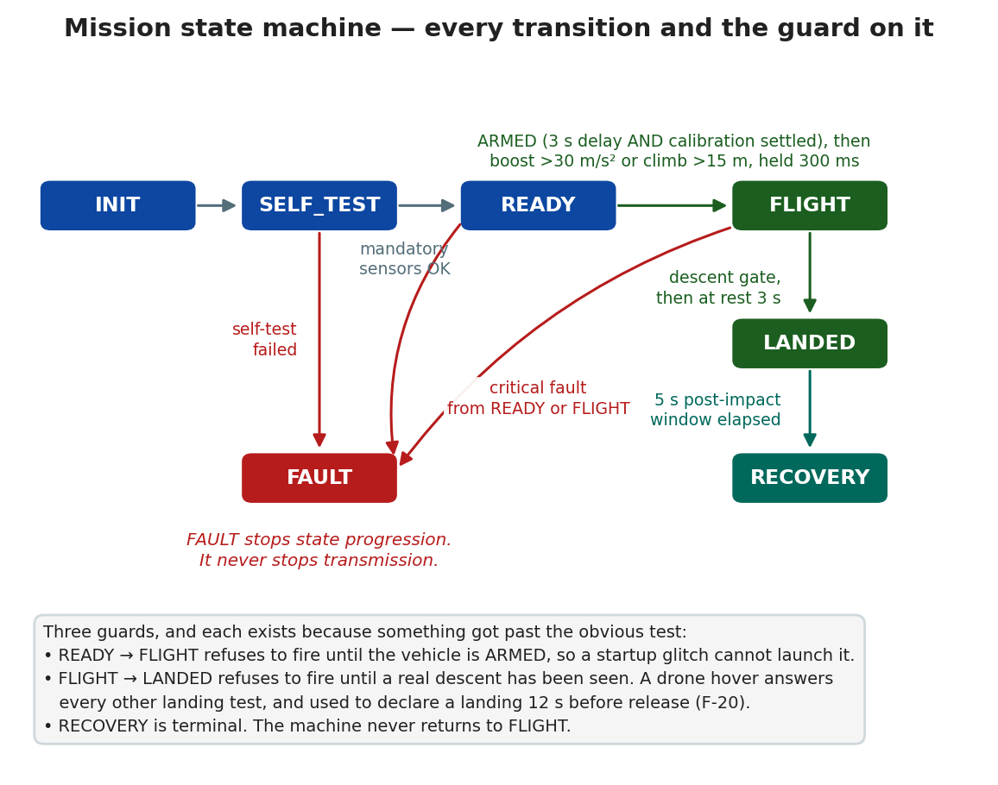
Figure 6 — every transition and the guard on it.

10.4 Six behaviours worth knowing about
It calibrates itself on the pad — and never lets that block the mission. While stationary it collects IMU and barometer samples and captures gyro bias, accelerometer offset and the barometric ground reference, so altitude reads ≈ 0 on the pad rather than the ~23 m an uncalibrated barometer showed on the bench. Acceptance needs 80 samples with per-axis gyro standard deviation under 2 °/s and acceleration magnitude within 1.5 m/s² of 1 g. If the vehicle is not still, calibration retries until a 20 s timeout and then resolves best-effort: the barometric reference is still used, but gyro and accelerometer bias are not applied — a bias measured while moving would be worse than no correction. A warning is raised and the mission continues.
A startup glitch cannot trigger a false launch. READY → FLIGHT is refused until the vehicle is armed: the 3 s arming delay has elapsed and calibration has settled. Then the launch condition — acceleration above 30 m/s² or a climb of more than 15 m — must hold continuously for 300 ms.
An implausible reading is treated as worse than no reading. A value outside datasheet-derived bounds is not merely skipped — the previously held value is dropped too, so the vehicle never coasts on data from a sensor that is actively wrong. Staleness is time-based: 2 s without a good read raises the fault, so one failed read changes nothing.
Wrong data is never transmitted, and suppression never fakes packet loss. If any mandatory field cannot be trusted, no packet is produced — and the packet number is not consumed. Transmitted packets stay strictly sequential, so a gap at the ground station means radio loss and nothing else.
Every peripheral can fail without stopping the mission. GPS missing? The optional fields are omitted. SD failing? Logging disables itself after 10 consecutive write failures. Radio down? Bounded re-initialisation with a 1 s back-off, never a blocking retry loop. Only a total loss of mandatory sensing counts as critical — and even then telemetry keeps running in FAULT.
It survives its own crashes. A 2 s hardware watchdog reboots a hung loop; telemetry restarts automatically and the reboot is reported as a fault so the ground station can see it.

10.5 The fault model
Faults are classified, not fatal:
Class | Effect | Examples
Warning | Counted and reported; nothing else changes | Calibration timed out, low battery, GPS stale
Degraded | A field or a subsystem is dropped; telemetry continues | SD logging disabled, radio re-initialising, sound stale
Critical | → FAULT, state progression stops — transmission does not | Bad configuration, failed self-test, both IMU and barometer stale

The design rule behind the whole table: telemetry never stops. No peripheral failure and no state, FAULT included, suppresses telemetry that can still be produced correctly.

10.6 Design rules
These are the invariants the code is built around. Breaking one is a design change, not a refactor.
- Telemetry never stops.
- Wrong data is worse than no data. Mandatory fields that cannot be trusted suppress the packet rather than transmitting a plausible-looking wrong value.
- Sequential numbering is over transmitted packets. Suppression does not consume a number.
- The flight core knows no hardware.
- Nothing in the flight loop blocks or allocates. Fixed-size buffers, bounded loops.
- Every constant says where it came from — rulebook, datasheet, textbook or engineering choice, named in a comment at the definition.
- Predictions stay labelled as predictions until a measurement replaces them.

10.7 Code originality
Every driver in the flight path is written here, against its datasheet and register map: MPU-9250 family, BMP280, NEO-6M, SX1278 and the SD card protocol. There are no third-party libraries anywhere in the flight path. The BMP280 compensation reproduces the datasheet's own reference vector; the SD card driver implements CMD0/CMD8/ACMD41 initialisation and SDHC vs SDSC block addressing; the FAT32 reader walks an MBR, a BPB and a cluster chain.

11. Telemetry protocol and the radio link

11.1 The packet
CAN-Team-25; P-042; Ti-00:01:23:450; A-118.4; Pr-99821.33; T-24.6; Ro-2.1; Pi--1.4;
Ya-15.9; AX-0.12; AY--0.31; AZ-9.79; GP-Lat-21.16450; GP-Lon-72.78480;
GP-Alt-121; SN-412.5;
Field | Meaning | Format
CAN-Team-XX | Team identifier | Correct identifier in every packet
P-XXX | Packet number | Starts at P-001, increments sequentially
Ti-HH:MM:SS:MS | Mission clock since power-on
A-XXX.X | Altitude | Metres, 1 decimal
Pr-XXXX.XX | Pressure | Pa, 2 decimals
T-XX.X | Temperature | °C, 1 decimal
Ro- / Pi- / Ya- | Roll / pitch / yaw | Degrees, 1 decimal
AX- / AY- / AZ- | Acceleration | m/s², 2 decimals
GP-Lat / GP-Lon / GP-Alt | GPS position, only when a fix exists | Optional
SN- | Acoustic level, mV peak-to-peak | Optional

Precision is enforced exactly, in the formatter and in all three parsers. The C++, Python and JavaScript implementations are held to one shared fixture file, test-data/protocol-fixtures.tsv, so they cannot drift apart.

11.2 Two packet shapes, and a 200-byte ceiling
Shape | Carries | Worst case
Rich | The twelve mandatory fields, then GP-Lat, GP-Lon, GP-Alt, then SN- | 209 B, held to 200 B on the air
Lean | The twelve mandatory fields only | 147 B

The 200-byte ceiling is not ours. The organizers' receiver — an ESP32 running the arduino-LoRa library, shared with the team on 2026-09-11 — reads into a 201-byte buffer and discards anything over 200 bytes, printing an error and scoring nothing. The competition scores what their station receives, so 200 is the ceiling whatever this project's own bridge can hear.
At 6 decimals of latitude and 1 of altitude the GPS block was 55 bytes and mandatory + GPS was 202 — two bytes over. Printed to what the NEO-6M actually resolves — 5 decimals (1.1 m, against its ~2.5 m horizontal error) and whole metres — it is 51, and the total is 198. The SD log keeps the full precision.
The byte figures are defended by construction, not by arithmetic. A test builds the widest packet each shape can produce — packet number 4294967295, a 99:59:59:999 clock, every axis at full scale — and checks it against its constant. That test corrected this design twice, once by 2 bytes on the lean packet, which crossed a LoRa symbol boundary and cost 5 ms of airtime on every packet.

11.3 The radio
Parameter | Value | Fixed by
Frequency | 433 MHz | Rulebook band
Spreading factor | SF7 | Engineering choice — airtime
Bandwidth | 125 kHz | Engineering choice
Coding rate | 4/5 | Engineering choice
TX power | 17 dBm (PA_BOOST) | RA-02 maximum without PA_DAC
Sync word | 0xA5 | Rulebook — and the organizers' station listens on nothing else

SF7 is airtime-driven, not range-driven. A ~190-byte packet needs 943 ms at SF9/125 kHz and about 302 ms at SF7/125 kHz; only the latter meets 1 Hz with margin. The link budget still closes with tens of dB to spare at the mission's 30 m range.
Both Picos fly 0xA5, for testing as well as for the launch. On the 2026-09-10 range test the vehicle was on the test word 0xF3, and the organizers' station heard only the few packets an SX127x sync filter lets through while the team's own station heard every one. That is a silent, total loss of telemetry that looks exactly like a dead radio, and it is the reason both images now fly the official word all the time.
One definition of the modem parameters is shared by both ends — link_profile.hpp — because before it existed the two carried separate copies and agreed only by coincidence.

11.4 The rate
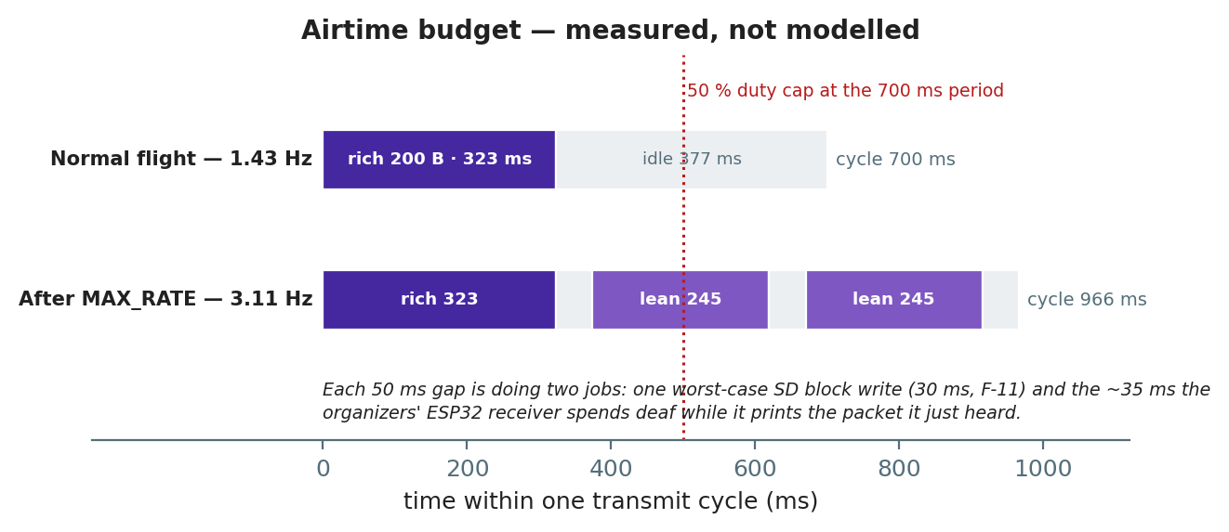
Figure 7 — where the transmit cycle goes, sized from measured airtime.
 | Normal flight | After MAX_RATE
Period / cycle | 700 ms | 966 ms (374 + 296 + 296)
Packet rate | 1.43 Hz | 3.11 Hz measured
Sensors on the air | 1.43 Hz | 1.04 Hz
Duty | 46.2 % measured | 84 %

The rulebook's 1 Hz is a floor this vehicle cannot be configured onto. Three independent mechanisms enforce it: a static_assert refuses to compile a profile above 950 ms, validate_config() refuses to run one, and check_doc_claims.py refuses to pass a repository whose documentation disagrees. A flight build silently running at 1 Hz is exactly the failure that is designed against.
Every slot is measured airtime + 50 ms, rounded up — not modelled airtime. The model reads 1.8 % low against this hardware, reproduced to 0.1 ms across four sessions.
The 50 ms guard does two jobs in the same gap. One is the vehicle's own worst-case SD block write — 30 ms, seen on two boards in two of five sessions. The other is the organizers' receiver, which is deaf for about 35 ms after every packet while it prints what it just heard at 115200 baud. The previous 40 ms guard covered the card and not that.

12. Onboard logging
The onboard log writes into raw 512-byte blocks with no filesystem, rewriting its header after every record. A brownout or an impact reset therefore resumes at the correct block instead of overwriting flight data.
The log runs at the 30 Hz sensor rate, not the radio rate, and carries satellite count, HDOP and full-precision position that never go on the air.
The SD log is the primary record, not a backup. The over-the-air descent dataset is nine to twelve packets; the card holds hundreds of rows across the same seconds. Every descent-rate number in the post-flight analysis will come from the card.
Two supporting tools exist: tools/prepare_sd_card.py creates and sizes the log file, and tools/inspect_sd_log.py reports its extent layout. The firmware maps log block numbers through an extent list of up to 16 runs, so a file in a few pieces is not a fault — only one broken into more runs than that is refused.

13. Ground station
Three interfaces over one pipeline:
Interface | Use
Web console — ground-station/web/index.html | Single file, no build, no dependencies. Demo replay, file replay, or live Web Serial
Tk dashboard — python src/main.py live --port COM5 --framed | Live numeric view, with plots when matplotlib is installed
CLI replay — python src/main.py replay … --export out.csv | Offline parse, validate, log and export

transport (serial / file / loopback)
-> CRC-16 frame decoder --(crc fail)--> counted separately:
| a transport fault is not a sensor fault
-> parser --(reject)----> logged with the reason
-> validator team, sequence, duplicates, GPS plausibility
-> link health rate, loss %, staleness
-> raw .tsv + parsed .csv + dashboard + web console
The receive pipeline runs on a background thread and hands the UI a snapshot through a bounded queue, so a slow interface can never stall reception or logging.
Nothing received is ever discarded. Malformed packets and CRC failures all reach the raw log with their receipt time and the reason they were rejected.
The bridge firmware is a pure bridge: it frames every received payload onto USB with a CRC and emits a status line at 1 Hz carrying its own frame and drop counters. On the first closed link those counters and the packet stream agreed exactly — frames incremented once per packet with dropped=0 — which is how it is known that the radio delivered everything it heard and USB carried everything the radio delivered.

14. Verification and testing
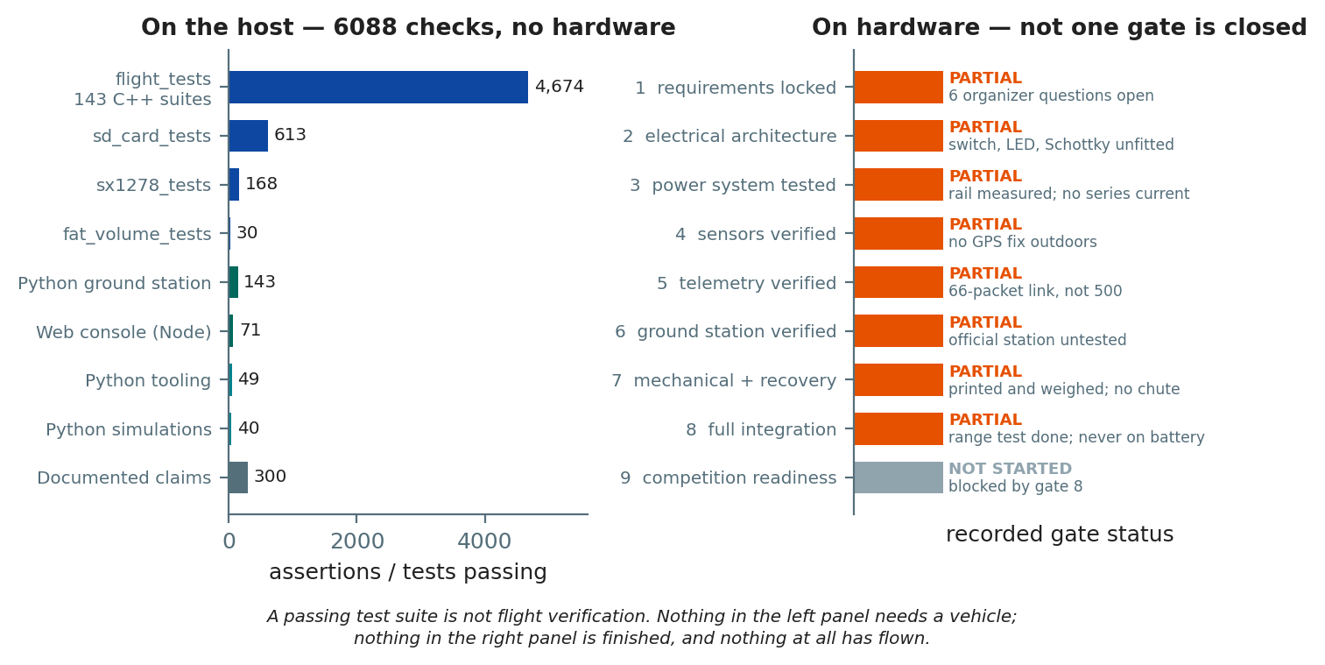
Figure 8 — what is verified on the host, and what is verified on hardware.
bash tools/build_host.sh
Compiles and runs every C++ suite, the Python suites and the Node suite, then checks the documentation against the source. All of it runs without hardware.
Suite | Coverage | Result
flight_tests | 143 suites: packet format, parser, shared fixtures, state machine, orientation and angle wrapping, GPS validation, sensor math, timing, calibration, faults, scheduler, block log and torn-header recovery, controller behaviour, link profile, LoRa airtime | 4674 / 4674
sd_card_tests | microSD init, SDHC vs SDSC addressing, block round trip, bus release, timeouts, write-error paths | 613 / 613
sx1278_tests | LoRa register sequence, TX timeout, RX and CRC handling, RSSI conversion | 168 / 168
fat_volume_tests | FAT32 log lookup: MBR and superfloppy, contiguity, missing file, a card that stops answering | 30 / 30
flight_smoke_test | Boot, first three packets, GPS parse | Passed
ground_station_tests | Framing, CRC detection, resync, known-answer vector | Passed
Python — ground station | Parser, validator, transport, health, logging robustness, bridge status, vehicle-restart recovery, and a cross-language end-to-end trace of real vehicle output | 143 / 143
Python — tooling | LoRa airtime model, pinned to published SX127x reference vectors | 49 / 49
Python — simulations | Descent model against closed-form limits, ISA density, mass-tolerance argument | 40 / 40
Node — web console | Framing, parser, validator, link health, bridge status, extracted from index.html | 71 / 71
Documented claims | Numbers in the documentation checked against the source that defines them | 300 / 300
Pico syntax | 11 translation units against SDK stubs | All OK

Total: 6088 automated checks.

14.1 What is actually proven
- The emitted packet matches the rulebook format byte for byte.
- The BMP280 compensation reproduces the datasheet's own reference vector.
- A boost before arming cannot trigger a launch.
- A hovering drone cannot be read as a landing.
- Invalid mandatory data suppresses a packet without consuming its number.
- crc16_ccitt("123456789") == 0x29B1 — the standard known-answer vector.
- The vehicle and the bridge are proven to configure the same radio modem.
- Three independent parsers in three languages agree on one fixture file.

14.2 What is not covered
The mechanical system, a real descent, and any of it in flight. The sensors, the radio link, the card and the power rail are no longer on this list — they have been measured — but a bench is not a flight, and none of this is evidence that the vehicle flies.

14.3 The documentation checker
tools/check_doc_claims.py is unusual enough to be worth describing: it reads numbers out of the documentation and checks them against the source that defines them — pin assignments, telemetry rates, watchdog periods, packet sizes, test counts, rulebook constants, the generated netlist, the descent model's own output, the mass budget's arithmetic, and every relative link and heading anchor across 53 documents.
It has caught real errors repeatedly, including two during the writing of this report. A documentation set that cannot be checked drifts from the code within days; this one fails the build instead.

15. Bring-up measurements
Every prediction was written down before the measurement was taken, and both are recorded side by side in documentation/testing/bring-up-record.md — 94 rows, of which 34 have been taken.

15.1 Highlights
Quantity | Predicted | Measured
Radio version register | 0x12 | 0x12
Airtime, 206-byte packet, SF7/125 kHz | 328 ms | 333.7 ms — +1.8 %, reproduced to 0.1 ms across four sessions
Gyro bias, per axis | Within ±25 dps | X −3.30, Y +0.86, Z −0.06 dps
Barometer output rate | 83 Hz | 83.0 Hz
GPS NMEA output | Clean sentences | All six, 162 B/s, 0 checksum errors
SD single block write | — | 2.678 ms mean, 4.9 ms typical worst, 29.8 ms occasional
SD sustained rate | — | ~300 writes/s, 3672 in ten seconds
Rail under 45 transmits | Holds | 3.28–3.29 V
Rail at 100 % write duty | Holds | 3.28–3.30 V
Sensor read cost | Under 33 ms | 0.833 ms worst
Altitude at rest after calibration | ≈ 0.0 m | −0.5 m to +0.1 m across 62 packets
First link | — | 66 packets, P-001–P-066, no gaps, no duplicates, 0 % loss, −44 dBm
MAX_RATE at the station | ~3.13 Hz | 3.11 Hz, 1 packet in 544 lost, RSSI −21 dBm, SNR 10.0 dB

15.2 The measurement that characterises the vehicle rather than testing it
Yaw drift, from a 36.8-minute stationary log of 2209 records. Yaw made more than a full revolution while the vehicle sat still — unwrapped, it ran −16.9° to +362.8° and back to +79.0°.
But it did not drift steadily, and that is the useful part. The first 15 minutes were nearly perfect: ±0.8° total, at 0.002 dps. Drift then switched on to ±0.39 dps and later reversed. Something changed at t ≈ 900 s, and 0.4 dps is what it costs — 70° of yaw error over a 180-second flight.
Two candidates and the data cannot separate them: board temperature moved from flat to rising at about the same moment, and the GPS acquired its first fix at t = 1073 s and lost it at t = 1812 s, which brackets the positive-drift phase almost exactly. But dT/dt does not track the sign. The experiment that separates them is one stationary re-run with the GPS antenna disconnected, and it has not been done.

16. Findings register
Twenty findings are recorded across receiving inspection and bring-up. The ones that changed the design:
# | What was expected | What happened | Outcome
F-1 | An MPU-9250: WHO_AM_I 0x71/0x73, AK8963 at 0x0C | 0x70 — an MPU-6500. No magnetometer. 0x0C never appears | Open. The vehicle has no absolute yaw. A procurement item, not a code change
F-5 | A radio that either works or does not | The same transmit failed 5/5 and then succeeded 45/45 minutes later, same code, same antenna | Closed by F-10 — the RA-02's 3V3 jumper
F-10 | A card that reads is a card that writes | With a long 3V3 jumper the card initialised, read its BPB and FAT, then went silent on the very first write, five runs running. A short jumper fixed it outright: 100/100 | Closed. The write-current spike arrives down whatever the supply wire can deliver; reads never draw enough to expose it. On the soldered board this became a short track and a 470 µF bulk capacitor
F-11 | Write latency small against the 33 ms sensor period | 29.8 ms worst case, seen twice in five sessions on two boards | Open. One telemetry append is two writes, so a bad second can block the loop for ~56 ms — close to two sensor periods
F-12 | The card to initialise as reliably as it had | 3 failures in the first 4 runs, then 11 consecutive passes, with the supply measured innocent | Bounded, not closed. Ten clean runs bound the rate at only ~30 % at 95 % confidence. The clustering favours something changed over random — and nobody can say what
F-16 | The card to work under the flight image as under the bring-up image | It failed every time under the flight image while passing twelve times under bring-up | Root cause found, and it is not the card. lora_cs was configured only by the radio driver, which runs second — so through the whole SD initialisation GP17 was an unconfigured pad, and an RP2040 pad resets with its pull-down enabled, which holds it LOW, which on the RA-02 means selected. The radio drove MISO for the entire sequence. Fixed by driving both chip selects high with the bus
F-17 | Yaw to drift steadily | It did not drift at all for 15 minutes, then drifted hard | Open. 0.39 dps is 70° over a 180 s flight
F-18 | A reported fix to be a holdable fix | 739 fixes from a stationary receiver: median 8.1 m from the centroid, max 50.9 m, and the largest single-second jump 55.6 m | Gated. The parser rejected only quality <= 0 and never tested satellite count at all. It now refuses a fix below 4 satellites or above HDOP 5.0, and parses HDOP — which it previously discarded
F-20 | Landing detection to need a landing | A landing declared under a hovering drone, 12 s before release | Closed by the descent gate

Two things are worth noticing about that list. Every one of these came from running something rather than from reading it. And the defects a host suite of five thousand assertions could not find — the chip-select ordering, the supply jumper, the wrong IMU — are all of the kind that only appear when a real board is powered up.

17. Project timeline
The project ran from 3 September to 12 September 2026 — ten days, over two hundred commits.
Days | What happened
09-03 → 04 | The whole software stack, written and tested on the host, then a second pass over it that found nine defects in code that already built and passed — a telemetry rate the radio could not have delivered, three parsers that disagreed, sensors that could not feed their own loop, an attitude filter wrong at the ±180° seam, a packet budget below the real packet, and two SPI drivers that had never executed
09-04 → 05 | Parts arrive and are photographed and identified one board at a time. The IMU is not the part that was ordered. The microSD reader turns out to be a 3.3 V board, which closes the blocker that had held up the power design for days
09-05 | Breadboard bring-up. The radio answers and transmits, the card initialises and writes, and two separate intermittents both turn out to be one long supply jumper
09-06 | The board is designed rather than assembled: floorplan to scale, coupling analysis, decoupling sized against a failure that actually happened, sixteen gated build steps
09-07 | The board is built and gates 3–7 pass on it. The first radio link closes — 66 packets, no gaps. Running the flight image finds a chip-select ordering bug no host test could have
09-08 | Telemetry to 1.43 Hz, an authorised erase command that is inert by construction, GPS gated on satellite count and HDOP, and the first mission analysis the project has had — which finds F-20
09-09 | The mechanical design arrives. Cansat_D1 modelled and exported, the organizers confirm a 12 cm sided box so it fits, PETG chosen and argued, three stress studies run, the electronics weighed at 151.299 g, print orientation decided
09-10 → 11 | The first range test, and the discovery that the organizers' station had barely heard the vehicle — it was on the test sync word. Both Picos move to 0xA5, the packet budget drops to 200 bytes, GPS and sound go on the air, and MAX_RATE is measured at 3.11 Hz
09-12 | The structure comes back from the printer and the vehicle becomes a physical object. White PETG, electronics mounted, egg chamber fitted, 280 g on a scale. The mass risk inverts and doubles

17.1 Development gates
Nine gates were defined at the start. Not one is closed. Eight are partial and one has not been started — see figure 8.
The honest summary is that gates 1–6 are substantially done and blocked on small, named items; gate 7 has its structure half built and its recovery half untouched; and gates 8 and 9 need a flight.

17.2 What remains
The critical path is now the parachute and one email.
- Sew the 80 cm canopy. Nothing blocks it, and it does not depend on the mass answer.
- Ask whether 450 g binds. Only the organizers can answer it, and it decides whether the structure is re-printed — which has a lead time.
- Fit four small parts on the power path, of which exactly one still has to be bought.
- Drop-test. The longest single remaining item, because it is the only thing that measures the drag coefficient the whole descent model rests on.
- Photograph the vehicle. An afternoon, and it is worth points in two sections.

18. Scoring assessment
Against the 200-point rulebook. This is an estimate, and half of it is a judgement call about work nobody has done yet — sections D and F are scored on appearance and presentation, and section C's descent scoring is explicitly comparative across teams.
Section | Max | Secured today | Achievable | Gap
A · Payload safety | 25 | 0 | 5 | Egg test declined — 20 points forgone by choice. Chamber built
B · Telemetry & communication | 25 | 0 | 23 | Link never flown
C · Parachute, descent, stability | 25 | 0 | 23 | No canopy, no drop test, no switch, no LED
D · Structural & material innovation | 30 | ~12 | 26 | Structure printed and assembled; unphotographed
E · Technical design & analysis | 70 | ~29 | 58 | Perfboard not PCB; sensor integration at its cap
F · Final report | 25 | ~20 | 24 | This report; needs photographs and flight graphs
Total | 200 | ~61 | ~159

The team has elected not to fly an egg payload, on personal grounds. The 20 points for egg integrity are treated as forgone. This is not a disqualification — the rulebook's disqualification list is closed and specific, and an absent egg appears on none of it. The egg chamber was built anyway, because PAY-002 is a separate requirement, it carries the +7 cm dimensional allowance, and section D scores effective use of permitted volume.

18.1 Where the strength is
Code originality — 9 or 10 of 10. Self-written, no third-party libraries in the flight path, heavily commented, held by 6088 automated checks. This section rewards exactly what this repository is.
Sensor integration — 25 of 25, at the cap. The mandatory set is 15, GPS is the first +5, and the microphone is the second. A third additional sensor scores nothing in this section — a point worth planning against, because it is easy to assume otherwise.

18.2 Where the gaps are
PCB design — near zero on a perfboard. The section asks for original PCB design with layout diagrams, minimal external wiring and well-routed traces, with a bonus for custom boards instead of generic dev boards. A hand-wired prototype board is the opposite of that on every criterion. The pin map has been frozen and hardware-verified since gate 5, so a schematic could be drawn today.
Data analysis — 20 points, tooling ready and unused. The ground station exports CSV and the web console plots live. Four hours post-launch is not long to build graphs from scratch: write the analysis notebook before launch day, against test-data/sample-mission.txt.

18.3 What would lose points
- Stray transmission during another team's launch. The 2026 revision made this five times harsher: −1 point per 2 packets. At 1.43 Hz that is 0.71 points per second — 35 seconds of a CanSat accidentally left on costs more than the entire telemetry section is worth. The firmware is required to transmit on power-up, so the manual switch is the only control.
- Wrong sync word. A mismatch is a silent, total loss of telemetry that looks exactly like a dead radio. This has already happened once, on the range test.
- Wrong team number or a malformed packet zeroes the telemetry section regardless of how well the link performs.
- Exceeding the size or mass limit by more than 10 % is a disqualification — and the mass limit may cut both ways. See section 19.

19. Open questions for the organizers
Ordered by consequence.
- Is the 500 g ± 10 % mass limit a band or a ceiling? It reads as 450–550 g, but the disqualification condition names only exceeding. The assembled vehicle is 280 g, projecting to 315–345 g. If 450 g binds, this vehicle needs 105–135 g added and the structure re-printed — which has a lead time. This is the question that decides work.
- What constitutes valid yaw data? The delivered IMU is a six-axis MPU-6500 with no magnetometer, so the vehicle can transmit only a relative, gyro-integrated yaw, declared YR-G. Is that acceptable, and is the declared reference an acceptable way to say which is being transmitted? If an absolute magnetic yaw is required, this is a part the vehicle does not have.
- How is the ≤ 5 m/s descent requirement enforced and scored?
- Are any LoRa parameters prescribed beyond the sync words?
- What scoring thresholds apply where the rulebook rewards higher performance? The 2026 revision rewards packet rates above 1 Hz and longer stable descents but names no thresholds.
- What are the actual report, media, video and arrival deadlines? No deadline appears in the supplied rulebook text, which is why this project's forward plan is written in phases and gates rather than dates.
- Does declining the egg carry any consequence beyond the 20 points, given the general rules call it mandatory while the disqualification list does not?

20. Lessons learned
1. Owning a component is not integrating it, and a listing is not a datasheet. Two of the delivered parts were not what they were sold as: the IMU is a six-axis MPU-6500 rather than the nine-axis MPU-9250 ordered, and the microSD listing described a board with a regulator when the delivered one had none. Both were found by photographing and identifying every board on arrival rather than by assuming. One of them cost a mandatory telemetry field; the other closed a blocker that had held the power design up for days. The inspection paid for itself twice, in opposite directions.
2. The defects that matter most are the ones a test suite cannot reach. Five thousand host assertions did not find the chip-select ordering bug, the supply jumper, or the wrong part number. All three needed a powered board. Write the tests — they caught nine real defects in code that already built — but do not mistake them for evidence about hardware.
3. A marginal wire is indistinguishable from a broken component. Two separate intermittents — a radio that transmitted 5/5 then 0/5, and a card that read perfectly and refused to write — turned out to be the same fault on the same kind of wire on two different modules. A supply jumper that carries an idle part will not carry a working one, and reads never draw enough current to expose it. Shortening the jumper fixed both outright.
4. Estimates are wrong in both directions, and the scale settles it in one minute. The avionics estimate was 31 g low; the structure estimate was 64 g high. Both had reasoning behind them and both were labelled as estimates. Neither survived contact with a scale, and the second one inverted the project's largest risk twice in three days.
5. Write the operational document before you think you need it. The concept of operations was written as documentation, and writing it found F-20 — a vehicle that declared a landing while hanging under the drone, twelve seconds before release. No test found it because no test described a hover. Describing the mission in order, minute by minute, was the thing that exposed a state the design had never considered.
6. Two systems that must agree should have one definition. The vehicle and the ground bridge carried separate copies of the modem parameters and agreed only by coincidence; three parsers in three languages disagreed about the packet format. Both were fixed the same way — one shared header, one shared fixture file — and both would otherwise have failed silently and totally.
7. Make the documentation fail the build. check_doc_claims.py checks 300 numbers in the documentation against the source that defines them. It has caught real drift repeatedly, including twice while this report was being written. A documentation set that cannot be checked is stale within a week, and stale documentation is worse than none because it is believed.
8. Say what you have not done. Every status in this project is written against the rule that nothing is claimed without evidence, and the most valuable part of that discipline is not the accuracy — it is that the list of what is missing stays short and visible, which is what makes it actionable. The three hardware blockers were closed because they were written down as blockers rather than described as risks.

Appendix A — pin assignment
BoardPins in firmware/flight-computer/include/flight/config.hpp is the source of truth. The netlist and the wiring diagrams are generated from it, and the generator refuses to run if they disagree.
GPIO | Function | Device
GP4 / GP5 | I2C0 SDA / SCL | MPU-6500 (0x68) + BMP280 (0x76)
GP16 / GP18 / GP19 | SPI0 MISO / SCK / MOSI | RA-02 + microSD
GP17 | Chip select | RA-02
GP6 | Chip select | microSD
GP20 / GP21 / GP22 | RESET / DIO0 / DIO1 | RA-02
GP12 / GP13 | UART0 TX / RX | NEO-6M
GP7 | Interrupt | MPU-6500 — wired, firmware does not enable it
GP14 | Status LED | External LED, blink rate encodes mission state
GP15 | Comparator input | LM393 DO
GP26 | ADC0 | Battery sense, divider ratio 2.0 (33 kΩ / 33 kΩ)
GP27 | ADC1 | LM393 AO

Appendix B — flight configuration constants
From firmware/flight-computer/src/pico/main.cpp and config.hpp. Every value is validated at startup by validate_config(), which refuses to run a configuration that cannot meet the rulebook.
Constant | Value | Note
team_id | CAN-Team-25 | The formatter refuses the rulebook's CAN-Team-XX placeholder
loop_tick_ms | 2 ms | Bounded twice: scheduling jitter, and draining the GPS UART before its FIFO fills
sensor_period_ms | 33 ms | 30 Hz attitude and altitude-rate update
telemetry_period_ms | 700 ms | 1.43 Hz. Hard ceiling 950 ms, enforced three ways
sd_flush_period_ms | 2000 ms | Appends happen per packet; this is the sync
Watchdog | 2000 ms | A hung loop reboots; telemetry restarts automatically
calib_samples | 80 | ~2.7 s at 30 Hz
calib_timeout_ms | 20 000 ms | Then resolve best-effort
arming_delay_ms | 3000 ms | And calibration must have settled
launch_confirm_ms | 300 ms | Launch condition must hold this long
launch_altitude_gain_m | 15 m | Or acceleration above 30 m/s²
min_flight_ms | 3000 ms | Landing detection suppressed until this into flight
landing_descent_rate_mps | −2 m/s | The descent gate — F-20
landing_descent_confirm_ms | 1000 ms | Held this long before the gate opens
landing_confirm_ms | 3000 ms | At-rest condition must hold this long
post_impact_transmission_ms | 5000 ms | ≥ the rulebook's 5 s; a shorter value will not build
sensor_stale_after_ms | 2000 ms | Time-based, not attempt-based
sd_max_failures | 10 | Consecutive write failures before logging disables itself
radio_recovery_backoff_ms | 1000 ms | Bounded re-init, never a blocking retry
battery_divider_ratio | 2.0 | 33 kΩ / 33 kΩ into GP26
battery_low_voltage | 3.5 V | Raises a warning; nothing more
command_window_ms | 300 000 ms | Five minutes from power-on, pre-arm only
auto_max_rate | true | Goes to max rate when the window closes, and after a watchdog reset

All detection thresholds are marked PROVISIONAL and want tuning against real drop data.

Appendix C — repository map
firmware/
common/ shared telemetry format + SX1278 driver (cansat::)
flight-computer/ flight core + Pico HAL + tests (flight::)
ground-station/ bridge firmware + USB CRC framing (ground::)
ground-station/
software/ Python receive pipeline + tests
web/ single-file browser telemetry console
avionics/ per-subsystem summaries against what was measured
electrical/
schematics/ machine-readable netlist, generated from the firmware
PCB/ board layout — perfboard today, nothing fabricated
mechanical/ envelope, mass budget, canopy spec, CAD, stress studies
simulations/ descent model + tests
tools/ host build, Pico syntax check, LoRa link-budget calculator,
netlist and drawing generators, documentation-claim checker,
SD-card and flight-log utilities, report figures, SDK stubs
test-data/ shared fixtures the C++, Python and JavaScript parsers all read
documentation/
requirements/ rulebook, requirement checklist, gates
mission/ concept of operations
design/ architecture, protocol, wiring, electrical, link budget
hardware/ BOM, inspection, assembly, compatibility, GPIO map, datasheets
project/ timeline, scoring, this report
testing/ test plan and the bring-up measurement record
operations/ runbook and launch-day procedure
audit/ repository audits

Nothing in this project is claimed as flight-ready.
The software is built and tested. The board is built, and every device on it has answered on a bench. The structure is printed, the vehicle is assembled, and it has been on a scale.
Nothing has flown, no parachute exists, nothing has been dropped, and the vehicle has never run on its own battery.

