PROJECT: LINUX SYSTEM MONITORING & AUTOMATED ALERTING TOOL

Table of Contents
1. Project Overview
2. Objectives
3. Environment and Technologies
4. Project Architecture
5. Directory Structure
6. Implementation
7. Monitoring Features
8. Threshold-Based Alerting
9. Logging and Report Generation
10. systemd Automation
11. Troubleshooting and Challenges
12. Testing and Validation
13. Screenshots to Add
14. Security Considerations
15. Project Outcome and Skills Demonstrated
16. Future Enhancements
17. Conclusion

1. Project Overview
The Linux System Monitoring & Automated Alerting Tool is a Bash-based monitoring utility developed on Red Hat Enterprise Linux 9.8. The project collects important system health information, checks configurable resource thresholds, monitors selected services and network connectivity, records monitoring output, and automates execution using systemd.
The project is designed to demonstrate practical Linux system administration concepts rather than relying only on existing monitoring applications. It combines Bash scripting with standard Linux commands, the /proc filesystem, systemd, logging, permissions, and SELinux troubleshooting.

2. Objectives
- Monitor basic Linux system information such as hostname, operating system, kernel and uptime.
- Monitor CPU utilization, load average and memory utilization.
- Monitor filesystem utilization and identify filesystems exceeding a configured threshold.
- Display top processes by CPU utilization.
- Monitor network interfaces, default route and Internet connectivity.
- Check the operational state of critical services such as sshd and firewalld.
- Generate WARNING and CRITICAL alerts when monitored conditions exceed defined limits or fail.
- Maintain a historical monitoring log and generate a current system report.
- Automate monitoring through a systemd service and timer.
- Troubleshoot real Linux security and execution issues, including an SELinux denial.

3. Environment and Technologies
Component | Details
Operating System | Red Hat Enterprise Linux 9.8 (Plow)
Virtualization | VMware virtual machine
Shell | Bash
Monitoring utilities | top, free, awk, df, ps, ip, ping, systemctl
Configuration | Bash configuration file (monitor.conf)
Automation | systemd service and systemd timer
Security | SELinux
Project path | /linux-system-monitor/

The attached reference document uses a structured Linux-project format covering project overview, objectives, environment, implementation steps, purpose, commands, explanations, troubleshooting and conclusion. This documentation follows the same practical, step-by-step style while adapting it to the monitoring project.

4. Project Architecture
systemd timer
|
v
linux-monitor.service
|
v
scripts/monitor.sh
|
+--> System information
+--> CPU / Load
+--> Memory
+--> Disk
+--> Top processes
+--> Network
+--> sshd / firewalld
|
+--> Threshold alerts
|
+--> logs/monitor.log
+--> reports/system-reports.txt

5. Directory Structure
/linux-system-monitor/
├── config/
│ └── monitor.conf
├── logs/
│ └── monitor.log
├── reports/
│ └── system-reports.txt
├── scripts/
│ └── monitor.sh
└── systemd/
├── linux-monitor.service
└── linux-monitor.timer

6. Implementation

Step 1 - Create the Project Structure
Purpose: Separate configuration, scripts, logs, reports and systemd unit files.
# cd /
# sudo mkdir -p /linux-system-monitor/{config,logs,reports,scripts,systemd}
# sudo chown -R kunjan:kunjan /linux-system-monitor
# cd /linux-system-monitor
Explanation: The structure keeps the project organized and makes the monitoring tool easier to maintain and document.

Step 2 - Create the Monitoring Script
Purpose: Build the main Bash script responsible for collecting system health information.
# vim scripts/monitor.sh
# chmod +x scripts/monitor.sh
Explanation: The script acts as the central monitoring engine.

Step 3 - Collect System Information
Purpose: Display hostname, OS version, kernel and uptime.
# hostname
# grep '^PRETTY_NAME=' /etc/os-release
# uname -r
# uptime -p
Explanation: These commands provide a quick baseline of the monitored host.

Step 4 - Monitor CPU, Load and Memory
Purpose: Measure current CPU utilization, load average and memory utilization.
# top -bn1
# awk '{print $1}' /proc/loadavg
# free
Explanation: top provides CPU statistics, /proc/loadavg provides load information, and free provides memory statistics. The script converts the relevant values into readable percentages.

Step 5 - Monitor Disk and Processes
Purpose: Identify filesystem utilization and display processes consuming the most CPU.
# df -h --output=target,pcent
# ps -eo pid,comm,%cpu,%mem --sort=-%cpu | head -6
Explanation: The script evaluates filesystem percentages and displays the top CPU-consuming processes.

Step 6 - Monitor Network Connectivity
Purpose: Display interfaces, default route and test connectivity.
# ip -br addr
# ip route | grep default
# ping -c 2 -W 2 8.8.8.8
Explanation: The network section provides interface status, routing information and a basic connectivity test.

Step 7 - Monitor Critical Services
Purpose: Verify that important services are running.
# systemctl is-active --quiet sshd
# systemctl is-active --quiet firewalld
Explanation: The script reports RUNNING or DOWN and produces a CRITICAL alert when a monitored service is not active.

Step 8 - Configure Monitoring Thresholds
Purpose: Keep alert limits separate from the monitoring logic.
# config/monitor.conf
CPU_THRESHOLD=80
MEMORY_THRESHOLD=80
DISK_THRESHOLD=80
Explanation: Thresholds can be changed without rewriting the monitoring logic.

Step 9 - Add Alerts
Purpose: Convert collected measurements into actionable status messages.
[OK] CPU usage is normal
[WARNING] CPU usage is above 80%
[OK] Memory usage is normal
[WARNING] Memory usage is above 80%
[CRITICAL] firewalld service is not running
[CRITICAL] Network connectivity failed
Explanation: Alerts make the tool useful for troubleshooting instead of only displaying raw metrics.

Step 10 - Configure Logging and Reporting
Purpose: Preserve monitoring history and create a current report.
# LOG_FILE="/linux-system-monitor/logs/monitor.log"
# REPORT_FILE="/linux-system-monitor/reports/system-reports.txt"
# exec > >(tee -a "$LOG_FILE" | tee "$REPORT_FILE") 2>&1
Explanation: The historical log is appended on each run, while the report file contains the latest run.

7. Monitoring Features
Feature | Implementation
System baseline | Hostname, RHEL version, kernel version and uptime.
CPU | Current CPU utilization with configurable threshold validation.
Load average | Reads the one-minute load value from /proc/loadavg.
Memory | Calculates memory utilization and validates it against a threshold.
Disk | Checks mounted filesystems and warns when utilization exceeds the configured limit.
Processes | Lists the top processes sorted by CPU usage.
Network | Displays interfaces, default route and connectivity status.
Services | Checks sshd and firewalld.
Alerts | Provides OK, WARNING and CRITICAL messages.
Logging | Maintains a historical monitoring log.
Reporting | Creates a current system report.
Automation | Runs through systemd on a schedule.

8. Threshold-Based Alerting
The tool uses a separate monitor.conf file so administrators can adjust thresholds according to the environment. The implemented baseline thresholds are 80% for CPU, memory and disk usage.
Example CPU alert logic:
if (( $(echo "$CPU_USAGE > $CPU_THRESHOLD" | bc -l) ))
then
echo "[WARNING] CPU usage is above ${CPU_THRESHOLD}%"
else
echo "[OK] CPU usage is normal"
fi
Disk and service conditions are handled with integer comparisons and systemctl state checks. This creates simple, readable operational alerts suitable for a small Linux administration environment.

9. Logging and Report Generation
The monitoring output is written to two destinations. monitor.log acts as the historical record, while system-reports.txt represents the latest report. The use of tee allows the same output to remain visible in the terminal while being stored on disk.
#btail -20 logs/monitor.log
# cat reports/system-reports.txt
# ls -lh logs/monitor.log reports/system-reports.txt

10. systemd Automation
Service unit:
[Unit]
Description=Linux System Monitoring Tool
After=network-online.target
Wants=network-online.target
[Service]
Type=oneshot
ExecStart=/linux-system-monitor/scripts/monitor.sh
User=kunjan
Timer unit:
[Unit]
Description=Run Linux System Monitor Every 5 Minutes
[Timer]
OnBootSec=1min
OnUnitActiveSec=5min
Unit=linux-monitor.service
Persistent=true
[Install]
WantedBy=timers.target
Installation and activation:
# sudo cp systemd/linux-monitor.service /etc/systemd/system/
# sudo cp systemd/linux-monitor.timer /etc/systemd/system/
# sudo systemctl daemon-reload
# sudo systemctl enable --now linux-monitor.timer
# systemctl status linux-monitor.timer
# systemctl list-timers --all | grep linux-monitor
The timer triggers the oneshot service. The service executes monitor.sh once, then exits. This design is appropriate because the timer controls the monitoring frequency.

11. Troubleshooting and Challenges

Challenge 1 - Log file permission denied
Symptom: Running the script produced a tee permission error when writing to monitor.log. The log file had been created with sudo and was therefore owned by root.
tee: /linux-system-monitor/logs/monitor.log: Permission denied
Solution:
# sudo chown -R kunjan:kunjan /linux-system-monitor
# sudo chmod 755 /linux-system-monitor/logs
# sudo chmod 644 /linux-system-monitor/logs/monitor.log
Verification showed monitor.log owned by kunjan and the file size increased after running the script.

Challenge 2 - Report file remained empty
Symptom: The report file existed but had zero bytes. The logging and report paths were separated so the report needed to be explicitly populated.
Solution: Route the monitoring output through tee for both the historical log and the current report:
exec > >(tee -a "$LOG_FILE" | tee "$REPORT_FILE") 2>&1
This preserves historical output in monitor.log and refreshes system-reports.txt with the latest run.

Challenge 3 - systemd service failed with 203/EXEC
Symptom: systemd could not execute monitor.sh and returned status 203/EXEC with Permission denied.
Failed at step EXEC spawning /linux-system-monitor/scripts/monitor.sh: Permission denied
status=203/EXEC
Investigation:
- Verified the script had executable permissions: -rwxr-xr-x.
- Verified the project and scripts directories were accessible to kunjan.
- Confirmed the root filesystem was not mounted with noexec.
- Confirmed the script could be executed as the kunjan user.
- Checked SELinux enforcement and audit logs.
Root cause:
SELinux was enforcing a policy that denied systemd execution of the script because the script had the default_t SELinux file type.
# getenforce
Enforcing
# ls -Z /linux-system-monitor/scripts/monitor.sh
...:object_r:default_t:s0
# sudo ausearch -m AVC -ts recent | tail -20
avc: denied { execute } ... tcontext=...:default_t:s0
Solution used:
# sudo dnf install policycoreutils-python-utils -y
# sudo semanage fcontext -a -t bin_t "/linux-system-monitor/scripts/monitor.sh"
# sudo restorecon -v /linux-system-monitor/scripts/monitor.sh
# ls -Z /linux-system-monitor/scripts/monitor.sh
The fix preserves SELinux in Enforcing mode instead of disabling the security control. This is a practical example of diagnosing a Linux service failure using audit evidence.

12. Testing and Validation

Test 1 - Service failure detection
# sudo systemctl stop firewalld
# ./scripts/monitor.sh
# sudo systemctl start firewalld
# systemctl is-active firewalld
Expected behavior: the monitor reports firewalld as DOWN and produces a CRITICAL alert. After the service is started again, the state returns to active.

Test 2 - Network failure detection
Temporarily test an unreachable documentation address
# ping -c 2 -W 2 192.0.2.1
The script can temporarily use this test address to demonstrate the NOT CONNECTED/CRITICAL path, then be restored to the normal connectivity target.

Test 3 - CPU threshold alert
Temporarily lower the threshold
# CPU_THRESHOLD=1
# ./scripts/monitor.sh
Restore the normal value
# CPU_THRESHOLD=80
With normal CPU usage above 1%, the monitor should generate a WARNING. The threshold must be restored after testing.

Final verification commands
# ./scripts/monitor.sh
# tail -20 logs/monitor.log
# ls -lh reports/system-reports.txt
# systemctl status linux-monitor.timer
# systemctl list-timers --all | grep linux-monitor
# journalctl -u linux-monitor.service -n 30 --no-pager
# ls -Z scripts/monitor.sh

13. Screenshots
Screenshot 1: Project directory structure using tree.
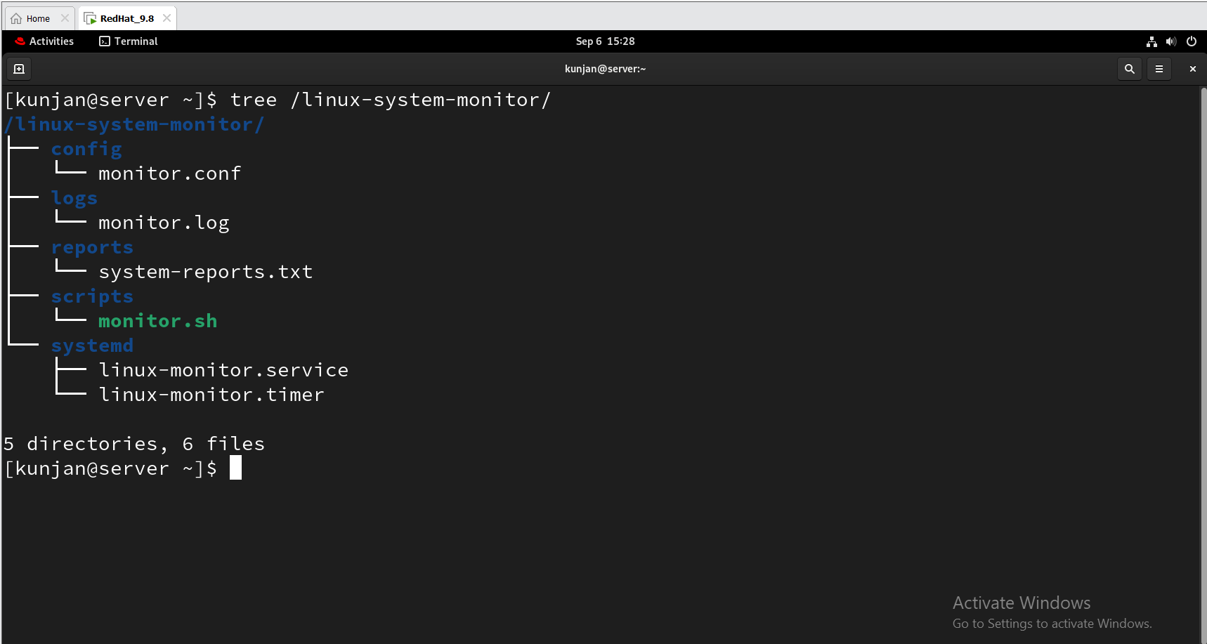
Screenshot 2: Successful monitor.sh execution showing system information.
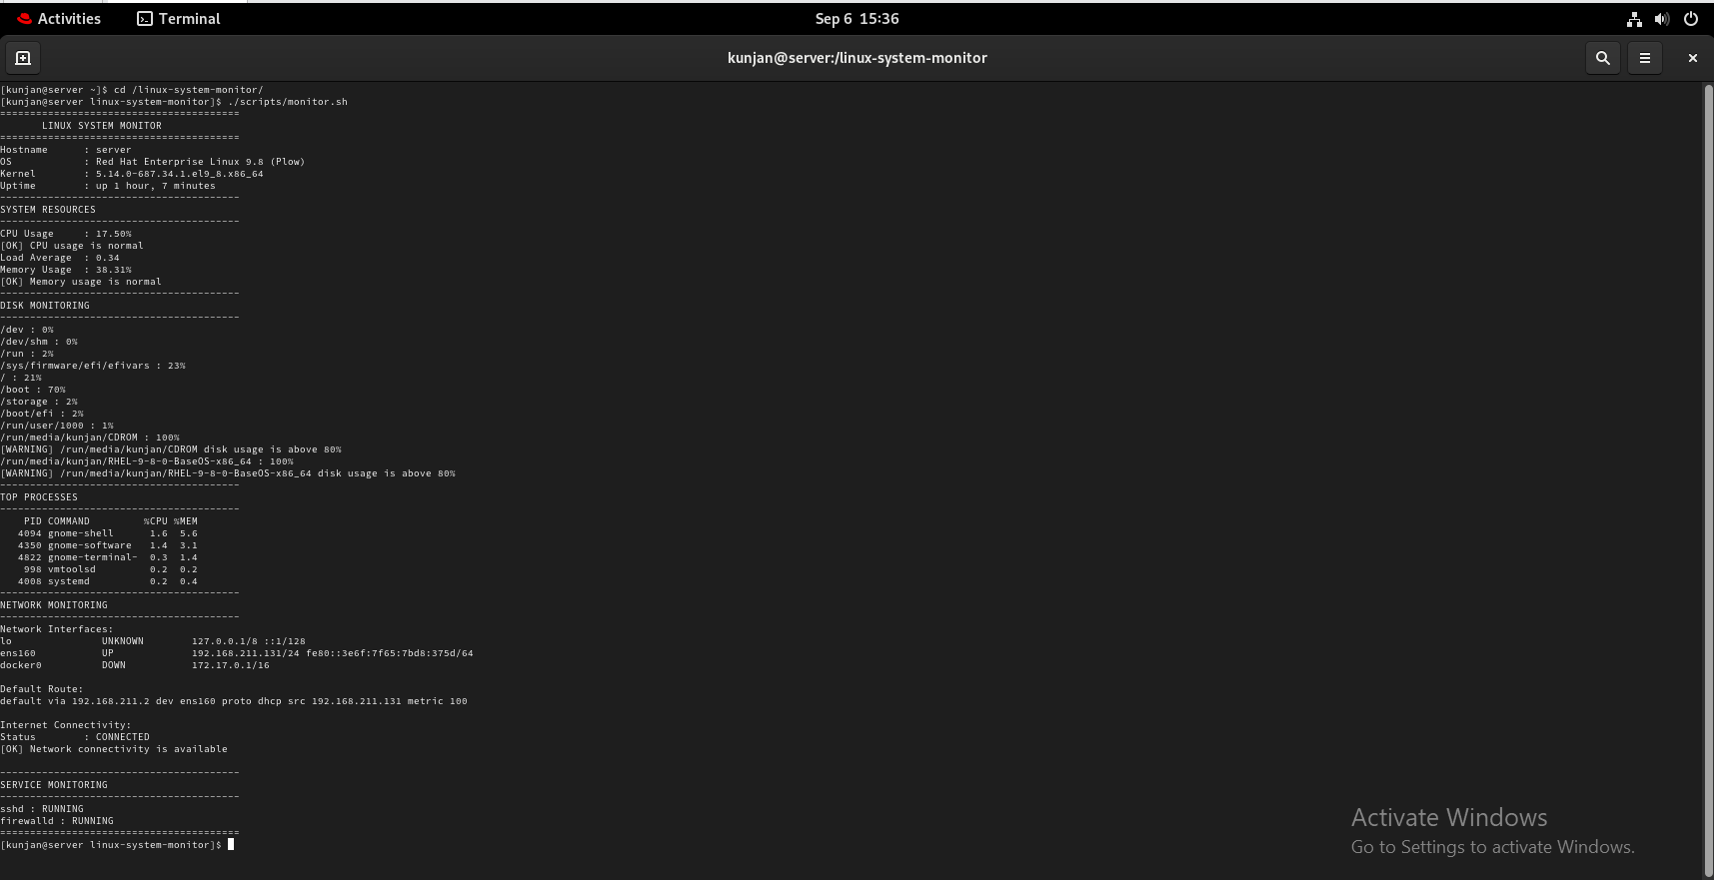
Screenshot 3: CPU, load and memory monitoring with [OK] status.
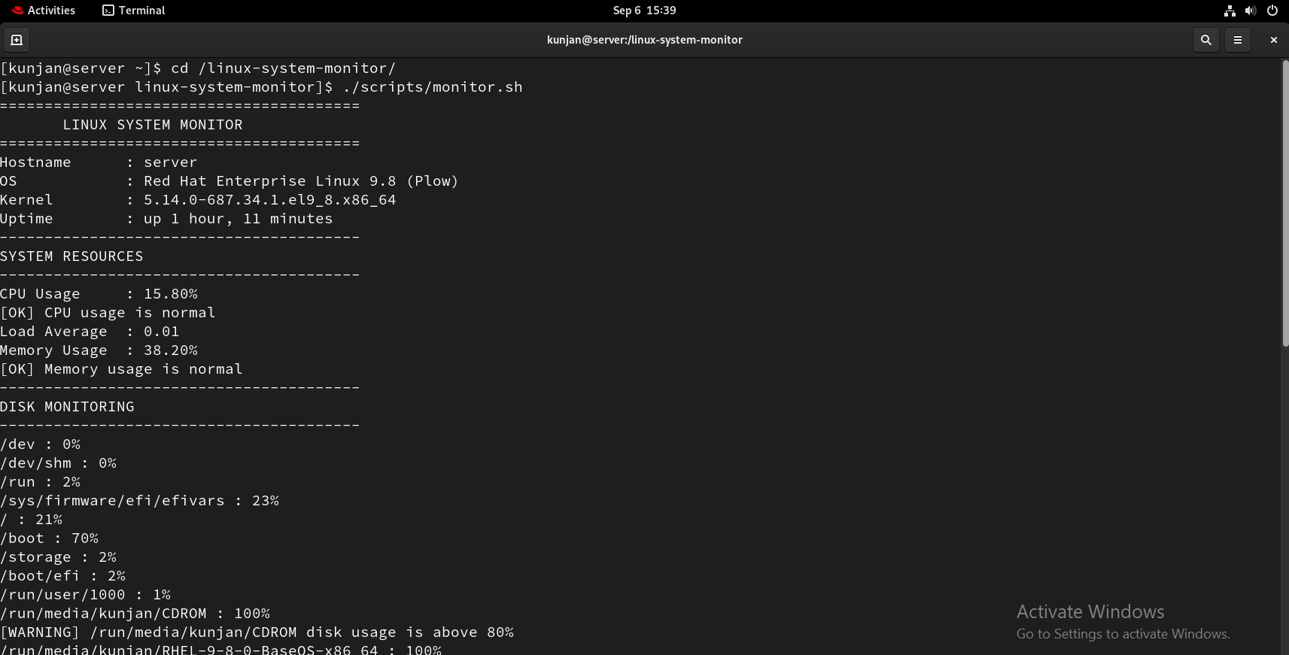
Screenshot 4: Disk monitoring and top-process output.
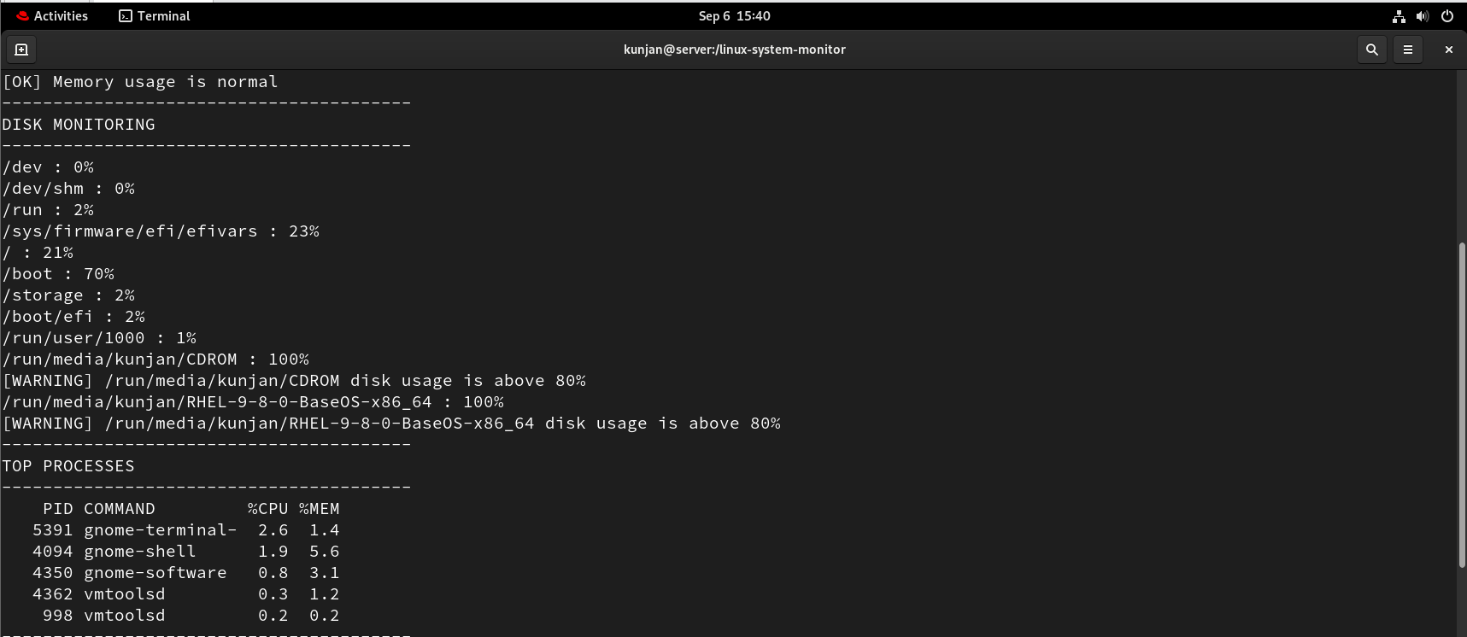
Screenshot 5: Network interfaces, default route and CONNECTED status.
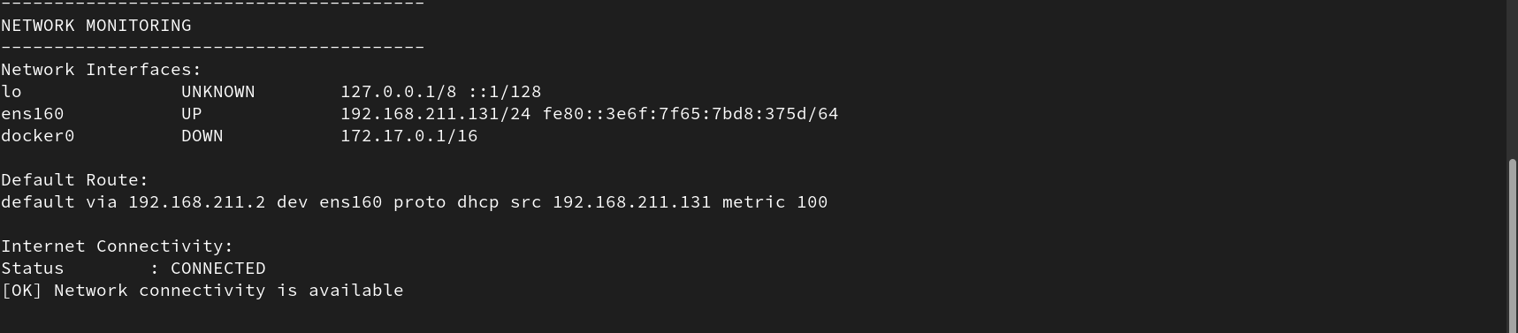
Screenshot 6: sshd and firewalld service status.
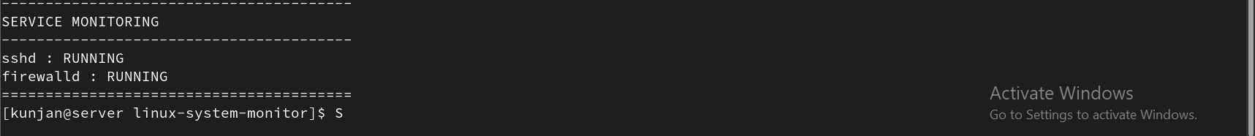
Screenshot 7: monitor.conf showing configured thresholds.
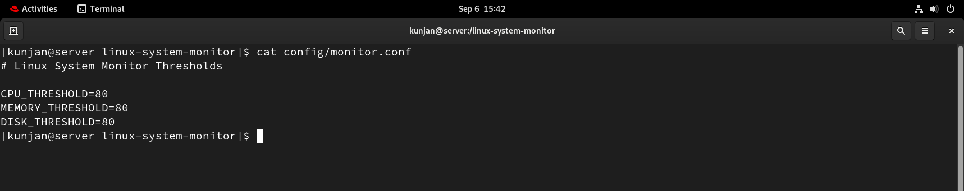
Screenshot 8: monitor.log containing monitoring output.
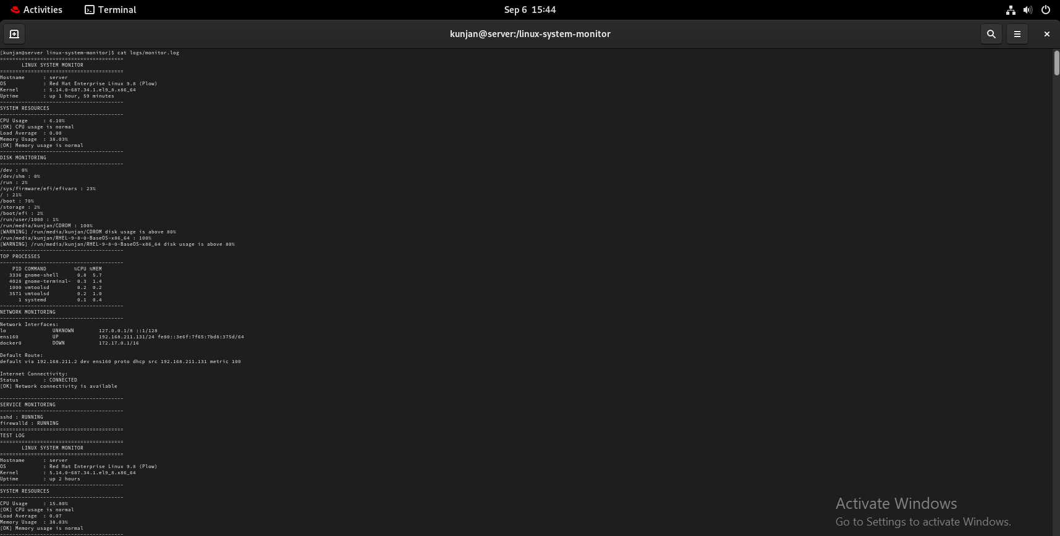
Screenshot 9: system-reports.txt containing the current report.
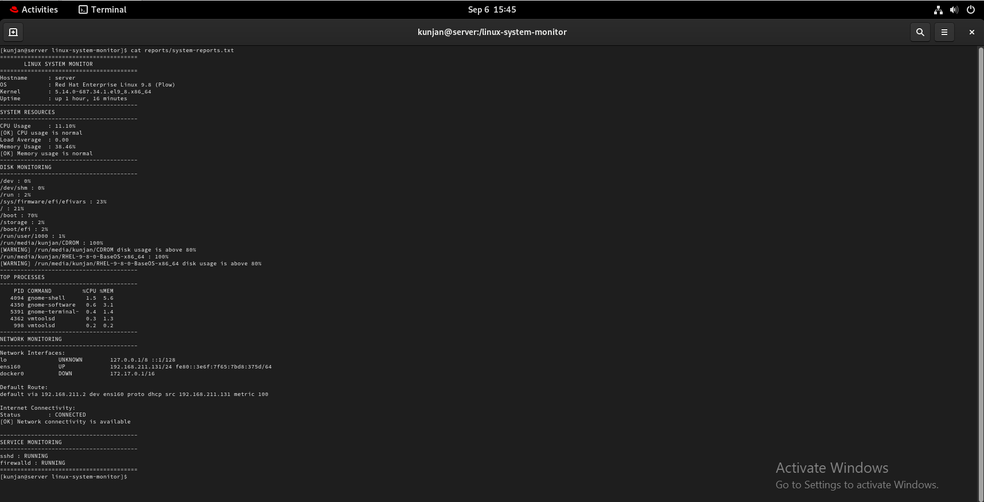
Screenshot 10: linux-monitor.service configuration.
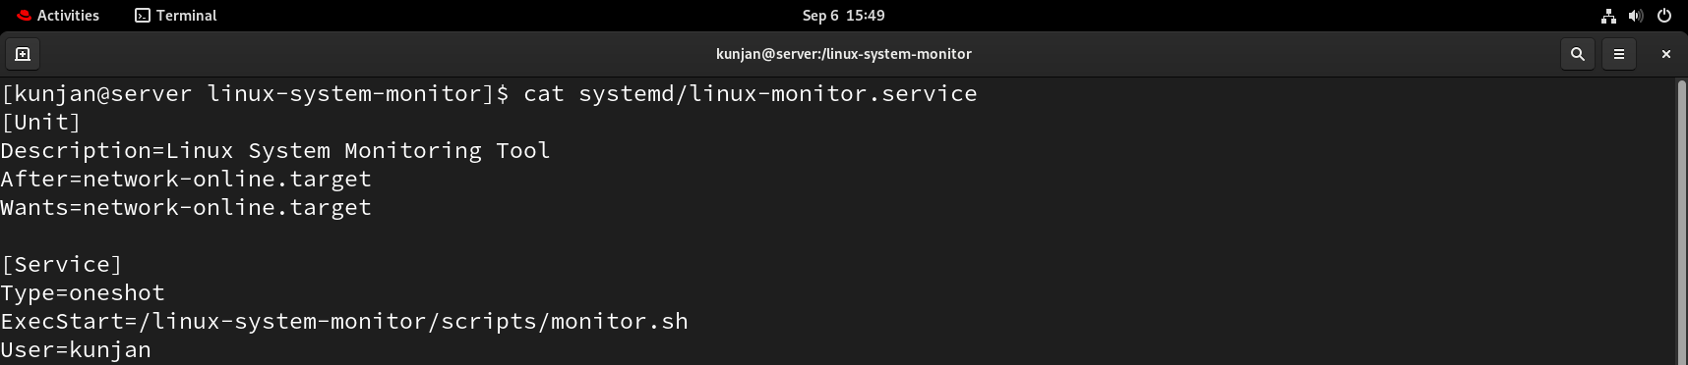
Screenshot 11: linux-monitor.timer configuration.
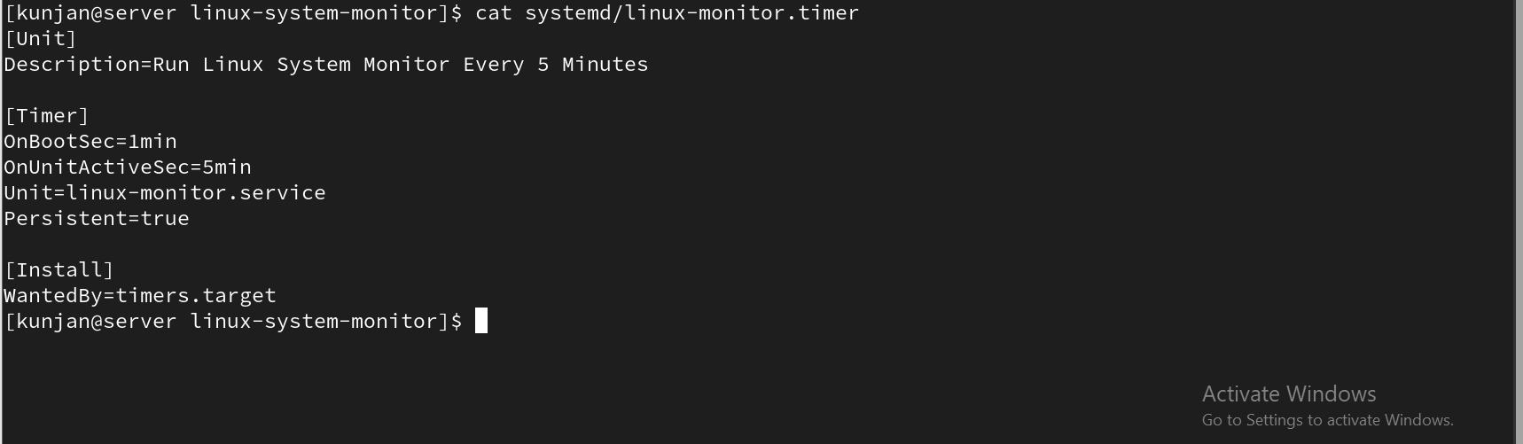
Screenshot 12: systemctl status linux-monitor.timer showing active/waiting.
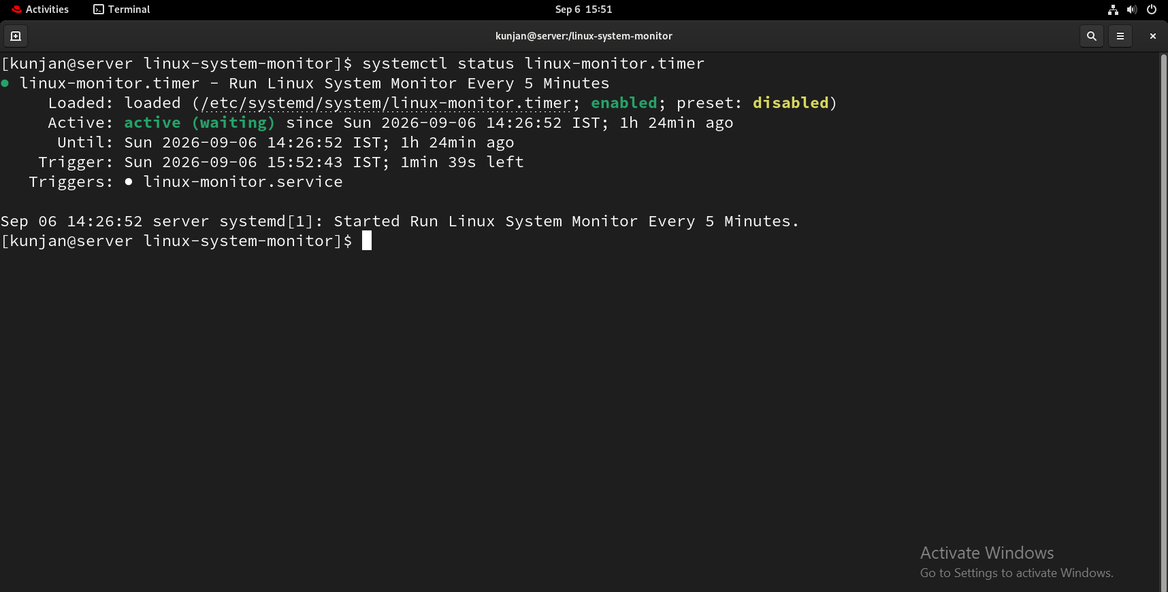
Screenshot 13: systemctl list-timers output showing the scheduled timer.
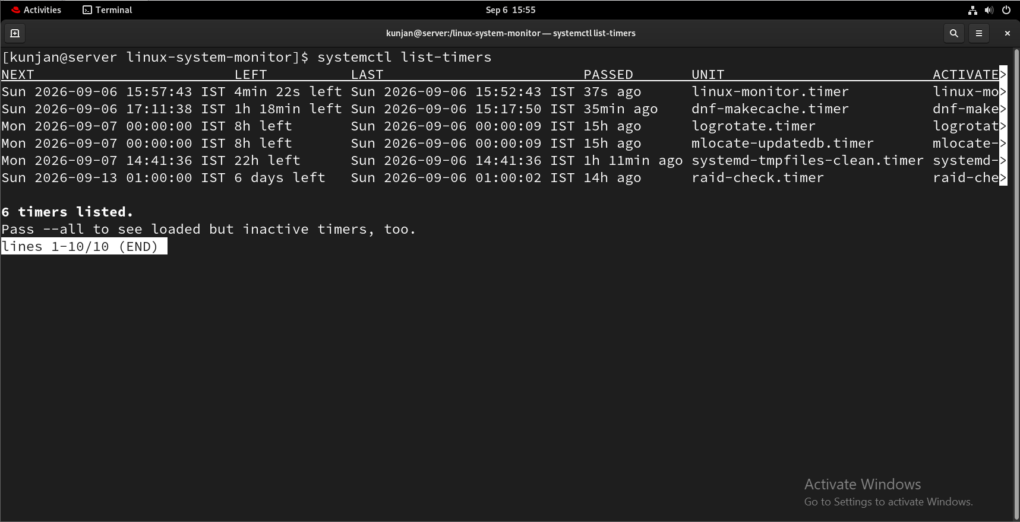
Screenshot 14: Intentional firewalld failure showing CRITICAL alert.
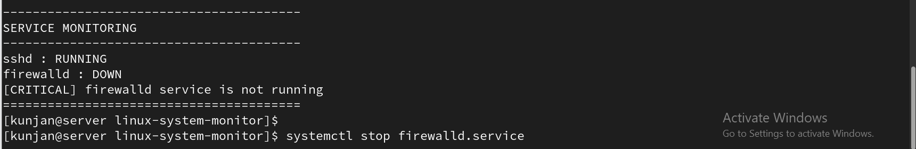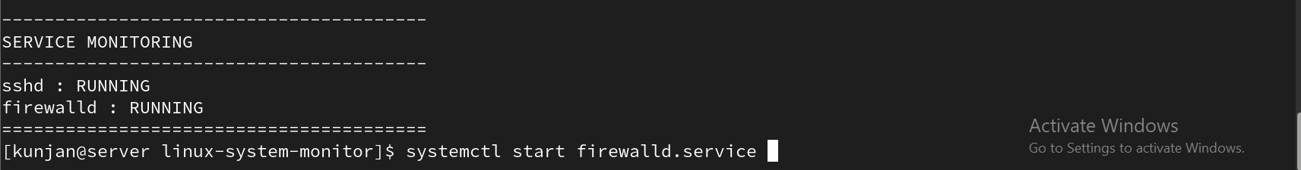
Screenshot 15: SELinux context after the fix showing bin_t.
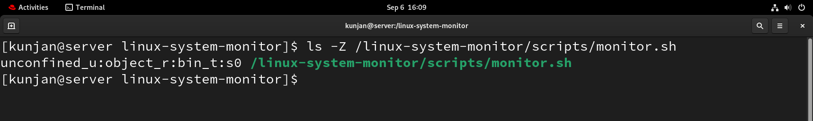
Screenshot 16: Successful systemd service execution and journal output.
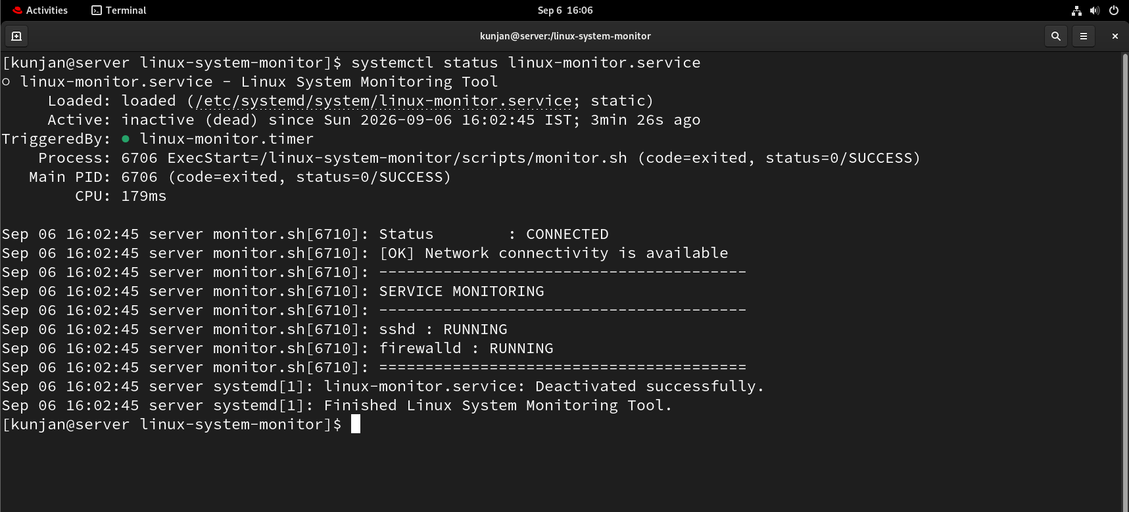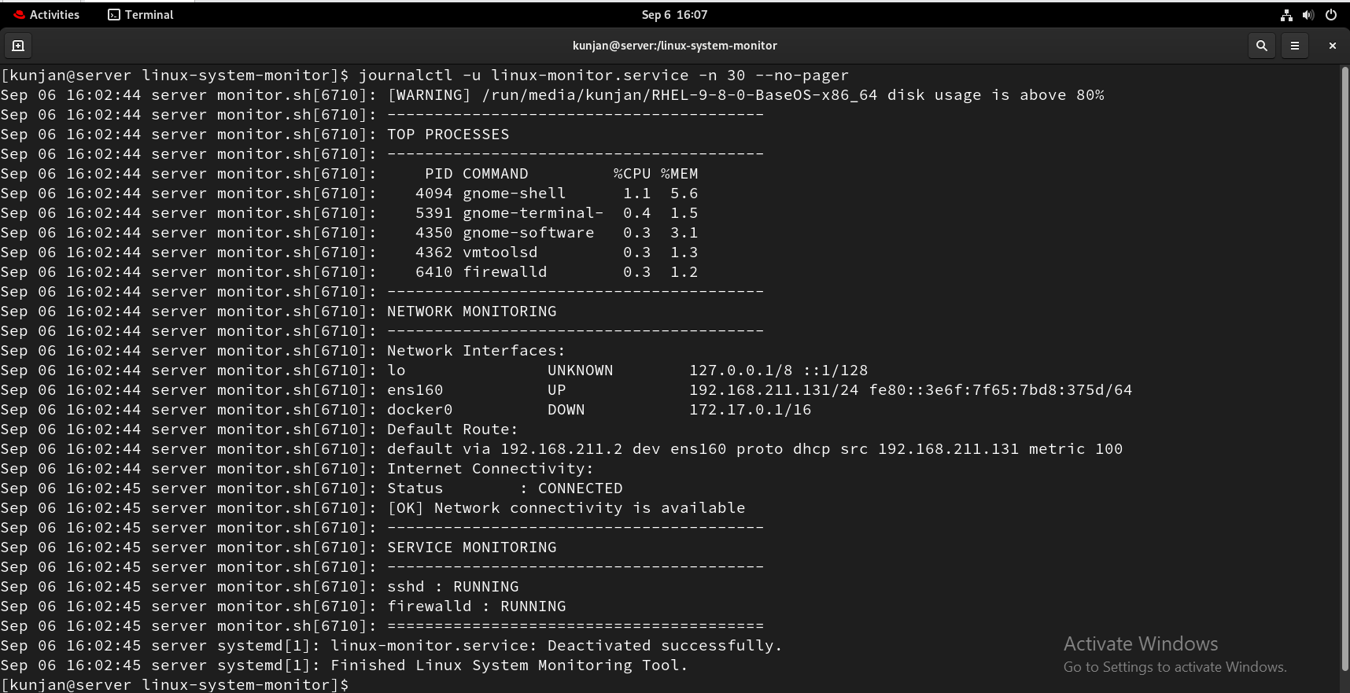

14. Security Considerations
- SELinux was kept in Enforcing mode throughout troubleshooting.
- The project directory is owned by the intended user rather than root to avoid unnecessary write-permission problems.
- The systemd service runs as the kunjan user instead of requiring the monitoring script itself to run as root.
- The monitoring tool checks firewalld status as part of basic host security monitoring.
- Thresholds are separated into a configuration file for easier administrative control.
- The project does not disable security controls simply to bypass errors; it diagnoses and fixes the underlying access policy.

15. Project Outcome and Skills Demonstrated
The completed project demonstrates practical skills in:
- RHEL system administration
- Bash scripting and shell automation
- Linux process and resource monitoring
- CPU, memory and filesystem analysis
- Linux networking and connectivity troubleshooting
- systemctl and systemd service management
- systemd timers and scheduled automation
- Linux file ownership and permissions
- SELinux context inspection and troubleshooting
- Log and report generation
- Threshold-based alerting
- Root-cause troubleshooting and verification

16. Future Enhancements
- Exclude read-only ISO and removable-media mounts from disk alerts.
- Add load-average and process-count thresholds.
- Monitor additional services through configuration rather than hard-coded checks.
- Add configurable alert destinations such as email or a messaging platform.
- Add JSON/CSV report output for integration with other tools.
- Add log rotation for long-term operation.
- Add a lightweight web dashboard if the project is expanded beyond the current Stage.

17. Conclusion
This project successfully demonstrates an end-to-end Linux system monitoring and automated alerting solution on RHEL 9.8. The tool collects system health information, evaluates configurable thresholds, monitors network connectivity and critical services, records results, generates a current report, and runs automatically through systemd.
The troubleshooting work is a significant part of the project. In particular, the systemd 203/EXEC failure was investigated through permissions, filesystem mount options and SELinux audit logs. The root cause was identified as an SELinux execution denial caused by the default_t context, and the issue was corrected without disabling SELinux. This demonstrates the practical workflow of
Monitor → Detect → Troubleshoot → Fix → Verify → Automate.
Overall, the project provides a compact but realistic demonstration of Linux administration, Bash automation, system monitoring, service management, security controls and troubleshooting.

