1. Grade Checker
score = int(input("Enter your score"))
if score>=90:
print("Grade: A")
elif score>=80:
print("Grade: B")
elif score>=70:
print("Grade: C")
elif score>=60:
print("Grade: D")
else:
print("Grade: F")
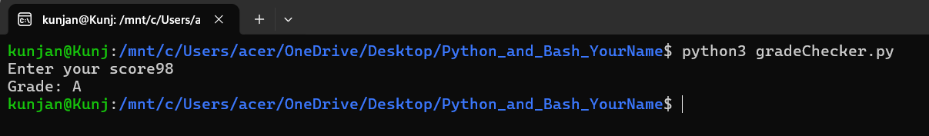
2. Student Grades
students = {
"Ankit": "A",
"Harsh": "B"
}

while True:

print("\n1. Add Student")
print("2. Update Student Grade")
print("3. Print all student Grades")
print("4. Exit")

choice = int(input("Enter your choice: "))

if choice == 1:
name = input("Enter your Name: ")
grade = input("Enter your grade: ")

if name in students:
print("Student already exists")
else:
students[name] = grade
print("Student added successfully.....")

elif choice == 2:
name = input("Enter your Name: ")

if name in students:
grade = input("Enter your grade: ")
students[name] = grade
print("Grade updated successfully.....")
else:
print("Student not found")

elif choice == 3:
print("\nStudent grades:")

for name, grade in students.items():
print(name, ":", grade)

elif choice == 4:
print("Program ended.")
break

else:
print("Invalid choice.")
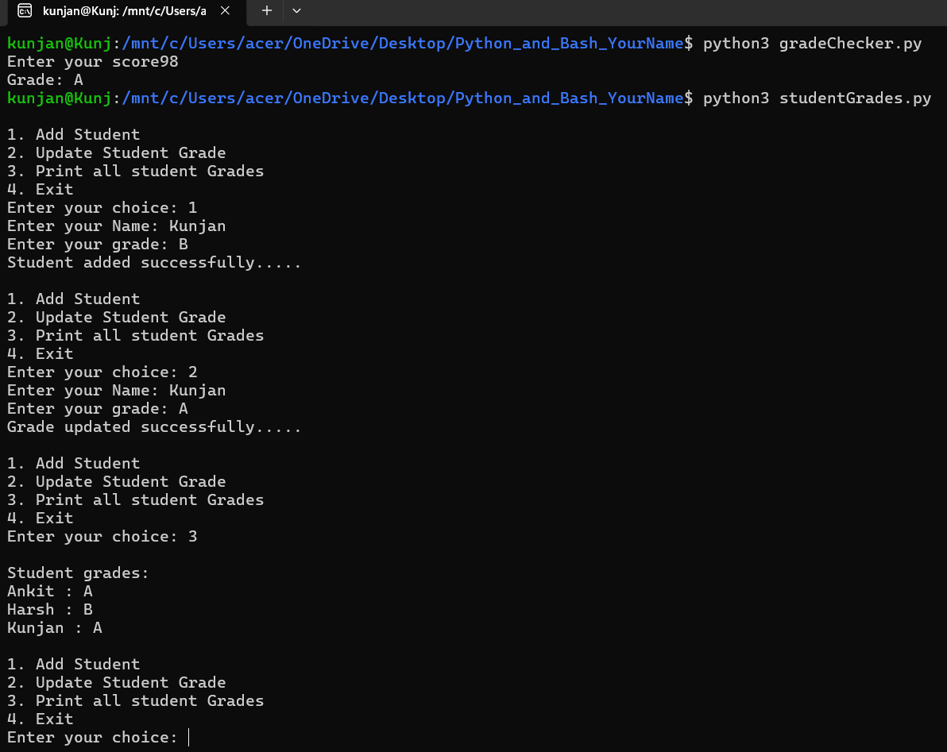
3. Write to a File
file=open("example.txt","w")
file.write("Hello, this is my python file.\n")
file.write("I am learning file handling.")
file.close()
print("Content written to file successfully....")
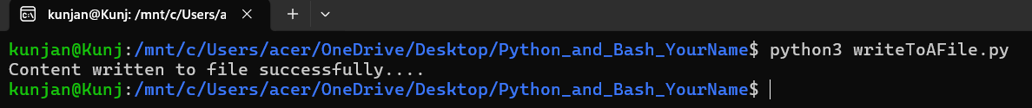
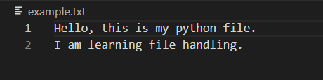
4. Read from a File
file=open("example.txt","r")
content = file.read()
print(content)
file.close()
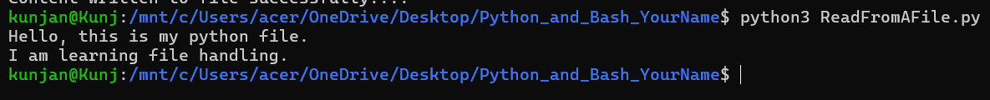

GitHub Link:
https://github.com/Kunjan1122/Python_and_Bash_Kunjan

