Predictive Forecasting of Care Load & Placement Demand
Internship Project Report
Prepared For
U.S. Department of Health and Human Services (HHS)
Project Domain
Predictive Analytics | Time Series Forecasting | Machine Learning
Prepared By
KUNJAN

Abstract
The Unaccompanied Alien Children (UAC) Program operates in a dynamic environment where fluctuations in border activity, policy changes, and humanitarian events can significantly impact the number of children entering federal care. Effective resource allocation requires accurate forecasting of future care loads and placement demand.
This project develops a predictive forecasting framework using historical operational data from the U.S. Department of Health and Human Services. The analysis combines time-series forecasting techniques and machine learning models to estimate future care loads, discharge demand, and potential capacity stress.
Exploratory Data Analysis (EDA), feature engineering, statistical forecasting methods (ARIMA and SARIMA), and machine learning approaches (Random Forest and Gradient Boosting) were applied. Model performance was evaluated using Mean Absolute Error (MAE), Root Mean Squared Error (RMSE), and forecasting stability indicators.
Results demonstrated that Gradient Boosting achieved the highest forecasting accuracy and significantly outperformed traditional statistical models. A Streamlit-based dashboard was developed to provide interactive forecasting insights, enabling proactive planning and evidence-based decision-making.
The proposed framework supports healthcare planners and child-welfare administrators in anticipating operational demands and improving resource allocation strategies.

1. Introduction
The Unaccompanied Alien Children (UAC) Program is responsible for providing temporary care and support to children transferred from Customs and Border Protection (CBP) custody into the care of the U.S. Department of Health and Human Services (HHS).
Managing shelter capacity, staffing requirements, medical resources, and placement operations requires timely and accurate forecasting. Traditional reporting methods primarily describe historical trends and provide limited support for proactive decision-making.
Predictive analytics offers an opportunity to transform historical operational data into actionable intelligence. By forecasting future care loads and placement demand, decision-makers can better prepare for periods of increased operational pressure and reduce the risks associated with overcrowding and delayed placements.
This project aims to develop a comprehensive predictive forecasting system capable of supporting short-term operational planning and resource allocation within the UAC Program.

2. Problem Statement
The Unaccompanied Alien Children (UAC) Program operates in a highly dynamic and uncertain environment where changes in border activity, policy implementation, and humanitarian events can rapidly increase the number of children entering federal care. Although the program maintains high-quality daily operational records, it currently lacks a predictive framework capable of forecasting future care loads and placement demand.
Existing reporting systems primarily focus on historical analysis and provide limited support for proactive planning. Consequently, operational responses are often reactive rather than preventive. Delays in anticipating increased care demand may lead to overcrowding, resource shortages, increased staff workload, and extended lengths of stay for children awaiting placement.
To address these challenges, a predictive forecasting system is required that can estimate future care loads, identify capacity stress risks, and support timely resource allocation decisions within the UAC Program.

3. Project Objectives
The primary objective of this project is to develop a predictive forecasting framework capable of estimating future operational demand within the UAC Program. The project seeks to transform historical operational data into actionable intelligence that supports proactive decision-making.
The specific objectives of the project are as follows:
- Forecast the number of children expected to remain in HHS care over short-term planning horizons.
- Estimate future imbalances between incoming transfers and outgoing discharges.
- Predict short-term discharge demand and placement requirements.
- Provide early-warning indicators for healthcare planners and operational managers.
- Quantify forecasting uncertainty and model reliability.
- Compare the performance of traditional statistical forecasting methods with machine learning approaches.
- Support evidence-based resource allocation and capacity planning.
By achieving these objectives, the project aims to improve operational preparedness and strengthen child-welfare outcomes through predictive analytics.

4. Dataset Description
The dataset used in this study was obtained from the HHS Unaccompanied Alien Children (UAC) Program and contains daily operational information related to child custody, transfers, care management, and discharge activities. The data represents key operational indicators that influence healthcare planning and shelter management within the program.
The dataset consists of the following variables:
- Date: Reporting date for each observation.
- Children Apprehended and Placed in CBP Custody: Daily intake volume entering the system.
- Children in CBP Custody: Number of children currently under CBP care.
- Children Transferred Out of CBP Custody: Daily transfers from CBP into HHS care.
- Children in HHS Care: Active care load managed by HHS.
- Children Discharged from HHS Care: Number of successful sponsor placements and exits from care.
The dataset contains daily observations collected over an extended period, making it suitable for time-series forecasting and predictive modeling applications. The availability of continuous operational records enables the identification of trends, patterns, and capacity stress indicators that are critical for forecasting future care demand.

5. Methodology
The methodology adopted in this project follows a structured predictive analytics framework consisting of data preprocessing, exploratory analysis, feature engineering, forecasting model development, model evaluation, and dashboard implementation. The workflow was designed to ensure data quality, forecasting accuracy, and practical usability for decision-makers.

5.1 Data Preprocessing
Data preprocessing was performed to ensure the dataset was clean, consistent, and suitable for time-series forecasting. The Date column was converted into datetime format and used as the primary temporal index for analysis. Missing observations and invalid values were identified and appropriately handled to maintain continuity within the time series.
Numerical variables were standardized and cleaned to ensure accurate calculations and visualizations. The processed dataset was then exported and stored for subsequent modeling and dashboard development activities.
These preprocessing steps improved data reliability and established a solid foundation for predictive analysis.

5.2 Exploratory Data Analysis
Exploratory Data Analysis (EDA) was conducted to gain insights into historical trends and operational patterns within the UAC Program. The analysis focused on understanding fluctuations in care load, transfer volumes, discharge rates, and relationships among key variables.
Several visualization techniques were applied to examine temporal trends, distributions, and correlations. Time-series plots revealed long-term patterns in HHS care load, while correlation analysis identified relationships between operational variables.
The findings from EDA informed the feature engineering process and provided valuable context for model development.

5.3 Feature Engineering
Feature engineering was performed to enhance the predictive capability of machine learning models by incorporating historical information and operational indicators.
Lag features were generated using previous observations from one day, seven days, and fourteen days prior. These variables allowed forecasting models to capture temporal dependencies within the data.
Rolling statistical features were also created, including seven-day and fourteen-day rolling averages and variances. These features provided information regarding recent trends and volatility.
A flow-based indicator called Net Pressure was developed using the following relationship:
Net Pressure = Transfers from CBP − HHS Discharges
This metric represents the balance between incoming and outgoing children and serves as an operational stress indicator. Positive values indicate increasing pressure on HHS care resources.
Additional calendar-based features such as day of week and month were included to capture temporal effects and recurring patterns.
These engineered features significantly improved the ability of machine learning algorithms to model complex operational dynamics.

5.4 Forecasting Models
Multiple forecasting approaches were implemented to compare predictive performance across different methodologies.
The first category consisted of statistical forecasting models. ARIMA (AutoRegressive Integrated Moving Average) was used to capture temporal dependencies and trend behavior within the care-load series. SARIMA (Seasonal AutoRegressive Integrated Moving Average) extended the ARIMA framework by incorporating seasonal effects and recurring temporal patterns.
The second category consisted of machine learning forecasting models. A Random Forest Regressor was developed using ensemble learning techniques to model nonlinear relationships among engineered features. Additionally, a Gradient Boosting Regressor was implemented to iteratively reduce prediction errors and improve forecasting accuracy.
Comparing these approaches enabled the identification of the most effective forecasting strategy for operational planning within the UAC Program.

5.5 Model Evaluation
The forecasting models were evaluated using multiple performance metrics to ensure a comprehensive assessment of predictive accuracy and reliability.
Mean Absolute Error (MAE) was used to measure the average magnitude of forecasting errors. Root Mean Squared Error (RMSE) was used to penalize larger prediction errors and assess overall model precision. Mean Absolute Percentage Error (MAPE) provided a relative measure of forecasting performance.
Additional operational indicators such as Capacity Breach Probability and Forecast Stability Index were calculated to evaluate the practical usefulness of the forecasting framework for resource planning and capacity management.
The evaluation framework enabled a rigorous comparison of all forecasting models and supported the selection of the most effective predictive approach.

6. Exploratory Data Analysis Findings
Exploratory Data Analysis (EDA) was conducted to understand historical trends, operational patterns, and relationships among variables within the UAC Program dataset. The analysis provided valuable insights that guided feature engineering and forecasting model development.
The time-series analysis of the Children in HHS Care variable revealed significant fluctuations over the observation period, indicating changing operational demands and variations in intake and discharge activity. These fluctuations demonstrated the need for a forecasting system capable of anticipating future care-load changes.
Distribution analysis showed that operational variables such as transfers, discharges, and care load exhibited non-uniform behavior, reflecting the dynamic nature of child-welfare operations. Several periods of elevated care load were observed, highlighting the importance of proactive capacity planning.
Correlation analysis indicated meaningful relationships among key operational indicators. In particular, transfers from CBP custody showed a positive relationship with the number of children in HHS care, while discharges contributed to reducing active care loads. These findings validated the inclusion of flow-based features during the feature engineering stage.
The Net Pressure indicator, defined as the difference between transfers and discharges, successfully identified periods of operational stress. Positive Net Pressure values corresponded to increasing demand on HHS resources and were later incorporated into predictive modeling.
Overall, the exploratory analysis confirmed the suitability of the dataset for forecasting applications and provided important operational insights into care-load dynamics.

7. Results and Discussion
Multiple forecasting models were developed and evaluated to identify the most effective approach for predicting future care-load demand. Both statistical and machine learning methodologies were assessed using standard forecasting performance metrics.
The models evaluated in this study included:
- ARIMA
- SARIMA
- Random Forest Regressor
- Gradient Boosting Regressor
The performance results are summarized below.
Model | MAE | RMSE
ARIMA | 272.55 | 323.05
SARIMA | 828.41 | 921.66
Random Forest | 66.48 | 88.57
Gradient Boosting | 64.44 | 86.99
The results clearly demonstrate that machine learning approaches significantly outperformed traditional statistical forecasting methods.
The ARIMA model achieved moderate forecasting performance and was capable of capturing basic temporal trends within the care-load series. However, its forecasting accuracy remained limited when compared with machine learning approaches.
The SARIMA model produced the highest forecasting errors among all evaluated models. Although seasonal effects were considered during model development, the underlying operational data exhibited complex patterns that were not adequately captured by seasonal statistical modeling alone.
The Random Forest Regressor delivered substantially improved forecasting accuracy. By leveraging engineered features and nonlinear relationships within the dataset, the model achieved a significant reduction in forecasting error compared with ARIMA and SARIMA.
The Gradient Boosting Regressor emerged as the best-performing forecasting model. It achieved the lowest Mean Absolute Error (MAE) and Root Mean Squared Error (RMSE), demonstrating superior predictive capability and robustness. The iterative error-correction mechanism of Gradient Boosting enabled the model to effectively capture complex operational patterns within the data.
The results indicate that machine learning models are more suitable for forecasting care-load demand within the UAC Program than traditional statistical approaches.

7.1 Forecast Accuracy Assessment
Forecasting accuracy is a critical factor in operational planning because inaccurate predictions may result in resource shortages or unnecessary capacity expansion.
The Gradient Boosting model consistently generated the most reliable predictions and demonstrated strong stability across the evaluation period. The low forecasting error suggests that the model can effectively support short-term planning activities and resource allocation decisions.
The substantial performance gap between machine learning and statistical approaches highlights the value of feature engineering and nonlinear predictive modeling in operational forecasting applications.

7.2 Capacity Stress Analysis
An important objective of this project was to identify potential periods of capacity stress within the HHS care system.
The Capacity Breach Probability was calculated using the Net Pressure indicator and was estimated at approximately 33.71%. This finding indicates that nearly one-third of the observed periods experienced positive operational pressure where incoming transfers exceeded outgoing discharges.
Such periods represent elevated risk for shelter overcrowding, staffing challenges, and increased resource utilization. The ability to identify these situations in advance provides significant value for healthcare planners and operational managers.
The forecasting framework developed in this project can therefore serve not only as a prediction tool but also as an early-warning system for capacity management.

7.3 Dashboard Implementation
To improve accessibility and practical usability, a Streamlit-based web dashboard was developed as part of the project.
The dashboard includes several interactive modules:
- Key Performance Indicators (KPIs)
- Children in HHS Care Trend Visualization
- Forecasting Module
- Model Comparison Dashboard
- Capacity Stress Indicator
- Executive Summary Panel
Users can interactively explore historical trends, compare forecasting models, and evaluate future care-load projections through a user-friendly interface.
The dashboard transforms analytical outputs into actionable insights and supports data-driven decision-making for operational stakeholders.
Figure 1: Dashboard Home Page
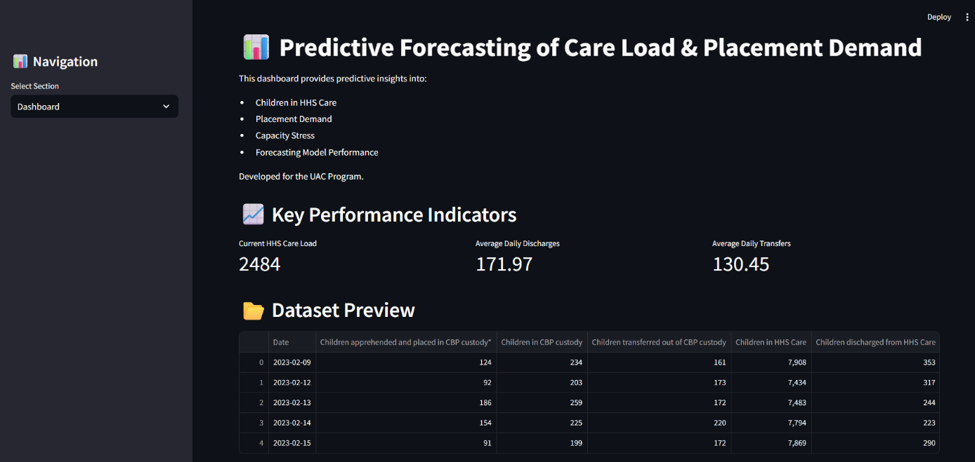
Figure 2: Forecasting Module
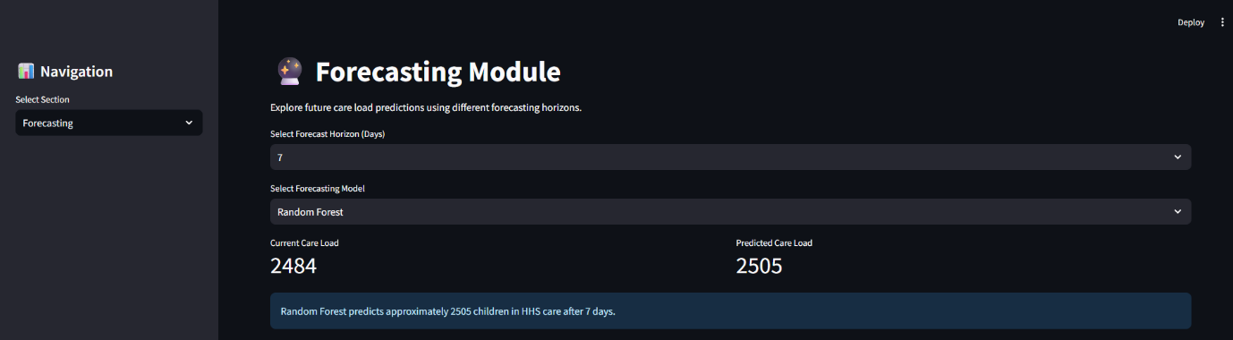
Figure 3: Executive Summary Dashboard
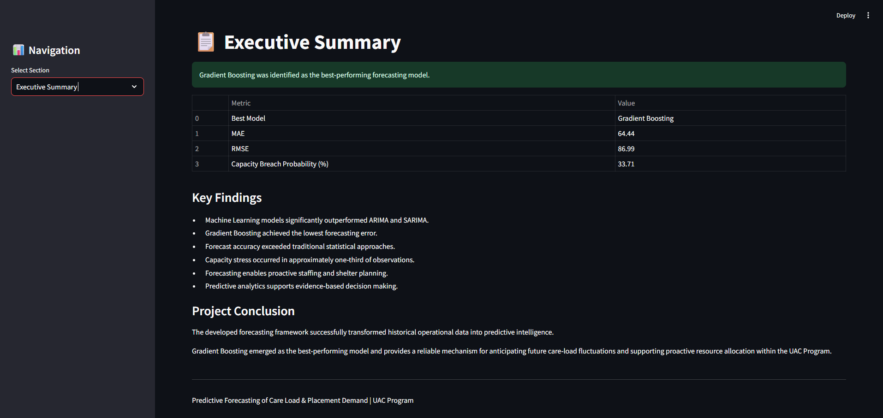

7.4 Discussion
The results obtained from this study demonstrate the effectiveness of predictive analytics in addressing operational challenges within child-welfare systems. Historical reporting alone provides limited support for future planning, whereas predictive forecasting enables organizations to anticipate demand before capacity constraints emerge.
The superior performance of Gradient Boosting suggests that machine learning approaches are particularly well-suited for modeling the complex relationships present within UAC operational data. Furthermore, the integration of forecasting outputs into an interactive dashboard enhances the practical value of the solution by enabling rapid interpretation of predictive insights.
The forecasting framework developed in this project provides a scalable foundation that can be extended to additional operational datasets and future planning initiatives.

8. Conclusion
This project successfully developed a predictive forecasting framework for estimating future care-load demand and placement requirements within the Unaccompanied Alien Children (UAC) Program. The primary objective was to transform historical operational data into actionable predictive intelligence capable of supporting proactive decision-making.
A comprehensive analytical workflow was implemented, including data preprocessing, exploratory data analysis, feature engineering, statistical forecasting, machine learning modeling, and dashboard development. Both traditional time-series forecasting techniques and advanced machine learning algorithms were evaluated to determine the most effective forecasting approach.
The results demonstrated that machine learning models significantly outperformed statistical forecasting methods. Among all evaluated approaches, the Gradient Boosting Regressor achieved the highest predictive accuracy with the lowest forecasting error values. This finding highlights the effectiveness of machine learning techniques in capturing complex operational relationships within the dataset.
The developed Streamlit dashboard further enhanced the practical utility of the project by providing interactive visualizations, forecasting capabilities, and executive-level performance indicators. The resulting framework enables healthcare planners and operational managers to anticipate future demand, identify potential capacity stress, and make data-driven resource allocation decisions.
Overall, the project demonstrates the value of predictive analytics in improving operational preparedness and supporting child-welfare outcomes through proactive planning.

9. Recommendations
Based on the findings of this study, the following recommendations are proposed:
- Integrate predictive forecasting into routine operational planning processes to improve preparedness and resource allocation.
- Utilize the Gradient Boosting forecasting model as the primary forecasting engine due to its superior predictive performance.
- Monitor Net Pressure indicators regularly to identify emerging capacity stress and operational bottlenecks.
- Expand dashboard usage among operational stakeholders to improve accessibility of forecasting insights and support evidence-based decision-making.
- Establish periodic model retraining procedures to ensure forecasting performance remains accurate as operational conditions evolve.
- Incorporate forecasting outputs into staffing, shelter capacity, medical planning, and placement management strategies.
Implementation of these recommendations can enhance operational efficiency and improve responsiveness to changing care-load demands.

10. Future Work
Although the forecasting framework achieved strong predictive performance, several opportunities exist for future enhancement.
Future work may include:
- Incorporating external factors such as policy changes, border activity indicators, and humanitarian events.
- Developing long-term forecasting models capable of predicting care-load demand over extended planning horizons.
- Implementing advanced machine learning techniques such as XGBoost, LightGBM, and deep learning architectures.
- Integrating real-time data pipelines for automated forecasting updates.
- Expanding uncertainty estimation and confidence interval analysis.
- Deploying the dashboard within a cloud environment to improve accessibility and scalability.
These enhancements would further strengthen forecasting accuracy and operational decision support capabilities.

11. References
- Hyndman, R. J., & Athanasopoulos, G. Forecasting: Principles and Practice. OTexts Publishing.
- Box, G. E. P., Jenkins, G. M., Reinsel, G. C., & Ljung, G. M. Time Series Analysis: Forecasting and Control. Wiley.
- Breiman, L. (2001). Random Forests. Machine Learning, 45(1), 5–32.
- Friedman, J. H. (2001). Greedy Function Approximation: A Gradient Boosting Machine. The Annals of Statistics, 29(5), 1189–1232.
- Pedregosa, F., et al. (2011). Scikit-learn: Machine Learning in Python. Journal of Machine Learning Research, 12, 2825–2830.
- Streamlit Documentation. Streamlit Inc.
- Statsmodels Documentation. Statistical Modeling and Econometrics in Python.
- U.S. Department of Health and Human Services. Unaccompanied Alien Children Program Operational Data.

