*software engineering**Assignment*

***Module – 1***

**SE – Overview of IT Industry**

1. ***What is software?What is software engineering?***

**What is software?**

Software is set of instructions. Software is a collection of programs and data that tell a computer how to perform specific tasks.Software is that part of a computer.

**What is software engineering?**

Software engineering the development of software using well define scientific principal and methods.

1. ***Explain types of software***

**Application software:**

These software programs are designed to run a computer's application programs and hardware. System software coordinates the activities and functions of the hardware and software. In addition, it controls the operations of the computer hardware and provides an environment or platform for all the other types of software to work in. The OS is the best example of system software; it manages all the other computer programs. Other examples of system software include the, computer language translators and system utilities.

**System software:**

These software programs are designed to run a computer's application programs and hardware. System software coordinates the activities and functions of the hardware and software. In addition, it controls the operations of the computer hardware and provides an environment or platform for all the other types of software to work in. The OS is the best example of system software; it manages all the other computer programs. Other examples of system software include the, computer language translators and system utilities.

**Driver software:**

Also known as device drivers, this software is often considered a type of system software. Device drivers control the devices and peripherals connected to a computer, enabling them to perform their specific tasks. Every device that is connected to a computer needs at least one device driver to function. Examples include software that comes with any nonstandard hardware, including special game

controllers, as well as the software that enables standard hardware, such as USB storage devices, keyboards, headphones and printers.

**Programming software:**

Computer programmers use programming software to write code. Programming software and programming tools enable developers to develop, write, test and debug other software programs. Examples of programming software include assemblers, compilers, debuggers and interpreters.

1. **What is SDLC? Explain each phase of SDLC**

SDLC is the acronym of Software Development Life Cycle.

* It is also called as Software Development Process.
* SDLC is a framework defining tasks performed at each step in the software development process.

**Stage 1: Planning and Requirement Analysis**

Planning for the quality assurance requirements and identification of the risks associated with the project is also done in the planning stage. The outcome of the technical feasibility study is to define the various technical approaches that can be followed to implement the project successfully with minimum risks.

## **Stage 2: Defining Requirements**

Once the requirement analysis is done the next step is to clearly define and document the product requirements and get them approved from the customer or the market analysts. This is done through an SRS (Software Requirement Specification) document which consists of all the product requirements to be designed and developed during the project life cycle.

## **Stage 3: Designing the Product Architecture**

SRS is the reference for product architects to come out with the best architecture for the product to be developed. Based on the requirements specified in SRS, usually more than one design approach for the product architecture is proposed and documented in a DDS - Design Document Specification.

This DDS is reviewed by all the important stakeholders and based on various parameters as risk assessment, product robustness, design modularity, budget and time constraints, the best design approach is selected for the product.

**Stage 4: Building or Developing the Product**

In this stage of SDLC the actual development starts and the product is built. The programming code is generated as per DDS during this stage. If the design is performed in a detailed and organized manner, code generation can be accomplished without much hassle Developers must follow the coding guidelines defined by their organization and programming tools like compilers, interpreters, debuggers, etc. are used to generate the code. Different high level programming languages such as C, C++, Pascal, Java and PHP are used for coding. The programming language is chosen with respect to the type of software being developed.

## **Stage 5: Testing the Product**

This stage is usually a subset of all the stages as in the modern SDLC models, the testing activities are mostly involved in all the stages of SDLC. However, this stage refers to the testing only stage of the product where product defects are reported, tracked, fixed and retested, until the product reaches the quality standards defined in the SRS.

## **Stage 6: Deployment in the Market and Maintenance**

Once the product is tested and ready to be deployed it is released formally in the appropriate market. Sometimes product deployment happens in stages as per the business strategy of that organization. The product may first be released in a limited segment and tested in the real business environment.

Then based on the feedback, the product may be released as it is or with suggested enhancements in the targeting market segment. After the product is released in the market, its maintenance is done for the existing customer base.

# **4)What is DFD? Create a DFD diagram on Flipkart**

Data Flow Diagram (DFD) represents the flow of data within information systems. Data Flow Diagrams (DFD) provide a graphical representation of the data flow of a system that can be understood by both technical and non-technical users. The models enable software engineers, customers, and users to work together effectively during the analysis and specification of requirements.

## **0 Level User Side DFD**



**Online**



**flipcart**



**shopping**



**ADMIN**



**USER**



**Request for Login**



**Response**



**Response**



**Request for Registration**

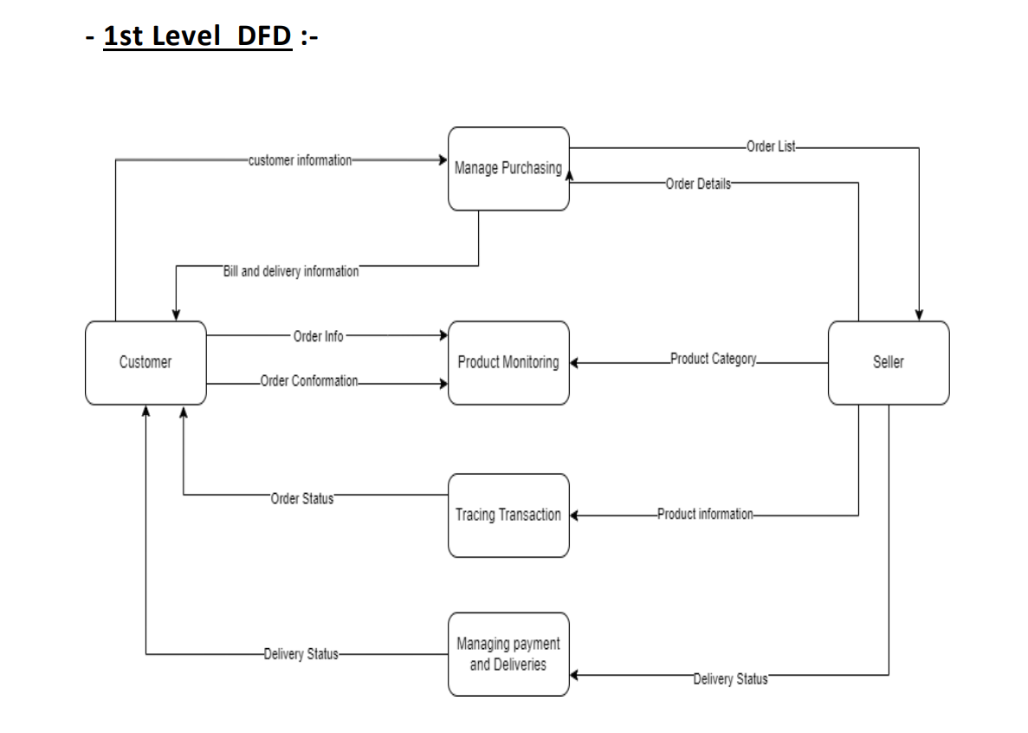

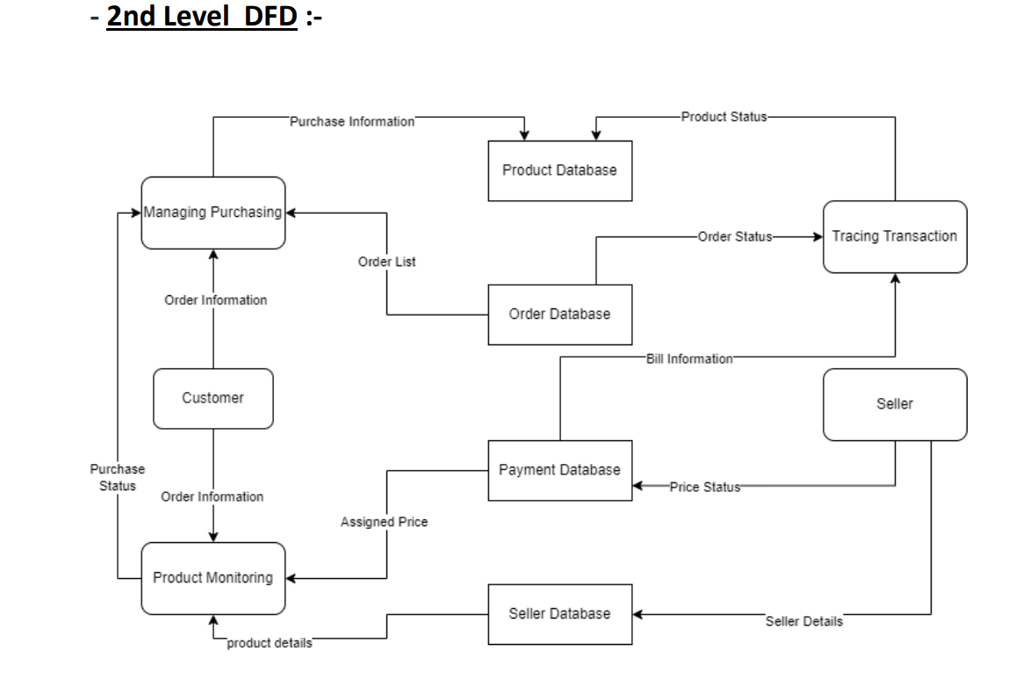

**5) What is Flow chart? Create a flowchart to make addition of two numbers**

A flowchart is a diagram depicting a process, a system or a computer algorithm. It is a diagrammatic representation of the solution to a given problem but, more importantly, it provides a breakdown of the essential steps to solving the problem

***6) What is Use case Diagram? Create a use-case on bill payment on paytm***

A visual depiction of the interactions between a system and its users, a use case diagram shows how users work with the system to accomplish specific objectives. It is made up of use cases (tasks or goals), actors (users or other systems), and the connections between them.

