ENTERPRISE PERFORMANCE MANAGEMENT SYSTEM (PMS)
User Hierarchy Structure, Performance Plan Workflow & Lifecycle Specification
Comprehensive Technical & Operational Architecture: Multi-Level Roles, Weight Governance, Approval States, Amendment Controls, and Visual Diagrams
Platform / App | Target Audience | Specification Version | Release Date
GDL PMS (Frappe/ERPNext) | HR, Leads, Developers | Version 2.0 (Official) | September 2026

Executive Summary & Architecture Overview
The GDL Performance Management System (PMS) is an enterprise-grade appraisal framework built natively on Frappe and ERPNext. It governs the complete performance planning, goal-setting, mid-cycle monitoring, evaluation, and grievance redressal cycle across diverse organizational tiers. This specification establishes the formal reference for user roles, reporting hierarchy linkages, mathematical weight distributions, status transition gates, amendment protocols, and data models.
CORE GOVERNANCE PRINCIPLE: The system strictly separates initial goal planning (Planning Open) from execution monitoring (Monitoring). Once a Performance Plan is Approved, direct editing of targets is locked at both the client UI and database backend levels. Any subsequent modifications require an official Plan Amendment routed through the multi-tier approval hierarchy.

1. User Roles & Organizational Hierarchy Structure
The PMS framework establishes five distinct user operational tiers, each backed by specific role permissions, document-level security rules, and tailored portal workspaces. The evaluation chain is constructed dynamically from the primary Employee record and stored immutably as snapshot references on individual appraisal documents.
System Role | Hierarchy Level | Core Responsibilities | Permitted Actions | Access Mode
Employee | Base Appraisee | Creates draft plans, defines work targets, submits for review, requests plan amendments, submits self-appraisal ratings. | Create, Save, Send for Approval, Request Amendment | Read/Write (Draft)
Supervisor (1) | First Reviewer (Reports-To) | Direct line manager. Conducts first-tier evaluation, assesses target clarity and realistic weights, provides approval or rejection remarks. | Approve Plan, Reject Plan, Approve/Reject Amendment | Read/Write (Pending)
Reviewer | Second Reviewer (VP / Dept Head) | Department head or functional executive. Ensures organizational alignment, equity across teams, and final authorization of goals. | Approve Plan, Reject Plan, Finalize Amendment | Read/Write (Pending)
Supervisor 2 | Secondary / Matrix Lead | Project manager, technical lead, or matrix coordinator. Maintains strict oversight of cross-functional team members. | View Performance Plans, View Amendments, Track Progress | Strict READ-ONLY
HR Admin / Manager | System Administrator | Appraisal cycle configuration, active employee synchronization, window opening/closing, dispute mediation, system audits. | Cycle Setup, Sync Employees, Override Permissions | Full Management
PERC Committee | Grievance Tribunal | Performance Evaluation & Review Committee. Adjudicates employee grievance cases, conducts hearings, and issues binding score overrides. | Review Cases, Conduct Hearings, Resolve Scores | Tribunal Authority

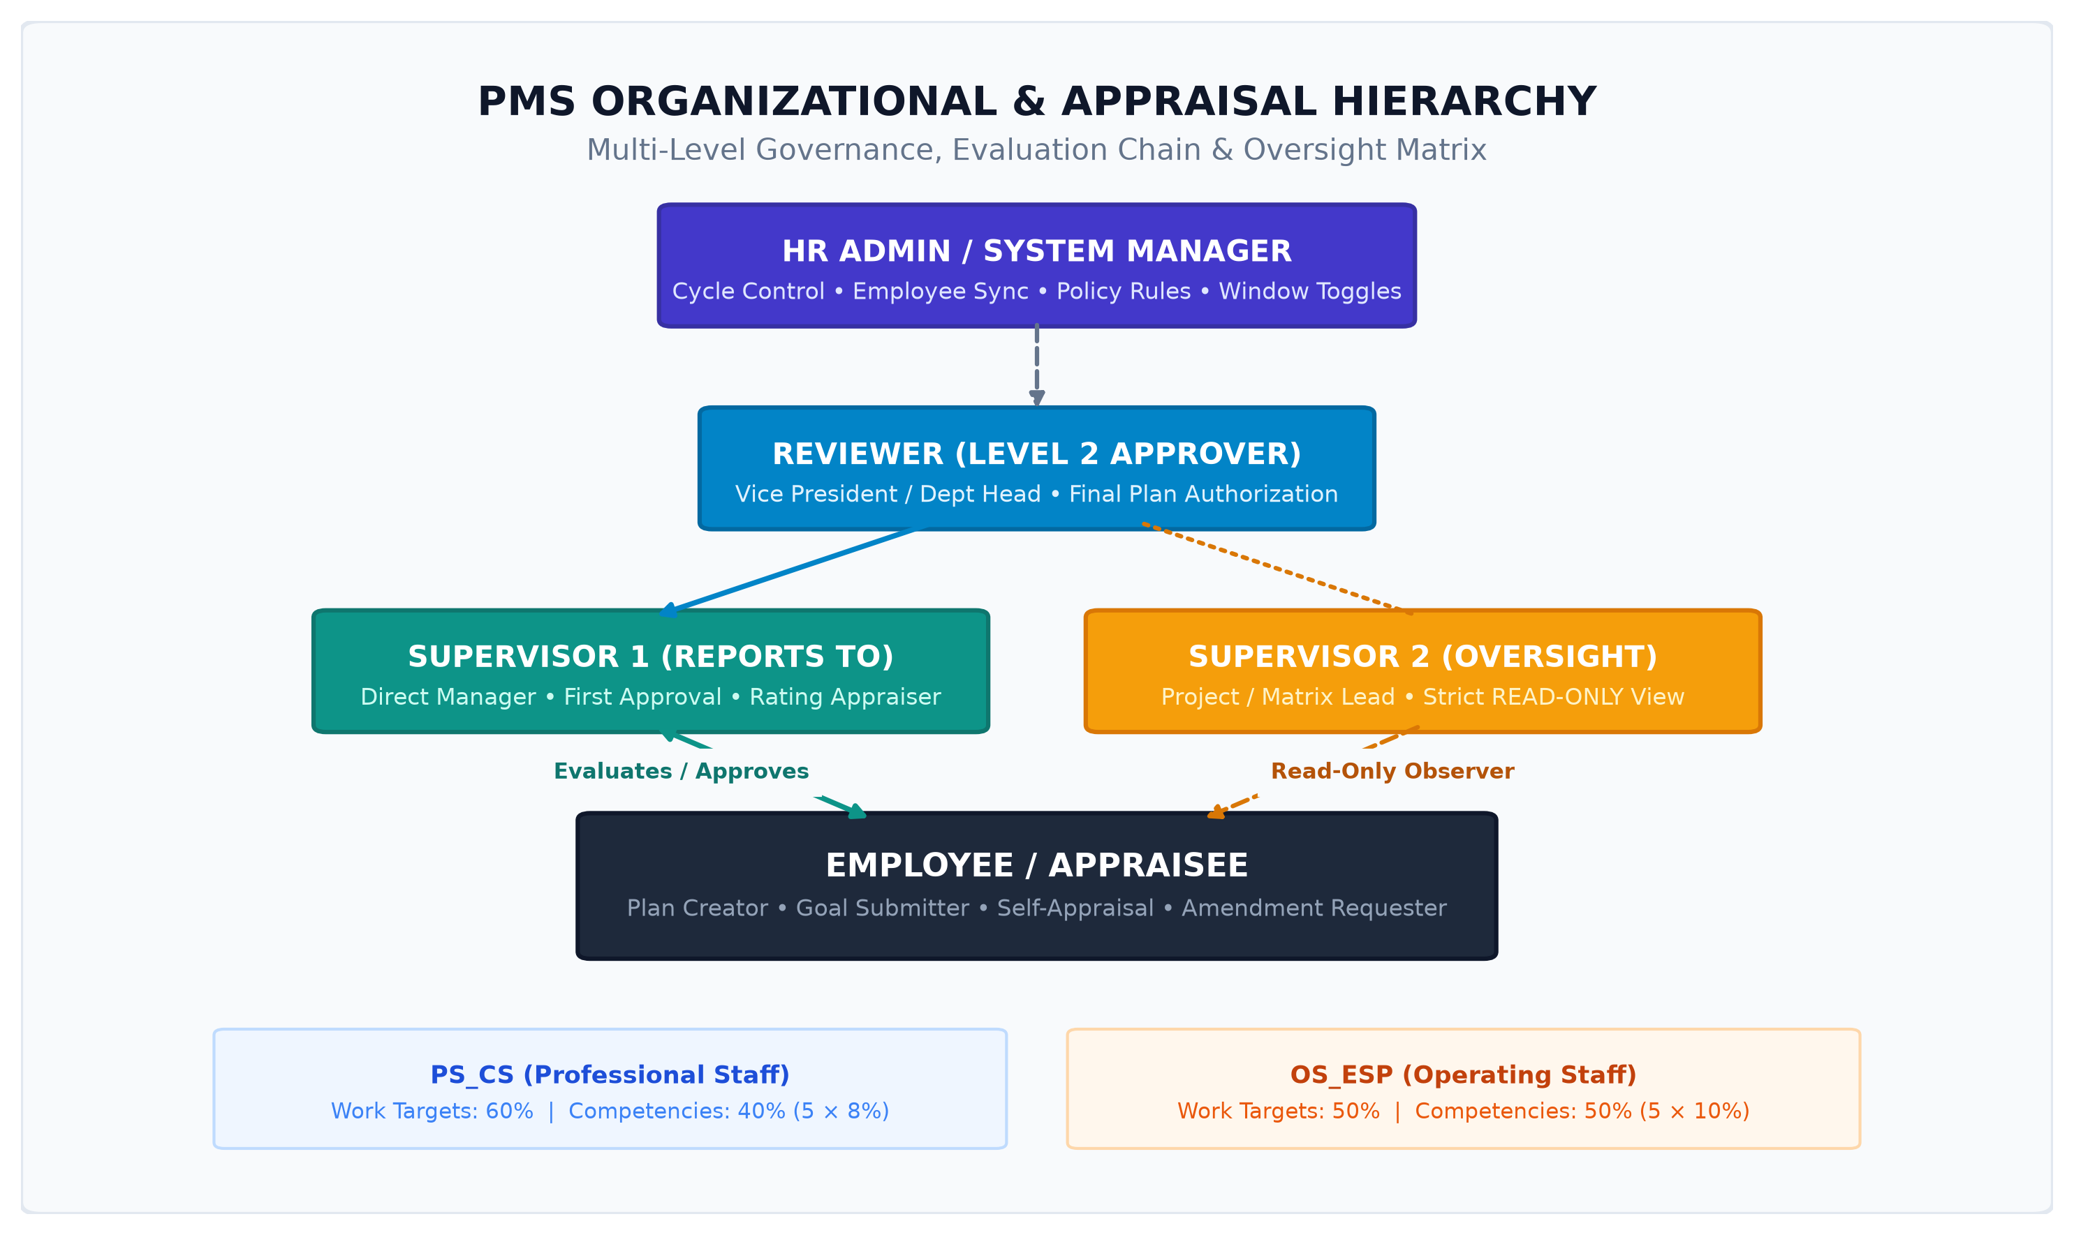
Figure 1: PMS Multi-Tier Organizational Hierarchy and Reporting Architecture

1.1 Grade Group Classifications & Mathematical Weight Rules
All employees are classified into one of two primary grade groups within ERPNext: Professional Staff (PS_CS) or Operating Staff (OS_ESP). The system automatically enforces distinct mathematical weighting rules upon plan creation:
Grade Group | Classification Name | Work Targets Total | Competencies Total | Per-Competency Wt
PS_CS | Professional Staff (PS) | 60% (Exact sum) | 40% (5 Competencies) | 8% per row
OS_ESP | Operating Staff (OS) | 50% (Exact sum) | 50% (5 Competencies) | 10% per row

VALIDATION ENFORCEMENT: System validation will throw a validation error blocking document save if the total sum of target weights does not equal exactly 60% for PS_CS or 50% for OS_ESP. The 5 standard behavioral competencies are automatically initialized by the system: (1) Job Knowledge & Skills, (2) Quality of Work, (3) Communication & Teamwork, (4) Initiative & Problem Solving, and (5) Attendance & Punctuality.

1.2 Automated Role Assignment & Security Architecture
To eliminate manual role administration, GDL PMS implements an automated permission hook (auto_assign_roles) triggered on every Employee record update. The mechanism operates as follows:
• Employee Role: Automatically assigned to the user linked in Employee.user_id.
• Supervisor Role: Automatically assigned to the user linked in Employee.reports_to.
• Reviewer Role: Automatically assigned to the user linked in Employee.reviewer.
• Supervisor 2 Role: Automatically assigned to the user linked in Employee.supervisor_2.
• Scoped User Permissions: Creates User Permissions restricted specifically to 'PMS Appraisal' doctype so supervisors only access records of their assigned team members without exposing broader company data.

1.3 Standard Implementation Hierarchy (Live System Reference)
Employee Name | Designation | Assigned PMS Role | Grade Group | System Scope
Rahul Sharma / Karma Wangchuk | Manager | Supervisor (Reports To) | PS_CS | Level 1 Appraiser
Amit Verma / Sonam Tobgay | Vice President | Reviewer | PS_CS | Level 2 Approver
Rajesh Kumar / Tashi Dorji | Project Manager | Supervisor 2 | PS_CS | Read-Only Oversight
Priya Patel / Dechen Peldon | Administrative Officer | Employee (Appraisee) | OS_ESP | Plan Creator / Submitter
HR Administrator | HR Head | HR Admin / System Manager | PS_CS | System Governance

2. Performance Plan Flow, Lifecycle & Status Specifications
The Performance Plan lifecycle is modeled as a deterministic finite-state machine governed by user roles, mandatory input checkpoints, and strict validation rules. The progression transitions through four distinct stages: Cycle Setup, Goal Setting & Approval, Mid-Year Monitoring, and Final Appraisal.

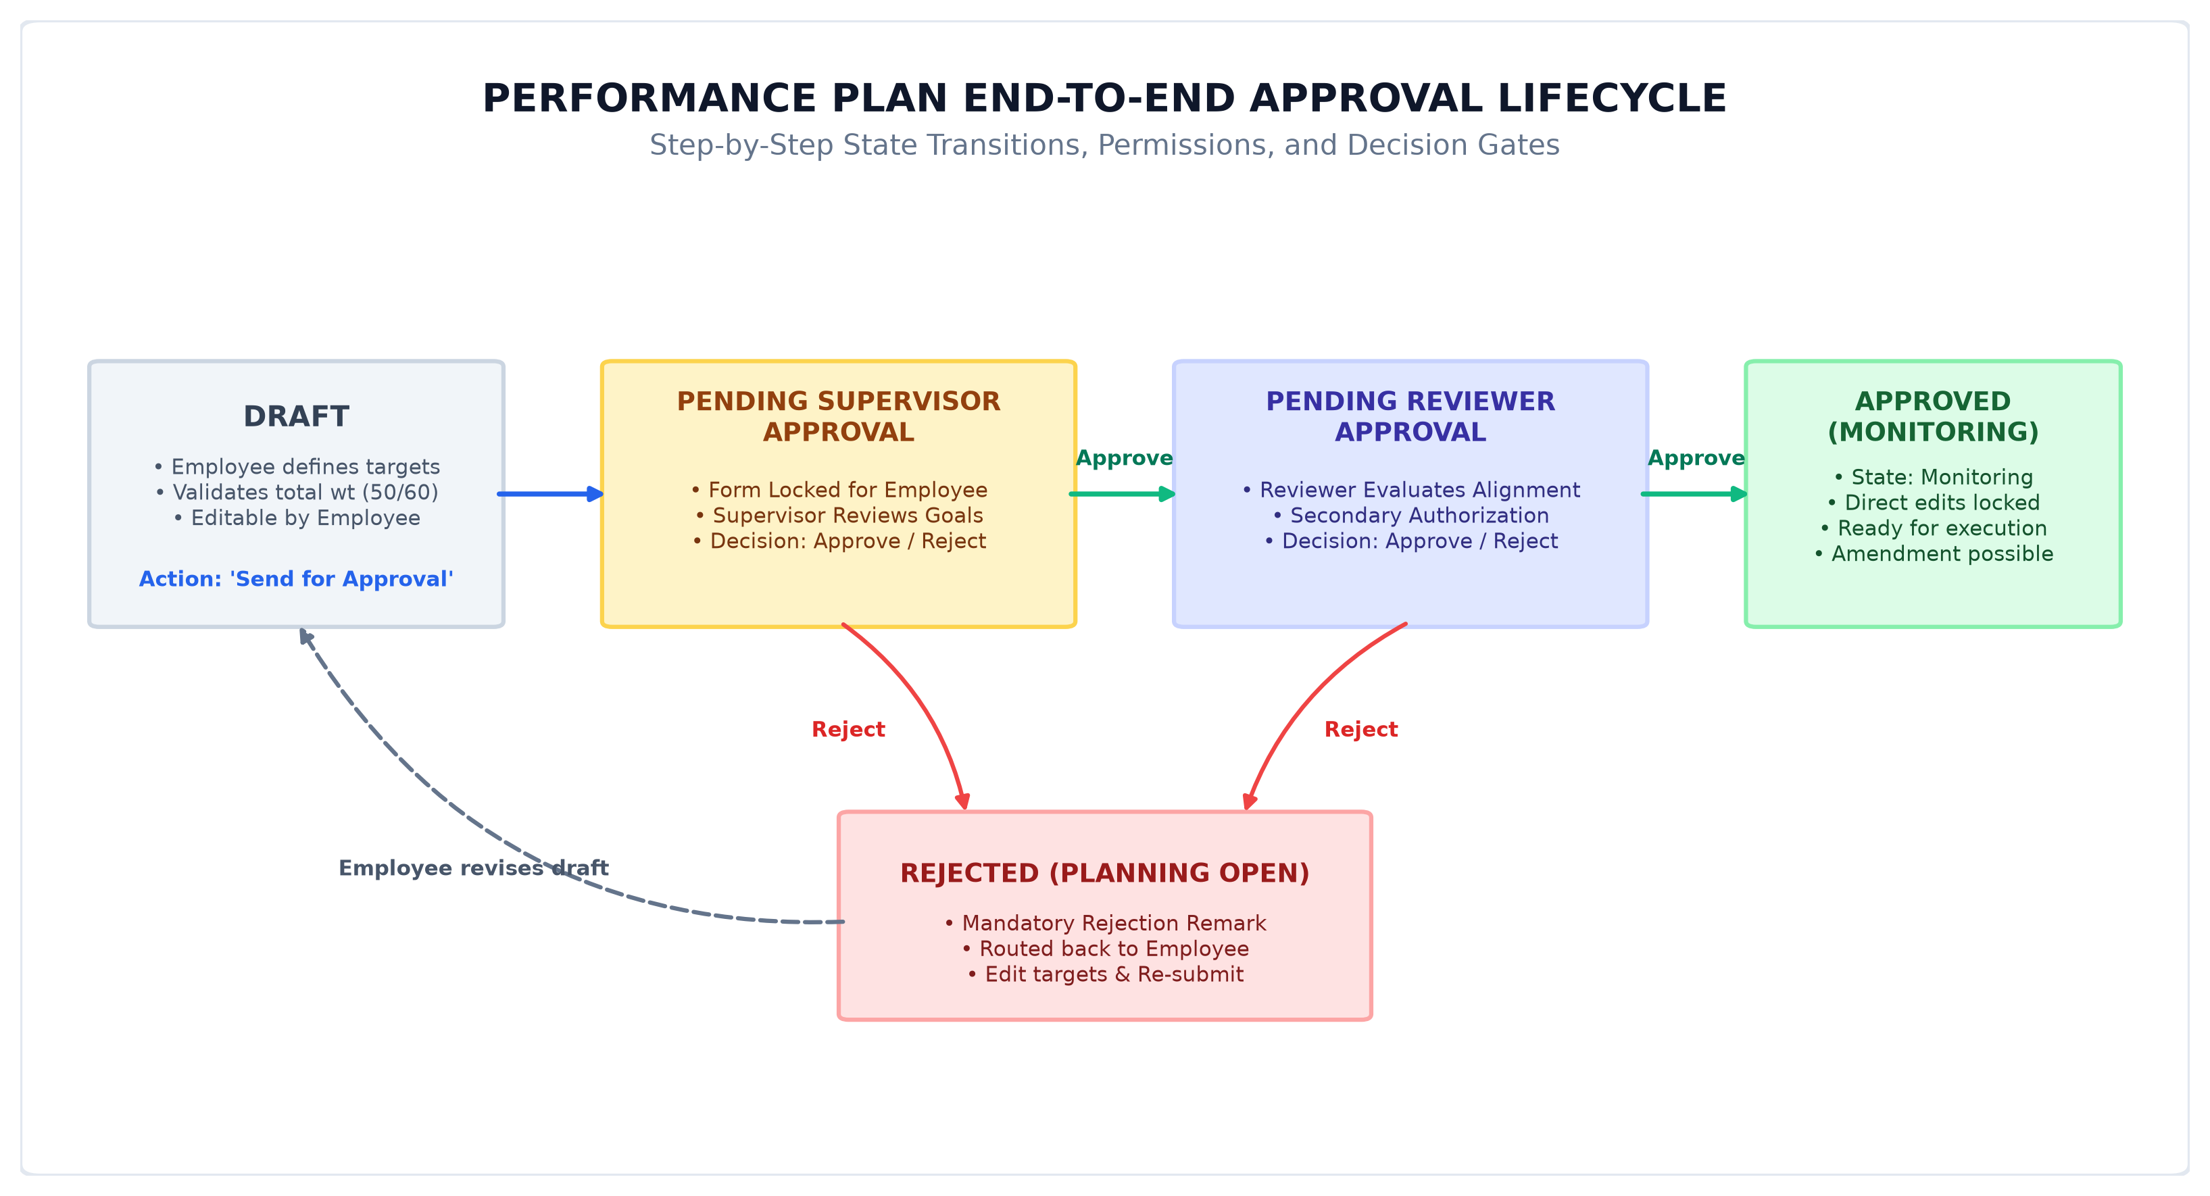
Figure 2: Performance Plan End-to-End Approval Lifecycle & Decision Gateway

2.1 Detailed Status Transition Matrix
Plan Status | Workflow State | Authorized Actor | Trigger Action / Event | Target System State
Draft | Planning Open | Employee | Save / Create Document | Editable by Employee only; weights must equal 50/60%.
Pending Supervisor Approval | Planning Open | Employee | Click 'Send for Approval' | Locked for Employee; action buttons shown to Supervisor only.
Pending Reviewer Approval | Planning Open | Supervisor | Click 'Approve' (Supervisor) | Routed to Reviewer for secondary check; Supervisor locked.
Approved | Monitoring | Reviewer / Supervisor | Click 'Approve' (Reviewer) | Live targets locked at DB level; workflow state becomes 'Monitoring'.
Rejected | Planning Open | Supervisor / Reviewer | Click 'Reject' with Remark | Returned to Employee; rejection remark displayed prominently in banner.

2.2 Step-by-Step Operational Lifecycle
• Phase 1: Appraisal Cycle Initialization (HR Admin): The HR Admin creates an appraisal cycle record (e.g., 'PMS Cycle 2026-2027') specifying the start date, end date, and applicable grade group. When the cycle is transitioned to 'Active' or 'Planning Open', the system triggers an automatic sync populating all active employees into the cycle's tracking registry with their assigned supervisors and reviewers.
• Phase 2: Performance Plan Drafting (Employee): The employee accesses their PMS Employee portal and initiates a new Performance Plan. The system automatically fetches employee profile metadata, links the active cycle, snapshots the supervisor/reviewer names, and populates the default competencies. The employee adds work targets ensuring the total weight matches exactly 60% (for PS) or 50% (for OS).
• Phase 3: Level 1 Review & Decision (Supervisor 1): Upon submission, the plan status changes to 'Pending Supervisor Approval'. The line manager accesses their supervisor dashboard. The supervisor inspects target descriptions and weight distributions. The supervisor may either Approve (routing to Reviewer) or Reject (which mandates entering a rejection remark, reverting the document to 'Rejected' for employee revision).
• Phase 4: Level 2 Review & Authorization (Reviewer): The Reviewer (VP or Department Head) conducts final executive review. Upon clicking 'Approve', the plan status becomes 'Approved' and the workflow state switches to 'Monitoring'. At this precise moment, targets become legally binding and immutable.

3. Mid-Year Monitoring & Plan Amendment Protocol
In dynamic business environments, operational priorities, project scope, or government directives may shift mid-way through an appraisal year. Rather than allowing unmonitored edits or resetting the appraisal, GDL PMS implements a rigorous Plan Amendment subsystem governed by HR policy controls.

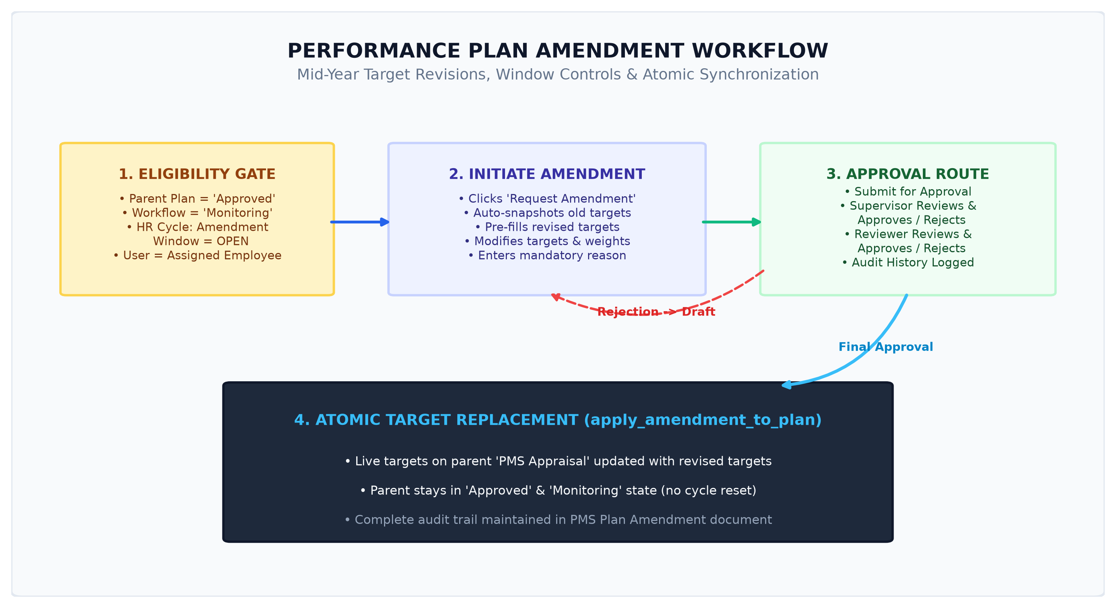
Figure 3: Mid-Year Plan Amendment Lifecycle, Window Check & Atomic Target Update

3.1 Key Technical Rules of Plan Amendment
1. HR Window Control: The 'Request Amendment' action button is only visible when HR has toggled 'amendment_window_open = 1' on the Appraisal Cycle.
• Immutable Parent Plan: Direct modifications to `tabPMS Target` rows on an Approved plan are completely prohibited in Python validation.
• Historical Target Snapshot: When an amendment is created, existing targets are converted to a JSON snapshot in `previous_targets` for complete historical audit.
• Auto-Increment Versioning: Each amendment for a plan is assigned an auto-incrementing `amendment_number` (1, 2, 3...) per appraisal.
• Approval Route: The amendment traverses Employee Submit -> Supervisor Approval -> Reviewer Approval.
• Atomic In-Place Replacement: Upon final Reviewer approval, the method `apply_amendment_to_plan()` replaces parent targets with `revised_targets` without altering the parent document's 'Approved' status or 'Monitoring' workflow state.

4. Data Architecture, Scoring Engine & Governance
The underlying database schema balances real-time referential integrity with immutable point-in-time snapshots. The scoring engine aggregates work results and behavioral ratings, automatically mapping numerical scores to statutory rating bands.

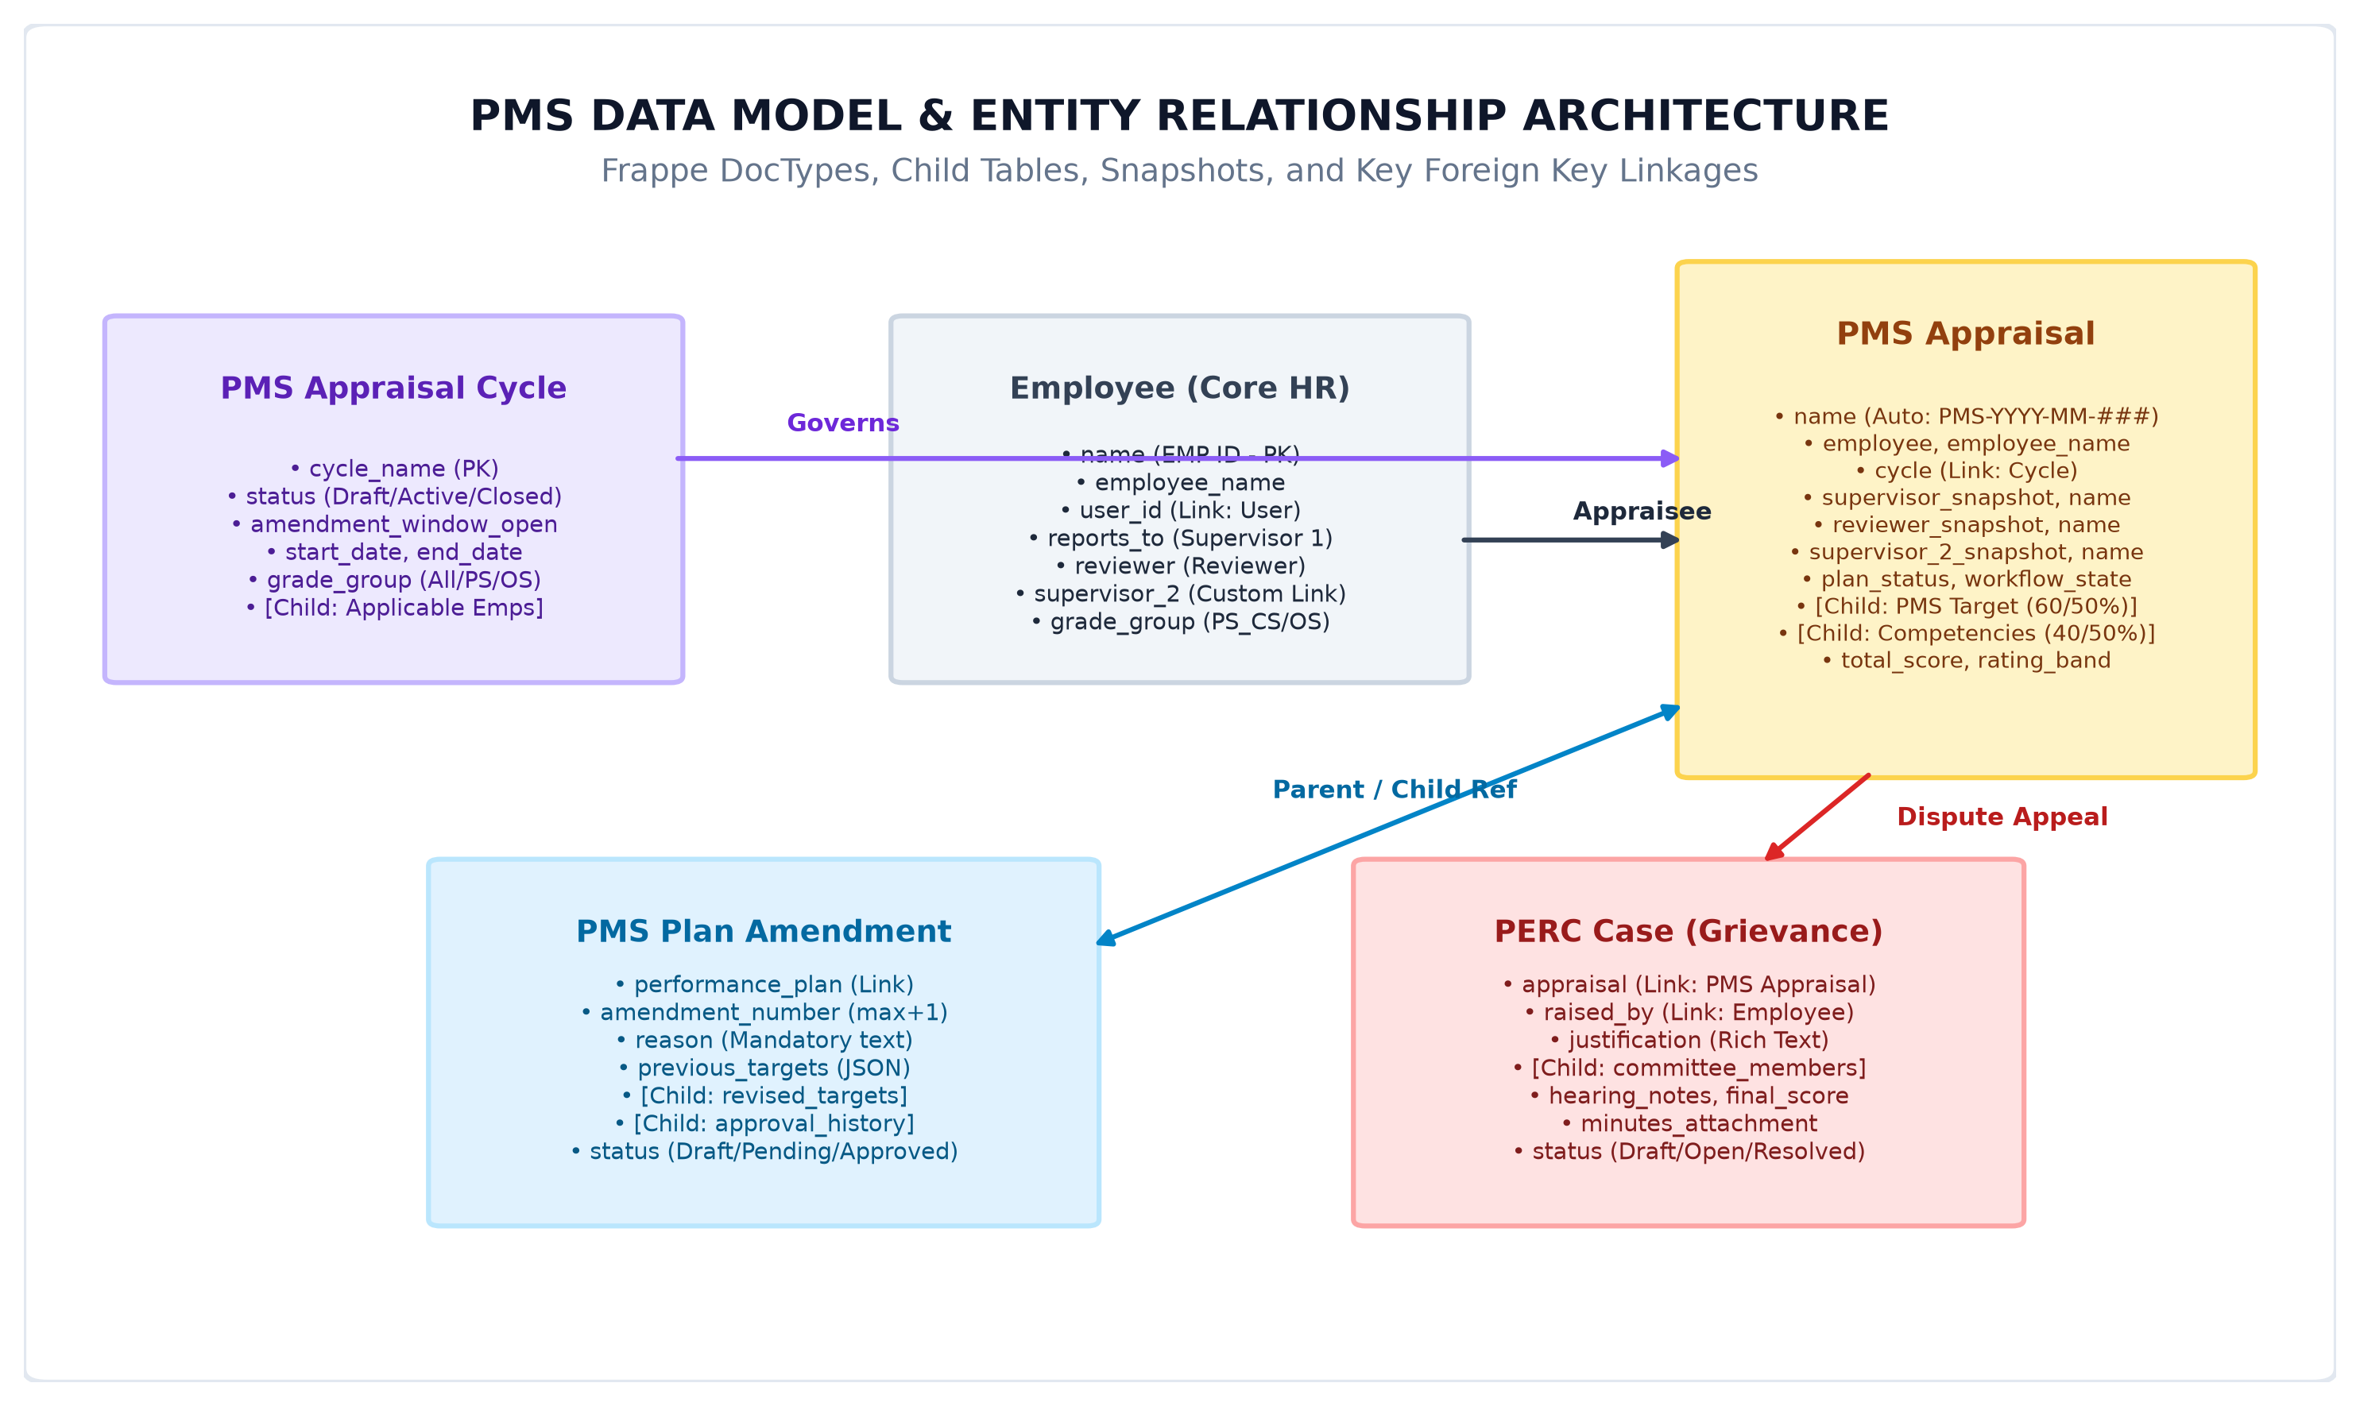
Figure 4: Core Entity-Relationship Diagram and DocType Architecture

4.1 Statutory Rating Bands & PIP Triggers
Score Range | Performance Rating Band | Performance Level | System Trigger / Consequence
90.00% - 100.00% | Outstanding Performance | Level 5 (Top Performer) | Eligible for fast-track increment & honors
80.00% - 89.99% | Exceeds Expectations | Level 4 (Superior) | Standard merit increment & promotion consideration
70.00% - 79.99% | Meets Expectations | Level 3 (Competent) | Standard annual increment eligible
60.00% - 69.99% | Needs Improvement | Level 2 (Marginal) | Performance warning & coaching plan required
0.00% - 59.99% | Unsatisfactory Performance | Level 1 (Substandard) | AUTOMATIC PIP TRIGGER (Performance Improvement Plan)

4.2 PERC Grievance Redressal & Score Override Protocol
To guarantee procedural justice, employees dissatisfied with their final evaluation may submit a PERC Case (Performance Evaluation & Review Committee). The tribunal conducts a formal inquiry involving appointed committee members, reviews meeting minutes, and records hearing notes. If a dispute is resolved in the employee's favor, the committee inputs a binding 'Final Score'. Invoking the resolution triggers `apply_perc_override()`, which locks the appraisal and submits the corrected score and rating band into the permanent personnel archive.

5. Master Role-Action Permission Matrix
The following matrix summarizes the exact technical operations permitted per user role across all doctypes and workflow states:
Operational Action | Employee | Supervisor | Reviewer | Supervisor 2 | HR Admin
Create PMS Appraisal | YES (Self) | NO | NO | NO | YES (Any)
Edit Targets in Draft | YES | NO | NO | NO | YES
Send for Approval | YES | NO | NO | NO | YES
Approve Initial Plan | NO | YES (L1) | YES (L2) | NO (Read-only) | YES
Reject Initial Plan | NO | YES (L1) | YES (L2) | NO (Read-only) | YES
View Monitored Plan | YES (Self) | YES (Team) | YES (Dept) | YES (Assigned) | YES (All)
Direct Edit Targets in Monitoring | LOCKED | LOCKED | LOCKED | LOCKED | LOCKED
Request Plan Amendment | YES (Window) | NO | NO | NO | YES
Approve Plan Amendment | NO | YES (L1) | YES (L2) | NO (Read-only) | YES
Raise PERC Grievance | YES (Self) | NO | NO | NO | NO
Open/Close Amendment Window | NO | NO | NO | NO | YES
Sync Appraisal Cycle Employees | NO | NO | NO | NO | YES

--- End of Technical Specification Document ---
Generated by Antigravity AI Engine for GDL PMS Project

